ROUTERMASTER: A Full-Stack Route and Logistics Management System using Java Spring Boot
Department of Computer Science and Engineering
University Institute of Technology, Barkatullah University, Bhopal

Ayush Verma CSE Student, BUIT Bhopal, India
ayushverma19171051@gmail.com
Aishwaryjeet Shrivastava CSE Student, BUIT Bhopal, India
aishwaryjeetshrivastava@gmail.com

Md. Abid
CSE Student, BUIT Bhopal, India abidmd7384@gmail.com

Krishnakant Markam CSE Student, BUIT Bhopal, India
krishnakantmarkam33@gmail.com
Dr. Kavita Chourasia Co-Guide, BUIT Bhopal, India
kavichourasia@gmail.com
Ms. Kamini Maheshwari Guide, BUIT Bhopal, India
kaminimaheshwari@gmail.com

Dr. Divakar Singh
CSE HOD, BUIT
Bhopal, India divakarsingh@gmail.com

Abstract—This paper presents RouterMaster, a full-stack route and logistics management system developed to streamline trans- portation processes including route creation, vehicle assignment, and delivery monitoring. Traditional route management sys- tems rely heavily on manual coordination, leading to delays, inefficiency, and poor tracking. RouterMaster leverages Java Spring Boot for backend development, MySQL for relational data storage, and a modern web frontend to automate logistics workflows. The system provides secure user authentication, CRUD operations for routes and vehicles, driver assignment management, and a centralized dashboard accessible through REST APIs. The application was tested using Postman and validated for correctness, data integrity, and API compliance. RouterMaster demonstrates how modern enterprise Java tech- nologies can replace manual logistics operations with scalable and efficient digital solutions.
Index Terms—Spring Boot, Java, Route Management, Logistics Automation, RESTful APIs, MySQL, Hibernate, MVC Architec- ture

- Introduction
The logistics and transportation sector has long relied on manual methods such as spreadsheets and paper-based records for route planning and vehicle management. These approaches are inefficient, error-prone, and difficult to scale as organiza- tions grow. The increasing demand for real-time visibility and process automation has made digital transformation essential in logistics operations.
Problem Statement: Existing manual route management systems lack centralized access, real-time update capabilities, and structured tracking, resulting in miscommunication, de- lays, and operational inefficiencies.
Objective: To develop a RESTful web application that enables organizations to digitally manage routes, vehicles, and
drivers through a secure and centralized platform, eliminat- ing the dependency on manual record-keeping. RouterMaster addresses these challenges by offering an integrated platform where administrators can add and update routes, assign drivers and vehicles, and monitor operations through a unified dash- board built using Java Spring Boot and MySQL.
- Literature Review
Several logistics and fleet management systems have been developed commercially and academically. Enterprise solu- tions such as Oracle Transportation Management and SAP TM offer comprehensive functionality but are proprietary, expen- sive, and overly complex for small and medium enterprises. Open-source alternatives often lack customization support or developer-friendly architecture.
Research in logistics automation indicates that digitizing route planning processes can reduce operational time by up to 40% and significantly minimize human error [1]. Modern backend frameworks like Spring Boot provide a lightweight yet powerful platform for building scalable REST APIs, while Hibernate ORM simplifies database interaction through object-relational mapping [2]. RouterMaster builds upon these findings to deliver a modular, open-source, and developer- extensible solution tailored for route and logistics manage- ment.
- Methodology

Tech Stack:
- Spring Boot (Backend Framework)
- Spring Security (Authentication & Authorization)
- Hibernate ORM / Spring Data JPA (Database Layer)
- MySQL (Relational Database)
- Maven (Dependency Management)

- Postman (API Testing)
- Git & GitHub (Version Control)

Architecture Overview:
- Model-View-Controller (MVC) layered architecture
- Entity-based modeling for Route, Vehicle, Driver, and User
- REST API design with standardized HTTP endpoints
- Centralized exception handling via @ControllerAdvice
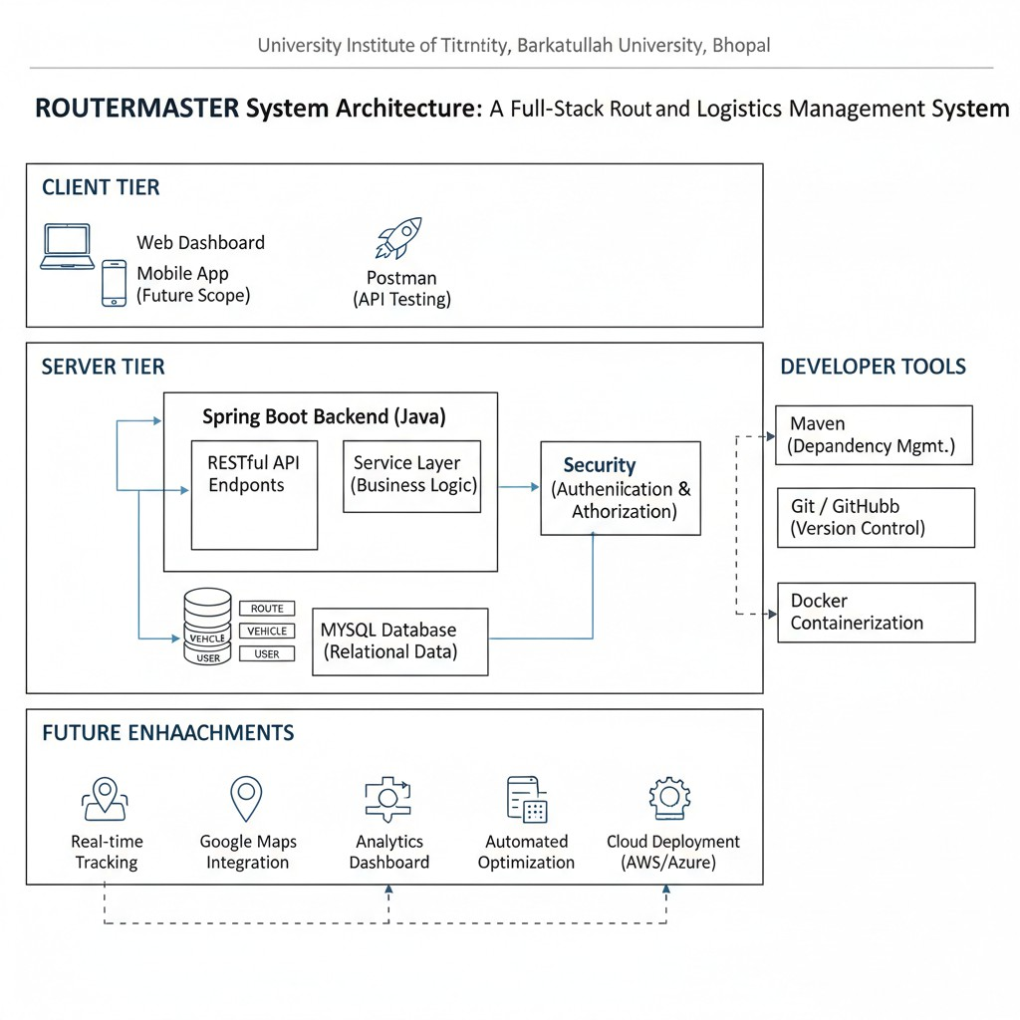

Fig. 1. ROUTERMASTER System Architecture: A Full-Stack Route and Logistics Management System

Development Workflow:
- Database schema design and normalization
- Entity mapping using Hibernate annotations
- Service layer implementation for business logic
- Controller layer implementation for REST endpoints
- API testing and validation using Postman
- Integration testing and debugging
- System Design & ER Model

Entities:
- User: Stores authentication credentials and role informa- tion
- Route: Stores source, destination, distance, and status
- Vehicle: Stores vehicle number, type, and capacity
- Driver: Stores driver name, contact details, and assign- ments

Entity Relationships:
- One User can manage many Routes (one-to-many)
- One Driver can be assigned to multiple Routes
- One Vehicle can participate in multiple Route assign- ments
- Route acts as the central entity linking Vehicles and Drivers
The system follows a normalized relational schema ensuring data integrity and minimal redundancy across all logistics entities.
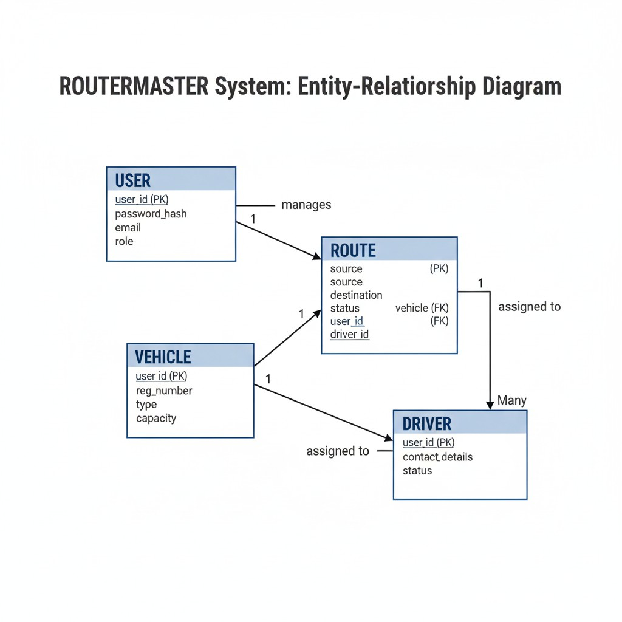
Fig. 2. ROUTERMASTER System: Entity-Relationship Diagram

- Implementation Details
RouterMaster is structured using the standard Controller- Service-Repository pattern in Spring Boot. Each module is implemented as an independent Spring component to main- tain clean separation of concerns. The RouteController handles incoming HTTP requests and delegates business logic to the RouteService. The service layer validates input data and enforces business rules such as preventing duplicate route entries. Persistence is managed through Spring Data JPA repositories that interface with the MySQL database. Spring Security is configured to protect all API endpoints, requir- ing authentication before access. Passwords are stored using BCrypt hashing to ensure security. Role-based access control differentiates between admin and standard user permissions.
- Results & Testing
- API Testing with Postman
All REST endpoints were tested using Postman to verify correctness, response structure, and HTTP status codes:
  - POST /api/auth/login — Authenticate user and return session
  - GET /api/routes — Retrieve all route records
  - POST /api/routes — Create a new route entry
  - PUT /api/routes/{id} — Update an existing route
  - DELETE /api/routes/{id} — Remove a route record

  - GET /api/vehicles — Retrieve all vehicle records
  - POST /api/drivers — Add a new driver
- Sample API Response

[
{
” r o u t e I d ” : 1 ,
” s o u r c e ” : ” Bhopal ” ,
” d e s t i n a t i o n ” : ” I n d o r e ” , ” d i s t a n c e ” : 1 9 5 . 5 ,
” s t a t u s ” : ”ACTIVE” ,
” a s s i g n e d D r i v e r ” : ” R a j e s h Kumar ” , ” v e h i c l e ” : ”MP09−AB−1234”
} ,
{
” r o u t e I d ” : 2 ,
” s o u r c e ” : ” I n d o r e ” ,
” d e s t i n a t i o n ” : ” Nagpur ” , ” d i s t a n c e ” : 3 1 0 . 0 ,
” s t a t u s ” : ”PENDING” ,
” a s s i g n e d D r i v e r ” : ” S u r e s h Yadav ” , ” v e h i c l e ” : ”MP09−CD−5678”
}
]
Testing Summary: All endpoints returned valid JSON responses with correct HTTP status codes (200 OK, 201 Created, 404 Not Found, 400 Bad Request). Invalid inputs were rejected with descriptive error messages. Data integrity tests confirmed that routes were stored accurately and that duplicate entries were prevented by the service layer.

- Discussion
- Conclusion & Future Scope
RouterMaster successfully demonstrates how logistics oper- ations can be modernized using a full-stack automation system built on Java Spring Boot and MySQL. The system provides secure authentication, complete route lifecycle management, vehicle and driver coordination, and reliable API communica- tion, effectively replacing inefficient manual processes.

Future Enhancements:
- Integration of JWT for stateless token-based authentica- tion
- Real-time GPS tracking for active route monitoring
- Google Maps API integration for visual route planning
- Analytics dashboard with route performance metrics
- Frontend development using React or Angular
- Mobile application for driver-side updates
- Cloud deployment via AWS or Azure
- Docker containerization for environment-independent de- ployment
- Automated route optimization using shortest-path algo- rithms
- Appendix: Sample Code Snippets
- Spring Boot Route Controller
@ R e s t C o n t r o l l e r
@RequestMapping ( ” / a p i / r o u t e s ” )
p u b l i c c l a s s R o u t e C o n t r o l l e r {

@Autowired
p r i v a t e R o u t e S e r v i c e r o u t e S e r v i c e ;

@GetMapping ( ” / ” )
p u b l i c L i s t g e t A l l R o u t e s ( ) {
return r o u t e S e r v i c e . g e t A l l R o u t e s ( ) ;

RouterMaster confirms that a modular Spring Boot backend can effectively replace manual logistics management sys- tems. The layered architecture ensures maintainability, while the REST API design enables seamless frontend integration. Compared to heavyweight ERP systems, RouterMaster is lightweight, open-source, and easy to customize for specific business needs.

Challenges Faced:
- Designing a flexible schema to support varied route and }
vehicle relationships
}

@PostMapping ( ” / ” )
p u b l i c R e s p o n s e E n t i t y add Route (
@RequestBody Route r o u t e ) {
return R e s p o n s e E n t i t y . s t a t u s ( 2 0 1 )
. body ( r o u t e S e r v i c e . add Route ( r o u t e ) ) ;
}

- Implementing role-based access control without overcom- plicating authentication logic
- Maintaining modular code structure while managing inter-entity dependencies

Advantages of RouterMaster:
- Eliminates manual errors in route and driver management
- Centralized dashboard improves operational visibility
- Scalable architecture supports future feature additions
- REST API design enables integration with any frontend or mobile client
- Open-source and developer-friendly codebase
- Hibernate Entity: Route
@ Entity
@Table ( name = ” r o u t e s ” )
p u b l i c c l a s s Route {

@Id
@ Generated Value (
s t r a t e g y = G e n e r a t i o n T y p e . IDENTITY )
p r i v a t e Long r o u t e I d ;

p r i v a t e S t r i n g s o u r c e ;

p r i v a t e S t r i n g d e s t i n a t i o n ;
p r i v a t e double d i s t a n c e ;
p r i v a t e S t r i n g s t a t u s ;

@ManyToOne
@JoinColumn ( name = ” d r i v e r i d ” )
p r i v a t e D r i v e r a s s i g n e d D r i v e r ;

@ManyToOne
@JoinColumn ( name = ” v e h i c l e i d ” )
p r i v a t e V e h i c l e v e h i c l e ;
}

- References References
- R. Kapoor and S. Mehta, Digital Transformation in Logistics and Supply Chain Management, Journal of Industrial Engineering, 2021.
- C. Walls, Spring Boot in Action. Manning Publications, 2019.
- C. Bauer and G. King, Java Persistence with Hibernate, 2nd ed. Manning Publications, 2015.
- L. Richardson and M. Amundsen, RESTful Web APIs. O’Reilly Media, 2013.
- P. DuBois, MySQL, 5th ed. Addison-Wesley Professional, 2013.
- L. Spilca, Spring Security in Action. Manning Publications, 2020.

