Ficus carica Linn as a Source of Potent Triterpenoids: Isolation, Characterization, and Biological Significance

1. INTRODUCTION
Ficus carica L. plant species belongs to the Moraceae family which is famous for its fruits. This indigenous plant is widely cultivated for its fruits throughout southwest Asia and semi-temperature zones. Edible fruits of this plant are known as figs and are consumed in fresh as well as dry form. The lush green leaves are covered with long hairy trichomes on the upper surface and fine trichomes cover its lower surface. Leaves are lobed, which may be three to five lobes, 10-25 cm in length and covered with cuticular wax. Leaves are rich in primary and secondary metabolites namely tannins, sugars, vitamins, pectin, flavonoids and terpenoids [1-4]. Varied range of secondary metabolites are present in this plant reported for its therapeutic utility as medicine for liver, blood, respiratory and gastrointestinal diseases.
Triterpenoids like bauerenol, oleanolic acid, caloptropenyl acetate, lupeol acetate, ficusogenin, 6- o-Linoleyl-β-D-glucosyl-β-sitosterol, 6-o-Oleyl-β-D-glucosy-β-sitosterol, 6-o-palmitoyl-β-D-glucosy-β-sitosterol and methyl maslinate isolated from leaves of F. carica. The rising demand for natural products for chronic disorders has stimulated research into the pharmacological significance of bioactive chemicals from nature. Oleanolic acid (OA)(Figure 2) a pentacyclic triterpenoid widely distributed in plants has been reported for its therapeutic potential. OA also serves as a template for the development of semi-synthetic triterpenoids. [5-7] OA plays a major ecological role in plants also reported for its potential pharmacological activities like anticancer, and antidiabetic, Screening of additional biological functions of OA (3β-hydroxyolean-12-en-28-oic acid) and its synthetic derivatives may lead to the production of potent pharmaceuticals to treat human disorders. Thus, Ficus carica is used for extraction and isolation of Oleanolic acid, and evaluated for antiproliferative, antioxidant, and antimicrobial activities. [8-11]

2. RESULTS AND DISCUSSION
2.1 Extraction and Isolation:
The methanolic extract of Ficus carica leaves is used for the isolation of Oleanolic acid. The obtained extract was separated with water and ethyl acetate to obtain two distinct fractions. The ethyl acetate fraction was subjected to solvent-solvent fractionation. Without using any chromatographic techniques, Oleanolic acid was isolated (Figure 1). The percentage yield of isolated Oleanolic acid was calculated and stored at room temperature.Oleanolic acid was obtained with a percent yield of 0.6%.
2.2 TLC analysis:
The TLC analysis of the isolated and standard compound revealed well-resolved spots of violet color with Rf value of 0.62. The developed chromatographic plate indicate towards good separation of both the standard and isolated compound in the given solvent system.
2.3 High‐performance thin‐layer chromatography (HPTLC) studies:
Isolated compound oleanolic aicd was exmined by analytical study, the findings were satisfactory. The Rf value for oleanolic acid was discovered to be 0.39 in the HPTLC investigation. The HPTLC analysis revealed that this chemical is completely pure. Oleanolic acid was the subject of an HPTLC analysis, and it was discovered that the synthetic compounds displayed peak purity of 99.88% at a retention time of 3.592 min. The methods were created to evaluate the purity of compounds. it was discovered that they were within the permissible range for recently isolated compounds and offer the opportunity to get compounds with high purity.
2.4 Structural Elucidation of Compound (Oleanolic acid):
UV: To determine lambda max of isolated Oleanolic acid, succeeding method accomplished.Take 10ug/10ml solution (1ug/ml) of standard Oleanolic acid.Pipette out 1 ml solution to 10 ml volumetric flask and make up the volume up to 10 ml to form a solution of 0.1ug/ml [36]. Observations under UV spectrophotometer were obtained as 0.094 absorbances at 240 nm wavelength and 0.081 absorbances at 250 nm wavelength for standard and isolated Oleanolic acid, respectively(Fig 1,4).
2.5 Mass spectroscopy:
In the given mass spectrum (Fig 7) Oleanolic acid has a molar mass of 456.7 gm/mol. The base peak obtained has an m/z value of 473.243 and the value for the molecular ion peak resembles the value of 708.588, with the major fragment ions having m/z values 504.366, 514.358, 537.377, 606.495.
2.6 1 H-NMR spectra:
In the given NMR spectra (Fig 8) of Oleanolic acid, obtained peaks based upon chemical shift (ppm) are 8.007, 7.997, 7.986, 7.509, 6.854, 6.830, 3.002, 2.546, 2.536.
2.7 Molecular docking:
The method used in this work is effective in locating strong Antiproliferative and Antioxidant effects. The interactions are stabilized by hydrogen bonding, and all the compounds exhibit the lowest docked energies. Certain ligands exhibit excellent protein binding affinities. The potential for additional research into selected proteins indicates better activity towards the potential antiproliferative and antioxidant activity of Oleanolic ligands as suggested by their favorable docking scores and drug likeliness(Tables 5 and 6).
2.8 Antioxidant activity:
The free radical scavenging activity of Oleanolic acid was examined by DPPH assay and the results showed a good free radical inhibition activity when compared to standard antioxidants (Ascorbic acid).
The percent inhibition of plant extract at concentrations 10, 20, and 30 ug/ml showed to be 69.6%, 73.7%, and 79.1% resp. (table 9) The percent inhibition for isolated Oleanolic acid for the same concentrations was found to be 85%, 89%, and 91.05% resp. The percent inhibition for marker Oleanolic acid for the same concentrations was found to be 86.06%, 87.7%, and 92.12% resp. The percent inhibition of ascorbic acid for the same concentrations was found to be 91.45%, 91.59%, and 92.50% resp(Graph 8).
2.9 Antiproliferative activity:
Antiproliferative activity of Oleanolic acid performed in a yeast model. The evaluation of antiproliferative activity showed results that the total number of viable cells at 4,5,6 ug/ml concentrations of extract were 242, 195, and 167, respectively. The total number of cells at similar concentrations for isolated Oleanolic acid, marker Oleanolic acid, and standard drug (quercetin) were 137, 117, 97, 123, 113, 97, 102, 99, 96, respectively (table 8).Percentage inhibition of extract at 4,5,6 ug/ml conc. were 52.17 %, 60.86 %, and 67.90 %, while isolated compounds (Oleanolic acid) at similar concentrations were found to have percent inhibition of 68.31%, 77.35%, and 81.08% resp. The percent inhibition of marker Oleanolic acid at these concentrations was found to be 76.18%, 78.28%, and 81.35%, while standard (quercetin) was found to have 80.46%, 81.41% and 81.52 percent inhibition activity(Graph 9).
2.10 Antimicrobial activity:
The antibacterial activity of gram-positive Staphylococcus aureus and gram-negative E. coli was examined in the leaves of the Ficus carica plant. The zone of inhibition for Staphylococcus aureus was found to be 15 mm – 24 mm. The zone of inhibition for Escherichia coli was found to be 16 mm – 27 mm(Fig)(table 10)(graph 11).
3. CONCLUSION
Oleanolic acid isolated from the Ficus carica plant can used as a suitable compound for various therapeutic activities mentioned above based on the observation drawn from the testing results as well as the molecular interaction demonstrated through in-silico studies. Though Oleanolic acid is present in low quantities in the leaves of fig plants it proved to be a reliable source to inhibit cell growth and to stabilize the free radical electrons in the body. Ficus carica plant leaves can also be an alternative to inhibit microbial growth with high antimicrobial activity. Hence Oleanolic acid has proven as an agent for Antioxidant, Antiproliferative, and Antimicrobial activities. On a futuristic aspect, with some additional improvement, Oleanolic acid can be considered to be formulated for different ailments.
4. MATERIALS AND METHODS
Collection and drying: Fresh leaves collected from the local region and authenticated by Rashtrasant Tukdoji Maharaj Nagpur University, Botany Department (Vaucher no. 1745) and shed dried for 7-10 days at room temperature. The leaves are crushed manually and stored in airtight containers until further use. [12,13]Extraction and isolation of Oleanolic acid: 500 g of crushed fig plant (Ficus carica) leaves immersed for 48 hours in methanol, filtered, and concentrated. This concentrated methanolic extract was washed with ethyl acetate multiple times and ethyl acetate extract concentrated as a thick paste by subje cting it to a rotary evaporator. For the isolation of oleanolic acid,(fig2) the solvent-solvent fractionation method was applied. This ethyl acetate extract was resuspended in water, and then time the water-insoluble content made free from solventby filtration. The ethyl acetate fraction was collected, mixed, concentrated, and fractionated with diethyl ether, followed by hexane. The insoluble fraction was resuspended in chloroform, and filtered, and the filtrate collected as OA is soluble in chloroform as Figure 1. On cooling in the refrigerator OA precipitated as buffy white particles.Purification:Purification is done by collecting precipitated compounds and recrystallizing them with cold methanol. The percentage yield of isolated OA is calculated by a formula and stored at room temperature[16].
Extract yield% = (weight of extracted plants residues)/(weight of plant raw sample)× 100
Preliminary confirmatory tests namely Liebermann Burchard and Salkowski test for triterpenoids performed for confirmation of the isolated compound. (Table 3)TLC analysis:Hand TLC was performed for qualitative confirmation of the isolated compound with standard OA on a pre-coated silica G plate with cyclohexane: acetone (1:1) mobile phase. Developed plate air dried, treated with anisaldehyde: sulphuric acid reagent, and heated in a hot air oven for 10 mins at 105°C. [17,18]
4.1 HPTLC studies
The HPTLC investigations for isolated compounds were completed under chromatography-optimized conditions. Precoated silica gel 60 F254 plates, which have a 200 m thickness, served as the stationary phase. The sample was applied as a band that was 5mm wide and 5 μl. in volume. The mobile phase with concentration 8:2 for n-butanol/toluene was choosen. A presaturated chamber was used with the ascending separation technique for 15 minutes before the run-up to 90 mm. The plate was scanned using the absorbance/reflectance scanning mode for oleanolic acid at a wavelength of 257 nm and a scanning speed of 20 nm/s. Graph is showing in figure 1.In silico prediction of bioactivities and molecular docking studies:In the current study, we used Pyrex software to conduct an in-silico investigation of the potential chemical pathways behind the antiproliferative, wound healing, and antioxidant effects of F. carica extract. We developed a dataset on the proteins from prior studies and discoveries. [19].
4.2 Molecular docking conducted using PyRx 0.8–Vina:
For each docking process, Vina uses the structures of both ligand and target molecules in a readable format (*. pdbqt), the search space coordinates that define the binding site. The following programs were used: Bovia Discovery for visualization tool for viewing, sharing, and analyzing protein and modeling data, SwissADME: for interpretation of pharmacokinetic properties, druglike nature, and medicinal chemistry friendliness of one or multiple small molecules to support drug discovery.Ligand preparation:Structural information about the bioactive compounds isolated from the leaves of F. carica retrieved from the literature review. The structure of the oleanolic acid of F. carica was modelled using ACD/ChemSketch FREEWARE. This optimized structure of Oleanolic acid (Figure 3) used in the molecular docking studies.Protein preparation: Crystallographic structure of the targets obtained from PDB (Protein Data bank)(Table 1).Bonded and non-bonded hydrogens, water molecules, and excess column charges are removed, hence it implies proper receptor grid generation at the side of the ligand bonding site. Proteins are converted into pdbqt form by loading into Pyrex.Autodock Vina wizard is used to load molecules and ligands to the site and form of grid box for docking stimulations. X, Y and Z axes were established for proper pocket bindings[19]– [22].
Molecular docking: Pyrex software with inbuild Autodock and Open-Beel functionalities used. Preliminary docking was performed by using Pyrex to identify the binding sites (Figure 4)[23].Docked proteins were further analysed with Bovia Discovery Studio.
4.3 Antioxidant activity:The body produces free radicals as a by-product of metabolism and highly harmful substances. This sets off a series of events that result in different metabolic disorders. To determine an individual compound’s antioxidant capacity, free radical scavenging activity is performed. The chemical substance used as an antioxidant agent donates the electron and converts it into a stable molecule[24], [25].Using the DPPH technique, the radical scavenging capacity of Oleanolic Acid was assessed. In summary, methanol was used to create a 0.004% DPPH solution before test samples of extract, isolated compound, marker Oleanolic acid, standard with various concentrations added. Following a thorough mixing process and 5 minutes at room temperature, this solution was measured for absorbance at 517 nm[26], [27].
The reagent solution and methanol, which did not include the sample or the standard, combined to create the control solution for this test[28]. Using this formula, the radical scavenging activity (RSA) measured:
Radial scavenging activity=(absorbance of control- absorbance of sample)/(absorbance of control)×10
4.4 Antiproliferative activity:
Antiproliferation is the control of cell division, cell cycle arrest, or DNA degradation to a specific level. Evaluation of antiproliferative activity done by yeast Saccharomyces cerevisiae model. Signal transduction pathways and JAK-STAT transcriptional activation start the anti-proliferative activity, which is a function of gene expression regulation.
4.4.1 Preparation of yeast ınoculum:
The yeast was cultured in seeded broth, and 5g of marketed yeast was added to 100 ml of sterilized nutrient broth that was incubated at 37°C for 24 hours. Obtain 25.4 ×10⁴ cells/ml, the seeded broth diluted with sterilized distilled water.
4.4.2 Preparation of Potato Dextrose Broth:
The potato slices of 200g boiled in one liter of distilled water for 1 hour. The filtrate of solution was diluted up to 1000ml using distilled water and 20g of glucose was added to the solution. This medium was then autoclaved.

4.4.3 Cell viability count:
A solution comprising 2.5 ml of potato dextrose broth and 0.5 ml of yeast inoculums compiled in different test tubes for the cell viability count. The initial tube was retained as a control with no extract.The conventional antiproliferative agent Quercetin was added with concentrations 4ug/ml, 5ug/ml, and 6ug/ml to the test tubes. Similarly, isolated compound, extract as well and marker Oleanolic acid were also added to the simultaneous test tubes with similar concentrations. At 37 °C, all tubes were incubated. Methylene blue differential staining was used to determine the cell viability count. 0.1% methylene blue dye was added to the cell suspension mentioned above, and all the tubes were examined under a low-power microscope. Dead cells stained blue, whereas living cells left uncolored ( Figure 5 & 6).In sixteen chambers of a Haemocytometer, viable cells were counted, and the average number of cells was determined. The formulas below are used to compute the number of cells per milliliter, the percentage of cell viability, and the percent inhibition of cell viability[29].
Viable cells/ ml = Average no of viable cells in one square x Dilution factor x 10⁴
% Cell viability=(Total viable cells)/(Total number of cells) X100
4.5 Antimicrobial activity:
The microbes were inoculated into 5.0 ml of nutrient broth and cultured there for 24 hours at 3 °C using a loopful.The solution was diluted by adding 0.2 ml from the microbial culture to 20 ml of sterile saline water. 1.7gm of agar dissolved in 20ml of distilled water and heated in a water bath till the transparent solution was attained. The solution was autoclaved at 15 atmospheric pressures for 15 min to sterilize the solution.
4.5.1 Well diffusion method:
The 100ul inoculum was mixed with the agar medium and the agar medium was poured into the sterilized Petri plates and left for cool. The medium becomes solidified.Four wells were bored into each plate and filled with solutions of test samples of different concentrations using a micropipette and incubated at 37°c for 48 h(Fig 3).The assessment of an antibacterial substance was done using the zone of inhibition measurement (mm) (Figure 7)[30]– [34].

TABLES AND FIGURES
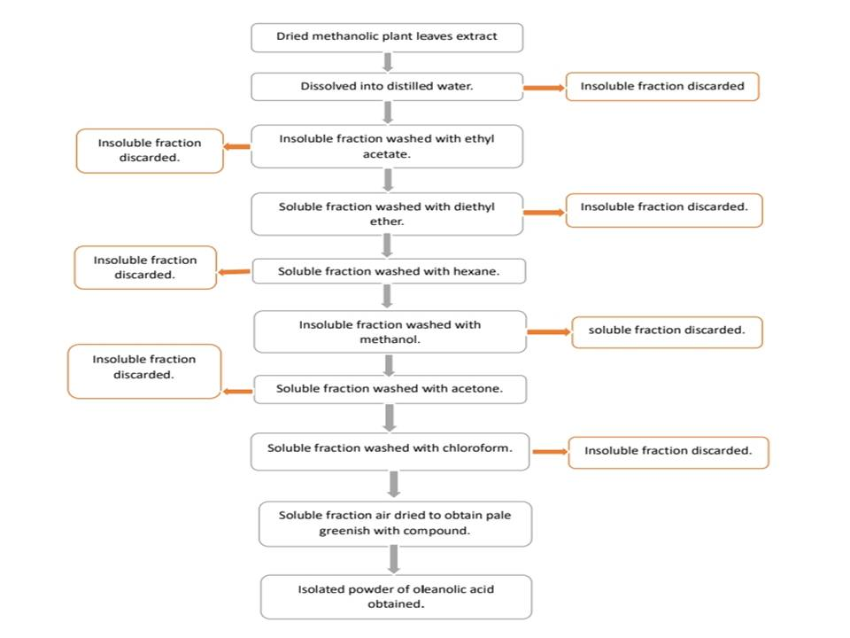
Fig1: Isolation method for Oleanolic Acid

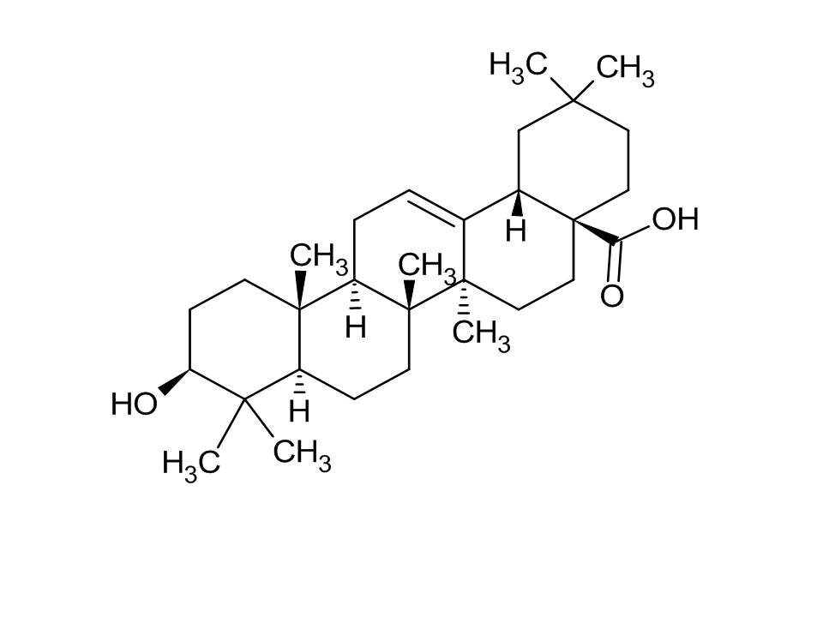
Fig 2: Structure of Oleanolic Acid
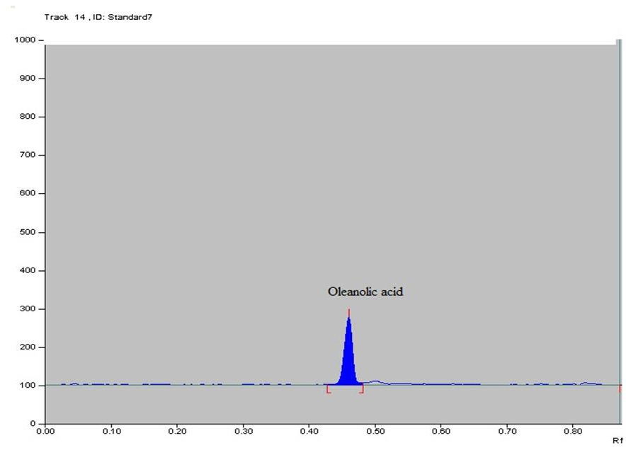

Figure 3: HPTLC densitogram for Oleanolic Acid.
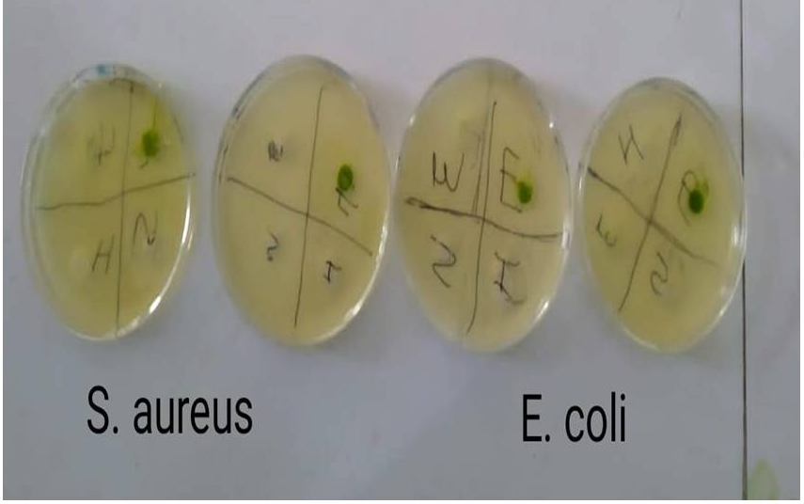

Figure 4: Antimicrobial activity by using well diffusion method.

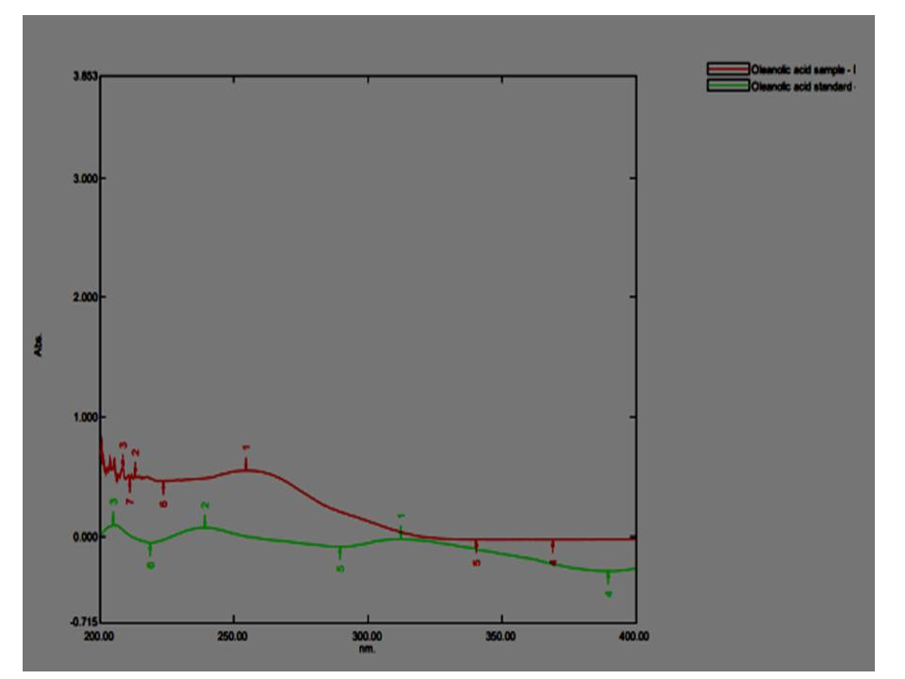

Figure 5: Overlay UV- Spectroscopy of standard and isolated Oleanolic Acid.

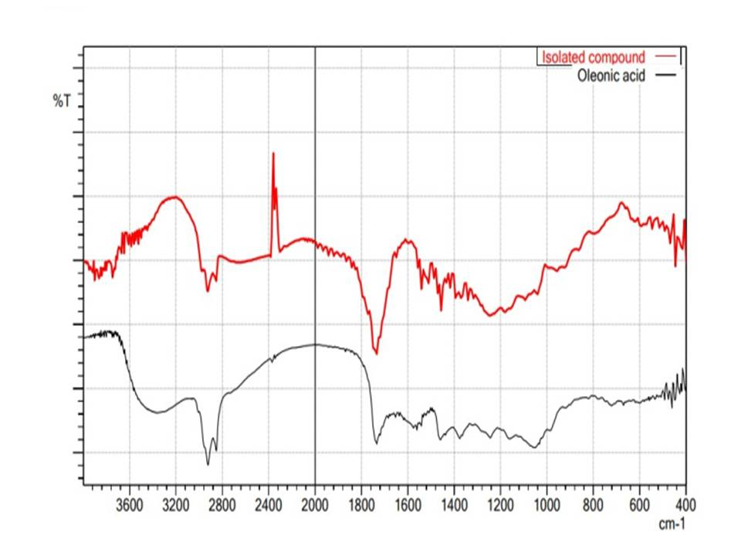

Figure 6 : Overlay Graph of IR Spectrum of Oleanolic acid and isolated oleanolic acid [37]

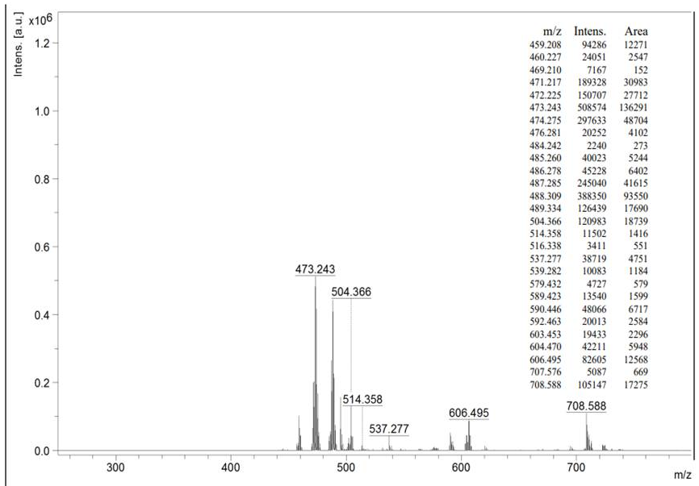
Figure 7: Mass Spectrum for isolated Oleanolic acid

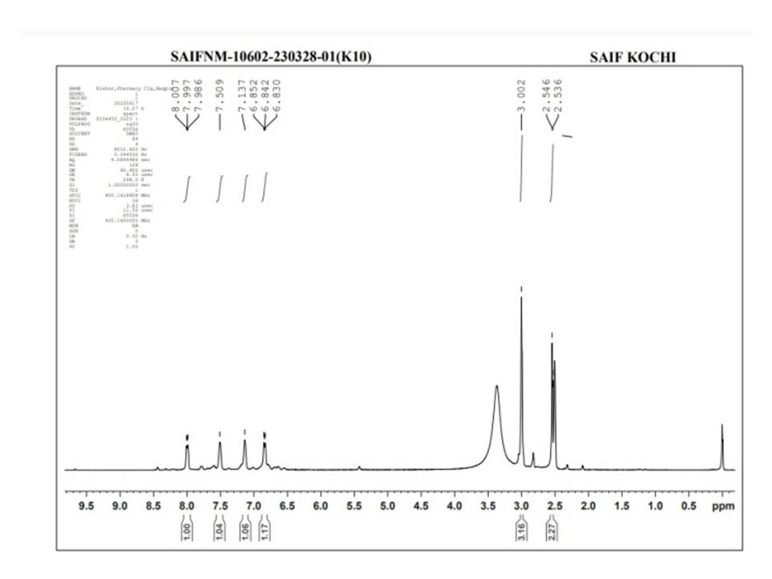

Figure 8: H- NMR Spectrum for isolated Oleanolic acid

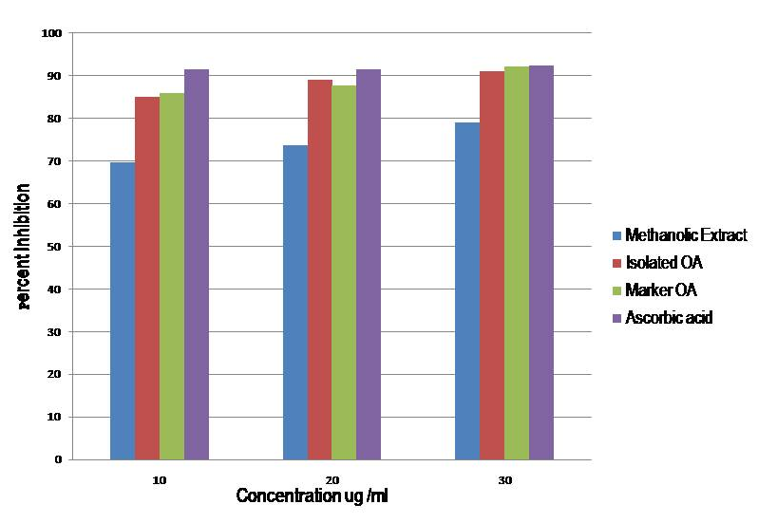

Figure 9: Graph for Antioxidant activity
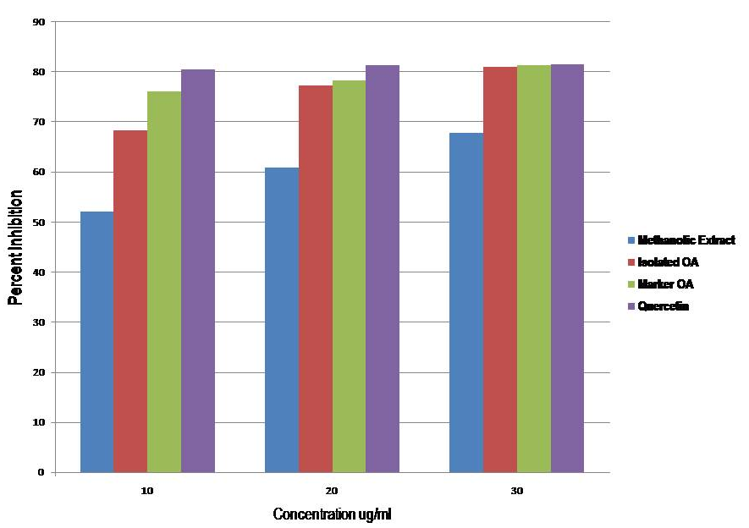
Figure 10: Graph for Antiproliferative Activity.

-
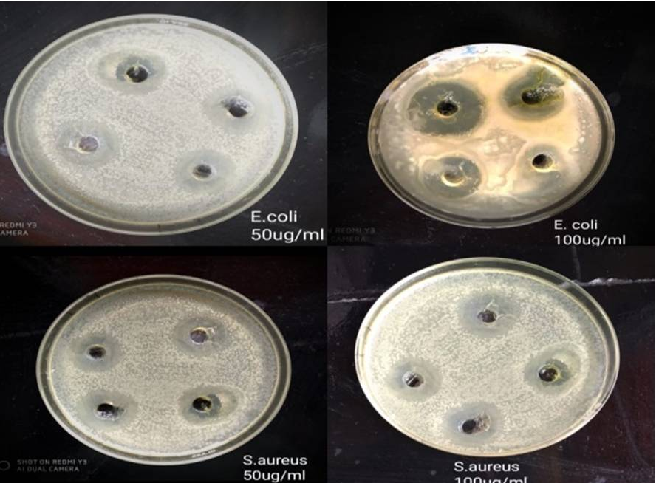

Figure 11: Zone of inhibition for Staphylococcus aureus and Escherichia coli.

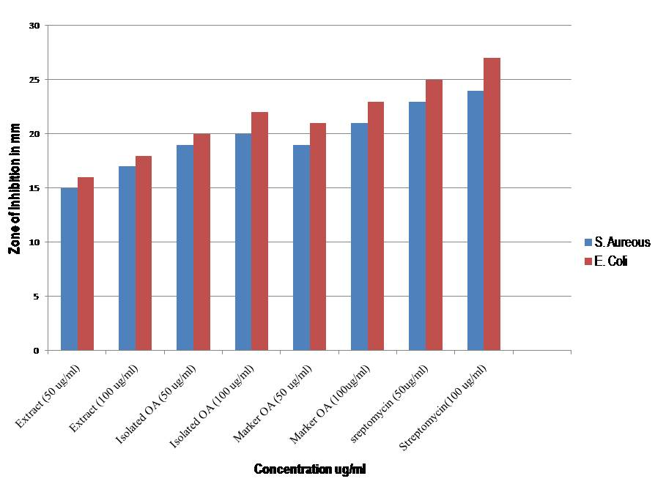
Figure 12: Graph for Antimicrobial Activity
Table 1: Descriptive information of Protein Codes.
 | PROTEIN RCSB CODE | DESCRIPTIVE
Proteins for Antioxidant properties | 7KPK | Crystal structure of the SPOP MATH domain in complex with a fragment of Pdx1
Proteins for Antioxidant properties | 7PHS | Highly potent IL6 antagonist antibody selected from a camelid immune phage display repertoire
Proteins for Antiproliferative property | 3DU6 | Structure of the catalytic subunit of telomerase, TERT

Table 2: Chemical Properties of Oleanolic Acid.
Property | Observations
Chemical formula | C₃₀H₄₈O₃
Molar mass | 456.711 g·mol−1
Appearance | Greenish white
Melting point | 302 °C
Solubility | 0.001748 mg/L

Table 3: Preliminary Analysis of Oleanolic acid[35].
TESTS | PROCEDURE | OBSERVATIONS | RESULTS
Liebermann- Burchard | Sample + Acetic anhydride, boil and cool + pour conc. sulfuric acid aligned to the walls of the test tube. | The deep red ring formed at the intersection of two layers | Triterpenoids present
Salkowski test | Sample + conc. sulphuric acid | Yellow color at the lower layer | Triterpenoids present
Ceric ammonium nitrate test | Take 1 ml solution and dissolve in a suitable solvent. Add a few drops of ceric ammonium nitrate solution. | Appearance of red color | OH- group present.
Litmus test | Put a drop of the liquid compound or a drop of the solution of the compound with the help of a glass rod on a moist blue litmus paper. | If the blue color of the litmus paper changes to red, the presence of either a carboxylic group or a phenolic group is indicated. | Carboxylic acid present

Table 4: IR spectrum analysis

Wavelength | Standard Range | Group Type
3600 cm⁻¹ | 3200-3600 | -OH Group
1734 cm⁻¹ | 1650-1750 | -COOH Group
1375 cm⁻¹ | 1375-1450 | -CH3 Group
2852.72 cm⁻¹ | 2850-2950 | C-H Stretch
1159 cm⁻¹ | 1100-1200 | -C-OH Group
1618 cm⁻¹ | 1475-1600 | -C=C- Group
1244 cm⁻¹ | 1200-1400 | -C-C- Group

Table 5: Docking score for Antiproliferative property.
Dadasaheb Balpade College of Pharmacy, Besa, Nagpur
15
Docking score for Antiproliferative activity
Protein code | Docking score
3du6 | -8.6
4erd | -10
5ugw | -7.4

Table 6: Docking score for Antioxidant properties.
Docking score for Antioxidant property
Protein code | Docking score
7kpk | -7.2
7phs | -8.7

Table 7: Swiss ADME outcomes.

Name of molecule | Oleanolic acid
PubChem ID | 10494
Structure
Molecular weight | 456.70 g/mol
H-Bond donor | 2
H-bond acceptor | 3
High lipophilicity (LogP) | 6.07
Molar refractivity | 136.67

Table 8: Observation for percent inhibition of cell viability for antiproliferative activity.

Sr. No. | Sample name | Total number of viable cells | Total number of cells | Total number of dead cells | Percent cell viability | Percent inhibition of cell viability
1 | Control | 511 | 550 | 39 | 92.9 | -
2 | Methanolic extract(4ug/ml) | 242 | 546 | 204 | 44.3 | 52.17
3 | Methanolic extract(5ug/ml) | 195 | 537 | 342 | 36.31 | 60.86
4 | Methanolic extract(6ug/ml) | 167 | 560 | 393 | 29.82 | 67.90
5 | Isolated Oleanolic acid(4ug/ml) | 137 | 557 | 420 | 24.59 | 68.31
6 | Isolated Oleanolic acid(5ug/ml) | 117 | 556 | 439 | 21.04 | 77.35
7 | Isolated Oleanolic acid(6ug/ml) | 97 | 552 | 455 | 17.57 | 81.08
8 | Marker Oleanolic acid(4ug/ml) | 123 | 556 | 443 | 22.12 | 76.18
9 | Marker Oleanolic acid(5ug/ml) | 113 | 560 | 447 | 20.17 | 78.28
10 | Marker Oleanolic acid(6ug/ml) | 97 | 560 | 463 | 17.32 | 81.35
11 | Standard drug(4ug/ml) (Quercetin) | 102 | 562 | 460 | 18.16 | 80.46
12 | Standard drug(5ug/ml) (Quercetin) | 99 | 573 | 474 | 17.27 | 81.41
13 | Standard drug(6ug/ml) (Quercetin) | 96 | 537 | 441 | 17.87 | 81.52

Table 9: Absorbance and percent inhibition for Antioxidant activity.

Table 10: Zone of inhibition for various samples.

Concentrations | Staphylococcus aureus | Escherichia coli | IC₅₀
(Diameter in mm) Zone of inhibition
Extract (50ug/ml) | 15 | 16 | 18.25
Extract (100ug/ml) | 17 | 18
Isolated oleanolic acid (50ug/ml) | 19 | 20 | 21.33
Isolated oleanolic acid (100ug/ml) | 20 | 22
Marker oleanolic acid (50ug/ml) | 19 | 21 | 16
Marker oleanolic acid (100ug/ml) | 21 | 23
Standard (Streptomycin 50ug/ml) | 23 | 25 | 18.33
Standard (Streptomycin 100ug/ml) | 24 | 27

Acknowledgements: The authors wish to acknowledge the support and contributions that facilitated the completion of this work

Author contributions: Concept –Ruchi Shivhare., Supervision – Ruchi Shivhare, Ashwini Ingole Resources – Sandhya Badge.; Materials and Data Collection and/or Processing – Kirti Korde, Priyanka Shukla.; Analysis and/or Interpretation – Shweta Kendre.; Writing Kirti Korde.; Critical Reviews – Sneh Agrawal.

Conflict of interest statement: The authors declared no conflict of interest.

5. REFERENCES
[1] Shehab NG, Abu-Gharbieh E, Almasri IM. Chemical composition, docking simulations and burn wound healing effect of Micromeria fruticosa extract and its isolated flavonoidal compound. Pakistan Journal of Pharmaceutical Sciences. 2022 Mar 1;35(2). doi.org/10.36721/PJPS.2022.35.2.REG.507-517.1
[2] Abu-Seraj Na, Omran Am, Al Mousawı Hg, Al-Sa'ady At. Phytochemıcal Analysıs of Ficus Carica Leaves by Usıng Technıcal Methods.
[3] Barku V. Wound Healing: Contributions from Medicinal Plants and Their Phytoconstituents.Annual Research & Review in Biology. 2018; 26(5): 1–14. DOI: 10.9734/arrb/2018/41301.
[4] Mawa S, Husain K, Jantan I. Ficus carica L.(Moraceae): phytochemistry, traditional uses and biological activities. Evidence‐Based Complementary and Alternative Medicine. 2013;2013(1):974256.; https://doi.org/10.1155/2013/974256 .
[5] Reddy MJ , Gayathri R , and Priya VV. Phytochemical analysis and antioxidant activity of aqueous peel extract of Ficus carica (fig extract) by DPPH, nitrous oxide method. Int. J. Pharm. Sci. Rev. Res.,2017, 43(2) 8, 148-151
[6] Ayeleso TB, Matumba MG, Mukwevho E. Oleanolic acid and its derivatives: biological activities and therapeutic potential in chronic diseases. Molecules. 2017 Nov 13;22(11):1915. https://doi.org/10.3390/molecules22111915.
[7] Vitale S, Colanero S, Placidi M, Di Emidio G, Tatone C, Amicarelli F, D’Alessandro AM. Phytochemistry and biological activity of medicinal plants in wound healing: an overview of current research. Molecules. 2022 Jun 1;27(11):3566. https://doi.org/10.3390/molecules27113566
[8] Badgujar SB, Patel VV, Bandivdekar AH, Mahajan RT. Traditional uses, phytochemistry and pharmacology of Ficus carica: A review. Pharmaceutical biology. 2014 Nov 1;52(11):1487-503. https://doi.org/10.3109/13880209.2014.892515
[9] Sharma A, Khanna S, Kaur G, Singh I. Medicinal plants and their components for wound healing applications. Future Journal of Pharmaceutical Sciences. 2021 Dec;7(1):1-3. https://doi.org/10.1186/s43094-021-00202-w
[10] Raheel R, Saddiqe Z, Iram M, Afzal S. In vitro antimitotic, antiproliferative and antioxidant activity of stem bark extracts of Ficus benghalensis L. South African Journal of Botany. 2017 Jul 1;111:248-57. https://doi.org/10.1016/j.sajb.2017.03.037
[11] Sasikumar K, Dubey V, Ghosh AR. Oleanolic acid from black raisins, Vitis vinifera with antioxidant and antiproliferative potentials on HCT 116 colon cancer cell line. Brazilian Journal of Pharmaceutical Sciences. 2020 Mar 16;56:e17158. https://doi.org/10.1590/s2175-97902019000417158
[12] Hoa Thien Do Nguyen HT, Thanh Phuoc Le TP, Tien Thanh Nguyen TT. Bioactivities of extracts and isolation of compounds from Tridax procumbens L., 2015, Vol. 84, 95-100.
[13] Ergül M, Ergül M, Eruygur N, Mehmet AT, Esra UÇ. In vitro evaluation of the chemical composition and various biological activities of Ficus carica leaf extracts. Turkish Journal of Pharmaceutical Sciences. 2019 Nov 11;16(4):401. https://doi.org/10.4274/tjps.galenos.2018.70037
[14] Allouche Y, Jiménez A, Uceda M, Aguilera MP, Gaforio JJ, Beltrán G. Triterpenic content and chemometric analysis of virgin olive oils from forty olive cultivars. Journal of agricultural and food chemistry. 2009 May 13;57(9):3604-10. https://doi.org/10.1021/jf803237z
[15] Abdelwahab MF, Hussein MH, Kadry HH. Cytotoxicity and antioxidant activity of new biologically active constituents from Micromeria nervosa grown in Egypt. Bulletin of Faculty of Pharmacy, Cairo University. 2015 Dec 1;53(2):185-94. https://doi.org/10.1016/j.bfopcu.2015.11.001
[16] Ngamkhae N, Monthakantirat O, Chulikhit Y, Boonyarat C, Maneenet J, Khamphukdee C, Kwankhao P, Pitiporn S, Daodee S. Optimization of extraction method for Kleeb Bua Daeng formula and comparison between ultrasound-assisted and microwave-assisted extraction. Journal of Applied Research on Medicinal and Aromatic Plants. 2022 Apr 1;28:100369. https://doi.org/10.1016/j.jarmap.2022.100369
[17] Jiang Z, Kempinski C, Chappell J. Extraction and analysis of terpenes/terpenoids. Current protocols in plant biology. 2016 Mar;1(2):345-58. https://doi.org/10.1002/cppb.20024
[18] Kaur J, Kumar D, Madaan R, Kumar S. Estimation of isolated triterpenoid-ursolic acid in Verbena officinalis L. aerial parts using TLC densitometry. Journal of Pharmaceutical Technology, Research and Management. 2014 Nov 29;2(2):121-35. DOI: 10.15415/jptrm.2014.22008
[19] Shahrajabian MH, Sun W, Cheng Q. A review of chemical constituents, traditional and modern pharmacology of fig (Ficus carica L.), a super fruit with medical astonishing characteristics. Polish Journal of Agronomy. 2021 Mar 31(44):22-9. https://doi.org/10.26114/pja.iung.452.2021.452.04
[20] Kapkoti DS, Singh S, Alam S, Khan F, Luqman S, Bhakuni RS. In vitro antiproliferative activity of glabridin derivatives and their in silico target identification. Natural Product Research. 2020 Jun 17;34(12):1735-42. https://doi.org/10.1080/14786419.2018.1530228
[21] Vaijanathappa J, Puttaswamygowda J, Bevanhalli R, Dixit S, Prabhakaran P. Molecular docking, antiproliferative and anticonvulsant activities of swertiamarin isolated from Enicostemma axillare. Bioorganic chemistry. 2020 Jan 1;94:103428. https://doi.org/10.1016/j.bioorg.2019.103428
[22] Shah V, Ashish P. Insilico drug design and molecular docking studies of some natural products as tyrosine kinase inhibitors. International Journal. 2017 Jan;5(1):5.
[23] Umar AB, Uzairu A, Shallangwa GA, Uba S. Ligand-based drug design and molecular docking simulation studies of some novel anticancer compounds on MALME-3M melanoma cell line. Egyptian Journal of Medical Human Genetics. 2021 Dec;22:1-5. https://doi.org/10.1186/s43042-020-00126-9
[24] Mariadoss AV, Park S, Saravanakumar K, Sathiyaseelan A, Wang MH. Ethyl acetate fraction of Helianthus tuberosus L. induces anti-diabetic, and wound-healing activities in insulin-resistant human liver cancer and mouse fibroblast cells. Antioxidants. 2021 Jan 12;10(1):99. https://doi.org/10.3390/antiox10010099
[25] Irfan A, Imran M, Khalid M, Ullah MS, Khalid N, Assiri MA, Thomas R, Muthu S, Basra MA, Hussein M, Al-Sehemi AG. Phenolic and flavonoid contents in Malva sylvestris and exploration of active drugs as antioxidant and anti-COVID19 by quantum chemical and molecular docking studies. Journal of Saudi Chemical Society. 2021 Aug 1;25(8):101277. https://doi.org/10.1016/j.jscs.2021.101277
[26] Teles Fujishima MA, Silva ND, Ramos RD, Batista Ferreira EF, Santos KL, Silva CH, Silva JO, Campos Rosa JM, Santos CB. An antioxidant potential, quantum-chemical and molecular docking study of the major chemical constituents present in the leaves of Curatella americana Linn. Pharmaceuticals. 2018 Jul 20;11(3):72. https://doi.org/10.3390/ph11030072
[27] Javed Ahmad JA, Iffat Khan IK, Salman Khan SK, Danish Iqbal DI. Evaluation of antioxidant and antimicrobial activity of Ficus carica leaves: an in vitro approach. 2013, Vol. 4, No. 1, 157.
[28] Dhanani T, Shah S, Gajbhiye NA, Kumar S. Effect of extraction methods on yield, phytochemical constituents and antioxidant activity of Withania somnifera. Arabian journal of chemistry. 2017 Feb 1;10:S1193-9. https://doi.org/10.1016/j.arabjc.2013.02.015
[29] Shrivastava VA, Sijoria RI, Dey YN, Pandey NK, Jadhav AN, Wanjari MA. Antimitotic and antiproliferative activity of stem bark of oroxylum indicum. Journal of Basic and Applied Research International. 2016;13(3):147-54.
[30] Ghiulai R, Roşca OJ, Antal DS, Mioc M, Mioc A, Racoviceanu R, Macaşoi I, Olariu T, Dehelean C, Creţu OM, Voicu M. Tetracyclic and pentacyclic triterpenes with high therapeutic efficiency in wound healing approaches. Molecules. 2020 Nov 26;25(23):5557. https://doi.org/10.3390/molecules25235557
[31] Jesus JA, Lago JH, Laurenti MD, Yamamoto ES, Passero LF. Antimicrobial activity of oleanolic and ursolic acids: an update. Evidence‐Based Complementary and Alternative Medicine. 2015;2015(1):620472. https://doi.org/10.1155/2015/620472
[32] Shafique F, Naureen U, Zikrea A, Ali Q, Sadiq R, Naseer M, Rafique T, Akhter S. Antibacterial and antifungal activity of Ficus carica plant extract. Journal of Pharmaceutical Research International. 2021;33(18):1-9. DOI: 10.9734/JPRI/2021/v33i1831311
[33] Wolska KI, Grudniak AM, Fiecek B, Kraczkiewicz-Dowjat A, Kurek A. Antibacterial activity of oleanolic and ursolic acids and their derivatives. Central European Journal of Biology. 2010 Oct;5:543-53.
https://doi.org/10.2478/s11535-010-0045-x
[34] Tkachenko H, Buyun L, Terech-Majewska E, Osadowski Z. In vitro antimicrobial activity of ethanolic extracts obtained from Ficus spp. leaves against the fish pathogen Aeromonas hydrophila. Fisheries & Aquatic Life. 2016;24(4):219-30. DOI 10.1515/aopf-2016-0019
[35] Kancherla N, Dhakshinamoothi A, Chitra K, Komaram RB. Preliminary analysis of phytoconstituents and evaluation of anthelminthic property of Cayratia auriculata (in vitro). Maedica. 2019 Dec;14(4):350. https://doi.org/10.26574/maedica.2019.14.4.350
[36] Schneider P, Hosseiny SS, Szczotka M, Jordan V, Schlitter K. Rapid solubility determination of the triterpenes oleanolic acid and ursolic acid by UV-spectroscopy in different solvents. Phytochemistry Letters. 2009 Apr 29;2(2):85-7. https://doi.org/10.1016/j.phytol.2008.12.004 .
[37] Vyas N, Argal A. Isolation and characterization of oleanolic acid from roots of Lantana camara. Asian J. Pharm. Clin. Res. 2014;7(2):189-91.

