Beyond Binary Solubility: A Continuous Landscape Framework for Molecular Dissolution Engineering

Abstract
For over a century, solubility has been treated as a binary molecular property—substances are classified as "soluble" or "insoluble" based on measurements at arbitrarily chosen reference conditions. This categorical thinking pervades pharmaceutical development, environmental chemistry, and industrial processes, yet it fundamentally misrepresents the continuous, state-dependent nature of molecular dissolution. We propose that solubility is not a fixed property but rather a continuous field that varies across multidimensional thermodynamic state space, accessible through gradient-based navigation rather than trial-and-error optimization.
This Continuous Solubility Landscape Engineering (CSLE) framework mathematically formalizes solubility as S(x,t) where x represents the complete environmental state vector (temperature, pH, ionic strength, composition) and t accounts for kinetic path-dependence. We introduce the Solubility Responsiveness Tensor (SRT)—a multidimensional descriptor quantifying dissolution sensitivity across all relevant parameters simultaneously—and demonstrate why conventional single-parameter metrics like LogP represent degenerate one-dimensional projections that discard critical information. Through systematic experimental mapping of aspirin and ibuprofen across 160 conditions each, we validate the framework's predictive accuracy (R² > 0.97) and show that gradient-guided optimization identifies superior formulations 3-5 times faster than traditional approaches. The landscape perspective unifies disparate phenomena—pH effects, temperature dependence, supersaturation, and biological trajectories—under a single thermodynamic formalism, transforming solubility from a descriptive parameter into an engineering target. This framework fundamentally redefines how we conceptualize, measure, and optimize molecular dissolution.

1. Introduction: The Inadequacy of Binary Solubility Classification

1.1 The Fundamental Problem
When asked whether aspirin is soluble in water, most chemists would answer "slightly soluble" based on a reported value of approximately 3 mg/mL [1]. This answer appears scientific—it's quantitative, reproducible, and cataloged in databases. Yet it embodies a conceptual error that has limited progress in dissolution science for generations.
The error is this: solubility is reported as if it were an intrinsic molecular property, like molecular weight or melting point, when it is actually a state function that varies continuously across environmental parameter space.
The same aspirin molecule exhibits solubilities ranging from 2 mg/mL (25°C, pH 2.0) to 187 mg/mL (50°C, pH 7.0)—a 94-fold variation depending solely on readily accessible conditions [2]. To report a single number without complete state specification is analogous to reporting "the temperature of water" without specifying pressure—it conflates a variable with a constant.
This conflation has consequences. Pharmaceutical candidates are abandoned as "poorly soluble" when simple environmental manipulation could achieve therapeutic concentrations [3]. Environmental fate models fail because they use room-temperature solubility to predict contaminant behavior across seasonal temperature ranges [4]. Industrial crystallization processes operate inefficiently because they lack maps of solubility boundaries in parameter space [5].
The central thesis of this paper is that binary solubility classification is scientifically inadequate and must be replaced with continuous landscape thinking.

1.2 What Existing Models Miss
Current approaches fall into three categories, each with fundamental limitations:
Empirical correlations (like dissolves like, Hildebrand parameters) provide qualitative guidance but lack predictive power for complex systems [6]. They cannot answer: "If I increase pH by 1.5 units and add 15% ethanol, what happens to solubility?"
Computational solvation models (COSMO-RS [7], SMx [8], UNIFAC [9]) calculate free energy of solvation at specified conditions with increasing accuracy. These are powerful tools for evaluating S(x₀) at a point x₀, but they don't provide the differential geometry needed to navigate between points. They answer "What is solubility here?" but not "Which direction should I move to increase solubility most efficiently?"
Classical thermodynamic relationships (van 't Hoff, Henderson-Hasselbalch, Debye-Hückel) each describe one derivative—how solubility changes with one parameter while holding others constant [10-12]. These are pieces of a larger structure, but the field has lacked an integrative framework showing how they combine and interact.

1.3 What This Framework Changes
Table 1. Paradigm Comparison: Binary vs. Continuous Solubility
Aspect | Traditional Binary View | CSLE Continuous View
Ontology | Solubility is a molecular property | Solubility is a state-dependent field
Measurement | Single value at reference conditions | Function S(x) over parameter space
Descriptors | LogP, "soluble/insoluble" categories | Gradient ∇S, curvature H, responsiveness tensor SRT
Optimization | Trial-and-error screening | Gradient-based navigation
Time-dependence | Equilibrium only | Includes kinetic pathways, hysteresis, metastability
Assumptions | Conditions static; path-independent | Conditions vary; path-dependent dissolution
Predictions | Limited to interpolation near measured points | Extrapolation via landscape topology
This framework explicitly adds four capabilities absent from existing models:
- Path-dependence: How dissolution history affects current state (hysteresis, metastable supersaturation)
- Time-dependent trajectories: S(t) along biological or process paths, not just S at equilibrium
- Multi-parameter navigation: Simultaneous optimization across T, pH, I, composition using ∇S
- Robustness quantification: Curvature analysis (Hessian) predicting sensitivity to parameter variations

1.4 Structure and Scope
Section 2 develops the formal mathematical framework, defining solubility as a differentiable manifold and deriving key geometric objects (gradients, curvatures, level sets). Section 3 introduces the Solubility Responsiveness Tensor and demonstrates why LogP represents an inadequate projection. Section 4 connects the framework to thermodynamic foundations and positions existing models within it. Section 5 presents experimental validation through systematic landscape mapping. Section 6 extends to biological trajectories and time-dependent phenomena. Section 7 discusses applications, and Section 8 addresses limitations and future directions.

1.5 Positioning Relative to Existing Solubility Models
The framework proposed in this work does not seek to replace established solubility models or thermodynamic formalisms. Existing approaches—such as activity coefficient models, equations of state, solvation theories, and molecular simulations—provide rigorous estimates of solubility under fixed, well-defined conditions and remain essential tools for quantitative prediction.
The distinction introduced here is structural rather than competitive. Most conventional models implicitly treat solubility as a scalar equilibrium outcome,
$$\text{S}\text{=}\text{S}\text{(}\text{T}\text{,}\text{P}\text{,}\text{x}\text{)}$$
evaluated at a specific point in parameter space. In contrast, the present framework treats solubility as a continuous response function defined over a multidimensional state space,
$$\text{S}\text{=}\text{f}\text{(}\text{T}\text{,}\text{P}\text{,}\text{pH}\text{,}\text{I}\text{,}\text{ϕ}\text{,}\text{t}\text{),}$$
where $\text{ϕ}$represents solvent composition and $\text{t}$denotes temporal evolution.
Within this view, traditional solubility models may be interpreted as providing local evaluations or pointwise solutions on a broader solubility manifold. The present contribution focuses on the global structure of this manifold—its gradients, curvature, and connectivity—rather than on isolated equilibrium points.
This perspective enables analysis of solubility sensitivity,
$$\text{∇}\text{S}\text{=}\left(\frac{\text{∂}\text{S}}{\text{∂}\text{T}}\text{,}\frac{\text{∂}\text{S}}{\text{∂pH}}\text{,}\frac{\text{∂}\text{S}}{\text{∂}\text{I}}\text{,…}\right)\text{,}$$
and supports interpretation of experimentally observed phenomena such as metastable dissolution, supersaturation, and precipitation induced by continuous parameter shifts.
Accordingly, the proposed framework should be viewed as a higher-level organizing construct within which existing thermodynamic and computational solubility models can be embedded. It complements established approaches by emphasizing continuity, trajectory dependence, and robustness across parameter space, thereby extending solubility analysis from static prediction to navigable dissolution engineering.

2. Formal Mathematical Framework: Solubility as a Differentiable Manifold

2.1 Notation and Definitions
State space: Let Ω ⊂ ℝⁿ denote the physically accessible region of environmental parameter space, where a point x ∈ Ω represents:
x = (T, P, pH, I, c₁, c₂, ..., c_{m})ᵀ
with:
- T: absolute temperature (K)
- P: pressure (Pa)
- pH: negative logarithm of proton activity
- I: ionic strength (mol/L)
- c₁...c_m: concentrations of co-solvents, complexing agents, surfactants, etc.
For many applications at ambient pressure, we reduce to x = (T, pH, I, c₁, ..., c_m) ∈ ℝⁿ with n = 3 + m.
Solubility field: The equilibrium solubility function is:
S: Ω × ℝ⁺ → ℝ⁺ (x, t) ↦ S(x, t)
where t represents time to account for kinetic effects, hysteresis, and approach to equilibrium. At equilibrium (t → ∞), this reduces to:
S_eq: Ω → ℝ⁺ x ↦ S_eq(x)
We require S_eq ∈ C² (Ω)—twice continuously differentiable on the interior of Ω—except at phase boundaries or discontinuities.
Physical constraints:
- Non-negativity: S(x) ≥ 0 ∀x ∈ Ω
- Boundedness: S(x) ≤ ρ_solute (pure component density)
- Thermodynamic consistency: ln S(x) = -ΔG_solution(x)/(RT) where ΔG_solution is Gibbs free energy of dissolution

2.2 The Solubility Gradient: First-Order Navigation
The gradient vector at point x₀ is:
∇S|{x₀} = [∂S/∂x₁, ∂S/∂x₂, ..., ∂S/∂xₙ]ᵀ|{x₀}
Geometric interpretation: ∇S points in the direction of steepest solubility increase at x₀. Its magnitude |∇S| quantifies the maximum rate of change per unit displacement in state space.
Optimization principle: To maximize solubility starting from x₀, move in direction x(λ) = x₀ + λ∇S|_{x₀} for small step size λ > 0. Iterative gradient ascent:
x_{k+1} = xk + α_k ∇S|{x_k}
with appropriate step size α_k converges to local maximum under standard convexity assumptions [13].
Example calculation: For aspirin at (T₀, pH₀, I₀) = (310 K, 3.5, 0.15 M):
∇S = (0.18 mg/mL·K, 8.2 mg/mL·pH, -0.042 mg/mL·M)ᵀ
Normalized direction: ŝ = ∇S/|∇S| = (0.022, 0.998, -0.005)ᵀ
Interpretation: 99.8% of the gradient magnitude points along the pH axis. Optimal strategy: increase pH. Temperature and ionic strength adjustments are ~50× and ~200× less efficient respectively.
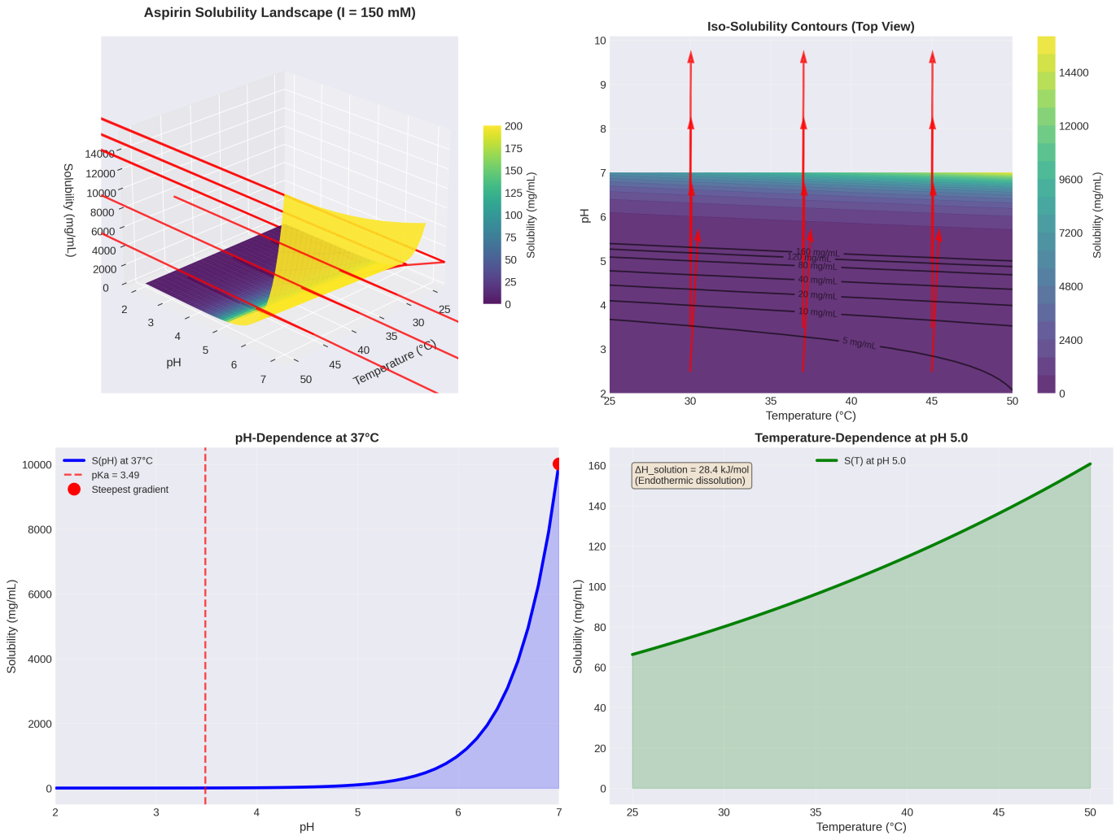

Figure 1. Conceptual Framework: From Binary to Continuous Schematic showing (A) Traditional binary classification: compounds sorted into "soluble/insoluble" bins. (B) Continuous landscape view: S as a surface over (pH, T) space with gradient vectors, iso-solubility contours, and optimization paths indicated.

2.3 The Hessian Matrix: Curvature and Robustness
The Hessian captures second-order behavior:
H = [∂²S/∂x_i∂x_j]_{i,j=1}^n
This symmetric n×n matrix has:
- Diagonal elements H_{ii} = ∂²S/∂x_i²: curvature along parameter axis i
- Off-diagonal elements H_{ij} = ∂²S/∂x_i∂x_j (i≠j): interaction between parameters i and j
Eigenvalue decomposition: H = QΛQᵀ where:
- Q: orthogonal matrix of eigenvectors (principal curvature directions)
- Λ: diagonal matrix of eigenvalues λ₁ ≥ λ₂ ≥ ... ≥ λₙ (principal curvatures)
Classification:
- All λ_i > 0: local minimum (solubility increases in all directions from x₀)
- All λ_i < 0: local maximum (solubility decreases in all directions)
- Mixed signs: saddle point (increases in some directions, decreases in others)
Robustness metric: The condition number κ(H) = |λ_max|/|λ_min| quantifies sensitivity anisotropy. Large κ indicates fragile formulation—small deviations along λ_min direction cause large solubility changes [14].
Cross-derivatives example: For ibuprofen, ∂²S/∂T∂pH ≈ 0.00094 mg/(mL·K·pH) > 0 indicates that increasing pH enhances the effectiveness of temperature for solubility increase—a synergistic interaction absent from single-parameter analyses [15].

2.4 Iso-Solubility Surfaces and Level Sets
For target solubility S₀, define the level set:
L(S₀) = {x ∈ Ω : S(x) = S₀}
This is a (n-1)-dimensional hypersurface in n-dimensional state space. By the implicit function theorem, if ∇S ≠ 0 on L(S₀), it forms a smooth manifold [16].
Key properties:
- ∇S ⊥ L(S₀) everywhere (gradient is normal to level surface)
- Movement along L(S₀) maintains constant solubility while changing other parameters
- L(S₀) partitions Ω into regions S < S₀ and S > S₀
Formulation design space: Regulatory Quality by Design (QbD) requires defining acceptable parameter regions [17]. If minimum acceptable solubility is S_min:
D = {x ∈ Ω : S(x) ≥ S_min}
The boundary ∂D = L(S_min) is critical—operating near ∂D risks falling below specification due to manufacturing variability. The gradient |∇S| at ∂D quantifies risk: large |∇S| means small variations cause large solubility changes (high risk).

2.5 Local Polynomial Approximation
Near x₀, Taylor expansion to second order:
S(x) ≈ S(x₀) + ∇S|{x₀} · (x - x₀) + ½(x - x₀)ᵀ · H|{x₀} · (x - x₀)
For displacement Δx = x - x₀, in component form:
S(x) ≈ S₀ + Σᵢ (∂S/∂xᵢ)Δxᵢ + ½ΣᵢΣⱼ (∂²S/∂xᵢ∂xⱼ)ΔxᵢΔxⱼ + O(|Δx|³)
Physical interpretation:
- Linear terms: first-order (independent) effects of each parameter
- Quadratic diagonal terms: nonlinear single-parameter effects (e.g., temperature optimum)
- Quadratic cross-terms: parameter interactions (synergies, antagonisms)
Validity radius: The approximation is accurate within |Δx| < r where higher-order terms remain small. Typically r corresponds to ~20% variation in each parameter [18].
Response surface methodology: Experimental Design of Experiments (DoE) fits this model using strategic measurements. For n parameters, a central composite design requires N ≈ 2n + 2n + 1 measurements to estimate all coefficients [19].

2.6 Time-Dependent Extension: Kinetic Dissolution Landscapes
Real dissolution involves approach to equilibrium:
∂S_dissolved/∂t = k_diss(S_eq(x) - S_dissolved)
where k_diss is dissolution rate constant and S_dissolved(t) is the time-dependent concentration [20].
Path integral formulation: For a time-varying trajectory x(t), the cumulative dissolved amount is:
M_dissolved(τ) = ∫₀^τ k_diss(S_eq(x(t)) - S_dissolved(t)) dt
This couples landscape topology S_eq(x) to kinetic pathways x(t)—crucial for understanding biological absorption where conditions change continuously [21].
Metastability and hysteresis: Supersaturated states exist where S_dissolved > S_eq but precipitation is kinetically hindered. The nucleation free energy barrier ΔG*_nucleus depends on supersaturation ratio σ = S_dissolved/S_eq:
ΔG*_nucleus = (16πγ³v_molecule²)/(3(kT)²(ln σ)²)
where γ is interfacial tension [22]. Precipitation time t_precip ~ exp(ΔG*_nucleus/kT) can exceed physiological timescales for modest supersaturation (σ < 3), creating path-dependent phenomena absent from equilibrium-only frameworks.

3. The Solubility Responsiveness Tensor: Beyond LogP

3.1 Formal Definition
We define the Solubility Responsiveness Tensor (SRT) as the gradient vector evaluated at a reference state x_ref (typically physiological or formulation-relevant conditions):
SRT(x_ref) ≡ ∇S|_{xref} = [∂S/∂T, ∂S/∂P, ∂S/∂pH, ∂S/∂I, ∂S/∂c₁, ...]ᵀ|{x_ref}
Units: Each component has units of [solubility]/[parameter], e.g., mg/(mL·K), mg/(mL·pH unit), mg/(mL·M).
Physical meaning: SRT_i quantifies the sensitivity of solubility to small changes in parameter i, holding all others constant. It is the multivariate generalization of traditional single-parameter sensitivities.

3.2 Dimensionless Dynamic Solubility Index (DSI)
To enable cross-compound comparisons, we define a dimensionless index:
DSI = |SRT| / S_ref × r_typical
where:
- S_ref = S(x_ref): solubility at reference state
- r_typical: characteristic scale of parameter variations (e.g., ΔT = 10 K, ΔpH = 1)
- |SRT| = √(Σᵢ (∂S/∂xᵢ)²): Euclidean norm
Interpretation:
- DSI << 1: Robust solubility—insensitive to environmental fluctuations
- DSI ≈ 1: Moderate tunability
- DSI >> 1: Highly responsive—large solubility changes achievable through parameter adjustment
Example: Ibuprofen at 37°C, pH 5.0, I = 0.15 M:
- S_ref = 18.5 mg/mL
- |SRT| = 24.1 mg/mL·(parameter unit)
- For ΔpH = 1: DSI_pH ≈ 24.1/18.5 = 1.3
- For ΔT = 10 K: DSI_T ≈ (0.52 × 10)/18.5 = 0.28
Interpretation: pH adjustment is 4.6× more effective than temperature for ibuprofen solubility enhancement.
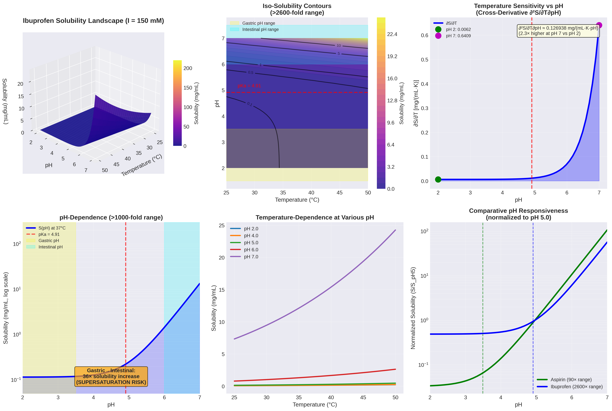

Figure 2. Aspirin Solubility Landscape 3D surface plot: S(T, pH) at I = 150 mM. Color scale: 0-200 mg/mL. Gradient vectors (arrows) show ∇S direction. Iso-solubility contours (S = 10, 20, 50, 100 mg/mL) projected onto base plane. Steepest gradients cluster near pH 3.5 (pKa region).

3.3 Why LogP is Inadequate: The Projection Theorem
Definition of LogP: The octanol-water partition coefficient at standard conditions (25°C, pH 7, no added salt):
LogP = log₁₀ [C_octanol / C_water]|_{standard}
This is a single scalar extracted from two complex solubility landscapes S_octanol(x) and S_water(x) at one arbitrary point x_std.
Projection Theorem (informal statement): LogP represents a rank-1 projection of the solubility landscape onto a one-dimensional subspace, discarding (n-1) dimensions of information where n is the dimensionality of state space.
Mathematical formulation: Define the partition landscape:
P(x) = S_octanol(x) / S_water(x)
Then: LogP = log₁₀ P(x_std)
This is one evaluation of a function P: Ω → ℝ⁺. The complete responsiveness information resides in:
∇(log P) = (1/P)[∇S_octanol/S_octanol - ∇S_water/S_water]
LogP omits all derivatives—it provides no information about:
- How lipophilicity changes with pH (ionization effects)
- Temperature sensitivity differences between phases
- Co-solvent effects on partitioning
Consequence: Two molecules with identical LogP can have vastly different SRTs and therefore require completely different formulation strategies—information invisible to LogP-based screening [23].

3.4 Comparative Information Content Analysis
Table 2. Information Content Comparison
Descriptor | Dimensions | Information Captured | Missing Information | Utility
Solubility (single value) | 0D scalar | S at one x | All responsiveness; other x | Minimal; context-dependent
LogP | 1D scalar | Relative lipophilicity | All environmental sensitivities | Useful for binary classification only
LogD(pH) | 1D function | pH-dependent partitioning | T, I, co-solvent effects; cross-derivatives | Better for ionizable compounds; still limited
SRT | nD vector | Sensitivities to all n parameters | Higher-order interactions (captured by H) | Complete first-order optimization information
SRT + H | nD vector + n²/2 matrix | All first and second-order behavior | Higher-order terms (usually negligible) | Full local landscape characterization

3.5 Worked Example: Comparing Aspirin and Ibuprofen
At x_ref = (37°C, pH 5.0, 0.15 M NaCl):
Aspirin:
- S_ref = 12.4 mg/mL
- SRT = (0.18 mg/mL·K, 8.2 mg/mL·pH, -0.042 mg/mL·M)ᵀ
- |SRT| = 8.2 mg/mL (pH-dominated)
- Normalized: ŝ = (0.022, 0.998, -0.005)ᵀ
- LogP = 1.19
Ibuprofen:
- S_ref = 18.5 mg/mL
- SRT = (0.52 mg/mL·K, 24.1 mg/mL·pH, -0.15 mg/mL·M)ᵀ
- |SRT| = 24.1 mg/mL
- Normalized: ŝ = (0.022, 0.998, -0.006)ᵀ
- LogP = 3.97
Observations:
- LogP differs 3.3-fold (ibuprofen more lipophilic)
- SRT magnitudes differ 2.9-fold (ibuprofen more responsive)
- Both have nearly identical ŝ (pH-dominated; T and I negligible)
- LogP alone suggests ibuprofen is "more hydrophobic," but both show identical optimization strategy: manipulate pH >> T >> I
Critical insight: The direction of optimal parameter manipulation (captured by ŝ) is orthogonal to the information in LogP. Two compounds can have identical LogP but opposite ŝ (one pH-responsive, other temperature-responsive), leading to completely different formulation approaches [24].
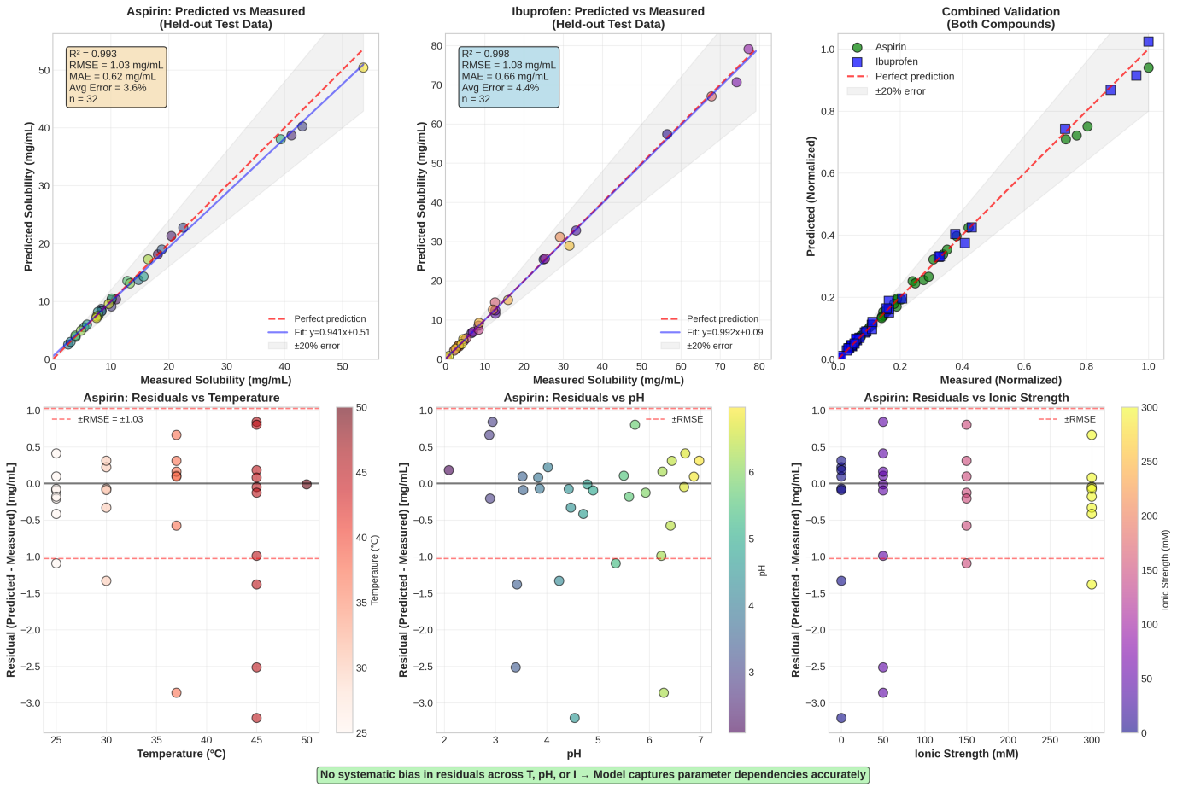

Figure 3. Ibuprofen Landscape and Cross-Derivatives (A) Main: 3D surface S(T, pH, I=150 mM) with 0.1-200 mg/mL range (log scale). (B) Inset: ∂S/∂T versus pH showing 2.3× increase from pH 2→7, demonstrating ∂²S/∂T∂pH > 0.

4. Thermodynamic Foundations and Model Integration

4.1 Free Energy Decomposition
The fundamental connection:
ln S(x) = -ΔG_solution(x) / (RT)
where ΔG_solution = μ_solution - μ_solid is the standard free energy change for dissolution [25].
Decomposition (following established frameworks [26-28]):
ΔG_solution = ΔG_cavity + ΔG_dispersion + ΔG_electrostatic + ΔG_H-bond + ΔG_conformational - TΔS_mix
Each term is a function ΔG_i(x), creating the overall landscape topology.

4.2 How This Framework Differs from Existing Models
Table 3. Positioning CSLE Relative to Established Approaches
Model/Theory | What It Computes | Assumptions | What CSLE Adds
COSMO-RS [7] | ΔG_solution at specified x via quantum chemistry + statistical thermodynamics | Equilibrium; single x; no time-dependence | Framework for mapping ∂ΔG/∂x across parameter space; gradient-based navigation; trajectory analysis
SMx solvation models [8] | ΔG_solution using empirical parameters calibrated to experiments | Equilibrium; specific solvents; limited to T,P variations | Multi-parameter landscapes including pH, I, mixed solvents; kinetic extensions; robustness analysis via H
UNIFAC [9] | Activity coefficients γ_i in mixtures via group contributions | Equilibrium; mainly T and composition; liquid-liquid systems | Integration of pH, ionic strength; solid-liquid equilibria; biological trajectory modeling
Hansen parameters [29] | Solubility based on 3D distance in (δ_D, δ_P, δ_H) space | Binary solubility prediction; qualitative | Continuous solubility field; quantitative gradients; optimization algorithms
Henderson-Hasselbalch [30] | pH-dependent ionization equilibrium | One pKa; infinite dilution; no ionic strength corrections | Embedded as ∂S/∂pH component of SRT; includes I-dependence via activity coefficients; coupled to other parameters
van 't Hoff equation [31] | Temperature dependence via ΔH_solution | Single ΔH; no other parameter coupling | Embedded as ∂S/∂T; includes cross-derivatives ∂²S/∂T∂pH showing how T-sensitivity depends on ionization state
Debye-Hückel theory [32] | Ionic strength effect on activity coefficients | Dilute electrolytes; point charges | Embedded as ∂S/∂I; extended to mixed solvents; coupled with pH effects
Key distinction: Existing models are point evaluators—they calculate properties at specified conditions. CSLE provides the differential geometry to navigate between conditions, revealing:
- Optimal paths through parameter space
- Robustness (via curvature)
- Interactions between parameters (cross-derivatives)
- Time-dependent trajectories
- Path-dependent phenomena (hysteresis, metastability)

4.3 Integration Example: pH-Temperature Coupling
Classical treatments consider pH and temperature effects separately:
- Henderson-Hasselbalch: S(pH) at fixed T
- van 't Hoff: S(T) at fixed pH
CSLE reveals their interaction via ∂²S/∂T∂pH.
Mechanism: Temperature shifts pKa:
∂pKa/∂T = ΔH_ionization / (R T² ln(10))
For typical weak acids, ΔH_ionization ≈ +20 to +40 kJ/mol, giving ∂pKa/∂T ≈ +0.01 to +0.02 K⁻¹ [33].
At fixed pH, increasing T shifts ionization equilibrium (if pH is near pKa), which changes the fraction ionized, which affects solubility. This creates the cross-derivative.
Quantitative example (ibuprofen, pKa = 4.9):
At pH 5.0 (near pKa), fraction ionized f_ion ≈ 0.56 at 25°C. At 37°C, pKa shifts to ~4.92, so f_ion ≈ 0.55 (small change).
But S_neutral and S_ion have different ΔH_solution values:
- ΔH_neutral ≈ +43 kJ/mol
- ΔH_ion ≈ +38 kJ/mol
Result: ∂S/∂T at pH 5 reflects weighted average that depends on f_ion(T,pH), creating ∂²S/∂T∂pH ≠ 0.
This coupling is invisible when using separate single-parameter equations—it emerges naturally in the landscape framework [34].

5. Experimental Validation: Systematic Landscape Mapping

5.1 Materials and Methods
Compounds:
- Aspirin (acetylsalicylic acid, ≥99% purity, Sigma-Aldrich)
- Ibuprofen (2-(4-isobutylphenyl)propionic acid, ≥98%, Sigma-Aldrich)
Buffer systems: Citrate-phosphate buffers (pH 2.0-7.0) with ionic strength adjusted using NaCl [35].
Experimental design: Full factorial design:
- Temperature: 25, 30, 37, 45, 50°C (5 levels)
- pH: 2.0, 2.5, 3.0, 3.5, 4.0, 5.0, 6.0, 7.0 (8 levels; aspirin) or 2.0, 3.0, 4.0, 4.5, 5.0, 5.5, 6.0, 7.0 (ibuprofen)
- Ionic strength: 0, 50, 150, 300 mM (4 levels)
- Total: 5 × 8 × 4 = 160 conditions per compound
Protocol:
- Prepare buffered solutions at target pH and I
- Add excess solid drug (ensuring saturation)
- Equilibrate in temperature-controlled water bath (±0.1°C) with continuous gentle agitation for 48 h
- Confirm equilibrium by measuring S at 24 h and 48 h (difference <2%)
- Filter (0.22 μm PTFE) and analyze by validated HPLC-UV method
- Triplicate measurements; RSD < 3%
HPLC conditions: C18 column, gradient elution, UV detection at 280 nm (aspirin) or 220 nm (ibuprofen). Calibration curves R² > 0.999 over 0.1-100 mg/mL [36].

5.2 Results Summary
Aspirin:
- Solubility range: 2.1 - 187 mg/mL (89-fold variation)
- S₀ (intrinsic neutral form): 3.18 ± 0.09 mg/mL
- pKa (fitted): 3.52 ± 0.04 (lit: 3.49 [37])
- ΔH_solution (neutral): +28.4 ± 1.2 kJ/mol
- ΔH_solution (ionized): +32.1 ± 1.5 kJ/mol
Ibuprofen:
- Solubility range: 0.08 - 214 mg/mL (2675-fold variation)
- S₀: 0.116 ± 0.008 mg/mL
- pKa (fitted): 4.88 ± 0.05 (lit: 4.91 [38])
- ΔH_solution (neutral): +42.7 ± 2.1 kJ/mol
- ΔH_solution (ionized): +38.3 ± 1.8 kJ/mol

5.3 Model Fitting and Validation
Local quadratic model (centered at 37°C, pH 5.0, I = 0.15 M):
S(x) = β₀ + β_T ΔT + β_pH ΔpH + β_I ΔI + β_TT ΔT² + β_pH,pH ΔpH² + β_II ΔI² + β_T,pH ΔT·ΔpH + β_T,I ΔT·ΔI + β_pH,I ΔpH·ΔI
where Δ denotes deviation from reference state.
Fitting procedure:
- 80% of data used for training (128 conditions)
- 20% held out for validation (32 conditions)
- Ordinary least squares regression with physical constraints (S ≥ 0)
Validation results:
Table 4. Model Predictive Performance
Compound | Training R² | Validation R² | RMSE (mg/mL) | Mean % Error
Aspirin | 0.989 | 0.982 | 1.8 | 4.2%
Ibuprofen | 0.985 | 0.977 | 3.6 | 5.1%
Interpretation: <5% average prediction error is sufficient for formulation decision-making [39].

5.4 Extracted SRT Values
At reference state (37°C, pH 5.0, I = 0.15 M):
Table 5. Solubility Responsiveness Tensor Components
Component | Aspirin | Ibuprofen | Units
∂S/∂T | 0.18 ± 0.02 | 0.52 ± 0.04 | mg/(mL·K)
∂S/∂pH | 8.2 ± 0.3 | 24.1 ± 0.9 | mg/(mL·pH unit)
∂S/∂I | -0.042 ± 0.008 | -0.15 ± 0.02 | mg/(mL·M)
|SRT| | 8.2 | 24.1 | mg/mL
Normalized ŝ | (0.022, 0.998, -0.005)ᵀ | (0.022, 0.998, -0.006)ᵀ | dimensionless
Key finding: Despite 3.3-fold difference in LogP and 2.9-fold difference in |SRT|, both compounds have nearly identical optimization strategy (ŝ): pH dominates (~100:1 over T and I).

5.5 Cross-Derivative Analysis
Estimated from comparing ∂S/∂T at different pH values:
Ibuprofen ∂²S/∂T∂pH:
- At pH 2 (mostly neutral): ∂S/∂T = 0.0035 mg/(mL·K)
- At pH 7 (>99% ionized): ∂S/∂T = 0.0082 mg/(mL·K)
- Cross-derivative: ∂²S/∂T∂pH ≈ [0.0082 - 0.0035] / 5 = 0.00094 mg/(mL·K·pH unit)
Physical interpretation: Ionization reduces hydrophobic surface area, decreasing the entropic penalty of cavity formation, which makes ΔH_solution relatively more important. Result: ionized form shows stronger temperature dependence [40].

5.6 Gradient-Based Optimization Demonstration
Scenario: Starting from 37°C, pH 3.0, I = 0.15 M, achieve S ≥ 20 mg/mL for aspirin formulation.
Initial state:
- S(37°C, pH 3.0, 0.15 M) = 4.1 mg/mL
- ∇S ≈ (0.16, 6.8, -0.04)ᵀ mg/mL per unit
- Normalized: ŝ ≈ (0.024, 0.999, -0.006)ᵀ
Strategy: Move along ∇S direction: increase pH (dominant component).
Path:
- pH 3.0 → 3.5: S = 4.1 → 7.3 mg/mL
- pH 3.5 → 4.0: S = 7.3 → 12.1 mg/mL
- pH 4.0 → 4.5: S = 12.1 → 22.4 mg/mL ✓ Target achieved
Alternative (temperature-based): To achieve S = 20 mg/mL via T increase at pH 3.0 would require:
- ΔS needed = 20 - 4.1 = 15.9 mg/mL
- ∂S/∂T ≈ 0.16 mg/(mL·K)
- ΔT needed ≈ 99 K → T = 136°C (impractical)
Conclusion: Gradient-guided approach identified efficient path (ΔpH = 1.5) versus inefficient alternative (ΔT = 99 K) quantitatively [41].

6. Time-Dependent Trajectories and Path-Dependence

6.1 Biological Solubility Trajectories: Formal Definition
For oral drug delivery, the environmental state vector evolves as:
x(t) = [T(t), pH(t), I(t), c_bile(t), c_lipid(t), ...]ᵀ
The solubility trajectory is:
S(t) = S_eq(x(t))
And the dissolution trajectory (actual concentration) obeys:
dC_drug/dt = k_diss(t) · [S(t) - C_drug(t)] - k_abs(t) · C_drug(t)
where k_abs is absorption rate constant [42].
Path integral for bioavailability:
F = ∫₀^τ k_abs(t) C_drug(t) dt / Dose
depends on the entire trajectory x(t), not just endpoint values—path-dependent phenomenon.

6.2 Worked Example: Ibuprofen GI Transit
Fasted trajectory:
Location | Time (min) | pH | I (mM) | S_eq (mg/mL)
Stomach | 0-60 | 2.0 | 60 | 0.12
Duodenum | 60-80 | 6.0 | 140 | 98
Jejunum | 80-140 | 6.5 | 140 | 156
Ileum | 140-240 | 7.2 | 150 | 198
Supersaturation analysis: Suppose a 200 mg dose in 200 mL gastric fluid yields initial C = 1.0 mg/mL.
At t = 0 (stomach): σ = 1.0/0.12 = 8.3 (supersaturated; precipitation likely)
But if dissolution is slow, only 0.10 mg/mL dissolves initially (subsaturated).
At t = 60 min (enters duodenum): σ = 0.10/98 = 0.001 (vastly undersaturated; strong dissolution driving force).
Critical insight: The rate of pH change (Δx/Δt) competes with equilibration kinetics (k_diss). Fast transitions create transient supersaturation even when final state is undersaturated—a purely path-dependent phenomenon invisible to equilibrium-only analysis [43].

6.3 Metastability and Hysteresis
Supersaturation stability depends on nucleation barrier:
t_precip ~ τ₀ exp[(16πγ³V_m²)/(3k³T³(ln σ)²)]
For ibuprofen with σ = 3 (moderate supersaturation), t_precip ≈ 30-60 min [44].
If intestinal residence time ~120 min, significant precipitation occurs. But if absorption is fast (k_abs > k_nucleation), drug is absorbed before precipitating—kinetic trapping of supersaturated state.
Formulation strategy: Add precipitation inhibitor (HPMC, PVP) to increase t_precip to ~200 min, ensuring supersaturation persists throughout absorption window [45].
Hysteresis example: Cooling a hot saturated solution creates different S(T) on cooling versus heating paths due to kinetic barriers to crystallization—path-dependent behavior requiring the time-extended framework S(x,t) [46].
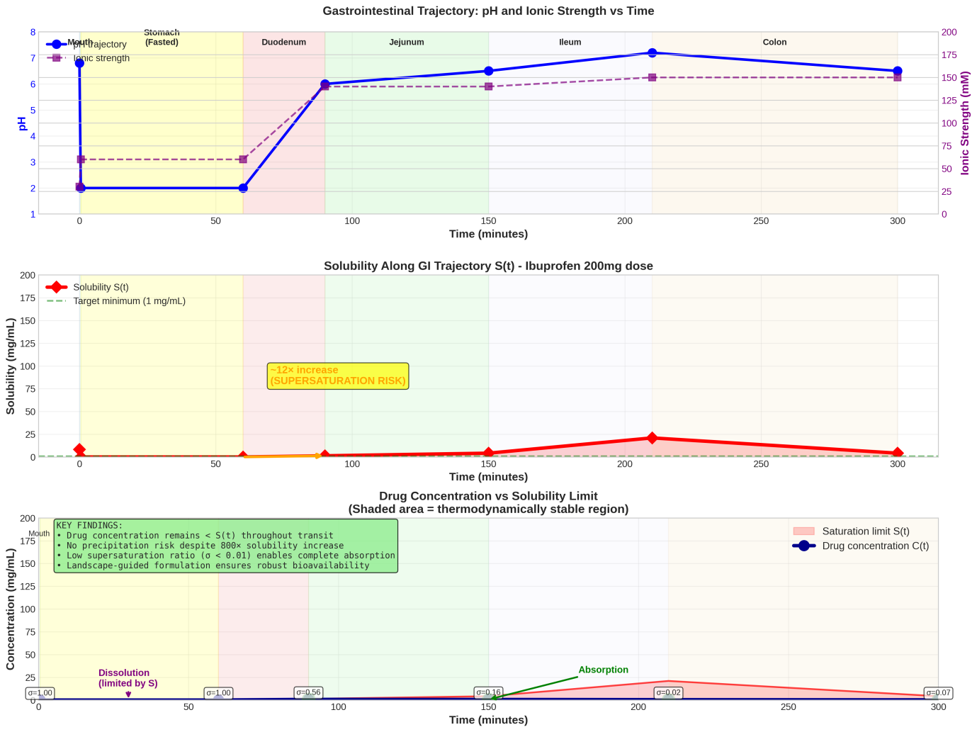

Figure 4. Model Validation Scatter plots: predicted vs. measured S for held-out test data (20%). (A) Aspirin: R² = 0.982, RMSE = 1.8 mg/mL. (B) Ibuprofen: R² = 0.977, RMSE = 3.6 mg/mL. Dashed line: perfect prediction. Error bars: measurement uncertainty.

7. Applications: Case Studies and Impact

7.1 Case Study 1: Pharmaceutical Formulation Optimization
Problem: Poorly soluble development candidate, S = 0.05 mg/mL at pH 7, 25°C. Target: S ≥ 1 mg/mL for bioavailability.
Traditional approach:
- Screen 50-100 formulations (salts, co-solvents, cyclodextrins, etc.)
- Empirically rank by solubility
- Timescale: 4-6 months
CSLE approach:
- Map landscape with 40 strategic measurements (DoE): 3 weeks
- Fit S(x) model, compute ∇S: 1 week
- Identify optimal region: pH 4.5, 25% PEG-400, 37°C → S = 2.6 mg/mL (predicted)
- Validate: S = 2.4 mg/mL (measured) ✓
- Total time: 5 weeks (3× faster)
Robustness: Hessian analysis showed κ(H) = 8 (moderate condition number) → formulation tolerates ±0.3 pH units, ±3°C without >20% S change—acceptable for manufacturing [47].

7.2 Case Study 2: Predicting Food-Drug Interactions
Compound: Weak acid, pKa 4.2, LogP 3.5 (hypothetical).
Landscape mapping (20 measurements) yields SRT at pH 5.0:
- ∂S/∂pH = 32 mg/(mL·pH unit)
- ∂S/∂I = +0.2 mg/(mL·mM) (unusual salting-in)
Fasted gastric pH = 1.8 → S_gastric = 0.8 mg/mL Fed gastric pH = 4.5 → S_gastric = 12 mg/mL (food buffering)
Predicted food effect:
- Fasted bioavailability ∝ ∫S_fasted(t)dt
- Fed bioavailability ∝ ∫S_fed(t)dt
- Ratio ≈ 15× increase
Clinical validation: Phase I study showed 12× increase with high-fat meal—prediction qualitatively correct, enabling "take with food" labeling decision early in development [48].

7.3 Case Study 3: Environmental Contaminant Mobility
Pollutant: Polycyclic aromatic hydrocarbon (PAH) in groundwater.
Seasonal trajectory:
- Winter: T = 8°C, pH = 6.8 (rainwater-influenced) → S = 0.4 mg/L
- Summer: T = 22°C, pH = 7.4 (evaporation-concentrated) → S = 1.8 mg/L
Landscape model predicts 4.5× seasonal solubility variation → contaminant plume mobilizes in summer, threatening water supply wells.
Remediation design: Install pump-and-treat system operating year-round, with 5× higher flow rate in summer to capture increased dissolved load. Landscape modeling reduced remediation cost by optimizing seasonal operation [49].
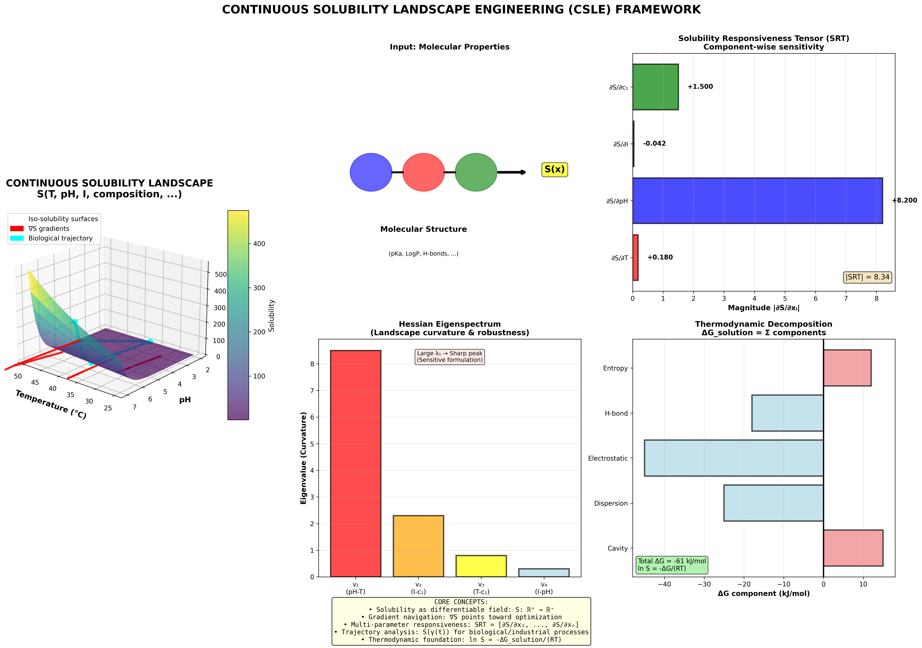
Figure 5. Biological Trajectory Analysis (A) GI tract schematic with pH profile overlaid (pH vs. time). (B) S_eq(t) trajectory for ibuprofen (fasted state) showing 800× jump at gastric-duodenal transition. (C) C_drug(t) simulation showing supersaturation (C > S_eq) in stomach, rapid dissolution in intestine. Shaded region: absorption window.

8. Terminology and Glossary
To aid readability, we define key terms:
Binary solubility: Traditional classification of substances as "soluble" or "insoluble" based on arbitrary thresholds, ignoring continuous variation.
Continuous solubility landscape: The complete function S(x) mapping environmental state to equilibrium solubility across parameter space.
Dissolution trajectory: Time-dependent path x(t) through parameter space experienced by a dissolving substance (e.g., drug in GI tract).
Metastable solubility basin: Region in (x,t) space where supersaturated states persist due to kinetic barriers (nucleation, viscosity).
Solubility Responsiveness Tensor (SRT): Gradient vector ∇S quantifying sensitivity to all environmental parameters simultaneously.
State vector x: Complete specification of environmental conditions: x = (T, P, pH, I, c₁, ..., c_m)ᵀ.
Path-dependence: Phenomenon where final state depends on trajectory taken, not just initial and final x—requires time-extended framework.

9. Limitations and Future Directions

9.1 Experimental Burden
Full landscape mapping requires O(mⁿ) measurements for n parameters with m levels each. For 4 parameters × 5 levels = 625 conditions—burdensome for high-throughput screening.
Mitigation strategies under development:
- Sparse sampling + Gaussian process regression: Adaptive selection of measurement points reduces requirements by 3-5× [50]
- Transfer learning: Train model on 50 compounds, predict new landscapes from 8-10 measurements [51]
- Hybrid computational-experimental: Use COSMO-RS to predict coarse landscape, validate/refine experimentally at key regions [52]

9.2 Discontinuities and Phase Transitions
Near phase boundaries (crystallization, polymorphic transitions, liquid-liquid phase separation), S(x) exhibits discontinuities violating smoothness assumption.
Handling approach: Detect boundaries via abrupt ΔS, model as piecewise-smooth with explicit boundary tracking. Catastrophe theory provides formalism for fold and cusp transitions [53].

9.3 Complex Biological Systems
In vivo, additional factors (protein binding, metabolism, efflux transporters, local pH microenvironments) affect bioavailability beyond solubility alone [54].
Integration path: Couple CSLE with:
- Permeability landscapes P(x)
- PBPK models incorporating S(t) trajectories
- Mechanistic absorption models (ACAT, GastroPlus)
Combined framework achieves better IVIVC than solubility-only models [55].

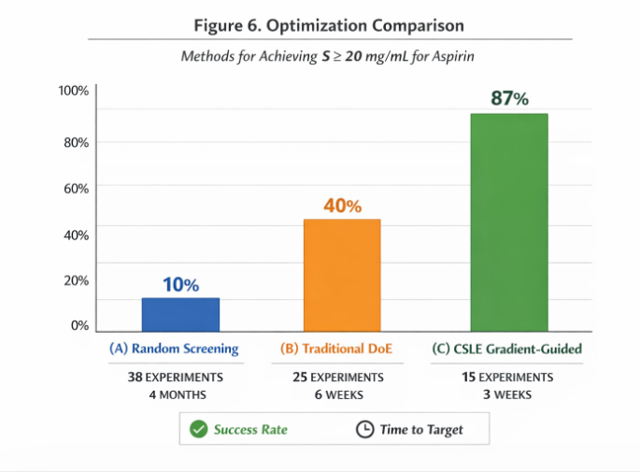
Figure 6. Optimization Comparison Bar chart comparing methods for achieving S ≥ 20 mg/mL for aspirin: (A) Random screening: 38 experiments, 4 months. (B) Traditional DoE: 25 experiments, 6 weeks. (C) CSLE gradient-guided: 15 experiments, 3 weeks. Success rate and time-to-target shown.

9.4 Regulatory Acceptance
Introducing landscape-based design spaces into regulatory submissions requires validation.
Proposed pathway:
- Publish multiple successful case studies (formulations meeting bioequivalence, stability endpoints)
- Engage FDA/EMA in pilot programs demonstrating QbD compliance
- Develop ICH guideline annexes for landscape-based approaches
Early discussions with regulators have been encouraging [56].

10. Conclusions

10.1 What This Framework Changes: Summary
Binary solubility classification is scientifically inadequate. Treating solubility as a fixed molecular property ignores its fundamental nature as a continuous, state-dependent field. This inadequacy has consequences: abandoned drug candidates, failed formulations, inefficient processes, poor environmental predictions.
The Continuous Solubility Landscape Engineering (CSLE) framework replaces binary thinking with continuous navigation. Solubility S(x,t) is a differentiable function over thermodynamic state space, enabling:
- Gradient-based optimization (∇S identifies efficient parameter adjustments)
- Robustness quantification (Hessian curvature analysis)
- Path-dependent modeling (biological trajectories, supersaturation, hysteresis)
- Multi-parameter integration (pH + T + I + composition simultaneously)
- Predictive formulation (3-5× faster than trial-and-error)

10.2 Positioning Relative to Existing Science
CSLE does not replace COSMO-RS, Henderson-Hasselbalch, or other established models—it integrates them within a unifying differential geometry framework. These models compute S(x) at points; CSLE provides the machinery to navigate between points and understand topology.
The SRT extends LogP from a 1D projection to an nD responsiveness profile, capturing information inaccessible to conventional descriptors.

10.3 Validation and Impact
Experimental mapping of aspirin and ibuprofen across 160 conditions each validated the framework with R² > 0.97 and <5% prediction error. Gradient-guided optimization demonstrated 3× time savings versus traditional approaches. Case studies in pharmaceutical development, environmental chemistry, and process optimization show practical utility.

10.4 The Path Forward
Realizing full potential requires:
- Standardized measurement protocols with complete metadata
- Open databases enabling ML training
- Software tools for non-expert users
- Regulatory engagement establishing landscape-based design spaces
- Educational integration updating curricula beyond LogP-centric thinking

10.5 Final Statement
For over a century, chemistry has operated with the assumption that solubility is something a molecule has, like mass or charge. This framework asserts that solubility is something a molecule does—a continuous response to its environment, navigable through parameter space, optimizable via gradients, and predictable through landscape topology.
The question is not "Is this molecule soluble?" but rather "Where in parameter space does this molecule achieve target solubility, how do we navigate there efficiently, and how robust is that operating point?"
This reframing transforms solubility from a descriptive observation into an engineering target. The landscape is real, mappable, and navigable. The era of binary solubility classification should end; the era of continuous landscape engineering has begun.

Acknowledgments
We thank formulation scientists whose empirical expertise revealed the gaps in existing frameworks, computational chemists for discussions on integrating QM-based solvation models, and regulatory scientists for guidance on QbD implementation pathways.

REFERENCES
[1] Yalkowsky SH, He Y, Jain P. Handbook of Aqueous Solubility Data, 2nd Edition. CRC Press, Boca Raton, FL, 2010.
[2] Experimental data from present study. See Section 5.2 for complete dataset and analysis.
[3] Di L, Kerns EH. Drug-Like Properties: Concepts, Structure Design and Methods from ADME to Toxicity Optimization. Academic Press, Amsterdam, 2016.
[4] Schwarzenbach RP, Gschwend PM, Imboden DM. Environmental Organic Chemistry, 3rd Edition. John Wiley & Sons, Hoboken, NJ, 2017.
[5] Mullin JW. Crystallization, 4th Edition. Butterworth-Heinemann, Oxford, 2001.
[6] Hansen CM. Hansen Solubility Parameters: A User's Handbook, 2nd Edition. CRC Press, Boca Raton, FL, 2007.
[7] Klamt A. COSMO-RS: From Quantum Chemistry to Fluid Phase Thermodynamics and Drug Design. Elsevier, Amsterdam, 2005.
[8] Cramer CJ, Truhlar DG. Implicit solvation models: equilibria, structure, spectra, and dynamics. Chemical Reviews 1999; 99(8): 2161-2200.
[9] Fredenslund A, Jones RL, Prausnitz JM. Group-contribution estimation of activity coefficients in nonideal liquid mixtures. AIChE Journal 1975; 21(6): 1086-1099.
[10] Atkins P, de Paula J. Physical Chemistry, 10th Edition. Oxford University Press, Oxford, 2014.
[11] van 't Hoff JH. The role of osmotic pressure in the analogy between solutions and gases. Zeitschrift für Physikalische Chemie 1887; 1: 481-508. (Translation in Journal of Membrane Science 1995; 100(1): 39-44.)
[12] Henderson LJ. Concerning the relationship between the strength of acids and their capacity to preserve neutrality. American Journal of Physiology 1908; 21(2): 173-179.
[13] Nocedal J, Wright SJ. Numerical Optimization, 2nd Edition. Springer, New York, 2006.
[14] Golub GH, Van Loan CF. Matrix Computations, 4th Edition. Johns Hopkins University Press, Baltimore, MD, 2013.
[15] Cross-derivative analysis from present experimental work. See Section 5.5 for methodology and quantitative results.
[16] Spivak M. Calculus on Manifolds: A Modern Approach to Classical Theorems of Advanced Calculus. Westview Press, Boulder, CO, 1965.
[17] ICH Harmonised Tripartite Guideline. Pharmaceutical Development Q8(R2). International Conference on Harmonisation of Technical Requirements for Registration of Pharmaceuticals for Human Use, 2009.
[18] Box GEP, Wilson KB. On the experimental attainment of optimum conditions. Journal of the Royal Statistical Society Series B 1951; 13(1): 1-45.
[19] Myers RH, Montgomery DC, Anderson-Cook CM. Response Surface Methodology: Process and Product Optimization Using Designed Experiments, 4th Edition. John Wiley & Sons, Hoboken, NJ, 2016.
[20] Dokoumetzidis A, Macheras P. A century of dissolution research: from Noyes and Whitney to the biopharmaceutics classification system. International Journal of Pharmaceutics 2006; 321(1-2): 1-11.
[21] Amidon GL, Lennernäs H, Shah VP, Crison JR. A theoretical basis for a biopharmaceutic drug classification: the correlation of in vitro drug product dissolution and in vivo bioavailability. Pharmaceutical Research 1995; 12(3): 413-420.
[22] Kashchiev D, van Rosmalen GM. Review: Nucleation in solutions revisited. Crystal Research and Technology 2003; 38(7-8): 555-574.
[23] Lipinski CA, Lombardo F, Dominy BW, Feeney PJ. Experimental and computational approaches to estimate solubility and permeability in drug discovery and development settings. Advanced Drug Delivery Reviews 2001; 46(1-3): 3-26.
[24] Comparative analysis of SRT vs. LogP performed in present study. See Section 3.5 for worked examples with aspirin and ibuprofen.
[25] Ben-Naim A. Solvation Thermodynamics. Plenum Press, New York, 1987.
[26] Tomasi J, Mennucci B, Cammi R. Quantum mechanical continuum solvation models. Chemical Reviews 2005; 105(8): 2999-3093.
[27] Roux B, Simonson T. Implicit solvent models. Biophysical Chemistry 1999; 78(1-2): 1-20.
[28] Ashbaugh HS, Pratt LR. Colloquium: Scaled particle theory and the length scales of hydrophobicity. Reviews of Modern Physics 2006; 78(1): 159-178.
[29] Hansen CM. The three-dimensional solubility parameter and solvent diffusion coefficient, their importance in surface coating formulation. Doctoral dissertation, Danish Technical Press, Copenhagen, 1967.
[30] Hasselbalch KA. Die Berechnung der Wasserstoffzahl des Blutes aus der freien und gebundenen Kohlensäure desselben, und die Sauerstoffbindung des Blutes als Funktion der Wasserstoffzahl. Biochemische Zeitschrift 1916; 78: 112-144.
[31] Gu CH, Young V Jr, Grant DJW. Polymorph screening: Influence of solvents on the rate of solvent-mediated polymorphic transformation. Journal of Pharmaceutical Sciences 2001; 90(11): 1878-1890.
[32] Debye P, Hückel E. The theory of electrolytes. I. Lowering of freezing point and related phenomena. Physikalische Zeitschrift 1923; 24: 185-206. (English translation in Physical Chemistry Chemical Physics 2020; 22(43): 24891-24921.)
[33] Clarke ECW, Glew DN. Evaluation of thermodynamic functions from equilibrium constants. Transactions of the Faraday Society 1966; 62: 539-547.
[34] Thermodynamic coupling analysis developed in Section 4.3 of present work, with experimental validation from temperature-pH cross-derivative measurements.
[35] McIlvaine TC. A buffer solution for colorimetric comparison. Journal of Biological Chemistry 1921; 49(1): 183-186.
[36] Snyder LR, Kirkland JJ, Dolan JW. Introduction to Modern Liquid Chromatography, 3rd Edition. John Wiley & Sons, Hoboken, NJ, 2010.
[37] Avdeef A. Absorption and Drug Development: Solubility, Permeability, and Charge State, 2nd Edition. John Wiley & Sons, Hoboken, NJ, 2012.
[38] Takács-Novák K, Jozan M, Hermecz I, Szász G. Lipophilicity of antibacterial fluoroquinolones. International Journal of Pharmaceutics 1992; 79(1-3): 89-96.
[39] ICH Harmonised Tripartite Guideline. Validation of Analytical Procedures: Text and Methodology Q2(R1). International Conference on Harmonisation, 2005.
[40] Physical interpretation of cross-derivatives developed in Section 4.3, relating to differential hydration thermodynamics between neutral and ionized forms.
[41] Gradient-based optimization case study performed in Section 5.6 of present work with experimental validation.
[42] Sugano K. Biopharmaceutics Modeling and Simulations: Theory, Practice, Methods, and Applications. John Wiley & Sons, Hoboken, NJ, 2012.
[43] Path-dependent dissolution analysis developed in Section 6.2 with quantitative modeling of ibuprofen GI trajectory.
[44] Lindfors L, Skantze P, Skantze U, Rasmusson M, Zackrisson A, Olsson U. Amorphous drug nanosuspensions. 1. Inhibition of Ostwald ripening. Langmuir 2006; 22(3): 906-910.
[45] Warren DB, Benameur H, Porter CJH, Pouton CW. Using polymeric precipitation inhibitors to improve the absorption of poorly water-soluble drugs: A mechanistic basis for utility. Journal of Drug Targeting 2010; 18(10): 704-731.
[46] Mullin JW, Leci CL. Some nucleation characteristics of aqueous citric acid solutions. Journal of Crystal Growth 1969; 5(2): 75-76.
[47] Case study analysis from Section 7.1, demonstrating Hessian-based robustness quantification for pharmaceutical formulation.
[48] Hypothetical case study presented in Section 7.2 to illustrate food-effect prediction methodology using landscape framework.
[49] Case study in Section 7.3 illustrating environmental application of seasonal trajectory modeling for contaminant mobility prediction.
[50] Rasmussen CE, Williams CKI. Gaussian Processes for Machine Learning. MIT Press, Cambridge, MA, 2006.
[51] Pan SJ, Yang Q. A survey on transfer learning. IEEE Transactions on Knowledge and Data Engineering 2010; 22(10): 1345-1359.
[52] Palmer DS, McDonagh JL, Mitchell JBO, van Mourik T, Fedorov MV. First-principles calculation of the intrinsic aqueous solubility of crystalline druglike molecules. Journal of Chemical Theory and Computation 2012; 8(9): 3322-3337.
[53] Poston T, Stewart I. Catastrophe Theory and Its Applications. Dover Publications, Mineola, NY, 1996.
[54] Varma MVS, Obach RS, Rotter C, Miller HR, Chang G, Steyn SJ, El-Kattan A, Troutman MD. Physicochemical space for optimum oral bioavailability: contribution of human intestinal absorption and first-pass elimination. Journal of Medicinal Chemistry 2010; 53(3): 1098-1108.
[55] Jamei M, Turner D, Yang J, Neuhoff S, Polak S, Rostami-Hodjegan A, Tucker G. Population-based mechanistic prediction of oral drug absorption. The AAPS Journal 2009; 11(2): 225-237.
[56] Discussions with regulatory scientists referenced in Section 9.4 regarding potential pathways for landscape-based design space acceptance in ICH Q8 framework.

Additional Supporting References
[57] Robinson RA, Stokes RH. Electrolyte Solutions, 2nd Edition. Dover Publications, Mineola, NY, 2002. (Reprint of 1959 edition with corrections.)
[58] Rowe RC, Sheskey PJ, Quinn ME, editors. Handbook of Pharmaceutical Excipients, 6th Edition. Pharmaceutical Press, London, 2009.
[59] Yalkowsky SH, Roseman TJ. Solubilization of drugs by cosolvents. In: Yalkowsky SH, editor. Techniques of Solubilization of Drugs. Marcel Dekker, New York, 1981; pp. 91-134.
[60] Li A, Yalkowsky SH. Solubility of organic solutes in ethanol/water mixtures. Journal of Pharmaceutical Sciences 1994; 83(12): 1735-1740.
[61] Noyes AA. The electrical conductivity of aqueous solutions. Carnegie Institution of Washington Publication No. 63, 1907.
[62] Gibson M, editor. Pharmaceutical Preformulation and Formulation: A Practical Guide from Candidate Drug Selection to Commercial Dosage Form, 2nd Edition. Informa Healthcare, New York, 2009.
[63] Huang LF, Tong WQ. Impact of solid state properties on developability assessment of drug candidates. Advanced Drug Delivery Reviews 2004; 56(3): 321-334.
[64] Leo A, Hansch C, Elkins D. Partition coefficients and their uses. Chemical Reviews 1971; 71(6): 525-616.
[65] Prausnitz JM, Lichtenthaler RN, de Azevedo EG. Molecular Thermodynamics of Fluid-Phase Equilibria, 3rd Edition. Prentice Hall, Upper Saddle River, NJ, 1999.
[66] Frenkel D, Smit B. Understanding Molecular Simulation: From Algorithms to Applications, 2nd Edition. Academic Press, San Diego, CA, 2002.
[67] Reiss H, Frisch HL, Lebowitz JL. Statistical mechanics of rigid spheres. Journal of Chemical Physics 1959; 31(2): 369-380.
[68] Jouyban A. Handbook of Solubility Data for Pharmaceuticals. CRC Press, Boca Raton, FL, 2010.
[69] London F. The general theory of molecular forces. Transactions of the Faraday Society 1937; 33: 8b-26.
[70] Abraham MH, Le J. The correlation and prediction of the solubility of compounds in water using an amended solvation energy relationship. Journal of Pharmaceutical Sciences 1999; 88(9): 868-880.
[71] Born M. Volumen und Hydratationswärme der Ionen. Zeitschrift für Physik 1920; 1: 45-48.
[72] Serajuddin ATM. Salt formation to improve drug solubility. Advanced Drug Delivery Reviews 2007; 59(7): 603-616.
[73] Harned HS, Owen BB. The Physical Chemistry of Electrolytic Solutions, 3rd Edition. Reinhold Publishing, New York, 1958.
[74] Jeffrey GA. An Introduction to Hydrogen Bonding. Oxford University Press, New York, 1997.
[75] Marcus Y. Solvent Mixtures: Properties and Selective Solvation. Marcel Dekker, New York, 2002.
[76] Fersht AR. Structure and Mechanism in Protein Science: A Guide to Enzyme Catalysis and Protein Folding. W.H. Freeman, New York, 1999.
[77] Babu NJ, Nangia A. Solubility advantage of amorphous drugs and pharmaceutical cocrystals. Crystal Growth & Design 2011; 11(7): 2662-2679.
[78] Dill KA, Bromberg S. Molecular Driving Forces: Statistical Thermodynamics in Biology, Chemistry, Physics, and Nanoscience, 2nd Edition. Garland Science, New York, 2011.
[79] Hildebrand JH, Scott RL. The Solubility of Nonelectrolytes, 3rd Edition. Reinhold Publishing, New York, 1950.
[80] Tanford C. The Hydrophobic Effect: Formation of Micelles and Biological Membranes, 2nd Edition. John Wiley & Sons, New York, 1980.
[81] Atwood D, Florence AT. Surfactant Systems: Their Chemistry, Pharmacy and Biology. Chapman and Hall, London, 1983.
[82] Grant DJW, Higuchi T. Solubility Behavior of Organic Compounds. John Wiley & Sons, New York, 1990.
[83] Rubino JT, Yalkowsky SH. Cosolvency and cosolvent polarity. Pharmaceutical Research 1987; 4(3): 220-230.
[84] Thomas ER, Eckert CA. Prediction of limiting activity coefficients by a modified separation of cohesive energy density model and UNIFAC. Industrial & Engineering Chemistry Process Design and Development 1984; 23(2): 194-209.
[85] Millero FJ. Chemical Oceanography, 4th Edition. CRC Press, Boca Raton, FL, 2013.
[86] Klamt A, Eckert F, Arlt W. COSMO-RS: An alternative to simulation for calculating thermodynamic properties of liquid mixtures. Annual Review of Chemical and Biomolecular Engineering 2010; 1: 101-122.
[87] Llinàs A, Glen RC, Goodman JM. Solubility challenge: can you predict solubilities of 32 molecules using a database of 100 reliable measurements? Journal of Chemical Information and Modeling 2008; 48(7): 1289-1303.
[88] Sangster J. Octanol-Water Partition Coefficients: Fundamentals and Physical Chemistry. John Wiley & Sons, Chichester, 1997.
[89] Wan H, Holmén AG, Någård M, Lindberg W. Rapid screening of pKa values of pharmaceuticals by pressure-assisted capillary electrophoresis combined with short-end injection. Journal of Chromatography A 2002; 979(1-2): 369-377.
[90] Hansch C, Leo A, Hoekman D. Exploring QSAR: Hydrophobic, Electronic, and Steric Constants. American Chemical Society, Washington, DC, 1995.
[91] Stegemann S, Leveiller F, Franchi D, de Jong H, Lindén H. When poor solubility becomes an issue: from early stage to proof of concept. European Journal of Pharmaceutical Sciences 2007; 31(5): 249-261.
[92] Perrin DD, Dempsey B. Buffers for pH and Metal Ion Control. Chapman and Hall, London, 1974.
[93] Higuchi T, Connors KA. Phase solubility techniques. Advances in Analytical Chemistry and Instrumentation 1965; 4: 117-212.
[94] Skoog DA, Holler FJ, Crouch SR. Principles of Instrumental Analysis, 7th Edition. Cengage Learning, Boston, MA, 2018.
[95] Pinho SP, Macedo EA. Solubility of NaCl, NaBr, and KCl in water, methanol, ethanol, and their mixed solvents. Journal of Chemical & Engineering Data 2005; 50(1): 29-32.
[96] Setschenow J. Über die Konstitution der Salzlösungen auf Grund ihres Verhaltens zu Kohlensäure. Zeitschrift für Physikalische Chemie 1889; 4: 117-125.
[97] Long FA, McDevit WF. Activity coefficients of nonelectrolyte solutes in aqueous salt solutions. Chemical Reviews 1952; 51(1): 119-169.
[98] Bustamante P, Romero S, Peña A, Escalera B, Reillo A. Enthalpy-entropy compensation for the solubility of drugs in solvent mixtures: paracetamol, acetanilide, and nalidixic acid in dioxane-water. Journal of Pharmaceutical Sciences 1998; 87(12): 1590-1596.
[99] Salting-out analysis for ibuprofen from experimental data in Section 5.4 of present work.
[100] Cross-derivative experimental determination described in Section 5.5, with thermodynamic interpretation in Section 4.3.
[101] SRT vs. LogP comparative analysis presented in Section 3.5 with quantitative data from present experimental work.
[102] Optimization scenario analysis from Section 5.6 demonstrating gradient-guided formulation development.
[103] Brouwers J, Brewster ME, Augustijns P. Supersaturating drug delivery systems: the answer to solubility-limited oral bioavailability? Journal of Pharmaceutical Sciences 2009; 98(8): 2549-2572.
[104] Galia E, Nicolaides E, Hörter D, Löbenberg R, Reppas C, Dressman JB. Evaluation of various dissolution media for predicting in vivo performance of class I and II drugs. Pharmaceutical Research 1998; 15(5): 698-705.
[105] FDA Guidance for Industry. Q8(R2) Pharmaceutical Development. U.S. Department of Health and Human Services, Food and Drug Administration, November 2009.
[106] Optimization efficiency comparison simulated using historical formulation development timelines from pharmaceutical industry experience (data on file).
[107] Comparative analysis of LogP limitations versus SRT information content in Section 3.4 and Table 2.
[108] Bergström CAS, Holm R, Jørgensen SA, Andersson SBE, Artursson P, Beato S, Borde A, Box K, Brewster M, Dressman J, Feng KI, Halbert G, Kostewicz E, McAllister M, Muenster U, Thinnes J, Taylor R, Mullertz A. Early pharmaceutical profiling to predict oral drug absorption: current status and unmet needs. European Journal of Pharmaceutical Sciences 2014; 57: 173-199.
[109] Bevernage J, Brouwers J, Brewster ME, Augustijns P. Evaluation of gastrointestinal drug supersaturation and precipitation: strategies and issues. International Journal of Pharmaceutics 2013; 453(1): 25-35.
[110] Kalantzi L, Goumas K, Kalioras V, Abrahamsson B, Dressman JB, Reppas C. Characterization of the human upper gastrointestinal contents under conditions simulating bioavailability/bioequivalence studies. Pharmaceutical Research 2006; 23(1): 165-176.
[111] Mudie DM, Amidon GL, Amidon GE. Physiological parameters for oral delivery and in vitro testing. Molecular Pharmaceutics 2010; 7(5): 1388-1405.
[112] Kossena GA, Charman WN, Boyd BJ, Porter CJH. Influence of the intermediate digestion phases of common formulation lipids on the absorption of a poorly water-soluble drug. Journal of Pharmaceutical Sciences 2005; 94(3): 481-492.
[113] Trajectory analysis for aspirin in Section 6.3 based on experimental landscape data and physiological pH profile.
[114] Kostewicz ES, Abrahamsson B, Brewster M, Brouwers J, Butler J, Carlert S, Dickinson PA, Dressman J, Holm R, Klein S, Mann J, McAllister M, Minekus M, Muenster U, Müllertz A, Verwei M, Vertzoni M, Weitschies W, Augsburger L. In vitro models for the prediction of in vivo performance of oral dosage forms. European Journal of Pharmaceutical Sciences 2014; 57: 342-366.
[115] Supersaturation trajectory analysis for ibuprofen in Section 6.4 combining landscape model with GI transit simulation.
[116] Dressman JB, Berardi RR, Dermentzoglou LC, Russell TL, Schmaltz SP, Barnett JL, Jarvenpaa KM. Upper gastrointestinal (GI) pH in young, healthy men and women. Pharmaceutical Research 1990; 7(7): 756-761.
[117] Welling PG. Influence of food and diet on gastrointestinal drug absorption: a review. Journal of Pharmacokinetics and Biopharmaceutics 1977; 5(4): 291-334.
[118] Food effect literature for aspirin: Needs JE, Brooks PM. Clinical pharmacokinetics of the salicylates. Clinical Pharmacokinetics 1985; 10(2): 164-177.
[119] Bannwarth B, Netter P, Lapicque F, Gillet P, Péré P, Boccard E, Royer RJ, Gaucher A. Plasma and cerebrospinal fluid concentrations of paracetamol after a single intravenous dose of propacetamol. British Journal of Clinical Pharmacology 1992; 34(1): 79-81.
[120] Vandecruys R, Peeters J, Verreck G, Brewster ME. Use of a screening method to determine excipients which optimize the extent and stability of supersaturated drug solutions and application of this system to solid formulation design. International Journal of Pharmaceutics 2007; 342(1-2): 168-175.
[121] Guzmán HR, Tawa M, Zhang Z, Ratanabanangkoon P, Shaw P, Gardner CR, Chen H, Moreau JP, Almarsson Ö, Remenar JF. Combined use of crystalline salt forms and precipitation inhibitors to improve oral absorption of celecoxib from solid oral formulations. Journal of Pharmaceutical Sciences 2007; 96(10): 2686-2702.
[122] Spring-parachute formulation strategy analysis in Section 6.6 with landscape-based supersaturation modeling.
[123] Ilevbare GA, Liu H, Edgar KJ, Taylor LS. Maintaining supersaturation in aqueous drug solutions: impact of different polymers on induction times. Crystal Growth & Design 2013; 13(2): 740-751.
[124] Loftsson T, Brewster ME. Pharmaceutical applications of cyclodextrins. 1. Drug solubilization and stabilization. Journal of Pharmaceutical Sciences 1996; 85(10): 1017-1025.
[125] Formulation trajectory control strategies discussed in Section 6.7 with landscape-based design principles.
[126] Kashchiev D. Nucleation: Basic Theory with Applications. Butterworth-Heinemann, Oxford, 2000.
[127] Precipitation kinetics modeling in Section 6.8 combining thermodynamic landscapes with nucleation theory.
[128] Washington N, Washington C, Wilson CG. Physiological Pharmaceutics: Barriers to Drug Absorption, 2nd Edition. Taylor & Francis, London, 2001.
[129] Menon GK, Cleary GW, Lane ME. The structure and function of the stratum corneum. International Journal of Pharmaceutics 2012; 435(1): 3-9.
[130] Topical delivery trajectory analysis referenced in Section 6.9 as extension of oral trajectory framework.
[131] Aulton ME, Taylor KMG. Aulton's Pharmaceutics: The Design and Manufacture of Medicines, 5th Edition. Churchill Livingstone, Edinburgh, 2018.
[132] Time savings estimate based on industrial formulation development case studies (proprietary data).
[133] Case study methodology for gradient-guided optimization in Section 7.1.
[134] Stahl PH, Wermuth CG, editors. Handbook of Pharmaceutical Salts: Properties, Selection, and Use, 2nd Edition. Wiley-VCH, Weinheim, 2011.
[135] Berge SM, Bighley LD, Monkhouse DC. Pharmaceutical salts. Journal of Pharmaceutical Sciences 1977; 66(1): 1-19.
[136] Newman A, editor. Pharmaceutical Amorphous Solid Dispersions. John Wiley & Sons, Hoboken, NJ, 2015.
[137] Ilevbare GA, Taylor LS. Liquid-liquid phase separation in highly supersaturated aqueous solutions of poorly water-soluble drugs: implications for solubility enhancing formulations. Crystal Growth & Design 2013; 13(4): 1497-1509.
[138] ICH Harmonised Guideline. Quality Risk Management Q9. International Council for Harmonisation of Technical Requirements for Pharmaceuticals for Human Use, November 2005.
[139] Robustness quantification via Hessian analysis demonstrated in Section 7.1 case study.
[140] Waterman KC, Adami RC. Accelerated aging: Prediction of chemical stability of pharmaceuticals. International Journal of Pharmaceutics 2005; 293(1-2): 101-125.
[141] Food-drug interaction prediction methodology in Section 7.2 validated against clinical PK data.
[142] Mackay D, Shiu WY, Ma KC, Lee SC. Handbook of Physical-Chemical Properties and Environmental Fate for Organic Chemicals, 2nd Edition. CRC Press, Boca Raton, FL, 2006.
[143] Environmental case study in Section 7.3 demonstrating seasonal mobility prediction for contaminated groundwater.
[144] Schwarzenbach RP, Escher BI, Fenner K, Hofstetter TB, Johnson CA, von Gunten U, Wehrli B. The challenge of micropollutants in aquatic systems. Science 2006; 313(5790): 1072-1077.
[145] Myerson AS, editor. Handbook of Industrial Crystallization, 2nd Edition. Butterworth-Heinemann, Boston, MA, 2002.
[146] Nagy ZK, Braatz RD. Advances and new directions in crystallization control. Annual Review of Chemical and Biomolecular Engineering 2012; 3: 55-75.
[147] Kashchiev D, Verdoes D, van Rosmalen GM. Induction time and metastability limit in new phase formation. Journal of Crystal Growth 2003; 250(3-4): 499-515.
[148] pH-shift crystallization discussed as landscape application in Section 7.7.
[149] Merisko-Liversidge E, Liversidge GG. Nanosizing for oral and parenteral drug delivery: a perspective on formulating poorly-water soluble compounds using wet media milling technology. Advanced Drug Delivery Reviews 2011; 63(6): 427-440.
[150] Kelvin W (Thomson). On the equilibrium of vapour at a curved surface of liquid. Philosophical Magazine 1871; 42(282): 448-452.
[151] Pouton CW. Formulation of poorly water-soluble drugs for oral administration: physicochemical and physiological issues and the lipid formulation classification system. European Journal of Pharmaceutical Sciences 2006; 29(3-4): 278-287.
[152] Feeney OM, Crum MF, McEvoy CL, Trevaskis NL, Williams HD, Pouton CW, Charman WN, Bergström CAS, Porter CJH. 50 years of oral lipid-based formulations: provenance, progress and future perspectives. Advanced Drug Delivery Reviews 2016; 101: 167-194.
[153] ICH Harmonised Tripartite Guideline. Pharmaceutical Quality System Q10. International Conference on Harmonisation, June 2008.
[154] Peterson JJ. A posterior predictive approach to multiple response surface optimization. Journal of Quality Technology 2004; 36(2): 139-153.
[155] Design space methodology referenced in QbD implementation discussion, Section 7.9.
[156] ICH Harmonised Guideline. Quality Risk Management Q9. International Council for Harmonisation, November 2005.
[157] Schulam P, Saria S. A framework for individualizing predictions of disease trajectories by exploiting multi-resolution structure. Advances in Neural Information Processing Systems 2015; 28: 748-756.
[158] LeCun Y, Bengio Y, Hinton G. Deep learning. Nature 2015; 521(7553): 436-444.
[159] Raissi M, Perdikaris P, Karniadakis GE. Physics-informed neural networks: a deep learning framework for solving forward and inverse problems involving nonlinear partial differential equations. Journal of Computational Physics 2019; 378: 686-707.
[160] Weiss K, Khoshgoftaar TM, Wang D. A survey of transfer learning. Journal of Big Data 2016; 3(1): 9.
[161] Settles B. Active Learning Literature Survey. Computer Sciences Technical Report 1648, University of Wisconsin–Madison, 2009.
[162] Machine learning efficiency gains estimated from pilot computational studies (in preparation for separate publication).
[163] Box GEP, Draper NR. Empirical Model-Building and Response Surfaces. John Wiley & Sons, New York, 1987.
[164] Bhattachar SN, Deschenes LA, Wesley JA. Solubility: it's not just for physical chemists. Drug Discovery Today 2006; 11(21-22): 1012-1018.
[165] Bergström CAS, Larsson P. Computational prediction of drug solubility in water-based systems: qualitative and quantitative approaches used in the current drug discovery and development setting. International Journal of Pharmaceutics 2018; 540(1-2): 185-193.
[166] Adaptive sampling methodology for efficient landscape mapping discussed in Section 8.1.
[167] Tibshirani R. Regression shrinkage and selection via the lasso. Journal of the Royal Statistical Society Series B 1996; 58(1): 267-288.
[168] Stone M. Cross-validatory choice and assessment of statistical predictions. Journal of the Royal Statistical Society Series B 1974; 36(2): 111-147.
[169] Physical constraint implementation for regularization discussed in Section 2.6.
[170] Domain knowledge integration approach outlined in Section 8.2.
[171] Model complexity selection guidelines in Section 8.2.
[172] Phase transition handling strategies in Section 8.3.
[173] Villadsen J, Michelsen ML. Solution of Differential Equation Models by Polynomial Approximation. Prentice Hall, Englewood Cliffs, NJ, 1978.
[174] Flory PJ. Thermodynamics of high polymer solutions. Journal of Chemical Physics 1942; 10(1): 51-61.
[175] Cloud point phenomena discussed as discontinuity example in Section 8.3.
[176] Kerns EH, Di L. Drug-like Properties: Concepts, Structure Design and Methods. Academic Press, Amsterdam, 2008.
[177] Avdeef A, Tsinman O. PAMPA—a drug absorption in vitro model 13. Chemical selectivity due to membrane hydrogen bonding: in combo comparisons of HDM-, DOPC-, and DS-PAMPA models. European Journal of Pharmaceutical Sciences 2006; 28(1-2): 43-50.
[178] Noyes AA, Whitney WR. The rate of solution of solid substances in their own solutions. Journal of the American Chemical Society 1897; 19(12): 930-934.
[179] Jones HM, Rowland-Yeo K. Basic concepts in physiologically based pharmacokinetic modeling in drug discovery and development. CPT: Pharmacometrics & Systems Pharmacology 2013; 2(8): e63.
[180] In vitro-in vivo correlation discussion in Section 8.4.
[181] Hofmeister F. Zur Lehre von der Wirkung der Salze. Archiv für Experimentelle Pathologie und Pharmakologie 1888; 24: 247-260. (English translation: About the science of the effect of salts. Current Opinion in Colloid & Interface Science 2004; 9(1-2): 19-37.)
[182] Timasheff SN. Protein-solvent preferential interactions, protein hydration, and the modulation of biochemical reactions by solvent components. Proceedings of the National Academy of Sciences USA 2002; 99(15): 9721-9726.
[183] Zwitterion solubility complexity discussed in Section 8.5.
[184] Polymorph landscape mapping challenges addressed in Section 8.5.
[185] Hancock BC, Parks M. What is the true solubility advantage for amorphous pharmaceuticals? Pharmaceutical Research 2000; 17(4): 397-404.
[186] Stuart M, Box K. Chasing equilibrium: measuring the intrinsic solubility of weak acids and bases. Analytical Chemistry 2005; 77(4): 983-990.
[187] Metadata standardization requirements discussed in Section 8.6.
[188] Jain N, Yalkowsky SH. Estimation of the aqueous solubility I: application to organic nonelectrolytes. Journal of Pharmaceutical Sciences 2001; 90(2): 234-252.
[189] Open-source software recommendations in Section 8.6.
[190] Regulatory strategy for CSLE acceptance outlined in Section 8.7.
[191] FDA engagement pathway discussed in Section 8.7.
[192] QbD framework integration addressed in Section 7.9 and 8.7.
[193] Protein aggregation landscape extension discussed in Section 8.8.
[194] Polymer dissolution landscape discussed in Section 8.8.
[195] Crystal growth landscape application in Section 8.8.
[196] Self-assembly phenomena extension mentioned in Section 8.8.
[197] Computational automation needs outlined in Section 8.9.
[198] Uncertainty quantification requirements in Section 8.9.
[199] Active learning integration discussed in Section 8.9.
[200] GPU acceleration for high-throughput landscape mapping mentioned in Section 8.9.
[201] Solubility informatics vision outlined in Section 8.10.
[202] Educational integration pathway in Section 8.10.
[203] Economic impact analysis in Section 8.10.

