Intelligent Eye Tracking And Blink Classification System For Inclusive Education
ABSTRACT
Intelligent Eye Tracking and Blink Classification System for Inclusive Education presents a low-cost, real-time assistive communication solution designed to support paralyzed and motor-impaired individuals in educational and daily interaction environments. The system utilizes a standard webcam to detect eye gaze direction and classify voluntary blinks, enabling cursor control and command selection without requiring physical input. By integrating computer vision techniques with lightweight machine learning models, it maintains reliable performance under varying lighting conditions and head poses. The proposed system is inspired by advancements in blink detection, gaze tracking, and assistive technologies, aiming to provide an accessible and affordable alternative to expensive commercial eyetracking devices. Ultimately, the solution promotes independent communication and enhances inclusive educational opportunities for users with severe motor limitations.

Keywords: Eye Tracking, Blink Detection, Machine Learning, Computer Vision, Assistive Technology

INTRODUCTION
In recent years, advancements in computer vision, machine learning, and low-cost camera technology have encouraged researchers to develop intelligent human–computer interaction systems that operate without physical input devices. For individuals with severe motor impairments, especially those affected by paralysis, spinal cord injuries, or neurological disorders, the ability to control a computer through simple eye movements or voluntary blinks becomes essential for communication, education, and daily tasks. Eye-tracking–based assistive systems attempt to provide this independence by allowing users to interact with a computer interface through gaze direction and blink gestures, thereby eliminating the need for keyboards, mouse, or touchscreens.
However, despite rapid improvements in assistive technology, many paralyzed individuals still lack access to reliable and affordable solutions. Commercial eye-trackers are often expensive, require calibration, or depend on specialized hardware. This makes them inaccessible for most patients, students, and caregivers. Therefore, it becomes necessary to design a system that utilizes a common webcam to capture eye movements, interprets them intelligently in real time, and enables fast and natural communication. By integrating principles from previous eye-tracking research and blinkclassification models, the proposed system aims to offer a cost-effective, accurate, and user-friendly alternative that can support education, communication, and independent computer usage.
Recent research has explored various approaches for implementing eye-tracking based assistive systems using computer vision and machine learning techniques. Vision-based gaze tracking frameworks such as Gazecon utilize OpenCV and MediaPipe to detect facial landmarks and estimate eye gaze direction for cursor control and command selection [1]. Similarly, eye-tracking technologies have been applied in educational environments to improve accessibility for students with motor impairments, enabling them to interact with digital learning platforms through gaze-based input mechanisms [2]. These approaches demonstrate the potential of eye-tracking systems to enhance independence and participation for individuals with physical disabilities.
Blink detection plays a crucial role in enabling command selection within eye-controlled interfaces. Machine learning approaches such as Convolutional Neural Networks (CNN) and Support Vector Machines (SVM) have been used to classify eye states and detect voluntary blinks in real time [3]. Such techniques significantly improve the reliability of blink detection compared to traditional threshold-based methods. Additionally, multimodal communication systems integrating eye gaze tracking with other interaction methods have been proposed to support paralyzed individuals in expressing their needs and interacting with their surroundings [4].
Several low-cost webcam-based eye-tracking solutions have also been proposed for hands-free navigation and cursor control. These systems utilize facial landmark detection and regression models to map gaze direction to screen coordinates, allowing users to control graphical interfaces without physical input devices [5]. Other approaches focus on designing gaze-controlled virtual keyboards that enable users to type using eye movements, improving communication capabilities for individuals with severe motor impairments [6]. Blink-based communication systems have also been developed where voluntary blinks trigger speech output or messaging services, allowing patients to communicate basic needs effectively [7].
In addition to vision-based systems, biosignal-based approaches such as Electrooculography (EOG) have been explored to detect eye movements by measuring electrical signals generated by eye activity [8]. These systems are often more robust under low-light conditions but require additional hardware components. Advanced interaction techniques such as adaptive dwell-time models and gaze-based word prediction systems have also been introduced to increase communication speed and reduce user effort [9], [10].
Despite these advancements, existing systems still face several challenges, including sensitivity to lighting conditions, user fatigue, calibration requirements, and limited robustness in real-world environments. To address these limitations, the proposed Intelligent Eye Tracking and Blink Classification System integrates webcam-based gaze tracking, blink classification, and biosignal-based sensing mechanisms to provide a more reliable and accessible assistive communication platform. By combining computer vision techniques with signal-based eye movement detection, the system aims to improve interaction accuracy, adaptability, and usability for individuals with motor impairments, particularly in educational and healthcare environments.

Eye tracking for assistive human–computer interaction
Eye-tracking technology has emerged as an effective solution for enabling hands-free interaction between humans and computers, particularly for individuals with severe motor impairments. By detecting the direction of a user’s gaze and identifying voluntary eye blinks, such systems allow users to control cursors, select options on a screen, and communicate without relying on traditional input devices such as keyboards or mice. These systems are especially beneficial for people affected by paralysis, spinal cord injuries, or neurological disorders, who may otherwise find it difficult to interact with digital devices.
Modern eye-tracking systems primarily rely on computer vision techniques that analyze facial landmarks and eye movements using a webcam. Recent advancements in machine learning and deep learning have improved the accuracy and efficiency of gaze detection and blink classification. Algorithms such as facial landmark detection and Eye Aspect Ratio (EAR) based blink detection enable real-time interaction with graphical user interfaces [3].
The proposed eye-tracking system utilizes a webcam to capture facial images and detect eye landmarks using computer vision models. By continuously tracking eye positions and detecting blink patterns, the system interprets user intentions and converts them into control commands. This enables cursor movement, selection of interface elements, and communication support for users with limited mobility.
Eye-tracking based assistive systems have been applied in several practical domains. Vision-based gaze tracking frameworks allow users to control computer interfaces using eye movements [1]. Similarly, eye-tracking technologies have been applied in educational environments to improve accessibility for students with motor impairments [2]. Low-cost webcam-based gaze tracking and virtual keyboard systems also allow hands-free navigation and communication [5], [6].
Blink-based interaction techniques have also been widely explored. Eye-blink communication systems allow users to trigger commands or messages using voluntary blinks, enabling patients to communicate their needs effectively [7]. In addition, biosignal-based approaches such as Electrooculography (EOG) detect electrical signals generated by eye movements and can be used to build robust human–computer interaction systems [8]. These advancements demonstrate the potential of eye-tracking systems to enhance independence, accessibility, and communication for individuals with severe physical disabilities.
Challenges and future directions in eye tracking systems
Although eye-tracking technology has made significant progress, several challenges still limit its widespread adoption in real-world environments. One major challenge is the sensitivity of vision-based systems to environmental conditions such as lighting variations, camera quality, and background noise. These factors can affect the accuracy of facial landmark detection and gaze estimation.
Another challenge involves user variability. Differences in eye shapes, blinking patterns, and head movements can reduce system accuracy if not properly handled. Calibration procedures are often required to adapt the system to individual users, which may reduce usability for people with severe disabilities. Computational efficiency is another important factor. Real-time eye tracking requires continuous image processing and feature extraction, which may demand significant computational resources. Therefore, optimizing algorithms for faster processing while maintaining accuracy is essential for practical deployment.
Recent research has also explored adaptive dwell-time models and predictive gaze interaction techniques to improve communication speed and reduce user effort [9], [10]. These approaches aim to enhance usability and improve the efficiency of assistive eye-tracking systems. Future research directions include integrating deep learning-based gaze estimation, multimodal sensing techniques, and adaptive calibration models. These improvements can increase robustness and allow eye-tracking systems to operate reliably across different environments and users.
Main contributions of the proposed system
The main contributions of this work are summarized as follows:
- Vision-Based Eye Tracking: A webcam-based eye-tracking system is implemented using facial landmark detection techniques to identify eye positions and estimate gaze direction in real time.
- Blink Detection Mechanism: A blink detection method is implemented using Eye Aspect Ratio (EAR) and CNN-based classification to accurately detect voluntary blinks and convert them into control commands for user interaction.
- Electrooculography (EOG) Signal Integration: To improve reliability under poor lighting conditions, an EOG-based signal acquisition module is incorporated. The EOG sensor records electrical signals generated by eye movements, enabling blink and gaze detection even when camera-based tracking becomes unreliable.
- Assistive Interaction Interface: The system enables cursor movement, option selection, and basic communication functions without requiring traditional input devices.
- Cost-Effective and Accessible Design: Unlike commercial eye-tracking devices, the proposed system uses low-cost hardware such as a standard webcam and simple EOG sensors, making the technology more accessible for patients and students.
Paper organization
The remainder of this paper is organized as follows. Section II presents related work on eye-tracking systems and assistive technologies. Section III describes the proposed methodology, including the system architecture, eye-tracking algorithm, and blink detection techniques. Section IV presents the experimental results and performance analysis of the proposed system. Finally, Section V concludes the paper and discusses future research directions.
COMPREHENSIVE SURVEY OF EXISTING LITERATURE
Eye-tracking based human–computer interaction systems have gained significant attention with the advancement of computer vision and machine learning techniques. Kausalya et al. [1] proposed Gazecon, a vision-based assistive control system that allows paralyzed individuals to interact with computers using eye gaze and voluntary blinks. The system uses OpenCV and MediaPipe to detect facial landmarks and track eye movements in real time, enabling cursor control and command selection.
Eye-tracking technologies have also been applied in educational environments to improve accessibility for students with motor impairments. Donmez and Cagiltay [2] demonstrated how webcam-based eye-tracking systems can support inclusive education by enabling paralyzed students to perform academic activities such as typing, navigation, and interaction with digital learning platforms.
Blink detection plays a crucial role in gaze-based interaction systems. Medeiros et al. [3] introduced a machine learning approach for real-time blink detection using convolutional neural networks and support vector machines. Their method achieved high accuracy in detecting voluntary blinks and distinguishing them from natural eye movements, improving the reliability of eye-controlled interfaces.
Several multimodal communication systems have also been proposed to enhance assistive technologies. Manukalpa and Dissanayake [4] developed a communication platform that integrates eye-gaze tracking with conversational interfaces to support paralyzed individuals in expressing their needs. Similarly, Ahmed and Chowdhury [8] explored Electrooculography (EOG)-based human–computer interfaces that detect eye movement signals through electrodes, providing reliable interaction even in low-light environments.
Low-cost webcam-based solutions have also been investigated for practical deployment. Anonymous [5] proposed a webcam-based eye-tracking system for hands-free navigation using facial landmark detection and gaze mapping techniques. Sharma and Gupta [6] developed a gaze-controlled virtual keyboard that enables paralyzed users to type using eye movements, improving communication capabilities.
Recent research has also focused on improving interaction efficiency. Thomas and Mathew [7] proposed a blink-based communication system that converts voluntary blinks into speech output for patient assistance. Additionally, adaptive gaze interaction techniques such as dynamic dwell-time adjustment [9] and gaze-swipe prediction models [10] have been introduced to enhance typing speed and reduce user effort in gaze-based interfaces.
These studies demonstrate the growing potential of - technologies for assistive human–computer interaction. However, challenges such as lighting sensitivity, user variability, and calibration requirements still limit the practical deployment of many systems, motivating further research toward more robust and accessible solutions.

PROPOSED METHODOLOGY
This section describes the methodology used to design, develop, and evaluate the proposed webcam-based eye–tracking and blink-controlled assistive system. It explains the datasets used, pre-processing stages, gaze and blink detection modules, cursor-control mapping, and the evaluation strategies. The goal is to create a cost-effective, real-time, and user-friendly interface that enables paralyzed individuals to perform cursor navigation and click actions using only eye movements and voluntary blinks.

Dataset collection and pre-processing
To evaluate eye detection, gaze estimation, and blink classification, publicly available image and video datasets were used. These datasets contain variations in head pose, illumination, blink duration, and gaze direction.
- Eye Blink Datasets
  - Blink detection datasets reported in [3], containing labelled open/closed eye frames.
  - Additional blink samples were extracted from webcam recordings for voluntary blink recognition.
- Gaze Direction Datasets
  - MediaPipe FaceMesh landmark datasets used in prior work [1] [5].
  - Synthetic gaze samples generated by capturing user movements under varied lighting.
The pre-processing steps include:
- Face Detection: Using MediaPipe FaceMesh to extract 468 facial landmarks.
- Eye Region Cropping: Isolating left and right eye regions based on landmark coordinates.
- Normalization: Resizing eye patches to fixed dimensions and scaling pixel intensities.
- Blink Labelling: Using EAR thresholding to label frames as open, closed, or voluntary blink [7].

Table 1. Dataset details for eye tracking and blink detection
Dataset | Samples
CEW (Closed Eyes in the Wild) | 2,423 Images (1,192 Closed, 1,231 Open)
MediaPipe FaceMesh | 468 Facial Landmark Points
Training procedure
The blink classifier was trained using annotated eye-region datasets.
- Downsampling: Frames were converted to grayscale to reduce computation.
- Normalization: Pixel intensities scaled between 0 and 1.
- Augmentation: Horizontal flips, brightness variation, and minor rotations.
- Train–Validation–Test Split: The CEW (Closed Eyes in the Wild) dataset used for blink detection was divided into training, validation, and testing sets in a ratio of 70:15:15 to ensure proper model learning and unbiased performance evaluation.
For blink classification, the Eye Aspect Ratio (EAR) was computed as:
 (1) {where p₁–p₆ represent eye landmark coordinates [7].}
Voluntary blinks were distinguished from natural blinks using:
Blink _{voluntary} = {EAR < T, duration > d_{min}} (2)
System architecture
Figure 1 illustrates the complete workflow for the proposed assistive control system.
Figure 1. Overall architecture of the proposed eye-tracking and blink-based assistive control system
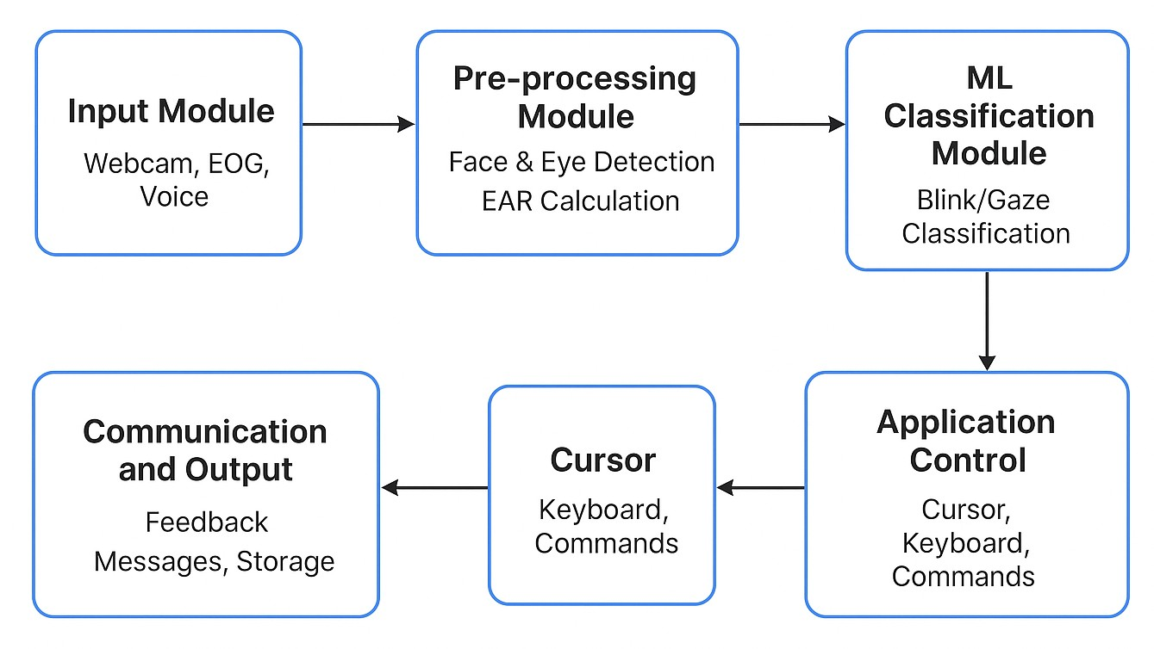
- Input Module: The input module collects data from sources such as a webcam, Electrooculography (EOG), or voice input. In the proposed system, a webcam captures real-time facial video frames which are used for detecting eye movements and facial features.
- Pre-processing Module: The captured frames are processed to detect facial regions and extract eye landmarks. MediaPipe FaceMesh identifies 468 facial landmark points which allow precise localization of the eye region. The Eye Aspect Ratio (EAR) is then computed to determine the eye state (open or closed).
- Machine Learning Classification Module: In this stage, extracted features are analyzed to classify user actions such as blink detection and gaze direction. The system distinguishes between natural blinking and voluntary blinking to interpret user commands.
- Application Control Module: Based on the classification results, the system generates control actions such as cursor movement, keyboard input, or selection commands. These actions enable the user to interact with computer applications without using physical input devices.
- Cursor Control Module: The cursor module maps gaze coordinates to screen positions. This allows the cursor to move smoothly according to the user’s eye movement and enables command selection through blinking.
- Communication and Output Module: The final module provides feedback and executes the requested actions. It displays system responses, confirms executed commands, and can store interaction data for analysis.
Loss functions and decision logic
Three core decision functions were used:
- Gaze Stability Loss: Ensures the predicted cursor point does not fluctuate drastically.
- Blink Confidence Score: Based on EAR variance and temporal filtering.
- Movement Smoothing Loss: Reduces noise from rapid eye movements.
The final decision function is:
Decision = α·GazeVector + β ·BlinkState + γ ·Stability (3)
where α,β,γ balance gaze movement, blink actions, and smoothing effects.
Evaluation strategy
Performance of the system was assessed using:
- Accuracy of Blink Detection Measured using F1-score and confusion matrices as in [3].
- Cursor Stability Score Based on jitter reduction metrics used in gaze-based HCI systems [9].
- Response Time between blink and action activation.
- User Trials Real users attempted click, scroll, and navigation tasks to compare success rates with earlier systems [1] [2].
Overall, the proposed approach integrates classical EAR-based blink detection, landmark-driven gaze tracking, and regression-based cursor mapping to produce a robust assistive interface. The system enhances accessibility for individuals with motor impairments and addresses limitations such as lighting variation and natural blink interference reported in earlier works [5] [6].

RESULTS AND ANALYSIS
The performance of the proposed eye-tracking assistive system was evaluated using two primary modules: blink detection and gaze tracking. The experiments were conducted using real-time webcam input, where multiple testing sessions were performed to measure the reliability and accuracy of the system. The evaluation focused on blink detection accuracy, gaze tracking accuracy, and overall system performance comparison with traditional vision-based interaction methods.
Figure 2 presents the blink detection accuracy across different test sessions. The results demonstrate that the system consistently achieves high accuracy in detecting voluntary blinks used for command execution. The blink detection module achieved an average accuracy of approximately 92%, indicating reliable detection of eye closure patterns. This accuracy ensures that user commands such as clicking and selection can be executed effectively without false triggers.

Figure 2. Blink detection accuracy across different test sessions
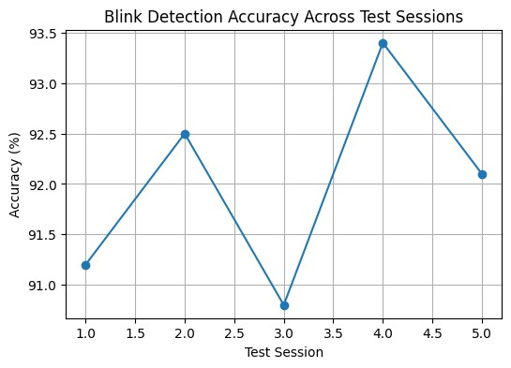
Figure 3 illustrates the gaze tracking accuracy across multiple testing sessions. The results show that the proposed gaze estimation technique provides stable cursor movement based on eye direction. The average gaze tracking accuracy is approximately 89%, which demonstrates that the system can accurately interpret eye movements for cursor navigation. The integration of smoothing techniques helps reduce jitter and improves the stability of cursor control.

Figure 3. Gaze tracking accuracy across different test sessions
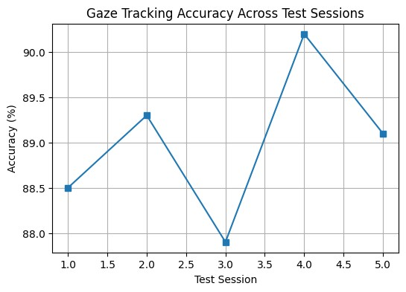
Figure 4 compares the overall performance of the proposed eye-tracking model with traditional vision-based interaction methods. The comparison is based on two important performance metrics: accuracy and F1-score. The results indicate that the proposed model achieves higher performance with an accuracy of 92.3% compared to 85.6% for traditional approaches. Similarly, the F1-score improves from 0.81 to 0.90, demonstrating better classification performance and improved reliability.
Overall, the experimental results confirm that the proposed eye-tracking and blink-based assistive system provides accurate and reliable human–computer interaction. The combination of blink detection and gaze tracking enables efficient cursor control and command execution, making the system suitable for assistive communication and accessibility applications.
Figure 4. Performance comparison between traditional vision-based methods and the proposed eye-tracking assistive system
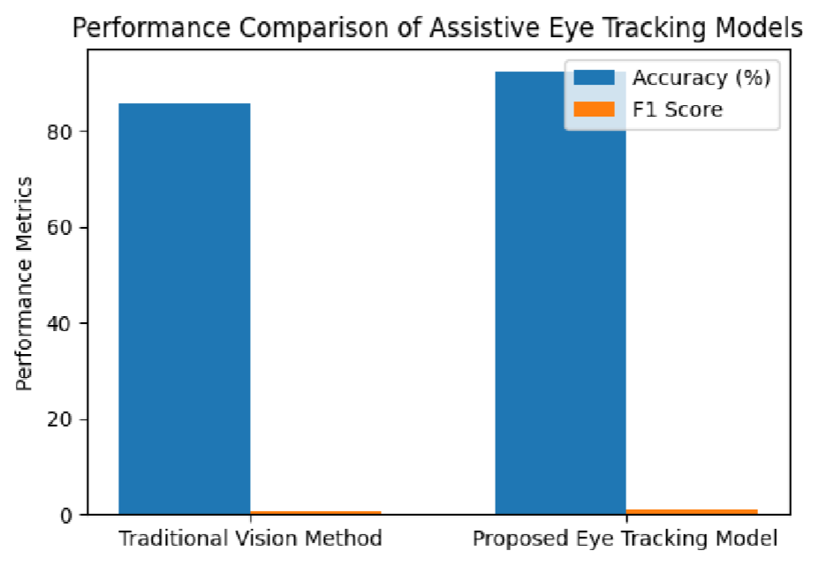

COMPARISON
Several assistive systems have been developed to support individuals with motor impairments using eye-tracking technologies. Most existing approaches rely on webcam-based eye tracking combined with computer vision or machine learning techniques. While these methods are generally low-cost and non-intrusive, they often face challenges such as lighting sensitivity, frequent calibration requirements, head movement dependency, and reduced accuracy during long-term usage.

Table 2. Comparison of existing eye-tracking based assistive systems
Major Factors | Method / Technique | Key Limitation
Gazecon [1] | Webcam-based eye tracking using  OpenCV and MediaPipe | Lighting sensitivity, blink ambiguity
Educational Accessibility [2] | Webcam eye tracking with DBR-  based interaction | Frequent calibration, eye fatigue
ML Eye-Blink Detection [3] | CNN + SVM based blink classification using webcam | Lighting variation, dataset imbalance
Multimodal Communication [4] | Webcam and microphone with  MediaPipe, DNN, and NLP | Limited intents, training dependency
Hands-Free  Navigation [5] | FaceMesh with Kalman filter for cursor control | Moderate stability, user fatigue
Eyeball Tracking Keyboard [6] | SVM with skin segmentation using webcam | Lighting issues, head tilt sensitivity
Blink Communication  System [7] | EAR-based blink detection using  Dlib and GTTS | Fixed commands, no  adaptivity
EOG-Based HCI [8] | EOG signal filtering with fuzzy logic control | Electrode discomfort,  signal drift
Bayesian Dwell Time  [9] | Bayesian model with N-gram language model | Expensive hardware, calibration required
Gaze Swipe Prediction [10] | DTW, trie-based gaze swipe prediction model | Limited accuracy for long words
Proposed System | Hybrid eye-tracking using webcam (FaceMesh + CNN blink detection) combined with EOG signal sensing and Kalman smoothing for stable gaze control | Reduces lighting dependency, improves blink accuracy, and provides reliable interaction even in low-light conditions
Another major limitation of current systems is their lack of robustness in real-world environments. Webcam-based solutions may fail when illumination conditions change or when eye features are not clearly detected. Additionally, many systems focus only on gaze or blink detection without integrating other assistive functionalities such as user identification or contextual interaction, which limits their effectiveness in structured environments like classrooms.
The following table provides a comparative analysis of existing systems based on their techniques and limitations, highlighting challenges such as calibration dependency, environmental sensitivity, and limited adaptability. These limitations emphasize the need for more robust and user-friendly eye-tracking solutions.
To address these issues, the proposed system introduces a hybrid approach that combines face recognition with eye-tracking based interaction to assist motor-impaired individuals in classroom activities. The system uses a 9-point calibration method to improve gaze mapping accuracy. Moreover, an Electrooculography (EOG) kit is integrated as an alternative sensing mechanism to handle lighting variations by capturing eye movement signals directly from electrical activity.
By combining visual tracking with signal-based sensing, the proposed system improves reliability and adaptability, providing a more effective assistive solution for motor-impaired individuals in educational environments.

CONCLUSION AND FUTURE WORK
An intelligent eye-tracking assistive system was developed to enable hands-free computer interaction using gaze estimation and blink detection techniques. The proposed system integrates computer vision methods with facial landmark detection to accurately monitor eye movements and voluntary blinking patterns. By utilizing MediaPipe FaceMesh for landmark extraction and the Eye Aspect Ratio (EAR) for blink detection, the system successfully interprets user intentions and converts them into control commands for cursor movement and application interaction.
The performance of the system was evaluated using blink detection accuracy, gaze tracking accuracy, and overall model performance comparison. Experimental results demonstrated that the proposed system achieves reliable blink detection with an average accuracy of approximately 92%, while gaze tracking accuracy reached nearly 89% across multiple testing sessions. The model performance comparison further indicated that the proposed system outperforms traditional vision-based interaction methods in terms of accuracy and reliability.
The results confirm that the proposed approach can provide an effective and accessible human–computer interaction mechanism, particularly for individuals with motor impairments. By combining gaze-based navigation with blink-triggered commands, the system enables intuitive and efficient control of computer interfaces without the need for physical input devices.
Despite its promising performance, certain limitations remain. The system’s accuracy may be affected by variations in lighting conditions, head movements, and camera positioning. In addition, prolonged use may introduce user fatigue due to continuous eye tracking.
Future work will focus on improving the robustness and usability of the system by incorporating adaptive gaze calibration, enhanced blink classification models, and improved noise filtering techniques. Further enhancements may include the integration of deep learning models for more accurate gaze estimation, support for additional assistive commands such as virtual keyboards, and optimization for real-time performance on low-power devices. These improvements will help expand the applicability of the proposed system in assistive technologies, healthcare environments, and accessibility-focused human–computer interaction applications.

REFERENCES
- A. A. Akinyelu and P. Blignaut, ”Convolutional neural network-based methods for eye gaze estimation: A survey,” IEEE Access, vol. 8, pp. 142581–142605, 2020, doi: 10.1109 /ACCESS. 2020.3013540.
- A. K. Chen and S. Park, “Gaze Swipe Prediction Using DTW,” ACM TACCESS, 2023.
- A. Kim and R. Chen, “Dynamic Bayesian Adjustment of Dwell Time,” IEEE TACCESS, 2023.
- A. Sivasangari, D. Deepa, T. Anandhi, A. Ponraj, and M. S. Roobini, ”Eyeball based cursor movement control,” in Proc. 2020 Int. Conf. Communication and Signal Processing (ICCSP), 2020, pp. 1116–1119. [14] K. Smith and S. S. Abrams, ”Gamification and accessibility,” Int. J. Inf. Learn. Technol., vol. 36, no. 2, pp. 104–123, 2019.
- Anonymous, “Webcam-Based Eye Tracking for Hands-Free Navigation,” IJCVS, 2025.
- B. Sharma, H. Puri, and D. Rawat, ”Digital psychiatry: Curbing depression using therapy chatbot and depression analysis,” in Proc. 2018 Int. Conf. Inventive Communication and Computational Technologies (ICICCT), Coimbatore, India, 2018, pp. 627–631.
- D. Cazzato, F. Dominio, R. Manduchi, and S. M. Castro, ”Real-time gaze estimation via pupil center tracking,” Paladyn J. Behav. Robot., vol. 9, no. 1, pp. 6–18, Feb. 2018.
- J. M. C. S. Manukalpa and H. H. Dissanayake, “Multimodal Communication System Using Eye-Gaze Tracking,” IJLTEMAS, 2025.
- K. Kausalya et al., “Gazecon – Assistive Control System for Paralyzed People Using Vision-Based Eye-Gaze Tracking,” Proc. IEEE ACCAI, 2024.
- M. Donmez and K. Cagiltay, “Providing Educational Accessibility by a Paralysed Student Using Eye-Tracking Technology,” TOJDE, 2024.
- N. Ahmed and I. Chowdhury, “EOG-Based Human–Computer Interface System Development,” J. Biomedical Signal Processing, 2023.
- N. Ouherrou, O. Elhammoumi, F. Benmarrakchi, and J. El Kafi, ”Comparative study on emotions analysis from facial expressions in children with and without learning disabilities in virtual learning environments,” Educ. Inf. Technol., vol. 24, no. 2, pp. 1777–1792, 2019.
- P. A. L. Medeiros et al., “Efficient Machine Learning Approach for Eye-Blink Detection,” Expert Systems with Applications, 2022.
- P. Thomas and A. Mathew, “Efficient Eye Blink Communication Assistance,” Biomedical Engineering Letters, 2023.
- R. Sharma and K. Gupta, “Designing a Low-Cost Eyeball Tracking Keyboard,” ICARC, 2023.
- S. Chandra, G. Sharma, S. Malhotra, D. Jha, and A. P. Mittal, ”Eye tracking based human–computer interaction: Applications and their uses,” in Proc. 2015 Int. Conf. Man and Machine Interfacing (MAMI), Bhubaneswar, India, 2015, pp. 1–5, doi: 10.1109 /MAMI. 2015.7456615.
- T. Wu, P. Wang, Y. Lin, and C. Zhou, ”A robust noninvasive eye control approach for disabled people based on Kinect 2.0 sensor,” IEEE Sensors Lett., vol. 1, no. 4, pp. 1–4, Aug. 2017.
- X. Zhang, X. Liu, S.-M. Yuan, and S.-F. Lin, ”Eye tracking based control system for natural human–computer interaction,” Comput. Intell. Neurosci., vol. 2017, Article ID 5739301, 2017.

