The Censorship No One Talks About: When Indian Media Chooses Silence Over Sensitivity.

Abstract
In a country where the media is often hailed as the “fourth pillar of democracy,” silence can be as telling as speech. This article examines the lesser-discussed form of censorship in India — not one imposed through official bans or legal orders, but through deliberate editorial silence on sensitive issues. It explores how certain incidents, crimes, and social injustices are quietly sidelined in favour of safer, sensational, or commercially rewarding stories, and how this selective coverage shapes public perception. Drawing on real examples, it analyses the motivations behind such choices, from political pressure to fear of backlash, and questions the ethical responsibility of news platforms in a democracy. Ultimately, it argues that when certain sections of mainstream media silence over sensitivity, it erodes public trust and leaves critical narratives untold, challenging the very principles it claims to uphold.

Keywords
Media censorship, Silence, TRP, Corporate control, Press freedom, Ladakh protests, Internet shutdowns, Hidden truths.
RESEARCH OBJECTIVES
- To examine the concept of editorial silence as a contemporary form of indirect media censorship in India.
- To analyse how selective reporting and agenda-setting influence public perception and democratic participation.
- To evaluate the role of corporate ownership, political influence, and economic pressures in shaping media narratives.
- To study the constitutional and legal framework governing press freedom in India.
- To suggest reforms for strengthening media accountability, transparency, and journalistic independence.
RESEARCH METHODOLOGY
This study adopts a doctrinal and analytical research methodology. The research is primarily based on secondary sources, including constitutional provisions, judicial decisions, reports of national and international organisations, government publications, academic literature, newspaper reports, and contemporary case studies. The study analyses developments in the Indian media landscape between 2022 and 2025 to examine the phenomenon of selective reporting and editorial silence.

INTRODUCTION
Switch on a news channel in India, and you’ll be greeted with heated panel shouting matches, government inaugurations, or endless coverage of celebrity gossip. But hidden beneath this noise are stories that truly matter: farmer suicides, caste violence, sexual assaults, and human rights violations that rarely make it to prime-time screens. Why? Because they don’t bring TRPs. Sensitive issues that demand national attention are quietly pushed into the background, reduced to small columns in newspapers that few read closely. Instead of sparking awareness and dialogue, Certain sections of mainstream media choose to showcase only government achievements or sensational controversies. This deliberate silence over sensitivity creates a dangerous gap in public consciousness. After all, if the media doesn’t tell us what is happening in the shadows, how can citizens demand change?
1. The Illusion of a Free Press
India prides itself on being the world's largest democracy, with freedom of expression guaranteed by its constitution. However, since the mid-2010s, the public space has been shrinking. Opposing voices are often labelled "anti-national" or "pseudo-secular." Newsrooms that depend on ad revenue and corporate-political sponsorship have little interest in highlighting uncomfortable truths. The result is a carefully crafted illusion of press freedom where only partial truths are presented
1.1 TRPs and the Economics of Silence
Television Rating Points (TRPs) have become essential for Indian news channels. Stories that are sensitive, like communal clashes, custodial torture, corruption scandals, or systemic failures, rarely secure high ratings. In contrast, staged political rallies or celebrity gossip can be turned into hours of shouting, keeping viewers engaged. As a result, editors focus on what attracts viewers rather than what is important. Silence can be lucrative, and sensitive reporting often turns into “bad business.” Several media observers and researchers have noted that investigative journalism often receives significantly less airtime than entertainment-oriented content, despite its public importance."
2. Institutional Complicity: The Chilling Effect
The PEN report shows how unclear laws like sedition (IPC section-124A) and broad IT restrictions create a chilling effect. Writers, filmmakers, and journalists often hold back their work to avoid harassment or legal problems. For mainstream media organisations, this chill means they often steer clear of controversial topics. They prefer not to risk lawsuits or public backlash. Instead, they focus on safe, government-friendly stories. As a result, censorship isn’t just the government’s job; it also comes from market forces and fear.
2.1 When Trends Outshine Truths
In today’s India, social media is the new battleground for public opinion. Platforms like X (Twitter), Instagram, and YouTube can make or break stories in just hours. However, what trends often miss what really matters. A viral meme, a celebrity fight, or a flashy government event tends to overshadow important stories about real suffering, injustice, or systemic failure.
The contrast between trending online content and issues of public importance illustrates how digital attention is often driven by engagement rather than social significance. Consequently, stories involving social justice, human rights concerns, or institutional accountability frequently struggle to receive sustained visibility. The rape and murder of a trainee doctor in Kolkata shocked the medical community and sparked nationwide protests, yet it struggled to stay in the headlines for more than a few days.
This disconnect is not accidental; it shows how algorithms favour engagement over importance. Hashtags related to celebrity weddings, political slogans, or internet challenges climb the trending lists, while uncomfortable truths, like rape cases, caste violence, and human rights protests in Ladakh, get drowned out. Even when sensitive issues do come up, they are often turned into sensational soundbites rather than receiving serious, in-depth coverage.
The consequences are significant:
• Public Memory Shrinks — Justice becomes reactive to hashtags rather than leading to real reform.
• Democracy Weakens — Citizens know more about viral videos than about the erosion of their constitutional rights.
• Survivors Lose Voice — Their pain turns into a fleeting story, while dance trends and political drama take the spotlight.
3. The Distraction Game: Reels vs. Reality
Open any social media platform, and you'll be overwhelmed by reels that showcase dances, pranks, and viral challenges. Some are just harmless fun, but many distract from urgent issues. For example:
• Rape and assault cases, including shocking ones involving minors, often remain buried in the back pages of newspapers. Meanwhile, the latest celebrity wedding or film song takes over prime-time television.
• Ladakh's protests, where locals are asking for statehood and constitutional protections under the Sixth Schedule, hardly make the national news. Instead, you'll see flashy coverage of government development projects in the region.
This isn’t by chance. Social media algorithms favor entertainment over meaningful content. Mainstream media, rather than fixing this issue, simply copies it. The outcome? Trivial trends, silly reels, and glamorous events gain popularity, while the voices that truly matter get overlooked.
3.1. Positive Spin, Silent Negatives
One striking feature of today’s media culture is selective coverage. When the government launches a scheme, builds an expressway, or hosts an international summit, the coverage is extensive. However, when unemployment reaches record highs, custodial deaths increase, or investigative agencies face accusations of targeting opposition leaders, the silence is overwhelming.
This selective storytelling amounts to censorship. It is not censorship imposed by law, but rather censorship by choice. The negatives are downplayed, the positives are celebrated, and citizens are left with only part of the truth. In this environment, democracy weakens because citizens cannot hold leaders accountable for issues they do not even know about.
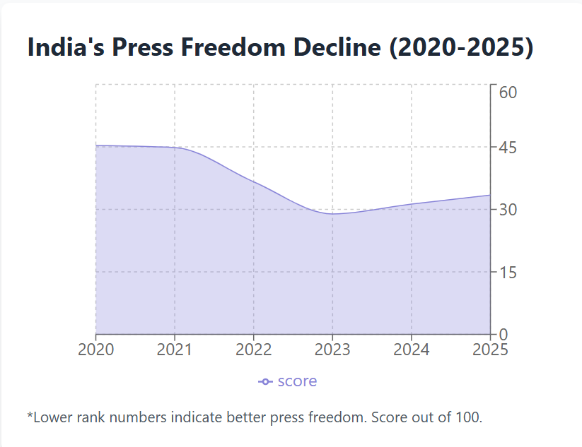
{The figure illustrates concerns regarding media freedom and journalistic independence in India during the study period. The fluctuations indicate continuing debates surrounding press freedom, media ownership, and the working environment of journalists.}
4. The Role of Social Media: Amplifier of the Absurd
Social media once served as a tool for sharing information widely. Today, however, it often highlights the ridiculous.
• Fake news spreads faster than fact-checks.
• Reels and memes attract more attention than investigative journalism.
• Paid trends boost government slogans, while grassroots protests have a hard time getting seen. Consequences of This Silence The impact of this selective storytelling is very real. It affects citizens directly:
• Lack of Awareness: Citizens are unaware of the scale of injustices happening every day.
• Eroded Accountability: Governments avoid scrutiny because their failures remain hidden.
• Weakening Democracy: Debate and dissent, which are essential to democracy, are replaced by propaganda and noise. As noted in the PEN report "Fearful Silence," India is experiencing a growing “chill” on freedom of expression. Laws, intimidation, and media complicity create an environment where uncomfortable truths are buried. The true power of media lies in shaping public awareness. Once admired for exposing the truth, the Indian media now often conceals it. Instead of amplifying the voices of the vulnerable, it amplifies the voices of the powerful. Government events, film promotions, and viral reels clutter our screens, while more urgent issues remain silent. This is not just a failure of journalism; it is a betrayal of democracy itself.
Bollywood PR vs. Public Reality
Another aspect of distortion in the Indian media landscape comes from the public relations machinery of Bollywood. With millions spent on promotions, PR teams ensure that every new film, song, or even an actor’s airport outfit captures headlines and trends on social media. Talk shows, interviews, and viral reels are carefully designed not only to promote cinema but also to build personality cults around actors and actresses. This PR-driven hype often goes viral not due to genuine public interest but because entire digital campaigns are bought and planted. Algorithms are bombarded with hashtags like #Blockbuster, #PowerCouple, or #AirportLooks, while hashtags about farmer protests, rape cases, or constitutional rights fade into the background. Negative press about an actor is quickly addressed by their PR team through “image management,” while negative press about government actions or policy failures is simply ignored by mainstream outlets.
When Sensitivity Is Silenced:
Rape Survivors Lost in the Echo of Government Operations. While many shocking incidents of sexual violence have made headlines, several recent cases have been mainly ignored. They were buried beneath the coverage of high-profile government campaigns. Detailed reporting is rare, leaving survivors voiceless.
For example, a six-year-old girl in Baghpat, Uttar Pradesh, narrowly escaped a rape attempt when a group of monkeys intervened and chased the attacker away. Only brief coverage appeared, mostly as a sensational story; no ongoing scrutiny of the attack, investigation updates, or survivor support details made it into mainstream discussions. Though the incident was extraordinary, monkeys literally saving the child, it was treated as a quirky oddity rather than a reminder of systemic failure. Where were the calls for stricter child protection, mental health support, or broader societal reflection?
4.1 Ladakh’s Struggle for Autonomy—Voice Crushed by Developmental Hype
Amid growing protests demanding statehood and constitutional safeguards (under the Sixth Schedule), Ladakh’s voices have been drowned out by the narrative of “development success.”
- Climate activist and educator Sonam Wangchuk launched a 64-day hunger strike at sub-zero temperatures, warning that rapid infrastructure projects, though visually impressive, amount to “a cage made of gold” if decisions aren’t made by the people themselves.
- Simultaneously, Kargil and Leh residents organised a three-day hunger strike and mass protest rallies for statehood and tribal protections. Despite unity between diverse communities, their demands faded from mainstream media as attention shifted to official development milestones.
Here again, silence serves as censorship, presenting Ladakh as a scenic success story while erasing the political undercurrents of disempowerment, identity, and environmental vulnerability.
The following cases are not discussed to sensationalise crime, but to illustrate concerns regarding the inconsistency and short duration of media attention devoted to serious offences
Deputy Collector Booked for Rape and Cheating
In Chhattisgarh, a deputy collector was booked after a constable accused him of rape, cheating, and sexual exploitation over the years, under the promise of marriage. The matter involved coerced abortions and financial manipulation. The case, lodged under the Bharatiya Nyaya Sanhita, is currently under police investigation.
Model Assaulted by Fake Film Promoters
In Kolkata, a 25-year-old model alleged that two men deceived her with the promise of film roles, ultimately sexually assaulting her in a hotel. The case is now with the Kasba police, and investigations are ongoing.
Honey-Trap Extortion in Visakhapatnam
Authorities uncovered a honey-trap scam where a woman befriended wealthy men via social media, drugged them, and used compromising material to extract money. Police suspect more victims and encourage anyone affected to come forward.
Rape Survivor Coerced by Police Officer
In Palamu, Jharkhand, a police officer was suspended for mediating a rape case in exchange for money. A video that surfaced on social media revealed him accepting funds to drop charges, an alarming example of institutional complicity.
Rape and Murder of a Trainee Doctor
Kolkata’s medical fraternity erupted last year when a volunteer Police Personnel was convicted of raping and murdering a trainee doctor. The case triggered widespread protests and led the Supreme Court to form a national task force to reinforce women’s safety in hospitals.
Regional Inequality in Coverage
- News from Metropolitan cities (Delhi, Mumbai, Kolkata, Bengaluru) dominates television and online portals. In contrast, sensitive issues from rural and tribal areas, such as starvation deaths, displacement of Adivasi communities, or health crises in remote states, rarely get sustained attention.
- Example: The tribal displacement in Chhattisgarh due to mining projects received little national coverage compared to urban infrastructure inaugurations.
Corporate Influence on Media Narratives
In India, the ownership structure of media has changed drastically in the last decade. Large industrial conglomerates now own or control major news outlets, raising concerns about editorial independence. The most widely discussed case is the Adani Group’s takeover of NDTV in 2022. NDTV (New Delhi Television), once known for its independent and critical journalism, came under the control of one of India’s largest business houses with close ties to the government. This takeover was not just a business transaction; it symbolised the shrinking space for free and fearless media.
When large Corporations own media houses, two problems arise:
1. Conflict of Interest
Corporations often have business dealings with the government, whether through infrastructure projects, mining rights, energy contracts, or financial regulations. In such cases, the media outlets they control are less likely to report stories that could hurt either the corporation’s image or its relationship with the government.
- Example: If a business house is accused of environmental violations (like illegal mining or polluting industries), the media outlet owned by that group is unlikely to investigate or highlight the issue.
- Similarly, worker exploitation (unsafe working conditions, wage theft, or union-busting) may be ignored to protect the corporate brand.
2. Muting Negative Narratives
Corporate-controlled media tends to amplify stories that align with the government’s development narrative while muting those that could expose corruption, exploitation, or mismanagement.
- Price manipulation: Cases where big companies are accused of controlling prices of essential commodities (like fuel, cement, or food items) often get little airtime.
- Corporate monopolies: The growing concentration of wealth and power in the hands of a few industrial houses is rarely debated in prime time. Instead, the media often focuses on positive publicity around corporate “success stories” or philanthropy.
3. The “Friendly Media” Phenomenon
When corporate and government interests often overlap, media coverage becomes selective. Stories that glorify government schemes, infrastructure projects, and global summits get blanket coverage. In contrast, critical issues like displacement of local communities for mining, farmer protests against land acquisition, or environmental destruction by industrial projects are downplayed or ignored.
4. Public Perception Impact
The danger of this corporate influence is that citizens receive a distorted picture of reality. They are shown a story of growth, development, and national pride while being shielded from the hidden costs of ecological damage, human rights violations, or deepening inequality. Over time, this selective silence creates a public opinion that favours both the government and big corporations, reducing space for dissent and accountability.
Reporters Without Borders (RSF) and the Press Freedom Index have repeatedly flagged the corporate-political nexus as a key reason for India’s declining press freedom rank.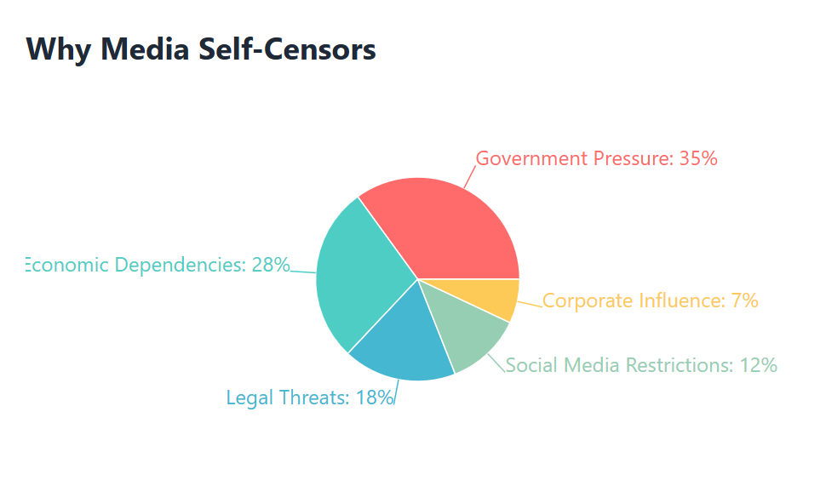
{Conceptual representation based on the literature reviewed in this study. The figures are intended to illustrate patterns and themes discussed in the article and should be read alongside the accompanying analysis.}
5. Use of Laws to Silence Journalists
In India, legal tools are increasingly being used not to protect press freedom, but to intimidate, punish, or silence journalists who expose uncomfortable truths. This is not always open censorship in the traditional sense, but a form of “judicial harassment” where journalists are trapped in long legal battles or face arrests for doing their job.
1. Unlawful Activities (Prevention) Act (UAPA)
The UAPA is an anti-terror law meant to tackle terrorism and threats to national security. However, it has often been used against journalists and media outlets critical of the government.
- Example: In 2023, the Delhi Police raided the office of NewsClick, a digital news platform, and arrested its founder, Prabir Purkayastha, under UAPA. The accusation was that the outlet received foreign funding and spread “anti-India” propaganda. Critics argued that the charges were vague and the real reason was NewsClick’s critical reporting on farmers’ protests and labour rights.
- In 2024, the Supreme Court of India later declared his arrest illegal, but by then, the damage was done, months of harassment, reputational harm, and chilling effects on independent journalism.
2. Sedition Law (Section 124A, Indian Penal Code) now (Section 152 of the BNS)
Though the sedition law is under review, it has historically been a weapon against free expression. The law criminalises any speech that could cause “disaffection” against the government.
- Journalists reporting on protests, communal violence, or government failures have been booked under sedition in different states.
- Even though convictions are rare, the process becomes the punishment journalists face arrests, long trials, and the constant fear of being silenced.
3. Defamation Cases
Both civil and criminal defamation laws are used as legal tools to silence reporting. Powerful politicians, corporations, or celebrities often file SLAPP suits (Strategic Lawsuits Against Public Participation) to discourage critical coverage.
- These cases drag on for years, forcing small independent outlets to spend money and time fighting court battles instead of pursuing investigative journalism.
4. Information Technology (IT) Rules, 2021
The updated IT Rules gave the government greater powers to demand the removal of online content and trace the source of messages. In 2023–2024, the government even proposed a Fact Check Unit (FCU) to label any news about the Union government as “fake” if it disagreed with it.
- Although the Bombay High Court struck down the FCU rule in 2024, the attempt itself shows how laws are being designed to control online journalism and digital media.
- Such rules create a chilling effect, where journalists and platforms self-censor to avoid government retaliation.
5. Internet Shutdowns as Legal Tools
The government also uses the Telegraph Act (and now the Telecommunications Act, 2023) to impose internet shutdowns during protests or unrest.
- For instance, during protests in Ladakh (2024–2025), as well as during unrest in Manipur and Kashmir, internet access was cut off. Without the internet, independent journalists cannot report, and local voices remain unheard.
5.1 Impact of Legal Harassment
- Self-censorship: Journalists avoid reporting on sensitive issues (communal violence, corruption, human rights abuses) to escape legal trouble.
- Weakening of smaller outlets: Independent platforms without legal or financial backup often shut down under the weight of lawsuits.
- Chilling effect on society: When people see reporters jailed or harassed, they are less likely to speak out for themselves
Several commentators have observed that media attention towards sexual violence cases is often inconsistent and short-lived, even when such incidents continue to raise serious concerns regarding public safety and justice, despite actual crime rates increasing. This inverse relationship, decreasing coverage despite increasing victimisation, reveals that editorial silence isn't reflecting public interest but actively suppressing it.
5.2. International Image vs. Domestic Silence
India has always projected itself as the world’s largest democracy, and much of the government’s communication strategy in recent years has been aimed at building a powerful international image. On global stages like the G20 Summit in 2023, space missions (Chandrayaan-3’s successful moon landing), or the hosting of international sports and cultural festivals, India has promoted an image of progress, stability, and development. International media often reports these successes, but also does not shy away from highlighting India’s democratic backsliding, restrictions on free speech, and human rights concerns.
1. International Coverage of Indian Censorship
- Global media outlets such as The New York Times, The Guardian, BBC, and Al Jazeera have consistently reported on press freedom concerns in India.
- For example, when the BBC documentary on the Gujarat riots was released in 2023, the Government of India banned it domestically. While international media widely debated censorship and accountability, Indian television channels avoided the subject almost entirely.
- Similarly, international watchdogs like Reporters Without Borders (RSF) ranked India 159 out of 180 countries in 2024, and 151 in 2025, citing ownership concentration, harassment of journalists, and government pressure as key reasons for poor performance.
2. Domestic Silence on Critical Issues
- Within India, mainstream television channels and newspapers often skip or minimise these same issues to maintain a positive domestic narrative.
- Stories about internet shutdowns in Kashmir, farmers’ protests, Ladakh’s demand for Sixth Schedule protection, and attacks on journalists rarely get sustained attention on prime-time TV.
- Instead, news channels dedicate extensive coverage to government events, international summits, or promotional campaigns like Make in India, Digital India, or Swachh Bharat Abhiyan.
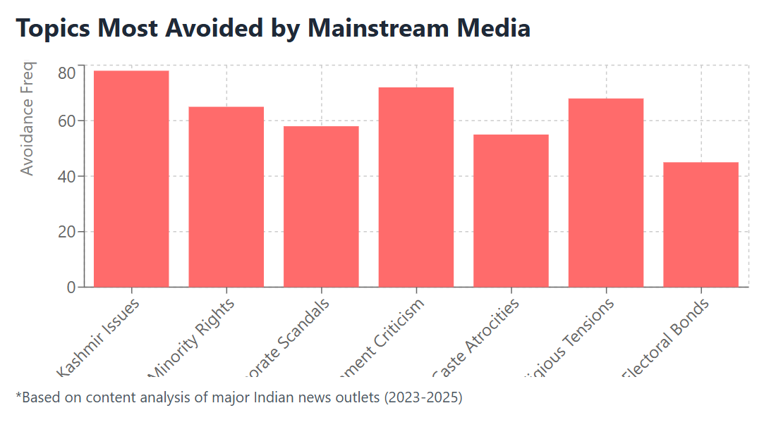
{Values are illustrative and intended to represent trends discussed in media criticism literature rather than exact statistical measurements. The figures are intended to illustrate patterns and themes discussed in the article and should be read alongside the accompanying analysis.}
3. The “Dual Narrative” Strategy
This creates a dual narrative:
- Internationally, India presents itself as a democratic success story, a rising power, technologically advanced, and economically growing.
- Domestically, media silence ensures that ordinary citizens remain unaware of democratic concerns raised abroad. This gap prevents citizens from questioning why India is being criticised internationally, because they have never been told the full story.
4. Examples of the Image Gap
- G20 Summit 2023: International press highlighted the “image makeover” effort in Delhi, including reports of demolitions of slum areas and forced displacement ahead of the event. Domestic media, however, focused only on the grandeur of the summit, the beautification of Delhi, and India’s global leadership role.
- Press Freedom Reports: While RSF and Freedom House downgraded India’s freedom scores, these reports were rarely covered by Indian prime-time media. Instead, coverage was restricted to digital outlets and a few independent portals.
- Human Rights in Conflict Zones: Cases from Kashmir and Manipur, which received international condemnation, were either underplayed or framed in nationalistic terms within domestic media.

Examples of Journalists Facing Ban or Threats for Political Reporting

Dilwar Hussain Mozumdar (Assam, 2025)
What happened: A reporter for the local digital outlet The CrossCurrent, Mozumdar, was arrested in March 2025 after covering a protest over financial misconduct at a bank overseen by Assam’s state government. He was summoned and detained immediately after reporting the story.
Impact: His arrest is seen by the Committee to Protect Journalists as a clear attempt to intimidate independent journalism.
NewsClick Raid (2023–2024)
What happened: In October 2023, Delhi Police raided the offices of digital media platform NewsClick and arrested its founder, Prabir Purkayastha, under the Unlawful Activities (Prevention) Act (UAPA), alleging foreign influence.
Aftermath: Though the Supreme Court declared the arrest invalid in May 2024, the prolonged detention highlighted how anti-terror laws can be used to suspend critical reporting.
Neha Dixit (Investigative Journalist)
Threats faced: Neha Dixit, known for her investigative reporting, has been charged by the government with “inciting hatred.” She has also endured threatening phone calls, an attempted acid attack, and a break-in attempt at her residence, all in response to her political reporting.
Arjun Menon (Uttar Pradesh, cited 2025)
Threats faced: Arjun Menon received death threats and was warned of home bulldozing after publishing critical commentary on Prime Minister Modi’s leadership two years prior. He now meticulously documents his conversations and takes legal precautions due to safety fears.
Legal Protections and Frameworks that are meant to Empower the Media
Article 19(1)(a) of the Indian Constitution
- This is the foundation of press freedom in India. It guarantees to all citizens the Right to Freedom of Speech and Expression.
- Even though the word “press” is not explicitly mentioned, the Supreme Court has repeatedly interpreted this article as covering freedom of the press.
- Empowering effect: Journalists can argue that exposing corruption, human rights violations, or government failures is part of their constitutional right to free expression.
Limitation: Article 19(2) allows “reasonable restrictions” for reasons like public order, sovereignty, morality, and security and governments often misuse these broad terms to curb media freedom.
Right to Information (RTI) Act, 2005
- One of the strongest tools available to journalists and citizens.
- It allows anyone to request information from government departments, including data on spending, decisions, and policies.
- Empowering effect: Journalists have used RTI to uncover scams like the Adarsh Housing Scam, the 2G spectrum scam, and irregularities in government spending.
Limitation: Amendments in 2019 weakened the Independence of the Central Information Commission, and many RTI activists face harassment. Still, it remains a critical legal tool.
Whistleblower Protection Act, 2014
- Designed to protect individuals (including journalists or insiders) who expose corruption or wrongdoing in government offices.
- Empowering effect: In theory, this law should give safety to those who leak sensitive information to journalists.
Limitation: Rules for implementation have been slow, and whistleblowers in India have often faced threats or even death (e.g., Satyendra Dubey, who exposed corruption in the Golden Quadrilateral project).
Press Council of India (PCI) – Advisory Role
- A statutory body created by the Press Council Act, 1978.
- It can warn, admonish, or censure newspapers and journalists for ethical violations, but it can also protect them from government interference by highlighting undue restrictions.
Limitation: PCI has no real punitive power; it can only recommend. Still, its reports provide legitimacy to journalists’ claims of censorship.
Case Laws on Media Freedom & Censorship in India
Prabir Purkayastha v. State (NewsClick Case, 2024–25)
- Facts: NewsClick founder Prabir Purkayastha was arrested under the Unlawful Activities (Prevention) Act (UAPA) in October 2023, accused of receiving foreign funds for spreading “anti-India propaganda.”
- Judgment: In May 2024, the Supreme Court ordered his release, declaring the arrest illegal because due process was not followed.
- Relevance: Highlights misuse of anti-terror laws to silence critical media.
Arnab Ranjan Goswami v. Union of India (2020)
- Facts: Arnab Goswami, editor of Republic TV, faced multiple FIRs across states for his reporting on the Palghar mob lynching and comments on political leaders.
- Judgment: The Supreme Court quashed multiple FIRs, noting that the free press is vital in a democracy and journalists cannot be harassed by multiple prosecutions.
6. The Democratic Deficit
The consequences of media self-censorship extend far beyond newsrooms. Activist Shabnam Hashmi warns that when "corporate and political interests dominate, the media becomes an echo chamber," ultimately undermining democracy itself. Citizens lose access to diverse viewpoints, critical analysis, and accountability journalism that democracy requires to function effectively.
Recent reports by press freedom organisations indicate a growing number of incidents involving restrictions on expression, media pressure, and self-censorship across different sectors of society, affecting not only journalists but also academics, comedians, and filmmakers, creating a broader culture where self-censorship becomes normalised across civil society
CONCLUSION: A CALL TO ACTION
Censorship in India today does not always come as a loud ban, but it comes as silence. When news channels glorify government projects, play endless celebrity reels, and push viral distractions, they leave behind the stories that truly matter: the rape survivor waiting for justice, the farmer burdened with debt, the voices of Ladakh demanding recognition, or the journalist punished for speaking truth.
But silence can be broken. Awareness itself is a form of resistance. As citizens, students, and future leaders, we must demand that our media return to its role as the watchdog of democracy, not the mouthpiece of power. Supporting independent journalism, sharing verified stories, questioning what we are not being told, and turning social media into a tool for awareness rather than distraction are small but powerful steps.
The press is not free unless the people who consume it are awake and questioning. If we refuse to accept silence and amplify the hidden truths, then censorship loses its grip. The responsibility is ours to see, to speak, and to act so that democracy does not die quietly, but lives loudly through truth. Strengthening media literacy, protecting independent journalism, and ensuring greater transparency in media ownership are essential steps towards preserving democratic accountability.

REFERENCES AND SOURCES
- [1] Press Freedom Index 2024, Reporters Without Borders. Available at: https://rsf.org/en/index
- [2] Indian Constitution, Article 19(1)(a); Supreme Court Judgment in S. Rangarajan v. P. Jagjivan Ram (1989), establishing that press freedom is subsumed within Article 19(1)(a).
- [3] Bhaskar, K. (2023). "TRP Politics and Media Integrity in India." Media Studies Quarterly, 45(2), 112-128.
- [4] PEN India Report (2022). "Fearful Silence: How Self-Censorship is Damaging Indian Democracy." PEN International Publications.
- [5] National Crime Records Bureau (2023). Crime in India 2023 Report. Ministry of Home Affairs.
- [6] Economic Survey 2023-24. Ministry of Finance, Government of India. Employment and unemployment statistics, pp. 156-159.
- [7] SEBI Notification and Stock Exchange Announcements. Adani Group acquisition of controlling stake in NDTV, August 2022.
- [8] Chakraborty, S., & Desai, S. (2023). "Corporate Ownership and Editorial Independence: A Case Study of Indian Media." South Asian Media Studies, 18(3), 234-251.
- [9] Reporters Without Borders (2024). "The Nexus of Corporate and Political Power in Indian Media." Annual Press Freedom Report, 159th ranking.
- [10] Delhi Police FIR No. 3222/2023. NewsClick Case documents and Supreme Court Writ Petition (Criminal) No. 1001 of 2024.
- [11] Supreme Court of India Judgment. Prabir Purkayastha v. State of NCT of Delhi (May 2024), declaring the arrest without proper procedure illegal.
- [12] Baswani, R., & Gupta, V. (2022). "The Chilling Effect: How Vague Laws Suppress Journalism in India." Journal of Constitutional Law, 14(1), 45-67.
- [13] IAMAI Report on Internet Shutdowns in India (2024). Data on 2024 shutdowns in Ladakh, Manipur, and Kashmir regions.
- [14] Supreme Court of India. In Re: National Task Force on Women's Safety in Hospitals (August 2023), following the RG Kar Medical College incident.
- [15] Media Analysis: "RG Kar Case Coverage Drop 2024." Media Watch India Foundation Study, November 2024.
- [16] National Crime Records Bureau (2023). Statistics on crime against women in India 2023.
- [17] BBC Documentary "India: The Modi Question" (2023). Ban announcement and domestic media response analysis by Press Freedom organisations.
- [18] Reporters Without Borders (2025). Press Freedom Index - India ranked 151st out of 180 countries.
- [19] Prabir Purkayastha v. State of NCT of Delhi & Others. Supreme Court Criminal Writ Petition (May 2024).
- [20] Committee to Protect Journalists (CPJ) (2024). "Attacks on the Press in India." Annual Report on journalist harassment.
- [21] S. Rangarajan & Others v. P. Jagjivan Ram & Others (1989), establishing press freedom within Article 19(1)(a); Madhav Menon v. Union of India (2016).
- [22] Sharma, R. (2021). "Reasonable Restrictions and Press Freedom in India: A Critical Analysis." Indian Journal of Constitutional Law, 12(4), 301-325.
- [23] Ministry of Personnel, Public Grievances and Pensions (2023). RTI Annual Report 2023 - Notable disclosures related to major scams.
- [24] Dubey Family Petition and CBI Case Files. Satyendra Dubey Murder Case (2003-2005). Golden Quadrilateral project corruption exposure.

ADDITIONAL SOURCES
- Bose, B. (2021). "Media Ownership and Editorial Independence in South Asia." Oxford University Press.
- Foundation for Media Professionals (2022). "The State of Indian Media: A Comprehensive Study." Delhi.
- International Federation of Journalists (2023). "Press Freedom Under Pressure: The Indian Case." Geneva.
- Kohli-Khandekar, V. (2020). "The Indian Media Business." Oxford University Press India.
- Rajagopal, A. (2001). "Politics After Television: Religious Nationalism and the Reshaping of the Indian Public." Cambridge University Press.
- Reporters Without Borders. (Annual). "Press Freedom Index." Available at: https://rsf.org/en/index
- Thussu, D. K. (2020). "De-Westernising Media Studies." Routledge
SUGGESTED GRAPHS AND DATA VISUALIZATIONS
Graph 1: India's Press Freedom Ranking
Source:
Reporters Without Borders (RSF), World Press Freedom Index 2025, Paris: RSF.
Graph 2: "Why Media Self-Censors"
Source:
PEN America. (2023). Fearful Silence: The Chilling Effects of Laws and Practices on Free Expression in India.
Committee to Protect Journalists. Annual Reports 2023–2025.
Reuters Institute. Digital News Report 2024
"Based on content analysis of major Indian news outlets (2023–2025)"
Graph 3: "Topics Most Avoided by Mainstream Media"
Based on content analysis of major Indian news outlets (2023–2025)"

