Exploring Research Trends in Glaucoma Detection: A Bibliometric Analysis Review of Medical Imaging and AI Approaches from 2016 to 2024

ABSTRACT
Aim: This bibliometric analysis aims to map global research trends and patterns in artificial intelligence applications for glaucoma detection using medical imaging from 2016 to 2024, by examining annual publication trends, influential journals and documents, keyword themes, institutional contributions, and collaboration networks to identify evolving AI techniques in ophthalmic diagnostics and guide future research directions
Background: Glaucoma, a leading cause of irreversible blindness, demands early detection through medical imaging like OCT and fundus photography, where AI integration addresses limitations in traditional diagnostics. This bibliometric analysis maps global research trends in AI-driven glaucoma detection from 2016 to 2024.
Methods: A systematic Scopus search on January 10, 2025, yielded 3,853 articles, refined to 2,193 relevant records from 541 sources and 6,711 authors after filtering for English articles. Analysis via RStudio covered publication trends, citations, keywords, affiliations, and thematic networks.
Results: The field has experienced rapid expansion, characterized by an annual growth rate of 93.06%, with deep learning (1,572 occurrences) and image segmentation (913 occurrences) emerging as the primary thematic drivers. Bibliometric evaluation identifies IEEE Access as the most impactful venue (H-index = 35) and COMSATS University Islamabad as the most prolific institution (57 papers). Furthermore, thematic clustering reveals a clear paradigm shift from conventional machine learning methodologies toward convolutional neural networks (CNNs), accompanied by a pronounced concentration of research output from Asian institutions that reflects shifting regional priorities.
Conclusions: While AI-driven imaging has transformed glaucoma diagnostics, critical gaps in data access, generalizability, and equity persist. To overcome limitations and achieve robust, inclusive tools, future research must leverage cross-institutional collaboration to prioritize multimodal datasets, explainable AI, and diverse real-world clinical trials.
Keywords: bibliometric analysis, glaucoma detection, medical imaging, AI, machine learning, deep learning

1.0 INTRODUCTION
Glaucoma is a progressive optic neuropathy and one of the leading causes of irreversible blindness worldwide. Globally, glaucoma affects over 76 million people and is projected to reach 111.8 million by 2040, with the highest burden of primary open-angle glaucoma (POAG) in Africa and primary angle-closure glaucoma (PACG) in Asia [1]. Asia accounts for more than half of global glaucoma cases, reflecting a significant regional public health concern [2]. Glaucoma occurs primarily through the impaired outflow of aqueous humor via the trabecular meshwork and Schlemm's canal, leading to elevated intraocular pressure (IOP). This pressure mechanically stresses and triggers the degeneration and apoptosis that lead to damage to the optic nerve [3]. Vision loss from glaucoma is irreversible and leads to disability and reduced quality of life, highlighting the importance of early detection and effective management [4]. Figure 1 depicts the anatomy comparison of a normal and a glaucomatous eye.

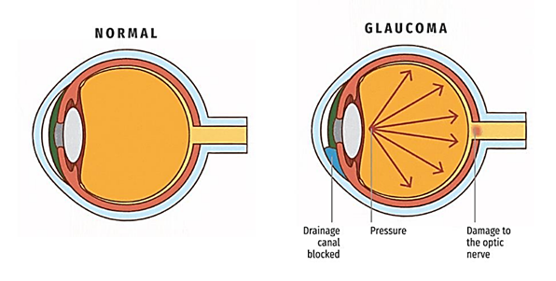
Figure 1: The anatomy of a healthy and glaucoma eye [5]

Glaucoma assessment relies heavily on medical imaging techniques such as fundus photography, optical coherence tomography (OCT), and visual field testing, which enable clinicians to examine the optic nerve and identify early signs of structural or functional damage. These modalities provide detailed and quantifiable information essential for monitoring disease progression. However, traditional diagnostic procedures, including OCT interpretation and visual field assessment, are often time-consuming, costly, and dependent on specialist expertise. In response to these limitations, the integration of artificial intelligence (AI) with medical imaging has emerged as a powerful strategy to enhance early glaucoma detection. This integration significantly contributes to early identification and subsequent intervention, which is crucial for preserving visual function in patients [6][7]. Fundus image-based AI diagnostic systems for example are now cutting-edge instruments for identifying glaucoma, retinal disorders, and other eye disorders [8].
Recent advances in AI enable automated image analysis, improved diagnostic accuracy, and the identification of subtle patterns that may not be immediately apparent to clinicians. AI-driven analysis of imaging data, particularly OCT, has shown strong potential in detecting glaucomatous changes within the optic nerve head and retinal layers, thereby supporting timely and more precise diagnosis. Further studies indicate a rapidly expanding research landscape focused on AI-enabled imaging techniques for glaucoma detection, highlighting evolving trends and the growing importance of these technologies in modern ophthalmic practices [9][10]. It is worth noting that ocular and systemic biomarkers, advancements in telemedicine, real-world clinical trials, and sophisticated AI algorithms will together impact AI-driven ophthalmology worldwide [11].
The objective of this study is to examine global research trends and patterns in the application of artificial intelligence for glaucoma detection using medical imaging. Specifically, the study aims to analyse annual scientific production, identify the most relevant journals and publication sources, determine the most influential and highly cited documents, evaluate frequent research keywords to understand thematic focus, and assess the contribution of leading institutional affiliations. Additionally, the study seeks to interpret the structure and patterns within the field to understand how AI techniques are evolving in ophthalmic diagnostics for glaucoma detection. We also aim to map the development of this field and offer remarks and recommendations for further research by examining these dimensions.

2.0 MOTIVATION AND PREVIOUSLY PUBLISHED STUDIES
The potential of artificial intelligence (AI) to improve diagnostic accessibility and accuracy has led to a recent surge in interest in the use of machine learning in glaucoma detection. As one of the main causes of permanent blindness, glaucoma requires early and precise detection to effectually manage the disease's progression. Traditional diagnostic techniques like optical coherence tomography (OCT) and visual field tests, though still effective, are time-consuming, expensive, and require specific training. As a result, researchers are progressively using machine learning models, especially deep learning approaches like convolutional neural networks (CNNs) to automate and accelerate the diagnostic process.
Bibliometric analysis is a systematic method used to evaluate scientific literature and offer perceptions such as research trends, influential publications, and collaborative networks within a field. Through the quantitative evaluation of variables like author affiliations, keyword co-occurrence, and citation counts, bibliometric analysis offers a summary of the composition and development of the research area. To find high-impact studies and research gaps, bibliometric techniques have been widely used in a variety of fields in recent years, including medical imaging and AI-driven diagnostics. For example, studies by Senthil et al. demonstrate the insights into research hotspots, thematic focus, and emerging trends in AI and health care research [12], while Kocak et al. and Cui et al. focusing on artificial intelligence (AI) within medical imaging and highlighted the exponential growth in publications related to deep learning techniques [13][14] while Chiroma et al. distribute comprehensive bibliometric analysis of AI applications in the IoMT [15].
Several studies have explored the use of machine learning algorithms in glaucoma detection, focusing on techniques such as CNNs, support vector machines (SVM), and ensemble methods. A study by Aljohani et al. introduced a hybrid framework that combines CNNs (ResNet50, VGG-16) with traditional machine learning models like Random Forest. Research by [16] has achieved an accuracy of 95.41%, demonstrating the effectiveness of integrating deep learning with conventional methods for glaucoma diagnosis using that approach. Another study by [17] used SVM to analyse features from Spectralis Optical Coherence Tomography (OCT) data has obtaining an area under the curve (AUC) of 0.82. The study demonstrated how SVM can process intricate OCT data to enhance the evaluation of glaucoma. Another research by [18] has shown promise in identifying early-stage glaucoma from fundus images with an automated detection system that used the VGG-19 CNN architecture in conjunction with SVM. The potential of ResNet-50 deep learning model in accurately detecting early-stage glaucoma was highlighted by Shoukat et al., who achieved a detection accuracy of 98.48% on multiple datasets [19]. These research studies have shown that machine learning techniques for glaucoma detection have advanced significantly with emphasizing how CNNs, SVMs, and hybrid approaches can improve diagnostic efficiency and accuracy in clinical settings.
Recent bibliometric studies have also shown a growing interest in combining expertise from both computer science and medicine, especially in ophthalmology. For example, research by [20] and [21] emphasizes that interdisciplinary collaboration is becoming increasingly important for developing effective machine learning applications for eye disease diagnosis. However, despite the promising findings, past studies also highlight the challenges of limited datasets, variability in image quality, and model generalizability, which affect the real-world implementation of these AI models. [22] noted that variations in imaging hardware and protocols can reduce model generalizability. [23] highlighted that inconsistent image quality across clinics, particularly for conditions like AMD, further impacts reliability. [24] also emphasized that many AI models, despite high accuracy in controlled settings, often underperform in real-world clinical environments due to these limitations.
This study aims to methodically assess the scientific contributions within this specialized field and identify important research areas by analyzing publication trends, citation impact, and keyword mapping. This bibliometric review will serve as a foundation for future research, guiding the growth of machine learning models that are both accurate and clinically relevant for glaucoma detection.

3.0 METHODOLOGY
A structured literature search was conducted using the Scopus database on January 10, 2025 as shown in the flow diagram of the search strategy in Figure 2. The search strategy of obtaining relevant articles that focus on glaucoma detection using medical imaging and AI involved the use of specific keywords, as stated in the flow diagram.
We restricted the literature search to articles available in Scopus as the scope of our study. To ensure the accuracy and relevance of the data, we applied three filtering criteria: selecting only documents categorized as "articles", focusing on published works, and limiting the language to English. The language filter was specifically applied to keep the analysis within a single language for consistency from 2016 to 2024. Initially, the search returned 3,853 articles, 1224 sources and 10480 authors. After removing irrelevant articles and inspection to eliminate duplicate and unrelated articles by evaluation of the title, abstract, and content, as many of 1,660 articles were excluded, leaving 2,193 for further analysis from 541 sources and 6711 authors. The retrieved data were then exported from Scopus in BibTeX format for processing. This bibliometric analysis was conducted using a structured workflow that involved data extraction, synthesis, and visualization within the RStudio environment.

Database: Scopus
Search Field: Article Title
Language: English
Source Type: Journal
Document Type: Articles
n = 3853
Record Identified & Screened
Bibliometric Analysis of medical imaging with AI approach for glaucoma detection.

Screening
Included

Topic, Scope & Eligibility
Topic
Scope & Coverage
Record Included for Bibliometric Analysis
n = 1660
Record Removed
n = 2193
10 January 2025
Date Extracted
Keywords & Search String
Glaucoma AND detection AND (“medical imaging" OR "image processing”) AND (deep AND learning OR machine AND learning OR artificial AND intelligence OR "computer-aided diagnosis”) AND (“retinal image analysis" OR "fundus image" OR "OCT imaging" OR "anterior segment imaging" OR "anterior segment photograph" OR "anterior eye segment") AND (classification OR segmentation OR feature AND extraction OR diagnosis)
Figure 2: Flow diagram of the search strategy of AI approach in medical imaging for glaucoma detection from 2016 to 2024

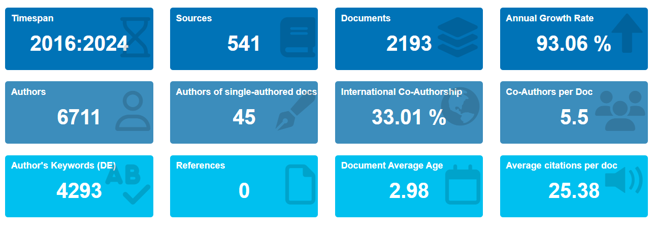
Figure 3: Basic information about articles published on glaucoma detection employing medical imaging and artificial intelligence from 2016 to 2024

Figure 3 summarizes the key bibliometric data on glaucoma detection research from 2016 to 2024 to capture the surge of glaucoma detection evolution. Around 2016, advancements in deep learning frameworks enabled practical AI applications for medical imaging analysis, marking a shift from traditional methods to automated glaucoma detection using fundus photos and OCT scans [9]. Result of articles extraction from this period, 2193 articles were published in 541 sources, with contributions from 6711 authors. Interestingly, only 45 were single-author papers, suggesting collaboration is a significant part of this research area. The annual growth rate of 93.06% shows that interest in this field has surged, likely driven by advancements in AI and imaging technology. More than 30% of the studies involved international collaboration, highlighting the global effort in tackling glaucoma detection. On average, each paper was cited about 25 times, which indicates a strong academic impact. These trends are similar to what has been observed in other studies focused on AI in ophthalmology [6] [25], suggesting an evolving landscape of AI and medical imaging in glaucoma detection.

4.0 RESULT AND DISCUSSION
This section explores and discusses the results of the research trend and pattern of AI for glaucoma detection, the number of publications, and identifies the key journals, top articles, and leading research centers.

4.1 Annual Scientific Production Trend
Publications on the research trend of glaucoma detection over medical imaging and AI have steadily increased since 2016, as shown in Figure 4. Scientific production in AI approaches for medical imaging in glaucoma detection shows dramatic growth from 2016 (3 publications) to 2024 (579 publications), representing a staggering 19,200% overall increase. Year-over-year percentage growth highlights two distinct phases: explosive early expansion from 2016–2019 (867% in 2017, 96% in 2018, 214% in 2019), aligning with deep learning breakthroughs in ophthalmology, followed by sustained but moderating growth post-2020 (40% in 2020, 36% in 2021, 27% in 2022, 19% in 2023, 26% in 2024). This trajectory, from 3 to 160 papers by 2019 (5,233% cumulative), reflects initial innovation surges, while the later stabilization to 579 papers indicates field maturation focused on validation and application, mirroring broader AI-medical imaging trends. The pattern underscores AI's transformative potential in glaucoma diagnostics amid rising global prevalence.

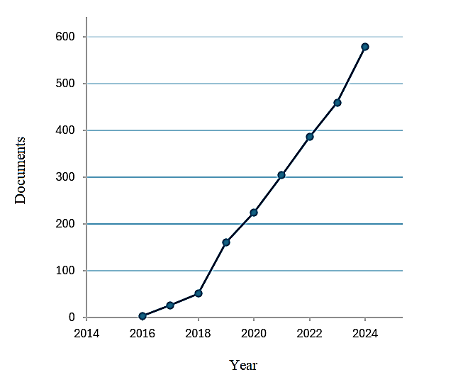
Figure 4: Graph of annual scientific production trend of AI approach in medical imaging for glaucoma detection from 2016 to 2024

4.2 Most relevant sources of literature
The two graphs in Figures 5 and 6 present conflicting opinions regarding the relative significance of various academic sources in the field of study. While Figure 5, "Source Local Impact," evaluates sources according to their H-index, a measure of both productivity and impact, Figure 6, "Most Relevant Sources," ranks sources based on the quantity or sheer number of published documents.

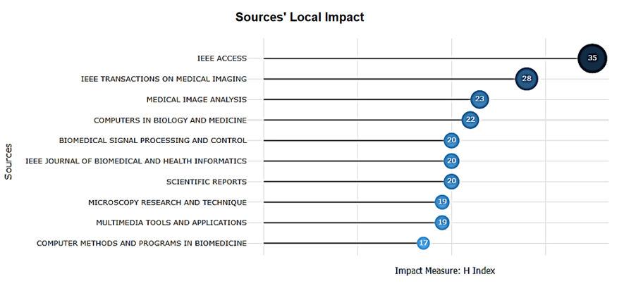
Figure 5: Source local impact (H Index)

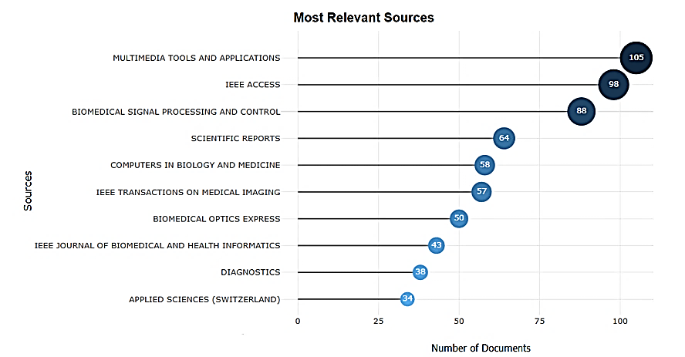
Figure 6: Most Documented (Published) Sources

With the highest H-index (35), IEEE Access is clearly the most influential in terms of citation impact in the graph shown in Figure 5. IEEE Transactions on Medical Imaging (H-index 28) and Medical Image Analysis (H-index 23), which focus on AI-driven diagnostic techniques and medical imaging technologies, are not far behind. The prevalence of IEEE-affiliated journals is reflected in this trend, which supports the notion that advances in AI-based glaucoma detection rely heavily on computational and engineering-driven methods. While they make significant contributions, lower-ranked journals like Computer Methods and Programs in Biomedicine (H-index 17) do not have the same impact on citations.
When journals are ranked by publication volume, however, the graph in Figure 6 shows a different picture. With 105 published studies, Multimedia Tools and Applications is in first place, followed by IEEE Access (98) and Biomedical Signal Processing and Control (88). A crucial realisation by the difference between this publication ranking and the H-index ranking is that journals with a large publication volume do not always have the greatest impact. Multimedia Tools and Applications, for instance, does not rank in the top three in the impact ranking despite having the most publications. In contrast, IEEE Transactions on Medical Imaging, which has a high H-index ranking, has 57 publications, suggesting that the distinction between productivity and impact is crucial for researchers determining where to publish or source credible studies.

4.3 Most Globally Cited Documents
This section presents an overview of the most important studies that have influenced current research as top eight globally cited papers relating to medical imaging and AI are visualised in Table 1. The most cited paper, Gu et al. [26], published in IEEE Transactions on Medical Imaging with 1737 overall citations demonstrated its significant contribution. The CE-Net architecture was presented in this paper and has since been widely used for medical segmentation tasks in the detection of glaucoma. The research’s sample results of lung segmentation, eye vessel detection, and cell contour segmentation are shown in Figure 7. The researchers developed CE-Net, a network architecture aimed at making 2D medical image segmentation more precise and reliable. It builds on the U-Net framework but replaces its encoder with a ResNet-34 backbone to capture richer features. CE-Net was tested on a range of medical imaging tasks, such as identifying optic discs and retinal vessels, outlining lung regions in CT scans, mapping layers in OCT images, and detecting cell boundaries, and consistently produced sharper, more accurate results than existing approaches. The findings show that the gains come from the combined effect of the enhanced encoder and the new context-aware modules, making CE-Net adaptable to different medical imaging challenges.
Table 1: Top 8 most cited references of AI approach in medical imaging for glaucoma detection from 2016 to 2024
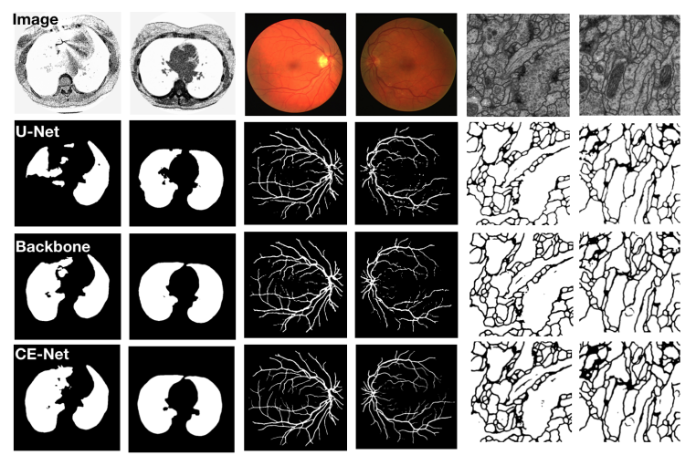
Figure 7: Sample results of lung segmentation, eye vessel detection and cell contour segmentation by [26]. From top to bottom: original images, U-Net, Backbone, CE-Net

Following Table 1, Liu et al. [27] and Siddique et al. [28] obtain 1039 and 1004 citations respectively. Deep learning integration with clinical ophthalmic workflows is the focus of Liu's study, which was published in Lancet Digital Health. Siddique's paper in IEEE Access offers a thorough overview of AI applications in healthcare imaging. Other notable contributions by Fu et al. [29] in IEEE Transactions on Medical Imaging (726 citations), which used multimodal deep learning for glaucoma screening using fundus and visual field data.
This list also includes recent but significant studies, like Jin et al. [30] and Li et al. [31], contributed to knowledge-based and hybrid AI systems for ophthalmic image analysis. These reflect the emerging trend towards explainability, clinical integration, and multimodal approaches are becoming increasingly important in the diagnosis of glaucoma.
This display of citations demonstrates a distinct trend that implies the combination of artificial intelligence and ophthalmic imaging is not only widespread but also has a significant impact on the scientific community worldwide.

4.4 Frequent Keywords
Top keywords that were taken from bibliometric data using the Keywords Plus method are shown in Figure 8. These keywords identified significant research topics of interest in the fields. The figure depicts the keyword "deep learning" dominating the research landscape with 1572 occurrences, suggesting its critical role in the field of ophthalmic diagnostic research today. With their ability to accurately analyse large-scale medical imaging datasets, AI-driven deep learning models have improved the precision of glaucoma diagnosis [25]. The basis for automated analysis is deep learning, supported by recent developments that highlight the accuracy and efficiency advantages of deep learning over conventional image analysis techniques [32].

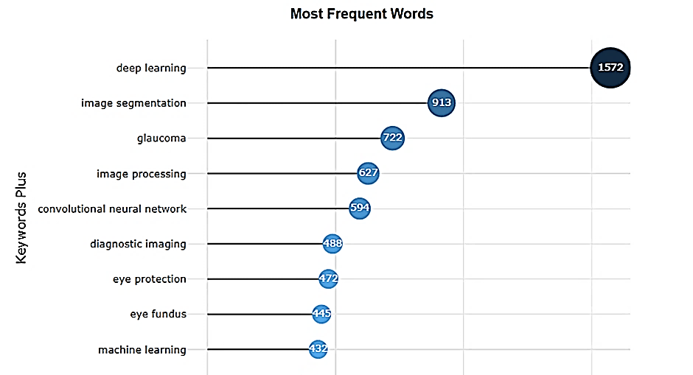
Figure 8: Most frequent words occurrences of AI approach in medical imaging for glaucoma detection from 2016 to 2024

Following, "image segmentation" (913 occurrences) and "glaucoma" (722 occurrences) show a strong importance in defining ocular structures that are essential for glaucoma evaluation, such as the optic cup and disc. These features can be precisely extracted using image segmentation techniques, which improves diagnostic decision-making [29].
Other distinguished keywords that support the larger theme of AI integration in diagnostic systems are "image processing" (627) and "convolutional neural network" (594). These terms reflect the technical foundation and decision support tools in developing automated glaucoma detection. The use of phrases like "diagnostic imaging" (488) and "eye protection" (472) highlights the clinical focus of this study and stresses patient safety as well as diagnostic precision. Methodological diversity and clinical validation of AI-driven approaches are highlighted by keywords such as "eye fundus" (443), and "machine learning" (432).
All things considered, this keyword frequency distribution illustrates how computer science and clinical ophthalmology strategically intersect. It reaffirms the convergence of computer science and clinical ophthalmology, emphasizing deep learning's fundamental role in advancing scalable, reliable and non-invasive glaucoma detection [33].

4.5 Most Relevant Affiliations
The distribution of research contributions across the top eight institutional affiliations in the field of glaucoma detection using medical imaging and AI is illustrated in Figure 9. The data reveal that COMSATS University Islamabad leads with 57 publications, reflecting a significant institutional commitment to advancing AI-driven ophthalmic diagnostics. This prominence may be attributed to the university's focus on computer vision applications in healthcare, particularly in developing regions where glaucoma prevalence remains high.

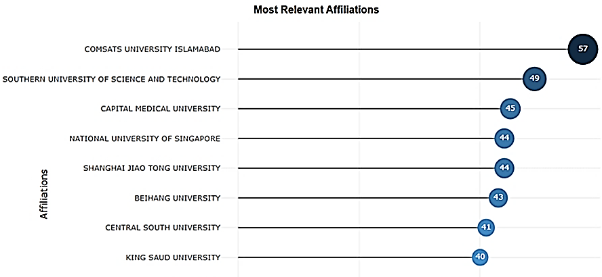
Figure 9: Most relevant affiliations of AI approach in medical imaging for glaucoma detection from 2016 to 2024

Trailing closely are the Southern University of Science and Technology (49 publications) and Capital Medical University (45 publications), both situated in China, underscoring the country's growing dominance in AI and medical imaging research. The National University of Singapore and Shanghai Jiao Tong University each contribute 44 publications, further emphasizing the leadership role of Asian institutions in this domain. These findings align with bibliometric studies by Zhao et al. [34], which highlights Asia, especially China as a hotspot for AI innovations in ophthalmology.
Owing to their regional diversity and potential for collaboration, universities like King Saud University, Central South University, and Beihang University are establishing the growing research internationalisation. Meanwhile, the academic investment in clinical translation and applied AI in eye care is demonstrated by the 36 publications each from Shenzhen University and Wenzhou Medical University. Building equitable and generalisable AI models in ophthalmology requires this diversification of the global distribution of contributions throughout different healthcare systems [35].
Improving partnerships across different regions and promoting data sharing can play a crucial role in developing AI models for ophthalmology that are more reliable, clinically relevant, and fair for diverse populations worldwide. This emphasizes the importance of involving a wide range of institutions and geographic areas to ensure these AI tools are effective and applicable in varied healthcare settings.

4.6 Conclusion
This bibliometric analysis examines 2,193 Scopus-indexed articles published between 2016 and 2024, revealing a remarkable expansion in research on AI and medical imaging for glaucoma detection. Spanning 541 sources and involving 6,711 authors, the field demonstrates an annual growth rate of 93.06%. Deep learning emerges as the dominant theme (1,572 keyword occurrences), closely followed by image segmentation (913 occurrences), with IEEE Access achieving the highest impact (H-index 35) and COMSATS University Islamabad leading institutional contributions (57 publications).​
These findings align logically with the deep learning revolution around 2016, which transformed OCT and fundus image analysis, exemplified by Gu et al.'s highly cited CE-Net framework (1,737 citations). The prominent role of Asian institutions, particularly from China, reflects both regional glaucoma prevalence and substantial investments in AI, consistent with observed collaboration patterns.​
The study's strengths include comprehensive Scopus data extraction, rigorous filtering from 3,853 to 2,193 relevant records, and insightful visualizations highlighting key trends and gaps, such as enhancing model generalizability. Limitations encompass the English-language restriction, potentially overlooking non-Western perspectives, and exclusion of gray literature.

5.0 CONCLUSION
This comprehensive bibliometric analysis provides an overview of research on machine learning for glaucoma detection, highlighting the rapid advancement of the field and its global significance. The principal findings signify that deep learning, especially CNN-based image processing, is crucial for the current diagnosis of glaucoma, despite ongoing challenges related to data access, privacy, and model suitability for diverse populations. Future studies are advised to tackle these challenges by enhancing the model's robustness and effectiveness in diverse clinical environments. It is important to recognise that progressions in machine learning could enhance glaucoma detection and promote global eye health as AI technology grows rapidly. It is worth noting that ocular and systemic biomarkers, advancements in telemedicine, real-world clinical trials, and sophisticated AI algorithms will together impact AI-driven ophthalmology worldwide [11]. On the other hand, by broadening collaboration, researchers can overcome current limitations related to data variability and accessibility, paving the way for glaucoma diagnostics that truly serve global needs. Looking ahead, the real wins will come from multimodal datasets, explainable AI to build clinician trust, and real-world trials across varied groups, steps that could finally turn these innovations into everyday tools for fairer, more effective eye care worldwide.

REFERENCES

[1] Y. C. Tham, X. Li, T. Y. Wong, H. A. Quigley, T. Aung, and C. Y. Cheng, “Global prevalence of glaucoma and projections of glaucoma burden through 2040: A systematic review and meta-analysis,” Ophthalmology, vol. 121, no. 11, pp. 2081–2090, 2014, doi: 10.1016/j.ophtha.2014.05.013.
[2] “https://www.who.int,” 2023. .
[3] R. K. Goit, “Exploring Glaucoma : From Pathogenesis to Emerging Diagnostic,” J. Ophthalmol., vol. 2025, 2025, doi: 10.1155/joph/8476785.
[4] K. V Stuart et al., “Prevalence of Glaucoma in Europe and Projections to 2050 Findings from the European Eye Epidemiology Consortium,” Am. Acad. Ophthalmol., pp. 1114–1124, 2025, doi: 10.1016/j.ophtha.2025.06.002.
[5] Y. Hagiwara et al., “Computer-aided diagnosis of glaucoma using fundus images: A review,” Comput. Methods Programs Biomed., vol. 165, no. July, pp. 1–12, 2018, doi: 10.1016/j.cmpb.2018.07.012.
[6] C. Liu, L. Y. Wang, K. Y. Zhu, C. M. Liu, and J. G. Duan, “Systematic bibliometric and visualized analysis of research hotspots and trends on the application of artificial intelligence in glaucoma from 2013 to 2022,” Int. J. Ophthalmol., vol. 17, no. 9, pp. 1731–1742, 2024, doi: 10.18240/ijo.2024.09.22.
[7] S. Hung and W. Yen, “Advances in Glaucoma Diagnosis and Treatment : Integrating Innovations for Enhanced Patient Outcomes,” Biomedicines, pp. 1–11, 2025.
[8] X. Huang et al., Artificial intelligence in glaucoma: opportunities, challenges, and future directions, vol. 22, no. 1. 2023.
[9] C. Lan, T. Chiu, and W. Yen, “Artificial Intelligence in Glaucoma : Advances in Diagnosis , Progression Forecasting , and Surgical Outcome Prediction,” Int. J. Mol. Sci., pp. 1–20, 2025.
[10] L. Liang and K. Xu, “Artificial intelligence and glaucoma : a lucid and comprehensive review,” Front. Med., no. December, pp. 1–6, 2024, doi: 10.3389/fmed.2024.1423813.
[11] X. Jiang, M. Xie, L. Ma, L. Dong, and D. Li, “International publication trends in the application of artificial intelligence in ophthalmology research: an updated bibliometric analysis,” Ann. Transl. Med., vol. 11, no. 5, pp. 219–219, 2023, doi: 10.21037/atm-22-3773.
[12] R. Senthil, T. Anand, C. S. Somala, and K. M. Saravanan, “Bibliometric analysis of artificial intelligence in healthcare research: Trends and future directions,” Futur. Healthc. J., vol. 11, no. 3, p. 100182, 2024, doi: 10.1016/j.fhj.2024.100182.
[13] B. Kocak, B. Baessler, R. Cuocolo, N. Mercaldo, and D. Pinto dos Santos, “Trends and statistics of artificial intelligence and radiomics research in Radiology, Nuclear Medicine, and Medical Imaging: bibliometric analysis,” Eur. Radiol., vol. 33, no. 11, pp. 7542–7555, 2023, doi: 10.1007/s00330-023-09772-0.
[14] J. Cui, X. Miao, X. Yanghao, and X. Qin, “Bibliometric research on the developments of artificial intelligence in radiomics toward nervous system diseases,” Front. Neurol., vol. 14, 2023, doi: 10.3389/fneur.2023.1171167.
[15] H. Chiroma, I. A. T. Hashem, and M. Maray, “Bibliometric analysis for artificial intelligence in the internet of medical things: mapping and performance analysis,” Front. Artif. Intell., vol. 7, 2024, doi: 10.3389/frai.2024.1347815.
[16] A. Aljohani and R. Y. Aburasain, “A hybrid framework for glaucoma detection through federated machine learning and deep learning models,” BMC Med. Inform. Decis. Mak., vol. 24, no. 1, 2024, doi: 10.1186/s12911-024-02518-y.
[17] C. W. Wu, H. Y. Chen, J. Y. Chen, and C. H. Lee, “Glaucoma Detection Using Support Vector Machine Method Based on Spectralis OCT,” Diagnostics, vol. 12, no. 2, 2022, doi: 10.3390/diagnostics12020391.
[18] J. Raja, P. Shanmugam, and R. Pitchai, “An Automated Early Detection of Glaucoma using Support Vector Machine Based Visual Geometry Group 19 (VGG-19) Convolutional Neural Network,” Wirel. Pers. Commun., vol. 118, no. 1, pp. 523–534, 2021, doi: 10.1007/s11277-020-08029-z.
[19] A. Shoukat, S. Akbar, S. A. Hassan, S. Iqbal, A. Mehmood, and Q. M. Ilyas, “Automatic Diagnosis of Glaucoma from Retinal Images Using Deep Learning Approach,” Diagnostics, vol. 13, no. 10, 2023, doi: 10.3390/diagnostics13101738.
[20] J. Zhao, Y. Lu, S. Zhu, K. Li, Q. Jiang, and W. Yang, “Systematic Bibliometric and Visualized Analysis of Research Hotspots and Trends on the Application of Artificial Intelligence in Ophthalmic Disease Diagnosis,” Front. Pharmacol., vol. 13, no. June, pp. 1–12, 2022, doi: 10.3389/fphar.2022.930520.
[21] R. Y. Wang, S. Y. Zhu, X. Y. Hu, L. Sun, S. C. Zhang, and W. H. Yang, “Artificial intelligence applications in ophthalmic optical coherence tomography: a 12-year bibliometric analysis,” Int. J. Ophthalmol., vol. 17, no. 12, pp. 2295–2307, 2024, doi: 10.18240/ijo.2024.12.19.
[22] R. T. Yanagihara, C. S. Lee, D. S. W. Ting, and A. Y. Lee, “Methodological challenges of deep learning in optical coherence tomography for retinal diseases: A review,” Transl. Vis. Sci. Technol., vol. 9, no. 2, pp. 17–19, 2020, doi: 10.1167/tvst.9.2.11.
[23] V. Mares, M. B. Nehemy, H. Bogunovic, S. Frank, G. S. Reiter, and U. Schmidt-Erfurth, “AI-based support for optical coherence tomography in age-related macular degeneration,” Int. J. Retin. Vitr., vol. 10, no. 1, pp. 1–11, 2024, doi: 10.1186/s40942-024-00549-1.
[24] D. S. W. Ting et al., “Artificial intelligence and deep learning in ophthalmology,” Br. J. Ophthalmol., vol. 103, no. 2, pp. 167–175, 2019, doi: 10.1136/bjophthalmol-2018-313173.
[25] E. Tonti et al., “Artificial Intelligence and Advanced Technology in Glaucoma: A Review,” J. Pers. Med., vol. 14, no. 10, pp. 1–16, 2024, doi: 10.3390/jpm14101062.
[26] Z. Gu et al., “CE-Net: Context Encoder Network for 2D Medical Image Segmentation,” IEEE Trans. Med. Imaging, vol. 38, no. 10, pp. 2281–2292, 2019, doi: 10.1109/TMI.2019.2903562.
[27] X. Liu et al., “A comparison of deep learning performance against health-care professionals in detecting diseases from medical imaging: a systematic review and meta-analysis,” Lancet Digit. Heal., vol. 1, no. 6, pp. e271–e297, 2019, doi: 10.1016/S2589-7500(19)30123-2.
[28] N. Siddique, S. Paheding, C. P. Elkin, and V. Devabhaktuni, “U-Net and Its Variants for Medical Image Segmentation: A Review of Theory and Applications,” IEEE Access, vol. 9, pp. 82031–82057, 2021, doi: 10.1109/ACCESS.2021.3086020.
[29] H. Fu, J. Cheng, Y. Xu, D. W. K. Wong, J. Liu, and X. Cao, “Joint Optic Disc and Cup Segmentation Based on Multi-Label Deep Network and Polar Transformation,” IEEE Trans. Med. Imaging, vol. 37, no. 7, pp. 1597–1605, 2018, doi: 10.1109/TMI.2018.2791488.
[30] Q. Jin, Z. Meng, T. D. Pham, Q. Chen, L. Wei, and R. Su, “DUNet: A deformable network for retinal vessel segmentation,” Knowledge-Based Syst., vol. 178, pp. 149–162, 2019, doi: 10.1016/j.knosys.2019.04.025.
[31] Z. Li, Y. He, S. Keel, W. Meng, R. T. Chang, and M. He, “Efficacy of a Deep Learning System for Detecting Glaucomatous Optic Neuropathy Based on Color Fundus Photographs,” Ophthalmology, vol. 125, no. 8, pp. 1199–1206, 2018, doi: 10.1016/j.ophtha.2018.01.023.
[32] G. Litjens et al., “A survey on deep learning in medical image analysis,” Med. Image Anal., vol. 42, no. December 2012, pp. 60–88, 2017, doi: 10.1016/j.media.2017.07.005.
[33] L. Zhang, L. Tang, M. Xia, and G. Cao, “The application of arti fi cial intelligence in glaucoma diagnosis and prediction,” Front. cell Dev. Biol., no. May, pp. 1–13, 2023, doi: 10.3389/fcell.2023.1173094.
[34] M. Zhao et al., “Bibliometric analysis of research on the application of deep learning to ophthalmology,” Quant. Imaging Med. Surg., vol. 15, no. 1, pp. 852–866, 2025, doi: 10.21037/qims-24-1340.
[35] Y. Xie et al., “Artificial intelligence for teleophthalmology-based diabetic retinopathy screening in a national programme: an economic analysis modelling study,” Lancet Digit. Heal., vol. 2, no. 5, pp. e240–e249, 2020, doi: 10.1016/S2589-7500(20)30060-1.
[36] J. Schlemper et al., “Attention gated networks: Learning to leverage salient regions in medical images,” Med. Image Anal., vol. 53, pp. 197–207, 2019, doi: 10.1016/j.media.2019.01.012.

