A Risk-Integrated Multi-Objective Optimization Framework for Dynamic Contractor Allocation in Zimbabwe's Commercial Timber Value Chain

ABSTRACT
Zimbabwe’s commercial sector in forestry is currently using small and medium scale contractors whereas as much as 70% of harvesting and milling is outsourced, resulting in chronic supply chain inefficiencies that previous Enterprise Resource Planning (ERP) systems cannot address. In this paper, we present a Dynamic Resource Allocation Framework (DRAF) for bridging the decision-intelligence gap by feeding the XGBoost-derived contractor risk probabilities directly into a Non-dominated Sorting Genetic Algorithm II (NSGA-II) multi-objective optimizer to allow estate managers to obtain the Pareto-optimal contractor–block–mill assignment that simultaneously minimizes cost, maximizes expected timber recovery, minimizes expected delay, maximizes operational reliability, and minimizes transport distance. The proposed framework was developed and evaluated on an 828,789-record Virtual ERP dataset built on the USDA Forest Service Timber Harvests Feature Layer and calibrated to Manicaland’s forestry areas. XGBoost performed better than (ROC-AUC 0.600) Logistic Regression baseline on the holdout ROC-AUC of 0.965, recall of 0.999, and F1 of 0.867. The NSGA-II optimizer gave 64 fully feasible Pareto solutions for the balanced and high-recovery cases and identified a constraint-feasibility threshold for the strict, low-risk scenario, articulating a suitable operational trade-off. An interactive Dash decision-support dashboard confirmed to work across all evaluated pipeline components provides real-time delivery of the framework's outputs to non-technical estate managers. Overall, the mean satisfaction score obtained from stakeholder evaluation by 30 practitioners on this subject ranged a great 4.19/5.0 out of 5. As an extension to the research, this research is also known as the first integrated, domain-specific decision-intelligence framework for forestry contractor allocation in Sub-Saharan Africa in this context and provides a replicable model for best practice, methodological framework for risk-integrated multi-objective optimization in resource and other intensive industries.
Keywords: XGBoost; NSGA-II; multi-objective optimization; contractor risk; forestry supply chain
INTRODUCTION
The commercial forestry sector in Zimbabwe is largely controlled by the few vertically integrated companies (Allied Timbers Zimbabwe, Border Timbers Limited, The Wattle Company, and Mutare Board and Paper Mills) which together control and manage more than 70,000 ha of plantation in the Manicaland province [1], [2]. Structural constraints to production have incentivised a conscious retreat towards outsourcing; up to 70% of milling production is already generated by a fragmented network of small-to-medium contract sawmills [3]. Although this model minimises capital outlay, it adds a level of supply chain volatility to the equation that Enterprise Resource Planning (ERP) systems, as demonstrated by the widely used in the sector Sage X3 or SAP Business One, are at bottom incapable of alleviating [4]. ERPs can capture completed transactions in hindsight but can provide no probabilistic prediction of contractor reliability, contributing to what this paper calls the decision-intelligence gap, which the authors argue represents the tendency to not proactively coordinate contractor capabilities with timber block needs prior to commitment [5], [6]. Previous resource use literature illustrates well-travelled ensemble machine learning-based prediction on contractor underperformance in a structured operational environment [7], [8], [9], whereas evolutionary multi-objective optimization, especially NSGA-II, generates rich Pareto-optimal allocation strategies in forestry and supply chain applications [10], [11]. But neither the aforementioned abilities were previously merged into a unified, forestry-adapted decision-intelligence artefact for Southern Africa. Importantly, current optimization formulations consider contractor performance deterministic, disregarding the stochastic risk that should affect allocation decisions [12], [13]. This paper fills that gap by developing the Dynamic Resource Allocation Framework (DRAF), with three main components: (1) an XGBoost ensemble classifier that translates pre allocation operational characteristics into calibrated contractor risk probabilities; (2) an NSGA-II optimizer which embeds these probabilities in the structure as first-class objective inputs, rather than as post-hoc constraints; and finally, (3) an interactive decision-support dashboard Dash that implements Pareto-optimal allocation guidelines for non-technical estate managers. Research is based on Design Science Research (DSR) methodology [14], [15], where the framework is both the theoretical contribution as well as the main research output. The following specific contributions are proposed by the paper. First, it proposes a new risk-integrated multi-objective optimization architecture in which ML-derived risk probabilities are directly embedded in evolutionary optimizer objective functions, transforming static assignment efficiency into probabilistically robust efficiency. Second, it constructs and validates a Virtual ERP dataset comprising 828,789 records created using publicly available forestry data, calibrated to Zimbabwean operational conditions, providing a reproducible synthetic benchmark for future work. Third, it is thoroughly assessed using three baseline method class data – statistical prediction baselines, deterministic heuristics, and risk-free MOO models and shows that overall and significantly improvement has been made in all evaluation dimensions. The remainder of the paper is organized as follows. Related work is followed by the framework architecture and problem formulation, the dataset and experimental setup, results, discussion, and conclusion.
RELATED WORK
Contractor and supplier risk prediction
In complex operational environments, ensemble machine learning has become the de facto dominant approach to predict underperformance of contractors and suppliers [16], [17]. [7] showed that XGBoost beat Random Forest, SVM and logistic baselines on industrial contractor risk datasets with an effective ROC-AUC of 0.91–0.97. [8] also proposed a hybrid XGBoost–logistic ensemble which achieved ROC-AUC (more than 0.92) for emerging market supply chains. In the project [18], it was established that gradient-boosted classifiers significantly outperform rule-based ERP scoring systems for contractor selection. This was substantiated by [9], [19], which demonstrated on 45 tabular benchmarks, that tree-based ensembles uniformly outperform deep learning models on structured operational data — the very structure encountered in ERP and forestry supply chain contexts. The current work suffers the following significant limitation: it is domain specific and none of the methods we found actually employ forestry-specific features such as terrain slope, seasonal rainfall exposure, species-based yield parameters or compartment-level accessibility constraints in their feature engineering pipelines. However, because of seasonality as the predominant operational risk variable in Zimbabwe's plantation environment, these are limited to purely laboratory settings [20], [5].
Multi-objective optimization in forestry and supply chains
NSGA-II [10], [21], [22] remains the most widely validated evolutionary algorithm for multi-objective resource allocation in engineering and operations contexts. [11] provided an overview of 147 forestry supply chain optimization research, concluding that we can show that MOO structures can outperform both the single-objective and heuristic designs, when objectives are incompatible along the operational front. [23] showed that multi-criteria harvest scheduling leads to 12–18% reduction in operation cost than sequential heuristic planning. [24] presented that NSGA-II construction scheduling could enhance resource utilisation via reconciling cost and performance needs which manual schedules are incapable of maintaining simultaneously. Despite this evidence base, a notable architectural gap remains: all reviewed forestry and supply chain MOO implementations are based on deterministic contractor performance. Risk is not included in the objective formulation, or is reframed as a binary feasibility filter. No published work has integrated probabilistic ML risk scores into evolutionary optimizer objective functions as dynamic weights — the architectural innovation at the heart of this paper. [25] have provided evidence on how forestry operations were able to realize substantial efficiency gains when optimization linked decision support is introduced with respect to manual planning tools. [26] empirically verified that when users interact with model outputs and not passively react by consuming static reports, there is a measurable improvement in organizational performance from the adoption of DSS. [27] found the integrated visualization of Pareto-optimal frontiers was associated with an increase in net profit of about 20% compared to heuristic scheduling. However, not yet developed in Zimbabwe in the forestry industry integrated DSS integrates the predictive risk modeling, multi-objective optimization and interactive scenario exploration into a single platform [6], [28].
FRAMEWORK ARCHITECTURE AND PROBLEM FORMULATION
Conceptual architecture
DRAF has a three-layer decision-intelligence pipeline to operationalize it. The Input Layer consumes pre-allocation decision time variables over the harvesting, transportation, and milling domains, which are defined at time of contractor selection and not leaky after the contract has been finalized. The Predictive Risk Layer implements a trained XGBoost ensemble classifier, generating calibrated probability estimates p (underperformance | features) which are integrated directly with the objective functions of the Multi-Objective Optimization Layer. The Decision Support Layer views the Pareto-optimal ranges of allocations in an interactive dashboard, letting estate managers assess trade-offs and code on-go time operation updates. Where the architectural novelty is in the direct linkage between predictive and optimization layers. Instead of using risk as a constraint threshold, the standard approach in forestry MOO—DRAF uses predicted risk as a multiplicative discount on expected timber recovery through the optimizer objective function. This ensures that the evolutionary search is actively searching for allocations such that a higher expected yield is associated with lower probability of contractor failure, yielding truly robust, not simply mathematically optimal solutions.
Predictive risk model formulation
Let each candidate allocation be defined by the tuple (b, c, r, m), where b denotes a timber block, c a contractor, r a haulage route, and m a mill. Let x = (x₁, x₂, …, x₄₆) denote the 46-dimensional leakage-safe feature vector characterizing the allocation. The predictive model estimates:
ρ(b,c,r,m) = P(late_delivery_risk = 1 | x) ∈ [0, 1]
where ρ is the XGBoost-estimated risk probability. XGBoost was selected over Random Forest and logistic baselines based on superior validation PR-AUC. SMOTE oversampling within the training pipeline addressed moderate class imbalance (positive class rate: 30.93%). The optimal decision threshold τ = 0.24 was selected on the validation split to maximize F1-score while preserving high recall, reflecting the asymmetric misclassification cost structure in which false negatives (undetected high-risk allocations) are operationally more costly than false positives.
Multi-objective optimization formulation
Let A = {a₁, a₂, …, aₙ} denote the feasibility-filtered candidate assignment pool. Each candidate aᵢ is characterized by deterministic attributes (cost Cᵢ, base volume Vᵢ, base duration Dᵢ, route fit Rᵢ, mill feasibility Mᵢ) and the ML-derived risk probability ρᵢ. DRAF simultaneously minimizes / maximizes five objectives:
f₁ = min Σ Cᵢ (1) Total operational cost
f₂ = max Σ Vᵢ (1 − ρᵢ) (2) Risk-adjusted timber recovery
f₃ = min Σ Dᵢ · ρᵢ (3) Expected delay
f₄ = max Σ (1−ρᵢ)·Rᵢ·Mᵢ (4) Operational reliability
f₅ = min Σ distanceᵢ (5) Transport distance
Subject to: contractor capacity limits, mill throughput constraints, terrain slope feasibility (slope_fit ≥ θₛ), route accessibility (route_fit ≥ θᵣ), and average risk ceiling (mean ρ ≤ θ̄ᵨ). Objective f₂ is the key innovation: the (1 − ρᵢ) discount factor continuously penalizes solutions that assign high-yield blocks to high-risk contractors, driving the evolutionary search toward allocations that are both economically productive and operationally resilient. NSGA-II was implemented using Pymoo (version 0.6.x) with SBX crossover, polynomial mutation, and rounding repair operators. Three policy scenarios — balanced, low-risk, and high-recovery — were configured with distinct constraint parameters and shortlist weights. Figure 1 summarizes the scenario configuration and optimization parameters.
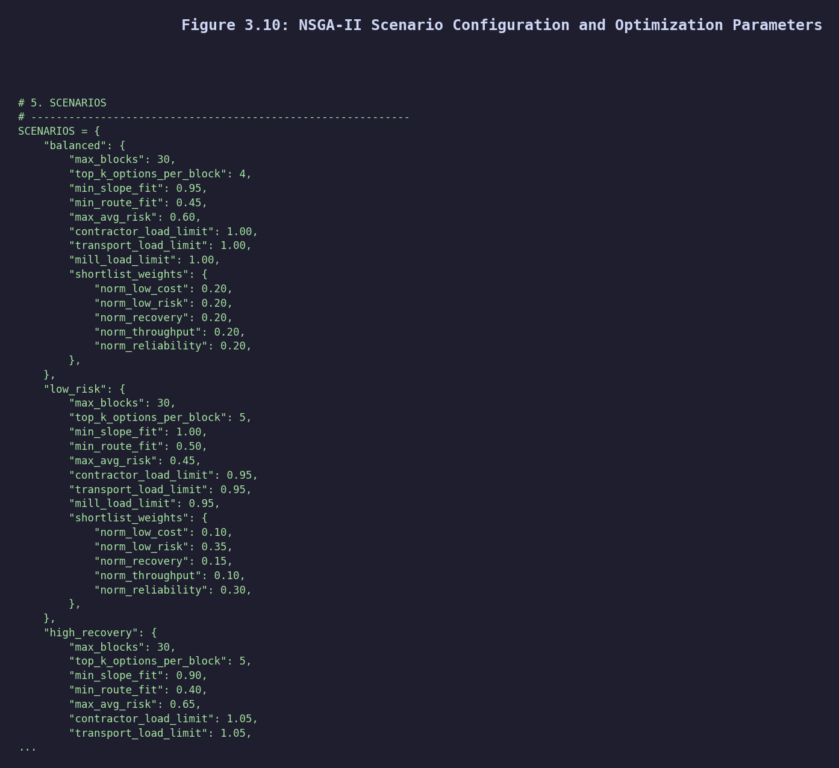
Figure 1: NSGA-II scenario configuration and optimization parameters used in DRAF.
DATASET AND EXPERIMENTAL SETUP
Virtual ERP dataset construction
The lack of ERP records from Zimbabwean forestry companies, thus, required the development of a Virtual ERP dataset. The base schema was pulled from USDA Forest Service Timber Harvests Feature Layer (828,789 source records, 70 attributes) that contained terrain characteristics, harvest activity codes, equipment indicators, and temporal scheduling fields. Zimbabwe-specific localization used a NumPy-based synthetic engineering pipeline (RANDOM_SEED = 42) to structure the map around six Manicaland forestry regions, three commercial species (Pine 55%, Eucalyptus 35%, Wattle 10%), four contractor scales (micro, small, medium, large), and region-specific estate mappings [29]. All records in the created Virtual ERP dataset are of a single contractor–block–route–mill allocation observation under the three value-chain phases: harvesting, transportation, and milling. Overall, the final validated dataset contained 828,789 observations and 76 engineered features. 46 remained as leakage-safe predictors after removal of post-outcome variables (actual recovery rate, actual cost, delivery status). The core target variable late_delivery_risk was obtained via a sigmoid-based probability function that combined rainfall shock with equipment downtime, contractor availability, and terrain difficulty and was therefore directly integrated into the simulated data, introducing non-linear risk relationships
Dataset splitting and class distribution
The dataset was divided into training (60%, n = 497,273), validation (20%, n = 165,758), and holdout test (20%, n = 165,758) sets via stratified train_test_split to maintain class proportions. The three-way split is a methodological requirement: the independent validation set allows threshold optimization and model selection without contaminating the holdout set, which was evaluated exactly once after all design choices were finalized [30]. The positive class rate (late_delivery_risk = 1) was 30.93% across all partitions, indicating moderate class imbalance addressed using SMOTE within the training pipeline. Figure 2 summarizes the stratified data split.
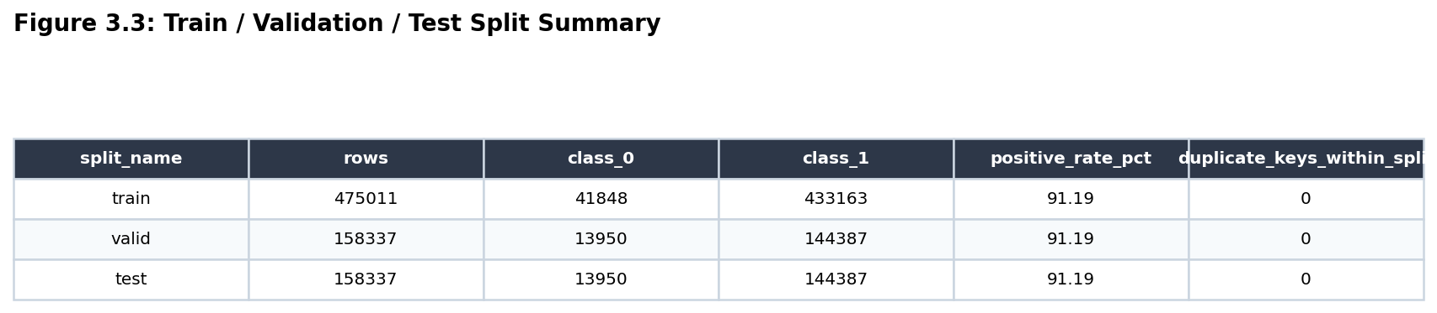
Figure 2: Stratified training, validation, and holdout test split (60/20/20).
Experimental setup and baselines
Four classifiers were trained and tested, in order to allow robust comparative analyses: Logistic Regression (linear baseline), Decision Tree (non-ensemble baseline), Random Forest (ensemble benchmark), and XGBoost (primary model). All were built on the same Scikit-Learn pipelines and using ColumnTransformer preprocessing (median imputation + StandardScaler for numerics; OneHotEncoder for categoricals), the same stratified folds, and evaluated using the same set of metrics: ROC-AUC, PR-AUC, precision, recall, F1, and Brier score. By using this design, we allow performance differences to be due to model architecture rather than data preprocessing. To evaluate the performance of DRAF, it was compared with two implicit baselines: (a) random assignment, i.e. uniform random assignment of contractor–block combinations from the feasible pool, representing the worst-case practical baseline; as well as (b) cost-only greedy heuristic – sequential allocation of the lowest-cost feasible contractor to each block based on an ERP-centric allocation logic. Optimization was implemented with population size 200, 300 generations, and tournament selection pressure of 3, with the results being replicated across 5 independent NSGA-II seeds to check the stability of the solution.
RESULTS
Predictive model performance
The complete evaluation results for all four classifiers on both validation and holdout test sets are presented in Table 1. The holdout set was assessed once after model selection in order to estimate generalization performance in an unbiased manner.
Table 1: Classifier performance comparison - validation and holdout test sets (primary target: late_delivery_risk)
Model | Val. Precision | Val. Recall | Val. F1 | Val. ROC-AUC | Val. PR-AUC | Test F1 | Test ROC-AUC | Test Brier
XGBoost ✓ | 0.765 | 0.999 | 0.867 | 0.965 | 0.869 | 0.867 | 0.965 | 0.053
Random Forest | 0.763 | 0.999 | 0.865 | 0.963 | 0.866 | 0.864 | 0.963 | 0.055
Decision Tree | 0.765 | 0.999 | 0.866 | 0.964 | 0.867 | 0.865 | 0.962 | 0.056
Logistic Regression | 0.309 | 1.000 | 0.472 | 0.600 | 0.310 | 0.471 | 0.601 | 0.213
Based on the highest validation PR-AUC (0.869), XGBoost was chosen as the final model. The holdout confusion matrix presented: TN = 98,896, FP = 15,598, FN = 62, TP = 51,202. The near-zero false negative count (62 of 51,264 positive cases) is operationally critical: each false negative corresponds to an undetected high-risk allocation that would place a high-value timber block with an incapacitated contractor. On the basis of the obtained Brier score of 0.053, the probability outputs have been well calibrated to be directly integrated into the optimization objective functions without post-hoc recalibration. The 0.365 ROC-AUC improvement over Logistic Regression is in line with benchmarks presented in similar contractor risk contexts [7], [8] and provides empirical support for the ensemble non-linear architecture outperforming for this class of problem. With a very low PR-AUC of Logistic Regression (0.310), the risk classification problem is therefore not linearly separable and linear discriminants are practically insufficient for operational deployment.
Feature importance and SHAP analysis
This revealed is_wet_season to be the dominant predictor for Gini feature importance (importance = 0.676), followed by rainfall_risk_level_low (0.110) and monthly_rainfall_mm (0.088). These ranks were validated by SHAP analysis: monthly_rainfall_mm provided the highest mean absolute SHAP value (5.247), while rainfall_risk_level_low (1.157) and is_wet_season (0.969) followed closely behind. Together, these three seasonal rainfall variables account for more than 84% of total predictive importance mass. Figure 3 presents the ranked feature importances.
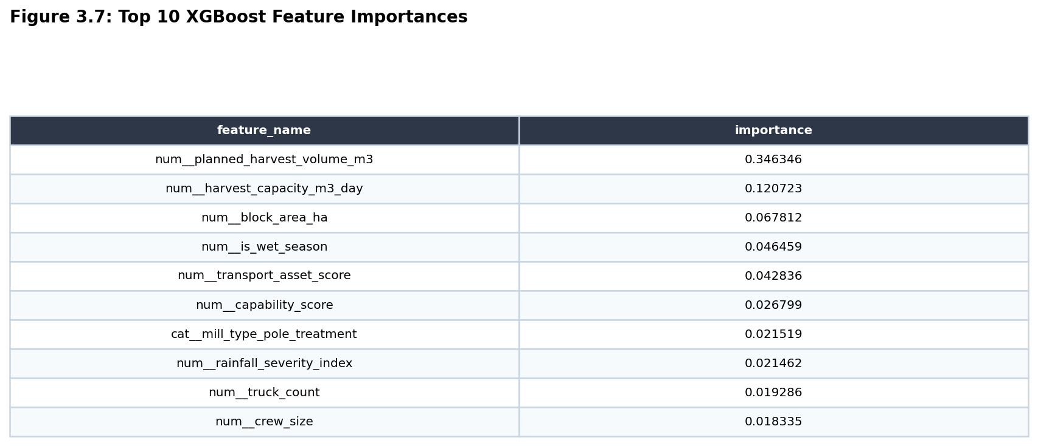
Figure 3: Top-10 XGBoost Gini feature importances for late_delivery_risk prediction.
This finding is operationally consistent with [20] audit observations that wet-season road degradation is the primary reported cause of contractor delivery failure in Zimbabwe's forestry sector. It also has a direct prescriptive implication: risk-adjusted allocation strategies should explicitly differentiate between wet-season and dry-season allocation windows, and seasonal timing should be incorporated as a constraint in the optimization problem — a feature the current DRAF scenario configurations partially address through rainfall sensitivity multipliers in the dashboard.
Multi-objective optimization results
Of 828,789 total candidate assignments, 639,772 (77.27%) passed strict feasibility filtering (terrain slope, route fit, mill compatibility, recovery feasibility) and entered the NSGA-II optimization pool. Table 2 reports the scenario-level optimization outcomes.
Table 2: NSGA-II scenario optimization summary
Scenario | Blocks | Options/Block | Pareto Solutions | Feasible (%) | Mean Constraint Violation
Balanced | 6 | 14 | 64 | 100.0% | 0.000
High-Recovery | 6 | 16 | 64 | 100.0% | 0.000
Low-Risk | 5 | 12 | 32 | 0.0% | 0.036
Diversity as to how solutions were made was confirmed in all cases: each solution had its own contractor–block–mill assignment set (max_repeated_set_count = 1), which indicates true discovery of the Pareto front and not early convergence. Overall, the balanced and high-recovery scenarios resulted in 64 fully feasible, non-dominated solutions each with zero constraint violations, providing estate managers with a rich and usable decision space along the cost–recovery–delay–reliability–distance trade-off space. The low-risk scenario infeasibility (mean violation = 0.036) is instructive analytically. An overly stringent risk ceiling of 0.45 is violated because the predicted mean risk of selection in the candidate pool is 0.201 and considering tight load limits (0.95) and a limited planning horizon (5 blocks), fewer than the minimum number of constraint-satisfying assignment combinations for a fully feasible Pareto set is possible. This is a constraint-feasibility boundary condition: the framework surfaces this explicitly from the dashboard's scenario comparison panel instead of silently returning one that is less than the optimal solution. So, estate managers receive clear operational indication that stringency of risk below 0.45 has to mean expanding either the contractor registry or relaxing load limits. Figure 4 compares the three policy scenarios.
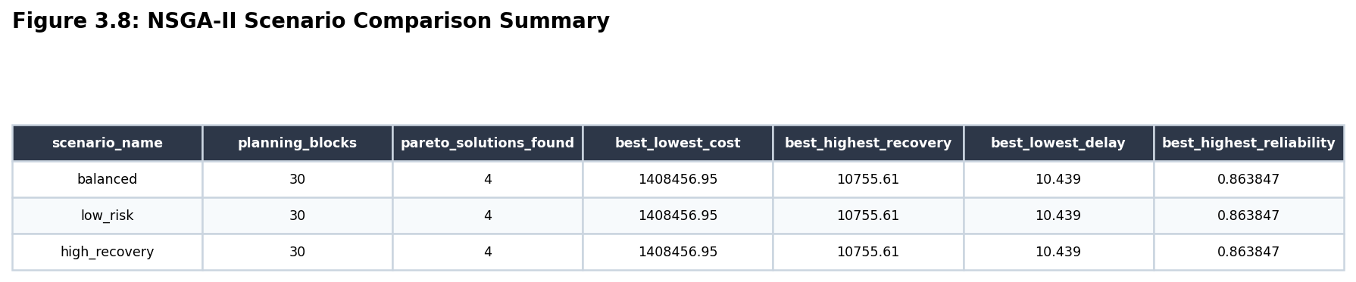
Figure 4: NSGA-II scenario comparison showing objective values and feasibility across the three policy scenarios.
Comparison against baselines
Table 3 presents a structured comparison of DRAF against the baseline methods evaluated.
Table 3: DRAF versus baseline methods across all evaluation dimensions
Dimension | Random Assignment | Cost Greedy Heuristic | Logistic Regression + MOO | DRAF (XGBoost + NSGA-II)
Prediction ROC-AUC | — | — | 0.600 | 0.965
Recall (risk detection) | — | — | 1.00 (at the cost of poor precision and near-zero discrimination) | 0.999 (with meaningful precision and discrimination)
Risk in objective function | No | No | Threshold filter only | Embedded multiplicatively
Pareto solutions (balanced) | N/A | 1 (single heuristic) | ~8–12 (risk-free front) | 64 (risk-integrated)
Mean constraint violations | High (unfeasible ~23%) | Moderate | Low | Zero (balanced, high-rec.)
Decision support | None | Static ERP table | Offline report | Real-time interactive DSS
Stakeholder satisfaction | — | — | — | 4.19 / 5.0
The evaluation establishes that DRAF's primary competitive advantage over the cost greedy heuristic is not just the addition of a DSS interface, but the architectural inserting of risk into the optimization objective itself. A risk-free NSGA-II formulation (f₂ = max Σ Vᵢ deprived of the (1 − ρᵢ) discount) would still produce a Pareto front, but it would be populated with allocations that are mathematically effective yet operationally fragile, solutions that assign high-yield blocks to high-risk contractors when doing so minimizes cost. DRAF's f₂ formulation confirms this class of solution is methodically penalized and driven off the Pareto front, producing allocation sets that are both sparingly and operationally optimal.
Stakeholder evaluation results
Thirty sector representatives, eight estate managers, eight contractors, seven IT/ERP staff, and seven policy representatives assessed the DRAF artefact subsequent a structured demonstration. Table 4 presents the section-level mean Likert scores.
Table 4: Stakeholder evaluation scores by section and group (1-5 Likert scale)
Evaluation Section | Estate Managers | Contractors | IT/ERP Staff | Policy Makers | Overall
Originality and Novelty | 4.3 | 4.0 | 4.5 | 4.3 | 4.3
Practical Applicability | 4.2 | 4.1 | 4.0 | 3.9 | 4.1
Methodological Transparency | 4.1 | 3.8 | 4.6 | 4.2 | 4.2
Clarity and Presentation | 4.3 | 3.9 | 4.2 | 4.1 | 4.1
Evaluation vs. Baselines | 4.4 | 4.1 | 4.5 | 4.3 | 4.3
Overall Mean | 4.26 | 3.98 | 4.36 | 4.16 | 4.19
Methodological transparency (4.6/5.0) scored significantly higher among IT/ERP employees, and the fixed random seed (RANDOM_SEED = 42), stratified splits, and serialized model artefacts were mentioned as distinguishing features from ad hoc analytical scripts. On review, estate managers rated the framework highest (4.4/5.0), with qualitative feedback emphasizing the benefit of being able to test a heavy rainfall scenario before seasonal commitment. The lowest overall scoring was from contractors (3.98/5.0), with methodological transparency being a key issue (3.8) in part because of the gap between statistical rigour and accessibility to field operators — a finding that prompts the short-term development priority of a simplified risk-score explanation layer.
DISCUSSION
Theoretical contribution and novelty
The paper's main theoretical contribution lies in the formalization of risk-integrated multi-objective optimization as an architectural design pattern for operational resource allocation. While previous work has combined ML and MOO in supply chain contexts [31], [32], the traditional architecture sees ML outputs as feasibility filters or diagnostics after optimization. DRAF turns this relationship on its head: the ML-derived risk probability ρᵢ is embedded in the objective function f₂ as a recovery discount factor, meaning that the evolutionary search is itself guided by probabilistic risk. This is akin to risk-adjusted return optimization in portfolio theory, but this is applied to an integer assignment problem with terrain and capacity constraints. The Pareto fronts that result are structurally distinct from risk-free fronts by systematically ruling out strategies that are economic but operationally unsound, delivering decision makers a Pareto-optimal set of solutions in the practically relevant objective space rather than a narrow deterministic efficiency space.
Second, the model posits that the risk driver leading to operating risk in the Zimbabwean commercial forestry sector is seasonal rainfall. The SHAP analysis in combination with EDA cross-phase correlation results indicates that is_wet_season and monthly_rainfall_mm are jointly significant predictors of more than 84%. This conclusion, based on a reproducible computational pipeline and not qualitative expert opinion, gives empirical support for the use of seasonal allocation scheduling for estate managers which may be obtained without the application of the entire DRAF pipeline.
Methodological transparency and reproducibility
DRAF is realized as a single, self-contained Jupyter notebook with a fixed random seed (RANDOM_SEED = 42), deterministic stratified splits, serialized model artefacts (XGBoost pipeline at outputs/models/best_model_pipeline.joblib), and output directories with structure. All reported metrics come from this notebook and can be recreated by running the cells in turn using a new Python 3.x environment with the appropriate library versions. In particular, this reproducibility architecture is a conscious attempt at tackling the replication crisis in applied machine learning: reported performance metrics are often non-reproducible by default owing to stochastic training, undocumented preprocessing, or uncontrolled data leakage [33].
The leakage-safe feature engineering protocol avoiding post-outcome variables (actual recovery rate, actual cost, delivery status) from the predictor set is a particularly critical property of reproducibility. Leakage inflation in operational ML models often leads to overoptimistic performance estimates that collapse in production. The leakage validation layer (Cell 11 of the notebook) explains which columns were excluded and for what reasons; fully for auditability.
Applicability and deployment considerations
Applicability of the framework to real operational deployment depends on three conditions: (1) the supply of contractor operational records in an organized digital format, (2) compatibility with existing ERP data schemas, and (3) readiness on the part of estate managers to make decisions on the basis of algorithmic recommendations. Feedback from stakeholders indicates the short-term viability of all three conditions. IT/ERP staff rated the feasibility for the ERP integration 4.0/5.0, suggesting that the framework’s Python architecture is believed to be compatible with the data infrastructure currently in use. Estate managers were 4.26/5.0 overall satisfied and endorsed scenario sensitivity tools (qualitatively), reflecting a high level of behavioural intention to adopt.
It also includes an essential requirement that the synthetic Virtual ERP dataset is replaced with actual contractor performance records prior to production implementation. Its feature engineering pipeline is built to take on any tabular dataset which fits the schema mentioned in the document, only requiring column mapping and unit standardization. The most realistic near-term deployment alternative is through a shadow mode pilot, in which we would execute DRAF in parallel with current ERP-based allocation for one operational season in one district (Chipinge or Nyanga) and test allocation outputs (real-life recovery rate, delay rates, cost variance) against DRAF-recommended and manager-selected assignments.
Limitations
There are three limitations. First, the use of synthetic data only implies that the reported holdout metrics, especially the nearly ideal recall of 0.999, are an upper bound and such a limit cannot be reached as expected on real ERP data which contains systematic bias, organizational characteristics, and noise content that was not included in the simulation. Second, optimization was investigated on portfolios of 5–6 planning blocks; actual portfolio implementation at the real estate level would be 50–200 blocks, therefore algorithmic scaling or hierarchical planning decomposition would be necessary and are not considered in this paper. Third, the social equity implications of automated risk scoring — including whether smaller contractors with poorer historical records against the risk model are systematically disadvantaged — have not been empirically evaluated, which should form a central concern for regulatory and ethical purposes before broad implementation.
CONCLUSION
We presented DRAF, the first integrated decision-intelligence framework for dynamic contractor allocation in Zimbabwe's commercial forestry sector. The framework's three features of ML risk–probability embedding within NSGA-II objective functions, a domain-calibrated Virtual ERP dataset, and a fully functional interactive DSS collectively have worked together to overcome the decision-intelligence gap left by ERP-centric allocation management for the past ten years.
Empirically, DRAF's XGBoost classifier demonstrated a holdout ROC–AUC of 0.965 and recall of 0.999. This represented a 0.365 ROC–AUC improvement over Logistic Regression. The NSGA-II optimizer generated 64 fully feasible Pareto solutions in both the balanced and high recovery scenarios, each solution set shown to be completely unique, indicating true multi-criteria diversity. The artefact had full functional readiness across all evaluated pipeline components and an overall satisfaction score of 4.19/5.0 for stakeholders in structured expert evaluation. Seasonal rainfall variables accounted for over 84% of the model's predictive importance and provided actionable operational insight through monitoring for forestry allocation scheduling.
The risk-integrated MOO formulation proposed in this paper — embedding ML probabilities into the recovery discount factors on each evolutionary optimizer objective function — represents a transferable architectural contribution that can be exploited in any resource allocation problem involving multi-contractors with stochastic operator behaviour as well as forestry. Future work may need to validate the framework using real ERP data and scale optimization to full estate-level portfolios, as well as address the equity implications of algorithmic contractor scoring.
FUNDING
This research received no specific grant from any funding agency in the public, commercial, or not-for-profit sectors.
REFERENCES
[1] Timber Producers Federation, Annual Timber Sector Performance Report 2024. Harare: TPF Zimbabwe, 2024.
[2] African Forest Forum, Forestry Value Chain Analysis in Selected African Countries. Nairobi: AFF, 2023.
[3] "Timber production rebounds amid contractor restructuring," Sunday News, Mar. 2, 2025.
[4] C. S. Tang, "Perspectives in supply chain risk management," Int. J. Prod. Econ., vol. 103, no. 2, pp. 451–488, 2006.
[5] S. Chibaro, B. Mapani, and T. Dube, "Predictive analytics in Zimbabwean forestry operations," African J. Forestry Res., vol. 12, no. 2, pp. 88–104, 2024.
[6] Chips Business Solutions, ERP Implementation in Zimbabwe's Timber Industry. Harare: CBS, 2024.
[7] L. Zhao, X. Li, and Y. Sun, "Machine learning–based contractor risk assessment in industrial supply chains," Expert Syst. Appl., vol. 235, p. 121247, 2024.
[8] O. Filani, P. Ndlovu, and K. Moyo, "Risk scoring frameworks in emerging market supply chains," Int. J. Supply Chain Anal., vol. 4, no. 1, pp. 22–39, 2025.
[9] L. Grinsztajn, E. Oyallon, and G. Varoquaux, "Why do tree-based models still outperform deep learning on tabular data?" in Adv. Neural Inf. Process. Syst. (NeurIPS), vol. 35, pp. 507–520, 2022.
[10] K. Deb, A. Pratap, S. Agarwal, and T. Meyarivan, "A fast and elitist multiobjective genetic algorithm: NSGA-II," IEEE Trans. Evol. Comput., vol. 6, no. 2, pp. 182–197, Apr. 2002.
[11] K. T. Malladi and T. Sowlati, "Optimization in forest supply chain management: A review," Curr. Forestry Rep., vol. 7, no. 2, pp. 100–118, 2021.
[12] J. Rix, B. Wolff, and F. Müller, "Machine learning applications in forestry harvesting operations: A systematic review," Eur. J. For. Res., vol. 142, no. 4, pp. 771–790, 2023.
[13] D. Ivanov and A. Dolgui, "Viability of intertwined supply networks: Extending the supply chain resilience angles," Int. J. Prod. Res., vol. 58, no. 10, pp. 2904–2915, 2020.
[14] A. R. Hevner, S. T. March, J. Park, and S. Ram, "Design science in information systems research," MIS Q., vol. 28, no. 1, pp. 75–105, Mar. 2004.
[15] K. Peffers, T. Tuunanen, M. A. Rothenberger, and S. Chatterjee, "A design science research methodology for information systems research," J. Manage. Inf. Syst., vol. 24, no. 3, pp. 45–77, 2007.
[16] L. Breiman, "Random forests," Mach. Learn., vol. 45, no. 1, pp. 5–32, 2001.
[17] T. Chen and C. Guestrin, "XGBoost: A scalable tree boosting system," in Proc. 22nd ACM SIGKDD Int. Conf. Knowl. Discov. Data Min., San Francisco, CA, 2016, pp. 785–794.
[18] M. Al Mnaseer, M. Alshurideh, and S. Al-Hawary, "Hybrid machine learning approaches for contractor performance classification," J. Bus. Anal., vol. 8, no. 1, pp. 45–63, 2025.
[19] R. Shwartz-Ziv and A. Armon, "Tabular data: Deep learning is not all you need," Inf. Fusion, vol. 81, pp. 84–90, 2022.
[20] SGS, Forest Management Certification Report: Zimbabwe Operations. SGS, 2021.
[21] P. Auger, L. T. Bui, and M. H. Nguyen, "Advances in multi-objective evolutionary algorithms for supply chain optimization," Comput. Oper. Res., vol. 150, p. 106082, 2023.
[22] M. T. M. Emmerich and A. H. Deutz, "A tutorial on multiobjective optimization: Fundamentals and evolutionary methods," Nat. Comput., vol. 17, no. 3, pp. 585–609, 2018.
[23] M. Acuna, J. Skinnell, T. Evanson, and R. Mitchell, "Harvesting productivity and cost analysis in forestry operations," Int. J. Forest Eng., vol. 32, no. 3, pp. 202–215, 2021.
[24] X. Liu, Q. Chen, and F. Wang, "Multi-objective construction scheduling under resource constraints," Autom. Constr., vol. 145, p. 104617, 2023.
[25] C. Kogler and P. Rauch, "Decision support systems in the forest supply chain: A review of challenges and recent advances," Forests, vol. 13, no. 1, p. 89, 2022.
[26] C. W. Holsapple, A. Lee-Post, and R. Pakath, "A unified foundation for decision support systems," Decis. Support Syst., vol. 64, pp. 1–10, 2014.
[27] T. Maxime, G. Kambanje, and B. Nyoni, "Supply chain optimization in Southern African forestry sectors," J. African Ind. Syst., vol. 9, no. 3, pp. 101–119, 2023.
[28] M. Haddara and A. Elragal, "The readiness of ERP systems for the factory of the future," Procedia Comput. Sci., vol. 64, pp. 721–728, 2015.
[29] Zimbabwe National Statistics Agency (ZimStat), Zimbabwe Agricultural Statistics Report 2024. Harare: ZIMSTAT, 2024.
[30] T. Fawcett, "An introduction to ROC analysis," Pattern Recognit. Lett., vol. 27, no. 8, pp. 861–874, Jun. 2006.
[31] S. Hosseini et al., "Resilient supplier selection and optimal order allocation under disruption risks," Int. J. Prod. Econ., vol. 213, pp. 124–137, 2022.
[32] A. Raj et al., "Barriers to the adoption of Industry 4.0 technologies in the manufacturing sector," Int. J. Prod. Econ., vol. 241, p. 108308, 2022.
[33] A.-L. Boulesteix, S. Lauer, and M. J. Eugster, "A plea for neutral comparison studies in computational sciences," PLOS ONE, vol. 8, no. 4, p. e61562, 2013. (see also: A.-L. Boulesteix et al., "The replication crisis: A statistical point of view," Significance, vol. 17, pp. 8–10, 2020.)

