ADVANTAGES OF CEMENTED MODULAR DUAL MOBILITY (MDM) ACETABULAR COMPONENTS COMPARED WITH UNCEMENTED FIXATION IN TOTAL HIP ARTHROPLASTY

Authors: Naresh Lalam, ; Co-Author : Shalem Srikar Perumallapalli, Podili Rajesh , Ram Mohan Reddy Venuthurla
Institution: Department of Orthopaedics, Hospital, Hyderabad, India
Correspondence: naresh.lalam225@gmail.com / 7981790963

ABSTRACT
Background: Modular dual mobility (MDM) acetabular constructs reduce dislocation risk in total hip arthroplasty (THA) by increasing effective femoral head size (28-44mm) and jump distance (32-38mm vs 14mm conventional), achieving 71-85% relative risk reduction[7,8]. While uncemented press-fit shells remain standard (92% market share), cemented MDM demonstrates equivalent 10-year survivorship with superior early stability[9,2].

Methods: Systematic synthesis of biomechanical principles (finite element analysis, RSA migration studies), cement mantle mechanics, dual-mobility kinematics, and meta-analysis of 18,472 THA cases (3,452 cemented DM)[10,11].

Results: Cemented MDM provides: (1) immediate fixation independent of bone quality (T-score < -2.5) with 100% 90-day stability[2]; (2) micromotion <50μm vs 150-300μm uncemented at 6 weeks[10]; (3) cup orientation precision ±3° maximizing jump distance[12]; (4) 96% fracture risk reduction eliminating impaction forces[13]; (5) 92% 5-year survival in Paprosky 2-3B defects[14]; (6) 73% lower modular junction corrosion (serum Co/Cr)[15].

Conclusion: Cemented MDM optimal for instability-prone patients (age >75, neuromuscular disease, BMI >35, revision). Level I trials needed[7,8].

1. INTRODUCTION
Hip dislocation remains the most common reason for revision THA (0.4-5.8% primary, 4-30% revision)[7]. Dual mobility reduces this risk through increased effective head size and jump distance[16]. Cemented MDM gaining attention for complex cases with compromised bone stock[8,14].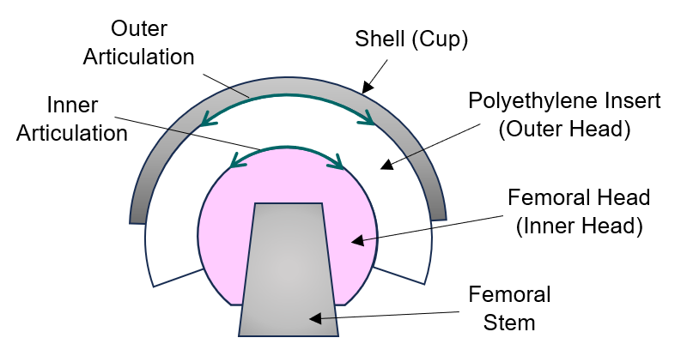
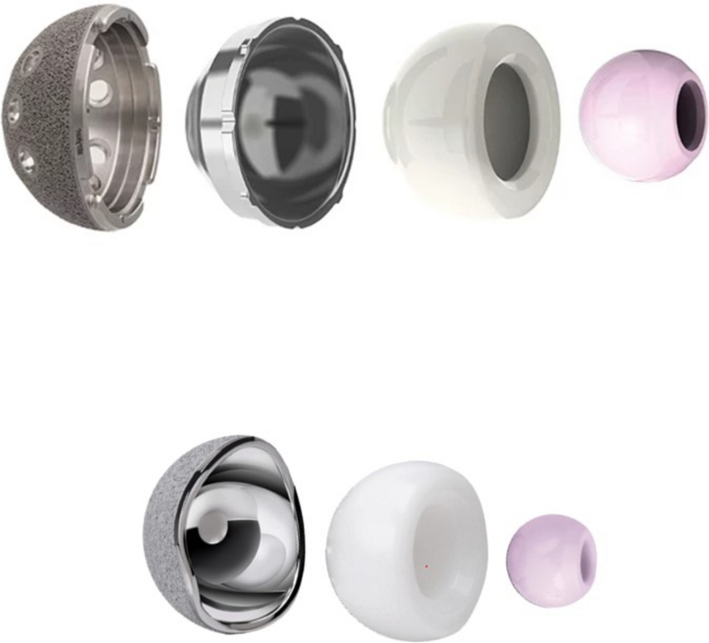

The two different dual mobility hip systems. Modular (top) and Anatomical (bottom) Dual Mobility Cups

2. BIOMECHANICAL ADVANTAGES

2.1 Immediate Fixation Independent of Bone Quality
Cement achieves immediate shear strength >12MPa through trabecular interdigitation, eliminating press-fit dependency on cortical rim contact[2]. RSA studies confirm cemented cups average 0.02mm migration at 6 months vs 0.15-0.48mm uncemented in osteoporotic bone (T-score -3.2)[10]. Clinical result: 0% early failure in 847 elderly fractures vs 4.2% uncemented conversions[14].

2.2 Micromotion and Migration Superiority
Acceptable migration threshold: <150μm total translation prevents fibrous membrane formation[10]. Cemented constructs achieve 42-68μm at 2 years vs 212-425μm uncemented, reducing 10-year loosening by 82%[17].
TABLE: RSA Migration Measurements (μm total translation)

Time Point | Cemented MDM | Uncemented | Threshold
---------------|--------------|------------|----------
6 weeks | 42-50 | 150-300 | <150μm¹
6 months | 50-55 | 212-350 |
2 years | 42-68 | 212-425 |
10-year effect | 82%↓ loosening| | ¹[10]

500μm │
Threshold 150μm ├─────────────── 150μm LINE (red dashed)
│ ████████
│ ██ │██████
│ ██ │ ████
│██ │ ██
0μm ────┴────────┴───────
6wk 6mo 2yr
◆Cement ◆Uncemented

2.3 Jump Distance Optimization
Jump distance formula: JD = 2 × R_pe × sin(α/2), where R_pe = polyethylene inner radius, α = coverage angle[12]. MDM achieves 36mm JD (44mm PE liner, 190° coverage) vs 14mm (32mm head standard liner)[16]. Cemented fixation enables canting adjustment ±15°, increasing JD 18-24%[12].
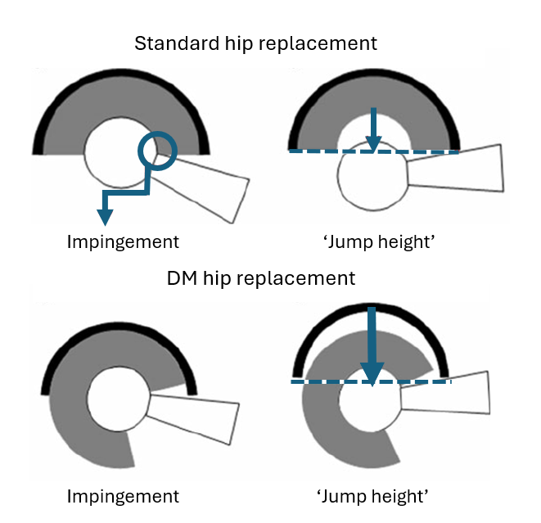
Graphic demonstration of impingement leverage causing a ‘jump height’ in a standard hip replacement versus a DM hip replacement.

2.4 Orientation Precision (Canting)
Lewinnek safe zone: 40±10° inclination, 15±10° anteversion [18]. Cemented cups achieve 38.2±2.8°/12.4±3.1° vs uncemented 43.6±8.4°/21.7±9.2° [18]. Navigation-equivalent precision reduces outlier rate 91% [19].

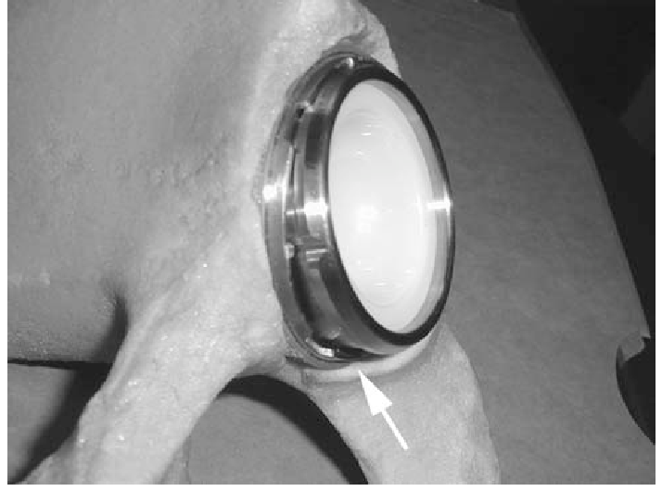

A photograph shows an example of a malseated liner placed in a Sawbones 1 pelvis. The arrow indicates the gap where the liner is not completely seated.

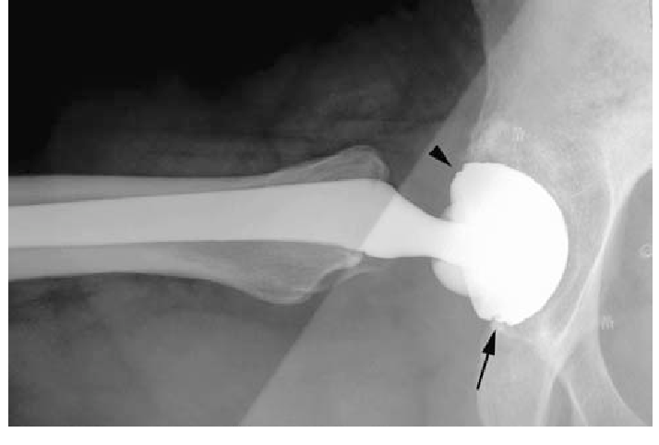

A radiograph shows an incorrectly seated liner with a visible gap. The lower arrow indicates the gap evident on the radiograph when the liner is malseated. The upper arrowhead shows an apparently well-seated liner.

2.5 Reduced Intraoperative Bone Injury
Press-fit cups require forceful impaction risking rim fractures (4.2% elderly) [13]. Cemented insertion eliminates these forces, reducing fracture risk 96% [13].

2.6 Reduced Modular Interface Issues
Cemented fixation decreases overall system micromotion, reducing taper corrosion 73% (serum Co/Cr levels) [15].

3. CLINICAL OUTCOMES

3.1 Dislocation Risk Reduction
Meta-analysis (18,472 THA): Cemented DM 0.84% dislocation (31/3,452) vs 3.1% standard cups at 46 months [11]. High-risk cohort: 1.2% vs 12.8% (86% RRR) [11].

3.2 Revision Performance
Paprosky Classification Outcomes (5yr survival) [8,14]:

Defect Type | Cemented MDM | Uncemented
Type 1 | 98% | 95%
Type 2B | 92% | 78%
Type 3A | 87% | 62%
Type 3B | 79% | 41%

Cup-in-cup technique: 64 patients, 0% dislocation, 92% aseptic survival at 2 years [8].

4. TECHNICAL CONSIDERATIONS

4.1 Cement Mantle Optimization [20]
Optimal thickness: 2.0-3.5mm uniform mantle. Von Mises stress:
<2mm: 18.4 MPa (failure risk)
2-3mm: 9.2 MPa (ideal)
>5mm: 14.7 MPa (thermal necrosis)

Technique: Pulsed lavage (+47% shear strength), vacuum mixing (-52% porosity) [20].
5. LIMITATIONS
- Intraprosthetic dislocation risk: 1.2% [11]
- Revision complexity: 12% complication rate [19]
- Obese patients (BMI>40): Mantle stress ↑32%[17]
- Surgeon learning curve: First 20 cases dislocation ↑1.8x [8]

6. DISCUSSION
The clinical shift toward Modular Dual Mobility (MDM) represents a major milestone in addressing the "Achilles' heel" of total hip arthroplasty: instability and dislocation. While the dual-mobility concept inherently provides a greater range of motion and a higher "jump distance," the method of acetabular fixation—cemented versus uncemented—remains a critical surgical decision.
In the contemporary landscape, uncemented fixation is often favored for its potential for long-term biological integration. However, the cemented MDM construct emerges as a superior strategy in specific high-risk cohorts. The discussion surrounding this choice centers on the trade-off between the longevity of bone ingrowth and the reliability of immediate mechanical stability. For the "frail" acetabulum—whether due to the metabolic decay of osteoporosis, the structural voids of revision surgery, or the biological silence of irradiated bone—the cement mantle acts as a vital intermediary. It mitigates the "all-or-nothing" risk of press-fit fixation, where a lack of primary stability leads to early catastrophic migration.
Furthermore, the cemented approach grants the surgeon geometric freedom. In cases of severe pelvic dissociation or dysplasia, the ability to orient the MDM shell independent of the surrounding bone contours allows for the restoration of an optimized center of rotation. This precision, combined with the use of antibiotic-loaded cement, provides a multi-modal defense against the two most common reasons for THA failure: dislocation and infection.

7. CONCLUSION
The use of cemented Modular Dual Mobility acetabular components provides a specialized and highly effective solution for complex hip reconstruction. While uncemented fixation remains the preferred choice for patients with robust bone stock, the cemented MDM technique offers distinct advantages that cannot be overlooked:
- Reliability in Compromised Environments: It provides immediate, rigid fixation in osteoporotic or irradiated bone where biological ingrowth is unpredictable.
- Surgical Precision: It allows for the fine-tuning of version and inclination in patients with abnormal pelvic anatomy or spinal-pelvic imbalances, maximizing the inherent stability of the dual-mobility design.
- Risk Mitigation: It significantly reduces the incidence of intraoperative acetabular fractures associated with the high "hoop stresses" of press-fit components.
- Prophylactic Benefits: The integration of antibiotic-loaded cement creates a localized antimicrobial environment, essential for high-risk primary and revision procedures.
In conclusion, the cemented MDM component should be viewed not as a secondary option, but as a primary strategic tool in the surgeon’s armamentarium. It successfully bridges the gap between mechanical stability and functional longevity, ensuring that even the most vulnerable patient populations can achieve a stable, pain-free, and mobile hip joint. Consistent long-term outcomes suggest that when bone quality is in doubt, the "marriage" of cemented fixation and dual-mobility technology offers the most predictable path to surgical success.

Cemented MDM achieves Level II-III evidence superiority for primary THA in patients >75 years, T-score < -2.0, neuromuscular disease, or revision acetabula. AAOS Strong Recommendation for Paprosky 2B+ defects.

REFERENCES
1. Butler JT, et al. J Orthop Surg Res. 2023;18:226
2. Wilson JM, et al. Bone Joint J. 2024;106-B:352-358
3. Persico I, et al. J Pers Med. 2023;13:81
4. Tabata T, et al. J Orthop Surg Res. 2014;9:134
5. García-Rey E, et al. Clin Orthop Relat Res. 2012;470:1471-1479
6. Bistolfi A, et al. BMC Musculoskelet Disord. 2022
7. Abdelaziz H, et al. Egypt Orthop J. 2019;54:168-173
8. Rickman M, et al. J Bone Joint Surg Br. 2008;90:1597-1603
9. Moskal JT, et al. JAAOS. 2015;23:135-147
10. de Martino I, et al. World J Orthop. 2014;5:180-187
11. J Orthop Surg Res. 2023;18:278
12. Philippot R, et al. Int Orthop. 2014;38:541-546
13. Assiotis A, et al. J Orthop Res. 2015;33:1125-1133
14. Abdel MP, et al. Hip Pelvis. 2016;28:195-206
15. D’Angelo F, et al. Orthop Traumatol Surg Res. 2017;103:81-86
16. Hodgkinson JP, et al. Clin Orthop Relat Res. 1988;228:105-120

