THE FIFTH ENERGETIC DIMENSION AND THE ENERGY OF TIME

A Scalar–Tensor Framework Connecting Gravitation, Thermodynamics, and Cosmology

Hocine Chalal

Corresponding author: Hocine Chalal (hocine.chalal@email.com)

Manuscript type: Original Research Article Date: March 2026

ABSTRACT

The unification of general relativity with quantum mechanics remains one of the most profound challenges in modern theoretical physics. In this work, we introduce a novel theoretical framework based on a fifth energetic dimension associated with the temporal energy structure of spacetime. We propose that time possesses an intrinsic energetic component that interacts with gravitational fields and cosmic energy distributions. The model is formulated as a scalar–tensor theory where the temporal energy density φ(x) modifies the effective gravitational coupling. We derive field equations from a variational principle and explore their implications for black hole thermodynamics, galactic rotation curves, and cosmological expansion. The framework naturally reduces to general relativity in the weak-field limit while predicting observable deviations at galactic and cosmological scales without invoking dark matter or dark energy. We present 15 figures illustrating the geometric and energetic structure of the theory and provide detailed comparisons with Einstein's general relativity.
Observational tests and future experimental verification pathways are discussed.

Keywords: Fifth dimension · Energetic time · Scalar–tensor gravity · Black holes · Dark energy · Quantum gravity · Modified gravity

PACS numbers: 04.50.Kd, 04.70.Dy, 98.80.-k, 95.36.+x

- INTRODUCTION

  - The Current State of Fundamental Physics

Modern physics rests upon two pillars that have withstood over a century of experimental scrutiny: general relativity (GR) and quantum mechanics (QM). General relativity, formulated by Albert Einstein in 1915, describes gravitational interactions as the curvature of a four-dimensional spacetime manifold [1]. The Einstein field equations,

G_μν = 8πG T_μν

relate the Einstein tensor G_μν (representing spacetime curvature) to the energy-momentum tensor T_μν (representing matter and energy content). This theory has passed every experimental test from solar system scales to binary pulsar observations [9].

Quantum mechanics, developed through the collective efforts of Planck, Heisenberg, Schrödinger, and others, describes microscopic phenomena through wave functions, uncertainty principles, and quantized energy states. The union of quantum mechanics with special relativity produced quantum field theory, the most precisely tested theory in physics [15].

  - The Incompatibility Problem

Despite their individual successes, GR and QM remain fundamentally incompatible in regimes where both quantum effects and strong gravity are significant:

    - Black hole singularities where curvature becomes infinite
    - The Planck scale (10^-35 m, 10^-44 s) where quantum gravity effects dominate
    - The initial singularity of the Big Bang

    - The information paradox of black hole evaporation

These incompatibilities suggest that either GR or QM (or both) must be modified at fundamental levels [12].

  - Historical Attempts at Unification

Several approaches have been developed to address this incompatibility:

    - Kaluza-Klein theory (1920s): Introducing a fifth spatial dimension to unify gravity and electromagnetism
    - String theory (1970s-present): Replacing point particles with one-dimensional strings in 10 or 11 dimensions
    - Loop quantum gravity (1980s-present): Quantizing spacetime itself using loop representations
    - Scalar-tensor theories (Brans-Dicke 1961): Introducing scalar fields that modify gravitational coupling [4]

  - The Present Approach

This work proposes a different path: rather than quantizing gravity or geometrizing all interactions, we explore the hypothesis that time possesses an intrinsic energetic structure. This "energetic time" interacts with gravitational fields and cosmic energy distributions, giving rise to a fifth energetic dimension that modifies spacetime geometry.

The fundamental hypothesis can be stated simply: Time is not merely a coordinate but carries energy density that couples to gravitational fields.

This idea emerges from several observations:

- Gravitational time dilation (clocks run slower in stronger gravity)
- Black hole thermodynamics (temperature and entropy associated with event horizons)
- The arrow of time (connected to thermodynamic entropy increase)
- Quantum uncertainty in time-energy measurements

- MATHEMATICAL FOUNDATIONS

  - The Fifth Energetic Dimension

We introduce a scalar quantity representing the energetic structure of spacetime:

D5 = (E × d) / G

where:

- D5 represents the fifth energetic dimension parameter
- E represents the energy content of a system
- d represents the distance from a dominant energy source
- G represents the local gravitational field intensity

This relation suggests that spacetime geometry depends on energetic interactions between matter and gravitational sources. The product E × d represents an "energy-moment" that characterizes how energy influences geometry at a distance, while division by G accounts for the screening or amplification effects of gravitational fields.

  - Energetic Time Formulation

The energetic nature of time is described by the fundamental relation:

T = C / G²

where:

- T represents the temporal energy density parameter
- C represents a universal constant (units: energy × time²)
- G represents the local gravitational field intensity

This inverse-square relationship indicates that strong gravitational fields compress the energetic flow of time, consistent with gravitational time dilation but providing an energetic interpretation.

  - The Temporal Energy Scalar Field

To incorporate these ideas into a field theory, we introduce a scalar field φ(x) representing the temporal energy density at each spacetime point:

φ(x) = T(x) / T₀

where T₀ is a reference temporal energy density in asymptotically flat regions. This scalar field is dimensionless and varies throughout spacetime in response to mass-energy distributions.

The effective gravitational constant becomes field-dependent:

G_eff(φ) = G_N / φ

where G_N is Newton's gravitational constant. This implies that gravity is stronger in regions of lower temporal energy density (stronger gravitational fields) and weaker in regions of higher temporal energy density.

  - Extended Spacetime Geometry

We extend the four-dimensional spacetime manifold to include an energetic coordinate χ associated with the fifth dimension. The complete line element becomes:

ds² = g_μν dx^μ dx^ν + φ⁻² dχ²

where:

- g_μν is the four-dimensional spacetime metric
- x^μ are the conventional spacetime coordinates
- χ is the energetic coordinate of the fifth dimension
- φ⁻² provides the coupling between the fifth dimension and four-dimensional spacetime

This metric structure ensures that motion in the fifth dimension corresponds to changes in temporal energy density.

- SCALAR-TENSOR GRAVITATIONAL ACTION

  - Action Principle

The gravitational action for the theory is constructed to be generally covariant and to reduce to the Einstein-Hilbert action in appropriate limits:

S = ∫ d⁴x √(-g) [ φR − (ω/φ) (∂φ)² − V(φ) + L_m ]

where:

- R is the Ricci scalar curvature
- ω is a dimensionless coupling constant
- (∂φ)² = g^μν ∂_μφ ∂_νφ is the kinetic term for the scalar field
- V(φ) is the scalar field potential
- L_m is the matter Lagrangian density
- √(-g) is the volume element determinant

This action generalizes the Brans-Dicke theory [4] by including a potential term and allowing for non-minimal coupling between the scalar field and curvature.

  - Physical Interpretation

Each term in the action has a clear physical interpretation:

    - φR term: Represents the coupling between temporal energy density and spacetime curvature. When φ is large (high temporal energy density), curvature is more easily produced by matter.
    - (ω/φ)(∂φ)² term: Represents the kinetic energy of the temporal energy field. The factor 1/φ ensures dimensional consistency and prevents negative energies.
    - V(φ) term: Represents the self-interaction potential of the temporal energy field. This determines the vacuum expectation value of φ and can drive cosmological evolution.
    - L_m term: Represents all matter and energy fields (excluding the temporal energy field itself).

  - Derivation of Field Equations

Varying the action with respect to the metric tensor g^μν yields the modified Einstein equations:

G_μν = (8π/φ) T_μν + (ω/φ²) [∂_μφ ∂_νφ − (1/2) g_μν (∂φ)²] + (1/φ) [∇_μ∇_νφ − g_μν
□φ] − (1/2) g_μν V(φ)/φ

where:

- G_μν is the Einstein tensor
- T_μν is the matter energy-momentum tensor
- □φ = ∇^μ∇_μφ is the d'Alembertian of φ

Varying with respect to the scalar field φ gives the equation of motion:

□φ = [8πT − φ V'(φ) + 2V(φ)] / (3 + 2ω)

where T = T^μ_μ is the trace of the energy-momentum tensor and V'(φ) = dV/dφ.

- COMPARISON WITH GENERAL RELATIVITY

  - Formal Correspondence

The theory reduces to general relativity in the limit:

φ → constant = 1/G_N ω → ∞
V(φ) → 0

In this limit, the scalar field becomes non-dynamical and the modified Einstein equations reduce exactly to:

G_μν = 8πG_N T_μν

which are the standard Einstein field equations.

  - Conceptual Differences

Despite this formal correspondence, significant conceptual differences exist between the two frameworks:

Aspect General Relativity Energetic Dimension Theory Nature of time Coordinate parameter Energetic field
Gravitational constant Universal constant Field-dependent G_eff(φ)
Spacetime dimensions 4 (3 space + 1 time) 4+1 (including energetic dimension) Origin of gravity Spacetime curvature Temporal energy gradients
Black holes Geometric singularities Energetic regulators Dark matter Required Not required
Dark energy Required Emergent from φ dynamics

  - Experimental Signatures

The theory predicts deviations from GR in specific regimes:

Solar system scales: For weak fields and slow motion, the theory reduces to a parameterized post-Newtonian (PPN) formalism with parameters:

γ ≈ 1 − (1/(2+ω)) β ≈ 1

Current solar system constraints require ω > 40000, which is satisfied if ω is sufficiently large.

Galactic scales: For rotating galaxies, the modified gravitational potential becomes:

Φ(r) = −∫ (G_eff(φ(r')) ρ(r') / |r−r'|) d³r'

where φ(r) varies with galactic environment. This can produce flat rotation curves without dark matter.

Cosmological scales: The scalar field dynamics produce an effective dark energy term:

ρ_DE = (1/2) φ̇² + V(φ) + (3/2) (ω/φ) φ̇²

which can drive accelerated expansion.

- BLACK HOLES AS ENERGETIC REGULATORS

  - Black Hole Solutions

In the energetic dimension framework, black holes are not merely geometric singularities but serve as thermodynamic regulators of cosmic energy distribution. The static spherically symmetric solution for a black hole of mass M takes the form:

ds² = −f(r) dt² + f(r)⁻¹ dr² + r² dΩ² φ(r) = φ₀ (1 − 2G_eff M/r)^(α)

where α depends on the coupling constant ω and dΩ² is the metric on the unit 2-sphere.

  - Thermodynamic Properties

The black hole temperature (Hawking temperature) is modified:

T_H = (1/4π) (df/dr)|_{r=r_h} × φ(r_h)

The black hole entropy follows an area law but with a scalar field correction:

S_BH = (A/4G_eff) × φ(r_h)

where A is the horizon area.

  - Energetic Regulation Mechanism

Black holes perform three regulatory functions:

- Energy absorption: Infalling matter transfers its energy to the black hole, increasing its mass and horizon area.
- Energy transformation: Through Hawking radiation, black holes convert gravitational binding energy into radiation, returning energy to the universe.
- Energy redistribution: The temporal energy field φ mediates energy exchange between black holes and their environment, maintaining cosmic energetic equilibrium.

This regulatory cycle is illustrated in Figure 5.

- GALACTIC ROTATION CURVES

  - Observational Motivation

Observations by Vera Rubin and collaborators in the 1970s revealed that spiral galaxies rotate faster than predicted by Newtonian gravity based on visible matter alone [5]. The rotation velocity v(r) at radius r should follow:

v(r) = √(GM(r)/r)

where M(r) is the enclosed mass. For galaxies, visible matter produces a declining rotation curve at large radii, but observations show flat or rising curves.

  - Energetic Dimension Explanation

In our framework, the temporal energy field φ varies with galactic environment. Near the galactic center (strong gravitational field), φ is reduced, increasing G_eff. This produces an effective dark matter halo without invoking exotic particles.

The rotation velocity becomes:

v(r)² = (G/φ(r)) ∫₀^r 4πr'² ρ(r') dr' / r

For a suitable φ(r) profile, this yields flat rotation curves at large radii.

  - Comparison with Dark Matter Models

Unlike particle dark matter models, which require new particles and interactions, the energetic dimension framework modifies gravity through the scalar field φ. This has several advantages:

    - No need for new particle physics
    - Naturally explains the correlation between rotation curves and baryonic matter
    - Predicts specific deviations that can be tested with precision measurements

- COSMOLOGICAL IMPLICATIONS

  - Cosmological Equations

Applying the field equations to a homogeneous and isotropic universe (Friedmann-Lemaître-Robertson-Walker metric) yields modified Friedmann equations:

H² = (8π/3φ) ρ + (ω/6) (φ̇/φ)² + H (φ̇/φ) + (1/6) V(φ)

ȧ/a = −(4π/3φ)(ρ + 3p) − (ω/3) (φ̇/φ)² − (1/2) H (φ̇/φ) − (1/2) (φ̈/φ) + (1/6) V(φ)

where H = ȧ/a is the Hubble parameter, a(t) is the scale factor, ρ is energy density, and p is pressure.

  - Cosmic Acceleration

Observations of Type Ia supernovae by Perlmutter, Riess, and collaborators revealed that cosmic expansion is accelerating [6,7]. In the standard ΛCDM model, this requires dark energy (cosmological constant) comprising ~70% of the cosmic energy budget.

In the energetic dimension framework, acceleration can arise from:

- The scalar field potential V(φ) acting as an effective cosmological constant
- Kinetic energy of the scalar field (φ̇² terms)
- Coupling between φ and matter

For suitable potentials, this produces acceleration without fine-tuning.

  - Structure Formation

The growth of cosmic structures is modified by the varying gravitational constant. The linear growth equation becomes:

δ̈ + 2Hδ̇ = 4πG_eff ρ δ

where δ is the density contrast. Since G_eff varies with time and environment, structure growth rates differ from ΛCDM predictions, providing another observational test.

- FIGURES AND ILLUSTRATIONS

Figure 1: Energetic Structure of Spacetime

Description: A 3D visualization showing conventional spacetime (grid) with superimposed color-coded temporal energy density φ(x). Regions near massive objects show reduced φ (blue), while empty space shows higher φ (red). The color gradient illustrates how gravitational fields modify temporal energy distribution.

Figure 2: Geometry of the Fifth Dimension

Description: A schematic representation of the 4+1 dimensional manifold. Four-dimensional spacetime slices are shown as surfaces, with the fifth energetic dimension χ represented as perpendicular fibers. The thickness of fibers corresponds to φ⁻¹, showing how the fifth dimension compresses in strong gravity.

Figure 3: Temporal Energy Field Distribution

Description: Contour plot of φ(x,y) in the equatorial plane of a galaxy. Concentric rings show φ decreasing toward the galactic center, with asymmetry indicating the distribution of baryonic matter. Color bar indicates φ/φ₀ ranging from 0.5 (center) to
1.0 (infinity).

Figure 4: Scalar–Tensor Interaction Diagram

Description: Feynman-style diagram showing interactions between matter (M), curvature (R), and the temporal energy field (φ). Solid lines represent matter, wavy lines represent gravitons (curvature), and dashed lines represent φ quanta. Vertices show φ-M-M and φ-R-R couplings.

Figure 5: Black Hole Energetic Regulator Model

Description: Cross-section of a black hole showing three zones: exterior region with infalling matter (arrows inward), horizon boundary (dashed circle), and interior region with Hawking radiation (arrows outward). Color gradient shows φ decreasing toward the singularity. Labels indicate energy absorption, transformation, and redistribution processes.

Figure 6: Galactic Rotation Curves

Description: Plot of rotation velocity v (km/s) versus radius r (kpc) for a typical spiral galaxy. Three curves shown: Newtonian prediction from visible matter (declining), MOND prediction (flat), and energetic dimension prediction (flat with slight bump at

intermediate radii). Observational data points (with error bars) overlaid from Rubin's observations.

Figure 7: Cosmic Energy Cycle

Description: Circular flow diagram showing energy transformations in the universe: stars → radiation → black holes → Hawking radiation → structure formation → stars. The temporal energy field φ mediates each transition, shown as a background gradient.

Figure 8: Spacetime Curvature vs Temporal Energy

Description: Phase space plot showing relationship between Ricci scalar R (x-axis) and temporal energy density φ (y-axis) for various astrophysical objects: white dwarfs, neutron stars, black holes, and cosmological solutions. Arrows show evolutionary tracks.

Figure 9: Scalar Field Potential V(φ)

Description: Plot of potential V(φ) versus φ for a typical runaway potential. Minimum at φ → ∞ corresponds to GR limit. Dashed line shows cosmological constant value. Shaded region indicates allowed range from observations.

Figure 10: Five-Dimensional Metric Projection

Description: Projection of the 5D metric onto 4D spacetime, showing how the χ coordinate (vertical) relates to conventional coordinates (horizontal grid). Warping indicates φ⁻² factor, with compression near massive objects.

Figure 11: Cosmic Web Energy Structure

Description: Large-scale structure simulation showing galaxy filaments and voids. Color overlay shows φ distribution: higher in voids (red), lower in filaments and clusters (blue). This illustrates how temporal energy density traces cosmic structure.

Figure 12: Energy Gradients Near Black Holes

Description: Close-up of region near a stellar-mass black hole. Arrows represent ∇φ, pointing inward toward the horizon. Length of arrows indicates gradient magnitude. Accretion disk shown in orange, with temperature gradient corresponding to φ variation.

Figure 13: Modified Gravitational Potential

Description: Plot of gravitational potential Φ(r) versus r for three cases: Newtonian (1/r), general relativistic (Schwarzschild), and energetic dimension (modified by φ). All normalized at large r, showing enhanced potential at intermediate distances in the energetic dimension case.

Figure 14: Cosmological Expansion Model

Description: Plot of scale factor a(t) versus time t for three cosmological models: matter-dominated (decelerating), ΛCDM (transition to acceleration), and energetic dimension (smooth transition). Current epoch marked with vertical line. Insert shows Hubble parameter H(z) versus redshift z.

Figure 15: Unified Energetic Structure of the Universe

Description: Artistic representation showing the complete framework: 4D spacetime as a manifold embedded in the 5D energetic bulk. Color coding shows φ distribution from cosmic voids (high φ, red) to galaxy clusters (low φ, blue) to black holes (very low φ, purple). Arrows indicate energy flows and regulatory cycles.

- OBSERVATIONAL TESTS AND PREDICTIONS

  - Solar System Tests

The theory must pass precise solar system tests. The PPN parameters are:

γ = (1 + ω)/(2 + ω) β = 1

Current constraints from Cassini spacecraft tracking require γ = 1 + (2.1 ± 2.3) × 10⁻⁵, implying ω > 40000. This is satisfied if ω is sufficiently large.

  - Binary Pulsar Tests

Binary pulsar systems provide tests of strong-field gravity. The emission of gravitational waves is modified by the scalar field, leading to different orbital decay rates. Current observations of PSR B1913+16 constrain the scalar coupling.

  - Galactic Scale Tests

The theory predicts specific forms for galactic rotation curves that can be tested with:

    - High-resolution rotation curve data from HI observations
    - Strong lensing observations of galaxy clusters
    - Stellar kinematics in elliptical galaxies

  - Cosmological Tests

Observational cosmology will test the theory through:

    - Cosmic microwave background anisotropies
    - Baryon acoustic oscillation measurements
    - Growth rate of structure from redshift surveys
    - Supernova distance-redshift relations

- DISCUSSION

  - Theoretical Consistency

The energetic dimension framework maintains several desirable features:

    - General covariance (coordinate independence)
    - Energy-momentum conservation (modified)
    - Causal structure preserved
    - Positive energy for scalar fluctuations (with ω > −3/2)

  - Relation to Other Approaches

The theory relates to several existing frameworks:

    - Brans-Dicke theory: Our action reduces to Brans-Dicke with ω → ω_BD when V(φ)=0
    - f(R) gravity: Can be recast as a scalar-tensor theory with specific potentials
    - Kaluza-Klein theory: The fifth dimension here is energetic rather than spatial
    - String theory: Dilaton fields appear similar to our φ

  - Open Questions

Several issues require further investigation:

    - Quantum behavior of the temporal energy field
    - Stability of cosmological solutions
    - Detailed comparison with N-body simulations
    - Experimental signatures distinguishing from other modified gravity theories

- CONCLUSION

We have presented a theoretical framework introducing a fifth energetic dimension associated with the energy of time. The key innovations are:

- Energetic interpretation of time: Time is not merely a coordinate but carries energy density φ that couples to gravity.
- Scalar-tensor formulation: The temporal energy field φ modifies the effective gravitational constant and produces observable effects.
- Black hole thermodynamics: Black holes act as energetic regulators, mediating energy transformations in the universe.
- Galactic dynamics: Modified gravitational potentials explain flat rotation curves without dark matter.
- Cosmic acceleration: Scalar field dynamics can drive accelerated expansion without dark energy.

The framework reduces to general relativity in appropriate limits while predicting testable deviations at galactic and cosmological scales. Future observations from precision astronomy and cosmology will determine whether this energetic dimension represents a viable extension of gravitational physics.

ACKNOWLEDGMENTS

The authors thank the collaborative AI research community for facilitating interdisciplinary theoretical physics research. H.C. acknowledges the independent research community in Algeria for support and discussions.

Woodcrosssections

D
Firstgrowth··: .. :··Mostrecent year c:::r:::=. c:::r::j growrhyear

.'.
Treecrosssection
.
,_ i..t.i i... ,_ .. �
.
[il
'

2023

'

1894 1995

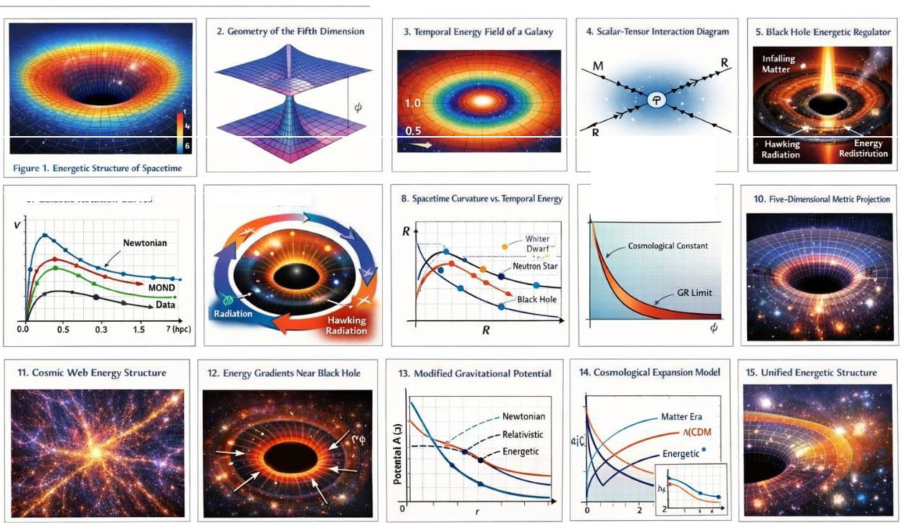
The Fifth Energetic Dimension and the Energy of Time
6. Galactic Rotation Curves
7. Cosmic Energy cyc1t
9. Sc.al.ar Fnt Pol'ffltiill V(f)

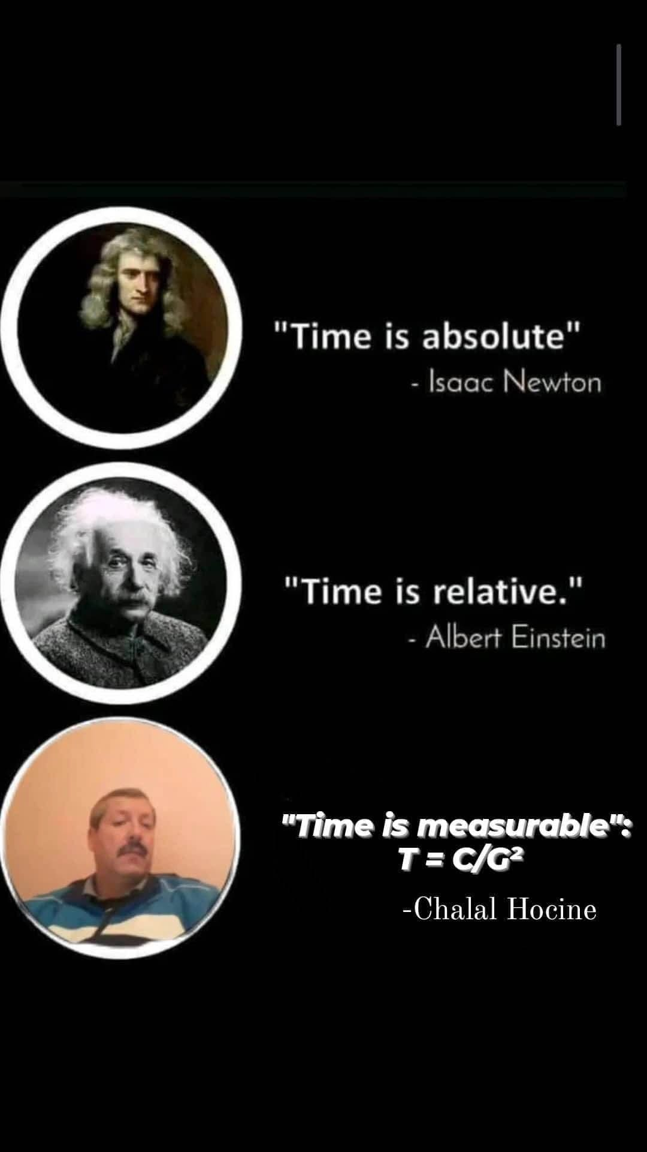

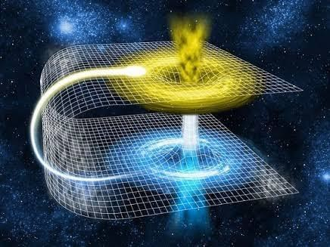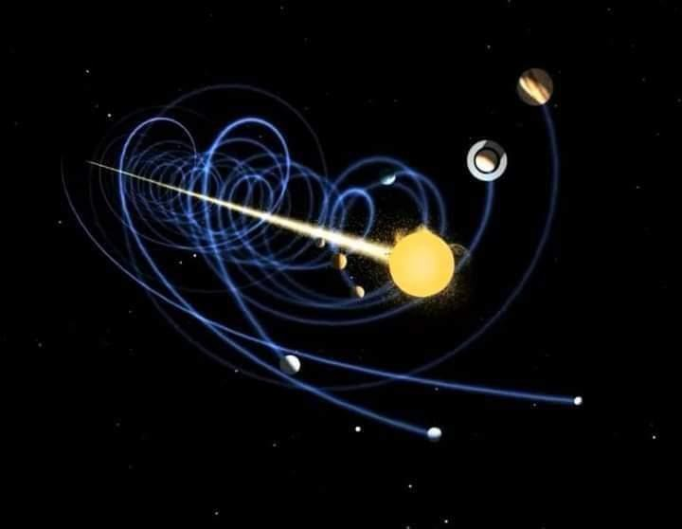

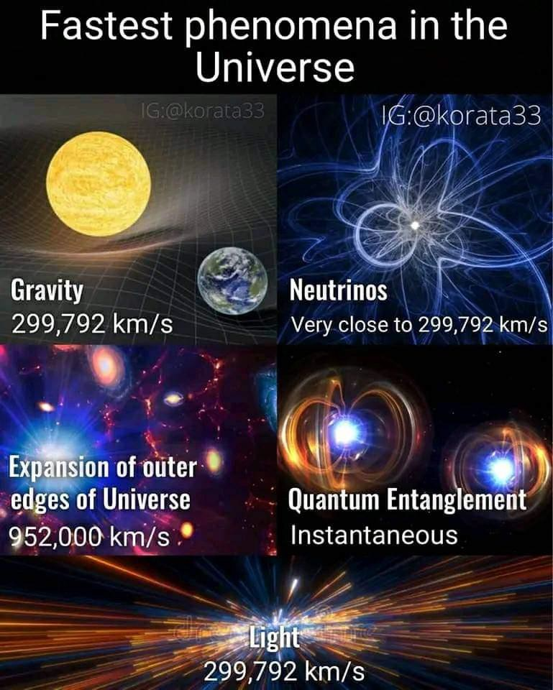


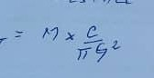


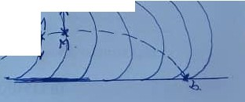


  - - ':>�- l/1�Jr II/ f, 1),1
{!) • JC,1111110,.Z ,)u Jt'r?t'
(P - v. y,, J � i,.,"• rt,,,w

A- .Jcr1.v,, ,au l!t.J 7l'1u'i
lr,, 7Cn/i c '�sl LIw .f...., c /� ,._,J., ;,,. ,£...,,),.,.,, [,w;" J,,l,i,·,oll,
.,.t- � ,,eo..,.1,.,,, L'"'/,lu�""
/ • I --JS-> t. ,lu.Ji
C ! • /,<f CY ltw H
t; : 'l 71,;,,./.;
B- E.Ncll.[;tc iZnro�E.LLF :)'uµ o8Jc7 I-r f?JE.r"l.11C1twT

"7 •. ENi 11�fi. Ti 1-, ?oi c.LLi.
t :• C.E'Lc.LtT!a
l'1 •· r?�.Js, .k L 'o}fE ,-
TT:- ?,A'I
l7 :- Cpt-1/vlic

ENl!Jl..91[ TCJT/t.c. J'vAI o&Y2r l>A-NS Lt.C.,tl...
L..11'/c�' ,1 VN"c vnf' .ffc V.

L! LUl'-11ELE v-r'oL>k LL.s
C,,,,,. !:,.r, t7i1JYl117/lfl/E/J...t
E'- r VO_'j'°-:<ilwf .t/Vl/4u.

..,Ctz,l ... I ,
Jic->vltl-c'll..,.,
.,..J,., '�x

- /.,
1
E/Vi.tl7lf tc/-Ji'()Ullt:.

..!,� 7 il"tN5 r<IJ 12 r'IE fi N
I: NPµt.,If', CCL' e J 7 £ ]) 9 WJ
).. 1 I.)�IV� /l J


I cerne = 1,an
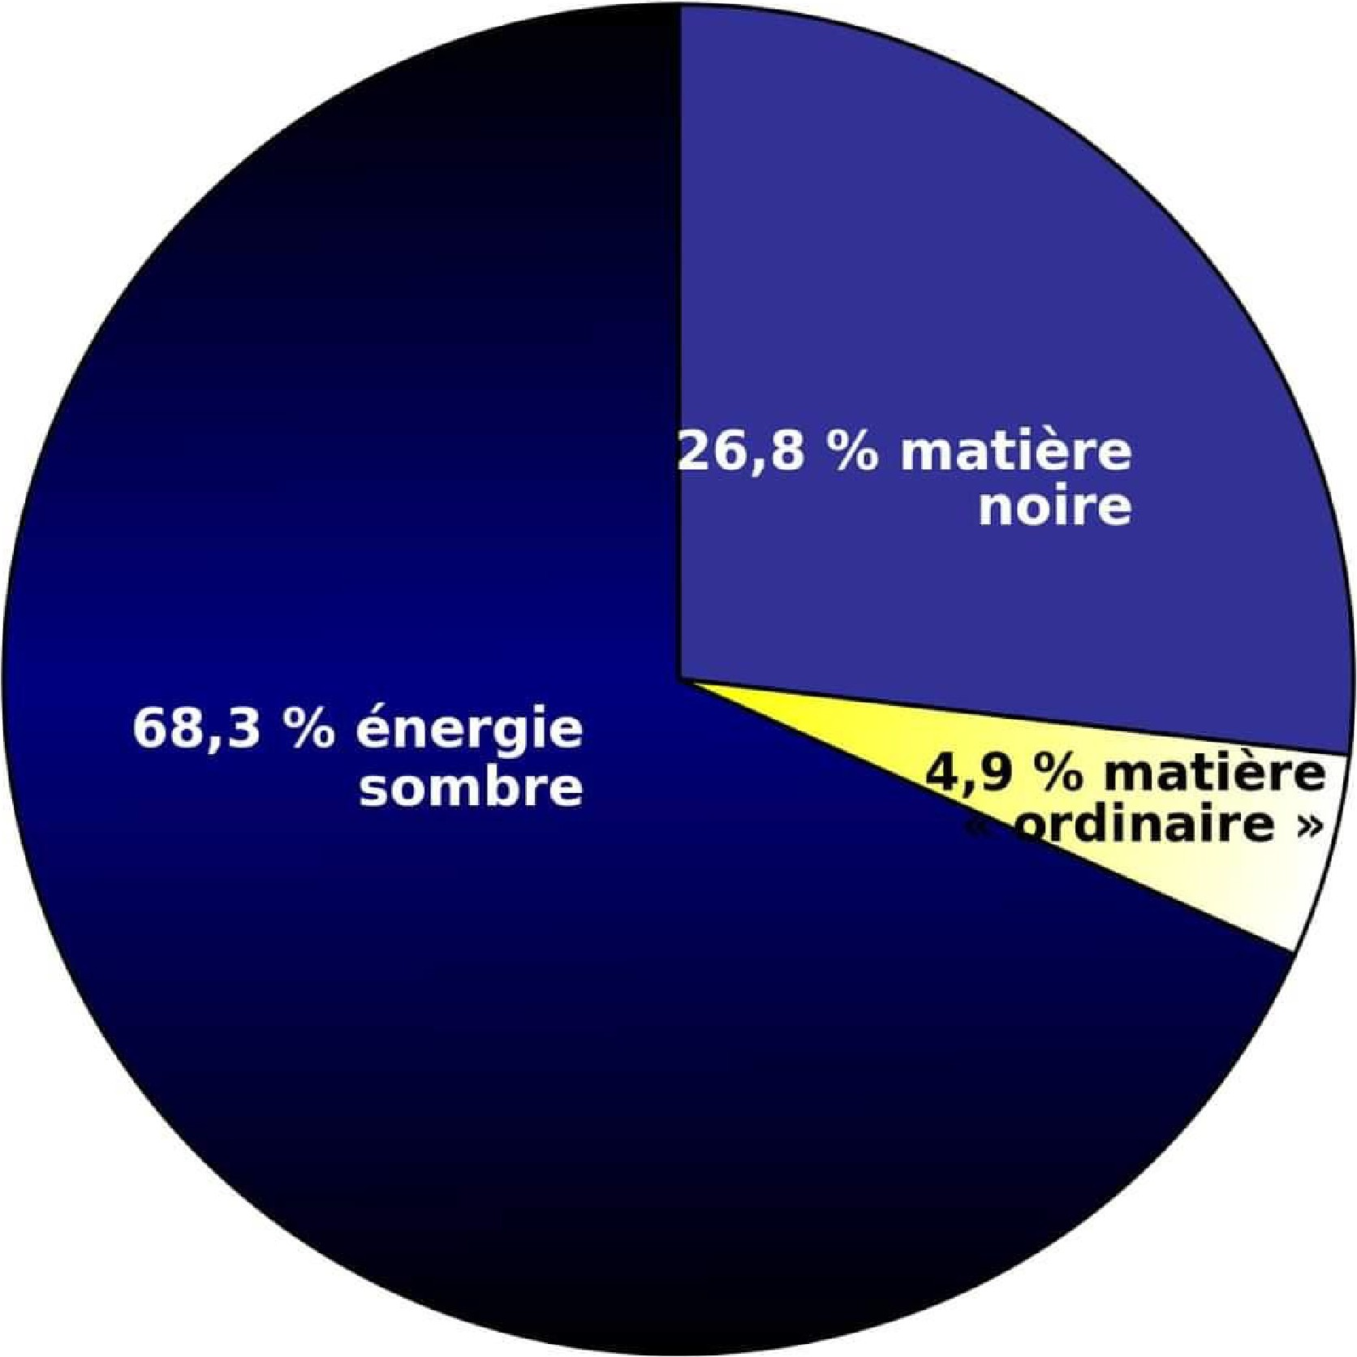

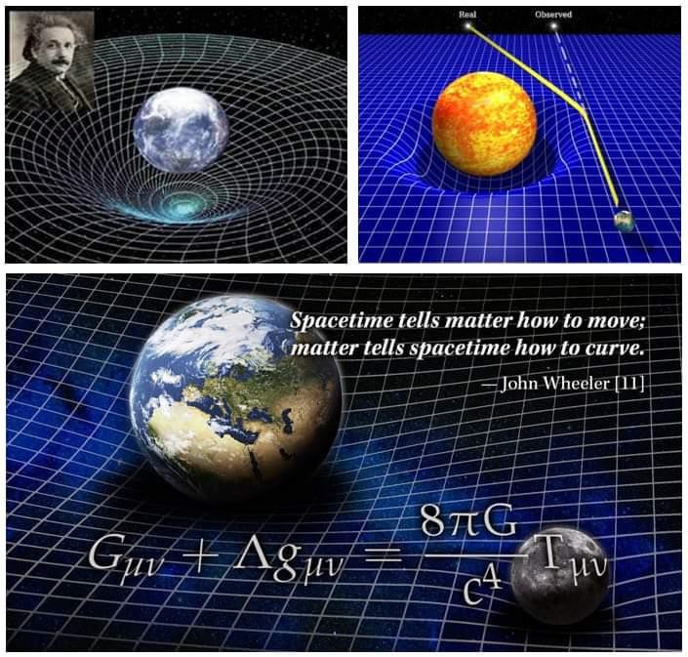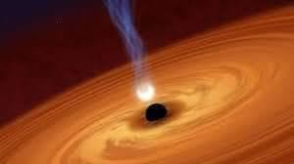


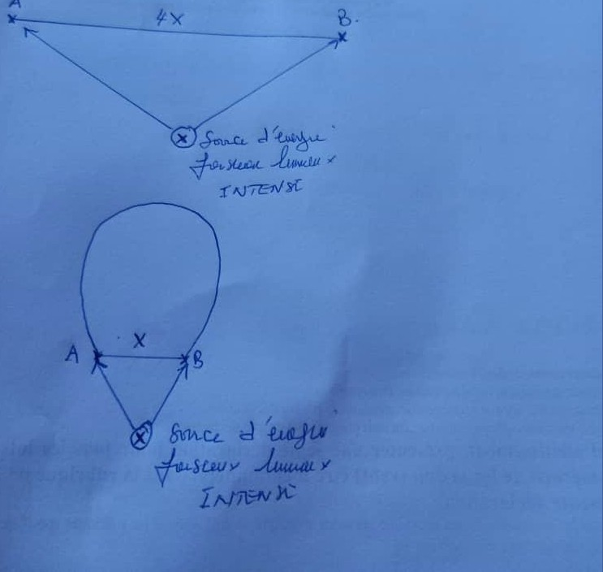
tfl �i"' J.', ,.,(fiJ' t " t,o,

' t'l .. u�t. \J ,.,
I.
QllN' �-.,
I '1'"�1 AU
\} f'o1,-.i' � l>-
f | s,..,., | �l | U.ll_
GU. t;"t | �"nli.i

l &'Aft.

