Language Perceptions: A prediction clue of Bukavu linguistic situation and its impact on the town socioeconomic development
Jean NTABALA MUSIRWA, jeanntabala@uob.ac.cd; jeanntabala@gmail.com;*Frank BUHENDWA MUNGANGA, frankbuhendwa@gmail.com;* CAGALINE BAGUMA, cagabag5.0016@gmail.com
Department of Languages and English Civilization ; Université Officielle de Bukavu- D.R.C.
ABSTRACT
This paper explores the language perceptions and attitudes as perceived by the population of Bukavu town in the Democratic Republic of Congo and the impact of such perceptions on language survival and the socioeconomic development of the town. The purpose is to reflect on the present and future linguistic situation of the town and relate the shown perceptions and attitudes to the town socioeconomic development. A questionnaire was addressed to 1,266 people selected from the three Bukavu communes. The results indicate growing negative attitudes towards local languages and Kiswahili (the regional language) and growing positive attitudes towards French and English. This is a good indication that even though Kiswahili is still the commonly used language in the town today, it is also already an endangered language considering its users perceptions and attitudes. Such endangerment goes also for all other local languages; Mashi, Kirega, Kifuliru, Kihavu, Kitembo. This negatively impact on the town socioeconomic in the sense that there is a very low involvement rate of the people into informal innovative and creative sectors despite the very high unemployment rate in the formal sector. However, French and English show a very promising future in the town. Perceptions and attitudes towards them are good indications of Bukavu openness to international economic (import–export) transactions. This positively contributes to Bukavu socioeconomic development. The study limited to one town (Bukavu) and its surroundings. It should be replicated to include the whole country to chek if the situation can be applied to the whole country. Key words: Bukavu, language perceptions, language attitudes, language threat, socioeconomic development.
INTRODUCTION AND RELEVANT LITERATURE
Language perceptions influence and shape language attitudes. Richards and Schmidt (2010) regard language attitudes as kind of attitudes which speakers of different languages or language varieties have towards each other’s languages or to their own language. Such perceptions and expressions of positive or negative feelings towards a language or languages may reflect impressions of linguistic difficulty or simplicity, ease or difficulty of learning, degree of importance, elegance, and social status. Language perceptions and attitudes may also show what people feel about the speakers of that language. The management of language perceptions and attitudes provide useful information in language teaching and language planning and policy.
Bukavu being a highly multilingual town, there is a permanent linguistic cohabitation between local and international languages. Such cohabitation should constitute a true linguistic heritage for Bukavu town in particular and the D.R. Congo in general and foster the integral nation development. However, this cohabitation creates a kind of linguistic competition leading to linguistic imbalance impacting, not only on the survival of local languages, but also on the languages contribution to the socioeconomic development of the town.
Thus, the primary concern of this study is to explore the perceptions and attitudes Bukavians show towards the different languages used within the town and examine the impact of such attitudes and perceptions on local languages survival and on Bukavu socioeconomic development. Secondary, to reflect on the stabilizing strategies of the current existing linguistic imbalance in the town.
The study builds on the following three questions: (1) what are the perceptions of Bukavians towards the different languages used in the town? (2) How such perceptions do impact on the socioeconomic development of Bukavu? (3)What is the impact of such perceptions on the future languages development?
As for the structure, this paper builds on the introduction and relevant literature; the methodology; the findings presentation; the findings discussion and the conclusion.

RELEVANT LITERATURE
In this point, key information on language perceptions, attitudes and ideologies and on economic and socioeconomic development are provided.
Language perceptions, attitudes and ideologies
Different authors such as Julia Sallabank 2013 ; Bambi, Kathryn and Paul 1998 ; Ofelia , Nelson and Massimiliano 2017 ; Gerard 2012 ; Richards and Schmidt 2010 and many others, have provided relevant information on language perceptions, attitudes and ideologies. For some, there are overlaps between definitions of attitudes, perceptions, beliefs and ideologies regarding language. The notions of attitudes, ideologies, motives, traits, beliefs, concepts, constructs and opinions are interrelated. Attitudes and motivation tend to be treated synonymously. Attitude is regarded as an evaluative orientation to a social object of some sort, but that, being a « disposition ». An attitude is at least potentially an evaluative stance that is sufficiently stable to allow it to be identified and in some sense, to be measured. Furthermore, attitudes are systematically linked to behavior because they predispose us to act in a certain way. Language ideologies have been described, defined and redefined numerous times. In this study they are regarded as a system of widely shared ideas, patterned beliefs, guiding norms and values, and ideas accepted as truth by a particular group of people (community) about a specific language.
Language perceptions, attitudes, motivations and ideologies are of key importance, both when languages are declining and during attempts at language revitalization. Language attitudes and ideologies are associated with both perceptions of a language vitality and with language practices, and thus with language policies at all levels of society, although there is no simple connection between expressed attitudes and actions. Language policies, attitudes and ideologies are also intrinsically linked to social processes and community dynamics. People do not react to the world through sensory input alone, but rather in terms of what they perceive that input means. People’s perceptions are central to language attitudes and ideologies, as has been highlighted by researchers in the field of perceptual dialectology.
Attitudes and ideologies do not simply arise without foundation. They are based on deep – seated dispositions and strongly held beliefs and perceptions concerning both language practices (what people do) and policies (what people should do). These dispositions are acquired through a gradual process of inculcation in which early childhood influences are particularly important. Such received ideologies often go unchallenged because they help organize the tremendous complexity of human experience into fairly simple, but distorted, images that serve as guide and compass for social and political action.
Since language is a commodity shared among all members of a speech community, it becomes the prime medium of ideological conflict and province of power struggles. The study of language ideology has therefore to account for (1) the processes in which ideology is created from dominant groups and (2) for the effects it takes on those whose interests are not recognized in these processes. One of these effects is the process of subordination, « erasure » and misrecognition of local languages. The progressive erasure of a language involves four stages: fragmentation, marginalization, sublimation and subordination.
- Fragmentation processes are characterized by a narrowing of a language or language variety to restricted functions.
- Marginalization refers to processes in which the subordinate status brought about as a result of fragmentation is reproduced.
- Sublimation refers to phenomena in which a language or a variety of language is decontextualized from its unmarked functions. As an effect, specific language behavior ceases to be regarded as normal and inevitably foregrounds specific connotations. That is to say, language structure and use which is regarded as neutral and is therefore expected unmarked, while everything which deviates from such expectations is marked.
- Subordination refers to the stage at which dominated communities find themselves in a position where they can no longer question the hegemonic imposition of the dominating culture. Subordination is the point of no return.

Language and socioeconomic development
Rhonda and Robert (2009) regard economic development as the process of creating wealth through the mobilization of human, financial, capital and natural resources to generate marketable goods and services. The economic developer’s role is to influence the process for the benefit of the community through expanding job opportunities and the tax base. Most economic developers concentrate on creating new jobs. This is generally the key to wealth creation and higher living standards. Job creation generally involves the « three – legged stool » of recruiting new business, retaining and expanding businesses already in the community, and facilitating new business start–ups.
Although language economics is well equipped to shed light on language policy decision – making, especially in less-developed countries, the problem of economic development in such countries, including many in Africa, has never been studied in connection with language variables. African speech communities will be empowered when they can live and operate in their own mother tongues, and when these mother tongues are actively promoted and used at all levels and in all functions of society, (Nkonko 2016). Language plays central role in regulating an individual’s access to the production, distribution and consumption of resources. This is particularly the case under the conditions of late capitalism, where language emerges as a key tool in creating the conditions for the management of the challenges and possibilities posed by the expanding markets. Although language and multilingualism seem to be key resources in creating the conditions for the social integration and economic emancipation of individuals in the time of late capitalism, there is also another story to be told. As in modernity, when language and culture were mobilized to produce and naturalize hierarchies between speakers and to legitimize relations of domination in society, critical scholars have shown that if language is a powerful tool for integration, it remains instrumental in excluding people as well.
Indeed, from the documented observations of the social differentiation processes in various research projects, the following tensions can be highlighted:
- A tension between the celebration of language and communication as an economic resource and the effects of these discourses on how languages, and especially their speakers, are categorized and hierarchized ;
- A tension between the potential of language to enable access to symbolic and material capital and the complex logics , interests, and technologies regulating the convertibility of language into capital in specific markets ;
- A tension between current discourses of the emancipatory nature of language and the invisibilization of the structural causes that exclude speakers from recognition and capital, a condition that leads society to hold affected speakers responsible for their own social and economic marginality, (Ofelia, Nelson and Massimiliano 2017).
UNESCO Institute for Lifelong Learning (2010) has also investigated into the advantages of linguistic and cultural diversity and their impact on the social and economic development of the target community. In their report, they dismantle several myths pertaining to diversity and the nation state:
- Recognizing cultural identities has resolved conflicts instead of creating them because cultural identity was not the cause of these conflicts. Cultural identities were used to fuel them; causes are usually economic inequalities and struggle over power.
- At the heart of multilingualism is belonging: Human beings always have several identities (gender, religion, nationality, ethnic group and friends). They belong and share the values of a variety of social groups. Thus, the recognition of diversity does not compete with the unity of a state because identification with the state will always be one of many identities of individuals.
- There is no proof that economic development correlates negatively with linguistic and cultural diversity. On the contrary, there are indications that economic growth is expected because more empowered and creative people are able to contribute.
Strong multilingual competences can foster regional socio-economic activities. The multilingual learning program supports the professional development of learners. It is responsive to socio – economic activities of the region. It builds – in professional training and provides bridges to technical, vocational and higher education careers. Effective mother-tongue- based multilingual education teaches linguistic and communicative competencies that are relevant to African multilingual economies characterized by a small formal economic sector and a large informal sector.
Generally, the informal sector accounts for a high percentage of existing and new jobs compared to the formal sector. Most communication in this sector takes place in African languages. This sector is highly innovative and creative, accommodates the least educated, trains the majority of the youth with the very little support from national governments, and has a huge demand for technical and vocational training. The interest in African languages has taken a new dimension. In the information technology sector, international companies such as Microsoft have discovered that investigating in African languages is beneficial because they want to reach the estimated 100 million Kiswahili speakers residing in Tanzania, Kenya, Uganda, and the Democratic Republic of the Congo. The case of Kiswahili shows that the business sector develops terminology informally when the need arises. Newspapers and cell phone companies communicate with their customers about computer technology and telecommunication in Kiswahili and software is being developed in Kiswahili and in other African languages. Furthermore, bilingual information services are offered to customers.
Communication is the economy foundation, specifically in the language industry and creative sectors. A general feature of the language industry and creative sector it that its services require complex linguistic and communication competencies. Thus, it is very likely that the creative industry and language industry benefit from mother – tongue – based multilingual education which aims at high – level proficiency in languages that are relevant to diverse social contexts. The creative sector is much tied to the local and regional markets and produces also for export. These markets are characterized by linguistic diversity whereby African languages are highly relevant for the majority of African producers and consumers. The language industry and the creative sector are lucrative and significant labour markets. Unfortunately, there are no known comprehensive surveys of language and creative industries in African countries that are available. Globally, economic research on the language industry and the creative industry is a relatively recent development. The language industry in Canada offers services such as language training, language testing, translation, interpretation, dubbing, editing and writing, proof reading, language technology development and terminology development.
Attitudes, perceptions and choice are due to a certain pressure that the socio-economic changes exert on the language mixes in a multilingual environment which decreases the languages vitality (UNESCO 2003). Today, more than ever, conducting business internationally requires communicating and negotiating in many languages. The language industry provides « bridges » that ensure people of different linguistic origins are able to communicate. Research on Creative industries in Europe shows that private creative companies demonstrate surprising economic dynamism in comparison to other sectors. The creative sector is an important labor market. The main capital of people working in the sector is their creativity and knowledge.
METHODOLOGY
The point describes the research design, population, sample and sampling procedures and the data collection and their analysis strategies.
Considering the nature of the raised questions, objective and the data collection tool, the study is globally qualitative. It seeks to understand and explore the perceptions and attitudes of a particular group of people (Bukavians) towards their languages, which is a ‘case study’.
The population was made of all Bukavians beyond 10 years old in general. This is because all the people despite their differences in terms of gender, study level and profession can and really use languages and have specific perceptions and attitudes towards them. As such, from that age, they can all provide relevant information regarding their attitudes, perceptions and preferences towards different languages. A representative sample of 1,266 individuals has been considered from the three constituent communes of Bukavu town; Ibanda, Kadutu and Bagira.
A questionnaire has been used for collecting the data. Structurally, the questionnaire had a section on participants’ demographic information and another section on the focus questions. The demographic section provided the information on the participants’ gender, age, commune and occupation. The section of focus questions provided the information on the participants’ language attitudes, perceptions and preferences.
The data have been collected from different schools of Bukavu at all levels; primary, secondary and universities considering a representative sample in each commune. In addition, they have also been collected in different Bukavu workplaces, streets and public places, churches and in different people homes. The questionnaires were submitted to the respondents into two exclusive formats: either online via Google forms or via hard copies. The data collection lasted from 15th December 2022 to 16th March 2023.

FINDINGS PRESENTATION
After the collection, the data have been prepared for analysis by encoding them into Excel software and presenting them thanks to the dynamic crossed spreadsheets (Tableaux croisés dynamiques) as summarized here. The four first Tables, i.e ; Tables 1 - 4 present the demographic information of the respondents and Tables 5 – 11 present the results of the focus questions about the respondents’ attitudes and preferences towards the different languages used within the town.

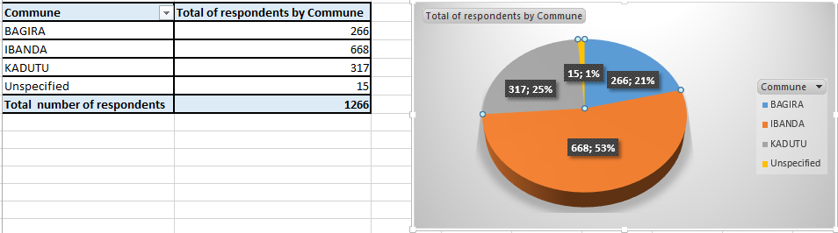
Table 1. Sample distribution for Commune

Table 2. Sample distribution for Gender
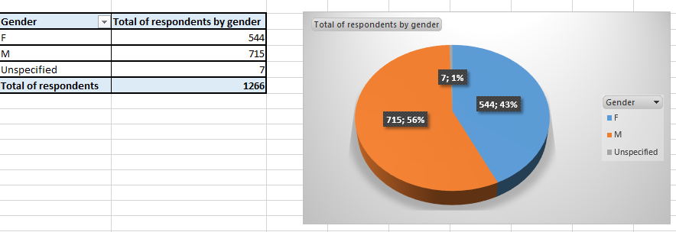

Table 3. Sample distribution for Age
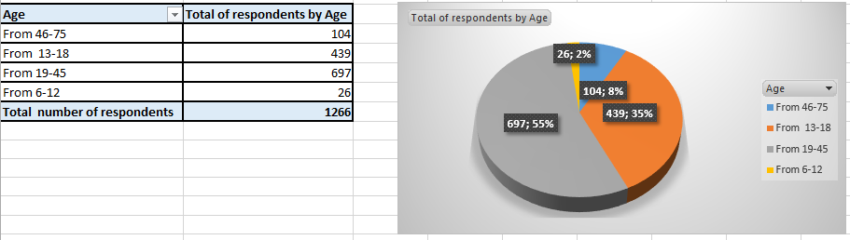

Table 4. Sample distribution for Profession
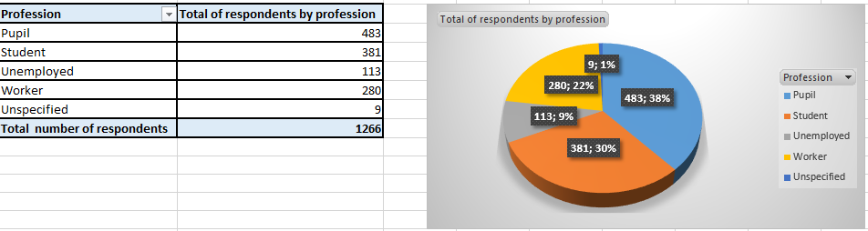

Table 5. Attitudes towards French
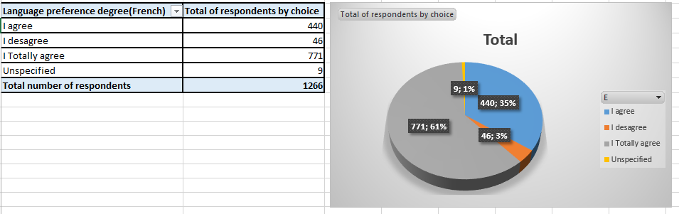

In Table 5 above, 61% of the respondents feel very happy when they speak or hear someone speaking French; 35% just feel happy; 3% feel unhappy and 1% of the respondents did not specify its attitude.

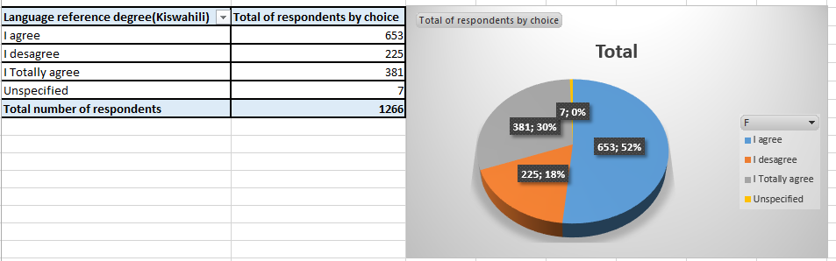
Table 6. Attitudes towards Kiswahili

In Table 6 above, 52% of the respondents feel just happy when they speak or hear someone speaking Kiswahili; 30% feel very happy and 18% feel unhappy.

Table 7. Attitudes towards English
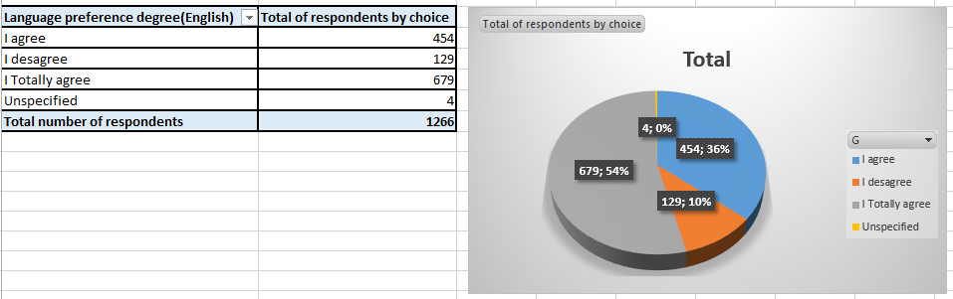

In Table 7 above, 54% of the respondents feel very happy when they speak or hear someone speaking English; 36% just feel happy and 10% feel unhappy.

Table 8. Attitudes towards local languages
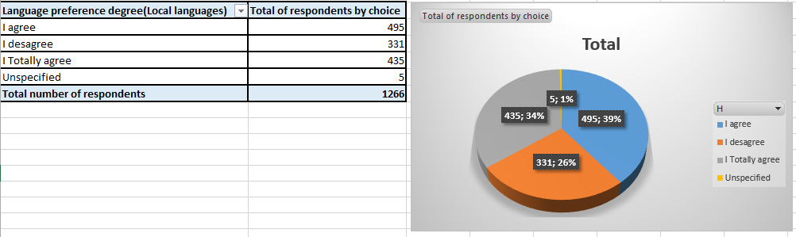

In Table 8 above, 39% of the respondents feel just happy when they speak or hear someone speaking Local languages; 34% feel very happy; 26% feel unhappy and 1% of the respondents did not specify its attitude.

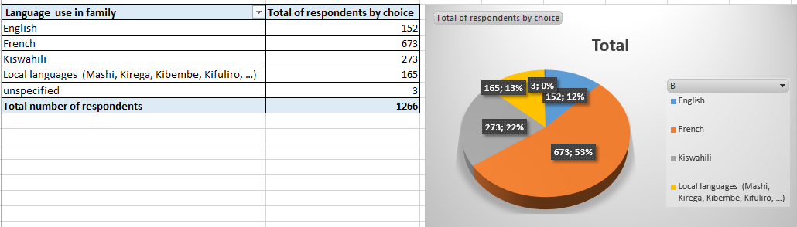
Table 9: Choice of language use in families

As can be seen in Table 9 above, 53% of the respondents prefer children to use French at home for it prepares them to face the studies at the school age; 22% prefer Kiswahili for it is the community common language; 13% prefer the local languages for we have to protect the cultural heritage and maintain local languages survival and promotion across generations and 12% prefer the use of English for it offers many opportunities today

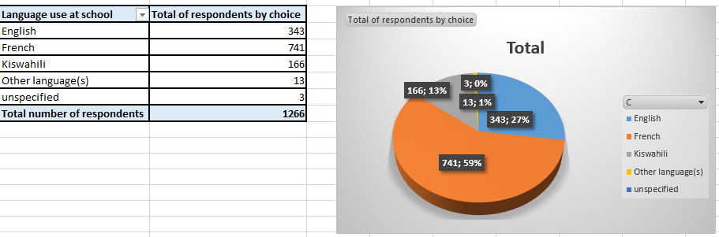
Table 10: Choice of language use at school

In Table 10 above, 59% of the respondents prefer children to use French at school for it is the official language of the country; 27% prefer English for it opens many horizons at the international level today; and 13% prefer the Kiswahili because effective knowledge acquisition for children is the one transmitted to them through a well-known and mastered language and 1% prefers the children to use others languages rather than French, English and Kiswahili.

Table 11: Language preferred as official today
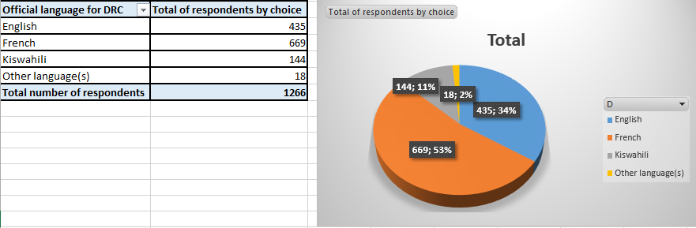

Table 11 above indicates that 53% of the respondents prefer French as the DRC official language for it is already documented, known and used in all the DRC provinces; 34% prefer English because the DRC , as all other world countries , has to adopt the globalizing policy for its integral development; 11% prefer Kiswahili for it is a Congolese language with African roots which is spreading all over the world today and which needs to be promoted and supported and 2% prefer other languages rather than French, English and Kiswahili.

FINDINGS DISCUSSION
This point explores the different perceptions, attitudes and preferences Bukavians show towards different languages and consequently reveals the impact of such attitudes on the survival and/or death of some languages and on the socioeconomic development of the town.

Attitudes towards the local languages
As shown in TABLE 9; 13% of the respondents prefer children to use the local languages at home for we have to protect the cultural heritage and maintain local languages survival and promotion across generations and as expressed in TABLE 8; 39% feel just happy when they speak or hear someone speaking Local languages; 34% feel very happy and 26% feel unhappy. With reference to these results, it can be noted that Bukavians have negative attitudes towards the use of local languages in families.
When families no longer prefer and encourage their children to use local languages at home, when they no longer feel happy to speak or hear other people speaking those languages, it is a very clear indication, to a high extent, that those languages are endangered and expected to die in the future unless special measures are taken in their favor. As shown in the literature review (Point 2.1.), languages attitudes and ideologies do not simply arise without foundation; they are based on deep – seated dispositions and strongly held beliefs and perceptions concerning both language practices (what people do) and policies (what people should do). These dispositions are acquired through a gradual process of inculcation in which early childhood influences are particularly important. In the same way, the current Bukavians attitudes towards the use of local languages in families root from such seated dispositions about language practices and policies. A gradual conscious awareness rising is needed among the entire population and specifically among the language policy implementers about the place and role of local languages for the town development. Such conscious awareness will create, with time, new helpful language attitudes and ideologies for the town development. Economically, the shown attitudes above, negatively impact on the socioeconomic development of the town in the sense that children, from their families, nursery to tertiary education, grow up with very negative perceptions towards their languages inculcated into them in their different developmental stages. As said previously (Point 2.2), languages and communication are the foundation of the economy, specifically in the language industry and creative sectors. A general feature of the language industry and the creative sector is that, its services require complex linguistic and communication competences. It is very likely that the creative industry and the language industry benefit, to a high extend, to mother – tongue communications. The attitudes shown about the use of local languages in families inhibit Bukavians language industry and creative sectors though important and crucial for developing entities as Bukavu. Language industry and creative sector are lucrative and significant labor markets in which local communication plays a very important role. Knowledge as an asset for socio-economic development is the storage and carrier of knowledge. Thus, any loss of language brings about not only knowledge loss but also transmission of such knowledge from generation to generation.

Attitudes towards Kiswahili
As shown in TABLE 9; 22% of the respondents prefer children to use Kiswahili at home for it is the community common language and in TABLE 10; 13% prefer children to use Kiswahili at school because effective knowledge acquisition for children is the one transmitted to them through a well-known and mastered language. In TABLE 11; 11% of the respondents prefer Kiswahili as the DRC official language for it is a Congolese language with African roots which is spread all over the world today and which needs to be promoted and supported. And consequently in TABLE 6; 52% of the respondents feel just happy when they speak or hear someone speaking Kiswahili; 30% feel very happy and 18% feel unhappy.
The above results reveal clearly the attitudes of Bukavians towards Kiswahili as home language, as instruction language of children at school; as the DRC official language and finally, the different feelings of Bukavians have when they speak or hear Kiswahili. From these results it can also be noticed that today Bukavians’ attitude towards Kiswahili is globally negative. These results constitute an indication of the present and future danger that Kiswahili and other Bukavian heritage languages are running.
The revelation behind the above result is that the attitudes shown towards Kiswahili have a negative impact on Bukavu socioeconomic development as described below. Today Kishwahili remains the commonly used language in Bukavu and serves also as lingua franca for people of different linguistic backgrounds. As such, it should be playing a very important role in the process of creative wealth in the town and to some extent, constitute a commercial commodity. As said in Point 2.2, effective mother – tongue based education teaches linguistic and communicative competencies that are relevant to African multilingual economies characterized by a small formal economic sector and a large informal sector. Generally, the informal sector accounts for a high percentage of existing and new jobs compared to the formal sector. The informal sector is highly innovative and creative, accommodates the least educated, trains the majority of youth with the very little support from the government and has a huge demand for technical and vocational training. With the revealed attitudes, it can be noticed that with negative attitudes towards that commonly used language (Kiswahili), people would not like using it in their everyday life and with time, the current and coming generations will no longer have the mastery of that language. Instead, people prefer to use, in all life circumstances, French and English though not mastered by many. Consequently, the inability of people to think in foreign languages and create new job opportunities. As a result, there is a very low rate of informal innovative and creative jobs in the town but a very high rate of unemployment throughout the community explained by the inability of the formal sector to respond to the job demand. Hence, the need of creating new job opportunities, i.e; entrepreneurship. Local communicative competencies are very relevant in that process of creating and managing new businesses. Unfortunately, once fluent in international languages, the tendency of many is either to operate exclusively in the formal sector (though very restricted) or to move to foreign countries for they no longer identify themselves to their own community.

Attitudes towards French
As shown in TABLE 9; 53% of the respondents prefer children to use French at home for it prepares them to face the studies at the school age and in TABLE 10; 59% of the respondents prefer children to use French at school for it is the official language of the country. In TABLE 11; 53% of the respondents prefer French as the DRC official language for it is already documented, known and used in all the DRC provinces and consequently in TABLE 5; 61% of the respondents feel very happy when they speak or hear someone speaking French; 35% just feel happy; 3% feel unhappy. These results reveal the attitudes of Bukavians towards French as home language, as instruction language of children at school; as the DRC official language and finally, the different feelings that Bukavians have when they speak or hear French. From these results it can be noticed that today Bukavians have positive attitude towards French.

Attitudes towards English
In TABLE 9; 12% of the respondents prefer children to use English at home for it offers many opportunities today and in TABLE 10; 27% of the respondents prefer children to use English at school for it opens many horizons at the international level today. In TABLE 11; 34% prefer English as the DRC official language because the DRC, as all other world countries today, has to adopt the globalizing policy for its integral development and consequently in TABLE 7; 54% feel very happy when they speak or hear someone speaking English; 36% just feel happy and 10% feel unhappy. These results show Bukavians’ attitudes towards English as home language, as instruction language of children at school; as the DRC official language and finally, the different feelings Bukavians have when they speak or hear English. From these results it can be noticed that even though English has no specific status in DRC despite the one of foreign language, a number of people, as described above (12%; 27%; 34%), would like English to be used at home and school by children and to be the DRC official language today. In addition, a very big number of Bukavians feel very happy and/or happy (90%) when they hear or speak English. This expresses the positive attitude Bukavians have towards English despite its lack of official status in the country. These results show clearly that French and English in Bukavu have much chance of survival compared to Kiswahili and other Bukavian heritage languages. From the results presented in 4.3. and in 4.4., it can be deduced that French and English have a very hopeful future in Bukavu. This is a good indication of the future town adaptation to the globalization requirements in terms of import – export transactions.

CONCLUSION
The paper on language perceptions: a prediction clue of Bukavu linguistic situation and its impact on the town socioeconomic development has examined the perceptions and attitudes Bukavians show towards the different languages used in the town and their impact on language survival and on the socioeconomic development of the town. To reach this goal, a questionnaire was addressed to 1,266 individual selected from the three Bukavu communes and retained as the representative study sample.
The results indicate, on one hand, growing negative attitudes towards local languages and Kiswahili but growing positive towards French and English. This implies that even though Kiswahili is still the commonly used language today in Bukavu, it is also already an endangered language considering its users perceptions and attitudes. The endangerment goes also for all other local languages (Mashi, Kirega, Kifuliru, Kihavu, Kitembo,). Socioeconomically, this impacts negatively on the town development. This is explained by a very low involvement rate into the informal innovative and creative sectors despite the very high rate of unemployment in the formal sector. On the other hand, French and English show a very promising future in the town. This implies the present and future Bukavu openness to the international economic sphere in terms of import – export transactions by Bukavians; which is the gaining side for French and English but losing for local and regional languages for they will be under threat of death.
The community awareness rising about balanced multilingualism is one of the strategies of managing the current Bukavu multilingualism. But, since perceptions, attitudes and ideologies build on deep seated dispositions and strongly held beliefs concerning both language practices and policies, such awareness-rising should primarily focus on language ideology and attitude shift. This is a gradual process of inculcation starting into families and extending to all the community by involving all institutions exercising public power such independent political and social groups, educators, familes, writers, churches, Non – Governmental Organizations and professional groups and the government.
The study limited to one town of the DRC and its surroundings. It should be replicated to include the whole region and country to check if the situation can be applied to the whole country.

BIBLIOGRAPHY
- Bambi B. S. (Eds) (1998). Language Ideologies: Practice and Theory. New York: Oxford University Press.
- Bernard Spolsky (2004). Language Policy. Cambridge University Press.
- Elisabeth C. Zsiga, (2014). Languages in Africa: Multilingualism, Language policy, and Education. Washington, DC: Georgetown University Press.
- George Orekan (2010). Language Policy and Educational Development in Africa: The case study of Nigeria; in Scottish Languages Review, Issue 21, spring 2010, 17 – 26. Scotland’s National Centre for languages.
- Gerard Van Herk (2012). What is Sociolinguistics? Willey – Blackwell
- Jack C. Richards and Richard Schmidt (2010). Longman Dictionary of Language Teaching and Applied Linguistics, 4th Edition. Pearson Education Limited.
- James Hawkey (2018). Language Attitudes and Minority Rights: The Case of Catalan in France. Palgrave Macmillan.
- Jon Orman (2008). Language policy and Nation – Building in Post – Apartheid South Africa. Springer.
- Julia Sallabank (2013). Attitudes to Endangered Languages: Identities and Policies. Cambridge University Press.
- Ken D. Thomas (2015). Handbook of Research on Sustainable Development and Economics. USA: Business Science Reference.
- Mari C. Jones (Ed) (2015). Policy and Planning for Endangered Languages. Cambridge University Press.
- Nkonko M. Kamwangamalu (2016). Language Policy and Economics: The Language Question in Africa. Palgrave Macmillan.
- Ofelia Gracia, (Eds) (2017). The Oxford Handbook of Language and Society. Oxford University Press.
- Raj Mesthrie (2006). Language, Transformation and Development: a sociolinguistic appraisal of post –apartheid South African language policy and practice, in Southern African Linguistics and Applied language studies. South Africa.
- Rhonda Phillips and Robert H. Pittman (Eds) (2009). An Introduction to Community Development. Routledge.
- Robert B. Kaplan and Richard B. Baldauf (1997). Language Planning from Practice to Theory. Multilingual Matters Ltd.
- UNESCO Institute for Lifelong Learning (2010). Why and How Africa should invest in African Languages and Multilingual Education. UNESCO Institute for Lifelong Learning.
- UNESCO (2003). Language Vitality and Endangerment. Paris
- Crystal, D. (2000). Language Death. CUP
- Isa,Baba Zanne (2014). Language death and endangered languages : Journal of Humanities and Social Science, Vol. 19, Issue 10, Ver. VI – Oct.2014 ; pp 46 – 48.
- Dulce , Gracia (n.d.). Language endangerment and language death. https://www.academia.edu
- Hohn, Viktor (2007). Language Death : When languages disappear. grin.com/document/73831
- UNESCO (2010). Atlas of the World languages in Danger. www.unesco.org

