Incidence of Galactic Cosmic Ray Fluxes at Polar and Middle Latitude Regions
Esther A. Hanson, Emmanuel Ukabrinachi, Olanike Akinola, and Onyebuchi Nnah
- Advanced Space Technology Applications Laboratory, Uyo, Nigeria.
Corresponding Author: Esther A. Hanson; esther.hanson.78720@unn.edu.ng
+234 806 932 7779

Abstract
Galactic Cosmic Rays (GCRs) incidence on the Earth’s near space environment is of major concern to humankind as it affects space weather. Upon entering Earth’s atmosphere, GCRs collide with atoms and molecules, and subsequently decay into muons and neutrinos which propagates through the earth’s surface. Theory and observations affirm that penetration of GCR from the Heliospheric Magnetic Field (HMF) to Earth’s atmosphere is leveraged by the earth’s magnetic force lines predominant at the polar regions. We used facilities at NASA Goddard Space Flight Center, Greenbelt, Maryland USA and analyzed GCR particles recorded by Neutron Monitors (NM) at Thule, Newark, Mc Murdo and South Pole hosted at Bartol Research Institute, University of Delaware, USA. Geomagnetic aa index was obtained from World Data Center for Geomagnetism, Kyoto, Japan. This work investigates the degree to which GCRs are modulated by Geomagnetic activities using Geomagnetic aa-index as a proxy to Geomagnetic activity. We studied GCRs incident at four Neutron Monitor (NM) Stations at; Thule in the Arctic region, McMurdo and South Pole in the Antarctica, and Newark in the Middle Latitude region across five solar cycles timescale (1964 to 2016). We performed Regression Analysis of GCR and Geomagnetic aa-index to observe the impact of geomagnetic activity on GCR flux at the designated regions of the Earth’s surface. Also, we carried out Time Series Analysis to observe GCR intensities at the four NM Stations for the period of study. Results from Regression Analysis revealed a weak association between GCR and Geomagnetic aa index, where Coefficient of Determination R² is less than 0.5. The Time Series Analysis revealed highest fluxes of GCR at Thule, McMurdo and South Pole as compared to incidence at the Mid-Latitude region in Newark. Our model indicate that GCR fluxes are controlled by Geomagnetic Field structure.
Keywords: South Pole, Galactic Cosmic Rays, Geomagnetic aa-index.

Corresponding Author:
Name: Esther A. Hanson
Email: esther.hanson.pg78720@unn.edu.ng
Phone: +234 806 932 7779

1 Introduction
Studies reveal that cocoons shocks around Active Galactic Nuclei (AGN) together with Galactic Supernova explosions provide the observed Galactic Cosmic Rays (GCRs) spectrum (Berezhko, 2008; Benyamin et al., (2016, 2017)). Propagation of GCR is highly modulated by the structure of geomagnetic fields (Perry, 2007). A study conducted by Hanson and Okeke, (2021) revealed an in-phase variation pattern between Sunspot Number and Geomagnetic aa-index; and deduced that the latter can be used as a proxy for studying solar magnetic activities. Paudel (2014) described possible way for utilization of GCR particles for energy generation to meet humanity energy need.
At sea level cosmic rays are made up of extensive air shower including muons with lifetime of 2μs (2 microseconds). These particles penetrate the Earth’s atmosphere and lose energy by ionization and electrons in turn, are generated from the decay of muon, with low penetrating power due to bremsstrahlung loss. Low energy neutrons (<10 MeV) are produced from excited nuclei while high energy protons are generated from knock-on collision. The GCR flux at sea level is not constant but is modulated by the 11year solar cycle and the cosmic ray count rate depends on geomagnetic latitude, altitude of the sensor and the design of monitor. However, Lara et al. (2016) carried out an altitude survey of GCR flux with a Mini Neutron Monitor at a low latitude [19º N] station with geomagnetic cutoff rigidity ~7.8 GV, and found that the flux remained constant from sea level up to 460 m above sea level, as the barometric coefficient was constant and independent on altitude, as opposed in earlier studies.
GCR fluxes are modulated when they enter the heliosphere due to the presence of magnetic field and solar wind and also, the geomagnetic field deflects the charged particle. GCR count rate are modulated by geomagnetic activities.
High energy particles limit the performance of onboard instruments deployed for space exploration. Particle detectors placed onboard spacecrafts allow for testing the reliability of prelaunch predictions of GCR energy spectra and for studying the modulation of protons and Helium overall flux above 70 MeV on a day to day basis. GCR flux variations up to approximately 15% in less than a month were observed with European Space Agency (ESA) Laser Interferometer Space Antenna (LISA) Pathfinder (LPF) orbiting around the Lagrange point L1 between 2016 and 2017. These variations appeared barely detected or undetected in neutron monitors. Grimani et al. (2019) deployed the LPF data and other observations carried out with the magnetic spectrometer AMS-02 experiment showed the effects of GCR flux short-term variations in monthly averaged measurements. Again, their study revealed that large-scale structures also cause continuous GCR fluxes modulation. The particle rigidity is the key governing factor in the motion of charged particles and GCR particles with rigidity less than the cutoff rigidity are unable to reach the Earth’s surface (Cecchini et al., 2003). Particle rigidity (R) is expressed by the equation;
$$R=\frac{cP}{Ze} (1)$$
where c is the velocity of light, P is the momentum of the particle, Z is the atomic number and e is the elementary charge of the particles. The response to solar modulation of cosmic ray at ground level is inversely proportional to particle rigidity and if the rigidity of cosmic ray is high, the Sun will not easily affect it but if the cosmic ray rigidity is low, then the magnetic field of the Sun embedded in the solar wind will readily change the phase and amplitude of the cosmic ray. Thus, a monitor having less cutoff rigidity will be very sensitive to modulation of CR as compared with the monitor having high cutoff rigidity provided all factors remain the same. Moreover, the altitude of the monitor also has significant role to the cosmic ray response due to different climatic conditions throughout the year (Bhattacharya et al., 2013). Consequently, the motion of charged particles in a magnetic field is defined by Lorentz Force F, given in equation (2). The combination of electric and magnetic forces on a charged particle due to electric fields is described by the Lorentz Force F as;
$$F=ZeE+Ze[v x B] (2)$$
where Ze is the charge of the moving particle, e is the elementary charge, E is electric field, v is the velocity of the particle, B is the magnetic field. The combination of electric and magnetic forces on a charged particle due to electric fields is described as the Lorentz Force F.
The trajectories of cosmic ray particles are curved by the Earth’s magnetic field and the effect of electric fields can be neglected in the geomagnetosphere due to its high electric conductivity. Thus, the force equation (2) becomes:
$$F=m.\frac{dv}{dt}=Ze\left[v x B\right] (3)$$
For a relativistic particle with mass m = γm_{o}, where γ is the Lorentz force factor (γ = (1-ʋ²/c²)^{-1/2}), m_{o} is the rest mass of the particle, it therefore follows that:
$$\frac{dv}{dt}=-\frac{Ze}{γm_{o}} \left[v x B\right] (4)$$
For a moving charged particle in a uniform magnetic field, the speed vector can be split into components parallel ʋ|| and perpendicular ʋ﬩ to the magnetic field B. The motion of the particle is then described by a movement with constant speed along the magnetic field ʋ|| and a circular motion around the magnetic field lines. The centripetal acceleration is given as;
$$\frac{ʋ^{2}﬩}{r_{c}}= \frac{Ze}{γm_{o}}.ʋ﬩.\left|B\right| (5)$$
where r_{c} is the cyclotron radius or gyroradius,
$$r_{c}= \frac{{ ʋ}^{2}﬩ γm_{o} }{Ze ʋ﬩ \left|B\right|}= \frac{ʋ﬩ γm_{o} }{Ze \left|B\right|} (6)$$
Bütikofer (2018) rearranged the above equations and derived a more practical expression for an estimation of cosmic ray trajectory characteristics. The ability of cosmic ray particles to penetrate magnetic fields and reach the top of the Earth’s atmosphere is controlled by their rigidity R (Kalugin and Kabin, 2015), which is defined as the product of the particle’s momentum and the speed of light per unit charge; and measured in Gigavolts (GV). GCRs propagating through the solar system interact with interplanetary magnetic field (IMF) and their fluxes are modulated by IMF’s intensity and direction. Hence, GCRs with different rigidities change differently since lower rigidity particles are more affected by the changes in the magnetic field (Wawrzynczak and Alania 2011). Terazi et al., (2016) observed a dependency of increasing GCR intensity on geomagnetic latitudes. It is obvious that the structure of Earth’s magnetic field controls the incidence of GCR on Earth’s surface. This study attempts to make a quantitative estimation of the effect of solar magnetic activity on GCR incidence at middle latitude and polar regions. The work covers a timescale of five solar cycles, ranging from 1964 to 2016.
2.1 Data
The data employed in this study were GCR and Geomagnetic aa index covering a period of five Solar Cycles starting from 1964 t0 2016. A network of ground-based NM stations at middle latitude and polar regions were chosen for GCR data collection. The NM station at mid-latitude was Newark. The Arctic NM station was Thule, while the Antarctica NM stations were Mc Murdo and South Pole. The geographic, geomagnetic coordinates and Rigidity Cut-offs of these NM Stations are shown in Table 1. The Arctic and Antarctica regions are strategic locations for observation of influx of high energy and middle energy cosmic ray particles into the Earth’s atmosphere. Several studies (Bhattacharya et al., 2013; Suyeon et al., 2013; Badruddin, 2015; Tezari et al., 2016) have utilized datasets generated at these stations. The Geomagnetic aa-index data was obtained from World Data Center for Geomagnetism, Kyoto, Japan and covered the period under investigation.

2.2 Method of Data Analysis
The facilities at National Aeronautics and Space Administration Goddard Space Flight Center, (NASA-GSFC) Greenbelt, Maryland, USA were used in studying the incidence of Galactic Cosmic Rays (GCR) at Polar and Mid-latitude regions of the Earth. The method of data analysis deployed in this study was Regression Analysis to observe the association of GCR and Geomagnetic aa index across five Solar Cycles, which spanned from 1964 to 2016. We also subjected the data to Time Series Analysis to observe the influx of GCR at Arctic, Antarctica and Middle Latitude regions.

3. Discussion of Results
In this section we discuss in sequence, the results obtained on GCR fluxes at NM Stations located at the Arctic, Antarctica and the Middle Latitude regions. The Regression Analysis reveals the association between GCR and Geomagnetic aa index at the aforementioned NM Stations, while the Time Series Analysis is computation of SSN and GCR fluxes at the four NM Stations across the timescale investigated. First we performed Regression Analyses for GCR and Geomagnetic aa indices, where GCR is the dependent variable and Geomagnetic aa index is the independent variable. Results for regression of GCR on Geomagnetic aa index are presented in the following sequence; first for the NM Station at the Arctic region, followed by the Antarctica and finally at the Middle Latitude region.

Arctic Region: Thule
Figure 1 is the Regression Analysis model of the relationship between GCR and Geomagnetic aa index in Thule, an Arctic Region NM Station with Rigidity Cutoff, R_{c}, 0.04 (GV) and Geomagnetic latitude, 86.43º. Data coverage in Thule NM Station spanned from August 1957 to December 2016, amounting to a 59-year period. Several studies (Tortermpun et al., 2018; Ross and Chaplin, 2019; Shuai et al., 2021; Hanson and Okeke, 2021) have utilized GCR data generated at Thule (and other NM Stations including Newark, McMurdo and South Pole), hosted at Bartol Research Institute, University of Delaware, USA; and Geomagnetic aa index hosted by World Data Center, Kyoto, Japan. The Regression of GCR on Geomagnetic aa index in Thule revealed that an increase in Geomagnetic aa-index by 1 [nT] resulted to a decrease in GCR by 15.4.8 [Counts]. From the Coefficient of Determination $R^{2}=0.2675$, the influence of Geomagnetic aa-index on GCR was mere 26%. Statistical analysis stipulates that an influence ≤ 50% is not effective to effect a reasonable change in a regressed parameter. On this premise, the variation of GCR at Thule was not forced by Geomagnetic aa-index.

Table 1: Geographic and Geomagnetic Coordinates of the Neutron Monitor Stations
S/N | Station Name | Region/  Country | Geogra. Lat. (º) | Geogra. Long. (º) | Geomag. Lat (º) | Geomag. Long. (º) | R_{c}  (GV)
1 | Thule | Arctic | 76.5 | 68.7 | 86.43 | 12.91 | 0.04
2 | Mc Murdo | Antarctica | -77.9 | 166 | -80.2º | 289.14 | 0.00
3 | South Pole | Antarctica | -90.0 | 0.0 | -74.2º |  | 0.11
4 | Newark | Delaware, USA | 39.7 | 75.7 | 49.48 | 355.87 | 2.20

Figure 1: Regression model of relationship between Geomagnetic aa-index and GCR flux recorded at NM Station in Thule. The timescale of GCR intensities sensed ranged between August 1957 and December 2016.

Antarctica Region: McMurdo and South Pole
At Southern Hemisphere Polar NM Station, McMurdo, the Regression of GCR on Geomagnetic aa index showed a negative association between GCR and Geomagnetic aa index as shown in Figure 2. The data analyzed covered a period ranging from May 1960 to December 2016. An increase in Geomagnetic aa-index by 1 [nT] resulted in an enormous decrease in GCR by 41.442 [Counts]. The Coefficient of Determination, R² reveals that the impact of Geomagnetic aa index on incidence of GCR at McMurdo was 31.7%. It is noted that at McMurdo, the Geomagnetic Rigidity Cutoff, R_{c} is 0.00 (GV). The zero R_{c} implies an influx of all the energy spectra of GCR at the polar region into Earth’s atmosphere without restrictions.

Figure 2: Regression of GCR on Geomagnetic aa-index at Antarctica NM Station, McMurdo. Data analyzed spanned from May 1960 to December 2016. This model revealed that a unit increase of Geomagnetic aa index by 1[nT] effected a decrease in GCR by 41.442 [Counts].

Figure 3: GCR regressed on Geomagnetic aa index. The GCR was obtained from the NM station at South Pole at the Arctic region, and the data spanned from January 1974 to December 2016. A unit change in Geomagnetic aa index by 1[nT] caused an average change in GCR by 61.923 [Counts]. The model reveals a negative change, implying that the corresponding change in GCR is negative. When Geomagnetic increases, GCR decreases.

Figure 3 is the Regression Model of GCR and Geomagnetic aa index for NM Station at South Pole. A unit positive change in Geomagnetic aa index by 1 [nT] produced a corresponding decrease in GCR flux at the NM in South Pole by 61.923 [Counts]. This result proves that the Coefficient of Determination proves that the influence of the independent variable, Geomagnetic aa index on the dependent variable GCR, is 23%. Data from January 1964 to December 2016 was deployed in this analysis, constituting a 52 year period.

Middle Latitude: Newark
Regressing GCR flux at Newark NM Station on Geomagnetic aa index reveals that an increase in the independent variable by 1 [nT] resulted in a decrease in the dependent variable by 12.046 [Counts] as shown in Figure 4. The data analyzed ranged from January 1964 to December 2016, which is a 52 year period. The Coefficient of Determination R₂ revealed that Geomagnetic aa index had a 25% impact on GCR during the period under investigation.

Figure 4: Regression model for GCR and Geomagnetic aa index. At Newark NM Station, Cosmic Ray flux started being recorded from 1964. Thus, GCR and Geomagnetic aa index in Figure 4 covers a period of over 5 Solar Cycles timescale. The data analyzed spanned from 1964 to 2016. The model shows that an increase in Geomagnetic aa index by 1 [nT] effected a negative change in GCR by 12.046 [Counts] as recorded at the Middle-Latitude NM Station in Newark.

Coefficient of Determination R² ranges in percentage between 0 and 100%, where 0% signifies that the model cannot offer explanation to the variability of the dependent parameter; and on the other hand, 100% reveals the model explains the variability of the dependent variable. The Regression Coefficients R² in Figures 1, 2, 3 and 4 are negative. The implication is that there is a negative correlation between the independent variable, Geomagnetic aa-index and the dependent variable, GCR. As the value of Geomagnetic aa index increases, the mean GCR flux tends to decrease accordingly. It was observed that Regression Indices are highest at Antarctica, where the Coefficients are -41.44 and -61.93 in McMurdo and South Pole respectively, with lowest Rigidity Cutoffs $R_{c}=0.00$ and $R_{c}=0.11$ accordingly, as shown in Table 1. A sharp contrast is the scenario observed at the Middle Latitude NM Station, Newark where Regression Index is -12.48 and Rigidity Cut-off $R_{c}=2.20$ (GV).
The R_{C} at the Middle Latitude NM Station, Newark [Geographic Latitude: 39.7º; Geomagnetic Latitude: 49.48º] is higher in comparison to the R_{c} at the Polar regions. At Newark, the shielding effect of Earth’s magnetic fields repels the Earth bound GCR, and thus changes their trajectories. Rigidity Cutoff is highest at the Equatorial region, hence, influx of GCR particles would be minimal at the low latitude and lowest at the Equatorial belt. The structure of the Earth’s Geomagnetic fields controls the influx of GCRs into the Earth’s atmosphere. At polar regions, penetration of GCRs is leveraged by magnetic lines of force, where Rigidity Cutoff R_{c} is approximately zero.
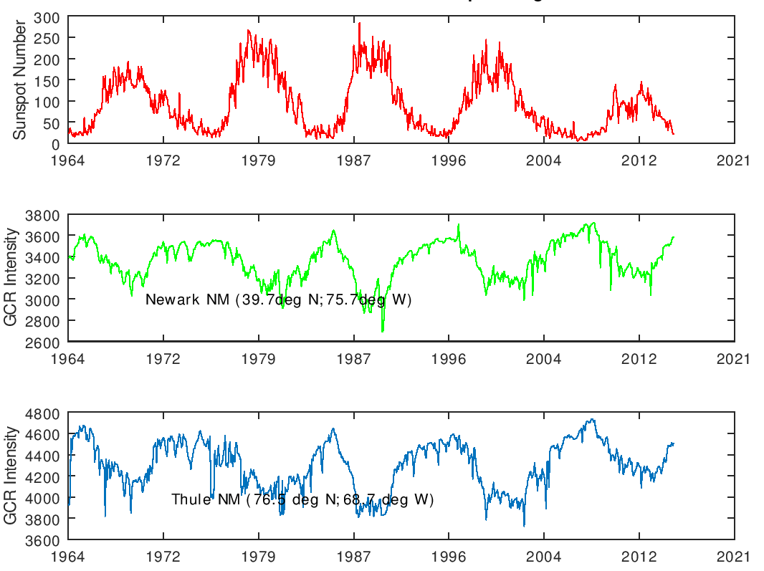
Figure 5: Time Series Analysis of SSN, GCR flux at NM Station in Newark and GCR intensities at NM Station in Thule. Geomagnetic latitude and Rc dependence of GCR incidence. Arctic region GCR peaked at 4700 (Counts). Upper Panel is the Variation of SSN across the 5 Solar Cycles. The peaks represent periods of Solar Maxima; and the lowest values are periods of solar minima. Solar Cycle 21 was the most active Cycle among the 5 Solar Cycles studied; where SSN attained a peak of approximately 250 (Counts) in the year 1979. This was followed by Solar Cycle 22 as SSN peaked at about 220 (Counts). It is obvious that Solar Cycle 24 was the least active Cycle as SSN peaked at about 80 (Counts) in the year 2012. Middle Panel depicts the GCR flux at a Middle Latitude NM Station in Newark, USA. Periods of lowest incidence of GCR correspond with periods of peak SSN counts. The trend shows that SSN and GCR are anti correlated. In other words, high solar activity results in reduction of GCR flux penetrating the Earth’s atmosphere. Also, at Solar Minima, GCR flux attained maximum values on the average of 3600 (Counts) throughout the period under investigation. Thus Geomagnetic fields creates a shielding effect on Earth. Lowest Panel: at the Arctic region NM Station in Thule, incidence of GCR is more pronounced; in the domain of 4600 (counts) during Solar Maxima periods across the 5 Solar Cycles. It is compelling to infer a higher influx of GCR at the Polar region in comparison to its incidence at the Middle Latitude.

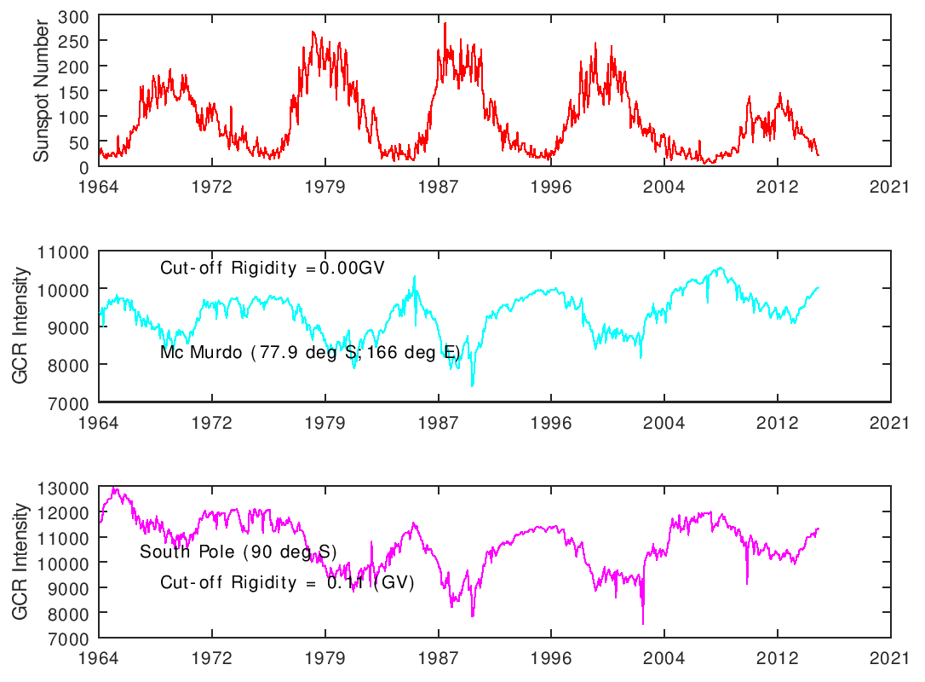
Figure 6: Variations of SSN and GCR from 1964 to 2016. The Upper Panel is the SSN signature for the 5 Solar Cycles; from 1964 to 2016. SSN peaked at Solar Maxima periods, while the lows are SSN observed at Solar Minima periods. At Solar Maxima, the peaks in SSN correspond with lowest values of GCRs as shown in the middle and last panels for NM Stations at McMurdo and South Pole respectively. The Middle Panel shows the trend of variation of GCR as recorded at NM Station in McMurdo at the Antarctica. At McMurdo, Rigidity Cut-off is 0.00 (GV) and the Geomagnetic latitude is -80.2º. The Lowest Panel is the Variation of GCR intensity at NM Station in South Pole.
At McMurdo, GCR variation was within the domain of 10,000 (Counts) at solar minima periods, where corresponding SSN was observed to be approximately 20 (Counts) as shown in Figure 6. Within the period under investigation, GCR flux at South Pole peaked at 13,000 (Counts) in 1966, whereas SSN was 20 (Counts). GCR and SSN variations exhibit an anti-phase pattern. Figure 7shows Smoothed GCR and Sunspots from 1960 to 2016. The signature in green is the variation of SSN. The red signature is GCR flux across the period of study. The smoothed GCR flux is high at Solar Minima and conversely low at Solar Maxima.

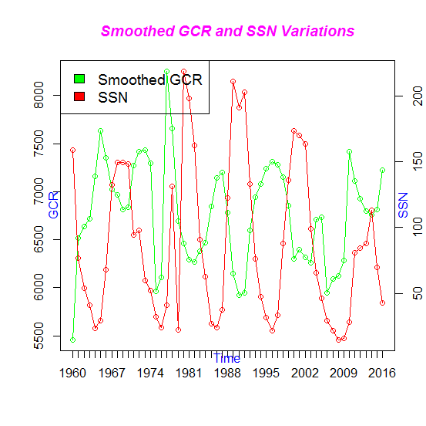
Figure 7: Smoothed GCR and Sunspots from 1960 to 2016. The signature in green is the variation of SSN. The red signature is GCR flux across the period of study. The smoothed GCR flux is high at Solar Minima and conversely low at Solar Maxima.

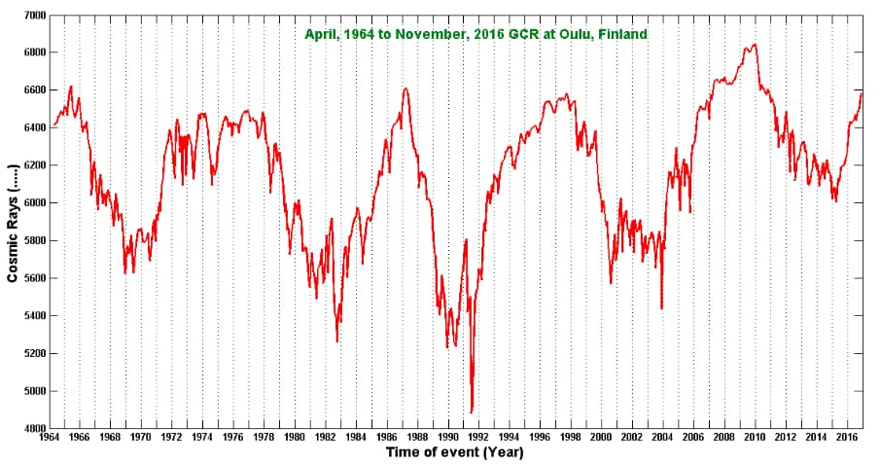

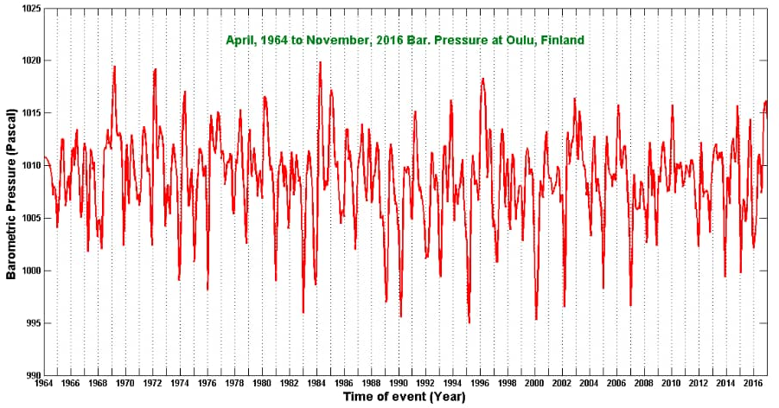

4 Conclusions
Propagation of Galactic Cosmic Rays in Earth’s atmosphere and subsequent incidence at the surface is reported to be controlled by the structure of Geomagnetic fields. This study attempted to estimate the extent of solar activity effect on incidence of GCR intensities at Arctic, Antarctica and Middle Latitude regions of the Earth.
We utilized the facilities at NASA Goddard Space Flight Center, Greenbelt, MD, USA and analyzed Geomagnetic aa index and GCR counts recorded at NM Stations in Thule at the Arctic, McMurdo and South Pole at the Antarctica and Newark located at the Middle Latitude region. Geomagnetic aa index was obtained from World Data Center for Geomagnetism, Kyoto, Japan. The Sunspot data used in this study was hosted at World Data Center Sunspot Index and Long Term Solar Observatory (WDC SILSO), Royal Observatory of Belgium, Brussels. And GCR data of the NM stations was hosted by Bartol Research Institute, University of Delaware, USA. These datasets spanned from 1960 to 2016, covering a 59 year period from the onset of solar cycles 20, towards the concluding period of Solar Cycle 24, in December 2016. Regression Analysis was employed for the analysis. Regression of the dependent variable, GCR on the independent variable, Geomagnetic showed that the Coefficient of Determination R², is less than 0.5 at the Arctic, Antarctica and Middle latitude regions throughout the period under investigation. The negative Regression Coefficients in the regression of GCR on Geomagnetic aa-index are a proof that Geomagnetic activities, vis a vis Geomagnetic fields impede penetration of GCR through the magnetosphere. The Time Series Analysis shows highest penetration of GCR particles into Earth’s atmosphere at the Polar regions, where the Rigidity Cutoff is lowest. Thus, we infer that influx of GCR into Earth’s Atmosphere is Geomagnetic latitude dependent.

Acknowledgement
I appreciate the Government of United States of America through the Catholic University of America for funding my Research Visit to the National Aeronautics and Space Administration Goddard Space Flight Center (NASA GSFC), Greenbelt, Maryland, USA where this study was conducted. It was a great privilege working with one of the World Renowned Space Scientists, Dr. Dean Pesnell of the Heliophysics Science Division of NASA GSFC. On behalf of the authors, I am thankful to the Atmospheric Research Group of Department of Physics and Astronomy, University of Nigeria, Nsukka. I acknowledge the invaluable support of my husband, Ikechukwu Nwanze who created the desired conducive family atmosphere in the course of writing this article. I am grateful to Sarah Hanson for always standing in my stead in executing some other forms of my routing activities.

References
Badruddin, O.P.M. Aslam. (2015). Influence of Cosmic-Ray Variation on the Monsoon Rainfall and Temperature. Jour. of Atm. and Solar-Terres. Physics. Vol. 122, pp 86 -96.
Benyamin D., Nakar E., Piran T., and Shaviv N. J. (2016). The B/C and Sub-iron/Iron Cosmic Ray Ratios—Further Evidence in Favor of the Spiral-Arm Diffusion Model. The Astrophysical Journal, Vol. 826, (1), pp. 47-53.
Benyamin D., Shaviv N.J., and Piran T. (2017). Electron-capture Isotopes Could Constrain Cosmic-Ray Propagation Models. The Astrophysical Journal, vol. 851, pp.109 -115.
Berezhko E.G. (2008). Cosmic Ray Acceleration by Supernova Shocks, Advances in Space Research, vol. 41, pp. 429-441, DOI:10.1016/j.asr2007.04.034.
Bhattacharya B., P. Barman, M. Roy. (2013). Response of Neutron Monitors to Cosmic Ray Counts: A Statistical Approach. International Journal of Engineering Science and Technology (IJEST), vol. 5 (09), pg. 1713 -1721, ISSN: 0975-5462.
Bütikofer R. (2018) Ground-Based Measurements of Energetic Particles by Neutron Monitors. In: Malandraki O., Crosby N. (eds) Solar Particle Radiation Storms Forecasting and Analysis. Astrophysics and Space Science Library, vol 444. Springer, Cham. https://doi.org/10.1007/978-3-319-60051-2_6.
Cecchini S., Cattini D., Gali M., Gionannini G., Lattanzi D., Pagliarin A. (2003). Cosmic ray intensity variations observed by environmental radiation monitors. Proceedings of the 28th international cosmic ray conference. July 31 – august 17, 2003. Tsukuba, japan, under the auspices of the international union of pure and applied physics (iupap), editors: t. kajita, y asaoka, a. kawachi, y. matsubara and m. sasaki, p. 3577.
Grimani C., Telloni D., Benalla S., Cesarini A., Fabi M., and Villani M. (2019). Study of Galactic Cosmic-Ray Flux Modulation by Interplanetary Plasma Structures for the Evaluation of Space Instrument Performance and Space Weather Science Investigations. Atmosphere, vol, 10, (12), 749. DOI: https://doi.org/10.3390/atmos10120749.
Hanson E. A. and Okeke F.N. (2021). Impacts of Sunspot Number and Geomagnetic aa-index on Climate of Wet Zone West Africa during Solar Cycles 22-24, Scientific Reports, https://doi.org/10.1038/s41598-021-90999-6.
Kalugin, G. and Kabin K. (2015). Estimation of Index of Power Law Rigidity Spectrum of Cosmic Rays using Effective Rigidity of Multidirectional Muon Detector, Earth, Planet and Space, 67, 149, https://doi.org/10.1186/s40623-015-0318-8.
Lara A., Borgazzi A., and Caballero-Lopez R. (2019). Altitude Survey of the Galactic Cosmic Ray Flux with a Mini Neutron Monitor. Advances in Space Research, vol. 58, (7), pp. 1441-1451.
Matsui, T., S. Q. Zhang, S. E. Lang, W. Tao, C. Ichoku, and C. D. Peters-Lidard. (2018). Impact of radiation Frequency, Precipitation Radiative Forcing, and Radiation Column Aggregation on Convection-Permitting West African Monsoon Simulations. Climate Dynamics. https://doi.org/10.1007/s00382-018-4187-2.
Paudel A. (2014) Energy Harvesting from Solar Wind and Galactic Cosmic Rays, Jour. Of Energy Research and Environmental Technology, vol.1 (1), pp 33-36.
Perry C.A. (2007). Evidence for Physical Linkage between Galactic Cosmic Ray and Regional Climate Time Series, Advances in Space Research, pp. 353-364, doi.org/10.1016/j.asr.2007.02.079
Ross E., and Chaplin W. J. (2019). The Behaviour of Galactic Cosmic Ray Intensity during Solar Activity Cycle 24. Solar Physics, vol. 294 (8).
Shuai F., Xiaoping Z., Lingling Z., and Young L. (2021). Variations of the Galactic Cosmic rays in the Recent Solar Cycles. Astrophy. Jour. Supplement Series, Vol. 254, (2).
Suyeon, O., J.W. Bieber, P. Evenson, J. Clem, Y. Yi, and Y, Kim (2013). Record Neutron Monitor Counting Rates from Galactic Cosmic Rays. Journal of Geophys. Res.: Space Physics, Vol. 118, pp 5431-5436, doi:10.1002/jgra.50544.
Tezari A., H. Mavromichalaki, D. Katsinis, A. Kanellakopoulos, S. Kolovi, C. Plainaki, and M Andriopoulou. (2016). Latitudinal and Longitudinal Dependence of the Cosmic Ray Diurnal Anisotropy during 2001 – 2014. Ann Geophys., vol. 34, pg. 1053-1068.
Tortermpun U., Rffolo D., and Bieber J.W. (2018). Galactic Cosmic Ray Anistropy During the Forbush Decrease Starting 2013, The Astrophys. Journ. Letters, Vol. 852, (no. 2).
Wawrzynczak A. and Alania M.V. (2011). Energy Dependence of the Rigidity of Spectrum of Forbush Decrease of Galactic Cosmic Ray Intensity. Conference Proceedings of the 32nd ICRC. DOI: 10.7529/ICRC2011?V10/0817.

