AGRICULTURE IN MALAYSIA: TRENDS, CHALLENGES, AND PATHWAYS TOWARD SUSTAINABLE GROWTH

ABSTRACT
This review paper provides a comprehensive analysis of the agriculture industry in Malaysia, focusing on its current landscape, prevailing challenges, government policies, and future prospects for sustainable development. Agriculture remains a vital sector in Malaysia, supporting food security, rural employment, and national economic growth. While traditionally dominated by commodities such as palm oil, rubber, and rice, the industry has seen gradual diversification into high-value crops, aquaculture, and agrotechnology-driven practices. Despite these advancements, the sector faces a range of structural and environmental challenges. These include limited arable land, aging farming populations, labor dependency, low technology adoption among smallholders, and the escalating impacts of climate change. Such constraints have hindered productivity growth and jeopardized long-term sustainability. In response, the Malaysian government has introduced a series of policy frameworks and strategic plans, including the National Agrofood Policy (NAP 2.0) and the 12th Malaysia Plan, aiming to modernize the sector through digital transformation, climate-resilient practices, youth empowerment, and enhanced food supply chains. The review also evaluates prospects for the agriculture sector, emphasizing the role of innovation, precision farming, and sustainable resource management. Emerging opportunities lie in smart farming systems, vertical agriculture, public-private partnerships, and the promotion of export-oriented, high-value produce. This paper concludes that Malaysia’s agricultural future depends on its ability to overcome longstanding limitations while embracing a forward-looking, inclusive, and technology-enabled development model. Strategic collaboration between stakeholders, evidence-based policymaking, and investment in sustainability-focused initiatives are essential to secure a resilient agricultural ecosystem for the coming decades.

Keywords: Agricultural Development in Malaysia, Agricultural Policy and Governance, Agrotechnology Adoption, Climate Change and Food Security, Sustainable Agriculture.

INTRODUCTION
We live in a world where billions of people still face inequalities, poverty, joblessness, environmental degradation, and disease. Unfortunately, the leaders are still looking to use military force and war to resolve conflicts and disputes, resulting in increased poverty, economic instability, displacement, and unwanted migration. Besides, climate change is another serious matter and has devastating and irreversible impacts on nature, the environment, and our lives (FAO, 2017; Fujimori, et al., 2019; Rahman, Rana, & Khanam, 2022; Samiullah & Khanum, 2024). In contrast, massive development has been achieved globally to improve our living standards and welfare. The advancement in technology has caused transportation, financial system, political affairs, communication, and societal relations to change in the last century (Bell, Hallak, & Silvia, 2022; ANNA & Eric, 2022; Stanley, Radey, & Wilke, 2024). Based on the mentioned world’s challenges and the capacity of high technology, the General Assembly of the United Nations adopted the 2030 Agenda for Sustainable Development, which contains 17 Sustainable Development Goals (SDGs) and zero hunger, and is ranked number two on the list. However, the goal is currently not on track, and one hundred thirty-five million people are now suffering from acute need, and it is mainly due to climate change and economic downturns (United Nations, 2025).
The Zero Hunger Goal is not limited to having some food to eat daily, it is defined as food security. According to the Food and Agriculture Organization (FAO), “food security exists when all people, at all times, have physical and economic access to sufficient safe and nutritious food that meets their dietary needs and food preferences for an active and healthy life” (FAO, 1996, p. 43). Poverty is often the root of food insecurity; every human inhabitant deserves the right to access quality and nutritious food. Achieving food security leads to a wide range of positive impacts such as job creation & economic growth, poverty reduction, increased global security and stability, trade opportunities, and improved health and healthcare (USDA, 2025). Unfortunately, food insecurity still exists predominantly in areas with low economic development.
Moreover, the agricultural and food industries play a vital role in achieving the Zero Hunger Goal because they are directly correlated with increasing food production and security. Additionally, they can support the achievements of the other goals because they are indirectly related to improving the economy, job opportunities, lifestyle standards, poverty, and the ecosystem in total (Bell, Hallak, & Silvia, 2022; ANNA & Eric, 2022; Sporchia, et al., 2024; Faghiri, Yusop, Othman, & Krauss, 2019). Furthermore, globalization has provided the opportunity for integrated agriculture and food production. This process has brought many benefits, but presents challenges in its regulation and the need to steer it toward more equitable and sustainable outcomes (FAO, 2017; Fujimori, et al., 2019; Rahman, Rana, & Khanam, 2022; Sansika, et al., 2023).
METHODS
This paper adopts a systematic review methodology. Academic databases (Scopus, Web of Science, Google Scholar) and institutional sources (FAO, World Bank, DOSM, and Malaysian government policy documents) were reviewed from 2010–2025. Search terms included “Malaysia agriculture,” “food security Malaysia,” “urban farming Malaysia,” and “National Agrofood Policy.” Literature was screened for relevance, credibility, and recency. This approach follows established methodologies for systematic reviews (Snyder, 2019; Tranfield, Denyer, & Smart, 2003)
OVERVIEW OF THE AGRICULTURE INDUSTRY IN MALAYSIA
The agriculture sector is one of the most critical industries in any nation. It sustains the global population via the cropping of plants and the domestication of animals by providing food and other products. The agriculture sector is crucial for economic growth and is a powerful tool to end extreme poverty (Harris & Fuller, 2014; Smyth & Gillis, 2022).
The agriculture sector has a long and rich history in Malaysia. It contains the transition from conventional farming to modern, commercial operations. The large-scale plantations were established by introducing export capacity crops such as rubber (1876), palm oil (1970), and cocoa (1950s) during the British colonialization period. These developments became the foundation for Malaysia's role as a global supplier of agricultural commodities (Huff, 2024; Graham & Floering, 2024). Over time, the agriculture sector has expanded to include more products such as rice, fruits, vegetables, aquaculture, and livestock to make a balance between the export and local food production to support domestic food security (Sultan, Shahar, Zain, & Komoo, 2024). However, the Malaysian agriculture sector has been lagging behind Indonesia, Thailand, Vietnam, China, and many more in terms of innovation, technology, knowledge methodology, and value chain development for some time now. The country has neglected the agriculture sector with a lack of funding and focus, as the industrialization sector pushed forward in 1981 (AS, 2019; Hoang, 2020; Xu & Nam, 2023).
According to the recent data, Malaysia’s agriculture sector contributed around 8% to the nation’s GDP in 2023, which increased from 6.6% contribution from the year before (Siddharta, 2025A; Siddharta, 2025B; Faghiri, Yusop, Othman, & Krauss, 2019). According to the World Bank (2025) employment in the agriculture sector in Malaysia still stands at about 10% of the country's workforce, with around 1.5 million people involved. However, the percentage of the workforce involved in the agriculture sector in Malaysia has constantly reduced over the decades. This indicates that there was a rapid urbanization in Malaysia between 1991 to 2023 and highlights the urgency of the agriculture sector and food security in this condition (RUSLI, et al., 2024). Figure 1 illustrates the total employment in Malaysia’s agriculture sector from 1991 to 2023.

Source: World Bank (2025)
Figure 1. Total employment in the agriculture sector in Malaysia
Malaysian agriculture sector plays a significant role in the country's economy and export performance, with RM 188 billion in 2022, driven primarily by palm oil (Siddharta, 2025C). Palm oil is considered the main export agricultural product of Malaysia. The country is the second largest palm oil producer globally, accounting for 26% of world production and 34% of exports in 2020 (ITA, 2025). The next major agricultural product is rubber, with production around 528,900 metric tons in 2023 (Malaysian Rubber Council, 2025). Another notable product is cocoa, with production around 30,000 metric tons, both are significant for export markets (Nurfadzilah, Nawi, Wong, & Mahirah, 2024). Figure 2 displays the gross value added of the agriculture sector by type of economic activity in Malaysia in the year 2022.
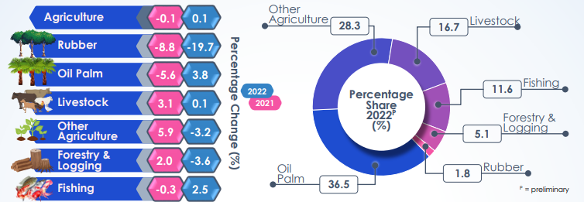
Source: DOSM 6 (2025)
Figure 2. Gross value added of the agriculture sector by type of economic activity in Malaysia in the year 2022 (Constant 2015 Prices)
The figure shows that oil palm holds the most significant percentage (36.5 %) of the gross value added of the agriculture sector by type of economic activity in Malaysia (2022). The next sector is other agricultural products with 28.3%, which contain food crops such as fruits, vegetables, and rice. It is then followed by livestock, fishing, forestry, logging, and rubber at 16.7%, 11.6%, 5.1%, and 1.8%, respectively. The percentage change illustrates that the total agriculture industry becomes slightly larger by 0.1% from 2021 to 2022. The oil palm had the greatest growth of 3.8%, followed by fishing with 2.5% and livestock with 0.1%. In contrast, rubber showed a massive decrease of 19.7%, which is the result of the global demand reduction after the COVID-19 pandemic. Forestry and Logging and the other agriculture products (Food crops) industries' gross value decreased by 3.6% and 3.2% respectively from 2021 to 2022 (DOSM 6, 2025). Also, Figure 3 shows the gross domestic product from the agriculture industry in Malaysia from 2010 to 2022.
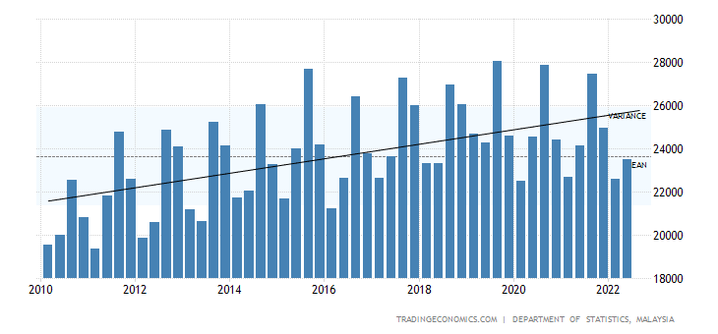
Source: Trading Economics (2022).
Figure 3. GDP from the agriculture sector in Malaysia
According to the above figure, the average GDP from agriculture is RM 23.63626 billion from 2010 until 2022, with the highest of RM 28030 million in the third quarter of 2019 and the lowest of RM 19362 million in the first quarter of 2011. The trend has shown an increase in GDP from 2010 to 2022. Although Malaysia's agricultural industry has shown growth in recent years, the speed of development has been slow (Trading Economics, 2022).
Department of Statistics Malaysia studied the production amount, exports and imports, and indicators of the Self-Sufficiency Ratio (SSR), Import Dependency Ratio (IDR), and consumption per capita for 54 selected agricultural commodities from 2019 to 2023. Figure 4 illustrates the SSR for selected agricultural commodities in 2023, where 26 items of selected agricultural commodities achieved more than 100% SSR in 2023 (Department of Statistics Malaysia, 2025).
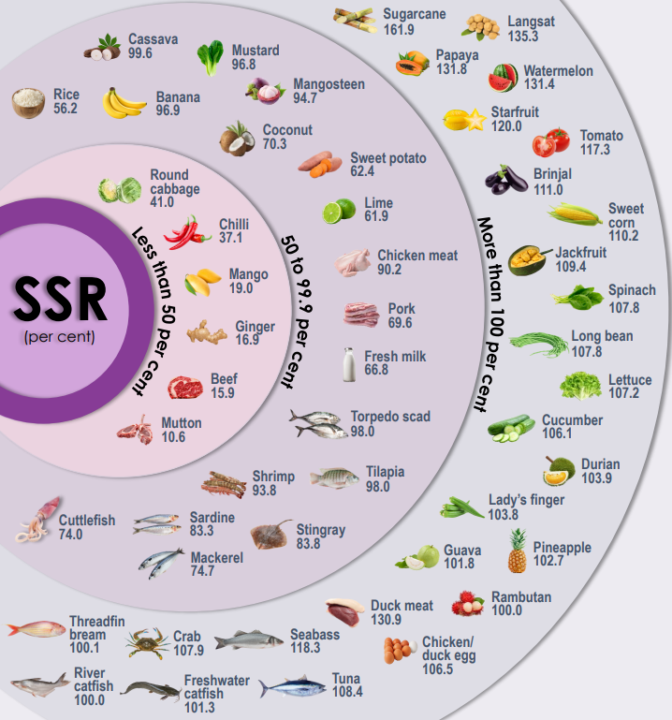
Source: (DOSM 1, 2025).
Figure 4. SSR of the selected agricultural commodities 2023
According to the Department of Statistics Malaysia (2025), there is a certain level of Import Dependency Ratio (IDR) for all selected agricultural commodities in 2023 (Figure 5).
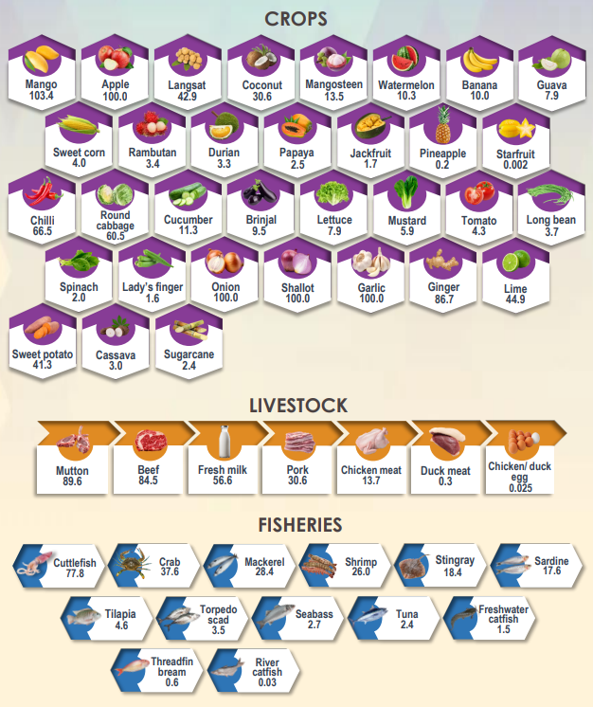
Source: (DOSM 1, 2025).
Figure 5. IDR of the selected agricultural commodities in 2023 (%)
The import dependency would not be limited to only the selected agricultural commodities studied and reported by the Department of Statistics Malaysia. Malaysia outsources food from many countries to meet the ever-growing demand, becoming a net importer of food. Malaysia spent RM 78.79 billion on imported food and beverages in 2023, an increase from the previous year’s RM 75.62 billion, which means the nation is still highly reliant on importing food in 2023 (Dardak, 2020; DOSM 1, 2025; Siddharta, 2025; Department of Statistics Malaysia, 2025).
CHALLENGES FACING MALAYSIA’S AGRICULTURE INDUSTRY
Malaysia's agriculture sector faces several challenges and problems that threaten its sustainability and growth:
Land Scarcity: Urbanization and competition from other sectors have negative effects on agricultural land use for food crops. As mentioned, Malaysia’s agricultural industry is primarily dominated by agricultural commodities such as palm oil and rubber. Currently, these plantations cover 83.7% of the total agricultural land, and only 16.3% of agricultural land has remained for agrifood production (Sharifulden, 2024). This scarcity affects food security, as noted by the Banting assemblyperson (Malaysiakini, 2025). Figure 6 illustrates the agricultural land distribution in Malaysia in 2021.
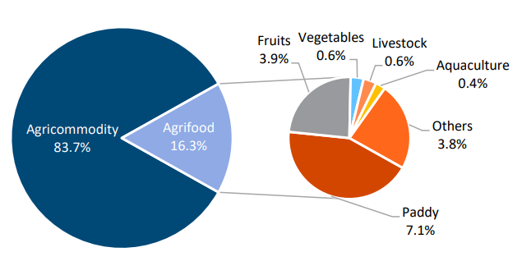
Source: Sharifulden (2024).
Figure 6. Agricultural land use by subsectors in Malaysia, 2021
Labor Shortages: The agriculture sectors depend heavily on foreign labor, with about 500,000 employed in 2022 (Siddharta, 2025D). Malaysian palm oil farmers had to let thousands of tons of palm oil fruits rot as the third year due to the labor shortage, and they were unable to increase their harvesting during the peak production season (Chu, 2025).
Climate Change: There are various impacts of climate change in the agriculture industry, such as rising temperatures, unusual rainfall, and extreme weather events, which reduce crop yields (Tan, Fam, Firdaus, Tan, & Gunaratne, 2021). According to Xiang & Solaymani (2022), for each 1% increase in temperature, there is a 2.87% decrease in cereal production.
Pest and Disease Management: The Widespread occurrence of pests and diseases has posed a serious threat to the Malaysian agriculture industry over the years. It caused hundreds of millions of dollars and total yield due to the wrong pest and disease management, such as conventional methods and chemical approaches (Lim, et al., 2023).
Technological Adoption: The adoption rates for applying technology in Agriculture are slow in Malaysia due to the smallholder farmers' weak financial situation, average age over 50 years, low education level, and lack of access to technology. However, Digital Agriculture Technologies (DATs) are considered key to future farming, but challenges remain in implementation (World Bank, 2024).
Food Safety and Quality Standards: Confirming compliance with standards like the Food Act 1983 is essential for export markets. However, the Food Safety & Quality Division (FSQD) oversees food supply chain safety, the smallholder farmers often struggle with the regulations (Louis, Fernandez, Tajuddin, & Ismail, 2022; Bee, 2025).
URBAN FARMING IN MALAYSIA
Malaysia is one of the most urbanized countries in East Asia due to its rapid urbanization. The urban population increased by an astonishing 66% in 2004 and 74% in 2014, and it is expected to grow even further. Migration from rural areas is often linked to a better economy and employment status in urban areas; at present, approximately 76% of the population resides in urban areas such as Kuala Lumpur, Selangor, and more (Statista, 2022). Implementing urban farming is a proposed way of creating sustainable food production for the growing urban population. Urban agriculture is the practice of cultivating, processing, and distributing food within the city's vicinity; the diversification of food sources and the route to self-sufficiency can ensure food security in urban areas as the food system improves (Haberman, et al., 2014). Urban farming techniques are abundant, from organic cultivation to eliminating herbicides and pesticides to a soilless culture of hydroponic production where crops are nourished via nutrient solution (Heikenfeld, 2017).
The market for urban agriculture, specifically commercial vertical farms, has become increasingly popular among investors and corporations such as IKEA, Google Ventures, SoftBank, and the Sheikh of Dubai. These corporations invested approximately 400 million dollars in 2017 and 2018 in companies and projects like AeroFarms, Bowery Farming, and Plenty (Forbes, 2025). In the context of Malaysia, a significant example is the joint venture collaboration between FarmByte from Malaysia and Archisen from Singapore in 2024 to set up a 52,000-square-foot smart indoor vertical farm in Johor Bahru, Malaysia. The estimated capital investment for this project is RM36.7 million, and the farm is expected to produce over 306 tons of premium leafy greens and vegetables per year to enhance local food production and create high-value jobs in agriculture (igrownews, 2025A). Such enterprises align with Malaysia's Digital AgTech strategic plans and policies, which encourage the integration of the advanced technologies such as the Internet of Things (IoT), artificial intelligence (AI), and automation to transform conventional agricultural practices to the modern farming, thereby improving productivity and efficiency at the farm level and contributing to the Malaysia’s GDP (Sharon, 2025)
The Malaysian government has recognized the potential of vertical farming and urban farming in achieving self-sufficiency and economic resilience. Incentives and policies are being initiated to encourage research, innovation, and investment in this area. Thus, they highlighted that by maximizing the efficiency of the land, space, and other resources usage and reducing reliance on food imports, vertical farming and urban farming could play a significant role in supporting Malaysia's GDP and food security (Musa, 2025). However, the vertical and urban farming's typical challenges, such as high initial investment costs and the need for technical skill, remain. Addressing these problems through financial support, proper training programs, and public-private cooperation is necessary to boost the adoption and success of vertical and urban farming in Malaysia (Senadjki, Nee, Kumaran, & Nathan, 2025).
MALAYSIA GOVERNMENT PLANS AND POLICIES
The agriculture industry is compromised by the aging population, while fewer young people are entering the industry. The stigma and impression that agriculture in society is a low-class and degrading sector are a few reasons for youth rejection of job prospects and further education. The menial work and discouragement from parental figures have ultimately reduced the willingness to work in the agricultural sector. The ever-growing population requires human capital, so youth participation is crucial for the agricultural economy to flourish and continue food production (Tiraieyari & Krauss, 2018).
The Malaysian government launched the National Agrofood Policy (NAP4) from 2011 to 2020; the policy was set to enhance and transform the Malaysian agricultural sector to be a sustainable, dynamic, and progressive industry. At the same time, they were facing climate change, land scarcity, environmental degradation, etc. The four main goals of NAP4 are (1) Adequate food supply and safety, (2) Developing the Agro-food industry into a competitive and sustainable industry, and (3) Increasing the income level of agricultural entrepreneurs. These primary objectives were created around eight main ideas for the agricultural sector development (Dardak, 2022):
- Expansion of high-value agriculture
- Sustainable agricultural
- Food security
- Dynamic agricultural cluster with profit maximization
- Private investment in modern agriculture
- Information and knowledge-based human capital
- Modernization of agriculture through Research and Development, innovation, and technology
- Premier agricultural support services
The policy has emphasized the use of modern technology, which makes vertical farming and urban farming an option. In addition, the government is in support of green programs for urban participation. Though the policies toward sustainable development need to be matched with current needs, leveraging investment through education and training is essential. This allows the public and youth to be empowered with knowledge and awareness (Rabu & Muhammad, 2015). Recently, the government launched a program called 'Program Sentuhan Kasih Tani-Pertanian Bandar 2.0' to create 20,000 urban farms to ensure food security and complete the food chain by 2020 (Albab, 2022). Amidst Covid-19, the government had revisited the approach to advance the agriculture sector to modernize (Murdad, et al., 2022).
The future is highly dependent on youth; policies and public perception must be changed for the sector to succeed and attain food security. Firstly, parental influence plays a crucial role in the decision-making of the youth regarding what to pursue in life. The impact of parents who perceive negatively is detrimental to society. Parents are encouraged to nurture the new generation and expose them to agricultural activity as a viable option in the future. Secondly, government initiatives such the support assistance like grants and subsidies can increase the efficiency of agricultural activity. Thirdly, A role model; the idea of being ‘anything you want to be is a narrative that has been played in society. The correct role model demonstrating the importance of agriculture can ultimately gain the confidence of youth and promote participation. Lastly, youth should be more in tune and seek knowledge about the industry to understand the importance of the agricultural sector. Information should not be relayed by the negative stigma that has been made by others who were not in the industry. In contrast, people in the industry should see the potential in youth. The youth should experience it firsthand before making a judgment of the sector. (Saili, Safari'ee, Saili, & Hamzah, 2018).
The importance of economic stability lies in the agricultural sector. Therefore, the Malaysian government encourages youth involvement in agro-entrepreneurship to transform the negative perception of agriculture through technology and modernization. The government package given to the youth includes several phases (Dardak, Haimid, & Masdek, 2020):
- Training and formation programs
- Advice and support services
- Technical and practical advice
- Financial support, including loans and grants
- Marketing advice services
- Continuous guidance/ monitoring
The government is currently prioritizing urban agriculture through the National Agrofood Policy 2.0 (NAP 2.0) 2021–2030, with an emphasis on building a resilient, technology-driven agrofood sector. Urban farming is being actively promoted as a key strategy under the National Food Security Policy Action Plan 2021–2025, which aims to integrate food production into city planning and support community farming initiatives (Ministry of Agriculture, 2025). Pilot urban farming projects in Kuala Lumpur are designed to address food insecurity while promoting environmental sustainability (The Malaysian Reserve, 2025).
In addition, strategic programs such as the Urban Community Agriculture Program (UCF) and initiatives by the All-Party Parliamentary Group Malaysia on Sustainable Development Goals (APPGM-SDG) have facilitated thousands of community projects, thereby increasing public awareness and participation in urban farming (Chong, Nawawi, Ali, Ahmad, & Juhari, 2024). The Department of Agriculture Malaysia has set ambitious targets to produce 8,800 metric tons of urban agriculture products by 2025, underscoring the government's commitment to scaling up urban farming at the national level (Department of Agriculture Malaysia, 2025).
Thus, the Malaysian government's plans and policies reflect a comprehensive and evolving strategy to revitalize agriculture, support sustainable urban farming, and empower the next generation. Through sustained investment in education, infrastructure, and technology, Malaysia aims to secure its food systems while transforming agriculture into a vibrant and attractive sector for future generations.
ETHICAL APPROVAL
Ethical approval was not required for this study, as it is a review paper based exclusively on previously published literature and did not involve human participants, animals, or the collection of primary data.
CONFLICT OF INTEREST
The authors declare that they have no known competing financial interests or personal relationships that could have appeared to influence the work reported in this paper.
CONCLUSION
Malaysia’s agriculture sector is at a crossroads: essential for food security yet constrained by structural inefficiencies, climate change, and global market volatility. Government policies and modernization efforts show promise, but long-term resilience requires stakeholder collaboration, evidence-based policymaking, investment in sustainable technologies, and scalable urban farming systems. By addressing structural gaps while embracing digital agriculture and urban farming, Malaysia can build a sustainable, self-sufficient, and globally competitive agricultural ecosystem.
REFERENCES
Albab, A. (2022, May 2). 20,000 Urban Garden Communities By 2020. Retrieved from My News Hub: https://www.mynewshub.tv/utama-sensasi/20000-komuniti-kebun-bandar-menjelang-2020/
ANNA, C., & Eric, P. (2022, April 27). SDG 2 – zero hunger, and EU action against hunger and malnutrition. Retrieved from Policy Commons: https://policycommons.net/artifacts/2221158/sdg-2/2978108/
AS. (2019, December 3). Malaysia's Lagging Agriculture Sector. Retrieved from Asia Sentinel: https://www.asiasentinel.com/p/malaysia-lagging-agriculture-sector
Bee, Y. G. (2025). Food Supply Chain in Malaysia. Krinstitute organization.
Bell, L., Hallak, L., & Silvia, L. (2022). Not Our Menu: False solutions to hunger and malnutrition (Right to Food and Nutrition Watch, issue 13. World Nutrition, 13(1), 125-128.
Chong, N. O., Nawawi, F. N., Ali, M. M., Ahmad, M. S., & Juhari, S. K. (2024). Urban agriculture activities scenario in relation to food security in Malaysia. Planning Malaysia, 22(31).
Chu, M. M. (2025, April 1). Labour shortages set up Malaysia for third year of palm oil losses. Retrieved from Reuters: https://www.reuters.com/markets/commodities/labour-shortages-set-up-malaysia-third-year-palm-oil-losses-2022-09-07/
Dardak. (2020). Addressing Food security in Challenging Times. Malaysian Agricultural Research and Development Insititute (MARDI), 1-9.
Dardak. (2022, May 10). Malaysia Agrofood Policy (NAP 2011-2020). Retrieved from FFTC Agricultural Policy Platform: https://ap.fftc.org.tw/article/1368#:~:text=The%20NAP4%20covers%20a%20period,destination%20in%20two%20years'%20time.
Dardak, R., Haimid, M., & Masdek, N. (2020). Youth and Agrotechnopreneurship Ecosystem in Malaysia. Policy Articles | Agricultural human resources development, Agribusiness, 1-9.
Department of Agriculture Malaysia. (2025, April 26). Community Agricultural Development Program. Retrieved from Department of Agriculture Malaysia: https://www.doa.gov.my/index.php/pages/view/332
Department of Statistics Malaysia. (2025, April 1). Self Sufficiency Ratio 2023. Retrieved from Department of Statistic Malaysia Official Portal: https://www.dosm.gov.my/uploads/release-content/file_20240926102216.pdf
DOSM 1. (2025, April 1). Supply and utilization account selected agriculture commodities, Malaysia 2019-2023. Retrieved from Department of Statistic Malaysia Official Portal: https://www.dosm.gov.my/portal-main/release-content/supply-and-utilization-accounts-selected-agricultural-commodities-malaysia-2019-2023-
DOSM 6. (2025, 4 1). Selected Agriculture Indicators, Malaysia, 2023. Retrieved from Department of Statistics Malaysia Official Portal: https://www.dosm.gov.my/portal-main/release-content/selected-agricultural-indicators-malaysia-
Faghiri, H., Yusop, Z., Othman, M. H., & Krauss, S. E. (2019). Factors influencing the dairy industry development and milk production level in Malaysia: A hybrid approach of coding and theme development. International Journal of Modern Trends in Business Research, 2(10), 34-51.
Faghiri, H., Yusop, Z., Othman, M. H., & Krauss, S. E. (2019). Structural Analysis of Factors Affecting Dairy Cattle Industry Development in Malaysia. Review of Politics and Public Policy in Emerging Economies 1, no. 1, 23-42.
FAO. (1996). Rome Declaration on World Food Security and World Food Summit Plan of Action : World Food Summit, 13-17 November. FAO (p. 43). Rome, Italy: FAO.
FAO. (2017). The future of food and agriculture–Trends and challenges. Rome: FAO.
Forbes. (2025, April 5). Investing in Vertical Farmings: Five Take Aways. Retrieved from Forbes: https://www.forbes.com/sites/erikkobayashisolomon/2019/04/05/investing-in-vertical-farming-five-take-aways/?sh=5d7ccd0e355c
Fujimori, S., Hasegawa, T., Krey, V., Riahi, K., Bertram, C., Bodirsky, B. L., & Drouet, L. (2019). A multi-model assessment of food security implications of climate change mitigation. Nature Sustainability, 2, 5, 386-396.
Graham, E., & Floering, I. (2024). The modern plantation in the Third world. Taylor & Francis.
Haberman, D., Gillies, L., Canter, A., Rinner, V., Pancrazi, L., & Martellozzo, F. (2014). The Potential of Urban Agriculture in Montréal: A Quantitative Assessment. ISPRS International Journal of Geo-Information, 3(3, 1101-1117.
Harris, D., & Fuller, F. (2014). Agriculture: Definition and Overview. In: Smith C. (eds) Encyclopedia of Global Archaeology. Springer, New York, NY, 104 - 113.
Heikenfeld, R. (2017). Explore four hydroponic grow systems for beginners. (GROWING::HYDROPINICS). Countryside and Small Stock Journal (1985), 101(4), 26-.
Hoang, V. V. (2020). Investigating the agricultural competitiveness of ASEAN countries. Journal of Economic Studies, 47(2), 307-332.
Huff, G. (2024). Vent-for-surplus in Southeast Asian development since 1870. World Development, 181, 106656.
igrownews. (2025A, April 26). FarmByte & Archisen Launch JV for Smart Indoor Vertical Farm in Johor Bahru. Retrieved from igrownews: https://igrownews.com/farmbyte-and-archisen-partner/?utm_source=chatgpt.com
ITA. (2025, 4 1). Malaysia Country Commercial Guide. Retrieved from International Trade Administration: https://www.trade.gov/country-commercial-guides/malaysia-agricultural-sector
Lim, J. A., Yaacob, J. S., Mohd Rasli, S. R., Eyahmalay, J. E., El Enshasy, H. A., & Zakaria, M. R. (2023). Mitigating the repercussions of climate change on diseases affecting important crop commodities in Southeast Asia, for food security and environmental sustainability—A review. Frontiers in Sustainable Food Systems, 6, 1030540.
Louis, M., Fernandez, A. A., Tajuddin, M. A., & Ismail, R. (2022). Enforcing CSR among Food Manufacturers in Malaysia Through Legal and Institutional Framework. Akademika, 92(2), 143-152.
Malaysiakini. (2025, April 1). Agricultural land scarce, says Banting assemblyperson. Retrieved from Malaysiakini: https://www.malaysiakini.com/news/462895#google_vignette
Malaysian Rubber Council. (2025, 4 1). Rubber Industry Overview. Retrieved from Malaysian Rubber Council: https://www.myrubbercouncil.com/industry/malaysia_production.php
Ministry of Agriculture. (2025, April 1). National Food Policy. Retrieved from KPKM: https://www.kpkm.gov.my/en/agro-food-policy/national-agrofood-policy
Murdad, R., Muhiddin, M., Osman, W. H., Tajidin, N. E., Haida, Z., Awang, A., & Jalloh, M. B. (2022). Ensuring Urban Food Security in Malaysia during the COVID-19 Pandemic—Is Urban Farming the Answer? A Review. Sustainability, 14(7), 4155.
Musa. (2025, April 26). Vertical farming the way to self-sufficiency. Retrieved from Institut Masa Depan Malaysia: https://institutmasa.com/ms/vertical-farming-the-way-to-self-sufficiency-2/?utm_source=chatgpt.com
Nurfadzilah, M., Nawi, N. M., Wong, M. Y., & Mahirah, J. (2024). APPLICATION OF SPECTROSCOPY TECHNOLOGY FOR NUTRIENT MONITORING IN COCOA PLANTATION: A REVIEW. Malaysian Cocoa Journal (16), 28-36.
Rabu, M., & Muhammad, R. (2015). The potential of urban farming technology in Malaysia policy intervention. Economic and Social Science Research Centre, Malaysian Agricultural Research and Development Institute (MARDI), 1-6.
Rahman, M. M., Rana, R., & Khanam, R. (2022). Determinants of life expectancy in most polluted countries: Exploring the effect of environmental degradation. Plos one 17(1).
RUSLI, N., LAI, L. Y., ROSLEY, M. S., Enn, L. C., HAMZAH, M., ALIAS, N. E., & MAMAT, M. R. (2024). Mapping of Sentiment Analysis on Food Security Among Malaysians Using Social Media Analytics. Journal of Sustainability Science and Management, 19(4).
Saili, A., Safari'ee, M., Saili, J., & Hamzah, N. (2018). YOUTH INCLINATION IN AGROPRENEURSHIP: STRATEGIES OF YOUTH. Sci.Int.(Lahore)., 497-500.
Samiullah, M., & Khanum, R. (2024). CLIMATE CHANGE AND ENVIRONMENTAL DEGRADATION: A SERIOUS THREAT TO GLOBAL SECURITY. European Journal of Social Sciences Studies, 9(5).
Sansika, N., Sandumini, R., Kariyawasam, C., Bandara, T., Wisenthige, K., & Jayathilaka, R. (2023). Impact of economic globalisation on value-added agriculture, globally. PLoS One, 18(7), e0289128.
Senadjki, A., Nee, A. Y., Kumaran, V. V., & Nathan, T. M. (2025). From Field to Market: Assessing the Adoption and Impact of Climate-Smart Farming Practices in Malaysian Bentong Ginger Cultivation. Advances in Economics, Business and Management Research. Atlantis Press.
Sharifulden, N. S. (2024). What Does it Take to Transform Malaysia’s Agriculture Sector into a High-Tech Industry? Khazanah Reserch Institute.
Sharon, A. (2025, April 26). Malaysia’s Digital Revolution in Agriculture. Retrieved from Open Gov: https://opengovasia.com/2024/08/30/malaysias-digital-revolution-in-agriculture/?utm_source=chatgpt.com
Siddharta, A. (2025, March 1). Import value of food in Malaysia from 2014 to 2023. Retrieved from Statista: https://www.statista.com/statistics/795515/import-value-of-food-malaysia/#:~:text=In%202023%2C%20the%20import%20value,ringgit%20in%20the%20previous%20year.
Siddharta, A. (2025A, 3 31). Share of agricultural sector to the gross domestic products (GDP) in Malaysia in 2023, by segment. Retrieved from Statista: https://www.statista.com/statistics/1338541/malaysia-share-of-agriculture-to-gdp-by-segment/
Siddharta, A. (2025B, 3 31). Contribution of agriculture to the gross domestic product (GDP) of Malaysia from 2015 to 2022. Retrieved from Statista: https://www.statista.com/statistics/952990/malaysia-agriculture-share-of-gdp/
Siddharta, A. (2025C, 4 1). Export value from the agricultural industry in Malaysia from 2017 to 2022. Retrieved from Statista: https://www.statista.com/statistics/1370394/malaysia-agriculture-export-value/
Siddharta, A. (2025D, April 1). Number of non-citizens employed in the agriculture, forestry or fishing industry in Malaysia from 2013 to 2022. Retrieved from Statista: https://www.statista.com/statistics/952403/non-citizens-employment-in-agriculture-industry-malaysia/
Smyth, J., & Gillis, R. (2022). Food and Farming Systems in the Neolithic–an Impossible Vista? Environmental Archaeology, 27(1), 1-7.
Snyder, H. (2019). Literature review as a research methodology: An overview and guidelines. Journal of Business Research, 104, 333–339.
Sporchia, F., Antonelli, M., Aguilar-Martínez, A., Bach-Faig, A., Caro, D., Davis, K. F., & Galli, A. (2024). Zero hunger: future challenges and the way forward towards the achievement of sustainable development goal 2. Sustainable earth reviews, 7(1), 10.
Stanley, L. H., Radey, M. L., & Wilke, D. J. (2024). CaseAIM: child welfare workers’ experiences using information and communication technology for case management services. Journal of Public Child Welfare, 1–20.
Statista. (2022, April 11). Urbanization in Malaysia 2019. Retrieved from Statista: https://www.dosm.gov.my/v1/index.php?r=column/cthemeByCat&cat=430&bul_id=Szk0WjBlWHVTV2V1cGxqQ1hyVlppZz09&menu_id=L0pheU43NWJwRWVSZklWdzQ4TlhUUT09
Sultan, M. T., Shahar, F. S., Zain, M. I., & Komoo, I. (2024). A systematic review of the role of integrated farming and the participation of universities in ensuring food security: Malaysia’s effort. Italian Journal of Food Safety, 13(2), 11854.
Tan, B. T., Fam, P. S., Firdaus, R. R., Tan, M. L., & Gunaratne, M. S. (2021). Impact of climate change on rice yield in Malaysia: a panel data analysis. Agriculture, 11(6), 569.
The Malaysian Reserve. (2025, April 26). Urban farming initiatives promote sustainable lifestyle. Retrieved from The Malaysian Reserve: https://themalaysianreserve.com/2024/06/17/urban-farming-initiatives-promote-sustainable-lifestyle/#google_vignette
Tiraieyari, N., & Krauss, S. E. (2018). Predicting youth participation in urban agriculture in Malaysia: Insights from the theory of planned behavior and the functional approach to volunteer motivation. Agriculture and Human Values, 35(3), 637-650.
Trading Economics. (2022, November 1). Malaysia GDP From Agriculture. Retrieved from Trading Economics: https://tradingeconomics.com/malaysia/gdp-from-agriculture
Tranfield, D., Denyer, D., & Smart, P. (2003). Towards a methodology for developing evidence-informed management knowledge by means of systematic review. British Journal of Management, 14(3), 207–222.
United Nations. (2025, March 1). Goal 2: Zero Hunger. Retrieved from Sustainable Development goals: https://www.un.org/sustainabledevelopment/hunger/
USDA. (2025, March 5). Global food security. Retrieved from National Institude of Food and Agriculture: https://nifa.usda.gov/topic/global-food-security
World Bank. (2024, April 1). Farming the Future: Harvesting Malaysia’s Agricultural Resilience through Digital Technologies. World Bank. Retrieved from https://www.worldbank.org/en/country/malaysia/publication/farming-the-future-harvesting-malaysia-s-agricultural-resilience-through-digital-technologies
World Bank. (2025, 3 31). Employment in agriculture (% of total employment). Retrieved from worldbank: https://data.worldbank.org/indicator/SL.AGR.EMPL.ZS
Xiang, X., & Solaymani, S. (2022). Change in cereal production caused by climate change in Malaysia. Ecological Informatics, 70, 101741.
Xu, H., & Nam, N. H. (2023). Determinants of Vietnam's potential for agricultural export trade to Asia-Pacific economic cooperation (APEC) members. Heliyon, 9(2).

