Bandwidth Estimation and Power distribution in Phase-Modulated Signals using Bessel Function Analysis
Dhiraj Saxena
Department of Physics,
Lachoo Memorial College of Science & Technology, Jodhpur (Raj.) India
Email: djlmcst@gmail.com

Abstract
This work presents a comprehensive spectral analysis for bandwidth estimation of phase-modulated (PM) signals using Bessel functions of the first kind. The mathematical framework of phase modulation is developed and expressed through Fourier–Bessel expansion, revealing the role of modulation index in determining sideband amplitudes and spectral distribution. Numerical simulations confirm theoretical predictions and demonstrate the redistribution of carrier power among sidebands with increasing phase deviation. The results provide analytical insight useful for communication system design and bandwidth optimization.
Keywords: Phase modulation, Bessel function, spectral analysis, modulation index, sidebands, communication theory.

1. Introduction
Phase modulation (PM) is a fundamental analog modulation technique widely employed in communication systems due to its constant envelope property and robustness against amplitude noise. In PM systems, the instantaneous phase of a high-frequency carrier varies in proportion to the message signal keeping the amplitude constant [1,2].
Spectral analysis of PM signals reveals an infinite number of sidebands whose amplitudes are governed by Bessel functions [3]. Understanding this relationship is essential for bandwidth estimation, system optimization, and interference control.
This work presents a unified analytical interpretation of Bessel-governed power redistribution in PM systems. It includes:
• Bessel function representation of PM spectrum
• Numerical spectral verification and bandwidth estimation
• Practical interpretation of modulation index effects

2. Theory of Phase Modulation
The general phase-modulated signal is
$$s(t)=A_{c}cos⁡[ω_{c}t+k_{p}m(t)]$$
Where $A_{c}$= carrier amplitude, $ω_{c}$= carrier angular frequency, $k_{p}$= phase sensitivity, $m(t)$= message signal
For sinusoidal modulation
$$m(t)=Mcos⁡(ω_{m}t) \\ s(t)=A_{c}cos⁡[ω_{c}t+βcos⁡(ω_{m}t)] \\ β=k_{p}M$$
The parameter $β$is the phase modulation index [4]
3. Spectral Analysis of PM Signal
The spectrum of a PM signal consists of a carrier at $f_{c}$and infinite sidebands spaced by $f_{m}$.
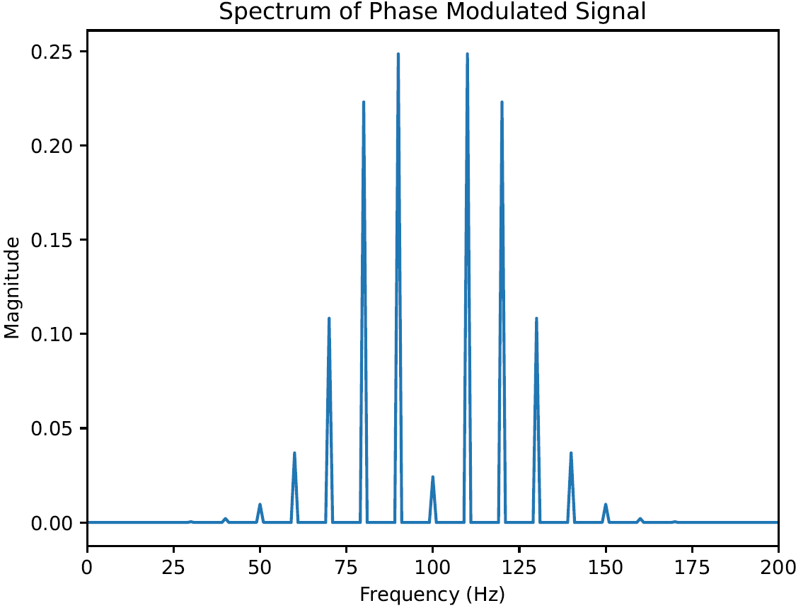
Fig 1. Frequency spectrum of a phase-modulated signal showing carrier and multiple sidebands spaced at integer multiples of the modulating frequency.

Bandwidth Estimation (Carson’s Rule)
$$BW≈2(Δf+f_{m})$$For PM:
$$Δf=βf_{m} \\ BW≈2f_{m}(β+1)$$
4. Fourier–Bessel Expansion of PM Signal
Using the Jacobi–Anger expansion:
$$e^{jβcos⁡x}=\sum_{n=-∞}^{∞}{j^{n}}J_{n}(β)e^{jnx}$$The PM signal becomes
$$s(t)=A_{c}\sum_{n=-∞}^{∞}{J_{n}}(β)cos⁡[(ω_{c}+nω_{m})t]$$Thus:
Amplitude of nth sideband
$$A_{n}=A_{c}J_{n}(β)$$
Power distribution
$$P_{n}∝∣J_{n}(β)∣^{2}$$
This result forms the analytical basis of spectral structure in PM systems.
5. Bessel Function Characteristics in Phase Modulation (PM)
The Bessel function magnitude determines how carrier power is distributed among sidebands.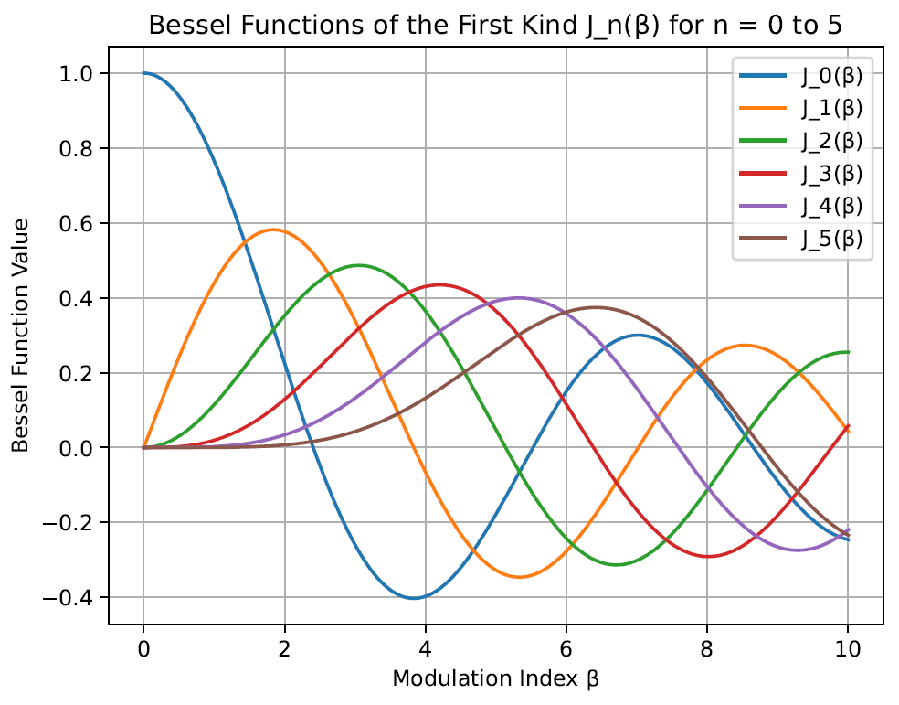
Fig 2. Bessel functions of the first kind $J_{n}(β)$for orders $n=0$to $5$ as a function of modulation index.
The curves determine the amplitudes of carrier and sideband components in phase-modulated signals.
Key observations:
• $J_{0}(β)$represents carrier amplitude
• Higher β → more significant sidebands
• Carrier may vanish at specific β values
For a single-tone phase-modulated signal,
$$s(t)=A_{c}cos⁡(ω_{c}t+βsin⁡ω_{m}t)$$
Using the Bessel function expansion:
$$cos⁡(ω_{c}t+βsin⁡ω_{m}t)=J_{0}(β)cos⁡ω_{c}t+\sum_{n=1}^{∞}{J_{n}}(β)\left[cos⁡(ω_{c}+nω_{m})t+(-1)^{n}cos⁡(ω_{c}-nω_{m})t\right]$$
This expression shows that a PM signal consists of the carrier component at f_{c}, infinite pairs of sidebands at $f_{c}±nf_{m}$ with amplitudes governed by Bessel functions $J_{n}(β)$
Physical Meaning of Bessel Coefficients
The coefficient $J_{n}(β)$represents the relative amplitude of the $n^{th}$order sideband.
As $β$increases we find that more sidebands appear. Moreover higher-order Bessel functions become significant only at larger $β$.
Range of β | Carrier $J_{0}(β)$ | Dominant Sidebands
Small β | Strong carrier | Only first sideband
Moderate β | Reduced carrier | Multiple sidebands
Large β | Carrier may vanish | Many sidebands

A crucial property is that carrier amplitude can become zero for specific β values (e.g., β ≈ 2.405, 5.52). This is a defining feature of angle modulation.

Power Distribution in PM Signal
In PM signals, since the amplitude does not change therefore the total transmitted power remains constant [4].
If $P_{T}$is total transmitted power:
$$P_{T}=\frac{A_{c}^{2}}{2R}$$
This power is redistributed among carrier and sidebands.
Carrier Power
$$P_{c}=P_{T} [J_{0}(β)]^{2}$$
Carrier power depends entirely on β. As the value of β increases the carrier power decreases. Carrier can disappear when $J_{0}(β)=0$
Sideband Power
Power in each sideband pair:
$$P_{n}=P_{T} [J_{n}(β)]^{2}$$Important property:
$$\left[J_{0}(β)]^{2}+2\sum_{n=1}^{∞}{[}J_{n}(β)]^{2}=1\right.$$
This equation proves power conservation in PM.
Power Redistribution Mechanism
Phase modulation does not create new power; it redistributes carrier power into sidebands.
- Small Modulation Index (β < 1)
Approximations:
$$J_{0}(β)≈1-\frac{β^{2}}{4} \\ J_{1}(β)≈\frac{β}{2}$$We find that most of the power resides in the carrier component. Moreover, only the first order sidebands are significant
Power distribution can therefore be tabulated as :
Bands | Status
Carrier | dominant
First sideband | weak
Higher orders | negligible

ii. Moderate Modulation Index (β ≈ 1–3)
Key features:
- Carrier power reduces rapidly
- Multiple sidebands carry energy
- Signal bandwidth increases
- Power spreads symmetrically around carrier
This is typical of wideband PM used in high-fidelity communication systems.

iii. Large Modulation Index (β >> 1)
Key features:
- Carrier may vanish completely
- Many sidebands carry comparable power
- Spectrum becomes highly spread
- Power distribution resembles a “spectral envelope”
Approximate number of significant sidebands:
$$N≈β+1$$Hence bandwidth (Carson’s rule equivalent):
$$BW≈2(β+1)f_{m}$$

7. Discussion
The analysis demonstrates that:
• Spectral structure is fully determined by Bessel functions
• The power is redistributed in the higher order sidebands with increasing modulation index
• Theoretical predictions match numerical spectral behavior
These results are relevant for:
• RF communication design
• Bandwidth planning
• Nonlinear channel transmission
• Phase-based digital modulation systems

8. Conclusion
This study presented a comprehensive theoretical analysis of phase modulation with emphasis on the Bessel-function-governed spectral structure and associated power distribution. The results demonstrate that phase modulation preserves constant total transmitted power while redistributing energy among the carrier and an infinite set of symmetrically spaced sidebands. The modulation index β was shown to be the key parameter controlling spectral complexity, carrier suppression, and bandwidth expansion.
The analytical treatment confirms that the amplitudes of spectral components follow Bessel functions of the first kind, leading to oscillatory power transfer from the carrier to higher-order sidebands as β increases. This behaviour explains the transition from narrowband to wideband phase modulation and provides a quantitative basis for bandwidth estimation and spectral efficiency analysis. The conservation relation among squared Bessel coefficients establishes that phase modulation is a constant-envelope process, which is advantageous for power-efficient transmission in nonlinear amplification environments.
The presented framework is directly applicable to modern communication systems where spectral shaping, noise immunity, and power efficiency are critical design considerations. Understanding the Bessel-based power distribution enables accurate prediction of occupied bandwidth, carrier behavior, and system performance under varying modulation strengths. The theoretical insights developed in this work therefore provide a rigorous foundation for both analytical modelling and practical implementation of angle-modulated communication systems.
Future work may extend the present analysis to include noise effects, nonlinear channel behavior, and experimental validation using phase-modulated hardware platforms, thereby bridging the gap between mathematical formulation and real-world communication system performance.

References
- J. G. Proakis, Digital Communications, McGraw-Hill.
- H. Taub and D. Schilling, Principles of Communication Systems.
- M. Abramowitz and I. Stegun, Handbook of Mathematical Functions.
- S. Haykin, Communication Systems, Wiley.
- Carlson, A. B., Communication Systems, McGraw-Hill.
- Carson, J.R.,“Notes on the Theory of Modulation”, Bell System Technical Journal, 1922.Foundation of bandwidth rule and angle modulation theory.
- P. Bhattacharya “Improved Bandwidth Estimation Techniques for PM Signals”
IEEE Transactions on Broadcasting, 2018.
- P. K. Ghosh “Advances in Modulation Techniques and Bandwidth Optimization”
IEEE Access, 2020.

