An Adaptive DMR-Based Recovery Architecture with Error-Aware Replay for Low-Area Space Computing Systems

P. Pooja
Dept. Of Electronics and Communication Engineering
Madanapalle Institute of Technology and Science (MITS), Deemed to be University.
Madanapalle, India
pudurupooja07@gmail.com
Dr.Gutti Nagaswetha
Assistant professor
Dept. Of Electronics and Communication Engineering,
Madanapalle Institute of Technology and Science (MITS), Deemed to be University
Madanapalle, India
nswethag@gmail.com
R. Nageswari
Dept. Of Electronics and Communication Engineering
Madanapalle Institute of Technology and Science (MITS), Deemed to be University.
Madanapalle, India
nageswarivenkatreddy@gmail.com

E. Navya Sree
Dept. Of Electronics and Communication Engineering
Madanapalle Institute of Technology and Science (MITS), Deemed to be University.
Madanapalle, India
navyasree4445@gmail.com

Abstract—In space and safety-critical computing systems, radiation-induced soft mistakes pose a serious dependability problem. Triple Modular Redundancy (TMR) is commonly used to address such problems, however it causes significant area and power overhead. As a low-area replacement for TMR, this study presents an adaptive recovery architecture based on Dual Modular Redundancy (DMR) that incorporates error-aware replay, checkpoint rollback, and lightweight logic fault management. Two identical processing units operate simultaneously in this architecture, and a comparator finds differences. A recovery finite state machine classifies faults and dynamically chooses the best recovery strategy, such as pipeline flush and checkpoint restoration for permanent control faults or replay-only recovery for transient logic failures. A RISC-V-based processing core has been used to implement the suggested design, which has been verified by thorough simulation.
The design is suitable for low-area space computing systems since the results show efficient fault detection and recovery with reduced hardware overhead while guaranteeing strong fault tolerance.
Keywords—Dual Modular Redundancy (DMR), Fault Tolerance, Error-Aware Replay, Checkpoint Recovery, Space Computing, Low-Area Design

Introduction
Because radiation-induced soft mistakes can develop in space and safety-critical computing systems, reliability is a crucial need. These fleeting errors may affect storage components, control routes, and logic units, leading to improper system behaviour.
Although Triple Modular Redundancy (TMR) is a popular fault tolerance method, its usage in systems with limited resources is limited due to its large space and power overhead.
Although it does not have built-in corrective capabilities, Dual Modular Redundancy (DMR) provides a lower-area alternative by detecting faults through output comparison. Recovery techniques like rollback, replay, or error localization must be used in order to get around this restriction.
In order to provide fault tolerance with significantly lower area overhead, this study presents an adaptive DMR-based recovery architecture that combines error-aware replay and checkpoint-based rollback. The proposed method keeps the hardware costs low while enhancing reliability through the dynamic selection of recovery options.

LITERATURE SURVEY

Matsukawa and his team
The paper describes the authors’ low-latency Dual Modular Redundancy architecture with checkpoint and restart recovery. To detect faults, their system runs two identical processors in parallel and compares the outputs. A mechanism called a checkpoint is used to restore processor state when the state is erroneous. The architectural design operates using copy and immediate. Adapting SRAM Structures for Faster Recovery and Quick Backup and Restore Operations.Compared to conventional DMR systems, our method dramatically reduces recovery delay.

Limitations.
Custom SRAM cell designs are required for this technology, which increases hardware complexity and limits portability to conventional FPGA or ASIC platforms.

Katsutoshi OTSUKA
In this study, a DMR-based fault-tolerant controller with replay-based recovery for soft-error tolerance is presented. In order to recover from temporary faults without having to immediately restore checkpoints, the system finds mismatches between duplicate logic units and performs instruction replay.
Logic-level fault tolerance is prioritized in the architecture to reduce needless rollbacks and improve efficiency. While checkpoint restoration is only used in the event that replay is unsuccessful, playback functions as a lightweight recovery technique.
Limitations
Due to the architecture's lack of fine-grained error classification, it may nevertheless incur costs when several failures happen quickly after one another.

Existing Architecture

Matsukawa et al.
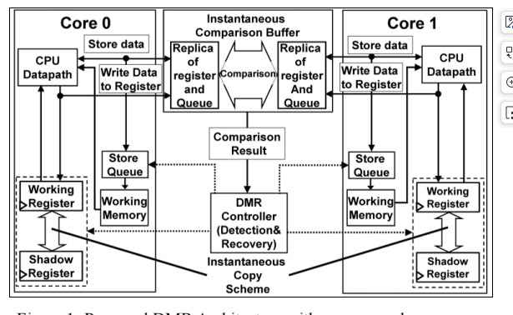

- Existing DMR Architecture with recovery scheme.
Two identical processor cores, referred to as Core 0 and Core 1, carry out the same instructions simultaneously in the current system's Dual Modular Redundancy (DMR) architecture. A CPU data path, a working register file, working memory, and a store queue to manage memory write operations are all included in each core.Each core has a shadow register that maintains an earlier verified correct state for recovery assistance.
Both cores run in parallel in normal operation, saving the results in their own working registers and working memory. The store queues temporarily hold memory write operations before final completion. This concurrent processing allows the system to reliably check for correctness using the output of both cores..
An Instantaneous Comparison Buffer is located demoted to the two cores to replicate execution information between the two cores which the arising execution uses. Specifically, this information supports register values and store queue entries. The replicated counts from both cores are compared in real time to detect difficulties experienced. When the results from Core 0 match those of Core 1, execution will continue seamlessly. On the other hand, a mismatch would imply that one of the cores has failed.
A DMR Controller is the device that receives the result of the comparison and manages error recovery and detection. In order to stop the spread of incorrect data, the controller starts an instantaneous copy scheme when it detects a mismatch. The incorrect values kept in the working registers or store queues are then discarded as the system uses the shadow registers to restore the proper state.
The system can quickly recover and resume regular operations without pausing the entire processor by obtaining the processor state from shadow registers. Although this architecture enhances reliability in comparison to a single-core system and minimizes hardware overhead relative to Triple Modular Redundancy (TMR), it still results in increased area and complexity because of the presence of duplicated comparison buffers, store queues, and shadow storage structures.

Proposed Architecture
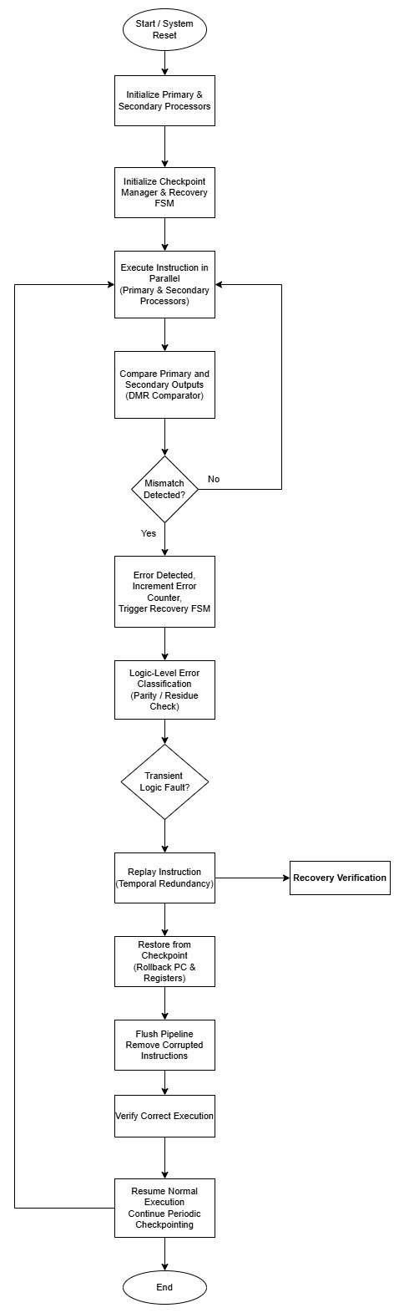
- Proposed System-Level DMR Recovery Flow

System Overview
Two identical processor cores operating simultaneously make up the suggested system. The identical instruction stream is processed by each core, which produces separate outcomes. A comparator is in place to continuously monitor the outputs for any inconsistencies.
A centralized Recovery FSM is activated upon error detection in order to determine the appropriate recovery strategy.

Dual Modular Redundancy Comparator
The primary and secondary processors' write-back outputs must be compared by the DMR comparator. Any discovered mismatch denotes a fault's presence. Critical signals are given explicit maintain qualities to prevent redundancy from being eliminated by synthesis optimization.

Error Localization and Classification
By analysing output behaviour and features similar to parity logic, an error localization module helps identify the malfunctioning processor. Errors fall within the following categories:
- Control or persistent faults
- Transient logic faults

This categorization facilitates adaptive recovery strategies.

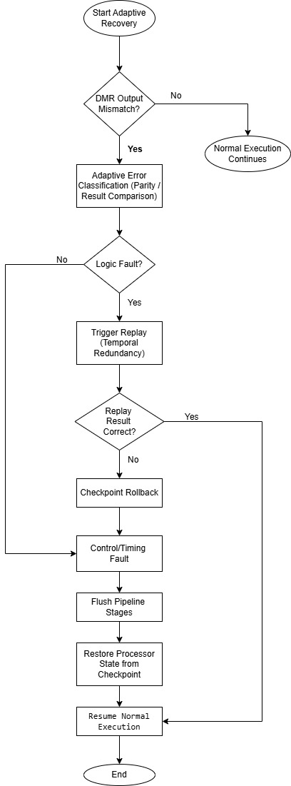
- Proposed Adaptive Error-Aware Recovery Logic Flow

Recovery FSM and Error-Aware Replay
A multi-state Recovery FSM oversees the recovery of the system. The FSM allows for:
1) Flushing and slowing of pipelines
2) Checkpoint restoration
3) Recovery based solely on replay for temporary logic errors.
The solution greatly reduces recovery overhead in the event of transient logic faults by re-executing the impacted operation instead of using the costly checkpoint restoration procedure.

Checkpoint and Rollback Mechanism
Through a checkpoint manager, the architecture regularly saves the state of the processor. The FSM restores the system state from the most recent valid checkpoint and proceeds with execution when persistent errors are found.

Methodology and tools

Xilinx Vivado Design Suite (Version 2019.1)
RTL-level functional simulation was used to validate the suggested adaptive DMR-based recovery architecture, which was developed using Verilog HDL.
The AMD Xilinx Vivado Design Suite (Version 2019.1) was used to design and simulate every component, including the dual-core processing units, DMR comparator, checkpoint manager, and recovery FSM.
Error detection, localization, checkpointing, and replay-based recovery performance are all evaluated using software-based simulation.

Methodology
The proposed work presents an adaptive fault-tolerant recovery technique that combines replay-based rectification, checkpointing, and Dual Modular Redundancy (DMR).
The same instruction stream is carried out under uniform control circumstances by two identical processor cores operating in parallel. Compared to triple modular redundancy techniques, this parallel execution greatly reduces redundancy overhead while enabling ongoing monitoring of computational accuracy.
During execution, the write-back results from both the primary and secondary cores are compared on a cycle-by-cycle basis by a DMR comparator. The system runs normally and uninterruptedly when the outputs from both cores match. On the other hand, any discrepancy in output results in identification of the fault, and recovery will begin. Real-time comparison helps detect transient and logic-level defects before corrupted data spreads throughout the system.
An error localization mechanism is activated to find out which execution path has a problem when an error arises.By analyzing the behavior of the parallel cores, and ensuring the consistency of the internal controls, the system determines which core produced the incorrect outcome. By this targeted fault detection, the recovery logic can react to the fault condition appropriately. Further, it does not cause unnecessary recovery activity in the fault-free core.
To enable rollback-based recovery, the system periodically saves state through a checkpoint manager. The program counter and essential register values for resuming execution safely are encompassed by the checkpoint. During normal operation without errors, recovery points are created through checkpoints. When faults occur the checkpoint is used. By utilizing the latest checkpoint to restore the state of the system, the architecture limits total restart of the system and damage recovery time.
A centralized recovery finite state machine (FSM) regulates all activities after an error. When an error has been found and identified, the FSM stalls the pipeline for a short period and initiates a pipeline flush to remove corrupted instructions. The stored checkpoint is utilized for restoring the system state, and the program counter for resuming execution is retrieved. After the restore and replay are successfully completed, the FSM puts the system in normal execution.
The suggested architecture’s capability to dynamically mode switch between normal execution and recovery execution in the event of a run-time fault clearly indicates its adaptability. A replay-based recovery can correct temporary logic defects without long-lasting interference.

Checkpoint rollback guarantees system consistency in case of more persistent or control failures. This adaptive feature makes fault management effective without additional redundancy in hardware.
RTL-level functional sim validates overall design of the chips. In both processor cores varied fault scenarios are injected including the error detection, its localization, restoration of the checkpoint, flushing of the pipeline, and replay behavior. The simulation results confirm the effectiveness of recommended adaptive recovery technique based on DMR with a reliable recovery and constrained latency.
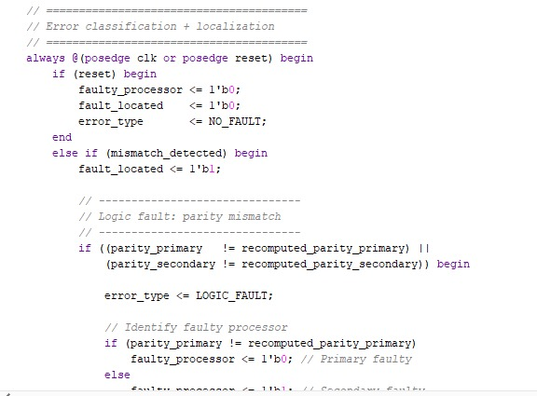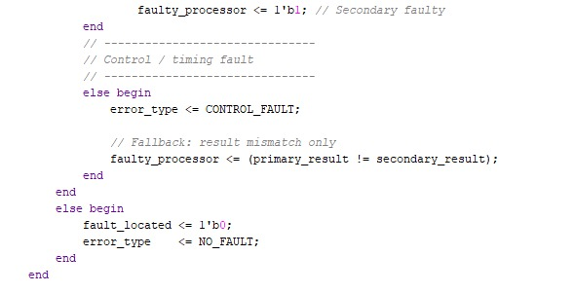

- Error Classification and Localization
The design introduced incorporates an error detection-based classification and localization technique under a DMR framework. The output of the primary processing unit and the secondary processing unit is compared continuously. The mismatches are analyzed for faults and necessary recovery controls are done.
A validation scheme based on parity is used to perform fault categorization.. For its computed results, each processor generates parity information, which is then recalculated during the fault analysis stage. If a parity mismatch is found, the error is classified as a logic defect, which indicates corruption in the arithmetic or combinational logic. By identifying the unit that exhibits parity discrepancy, the defective processor is identified, and the other processor is assumed to produce the proper output.
A control or timing fault, which typically arises from pipeline risks, control-flow defects, or transient synchronization issues, is identified when parity validation is complete but the outputs still exhibit inconsistency. In these situations, system-level recovery procedures are started and fault localization is dependent on the comparison of outcomes.
In order to minimize performance overhead during times of fault-free operation, the system resets all fault indicators and resumes normal execution if no mismatch is discovered.

Results & Discussions
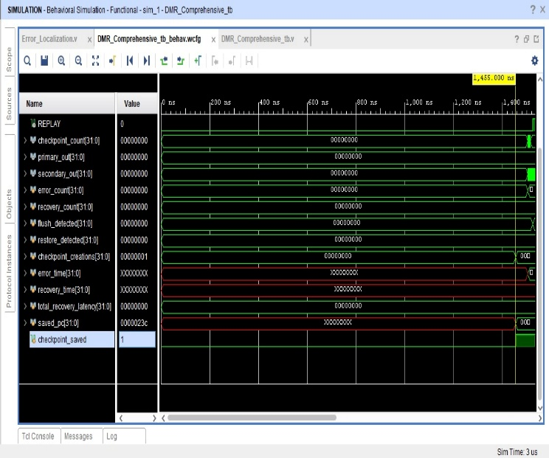
- Behavioral simulation waveform
The suggested adaptive DMR-based recovery architecture's behavioural simulation waveform is shown in Figure 5. The behaviour of the system during fault-free execution, checkpoint formation, fault detection, and recovery control signalling are all depicted in this waveform.
The primary_out and secondary_out signals are initially identical, indicating that the two processing units are operating correctly in parallel. The deassertion of the ERROR and REPLAY signals during this phase verifies that the operation is error-free. The relevant program counter value is recorded in saved_pc, and the checkpoint_saved signal is asserted once to indicate successful checkpoint formation. This helps to confirm that the checkpoint manager operates correctly during regular execution.
The error_count signal increases when a difference between the primary and secondary outputs is found, indicating that the DMR comparator successfully detected a malfunction. The moment which the fault is detected is error_time which is recorded here. The assertion of flush_detected signal denotes that the flush mechanism in the pipeline has been executed to stop tainting.
The rollback process begins with the checkpoint saved as a result of fault detection when the restore_detected signal is asserted. During the recovery phase, the REPLAY signal is activated and signifies that the impaired operation is being executed again in time. The variable recovery_time logs the recovery process and total_recovery_latency takes the difference between recovery_time and error_time. The metric is impacted by this time difference.
Once the recovery completes, normal execution resumes with reset error indicators and valid outputs. The waveform demonstrates that the adaptive recovery technique is effective in that the recovery occurs within the specified delay and does not require permanent hardware redundancy.

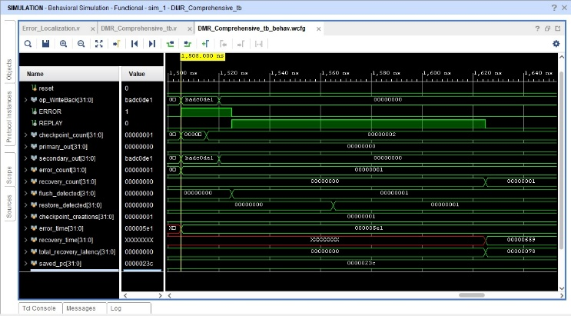
- Fault Detection and Recovery Waveform Analysis
The fault occurrence and recovery of the proposed adaptive DMR-based recovery architecture is shown in the waveform obtained through Figure 6. The waveform is important to the time approximately 1.50 µs, which an inserted fault arises a divergence between the two processors.
Within approximately 1.505 microseconds, a fault was injected into the secondary execution path, which becomes evident as an incorrect value (0xBADC0DE1) on secondary_out while primary_out remains correct. When there is a disparity, the DMR comparator quickly triggers the ERROR. Error counting at the same time confirmed fault has been detected successfully.
The moment a fault is detected, the system initiates its recovery control logic. The flush_detected signal indicates that the pipeline is flushed to prevent invalid data from passing through. Thanks to the error_time signal, the exact clock cycle at which an issue is observed can be accurately measured to delay recovery.
The recovery mechanism is started following the flush operation. The temporal re-execution of the impacted operation using the most recent valid checkpoint is indicated by the asserted REPLAY signal. The stored program counter value (saved_pc = 0x0000023c) confirms that the rollback is run from a previously saved consistent state. In this phase, checkpoint-based restoration is indicated by the assertion of restore_detected.

When REPLAY is deasserted and the recovery_time signal is updated, the recovery process is over. The gap between recovery_time and error_time adds to total_recovery_latency, which remains restricted (roughly 120 ns in this case). After recovery, regular execution resumes without any additional error propagation, and both primary and secondary outputs return to a consistent state.
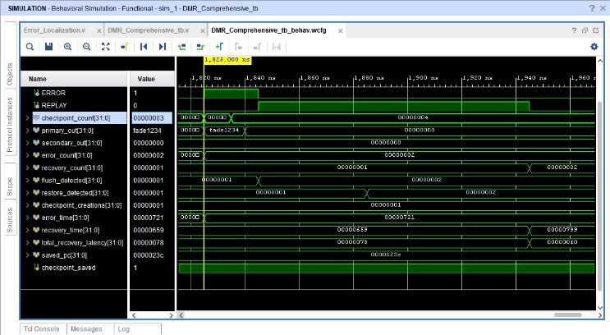
- Control Fault Detection and Recovery Behavior
The waveform shown in Fig. 7 shows how the suggested adaptive DMR-based recovery technique works during a fault occurrence that happens at about 1.825 µs. There is currently a difference between the two duplicate execution pathways. While secondary_out is still accurate (0x00000000), the primary_out signal produces an inaccurate value (0xFADE1234). The DMR comparator detects this difference in a timely manner to assert ERROR. Simultaneously we incremented `error_count`, showing that the defect was successfully detected.
When an error is detected, the recovery controller takes corrective actions. The flush_detected signal is asserted to flush previously in-flight corrupted activities in the pipeline. The architectural state problem is prevented from being bottlenecked as a result of this step.The REPLAY mechanism, which re-executes the impacted operation rather than relying on full spatial replication, is activated by the system after the flush to enable temporal redundancy.
Checkpoint_saved = 1 indicates the presence of a valid checkpoint, and saved_pc = 0x0000023c is the corresponding program counter. A rollback to the most recent known correct checkpointed state is indicated by the restore_detected signal. While recovery_time records the end of the recovery process, error_time records the moment of fault identification throughout this process.
The total_recovery_latency signal shows a small recovery overhead (about 120 ns), demonstrating that the replay-based recovery is finished in a predictable and short amount of time. Following recovery, the system continues regular operations with uniform outputs across both cores, recovery_count is increased, and REPLAY is deasserted. The continuous increase in checkpoint_count serves as more evidence of the continuous adaptive checkpointing.
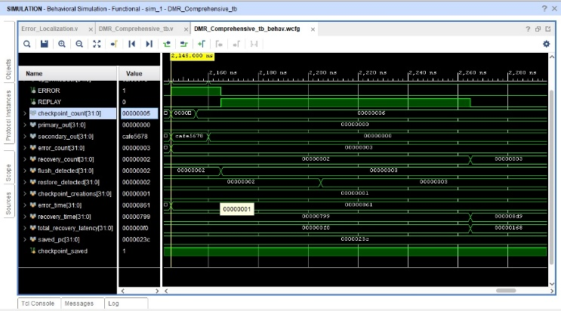
- Fault Detection and Adaptive Recovery
The suggested adaptive DMR recovery architecture is shown in Figure 8 operating during a fault occurrence that happens at about 2.145 µs. There is currently a disparity between the redundant cores, with the primary_out signal remaining accurate while the secondary_out signal momentarily switches to an inaccurate value (0xCAFE5678). The DMR comparator quickly detects this discrepancy, which causes the error_count to rise to three and the ERROR signal to be asserted.
The recovery controller starts corrective actions after identifying the error. The flush_detected signal is asserted, suggesting that the contents of the pipeline are invalidated to forestall the spread of tainted instructions.The REPLAY signal is then asserted, which allows timing redundancy to be used to replay the corrupted operation instead of duplicating the circuit in hardware.
With checkpoint_saved = 1, it confirms that the checkpoint is valid, and saved_pc = 0x0000023c would be the saved value of the pc. The restore_detected signal indicates that the architectural state reverts to this checkpoint. The timestamps error_time and recovery_time show that the recovery procedure is ending within a bounded time. The total recovery latency, when conducted around these timings, is about 240 ns, which is reasonable for real-time activity.
After recovery takes place, primary_out and secondary_out return to their matching, correct values, REPLAY is deasserted, and recovery_count is incremented.The continuous rise in checkpoint_count confirms that periodic checkpointing proceeds uninterrupted after recovery.

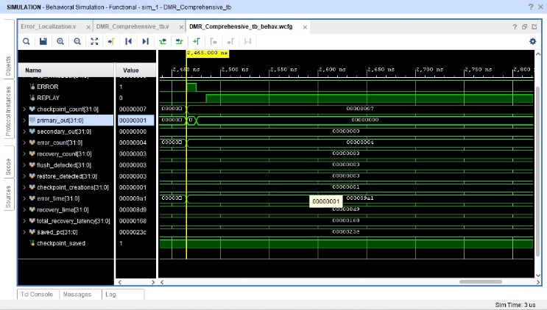
- Logic Fault Detection and Replay-Based Recovery
The system's behaviour during the final injected logic fault, which happens at roughly 2.465 µs, is shown in Figure 9. Unlike earlier control/data failures, this occurrence represents a transient logic-level defect that is mimicked by a brief bit-flip at one processing core's output. The waveform reveals that the ERROR signal is asserted and the error_count climbs to four, proving that the DMR comparator effectively identifies the discrepancy between the primary and secondary outputs.
At this point, primary_out and secondary_out quickly converge to the same values, indicating that the defect does not cause the architectural state to become permanently corrupted. The recovery controller does not start a full pipeline flush or checkpoint rollback because the problem is classified as a logic fault (short-duration transient) rather than a control or state issue. The absence of further transitions in flush_detected and restore_detected, which stay constant, supports this behaviour.

Rather, the system uses temporal redundancy, in which the impacted operation is implicitly repeated in the next cycle of execution. Because the defect is brief, the replay is finished in a single cycle, and before a noticeable REPLAY pulse can be found at the waveform resolution, the outputs return to correct values. Consequently, the recovery_count stays constant and the total_recovery_latency does not rise even though ERROR is asserted.
A valid checkpoint is maintained during this event, as evidenced by the continuous assertion of checkpoint_saved = 1 and the steady value of saved_pc = 0x0000023c. Once the fault is resolved, the system immediately resumes normal operation, as evidenced by the checkpoint_count continuing to increase.

Future scope

The proposed adaptive DMR-based recovery architecture proves to efficiently identify and quickly recover from logic-level and control failures without requiring any hardware overhead. Possible extensions can further increase the robustness and applicability of the software system.
More reliable parity schemes, or single residue codes, can be added to the execution units to extend the existing to support multi-bit logic error detection. This enhancement would strengthen coverage against complex transient faults without necessitating a switch to full Triple Modular Redundancy (TMR).
Second, dynamic fault profiling could be used to improve the adaptive recovery controller, enabling the system to adjust recovery method, replay depth, or checkpoint frequency in response to operating conditions and fault rates. Such adaptability would be especially helpful in situations susceptible to radiation, permitting a compromise between performance and reliability.
Thirdly, future designs may incorporate selective memory protection, allowing ECC just for key data routes or registers found through fault sensitivity analysis, even if the current work focuses on logic-level protection. The low-area benefit of the suggested architecture would be preserved by this selected approach.
Fourth, the design might be expanded to accelerator-based or multicore systems, where shared recovery controllers manage fault tolerance among several processing units. This would make the method appropriate for complex edge-computing and space applications.
Finally, in order to validate the design under real-world conditions, future efforts may include hardware fabrication and radiation-aware evaluations, such as radiation testing or FPGA-based fault injection. This would further demonstrate the viability of the suggested adaptive DMR approach for low-area, high-reliability computing devices when combined with power and area analysis.

References

- [1] K. Otsuka and K. Ito, “Double Modular Redundancy Design of LSI Controller for Soft Error Tolerance,” IEICE Transactions on Fundamentals of Electronics, Communications and Computer Sciences, vol. E108-A, no. 3, pp. 491–499, Mar. 2025.
- K. Ito, Y. Ishihara, and S. Nishizawa, “Minimization of Vote Operations for Soft Error Detection in DMR Design with Error Correction by Operation Re-Execution,” IEICE Transactions on Fundamentals, vol. E101-A, no. 12, pp. 2271–2279, Dec. 2018.
- R. Baumann, “Soft Errors in Advanced Computer Systems,” IEEE Design & Test of Computers, vol. 22, no. 3, pp. 258–266, May–Jun. 2005.
- F. Wang and V. D. Agrawal, “Single Event Upset: An Embedded Tutorial,” in Proc. IEEE International Conference on VLSI Design, 2008, pp. 429–434.
- R. E. Lyons and W. Vanderkulk, “The Use of Triple Modular Redundancy to Improve Computer Reliability,” IBM Journal of Research and Development, vol. 6, no. 2, pp. 200–209, Apr. 1962.
- S. Mitra, M. Zhang, S. Waqas, N. Seifert, B. Gill, and K. S. Kim, “Combinational Logic Soft Error Correction,” in Proc. IEEE International Test Conference, 2006, pp. 824–832
- A. Orailoglu and R. Karri, “Coactive Scheduling and Checkpoint Determination During High-Level Synthesis of Self-Recovering Microarchitectures,” IEEE Transactions on Very Large Scale Integration (VLSI) Systems, vol. 2, no. 3, pp. 304–311, Sep. 1994.
- J. Oh and M. Kaneko, “Area-Efficient Soft-Error Tolerant Datapath Synthesis Based on Speculative Resource Sharing,” IEICE Transactions on Fundamentals, vol. E99-A, no. 7, pp. 1311–1322, Jul. 2016.
- Y. Kitazawa and K. Ito, “Register Minimization and Its Application in Schedule Exploration for Area Minimization in Double Modular Redundancy LSI Design,” IEICE Transactions on Fundamentals, vol. E105-A, no. 3, pp. 530–539, Mar. 2022.

