Resource-depleted quarries
Adaptive re-use for Sustainable redevelopment & Land Reclamation

Dr. (Ar.) Rishi Raj Kapoor
Architect & Interior Designer
Director, Axis Institute of Architecture, Axis Colleges, Rooma, Kanpur, Uttar Pradesh, India.

ABSTRACT :
A quarry is an area from which rocks such as marble, limestone, and granite are extracted for industrial use. Once depleted of their desired resources, quarries are frequently abandoned. The resulting gaping holes can fill with water and form dangerous quarry lakes while others are turned into unsightly landfills. When quarries are in close proximity to urban environments, inhabitants are subjected to pollution and noise, and the undeniable eyesore of an abandoned quarry remains long after excavation is completed. Sustainable redevelopment has become a shining solution for these abandoned, resource depleted quarries. Dozens of cities have undertaken adaptive re-use projects to transform quarries into a variety of public and private spaces. The potential new uses for these expanses of land include sites for research and education, aquaculture, recreational activities, storage, industry and housing.
Not only do quarries often negatively impact those who live nearby, but they often leave residual negative impacts on the environment. Runoff of chemical pollutants into bodies of water, loss of natural habitats, farmland, and vegetation, and natural resource exhaustion are among the most harmful environmental impacts.
While quarrying can be a negative industry for society and for the environment, the necessity of quarrying is undeniable. In order for human civilization to continue as it has since the industrial revolution, we need the retrieval of resources from quarries in order to create our homes foundations, transportation structures with cement, concrete, asphalt, and crushed stone, and other industrial uses such as abrasives, binders, additives, and roofing. Millions of people worldwide are employed by quarrying practices, and therefore a removal of the quarrying industry would result in the loss of jobs for countless families. Therefore, in order to remedy the negative effects of quarrying, we must use the resource depleted spaces for other practices once the quarries cease being operational. The potential transformation of quarry sites into a variety of sustainable uses would not only remedy the negative effects of quarrying, but could create sites of greater social, environmental value.
The goal of this research is to encourage the rehabilitation of land disturbed by quarrying by making the areas suitable for new sustainable land uses.
Key Words : Abandoned, Quarries, Urban Environment, Adaptive re-use.

INTRODUCTION :
Depleted and abandoned quarries in India constitute a significant environmental and safety hazard, with an estimated 40,000 stone quarries existing across the country, of which only 20% are legal. These abandoned sites, often left without reclamation, create deep, water-filled pits, destroy local ecology, and fuel illegal mining activities.
Key Locations and Impacted Areas
- Kerala: A survey in Malappuram identified 1,185 abandoned quarries out of 1,342 total quarries. In Central Kerala, specifically Thrissur, Palakkad, and Kozhikode, there are nearly 3,000 abandoned quarries, some of which are being assessed for storing water.
- Maharashtra: Several quarries around Pune (Chinchwad, Pune University, Model Colony) and Nasik have been abandoned for 40–100 years. Many are now filled with stagnant, polluted water, used as illegal dump sites, or have been encroached upon by slum dwellers.
- Tamil Nadu: Abandoned quarries are a major issue in the Chennai region. In the Kancheepuram district, rampant mining has transformed the landscape, leaving behind abandoned sites that have caused a decline in agriculture and environmental damage.
- West Bengal & Uttar Pradesh: Birbhum district (West Bengal) faces severe water crises due to abandoned quarries, while in Mirzapur (Uttar Pradesh), deep mining has broken into groundwater tables, leading to dry wells and widespread, sometimes deadly, silicosis among laborers.
- Rajasthan: Rajasthan accounts for around 90% of the total dimensional stone in India, (ICN 2005). There is a range of negative environmental impacts associated with extractive industries. This is especially true of opencast mining of the sort used in extracting sandstone in India (Basu, 1990). The greatest impact is the destruction of the habitat where the quarrying occurs (Walker and del Moral, 2003).

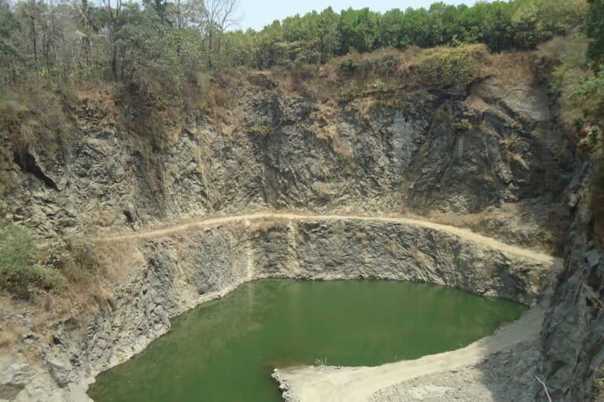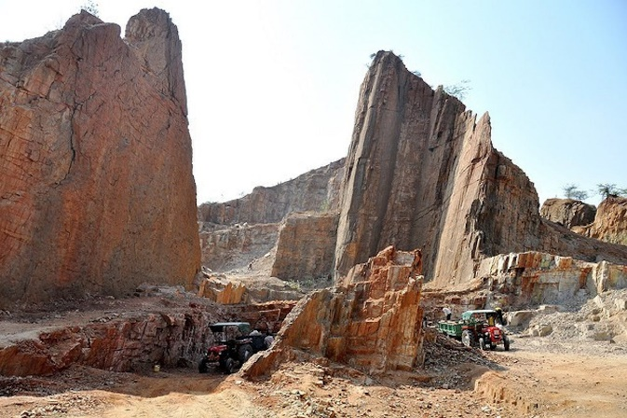
( Source : Mongabay-India ) ( Source : Eco-Business )

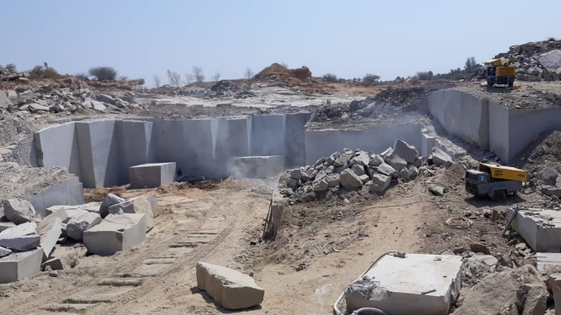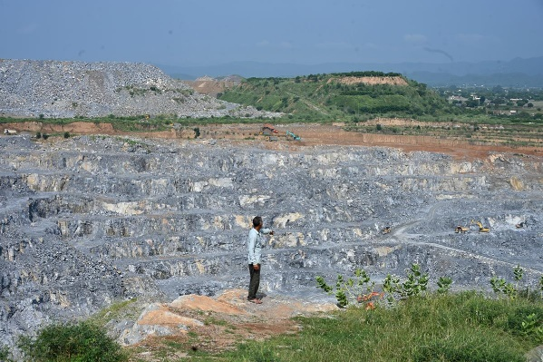
( Source : The Hindu ) ( Source : The Hindu )

Environmental and Social Consequences
- Groundwater Depletion: Unregulated, deep mining hits aquifers, causing water levels to drop drastically, with some areas in West Bengal seeing water levels drop by 15 ft in a decade.
- Dangerous "Quarry Lakes": Abandoned pits fill with water, acting as death traps for local youth due to drowning risks, particularly in Tamil Nadu.
- Health Hazards: Dust pollution from abandoned and active sites causes severe respiratory issues like tuberculosis and silicosis among local residents.
- Ecological Damage: The destruction of hills, particularly in the Western Ghats of Kerala, has severely impacted biodiversity.

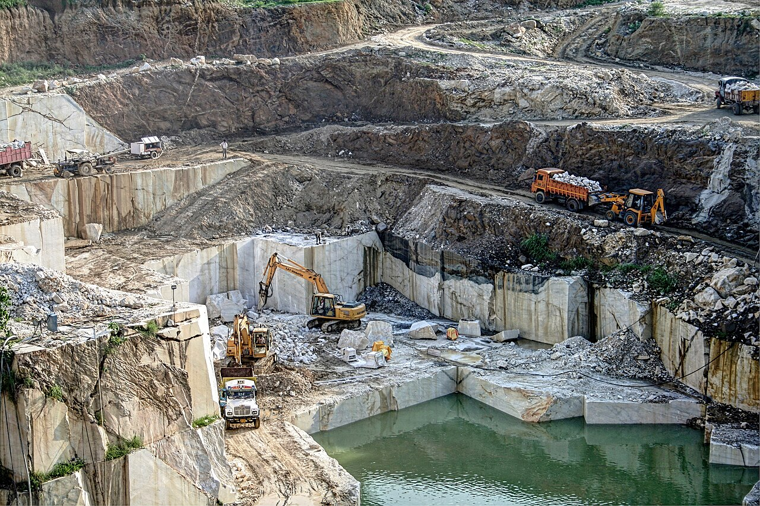
( Source : Wikimedia Commons )

Reclamation and Repurposing Efforts
Reclamation commonly is considered to be the start of the end of environmental impacts from mining. The development of mining provides an economic base and use of a natural resource to improve the quality of human life. Equally important, properly reclaimed land can also improve the quality of life. Wisely shaping mined out land requires a design plan and product that responds to a site’s physiography, ecology, function, artistic form, and public perception.
While many sites are abandoned, some initiatives are aimed at rehabilitation:
- Water Storage: Some abandoned quarries in Kerala are being used for storing water to meet local needs.
- Land Rehabilitation: Projects have been initiated for plantations in old mining areas, such as in the Nasik district.
- Recreation/Tourism: Proposals have been made to convert quarry sites into tourist spots, such as at Tirusulam in Tamil Nadu.
- Ecological Restoration: Examples exist, such as at Anemane near Bengaluru, where a dusty, abandoned quarry has been transformed into a sanctuary for plants and animals.
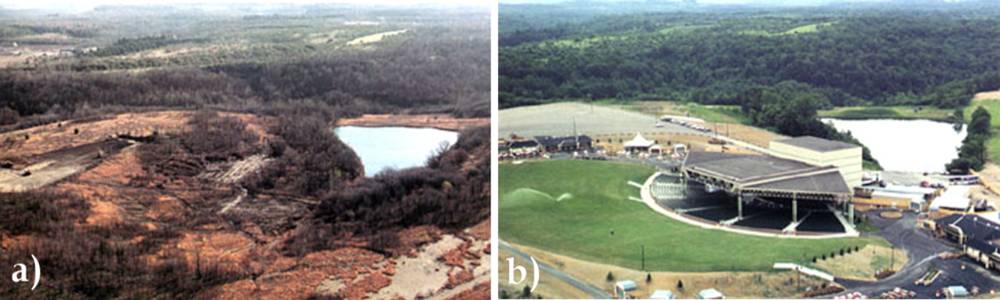
(Source : IntechOpen )
Government regulations regarding reclamation
1. The Central Government vide Notification No. GSR 329 (E) dated 10.04.2003 and No. GSR 330 (E) dated 10.04.2003 amended the Mineral Concession Rules, 1960 and Mineral Conservation and Development Rules, 1988 respectively. As per these amendments all the existing mining lessees are required to submit the "Progressive Mine Closure Plan" along with prescribed financial sureties within 180 days from date of notification. Further, the mining lessee is required to submit "Final Mines Closure Plan" one year prior to the proposed closure of the mine. In the notification it has been enumerated that the "Progressive Closure Plan" and "Final Closure Plan" should be in the format and as per the guidelines issued by the Indian Bureau of Mines.
2. Mine closure encompasses rehabilitation process as an ongoing programme designed to restore physical, chemical and biological quality disturbed by the mining to a level acceptable to all concerned. It must aim at leaving the area in such a way that rehabilitation does not become a burden to the society after mining operation is over. It must also aim to create as selfsustained ecosystem.
3. The final mine closure plan will thus be a separate document with detailed chapters as per guidelines issued by the Indian Bureau of Mines.
“Mine Closure” means steps taken for reclamation, rehabilitation measures taken in respect of a mine or part thereof commencing from cessation of mining or processing operations in a mine / cluster or part thereof.
“Progressive mine closure plan” means a plan, for the purpose of providing protective, reclamation and rehabilitation measures in a mine or part thereof that has been prepared in the manner specified and in the standard format as per the guidelines issued by the Indian Bureau of Mines or State Government.
“Final mine closure plan” means a plan for the purpose of decommissioning, reclamation and rehabilitation in the mine, cluster or part thereof after cessation of mining and mineral processing operations that has been prepared in the manner specified and in the standard format as per the guidelines issued by the Indian Bureau of Mines or State Government. There are statutes under Indian Law affecting quarrying and the rehabilitation of quarry sites. These include the, Mines and Mineral (Development and Regulation) Act, 1957, Mineral Concession Rules, 1960, Mineral Conservation and Development Rules, 1988 and the National Mineral Policy, 2008. The granting of a mining licence is subject to the submission and approval of a mine closure plan consisting of a progressive mine closure plan and a final mine closure plan under the Mineral Conservation and Development rules (1988, amendments 2003). Under Rule 23 of the Mineral Conservation and Development Rules (1988) there is a requirement for the Rajasthan Government to be informed prior to the closure of any quarry. There also exist statutes under Indian law which require quarry companies to rehabilitate abandoned sites (National Mineral Policy 1993 sections 7.13.2 and 7.13.3). The prescribed measures include fencing off sites and afforestation, although not necessarily on the quarry site. These measures are rarely followed or enforced and sites are usually just abandoned (ICN, 2005, Joshi, 2008 pers. com.).
CASE STUDIES
The cases chosen are to include each serve as examples of different methods that the successful adaptive re-use of quarries can follow. The six cases are each located in a different geographic location three in the United States, one in China, one in Canada and one in Chicago. The map below depicts the relative location of each case.
- Stearns quarry park, Chicago, Illinois
1.1 Location and Purpose
The very first of Chicago’s limestone quarries, Stearns Quarry a 27-acre site, opened in the 1830s and was continuously mined until 1970. Surrounded by the historic and diverse Bridgeport neighbourhood, the once 380 foot deep excavation played a new role in the life of the city as a municipal landfill. After convening community meetings to determine the needs of local residents, the Chicago Park District hired Site Design Group to develop a plan for the park. The environmentally-sustainable design was inspired by the natural history of the site.
1.2 Issues Prior to Redevelopment
The strategy for transforming the quarry into a dramatic urban park called for orchestrating the on-going importation of fill, truckloads dumped and sculpted to form a giant ziggurat rising above the preserved remnant pit. Landfill leachate was to be remediated on site in a series of treatment gardens, offering environmental education on the way to fishing in a clean pond with walls full of ancient fossils.
1.3 Funding
To begin turning this space into a park, the Chicago Park District secured a Landfill Closure Permit from the Illinois Environmental Protection Agency. The funding is most likely coming from the Chicago Park District. However, the source could not be confirmed.
1.4 Features
The park’s design includes native plants which will reduce the need for fertilizers and herbicides. The Chicago Park District has incorporated environmentally conscious features such as a storm water containment system that collects and treats rainwater, then channels it to the park’s wetlands and pond. The boardwalk is made from recycled plastic and wood particles, and the waterfall’s base and the steps to the fishing pond include pieces of concrete and foundation reclaimed from other City projects. This is a dynamic park, with a fishing pond, interpretive wetlands, preserved quarry walls, trails, an athletic field, a running track, and a hill that offers dramatic views. Over 1.7 miles of paths, including recycled timber boardwalks, concrete walks, a crushed stone running path, and metal grating walkways traverse the park. These trails allow for a variety of experiences along the quarry wall, across the terracing wetlands, and down to the pond. Scenic overlooks provide dramatic overviews of the pond and wetlands, and spectacular city views can be seen from the mound. The parks design also included native plants such as black-eyed susans, cosmos, poppies, and prairie grasses, which will reduced the need for fertilizers and herbicides.
1.5 Benefits
The new park would be especially important because the surrounding Bridgeport neighbourhood had long suffered from a lack of adequate green space. Today, visitors to Palmisano Park can go fishing in a pond that retains old quarry walls; stroll along a wetland area that drains into the pond; watch for birds and other wildlife attracted by the site's vast range of native plants; fly kites in an open meadow; or take in the views of the cityscape.
1.6 Drawbacks
The delay in completion due to weather and some construction issues were the only drawback. Also arranging landfill added to complexity.
1.7 Public Response
The Stearns Quarry of today has certainly come a long way from the days of a limestone quarry. It was transformed from coral reefs to quarry to landfill to park. Each incarnation played a major role in developing the next. The vibrant, active park is a welcome respite from city life, an educational opportunity, a place for recreation and a prime example of what creative thinking can accomplish and yet the memory of the quarry and its lasting historic legacy remain inextricably a part of the park.

- Ground scraper Hotel, Shanghai, China
2.1 Location and Purpose
Located just 30 miles outside of Shanghai, China, the InterContinental Shimaore Shanghai Wonderland Hotel, also referred to as the Ground scraper Hotel, is a proposed luxury resort that will have 16 floors below the surface of the earth—hence the coined phase “Ground scraper”—in an abandoned quarry at the foot of Tianmashan Mountain.
2.2 Issues Prior to Redevelopment
The 100 meter, or 330 feet, deep crater was a source of industrial resources since the 1950s. The pit was initially abandoned in 2000, and the land was neglected, unsightly, and dangerous.
2.3 Funding
Recently, a British engineering firm called Atkins proposed a plan to utilize the abandoned land into a tourist attraction in conjunction with developers in Shanghai. An estimated $555 million endeavour, the funding is most likely coming from the Shanghai Shimaore Property Group and the city of Shanghai. However, my research could not confirm the funding source.

2.4 Features
The Ground scraper Hotel features 380 rooms, a spa, an athletic complex for water sports at the basin of the quarry, an underwater restaurant, and a 32-feet deep aquarium. All features of the hotel will utilize sustainable practices, such as a green roof and an artificial lake to generate geothermal energy. Down the centre of the hotel will be a 60-meter glass curtain, built to mimic a waterfall.
2.5 Benefits
The transformation from a resource-depleted quarry into a luxury hotel will generate a vast amount of job opportunities. It will also bring many tourists to the area, as the hotel is somewhat of a cross between a vacation spot and a theme park. The use of sustainable energy sources is also an incredible bonus of the hotel and will hopefully inspire similar energy practices in other projects in China.
2.6 Drawbacks
The idea of creating a luxury hotel from a depleted quarry is somewhat ostentatious and only benefits an elite few. With hotel rooms starting at $320 per night, there is definitely a social class limitation by creating such an establishment. However, with such a lavish exterior and a re-use of the land, the issue of being a hazardous eyesore is eliminated and the revenue that will be generated will benefit the developers and workers.
2.7 Public Response
The projected completion date is expected to be late 2014 or early 2015, but the public response thus far has been very positive. The beautifully rendered plans have evoked such amazement from the public and Atkins received the Gold Medal at last year’s commercial real estate MIPIM Asia Awards. The most appealing aspect of the hotel is its use of green design and sustainable energy sources, as well as the illusion that the hotel is a part of nature.

- Butchart Gardens, Canada
3.1 Location and Purpose
Located near Victoria Canada on Vancouver Island, the Butchart Gardens are a group of floral display gardens made in an exhausted limestone quarry. Robert Butchart, a pioneer in the thriving North American cement industry, was attracted to Canada’s West Coast by rich limestone deposits. In 1904, he developed a quarry and built a cement plant to satisfy the cement demand from San Francisco to Victoria, Canada. The Butcharts established the family home close to the quarry. As Mr. Butchart exhausted limestone deposits, his enterprising wife, Jennie, made plans to create something of beauty in the gigantic exhausted pit. Little by little, the quarry blossomed into the spectacular Sunken Garden by 1921, the ownership of which has been passed on for generations.
3.2 Issues Prior to Redevelopment
Prior to redevelopment, the limestone quarry was a giant, hideous pit left near the Butchart family’ home after the limestone was depleted.
3.3 Funding
Initially, funding for the Butchart Gardens was granted by the Butchart family’s success in the quarrying industry. However, through the generations, funding for the gardens has been generated primarily from the millions of visitors that enter the gardens each year.
3.4 Features
The Butchart Gardens features a series of beautiful gardens—each of which have a different cultural theme—outdoor symphony concerts, a yearly Christmas light display and ice skating, greenhouses, firework shows, a children’s carousel, a boat tour and family restaurants. The site even offers educational features, such as an ornamental bird collection for education and conservation. The gardens are dog friendly and feature a variety of reservation opportunities for weddings, birthdays, and other social events.

3.5 Benefits
The Butchart Gardens attracts over a million visitors each year and has been deemed a National Historic Site in Canada. The site attracts tourism for the region, creates job opportunities, re-uses resource-depleted land, and engages the community and provides family entertainment. The creation of such a site creates encourages visitors to interact with nature, engage with their families in outdoor activities, and bask in cultural entertainment such as the symphonies and other educational opportunities.
3.6 Drawbacks
According to my research, the gardens’ only drawback is the cost of maintenance of such a large national park. However, the revenue yielded from the millions of visitors is more than enough to cover the cost of maintaining the beloved park.
3.7 Public Response
The public response is incredibly positive. As mentioned previously, the Butchart Gardens were deemed a National Historic Site in Canada and attract over a million visitors per year. With the incredible amount of family activities and community engagement, this re-use of this derelict quarry has been widely successful and beloved.

ANALYSIS
These cases serve as successful adaptations of resource depleted quarries into sites that promote community engagement, housing, and/or practical use of land. Butchart Gardens seamlessly utilize the empty quarry sites into parks that have become beloved by locals and tourists. Chinese Ground scraper Hotel, once completed, are projected to provide permanent and temporary housing that both yield sustainable practices. The Stearns quarry, after convening community meetings to determine the needs of local residents, was developed into a park. While the cases presented, depict a recreational park, a mixed-use housing district, a water management system, a National Park, and a luxury hotel, adaptive re-use projects can transform quarries into a variety of public and private spaces other than these uses. Such options include geological sites for research and education, nature preservation areas, training courses for rescue dogs, personnel, and the military, open-air theatres, museums on quarrying heritage, film sets, rock climbing, storage and warehouses, landfills, harbours, cooling water for industry, and industrial plants.

RECOMMENDATIONS FOR QUARRIES RECLAMATION
Upon regenerating quarries, one should consider additional evaluation criteria, besides ecological factors. Among these are economic, historical, cultural, social, moral, and aesthetic criteria. Other essential factors are political will and government capacity to coordinate the interests of those parties involved in regeneration. Factors to consider upon realizing quarry regeneration projects in Rajasthan, India.

LIMITATIONS
Legal
• Unclear laws
• Lack of follow-up on mitigation activities
• Lack of current information on regeneration activities
• Actualize laws and enforce them
• Training of personnel in charge of follow-up
• Renovating information on active and passive quarries
Economic
• High investment costs
• Few profits
• Negligence
• Determine who should pay
• Establish productive conservation systems
• Motivate investment
Ecological
• Scarce, infertile soil
• Long term recuperation
• Lack of studies recommending management practices
• Site conditioning
• Studies identifying native species which activate and facilitate ecological succession
• Support for research projects
• Publicizing information generated

CONCLUSION
The cases are examples of how sustainable redevelopment is a solution for abandoned, resource-depleted quarries that benefits everyone. By encouraging the rehabilitation of land disturbed by quarrying, society can remedy the negative effects of anthropogenic industrial activity. The redevelopment of quarries can both benefit humans and lessen the environmental impact of quarrying without removing quarrying as a global and regional industry. The after-use of quarries is important because it increases public acceptance of quarrying and shows that former quarry sites are not merely degraded areas, but can give value added to the land and can even act as a catalyst for the development of a region, like that of Quarry Falls. Land rehabilitation is an essential part of quarrying and aims at making disturbed areas suitable for new sustainable land uses, and is it disappointing that such practices are not the norm. Rehabilitation of quarries can yield so many positive social, economic, and environmental that it only makes sense that they should be reintroduced into society after their resources are depleted. Although remediation is a costly feat for most quarry sites, the benefits seen in the cases presented, display how the costs will be outweighed by benefits, and adaptive re-use should be undertaken as measures to make our cities more ecologically healthy and aesthetically pleasing. Abandoned quarries can be scenically very attractive. Even if they are less attractive, they can be asset to specific groups of people. Only thing required is AN INITIATIVE.
BIBLIOGRAPHY

- education.nationalgeographic.com
- Indian Bureau of Mines, ibm.gov.in
- www.ideals.illinois.edu
- www.hogriver.org
- www.mit.edu
- ecosystems.psu.edu
- journals.bg.agh.edu.pl
- Rajasthan Department of Mines and Geology
- www.dmg-raj.org/
- Quarry Falls Specific Plan 2008 http://www.sandiego.gov/planning/community/profiles/
- missionvalley/pdf/plans/quarryfallsspecificplan.pdf
- Civita Project Website
- http://www.civitalife.com/
- Alexander and Garvin Associates http://www.tpl.org/our-work/parks-for-people/bellwoodquarrywestside- park
- Atlanta Beltline Tour http://www.lizlapiduspr.com/2011/tour-the-atlanta-beltline
- Butchart Gardens Website
- Architizer Website
- http://architizer.com/blog/construction-begins-on-shanghai-groundscraper-hotel/
- IS 8381 (1977): Recommended practice for quarrying stones for construction purposes [CED 6: Stones]

