A Smart Cobot to Enhance Farming Productivity and Sustainability

Anuj Gurav Student, SLRTCE | Vaibhav Lad Student, SLRTCE | Yash Shevde Student, SLRTCE | Ayush Gairola Student, SLRTCE | Mrs. Aparna Majare Asst. Prof, SLRTCE
Abstract - This paper presents a technological solution that uses a collaborative robotic (cobot) system to boost both sustainability and productivity in agriculture. The system architecture is built around ROS 2 and a Raspberry Pi, which control a mobile rover and a robotic arm that work together to monitor plants and apply precise treatments. The rover navigates the environment using sensor fusion and cameras to collect real-time data on plant health. A comprehensive plant database allows the cobot to identify plant species and diagnose diseases by cross-referencing this data stream with known symptoms. Once a problem is found, the robotic arm uses its precise, multi-axis control to deliver a minimal, targeted dose of pesticide. This data-driven approach significantly cuts down on pesticide use, minimizes environmental impact, and saves resources while also improving crop yield and quality through accurate, immediate treatment. The paper details the system's design, its ROS 2-based algorithms for navigation and plant recognition, and its mechanisms for precision application, demonstrating its potential to transform sustainable agriculture.

Keywords - Collaborative Robotics (Cobot), Raspberry Pi, ROS 2.

Introduction
Agriculture is one of the most vital sectors for human survival, but it faces challenges such as low productivity, high resource usage, and environmental degradation due to excessive use of chemicals. Traditional methods often fail to balance productivity and sustainability.

Recent advances in robotics and artificial intelligence provide opportunities to address these challenges. Collaborative robots (cobots) offer precision, adaptability, and scalability. By integrating ROS 2 (Robot Operating System 2) and IoT-enabled platforms like Raspberry Pi, we can build smart farming solutions that reduce human effort and optimize agricultural practices.

This paper proposes a Smart Cobot System that integrates a mobile rover, robotic arm, and plant monitoring database to perform targeted pesticide spraying and plant health monitoring.

PROBLEM STATEMENT
The agriculture industry is under increasing pressure to produce more food while addressing sustainability concerns such as soil degradation, excessive pesticide use, and labor shortages. Traditional farming practices often involve uniform pesticide spray labor-intensive operations, which lead to resource wastage, environmental harm, and higher production costs [1].
Recent research has shown that agricultural robots can automate planting, weeding, spraying, and harvesting, thus increasing efficiency and reducing operational costs [1]. However, many existing systems lack adaptability and precision in real-world farming conditions, especially in dynamic environments like greenhouses and open fields. While some robotic solutions have demonstrated autonomous navigation and high payload capabilities [2], their integration with collaborative functions for disease detection and targeted pesticide application is still limited.
Moreover, human–robot collaboration (HRC) in agriculture has emerged as a promising approach to combine human decision-making with robotic precision [3]. Yet, current systems face challenges in sensor integration, real-time data analysis, and effective collaboration frameworks that can scale to different farming environments.
Therefore, there is a need for a smart, collaborative robotic (cobot) system that integrates ROS 2-based navigation, sensor fusion, and precision robotic arms to monitor plant health, diagnose diseases, and perform targeted pesticide application. Such a system would directly address the dual goals of enhancing productivity and ensuring environmental sustainability in agriculture.

Literature Review
Multiple studies have investigated the role of robotics and collaborative systems in agriculture.
A. J. Moshayedi et al. (2024) emphasized that agricultural robots improve productivity, reduce costs, and minimize environmental impact through precision farming [1].
F. Cañadas-Aránega et al. (2024) developed a collaborative mobile robot for greenhouses, integrating sensors and ROS 2 to ensure safe navigation and human–robot collaboration [2].
M. O. Yerebakan and B. Hu (2024) reviewed human–robot collaboration in agriculture, highlighting its potential to combine robotic efficiency with human decision-making for sustainable farming [3].

PROPOSED SYSTEM
The proposed system integrates a mobile rover and a multi-axis robotic arm controlled by a Raspberry Pi with ROS 2. The rover uses sensor fusion (camera, ultrasonic, LiDAR) for autonomous navigation and plant monitoring. Data collected is compared with a plant health database to detect diseases.
When issues are identified, the robotic arm applies targeted pesticide spraying, minimizing chemical use and environmental impact. The system’s modular design supports additional sensors and cloud connectivity, making it adaptable for both open fields and greenhouses.

SOFTWARE USED
- ROS 2 (Robot Operating System 2) – Middleware for communication and modular control.
- OpenCV – For image processing and plant disease detection.
- Python / C++ – For programming and algorithm development.
- Raspberry Pi OS – Operating system environment.
- Gazebo / RViz – Simulation and visualization of robot operations.
- Firebase / Cloud Platform (optional) – For data logging and remote monitoring.

HARDWARE USED
- Raspberry Pi 4 Model B – Main controller running ROS 2.
- Robotic Arm (multi-axis) – For precision pesticide spraying.
- Mobile Rover Platform – For autonomous navigation.
- Camera Module – For plant monitoring and disease detection.
- LiDAR / Ultrasonic Sensors – For obstacle detection and navigation.
- Power Supply / Battery Pack – To ensure mobility and field operation.
- Additional Sensors – Soil moisture, temperature, and humidity sensors for enhanced monitoring.

EXPECTED RESULTS
The proposed system is expected to:
- Reduce pesticide usage by delivering precise, targeted spraying.
- Improve crop health and yield through early disease detection and timely treatment.
- Minimize environmental impact by lowering chemical waste.
- Enhance efficiency by automating navigation and plant monitoring.
- Support scalability by allowing additional sensors and cloud integration for larger farms or greenhouses.

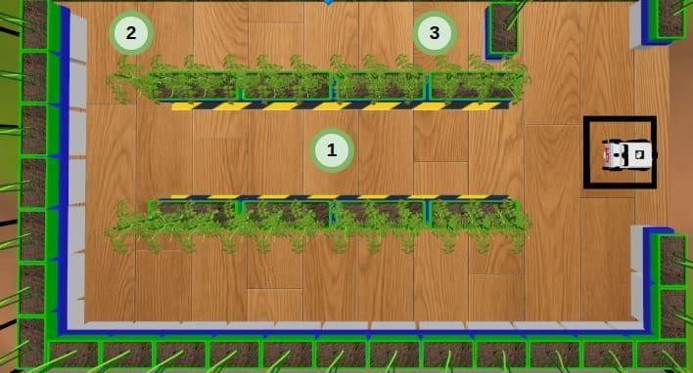

Fig 6.1 Gazebo Virtual Simulation of Arm
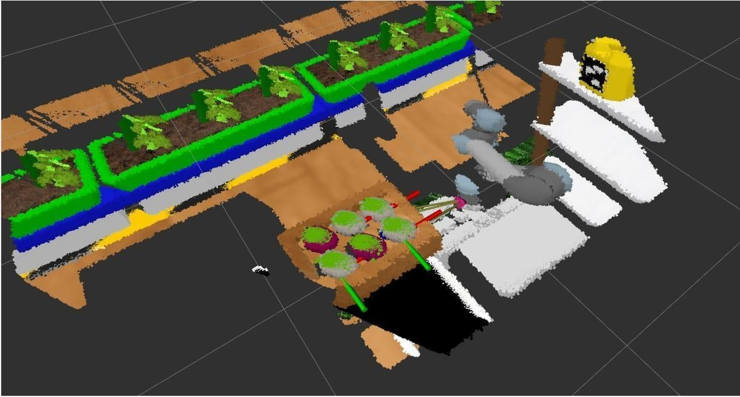

Fig 6.2 Gazebo Virtual Simulation of Rover

CONCLUSION
This paper presented a smart collaborative robotic (cobot) system for sustainable agriculture. By combining a mobile rover, robotic arm, and plant health database under ROS 2 control, the system ensures real-time monitoring, autonomous navigation, and precision pesticide application.
The approach reduces resource wastage, lowers environmental harm, and supports farmers in improving productivity. With its modular design and adaptability, the system lays the foundation for future advancements such as cloud-based analytics, drone integration, and large- scale deployment in modern farming practices.

References
1] A. J. Moshayedi, A. S. Khan, Y. Yang, J. Hu, and A. Kolahdooz, “Robots in Agriculture: Revolutionizing Farming Practices,” EAI Endorsed Transactions on AI and Robotics, vol. 4, no. 2, pp. 1–12, Jun. 2024. doi: 10.4108/airo.5855.
- F. Cañadas-Aránega, J. C. Moreno, J. L. Blanco- Claraco, A. Giménez, F. Rodríguez, and J. Sánchez- Hermosilla, “Autonomous collaborative mobile robot for greenhouses: Design, development, and validation tests,” Smart Agricultural Technology, vol. 4, pp. 1–10, 2024. [Online].
- M. O. Yerebakan and B. Hu, “Human–Robot Collaboration in Modern Agriculture: A Review of the Current Research Landscape,” Advanced Intelligent Systems, vol. 6, no. 7, pp. 1–18, Jul. 2024. doi: 10.1002/aisy.202300823.

