Chapter I

INTRODUCTION

Effective assessment was an indispensable component of quality education, extending far beyond simply assigning grades. A well-designed assessment served as a powerful tool to observe students' behavior and products data that were used to draw reasonable inferences about what students knew (Pellegrino, 2023). Effective assessment was crucial for achieving Sustainable Development Goal 4, as it provided the necessary data and insights to monitor progress, identify areas for improvement, and ensure that education truly led to relevant and effective learning outcomes for all learners United Nations Educational, Scientific and Cultural Organization (UNESCO 2022).

International assessments like Programme for International Student Assessment (PISA 2022) continued to reveal that despite satisfactory performance in traditional evaluations, many students struggled to apply mathematical knowledge to real-world problems Organisation for Economic Cooperation and Development (OECD 2022). This highlighted a global disconnect where students might perform well on tests but lacked the critical thinking and problem-solving skills needed for complex, real-world scenarios.

Global data from United Nations Children’s Fund (UNICEF) revealed that 617 million children and adolescents lacked minimum proficiency in mathematics and reading, which strongly suggested a fundamental failing in effective assessment practices. Furthermore, in formative assessment it suggested a weakness in ongoing checks during learning. While summative assessment highlighted the widespread problem and underscored that assessments were often used merely to identify failure rather than to inform a proactive cycle of teaching and learning improvements.

In the United States and Canada, there was a strong focus on both the technical quality and the authenticity of mathematics assessments. Educators reported that a major weakness in teacher-made assessments was their poor technical quality (Brookhart, 2021). A study by Demir et al. (2019), which aligned with common research in the American education system, found that these assessments often suffered from misaligned Tables of Specifications, weak item construction, and low psychometric reliability. These issues directly compromised the validity and fairness of the assessments, making it difficult to accurately measure student learning.

Furthermore, a study by McFeetors et al. (2021), conducted by researchers from U.S. and Canadian universities, criticized the limitations of traditional, high-stakes testing. They argued that this type of assessment often led to "teaching to the test," which narrowed the curriculum and inhibited students from developing deep conceptual understanding and higher-order thinking skills. Instead, these researchers advocated for the use of generative and authentic assessment practices to foster creative and conceptual thinking in mathematics classrooms. They concluded that improving assessment required moving beyond simple procedural knowledge and focusing on authentic, dynamic tasks that better reflected a student's true learning.

To ensure quality assessment in the Philippines, the Department of Education implemented initiatives such as DepEd Order No. 8, s. 2015 otherwise known as Policy Guidelines on Classroom Assessment for the K to 12 Basic Education Program, which explicitly called for assessments to be reliable, valid, and transparent and to align with the most essential learning competencies. DepEd Order No. 31, s. 2020 otherwise known as Interim Guidelines for Assessment and Grading in Light of the Basic Education Learning Continuity Plan provided schools with temporary adjustments for assessment and grading, allowing flexibility in how summative assessments were conducted during distance learning. More recently, DepEd Order No. 9, s. 2024 otherwise known as Implementing Guidelines on the School Calendar and Activities for the School Year 2024–2025 reinforced the need for continuous monitoring of student progress through both formative and summative evaluations.

Demir et al. (2019) evaluated alternative assessment methods in elementary schools, revealing critical flaws in traditional teacher-made mathematics assessments. Andres (2023) examined issues with teacher-created tests that were implemented to ensure quality assessment practices of teachers.

Despite their initials, a study by Orongan et al. (2024) analyzed summative assessments in Grade 11 across subjects including mathematics and found that while the tests generally followed a division-wide Table of Specifications (TOS) and achieved acceptable reliability scores, many items were misaligned with intended learning competencies.

Similarly, Galanan (2024) from Sultan Kudarat State University found that education students recognized the value of summative assessments in measuring final learning outcomes. However, the study emphasized that these tools often lacked diagnostic depth, limiting their ability to uncover students’ conceptual misunderstandings. This suggested a need for more flexible and thoughtfully designed assessment instruments that went beyond surface-level mastery.
Most of the studies on assessment practices concentrated on national and international levels, examining issues such as technical quality, alignment with learning competencies, and the diagnostic limitations of summative assessments (Brookhart, 2021; Demir et al., 2019; McFeetors et al., 2021; OECD, 2022; UNESCO, 2022). While these studies provided valuable insights into systemic challenges such as poor item construction, misaligned Tables of Specifications, and the tendency of assessments to measure surface-level mastery, only a few of them explored how these issues manifested in specific local contexts.

However, only a few of them investigated the specific strengths and weaknesses of mathematics teachers in the local context of Cervantes, Ilocos Sur, particularly regarding the design and implementation of summative assessment tools used in examinations, indicating a spatial gap.

The purpose of this research study was to investigate the current practices, strengths, and weaknesses of mathematics teachers in Cervantes, Ilocos Sur, regarding the design and utilization of summative assessment tools under their real classroom conditions. By focusing on the local context such as mathematics teachers in Cervantes, Ilocos Sur, this study sought to address a critical gap in the literature and contribute to the broader goals of quality education under SDG 4.

Framework of the Study
This study was anchored in Assessment Theory, particularly as advanced by the educational theorists Robert Stake and Michael Scriven, who emphasized the purposeful and systematic nature of assessment in shaping educational outcomes. Assessment Theory explored how assessment tools, especially summative assessments, served to measure student learning against predefined standards and informed instructional effectiveness. In the context of mathematics education, this theory provided a critical lens for examining the design, alignment, and psychometric quality of teacher-made assessments (Stake, 2019; Scriven, 2020).

The framework supported the investigation of how well these assessments aligned with the Most Essential Learning Competencies (MELCs) set by the Department of Education (Philippines) and whether they promoted a valid and fair evaluation of student performance. Drawing from this theoretical foundation, the study examined the interplay between the purpose of assessment (e.g., certification and accountability), design features (e.g., item quality and table of specifications), and classroom realities such as limited resources, teacher workload, and multigrade instruction prevalent in local schools in Cervantes, Ilocos Sur.
By applying Assessment Theory, the research aimed to evaluate not only the effectiveness of summative assessment tools but also their influence on instructional practices and student learning outcomes in mathematics. This theoretical perspective facilitated a deeper understanding of how summative assessments could be improved to better support evidence-based teaching, curriculum alignment, and equitable learning opportunities.

The research was further supported by existing policy frameworks issued by the Department of Education (Philippines) that guided assessment practices in Philippine basic education. These included DepEd Order No. 8, s. 2015, also known as the Policy Guidelines on Classroom Assessment for the K to 12 Basic Education Program, which explicitly called for assessments to be reliable, valid, and transparent and aligned with the Most Essential Learning Competencies. The order also highlighted the importance of using varied assessment strategies, with summative assessment measuring whether learners had met the required content and performance standards.

Another relevant policy was DepEd Order No. 31, s. 2020, also known as the Interim Guidelines for Assessment and Grading, which provided temporary adjustments during the transition to distance learning modalities brought about by the COVID-19 pandemic. This order reaffirmed the continued use of written works and performance tasks for summative assessment while allowing greater flexibility and adaptation of assessment strategies to address the challenges of remote learning environments.

Additionally, DepEd Order No. 9, s. 2024, which outlined the Implementing Guidelines on the School Calendar and Activities for the School Year 2024–2025, reinforced the need for continuous monitoring of learner progress through both formative and summative evaluations. While continuous monitoring was essential for tracking learning progress, the implementation of frequent assessments could also lead to assessment fatigue among both teachers and students if not carefully managed.

Review of Literature
Strengths of the assessment tools employed by mathematics teachers

The study of Tomáš Chytrý and Petr Kubiatko (2021) aimed to examine pupils' summative assessments in mathematics as dependent on selected factors. They utilized a methodology not explicitly detailed in the provided text, but implying an analysis of quantitative data. The findings stated that summative assessments aimed to evaluate student learning at the end of instructional periods, measuring performance against established standards and often influencing decisions about student progression, certification, or curriculum refinement, suggesting these were inherent strengths. It was concluded that when designed and implemented effectively, summative assessment tools were strong in their capacity to provide a comprehensive evaluation of learning, guide student progression, support certification processes, and inform curriculum improvements. The study implicitly recommended that educators should ensure that summative assessments were well-aligned with established standards to leverage their strength in supporting crucial educational decisions.

According to Megan McFeetors et al. (2021), they explored generative unit assessment to achieve authenticity in mathematics classroom assessment practices. They utilized a methodology not explicitly detailed but focused on conceptualizing and discussing authentic assessment practices. The findings implicitly argued for the strength of assessment tools that promoted authenticity and generative learning, moving beyond traditional "teaching to the test" by encouraging deep, conceptual, and creative thinking. It was concluded that the inherent strength of assessment tools in mathematics lay in their potential to foster authentic learning, encourage profound conceptual understanding, and stimulate creative problem-solving when designed with these aims. The researchers recommended that mathematics teachers should prioritize designing assessments that were authentic and promoted deeper understanding rather than merely testing for procedural knowledge, to enhance their quality and impact.

The study of Basil Chigonga (2020) aimed to theorize the role and practices of formative assessment in 21st-century mathematics education. He utilized a theoretical review or discussion as his method. The findings likely highlighted the crucial role and inherent strengths of formative assessment in mathematics for facilitating ongoing learning, providing immediate feedback, and enabling adaptive instruction. It was concluded that the strength of assessment tools, particularly formative ones in mathematics education, lay in their ability to dynamically support continuous student learning, identify misconceptions in real time, and allow adaptive teaching strategies. The researcher recommended that mathematics teachers should skillfully integrate formative assessment practices into their daily teaching to leverage its power for continuous learning improvement and to complement summative evaluations.

The study of Ronaldo Marquez (2023) aimed to examine the processes, practices, and strategies involved in assessment utilization as a basis for developing an enhanced assessment tool. They utilized a methodology not specified but likely involved an analysis of current assessment practices. The findings suggested that when teachers effectively utilized established processes and strategies, assessments could successfully serve their intended purposes, such as informing grading, guiding curriculum alignment, and supporting educational accountability. It was concluded that the strengths of assessment tools often depended heavily on the effective processes, practices, and strategies employed by teachers in their utilization, which could lead to the successful achievement of assessment objectives. The researcher implicitly recommended that teachers should continuously reflect on and refine their assessment utilization processes, practices, and strategies to maximize the effectiveness and positive impact of their assessment tools.

Weaknesses of the assessment tools employed by mathematics teachers
The study of Megan McFeetors et al. (2021) aimed to explore generative unit assessment to achieve authenticity in mathematics, implicitly critiquing less effective traditional approaches. They utilized a methodology not explicitly detailed. The findings argued that traditional high-stakes testing fostered “teaching to the test,” narrowing curriculum expansion and discouraging deep, conceptual, or creative thinking, especially in mathematics contexts, highlighting this as a critical weakness. It was concluded that a major weakness of summative mathematics assessment tools was their propensity to narrow the curriculum and inhibit the development of higher-order thinking skills when the focus was exclusively on rote memorization for high-stakes evaluation. The researchers recommended that assessment design in mathematics should prioritize authenticity and conceptual understanding to overcome the limitation of "teaching to the test."

The study of Seher Demir et al. (2019) aimed to evaluate alternative assessment methods used in elementary schools, implicitly highlighting weaknesses of traditional ones. They utilized an evaluation study, likely including an analysis of existing assessment instruments. The findings indicated that teacher-made mathematics assessments often suffered from misaligned Tables of Specifications, weak item construction, and low psychometric reliability, which collectively compromised validity and fairness. It was concluded that a primary weakness of teacher-made mathematics assessment tools was their poor technical quality, characterized by issues in aligning content with objectives, flawed question design, and inconsistent results, leading to questionable validity and fairness. The researchers recommended that extensive professional development for mathematics teachers in assessment literacy, focusing on the principles of TOS construction, valid item writing, and reliability checks, was crucially needed to address these technical shortcomings.
The study of Andres (2023) aimed to establish a quality instrument for the summative assessment of pre-service elementary teachers, implicitly by identifying gaps in current practices. They utilized a methodology not explicitly detailed but involved instrument development and validation. The findings noted that the shortcomings of teacher-made assessments were compounded by insufficient assessment literacy among teachers, limited professional development, and uneven resource allocation, particularly affecting under-resourced and smaller schools. It was concluded that weaknesses in the quality of assessment tools were often a symptom of broader systemic issues, including a lack of adequate teacher training in assessment principles, limited opportunities for professional growth, and disparities in educational resources. The researcher recommended that educational policies should focus on strengthening teacher assessment literacy through sustained professional development and ensuring equitable distribution of resources to support the creation and use of quality assessment instruments.

The study of Verzosa and Josefina Vistro-Yu (2019) aimed to discuss the prospects and challenges in implementing a new mathematics curriculum in the Philippines. They utilized a methodology not explicitly detailed but served as a review or discussion of curriculum reform. The findings implicitly suggested that challenges in curriculum implementation, particularly in mathematics, could negatively affect assessment tool quality; if teachers struggled with new content or pedagogical approaches, their ability to design assessments that genuinely reflected the new curriculum's intentions would be hampered. It was concluded that weaknesses in mathematics assessment tools could arise from broader challenges in curriculum implementation, as teachers might struggle to align assessments with new content or pedagogical demands. The researchers recommended that curriculum reform efforts be coupled with adequate support and professional development for teachers to ensure that assessment practices effectively aligned with and measured the new curriculum's objectives.

The study of Suchyadi et al. (2020) aimed to improve the ability of elementary school teachers through the development of competency-based assessment instruments in a teacher working group in North Bogor City. They utilized a community engagement methodology, focusing on the development and implementation of assessment instruments in a collaborative setting. The findings demonstrated that developing and implementing competency-based assessment instruments, especially when done collaboratively through teacher working groups, could significantly improve teachers' assessment abilities. It was concluded that an effective output for improving assessment practices involved not only the development of practical, competency-based assessment instruments but also their implementation through collaborative teacher engagement and professional development. The researchers recommended that outputs encompass both tangible assessment tools and a pedagogical framework for their integration, supported by collaborative teacher learning communities to ensure sustainability and efficacy.

The study of Ronaldo Marquez (2023) aimed to examine existing processes, practices, and strategies on the utilization of assessment as a basis for an enhanced assessment tool. They utilized a methodology not specified but suggested an analysis leading to tool development. The findings implied that a thorough investigation into current assessment processes and practices could serve as a strong foundation for the development of a refined, improved, or new assessment instrument. It was concluded that research into existing assessment processes and practices could serve as a strong foundation for the development of an "enhanced assessment tool" designed to address identified shortcomings. The researcher recommended that the development of new assessment tools should be informed by a thorough analysis of current teacher practices and the specific challenges they faced.

The review of literature revealed several critical gaps: first, misaligned Tables of Specifications; second, weak item construction; third, low psychometric reliability; and challenges related to insufficient assessment literacy, along with compounding local issues in Cervantes, Ilocos Sur. The most relevant and impactful output that could be developed was a Contextualized Summative Mathematics Assessment Toolkit for Mathematics Teachers in Cervantes, Ilocos Sur.

Research Question
This study aimed to investigate the summative assessment practices of mathematics teachers. Specifically, it aims to answer the following questions:
- What are the strengths of the assessment tools employed by mathematics teachers?
- What are the weaknesses of the assessment tools employed by mathematics teachers?
- What output can be developed based on the results?

Importance of the study
This study was significant to various stakeholders in the field of education, as it provided insights into the effectiveness of summative assessment tools used by mathematics teachers. The findings benefited the following:

Learners. The summative assessment helped the learners to improve their summative assessment in mathematics.

Teachers. The study provided mathematics teachers with insights into the strengths and weaknesses of the summative assessment tools they used. It also offered practical recommendations to help them design assessments that were more aligned with learning competencies and cognitive skills, improving both instructional planning and student learning outcomes.

School Administrators. The findings guided school leaders in identifying areas for professional development related to assessment literacy. This included organizing training workshops and providing resources that supported teachers in constructing valid, reliable, and effective summative assessments.

Policy Makers. This study informed educational policy by providing evidence-based recommendations for improving classroom assessment practices. Policy makers used the results to update assessment guidelines, frameworks, and support mechanisms to promote quality teaching and learning in mathematics.

Curriculum Developers. The insights from this study helped curriculum planners ensure better alignment between learning competencies and the assessments used to measure them. This contributed to more coherent instructional design across grade levels in mathematics education.

Future Researchers. The study served as a valuable reference for future research on classroom assessment practices, particularly in local and rural settings. It also opened opportunities for comparative studies and innovations in designing assessments that better captured learners' mathematical abilities.

Parents and Guardians. By highlighting the importance of well-structured assessments, this study also benefited parents and guardians who sought transparency and fairness in how their children’s academic performance was evaluated.

Chapter II

METHODOLOGY

This chapter presents a brief discussion of how the study was conducted, the research design, the sources of data, the research instrument, the research gathering procedure, and the treatment of data.

Research Design

This study employed document analysis as its research design. Document analysis was a qualitative research method used to systematically evaluate documents such as teacher-made assessment tools to gain understanding and develop empirical knowledge. This approach was appropriate for the study because it allowed the researcher to analyze actual summative assessment tools used by mathematics teachers in Cervantes, Ilocos Sur.

By examining the content, structure, alignment with curriculum standards, and cognitive demands of these documents, the researcher could assess their strengths and weaknesses. This method provided a detailed view of how assessment practices were reflected in the documents themselves, rather than relying solely on self-reported data. Through document analysis, the study could uncover patterns, inconsistencies, and areas for improvement in assessment design.

This research design allowed the study to generate context-specific insights that could inform the development of more effective and equitable summative assessments in mathematics, thereby supporting improved instructional practices and student learning outcomes.

Sources of Data

The study was conducted in all twenty-two public elementary schools in Cervantes District, Ilocos Sur during the 2025–2026 school year, specifically focusing on Grade 6 mathematics teachers. The participating institutions included Aluling Elementary School, Bissayot Elementary School, Biwak Elementary School, Cabaroan Elementary School, Cervantes Central School, Comillas North Integrated School, Comillas South Elementary School, Daing Integrated School, Dinwede West Elementary School, Libang Elementary School, Lamagan Elementary School, Liqueo Elementary School, Malaya Elementary School, Namaligan Elementary School, Naiba Elementary School, Paang Elementary School, Pilipil Elementary School, Quinayad Elementary School, Rosario Elementary School, San Juan Elementary School, Tagpeo Elementary School, and Zigzag Elementary School.

Data were gathered through document analysis, with the primary sources being Grade 6 second grading summative assessment tests. The data collection process involved securing authorization from district and school officials, employing a standardized checklist to ensure consistency across all schools, and carefully cataloging each document with metadata (teacher, school, date, grading period). Documents were evaluated for authenticity, relevance, and alignment with the timeline of the study.

Analysis adopted content and thematic coding strategies to assess curriculum alignment, cognitive demand, and question types. Data collection was deemed sufficient when data saturation was achieved—that is, when the tools collected in the second grading period began to reveal only recurring themes, formats, and patterns, with no new design elements emerging, a recognized criterion for qualitative rigor in document-based research.

Research Instrument
The main research instrument that was used in this study was a document analysis guide. This guide served as a tool to systematically evaluate the second grading summative assessment tools in mathematics developed and used by teachers in all schools in Cervantes District, Ilocos Sur.

Each collected document was evaluated against these indicators using a descriptive analysis format. The researcher also took field notes during the document review process to record observations about layout, formatting, instructional alignment, and patterns across documents.

If necessary, brief follow-up conversations or written clarifications were requested from teacher-participants to contextualize unclear portions of the assessment tools. However, the primary data came from the documents themselves.

All collected documents and related data were handled with strict confidentiality and were used solely for research purposes. Teachers’ identities and school affiliations were not disclosed in the reporting of the study.

Data Collection Procedures

This study followed a systematic process in gathering and analyzing documents related to second grading summative assessments in mathematics. The researcher began by seeking official permission from the Schools Division Office of Ilocos Sur and from the school heads of all public elementary schools in the Cervantes District, Ilocos Sur. This district-wide approach was intended to ensure a comprehensive and representative understanding of assessment practices in a rural context.

After identifying the participants, the researcher explained the purpose, scope, and significance of the study and obtained their informed consent to access and review their second grading summative assessment tools. These documents included periodical test papers.

The collection of documents was done in a respectful and non-intrusive manner, with assurance of confidentiality and ethical handling of all materials. The researcher organized and labeled each document for proper tracking and documentation.

Using a document analysis guide, each assessment tool was systematically reviewed based on specific criteria such as curriculum alignment, item quality, level of cognitive demand, and scoring practices. The researcher also kept field notes to record insights, document patterns, and reflect on any emerging themes or concerns during the analysis.

If clarification was needed regarding the structure or purpose of certain assessment items, the researcher requested brief follow-up conversations with the teacher, ensuring the validity of the analysis.

Once the review of all collected documents was completed, the researcher proceeded to analyze the data by identifying recurring themes, strengths, weaknesses, and patterns that addressed the main research question and sub-questions of the study.

Mode of Analysis

This study used the thematic analysis method to analyze the data obtained from the collected teacher-made summative assessment tools used during the second grading period. The researcher began by familiarizing themselves with the documents through multiple readings of each assessment tool, along with any supporting materials such as tables of specifications (TOS).

Next, the researcher generated initial codes by identifying recurring features and noteworthy aspects of the assessment tools such as alignment with MELCs, types of questions used, level of cognitive demand, and clarity of item construction. These codes represented meaningful patterns observed in the documents.

Once the initial coding was completed, the researcher organized the codes into themes that reflected broader strengths and weaknesses in the design and quality of the assessment tools. For instance, themes included “limited coverage of higher-order thinking,” “strong alignment with competencies,” or “lack of item variety.”

Finally, the researcher interpreted these themes to draw conclusions and provided a well-supported understanding of how summative assessment tools were being used by mathematics teachers in the Cervantes District, Ilocos Sur. This method allowed the study to highlight both the effective features and areas in need of improvement in assessment practices, contributing to the development of better-designed tools that enhanced learning and supported instructional goals.

Ethical Considerations

This study was conducted following ethical guidelines to protect the rights, dignity, and confidentiality of all participants. Prior to data collection, the researcher obtained formal approval from the Schools Division Office of Ilocos Sur and secured written consent from the school principals of all participating elementary schools in the Cervantes District, Ilocos Sur.

The researcher then informed the participating mathematics teachers about the purpose, scope, and procedures of the study. Participation in the research was strictly voluntary, and participants had the right to withdraw from the study at any time without any negative consequences or penalties.

To ensure confidentiality, no real names or identifying information were included in the final write-up. All collected documents and supporting materials were handled with care and were stored securely. Electronic data were password-protected to prevent unauthorized access.

Additionally, the study was designed to ensure that no physical, psychological, or emotional harm was inflicted on participants. The researcher approached all interactions with professionalism, respect, and sensitivity. The study adhered to the ethical standards of educational research as outlined in DepEd research guidelines and other relevant institutional or national protocols.

By upholding these ethical principles, the study aimed to maintain the integrity of the research process and the trust of its participants, while ensuring that findings were responsibly and respectfully reported.

Chapter III
RESULTS AND DISCUSSION

This chapter presents the results and discussion of the study based on the analyzed summative assessment tools in Mathematics used in some selected public elementary schools in the Cervantes District, Schools Division Office of Ilocos Sur. Guided by the statement of the problem, the findings are organized into two overarching categories that capture the quality of these assessment instruments, which yielded two major categories: (1) Strengths of the Assessment Tools Employed by Mathematics Teachers, and (2) Weaknesses of the Assessment Tools Employed by Mathematics Teachers.

Strengths of the Assessment Tools Employed by Mathematics Teachers

The document analysis of the summative assessment tools across multiple quarters and schools in the Cervantes District revealed five major sub-themes under the strengths of the assessment tools: (1) Promotion of Higher-Order Thinking Skills, (2) Inclusion of Real-life Problems, (3) Variety of Test Types is Present. Each sub-theme is elaborated below through their respective codes.

Promotion of Higher-Order Thinking Skills

The findings show that the assessment tools include items that promote higher-order thinking skills. These are evident in tasks that require learners to engage in problem-solving, analytical thinking, application of concepts, and mathematical reasoning. Learners are exposed to multi-step problems, evaluative questions, and situations that require justification of answers rather than simple recall.
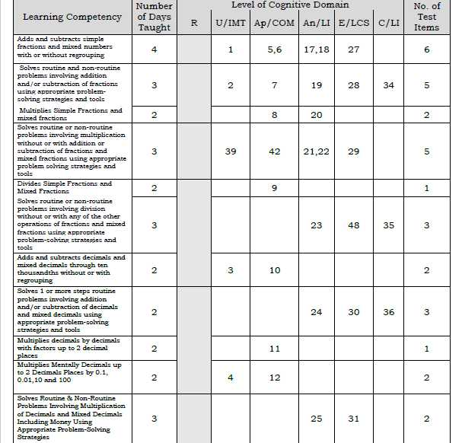
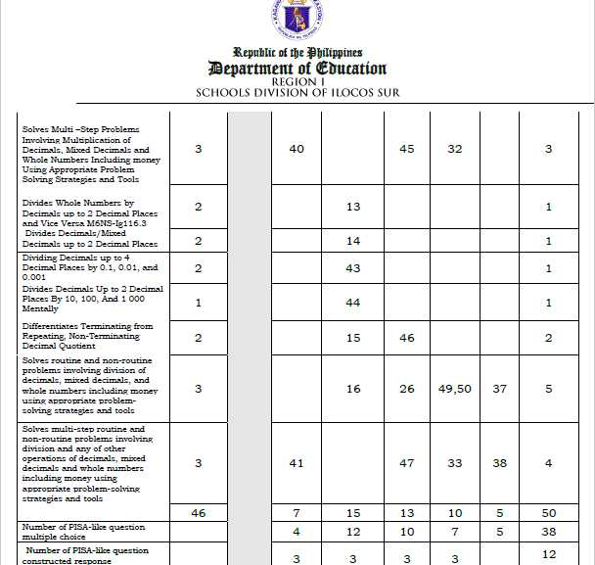

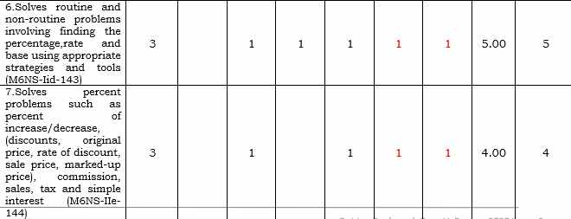
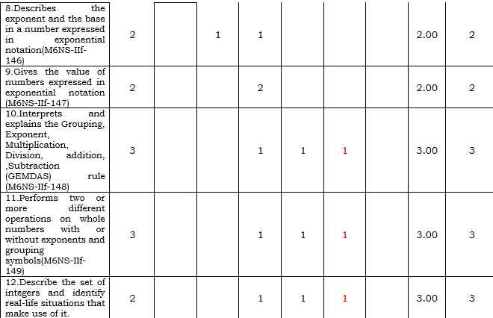
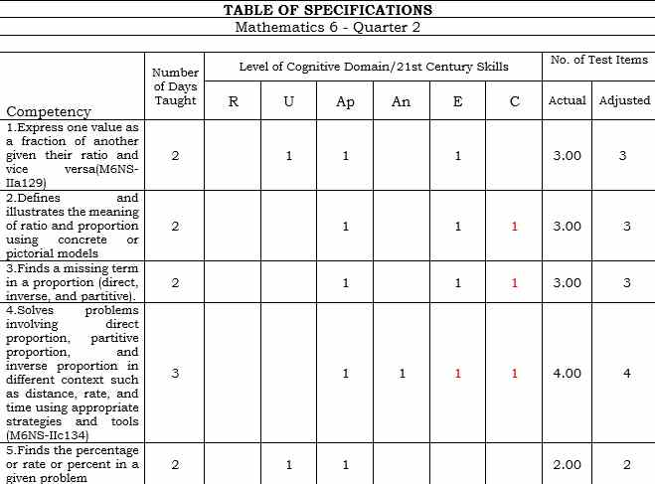

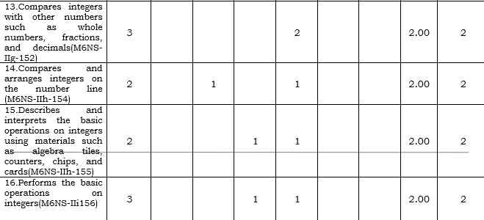
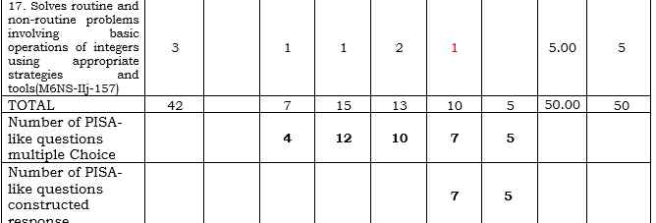

Figure 1: Sample TOS for Quarter 2 showing the Promotion of Higher-Order Thinking Skills

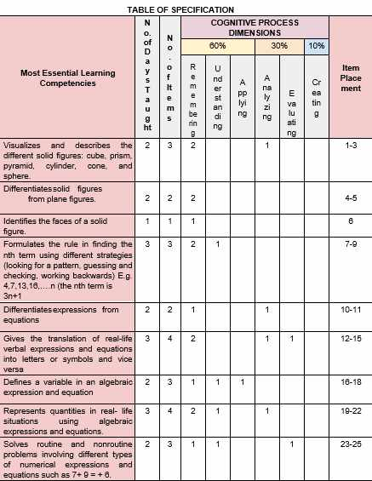
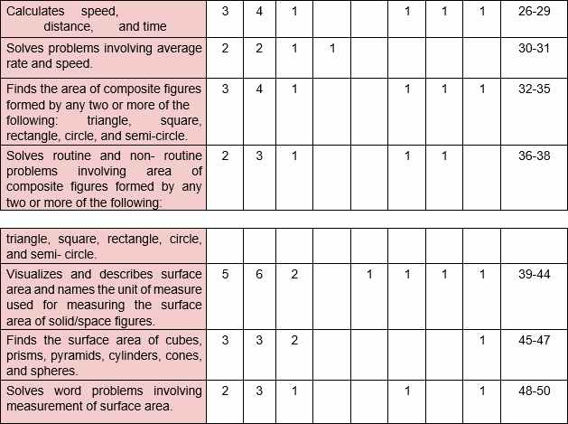

Figure 2: Sample TOS for Quarter 3 showing the Promotion of Higher-Order Thinking Skills

Figures 1 and 2 present samples of the Tables of Specifications (TOS) for Quarter 2 and Quarter 3, showing how test items are distributed across cognitive levels. The figures demonstrate that a portion of the test items is allocated to higher-order thinking skills (HOTS) such as analysis, evaluation, and problem-solving. This suggests that teachers intentionally include items that go beyond simple recall and computation.

This indicates that the assessment tools go beyond basic computation and memorization, encouraging learners to think critically and develop deeper understanding of mathematical concepts. Such practices are essential in fostering independent thinking and problem-solving abilities among students.

The finding corroborates the study of McFeetors et al. (2021), which emphasized that assessment tools are most effective when they promote authentic and generative learning, allowing students to develop conceptual understanding and creative problem-solving skills. Similarly, Chigonga (2020) highlighted that effective assessment practices support higher-order thinking by enabling learners to analyze and evaluate their knowledge.

The inclusion of higher-order thinking tasks implies that the assessment tools support the development of learners’ critical thinking, problem-solving, and reasoning skills rather than focusing solely on recall and computation. This reflects alignment with modern educational goals that emphasize deeper understanding. It is concluded that the assessment tools effectively promote higher-order thinking skills through the inclusion of problem-solving, analytical, and reasoning-based tasks, contributing to deeper mathematical understanding. This finding is consistent with studies, who emphasized the role of authentic assessments in fostering critical thinking, noted that such practices strengthen cognitive development (McFeetors et al., 2021; Chigonga, 2020).

It is recommended that teachers continue and further enhance the integration of higher-order thinking tasks by increasing the number and complexity of problem-solving and reasoning items in assessments. This is supported by studies, who advocate for deeper conceptual assessment, and emphasized strengthening higher-level cognitive engagement. (McFeetors et al., 2021; Chigonga, 2020).

Inclusion of Real-life Problems
Another strength observed in the assessment tools is the inclusion of real-life problems. The items are contextualized using everyday situations such as budgeting, shopping, measurement, and other practical scenarios familiar to learners. In some cases, the problems are localized, reflecting community-based contexts that are relevant to students’ daily experiences.

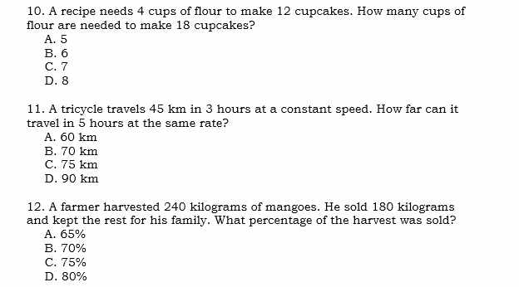
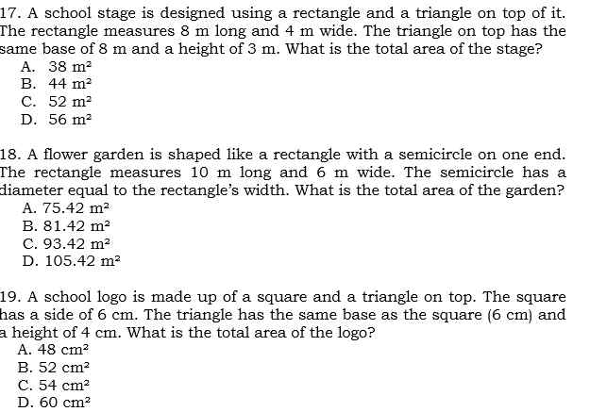

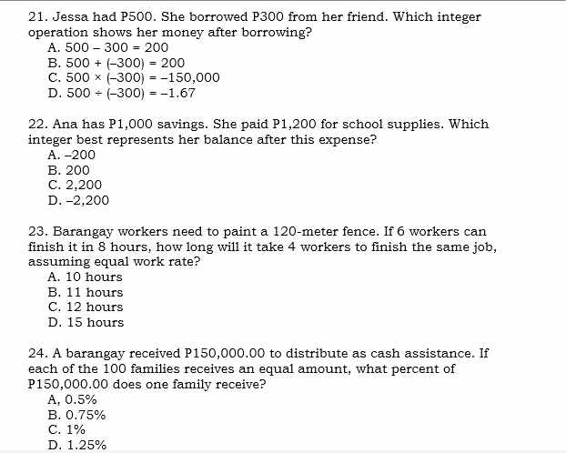
Figure 3: Sample of Test showing the Inclusion of Real-life Problems

This figure shows test items that are contextualized in real-life situations, such as budgeting, shopping, or measurement.

The inclusion of real-life problems makes mathematics more meaningful and relatable to learners. It allows students to connect abstract mathematical concepts to their daily experiences, which improves engagement and understanding.

This approach makes mathematics more meaningful and relatable, allowing learners to connect abstract concepts to real-world applications. It also increases student engagement and motivation, as learners can see the relevance of mathematics in their daily lives.

This finding supports the study of McFeetors et al. (2021), which emphasized the importance of authentic assessment in promoting meaningful learning experiences. Furthermore, Chytrý and Kubiatko (2021) noted that summative assessments are most effective when they measure learning in ways that reflect real-world applications and align with educational standards.

The use of real-life and contextualized problems implies that the assessment tools promote meaningful learning by connecting mathematical concepts to learners’ everyday experiences, thereby improving engagement and practical understanding. It is concluded that the integration of real-life problems strengthens the relevance and authenticity of the assessment tools, enabling learners to apply mathematical knowledge in practical situations. This is consistent with McFeetors et al. (2021), who highlighted the importance of authentic learning tasks. Similarly, Chytrý and Kubiatko (2021) who emphasized real-world alignment in assessment practices.

It is recommended that teachers expand the use of contextualized and localized problems to further enhance learner engagement and real-world application of mathematics. This is supported by studies, who advocate for authentic assessment practices, and emphasize meaningful and context-based assessment design (McFeetors et al., 2021; Chytrý & Kubiatko, 2021).

Variety of Test Types is Present
The findings also revealed that the assessment tools utilize a variety of test formats, including multiple-choice items, word problems, visual representations, and tasks that measure different cognitive levels. This diversity allows teachers to assess a wide range of skills, from basic knowledge to higher-order thinking.
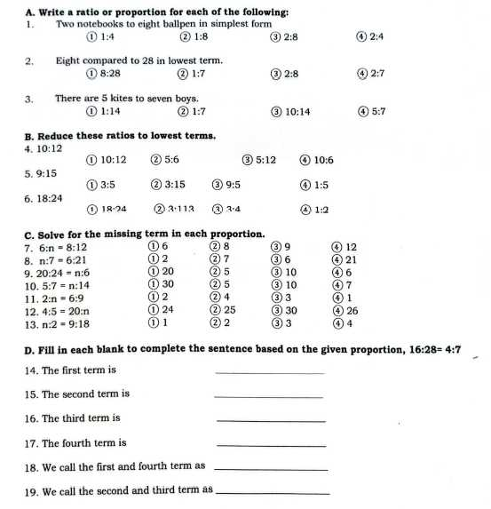

Figure 4: Sample of Test in Quarter 2 showing the Variety of Test is Present

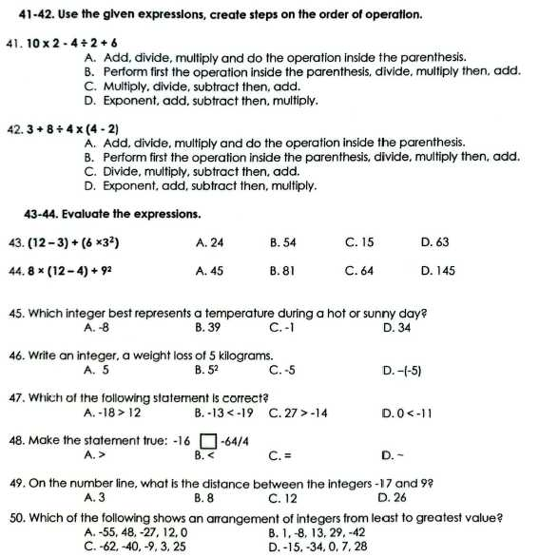

Figure 5: Sample of Test in Quarter 3 showing the Variety of Test is Present
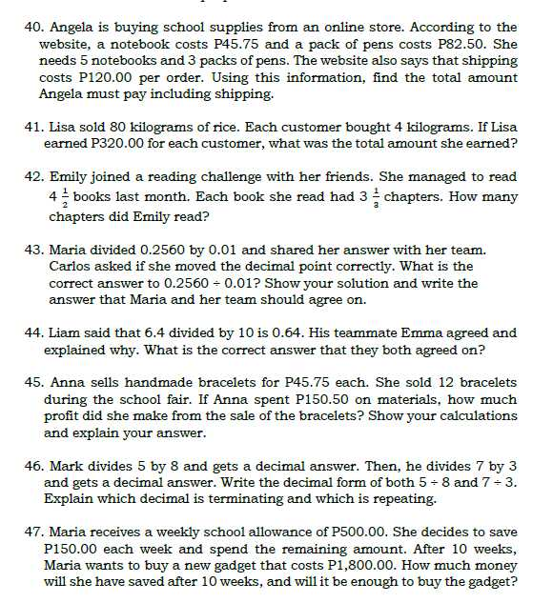
Figure 6: Sample of Test in Quarter 3 showing the Variety of Test is Present

The figures show that teachers use a variety of assessment formats, which helps measure different skills and cognitive levels.

This variety is beneficial because it ensures comprehensive assessment it accommodates different learning styles it prevents over-reliance on a single test format.

The use of varied test types enhances the comprehensiveness of the assessment, ensuring that different aspects of learning are measured. It also accommodates different learning styles, providing learners with multiple ways to demonstrate their understanding.

This finding is consistent with Marquez (2023), who emphasized that the effectiveness of assessment tools depends on the strategies used in their design, including the use of varied formats. In addition, Chigonga (2020) highlighted that combining different assessment approaches improves the quality of evaluation and supports continuous learning.

The use of varied test formats implies that the assessment tools provide a more comprehensive and inclusive evaluation of student learning by measuring different cognitive skills and accommodating diverse learning styles. It is concluded that the use of varied test types enhances the overall quality of the assessment tools by allowing for a broader measurement of knowledge and skills, leading to a more accurate evaluation of student performance. This is consistent with studies, who underscored the importance of varied assessment strategies, and emphasized comprehensive evaluation practices (Marquez, 2023; Chigonga, 2020).

It is recommended that teachers maintain and refine the use of diverse test formats while ensuring alignment with competencies and cognitive levels to further improve assessment quality. This is supported by studies, who highlighted effective assessment design, and emphasized the integration of varied assessment methods for better learning outcomes (Marquez, 2023; Chigonga, 2020).

Weaknesses of the Assessment Tools Employed by Mathematics Teachers

The document analysis also present significant and recurring weaknesses across the assessment tools examined. These are organized into five major sub-themes. (1) Mismatch of Learning Competencies in the TOS and Curriculum Guide, (2) Inconsistencies in Item Distribution, (3) Incorrect Computation of number items, (4) Poor Face Validity, (5) Poor Construction of Directions.

Mismatch of the Learning Competencies in the TOS and Curriculum Guide

The findings show that some test items do not align with the intended learning competencies, with instances of incomplete coverage, irrelevant items, and mismatched cognitive levels. Some competencies are underrepresented, while others are overemphasized, particularly basic computation.

Learning Competency in the Competencies
Curriculum Guide Quarter 2 included in the TOS
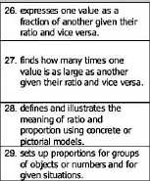
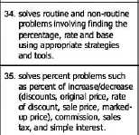
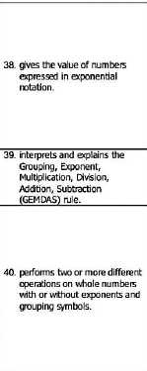
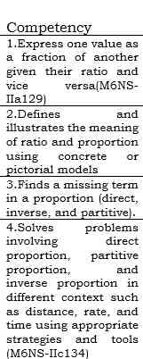
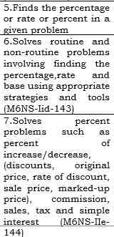

Figure 7: Sample of Quarter 2 of Mismatch of Learning Competency to the Table of Specification

Learning Competency in the Sample TOS
Curriculum for Quarter 3
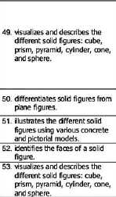
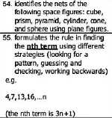
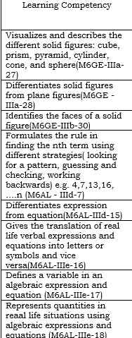

Figure 8: Sample of Quarter 3 of Mismatch of Learning Competency to the Table of Specification

These figures compare the Curriculum Guide competencies with the actual TOS. It shows that some competencies are missing or underrepresented, some items are misaligned with intended objectives. This indicates poor alignment, which affects the validity of the test. If the test does not measure the intended competencies, it cannot accurately evaluate student learning.
This implies that the assessment tools may not accurately measure the intended learning outcomes, leading to gaps in evaluating students’ mastery of competencies. It is concluded that misalignment between assessment items and learning competencies weakens the validity and reliability of the assessment tools. This is consistent with studies, who identified alignment issues as a major flaw in teacher-made tests, and linked these weaknesses to insufficient assessment training (Demir et al., 2019; Andres, 2023).

It is recommended that teachers strengthen alignment between test items and competencies by improving the use of Tables of Specifications (TOS) and ensuring full competency coverage. This is supported by studies, who emphasized proper test alignment, and advocated for improved assessment literacy (Demir et al., 2019; Andres, 2023).

Inconsistencies in Item Distribution
The findings indicate uneven distribution of items across topics and cognitive levels, including clustering of similar items and overrepresentation of certain content areas.

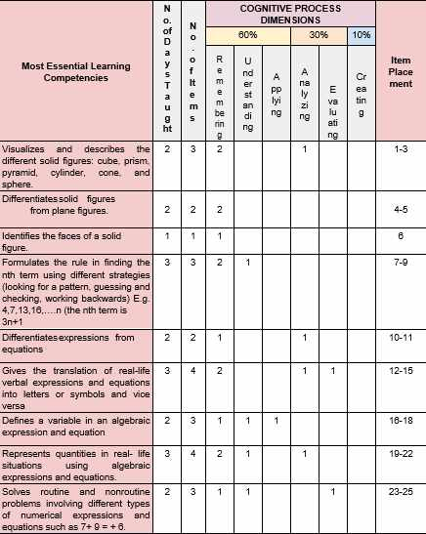
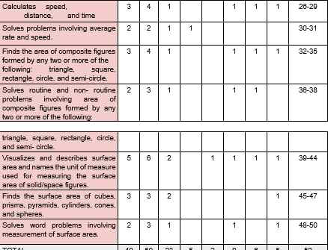

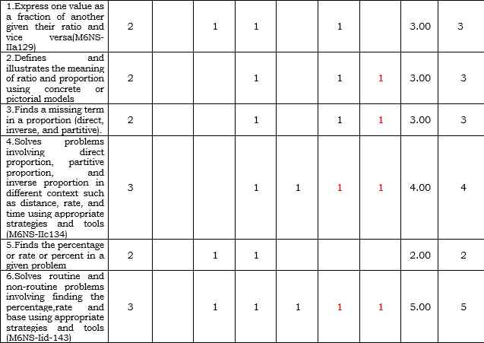

Figure 9: Sample TOS for Quarter 2 showing Inconsistences in Item Distribution

This figure shows uneven distribution of items across topics and cognitive levels. Some topics have too many items, while others have too few. This leads to bias in assessment and incomplete measurement of learning.

This implies that the assessment tools may provide a biased measurement of student learning, as some topics and skills are either over-assessed or under-assessed. It can be concluded that inconsistencies in item distribution reduce the fairness and comprehensiveness of the assessment tools. This is consistent with Demir et al. (2019), who highlighted that balanced item distribution is essential for valid assessment.

It is recommended that teachers ensure balanced distribution of items across topics and cognitive levels by strictly following the TOS. This is supported by Demir et al. (2019), who emphasized the importance of proper test planning and distribution.

Incorrect Computation of Number of Items
The findings reveal errors in the computation and allocation of items, including incorrect totals, numbering issues, and mismatched percentages.
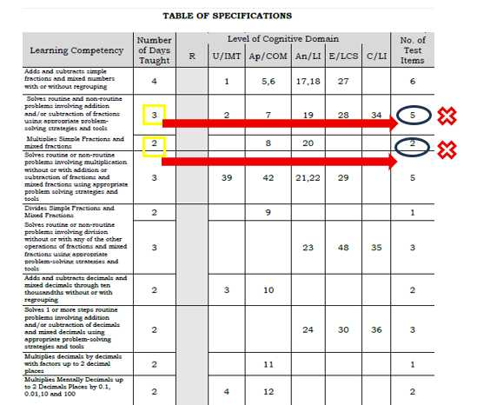

Figure 10: Sample TOS for Quarter 1 showing the Incorrect Computation of
Number of Items

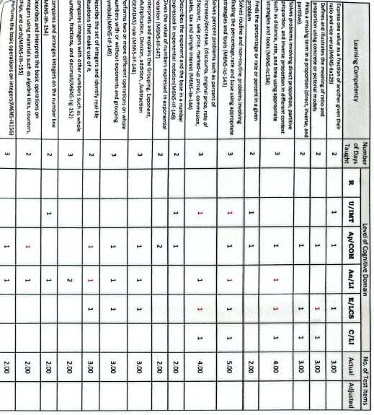

Figure 11: Sample TOS for Quarter 2 showing the Incorrect Computation of Number of Items

These figures highlight errors such as incorrect total number of items, wrong percentage allocation, miscounted distribution. These technical errors weaken the reliability and organization of the test and may confuse both teachers and students.

This implies that technical errors in test construction may affect the accuracy and organization of the assessment tools, potentially confusing students and reducing test reliability.

It can be concluded that errors in item computation and allocation weaken the technical quality of the assessment tools. This is consistent with Andres (2023), who emphasized that such issues affect the reliability and credibility of assessments.

It is recommended that teachers carefully review and validate item computations, numbering, and percentage distributions before administering tests. This is supported by Andres (2023), who advocated for improved technical accuracy through assessment training.

Poor Face Validity
The analysis of the test papers revealed significant issues related to face validity, particularly in terms of formatting, layout, and overall presentation of test items. Several items exhibited misaligned answer choices, inconsistent spacing, disorganized structure, and poorly arranged stems and options. In some cases, answer choices appeared before the question, while in others, mathematical expressions were not properly aligned with the corresponding items. Additionally, inconsistencies in punctuation, font spacing, and numbering were evident, making the test visually confusing and difficult to follow.

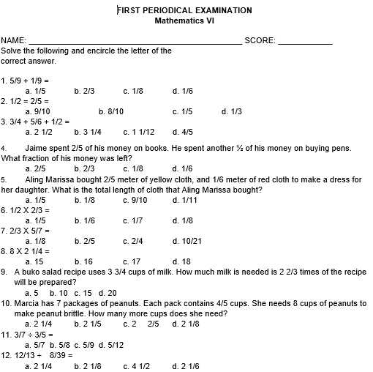
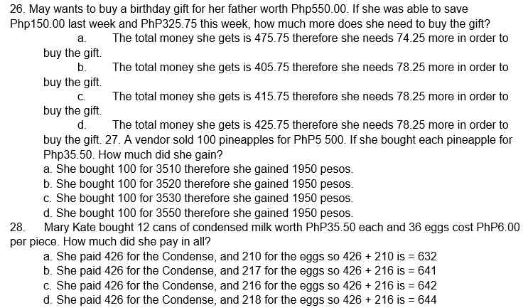

Figure 12: Sample Exam for Quarter 1 for Poor Face Validity

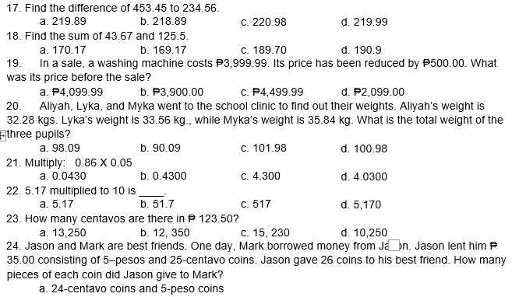
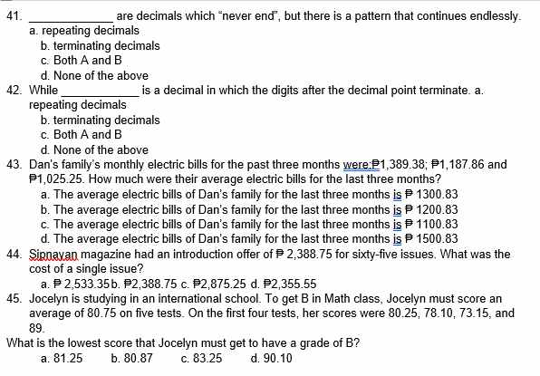
Figure 13: Sample Exam for Quarter 2 for Poor Face Validity
These figures show issues in formatting, layout, spacing and alignment, organization of items poor presentation affects readability and clarity, making the test difficult to understand. Even if the content is correct, poor formatting reduces the credibility of the assessment.

These formatting issues negatively affect the readability and professional appearance of the assessment tools. Since face validity refers to how appropriate and clear a test appears to test-takers, such weaknesses may lead learners to question the credibility of the test and experience unnecessary difficulty unrelated to mathematical ability.

This finding corroborates the study of Demir et al. (2019), which emphasized that poor technical quality in teacher-made assessments—including issues in formatting, structure, and item presentation—can significantly compromise validity and fairness. Similarly, Andres (2023) highlighted that technical flaws such as disorganized test layout and inconsistent formatting reduce the clarity and reliability of assessment tools. Moreover, Marquez (2023) stressed that effective assessment depends not only on content alignment but also on the proper organization and presentation of test materials, as these influence how accurately student performance is measured.

The presence of formatting and structural inconsistencies implies that the assessment tools may confuse learners, increase cognitive load, and lead to misinterpretation of items, thereby affecting the accuracy of their responses. These issues shift the focus away from measuring mathematical understanding to decoding poorly presented questions, which weakens the overall validity of the test. This supports Demir et al. (2019), who noted that clarity and organization are essential for valid assessment, and Andres (2023), who emphasized that technical accuracy directly impacts reliability and fairness.

It is therefore concluded that poor formatting and presentation of test items significantly weaken the face validity of the assessment tools, as they reduce clarity, readability, and learner confidence in the test. This finding is consistent with Demir et al. (2019) and Andres (2023), who identified technical and structural flaws as major contributors to weak assessment quality, and with Marquez (2023), who emphasized the importance of well-organized assessment design in achieving accurate measurement of learning.

No General Instructions
The findings indicate unclear, inconsistent, redundant, or missing instructions across different parts of the test.

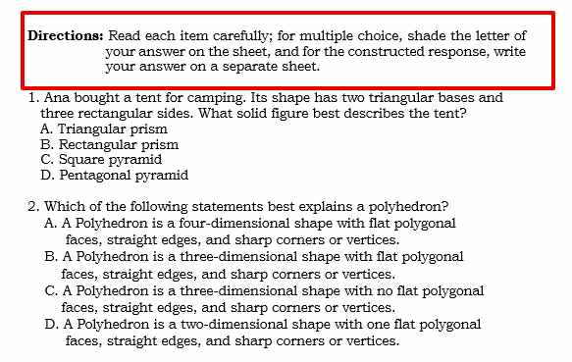

Figure 14: Sample Examination of Quarter 3 for No General Instruction

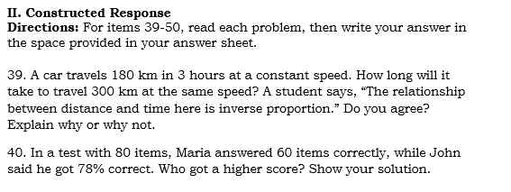

Figure 15: Sample Examination of Quarter 2 for No General Instruction

These figures show tests with missing or unclear general directions. Without clear instructions students may not know how to answer and errors may occur unrelated to knowledge. This weakens the usability of the test.

This implies that unclear directions may hinder students’ understanding of how to answer the test, leading to errors unrelated to their actual knowledge. It is concluded that poorly constructed directions reduce the usability and effectiveness of the assessment tools. This is consistent with Andres (2023), who emphasized the need for clear and structured assessment guidelines.

It is recommended that teachers provide clear, consistent, and concise directions for all test items to ensure proper understanding and accurate responses. This is supported by Andres (2023), who advocated for improved assessment design practices.

Poor Direction/Instructions
The findings revealed that several assessment tools contained poorly constructed directions characterized by ambiguity, inconsistency, and lack of clarity. Some instructions were either too vague, incomplete, or overly worded, making it difficult for learners to clearly understand what was required of them. In some cases, directions were missing entirely, while in others, different formats were used within the same test, leading to confusion among test-takers.

The following figures show highlight directions that are vague and inconsistent. Poor directions increase students’ cognitive load, forcing them to interpret instructions instead of focusing on solving problems

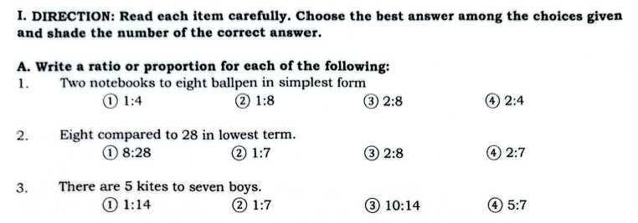

Figure 16: Sample Examination of Quarter 2 for Poor Direction

In figure 16, the direction says, “Write a ratio or proportion…”, however the format is a multiple choice and not a constructed response. This shows inconsistency between the task and response type.

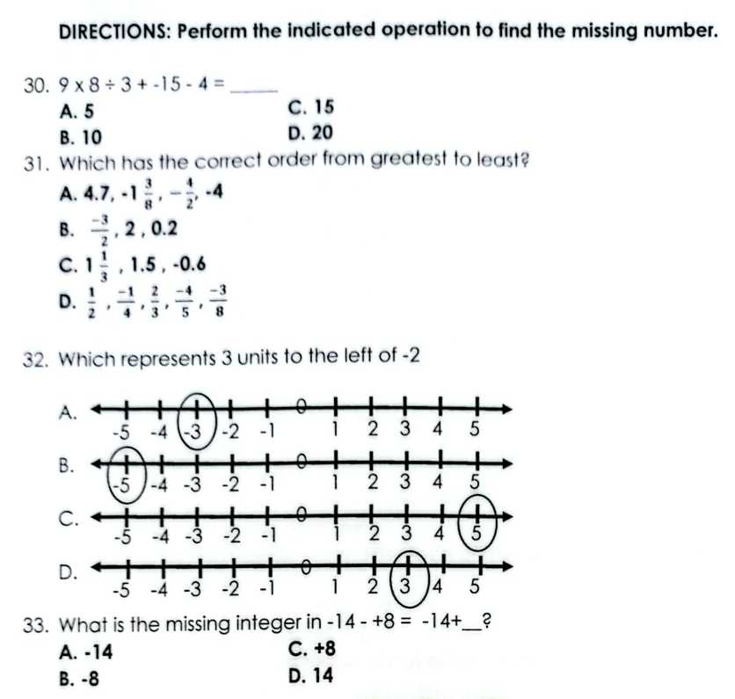

Figure 17: Sample Examination of Quarter 3 for Poor Direction

Another example that shows misalignment between the directions and the problem type is shown in Figure 17. The single set of directions suggests all items involve computation, but some of the items do not involve computation. This inconsistency can confuse students and reduce clarity in assessment.
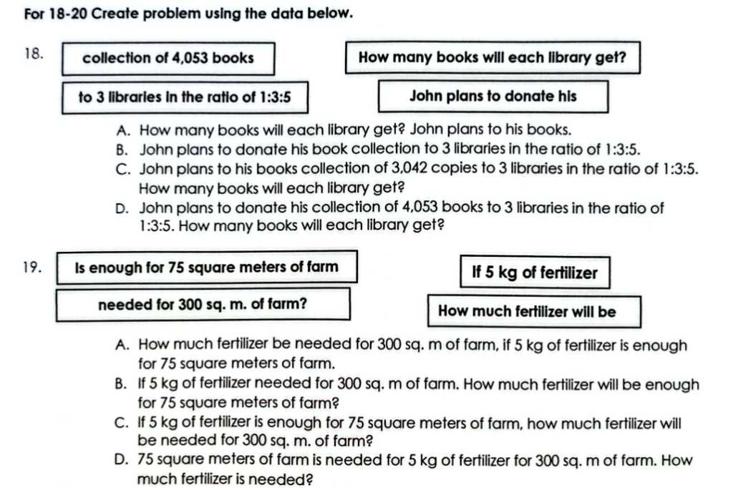

Figure 18 shows that the directions on the worksheet are unclear and inconsistent. The instruction says, “For 18–20 Create problem using the data below”, but the multiple-choice items already contain partly formed problems. This creates confusion because students don’t know whether they should choose the correct problem statement or solve the problem itself.

This finding corroborates the study of Andres (2023), which emphasized that unclear and poorly structured directions reduce the usability and effectiveness of assessment tools. Similarly, Demir et al. (2019) highlighted that weak item construction, including unclear instructions, contributes to poor technical quality and compromises the validity and fairness of assessments. When directions are not clearly communicated, learners may misinterpret tasks, resulting in responses that do not accurately reflect their true understanding.

The implication of this finding is that unclear directions increase students’ cognitive load, as they are forced to interpret instructions rather than focus on solving the mathematical problems. This shifts the purpose of assessment from measuring learning to testing comprehension of poorly written instructions. As supported by McFeetors et al. (2021), ineffective assessment practices hinder meaningful learning and may contribute to “teaching to the test” rather than promoting conceptual understanding.

It is therefore concluded that poor construction of directions significantly weakens the effectiveness and validity of assessment tools, as it prevents accurate measurement of student learning. This aligns with Andres (2023) and Demir et al. (2019), who both emphasized that clarity in assessment design is essential for ensuring fairness and reliability.

It is recommended that teachers ensure all test directions are clear, concise, and consistent across all sections of the assessment. Directions should be standardized, specific, and aligned with the task requirements. This recommendation is supported by Andres (2023), who advocated for improved assessment literacy, and by Suchyadi et al. (2020), who emphasized the role of teacher training and collaborative development in improving assessment practices.

Mismatch of Items and Cognitive Level
The analysis shows a mismatch between the intended cognitive levels indicated in the Table of Specifications (TOS) and the actual cognitive demand of the test items. While some competencies were intended to measure higher-order thinking skills (HOTS), many of the
corresponding items only required lower-order thinking skills (LOTS), such as recall and basic computation.
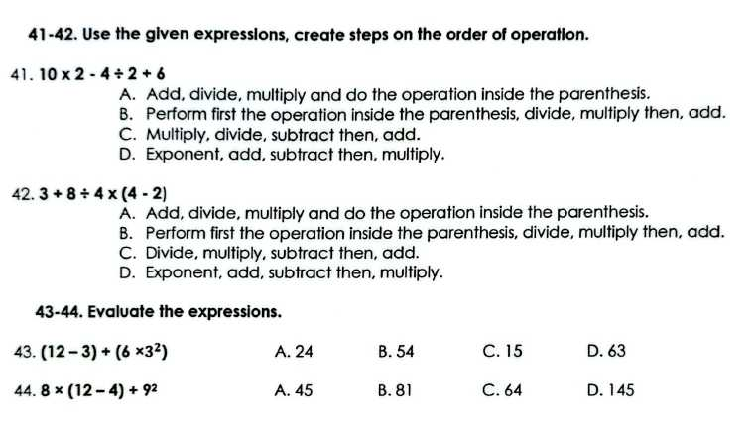
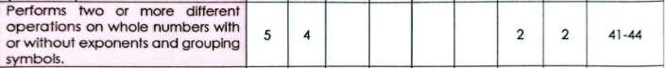
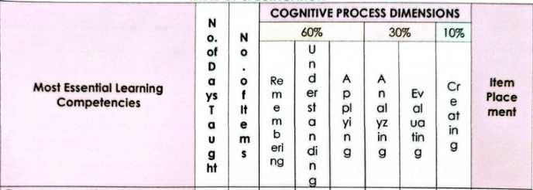

Figure 18: Sample Exam and TOS of Quarter 2 of Mismatch of Items and Cognitive Level

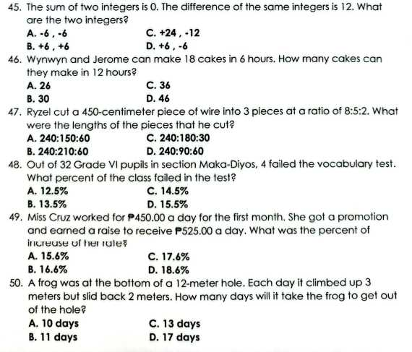
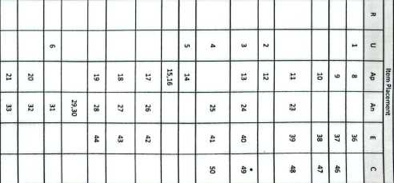

Figure 19: Sample Exam and TOS of Quarter 2 of Mismatch of Items and Cognitive Level

These figures compare the intended cognitive level in the TOS with the actual test items. They show that items intended for HOTS are actually LOTS (recall-based). This mismatch weakens the construct validity of the test because it does not measure the intended thinking skills.

This finding corroborates the study of Demir et al. (2019), which identified misalignment between test design and intended learning objectives as a major flaw in teacher-made assessments. Similarly, McFeetors et al. (2021) argued that traditional assessment practices often fail to promote higher-order thinking, as they tend to focus on procedural knowledge rather than conceptual understanding. Additionally, Chigonga (2020) emphasized that effective assessment should support analysis, evaluation, and reasoning, rather than mere recall.

The implication of this mismatch is that the assessment tools fail to accurately measure the intended learning outcomes, particularly higher-order thinking skills. As a result, learners may not be adequately challenged to develop critical thinking and problem-solving abilities. This supports the claim of McFeetors et al. (2021) that poorly designed assessments contribute to shallow learning and limit the development of deeper conceptual understanding.
It is concluded that the mismatch between items and cognitive levels weakens the construct validity of the assessment tools, as they do not measure what they are intended to assess. This finding is consistent with Demir et al. (2019), who emphasized that alignment between objectives, instruction, and assessment is essential for valid measurement, and with Chigonga (2020), who highlighted the importance of higher-order cognitive engagement.

It is recommended that teachers align test items with the intended cognitive levels specified in the TOS by ensuring that higher-order competencies are assessed using tasks that require analysis, reasoning, and problem-solving. This recommendation is supported by McFeetors et al. (2021), who advocated for authentic and conceptual assessments, and by Andres (2023), who emphasized strengthening assessment literacy to improve alignment and quality.

Errors in Writing Symbols
The findings also identified errors in the writing and presentation of mathematical symbols, including incorrect notation, improper formatting, and inconsistent use of symbols. Some items contained unclear or incorrectly written mathematical expressions, which could lead to confusion or misinterpretation among learners.

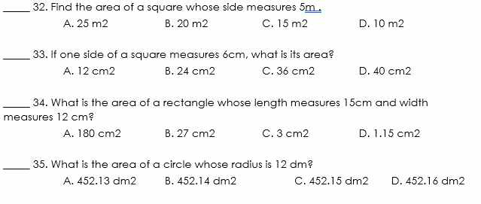
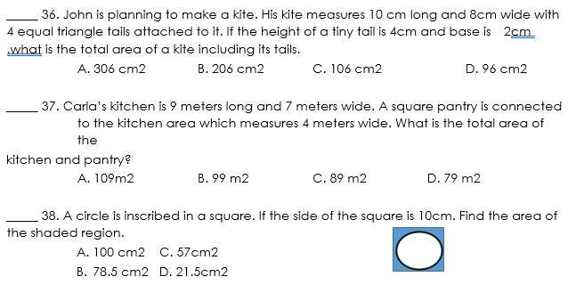

Figure 20: Sample Exam of Quarter 3 for Errors in Writing Symbols

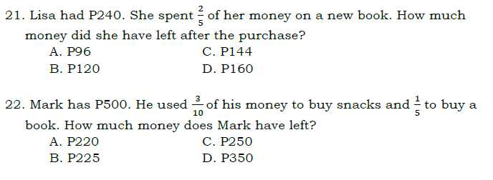

Figure 21: Sample Exam of Quarter 3 for Errors in Writing Symbols

This figure shows incorrect or unclear mathematical symbols and notations. These errors cause confusion, lead to misinterpretation and affect student performance unfairly.

This finding corroborates the study of Demir et al. (2019), which highlighted those technical errors in test construction, including inaccuracies in symbols and formatting, significantly compromise the validity and reliability of assessment tools. Similarly, Andres (2023) emphasized that technical quality, including accuracy in content presentation, is essential for credible and effective assessments. Marquez (2023) further noted that proper organization and presentation of test materials are critical in ensuring accurate measurement of student performance.

The implication of these errors is that learners may misinterpret questions due to incorrect or unclear symbols, leading to incorrect responses that do not reflect their actual understanding of the concept. This undermines the fairness of the assessment and may disadvantage students who are otherwise competent. As supported by Demir et al. (2019), such technical flaws reduce the accuracy and trustworthiness of assessment results.

It is therefore concluded that errors in writing mathematical symbols weaken the technical quality, clarity, and validity of assessment tools, as they interfere with accurate interpretation of test items. This conclusion aligns with Andres (2023) and Marquez (2023), who emphasized the importance of technical precision in assessment design.
It is recommended that teachers carefully review and validate all mathematical symbols and notations before administering tests. Peer review, proofreading, and the use of standardized formats are encouraged to ensure accuracy. This recommendation is supported by Andres (2023), who advocated for improved assessment practices through professional development, and by Suchyadi et al. (2020), who highlighted the importance of collaborative efforts in enhancing teachers’ assessment competencies.

Poor Constructed Options
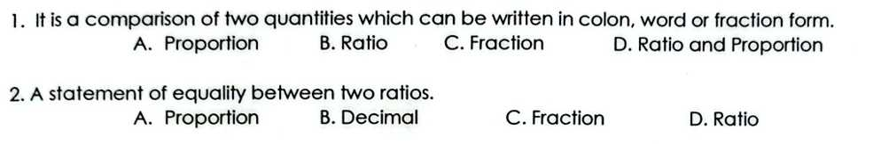

Figure 22: Sample Exam of Quarter 2 for Poor Constructed Options

The findings show that the distractors in both items are largely implausible and weaken the quality of the test. In Item 1, the stem clearly defines a ratio, yet distractors such as Proportion and Ratio and Proportion are conceptually inaccurate, while Fraction is only partially related. This makes the correct answer too obvious, reducing the item’s ability to discriminate between students who truly understand the concept and those who are guessing. In Item 2, the stem correctly defines a proportion, but distractors like Decimal and Fraction are irrelevant to the concept, while Ratio is misleading but still not a valid definition. Because most distractors are either unrelated or redundant, students can easily eliminate them, which undermines the challenge and validity of the assessment. Overall, the lack of plausible distractors diminishes the effectiveness of these items in measuring conceptual understanding of ratio and proportion. Stronger alternatives that are conceptually closer such as Rate, Equation, or Percentage would make the items more discriminating and reliable.
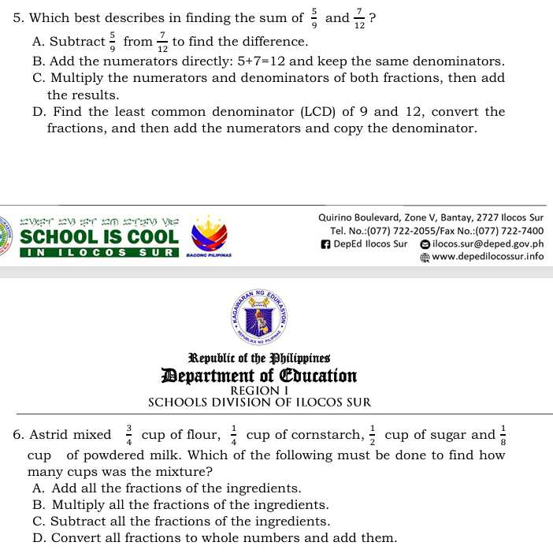

Figure 23: Sample Exam of Quarter 1 for Poor Constructed Options

Figure 23 shows that the distractors are not sufficiently plausible, which weakens the overall quality of the assessment. In Item 5, the correct process is to find the least common denominator, convert the fractions, and then add the numerators. However, distractors such as “subtract the fractions,” “add the numerators directly,” or “multiply the numerators and denominators” are implausible because they do not reflect any valid mathematical procedure for adding fractions. While they may serve as common student errors, their wording makes them appear obviously incorrect, reducing the item’s ability to challenge learners. In Item 6, the correct answer is to add all the fractions of the ingredients to find the total mixture. The distractors multiplying, subtracting, or converting fractions to whole numbers are not plausible strategies in this context. Multiplication and subtraction do not apply to combining ingredient amounts, and converting fractions to whole numbers is mathematically inaccurate. As a result, students can easily eliminate the distractors, making the correct answer too obvious.

Overall, the distractors fail to provide meaningful alternatives, which diminishes the discriminatory power of the items. To strengthen them, distractors should be designed to reflect more realistic misconceptions, such as “find a common denominator before adding” or “convert fractions to decimals first,” so that the items better assess students’ understanding of fraction operations.
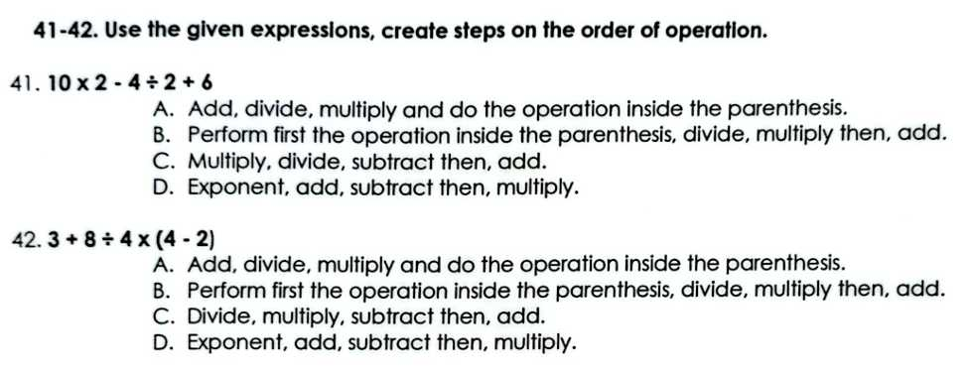
Figure 24: Sample Exam of Quarter 2 for Poor Constructed Options

In Figure 22, the direction “Use the given expressions, create steps on the order of operation” presents a mismatch with the format of the items. Aside from the direction, the choices in the items also show issues. In Item 41, the correct sequence is to multiply, divide, subtract, and then add. However, distractors such as “add, divide, multiply and do the operation inside the parenthesis” or “exponent, add, subtract then multiply” are implausible because the given expression contains no parentheses or exponents. These options introduce operations that are irrelevant to the problem, making them easy to dismiss. Similarly, in Item 42, the correct process is to perform the operation inside the parentheses first, then divide, multiply, and finally add. Yet distractors like “add, divide, multiply and do the operation inside the parenthesis” or “exponent, add, subtract then multiply” are not plausible since addition is not the first step and exponents are not present in the expression. As a result, students can quickly eliminate these distractors, which reduces the discriminatory power of the items.

Overall, the distractors fail to reflect realistic misconceptions about the order of operations. To strengthen the items, distractors should be designed to mirror common student errors, such as performing addition before multiplication or ignoring parentheses, so that the test more effectively measures students’ understanding of the correct sequence of operations.

Developed Output
The developed output, titled "Guidelines in Constructing Different Types of Paper-and-Pencil Tests," is fundamentally rooted in the critical need to bridge the gap between curriculum standards and actual classroom evaluation practices. The rationale for this instructional material stems from the research findings which identified significant technical deficiencies in the summative assessment tools used by Grade 6 Mathematics teachers in the Cervantes District. Specifically, the study revealed recurring weaknesses such as a lack of alignment between the Table of Specifications (TOS) and the Most Essential Learning Competencies (MELCs), computational errors in item distribution, and poor face validity due to unclear or missing instructions. By synthesizing these empirical observations with established pedagogical principles, the booklet serves as a strategic intervention to enhance teacher assessment literacy. It aims to transform assessment from a mere grading mechanism into a robust tool for measuring higher-order thinking skills and real-world problem-solving, thereby aligning local educational practices with national Department of Education standards and global targets for quality education and student proficiency.

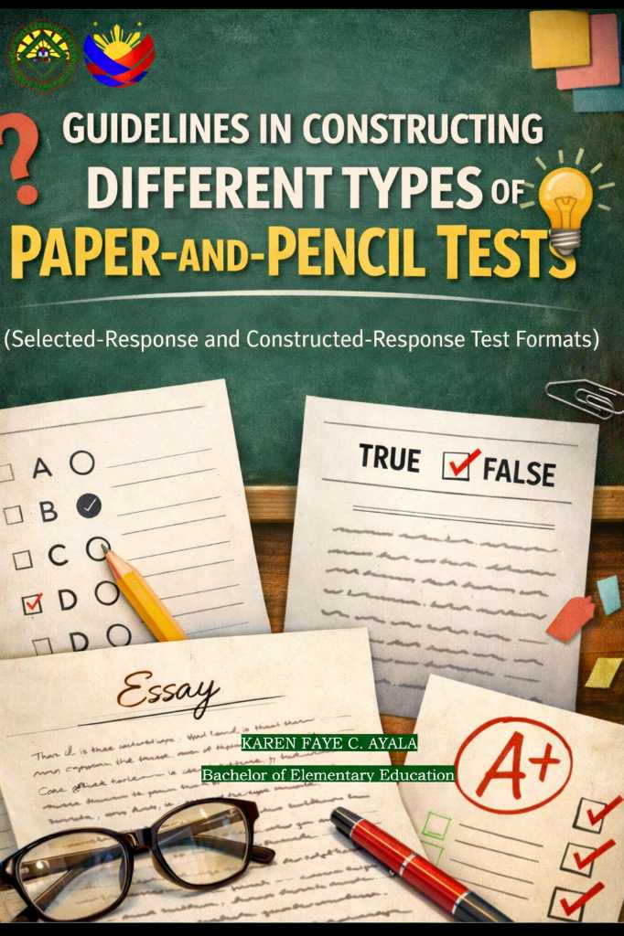
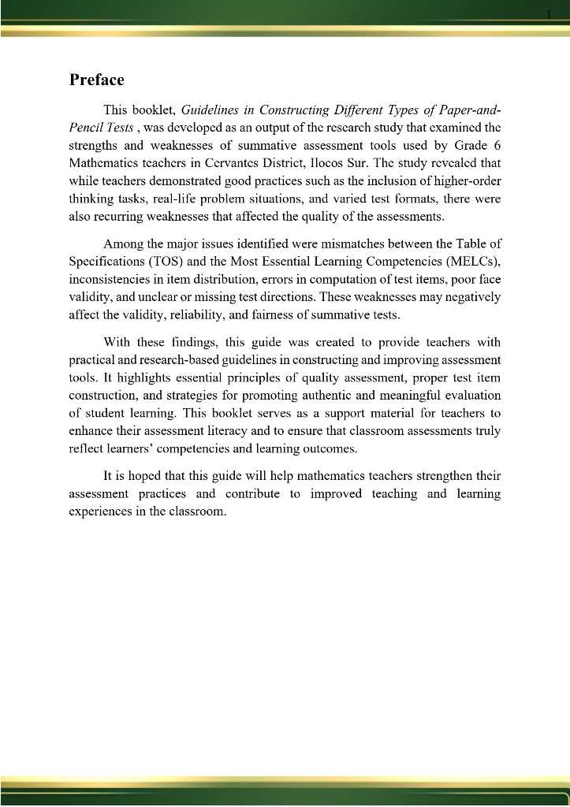
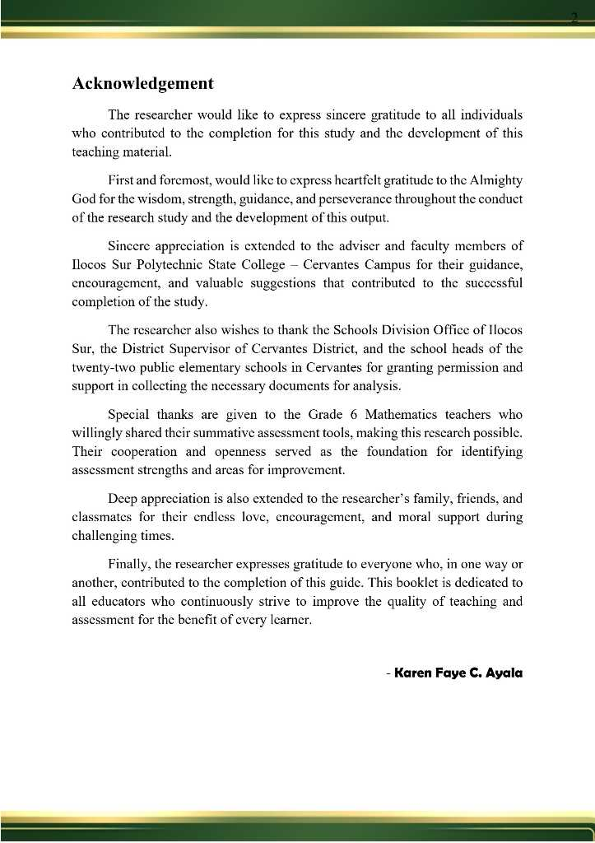
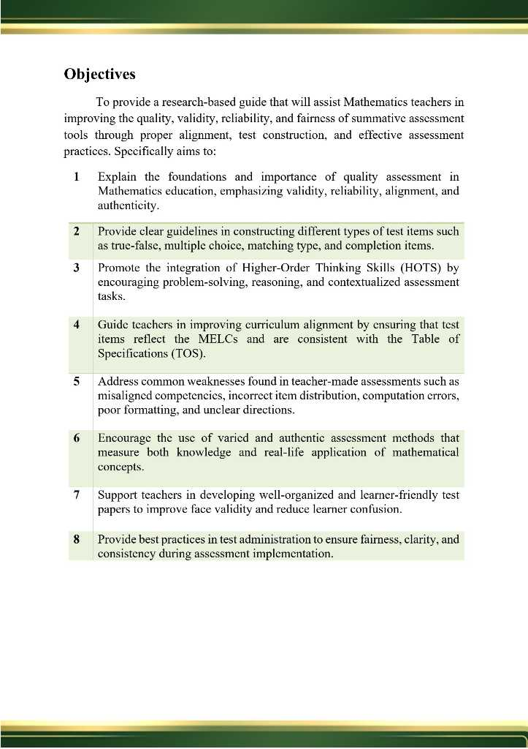
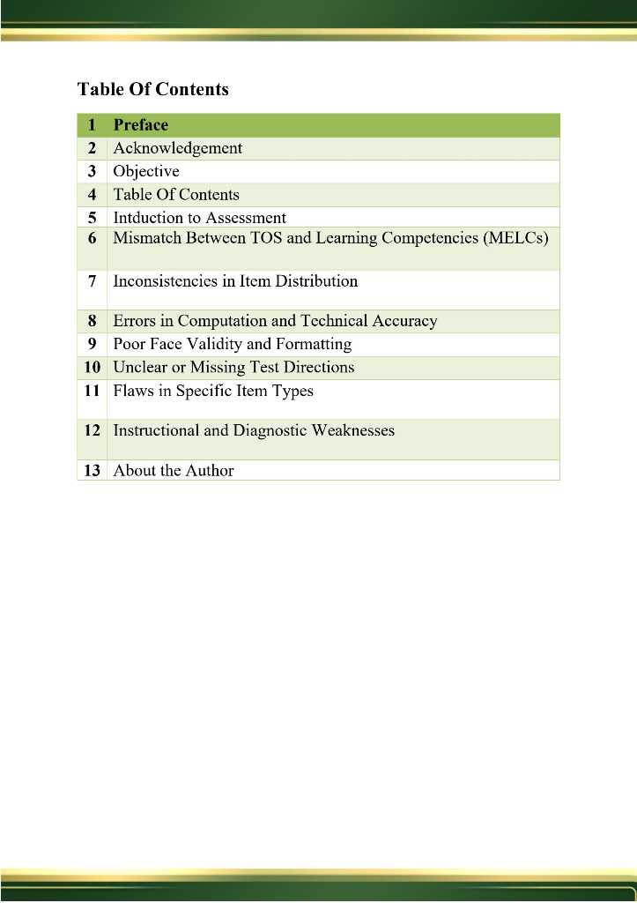
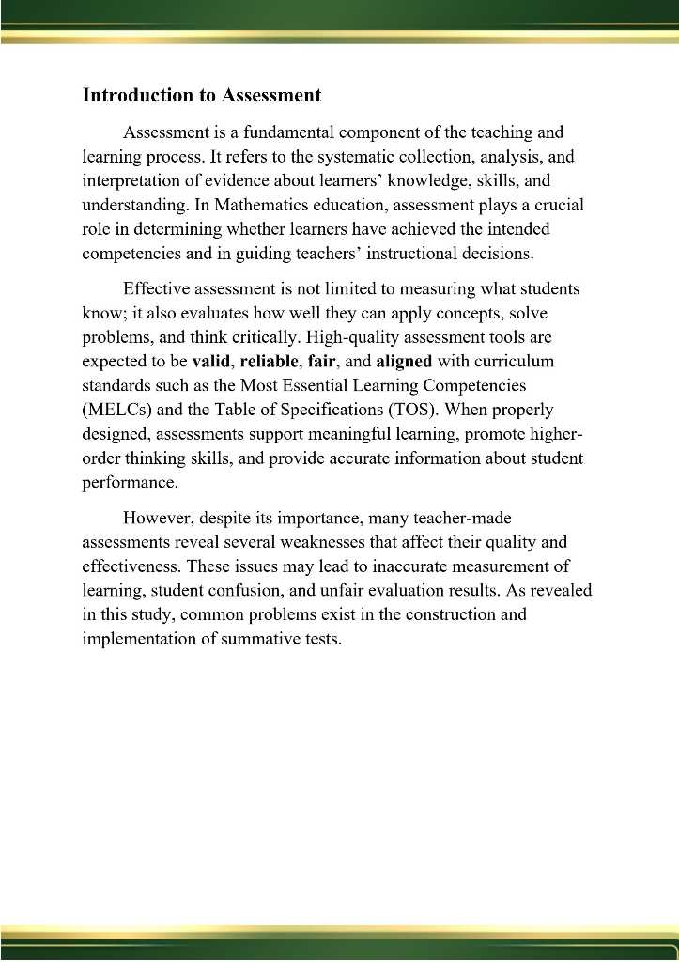
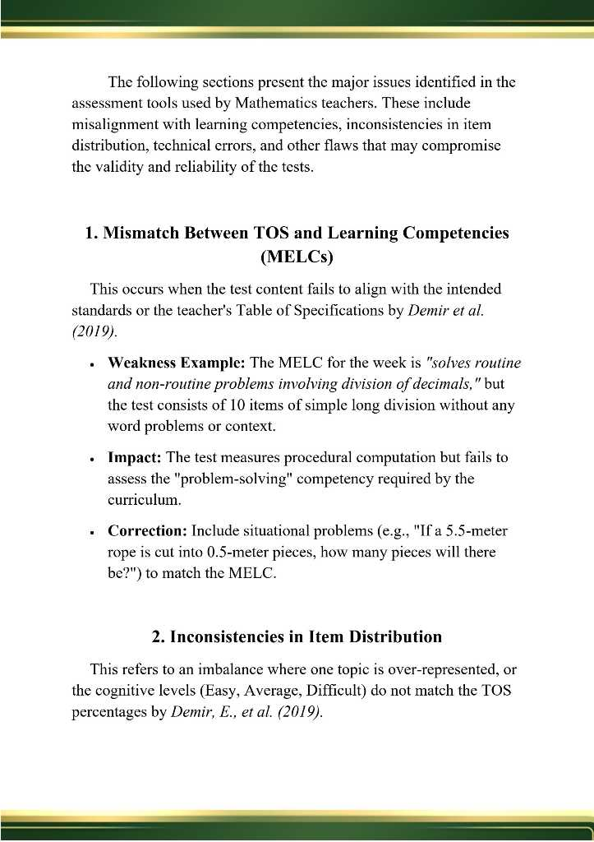
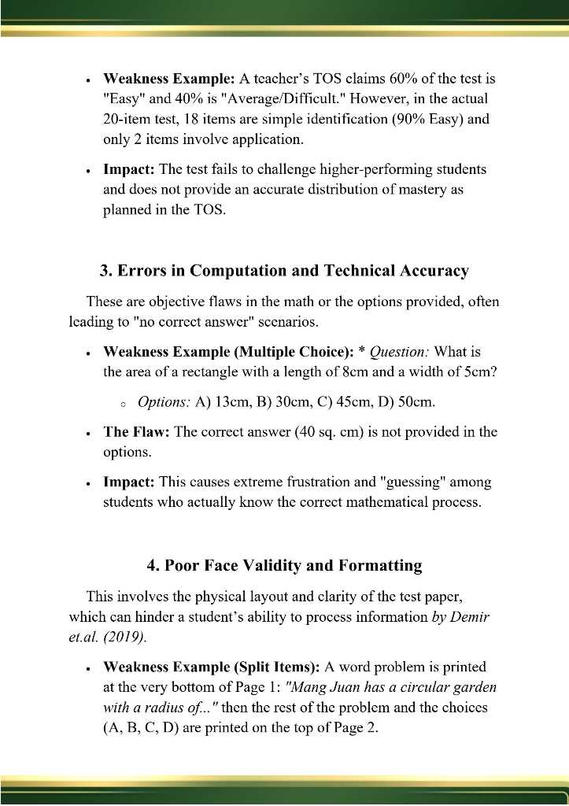
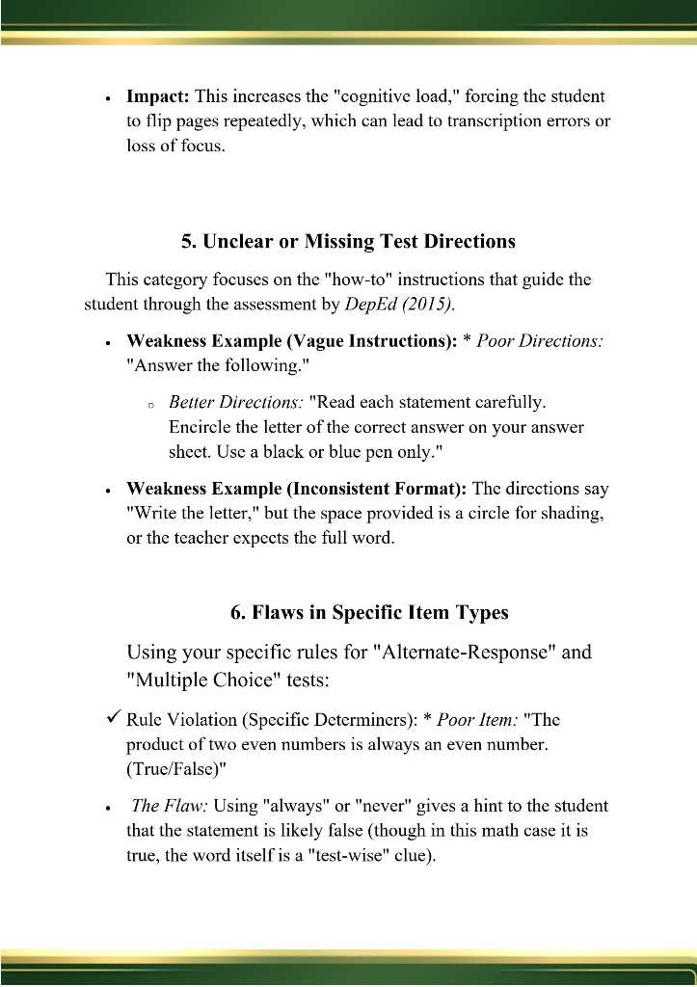
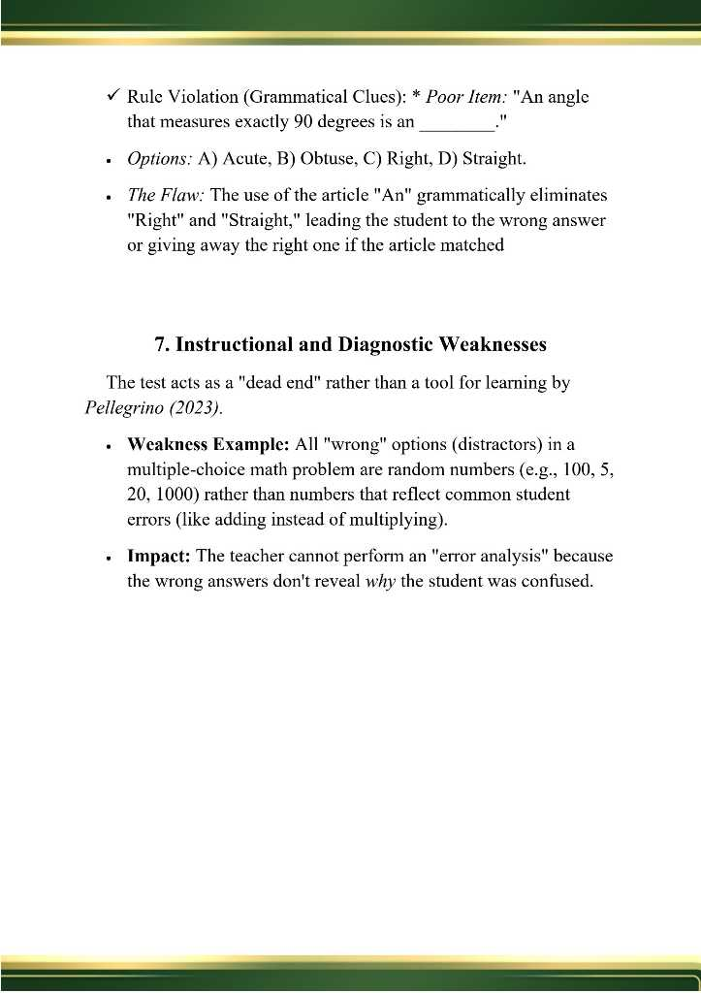
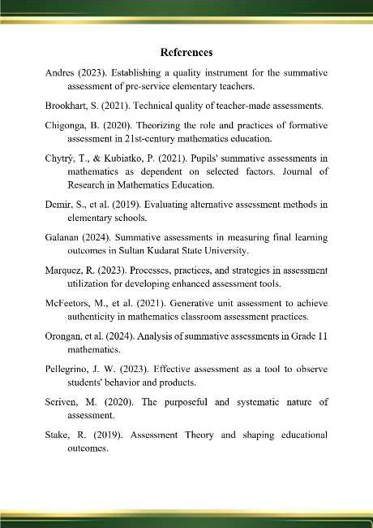

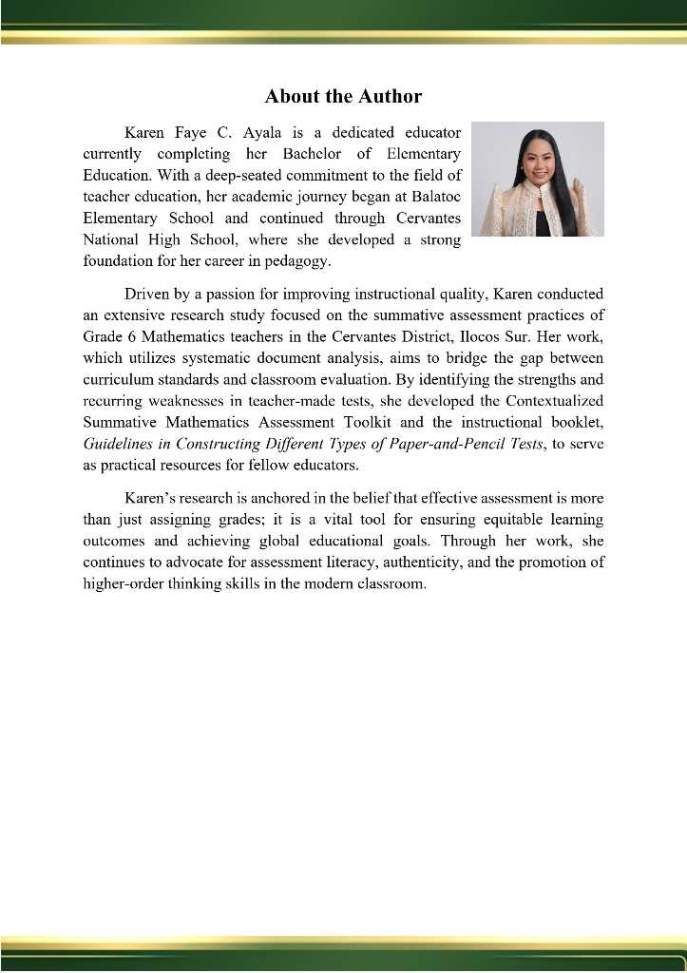
Conclusions
- Current assessment tools effectively promote higher-order thinking skills by incorporating problem-solving and reasoning tasks that go beyond basic recall. These tools are further strengthened by the inclusion of real-life problems often contextualized or localized which makes mathematics more meaningful and relatable for students. Additionally, the use of varied test formats (e.g., multiple-choice, word problems, and visual aids) allows for a more comprehensive and inclusive evaluation of different cognitive skills and learning styles.
- Many teacher-made assessments suffer from poor technical quality, specifically a misalignment between test items and the intended learning competencies in the Table of Specifications (TOS) and Curriculum Guide. There are significant inconsistencies in item distribution and incorrect computations regarding item totals and percentages, which compromise the fairness and reliability of the tests. Furthermore, many tools lack face validity due to disorganized layouts, misaligned answer choices, and vague or redundant instructions, all of which can hinder student performance and test credibility.
- Given the gap between teachers' pedagogical intent (using authentic tasks) and their technical execution (formatting and alignment errors), the study concludes that a specialized resource is necessary to bridge this gap. The most effective intervention is identified as a Contextualized Summative Mathematics Assessment Booklet specifically designed for the local district.

Recommendations
- Teachers should continue to enhance the integration of higher-order thinking tasks by increasing the complexity of reasoning-based items. It is also recommended that they expand the use of localized and contextualized problems to further bridge the gap between abstract math and real-world applications. To improve technical quality, teachers must strictly follow the Table of Specifications (TOS) to ensure balanced item distribution and complete competency coverage.
- School administrators should prioritize assessment literacy training for teachers, focusing on the principles of valid item writing, accurate TOS construction, and rigorous pre-administration reviews to eliminate technical and formatting errors. Sustained professional development is needed to help teachers align their assessments with new curriculum demands and improve the clarity of instructional directions.
- The study strongly recommends the development and implementation of the Guidelines in Constructing Different Types of Paper-and-Pencil Tests. This booklet may include standardized templates, competency-based item banks, and a pedagogical framework to ensure that all summative evaluations in the district are valid, reliable, and professionally presented.

REFERENCES
Andres, A. D. (2023). Establishing quality instrument for the summative assessment of pre-service elementary teachers. Journal of Education, Teaching and Technology, 14(3), 9–16.
Chigonga, B. (2020). Formative assessment in mathematics education in the twenty-first century. In Theorizing STEM education in the 21st century. IntechOpen. https://doi.org/10.5772/intechopen.90145
Chytrý, V., & Kubiatko, M. (2021). Pupils’ summative assessments in mathematics as dependent on selected factors. EURASIA Journal of Mathematics, Science and Technology Education, 17(8). https://doi.org/10.29333/ejmste/11012
Demir, M., Tananis, C., & Trahan, K. (2019). Evaluation of alternative assessment methods used in elementary schools. Education and Science, 44(197), 223–238. https://doi.org/10.15390/EB.2019.7722
Department of Education. (2015). DepEd Order No. 8, s. 2015: Policy guidelines on classroom assessment for the K to 12 basic education program. https://www.deped.gov.ph
Department of Education. (2020). DepEd Order No. 31, s. 2020: Interim guidelines for assessment and grading in light of the basic education learning continuity plan. https://www.deped.gov.ph
Department of Education. (2024). DepEd Order No. 9, s. 2024: Implementing guidelines on the school calendar and activities for the school year 2024–2025. https://www.deped.gov.ph
Galanan, J. R. (2024). Effectiveness of summative assessment tools in measuring student learning outcomes in higher education. International Journal of Educational Research and Innovation, 12(1), 45–58.
Marquez, J. (2023). Processes, practices, and strategies on the utilization of assessment: Basis for enhanced assessment tool. Psychology and Education: A Multidisciplinary Journal, 11, 851–861.
McFeetors, P. J., Marynowski, R., & Candler, A. (2021). Generative unit assessment: Authenticity in mathematics classroom assessment practices. Education Sciences, 11(7), 366. https://doi.org/10.3390/educsci11070366
Organisation for Economic Co-operation and Development. (2022). PISA 2022 results. https://www.oecd.org
Orongan, M. A., Reyes, L. T., & Cruz, P. D. (2024). Alignment and reliability of summative assessments in senior high school: Basis for improved test design. Asian Journal of Education and Social Studies, 18(2), 101–115.
Pellegrino, J. W. (2023). Assessment as a tool for learning and instruction: Foundations and practices. Educational Psychologist, 58(2), 75–90. https://doi.org/10.1080/00461520.2023.2171234
Scriven, M. (2020). The logic of evaluation. Edgepress.
Stake, R. E. (2019). Qualitative research: Studying how things work (2nd ed.). Guilford Press.
Suchyadi, Y., Sundari, F. S., Sutisna, E., Sunardi, O., Budiana, S., Sukmanasa, E., & Windiyani, T. (2020). Improving the ability of elementary school teachers through the development of competency-based assessment instruments in teacher working groups. Journal of Community Engagement, 2(1), 1–5.
United Nations Children’s Fund. (2024). Annual report 2023. https://www.unicef.org
United Nations Educational, Scientific and Cultural Organization. (2022). Global education monitoring report. https://www.unesco.org
Verzosa, D. M. B., & Vistro-Yu, C. P. (2019). Prospects and challenges in implementing a new mathematics curriculum in the Philippines. In School mathematics curricula: Asian perspectives and glimpses of reform (pp. 207–226). Springer. https://doi.org/10.1007/978-981-13-6312-2_10

