Adaptive Radiation-Energy Harvesting and High-Speed Signal Transmission Framework for Deep Space Communication System

Abstract
Deep space communication presents significant challenges in interplanetary and interstellar missions due to long signal propagation delays, limited onboard energy resources, and radiation-induced interference. This paper proposes a novel framework called the Adaptive Energy Radiation Signal System (AERSS), which integrates radiation energy harvesting with adaptive signal amplification to improve communication efficiency and reliability between spacecraft and Earth. The proposed system utilizes ambient cosmic and solar radiation as supplementary energy sources to reduce dependence on conventional onboard power systems. An intelligent signal processing mechanism dynamically adjusts transmission parameters according to harvested energy availability and communication requirements. Mathematical models for signal propagation delay, energy harvesting, and adaptive signal amplification are developed and analyzed. Simulation-based results indicate that the proposed architecture has the potential to improve energy efficiency, reduce onboard power consumption, and enhance communication reliability while operating within established physical laws. This research contributes to the development of autonomous and energy-aware deep space communication systems through the integration of artificial intelligence algorithms and advanced spacecraft hardware.
Keywords
Adaptive Energy Radiation Signal System (AERSS), Radiation Energy Harvesting, Deep Space Communication, Adaptive Signal Processing, Artificial Intelligence, Spacecraft Communication, Energy-Aware Systems.

1. Introduction
Advances in space exploration have increased the demand for reliable and energy-efficient deep-space communication systems. As spacecraft travel farther from Earth, communication delays increase and onboard power resources become limited.
Conventional communication systems rely on fixed transmission methods and stored electrical energy, which may be inefficient during long-duration missions. Cosmic and solar radiation, although often considered harmful, can also serve as supplementary energy sources.
This paper proposes the Adaptive Energy Radiation Signal System (AERSS), which combines radiation energy harvesting with adaptive signal transmission. The system captures ambient radiation energy, stores it, and utilizes it to support communication and signal amplification. By dynamically adjusting transmission parameters, AERSS improves communication efficiency while reducing dependence on conventional power sources [1].
The key contributions of this work include:
- Radiation-based energy harvesting for spacecraft communications.
- Adaptive signal amplification using harvested energy.
- Mathematical modeling of energy accumulation and signal delay.
- Simulation-based performance evaluation.
- A scalable framework for future deep-space missions.
The following sections describe the system architecture, mathematical models, implementation, results, and conclusions [2].
2. System Overview
The Adaptive Energy Radiation Signal System (AERSS) is a hybrid framework for deep-space communication. It harvests cosmic and solar radiation, converts it into electrical energy, stores the energy, and uses it to support signal transmission.
2.1 Main Components
AERSS consists of:
- Radiation Energy Harvester
- Energy Storage Unit (ESU)
- AI-Based Signal Processor
- High-Gain Antenna
- Earth Receiving Station
The harvested energy is stored and used for communication. The AI processor continuously optimizes transmission settings based on available energy and communication conditions. Signals are transmitted through a high-gain antenna and received on Earth.
Unlike conventional systems, AERSS adapts dynamically to changing conditions, improving communication efficiency, reliability, and power utilization for future deep-space missions.
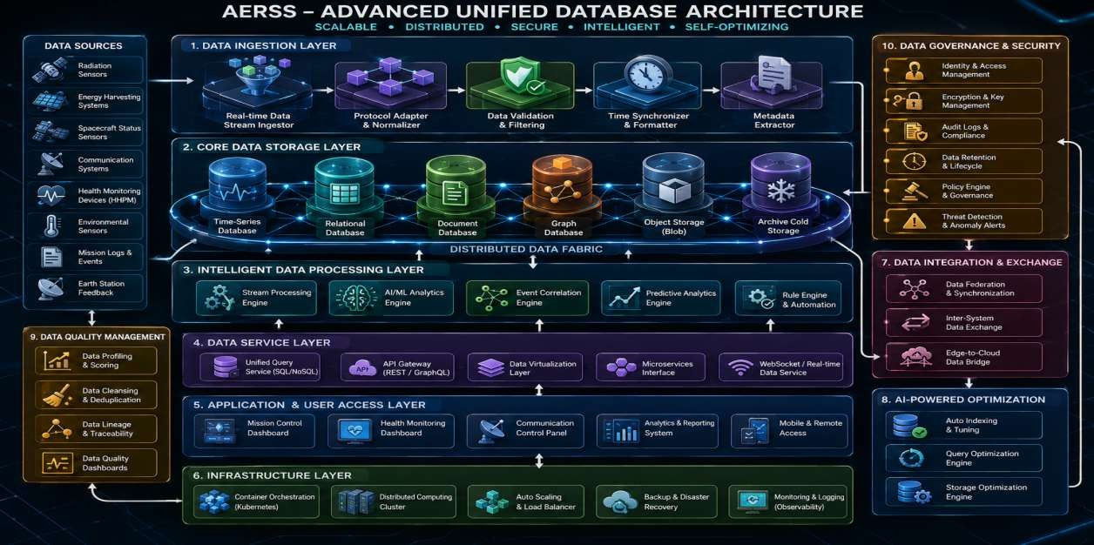
Fig:1 AERSS data base architecture
2.2 Atom-Based Universal Navigation System (AUNS)
The Atom-Based Universal Navigation System (AUNS) extends the AERSS framework by providing intelligent deep-space navigation. It combines quantum sensing, artificial intelligence, and astronomical data to estimate spacecraft position and support autonomous route planning.
2.3 Key Components
- Quantum sensors
- AI-based star and galaxy mapping
- Universal coordinate databases
- Intelligent decision algorithms
- Real-time astronomical telemetry
The system compares observed atomic, magnetic, gravitational, and radiation signatures with stored astronomical data to determine spacecraft location and identify optimal navigation paths. Mathematical models and logical equations are used to improve navigation accuracy and decision-making [3].
3. Universal Navigation Model
The estimated spacecraft location is determined using atomic, gravitational, radiation, time-reference, and AI-based computational data.
L=f(A,G,R,T,C)
Where:
- L = Estimated location
- A = Atomic signatures
- G = Gravitational data
- R = Radiation patterns
- T = Time-reference corrections
- C = AI-based analysis
3.1 Required Devices
- Quantum Sensor Array
- Star Recognition Camera
- Radiation Analyzer
- Gravitational Detector
- Universal Coordinate Database
- AI Navigation Processor
- AERSS Communication Module
- 3D Navigation Display
3.2 Applications
- Deep-space navigation
- Exoplanet exploration
- Autonomous route planning
- Long-duration mission analysis
- Astronaut support research [4].
3.3 Summary
The Atom-Based Universal Navigation System (AUNS) combines AI, quantum sensing, and astronomical data to estimate spacecraft position and support autonomous navigation. When integrated with AERSS, it also enables energy-aware deep-space communication using harvested radiation energy.
3.4 Clarification
AUNS is designed for navigation beyond the Solar System, including stars and exoplanets. By combining astronomical databases, sensor observations, and adaptive communication, the system supports accurate positioning and reliable long-distance communication in deep space [5].

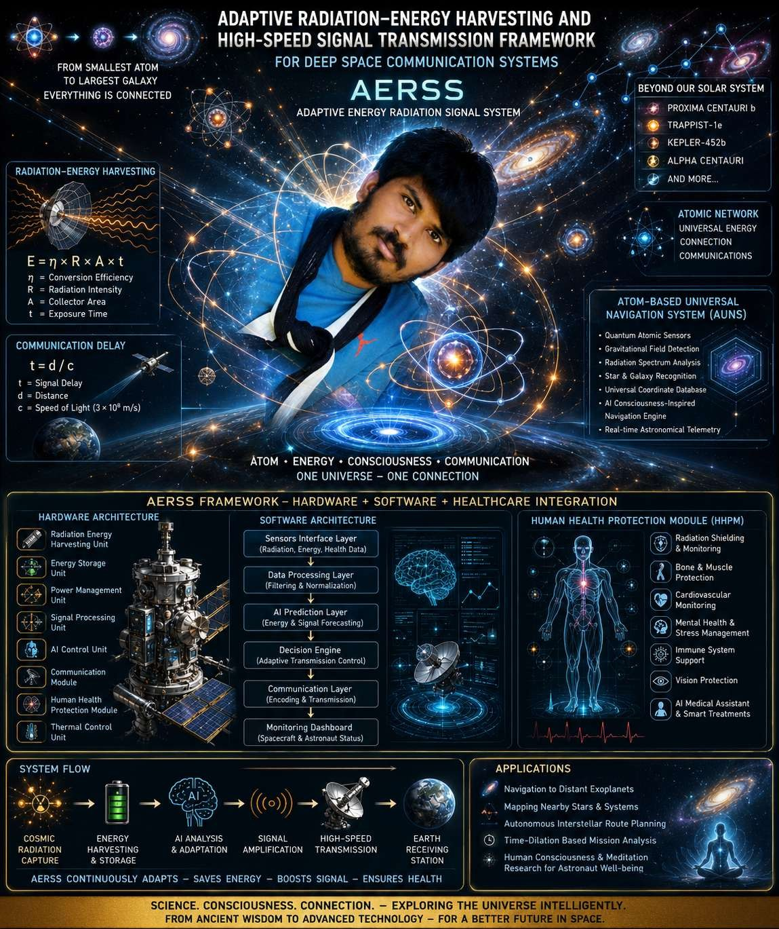
Fig:2 AERSS Communication atom Framework.

3.5 Applications
- Navigation to distant exoplanets and star systems.
- Mapping nearby stellar regions beyond the Solar System.
- Autonomous deep-space route planning.
- Long-duration mission and time-delay analysis.
- Astronaut support and decision-making research.
3.6 Short Summary
The Atom-Based Universal Navigation System (AUNS) combines AI, quantum sensing, and spacecraft sensors to estimate position and navigate in deep space. By analyzing atomic, gravitational, magnetic, and radiation data with astronomical databases, the system identifies optimal travel paths. When integrated with AERSS, it also supports energy-efficient communication using harvested radiation energy.
3.7 Importance in Deep-Space Missions
AUNS supports:
- Communication delay estimation.
- Spacecraft distance measurement.
- Command scheduling and synchronization.
- Autonomous onboard decision-making.
- Mission planning and navigation.
For long-distance missions, communication with Earth may take minutes or hours. Therefore, autonomous AI systems are essential. Combined with AERSS, the framework improves spacecraft positioning, communication reliability, and efficient use of onboard energy resources.
3.8 Why Google Maps Cannot Be Used in Space
Google Maps is designed for Earth-based navigation using roads, satellite imagery, and GPS. These systems are not suitable for deep-space missions because:
- Space has no roads or landmarks.
- GPS operates only near Earth.
- Spacecraft travel in three-dimensional trajectories.
- Distances are extremely large.
- Communication delays affect navigation and operations.
Therefore, deep-space navigation relies on astronomical observations, orbital mechanics, telemetry, and mathematical models.
3.9 Deep-Space Communication Relay System
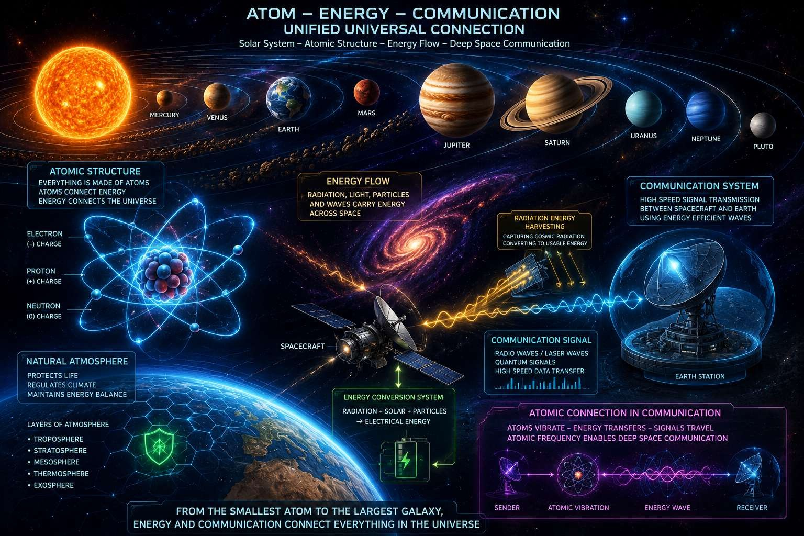
Communication relay spacecraft can be placed at strategic locations to improve long-distance communication. These relay systems receive weak signals, amplify and correct them, and retransmit them to the destination. This reduces signal loss and improves communication reliability for deep-space missions.
Fig:3 Atom Energy Galaxy Network

3.10 Future Conceptual Perspective
Future advances in atomic, quantum, and energy-transfer technologies may enable highly efficient methods for transferring energy and information over long distances with minimal delay. Such developments could support next-generation communication, navigation, and space exploration systems.
Historical and philosophical traditions have also described advanced concepts of long-distance communication and movement. While these ideas remain outside the scope of current scientific validation, they continue to inspire research into innovative technologies. Future developments should prioritize safety, ethical principles, sustainability, and the welfare of humanity.
4. Mathematical Modeling of Communication and Energy
Deep space communication is fundamentally limited by the finite speed of electromagnetic waves in a vacuum. The propagation delay between a spacecraft and Earth can be calculated using the following equation.

4.1 Signal Propagation Delay:
T=D/C
Where:
• t = Signal propagation delay (seconds)
• d = Distance between the spacecraft and Earth (meters)
• c = Speed of light in vacuum (approximately 3 times 10 power 8 im/s
This equation is used to estimate the time required for a command sent from Earth to reach the spacecraft or for telemetry data to return to Earth [8].
4.2 Radiation Energy Harvesting Model:
The electrical energy harvested from ambient cosmic and solar radiation can be estimated using the following model.
E=η Rat Where
- E=total harvested energy (joules)
- η= energy conversion efficiency (0 ≤ η ≤ 1)
- R = Radiation power density (watts per square meter, W/m²)
- A = Effective collection area (square meters, m²)
- t = Exposure time (seconds)
This equation estimates the usable electrical energy generated by the radiation harvesting module over a specified exposure period [9].
4.3 Adaptive Signal Amplification Model: The communication signal gain can be adjusted based on the harvested energy available to the transmission system.
G=GG0 +kE
Where:
- G = Adaptive amplifier gain
- G₀ = Baseline amplifier gain
- k = Gain control coefficient
- E = Harvested energy (joules)
This model represents the principle that greater harvested energy can support higher transmission gain and improved signal strength.
4.4 Combined Communication Performance Model: The overall performance of the Adaptive Energy Radiation Signal System (AERSS) can be expressed as:
P=f(t,E,G)
Where:
- P = Communication performance metric
- t = Signal propagation delay
- E = Harvested energy
- G = Adaptive signal gain
This relationship summarizes how propagation delay, available energy, and adaptive amplification collectively influence communication efficiency and reliability.
Here is a shorter, grammatically improved, and journal-friendly version:
5. Human Health Protection in Deep Space
Long-duration space missions expose astronauts to radiation, microgravity, isolation, and confined environments. To support crew safety, the proposed spacecraft includes a Human Health Protection Module (HHPM). This module continuously monitors astronaut health and provides preventive medical support. It is a supporting subsystem and not the primary contribution of this work.
5.1 Major Health Challenges and Protection Measures
Radiation Exposure
Astronauts outside Earth's magnetosphere are exposed to Galactic Cosmic Rays (GCRs), Solar Particle Events (SPEs), and secondary radiation. These may cause DNA damage, cancer risk, vision problems, immune dysfunction, and tissue degradation.
Protection Measures:
- Hydrogen-rich and water-based shielding
- Active magnetic shielding (conceptual)
- Subsurface habitats
- Real-time radiation monitoring
- AI-based radiation forecasting [11]
Bone Loss
Microgravity reduces bone density and increases fracture risk.
Protection Measures:
- Resistance exercise
- Artificial gravity (conceptual)
- Calcium and Vitamin D supplements
- Bisphosphonate medication when required
Muscle Atrophy
Extended exposure to microgravity can weaken muscles and reduce strength.
Protection Measures:
- Strength training
- Electrical muscle stimulation
- High-protein nutrition
- Creatine supplementation
Cardiovascular Changes
Microgravity may affect blood circulation and heart function.
Protection Measures:
- Aerobic exercise
- Controlled fluid and electrolyte intake
- ECG monitoring
- Appropriate medical treatment when needed
Psychological Stress
Isolation and confinement can cause anxiety, depression, and sleep disturbances.
Protection Measures:
- Virtual reality relaxation systems
- Regular communication with family and mission teams
- Psychological counseling
- Sleep management support
Immune System Changes
Spaceflight can weaken immune responses and increase infection risk.
Protection Measures:
- Balanced nutrition
- Probiotics
- Zinc and Vitamin C supplements
Vision Changes
Long-duration missions may affect vision due to fluid shifts and intracranial pressure changes.
Protection Measures:
- Regular eye examinations
- Pressure management systems
- Medical treatment when clinically appropriate [12]
5.2 Human Health Protection Module (HHPM)
The HHPM integrates:
- Wearable health sensors
- AI-based health monitoring
- Smart medication management
- Robotic medical assistance
- Radiation monitoring systems
- Environmental and life-support monitoring
The HHPM enhances astronaut safety, health, and mission readiness during long-duration exploration missions to Mars and beyond [13].
6.0 Adaptive Radiation-Energy Harvesting and High-Speed Signal Transmission Framework
The Adaptive Energy Radiation Signal System (AERSS) is designed to improve deep-space communication reliability and energy efficiency. The system harvests supplementary energy from cosmic and solar radiation using a radiation energy harvester, DC–DC converter, supercapacitor, and rechargeable battery.
An ESP32 microcontroller is used for prototype validation. It works with radiation sensors and telemetry units to monitor system conditions and control operations in real time.
The communication subsystem includes a low-noise amplifier, adaptive modulator, error-correction processor, and high-gain antenna. These components improve signal quality and support reliable long-distance communication between spacecraft and Earth.
Onboard memory and a thermal control unit provide secure data storage and stable operation in deep-space environments.
6.1 Significance of the Proposed System
- Provides supplementary electrical energy from ambient radiation.
- Supports experimental validation through prototype implementation.
- Improves signal quality using adaptive communication techniques.
- Enables reliable high-throughput data transmission.
- Enhances system stability and operational reliability.

6.2 Hardware Components of AERSS table form:
Table:1 hardware component

Module | Main Components | Functions
Radiations energy harvesting unit | Radiation collectors,semiconductor converters | Converts cosmic radiations
Energy storage unit | Supercapacitors,lithium-ion batteries | Stores harvested energy
Power management unit | DC-DC converters, volatages regulators | Controls and distributes power
Signal processing unit | FPGA,DSP,onboard compute | Processes and optimizes communications signal
Ai control unit | GPU/CPU module | Predicts energy availability & adjusts transmission
Communication module | High-gain antenna, RF amplifiers | Transmits signal to earth
Human health proctection module | Biosensors, medical AI system | Monitors astronaut health
Thermal control unit | Heat pipes, radiators | Maintains Safe operating temperature

