A Rare Case of Tuberculous Thyroiditis Mimicking as Follicular Neoplasm

Background: Thyroid tuberculosis is an exceptionally rare extrapulmonary manifestation of tuberculosis, even in endemic regions. It can mimic thyroid malignancy both clinically and on investigation, presenting with a painless neck swelling and constitutional symptoms like weight loss.
Methods: A 53-year-old female presented with a progressive neck swelling and significant weight loss. Evaluation included clinical examination, thyroid ultrasound, contrast-enhanced CT neck, fine needle aspiration cytology (FNAC), and biochemical tests. Due to a high suspicion of malignancy (Bethesda IV cytology and elevated thyroglobulin), the patient underwent a right hemithyroidectomy. The definitive diagnosis was made through histopathological examination of the surgical specimen and confirmed with a GeneXpert MTB/RIF test.
Results: Histopathology unexpectedly revealed caseating granulomas with Langhans giant cells, and GeneXpert confirmed Mycobacterium tuberculosis with a very low bacillary load. The patient was diagnosed with tuberculous thyroiditis and started on a standard 6-month antitubercular therapy (ATT) regimen. Her postoperative recovery was uneventful, with complete resolution of symptoms on follow-up.
Conclusion: This case highlights that thyroid tuberculosis, though rare, is a crucial differential diagnosis for a thyroid mass, particularly in tuberculosis-endemic areas. A definitive diagnosis often requires histopathology, as FNAC can be misleading. Treatment with ATT is highly effective.
Keywords: Thyroid Tuberculosis; Extrapulmonary Tuberculosis; Caseating Granuloma; Hemithyroidectomy & Antitubercular Therapy.

INTRODUCTION: Thyroid tuberculosis is an exceptionally rare condition, even in regions where tuberculosis is endemic [1]. Patients may present with nonspecific systemic symptoms such as fever, weight loss, or night sweats, though some remain entirely asymptomatic [2]. A high index of clinical suspicion is crucial, particularly when evaluating patients with goiter or cervical adenopathy accompanied by constitutional symptoms [3]. Given its potential to mimic other thyroid pathologies, thyroid tuberculosis should be included in the differential diagnosis of thyroid masses, especially in high-prevalence tuberculosis areas [4]. Fine needle aspiration cytology (FNAC) serves as the primary diagnostic modality, while histopathological examination of tissue specimens provides definitive confirmation [5]. Standard management involves anti-tuberculous therapy, with surgical intervention reserved for cases requiring removal of affected thyroid tissue [6]. Ultrasound imaging plays a valuable role in monitoring treatment response during follow-up [7].
CASE PRESENTTION: A 53-year-old female presented with a one-year history of a progressive, painless anterior neck swelling accompanied by significant weight loss (approximately 10 kg over six months), raising initial concerns of malignancy. She denied any fever, dysphagia, hoarseness, or symptoms of thyrotoxicosis. On examination, a firm-to-hard, non-tender 4 cm swelling was noted in the right thyroid lobe, which moved with deglutition, along with a mobile, non-tender 1.5 cm left jugulodigastric lymph node. Oral and systemic examinations were otherwise unremarkable. Initial imaging, including neck and chest X-rays, revealed no abnormalities, while thyroid ultrasound identified a right-sided hypoechoic nodule with minimal peripheral vascularity. Contrast-enhanced CT neck further delineated a 24×25×42 mm encapsulated, heterogeneously enhancing lesion in the right thyroid lobe displacing adjacent vessels, alongside a small colloid cyst in the left lobe. Fine-needle aspiration cytology (FNAC) suggested a follicular neoplasm (Bethesda IV), and biochemical evaluation showed markedly elevated thyroglobulin (3519 ng/dL) with normal calcitonin (0.948 pg/mL) and thyroid function tests (T3 179.3 nmol/L, T4 10.48 nmol/L, TSH 0.48 mU/L). Given the suspicion of malignancy, the patient underwent right hemithyroidectomy with central neck dissection. Intraoperatively, the nodule appeared firm and well-circumscribed without extrathyroidal extension, and lymph nodes were non-suspicious. Histopathology unexpectedly revealed nodular goiter with focal granulomatous inflammation featuring caseating granulomas and Langhans giant cells, suggestive of tuberculosis, while lymph nodes showed only reactive hyperplasia. GeneXpert MTB/RIF confirmed Mycobacterium tuberculosis (very low bacillary load) with indeterminate rifampicin resistance. Postoperatively, the patient was diagnosed with tuberculous thyroiditis - a rare extrapulmonary manifestation and initiated on a 6-month antitubercular therapy (ATT) regimen per India’s Revised National Tuberculosis Control Programme (RNTCP): intensive phase (2 months of HRZE - isoniazid, rifampicin, pyrazinamide, and ethambutol) followed by continuation phase (4 months of HRE - isoniazid, rifampicin, and ethambutol). Her recovery was uneventful, with resolution of symptoms on follow-up.

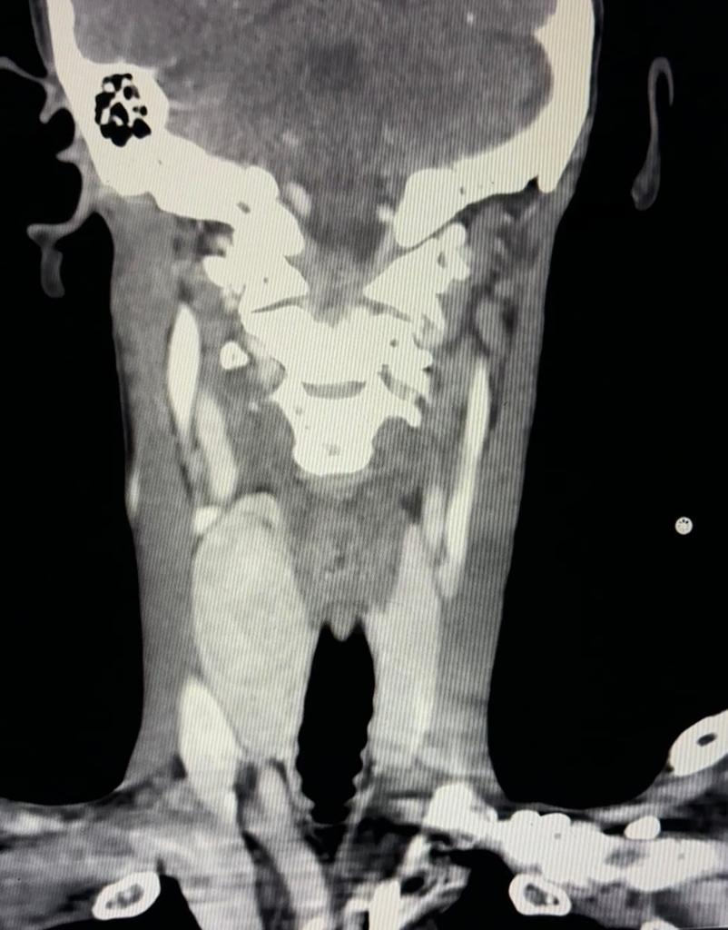
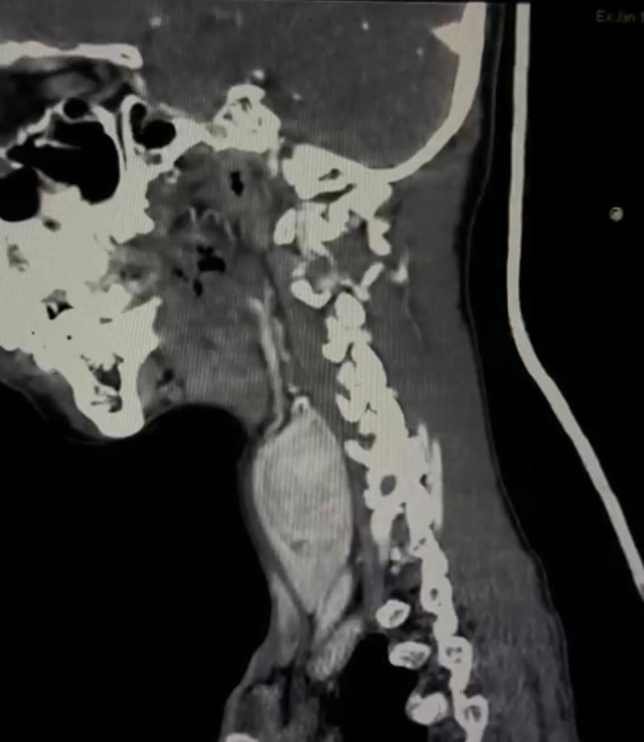

CT scan suggestive of well defined , oval encapsulated soft density lesion in the right lobe of thyroid gland. It shows heterogenous enhancement on post contrast study. It is seen displacing the neck vessels on right side laterally. Findings suggestive of thyroid nodule.
There is also well defined ,rounded hypodense non enhancing lesions noted in left lobe of thyroid gland suggestive of colloid cyst.

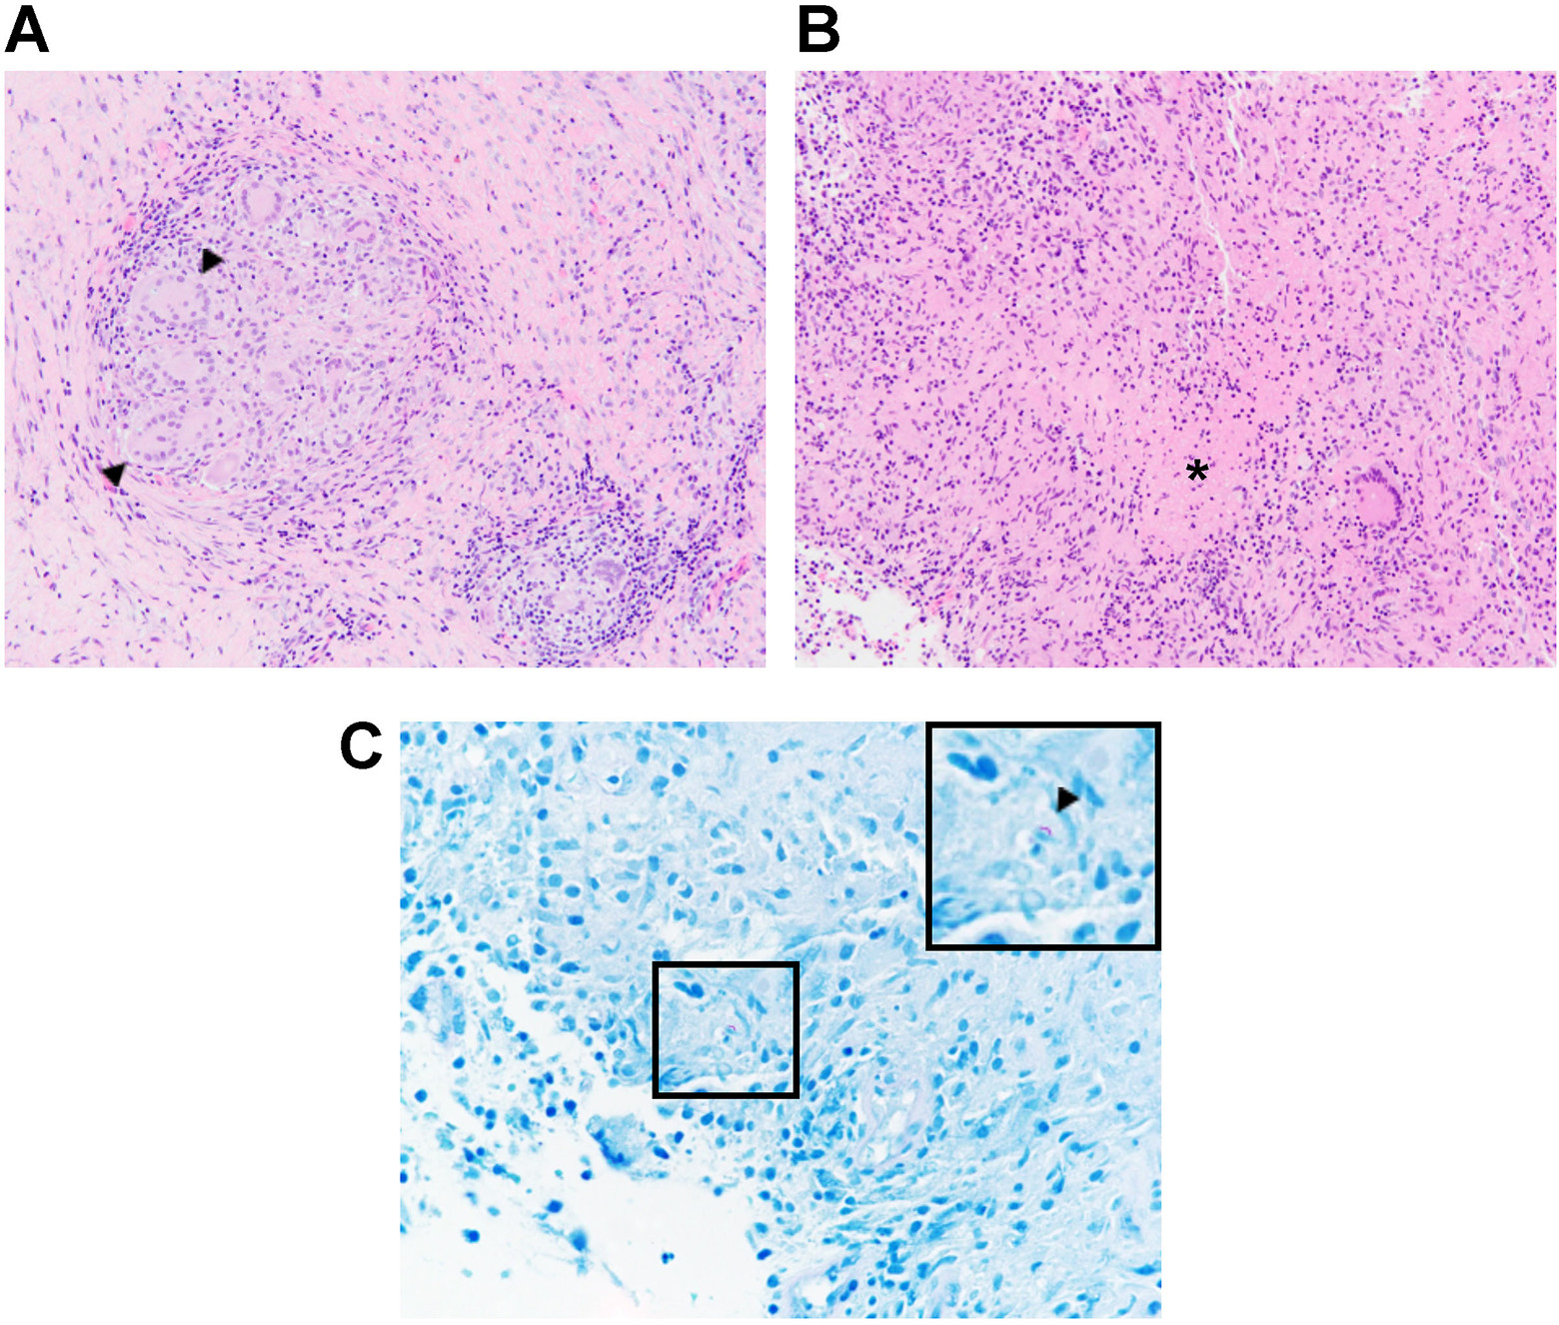

A, Thyroid tuberculosis featuring confluent epithelioid granulomas with numerous giant cells (arrowheads) (hematoxylin–eosin, 200×). B, Necrosis can be seen in the middle of granulomatous nodules which were marked with an asterisk (hematoxylin–eosin, 200×). C, Photomicrograph showing acid fast bacillus (arrowhead) magnified in inset in upper right corner (ZN stain, 600×).

DISCUSSION: This case report provides a valuable contribution to the medical literature on thyroid tuberculosis (TT), a condition so rare that it is often overlooked in differential diagnoses, even in endemic regions. Its principal strength lies in its illustrative depiction of a classic diagnostic pitfall: the presentation of TT masquerading as a follicular neoplasm. The patient's presentation with a painless, progressive neck swelling and significant weight loss rightly raised a high suspicion for malignancy, which was further supported by cytological findings (Bethesda IV) and markedly elevated thyroglobulin levels. This sequence of events underscores the critical limitation of fine-needle aspiration cytology (FNAC) in isolating TT, as the granulomatous architecture can be misinterpreted or obscured, leading to potentially unnecessary surgery [8, 9]. The definitive diagnosis was only achieved post-operatively through histopathology and GeneXpert MTB/RIF testing, highlighting the gold-standard role of histological examination.
A further strength is the demonstration of a successful treatment outcome with a full course of anti-tubercular therapy (ATT) alone following hemithyroidectomy, resulting in complete symptom resolution. This aligns with current literature suggesting that surgery is often diagnostic or reserved for tissue removal in complex cases, while ATT remains the therapeutic basis [2, 10].
The primary limitations of this report are inherent to its design as a single case study. It cannot establish causality or prevalence. The diagnosis was retrospective, and the initial workup, while comprehensive, did not include advanced microbiological tests like PCR on the FNA sample, which might have allowed for a pre-operative diagnosis and potentially avoided surgery [11]. Furthermore, the patient’s immune status was not extensively investigated, which is a relevant factor given emerging evidence of immune dysregulation (e.g., post-viral, as discussed in the literature) potentially predisposing individuals to such rare manifestations [12].
Thyroid tuberculosis remains an exceptionally rare entity, representing less than 0.1% to 1% of all tuberculosis cases even in highly endemic countries [8, 13]. The thyroid gland is considered remarkably resistant to mycobacterial infection due to its rich vascular supply, high iodine content, and bactericidal properties of colloid material [14, 15].
The clinical presentation of TT is highly variable and nonspecific, making pre-operative diagnosis a significant challenge. As demonstrated in this case and supported by numerous reports [8, 9, 16], patients most commonly present with a solitary thyroid nodule or a multinodular goiter, which can be hard and progressive, mimicking carcinoma. Constitutional symptoms like fever, night sweats, and weight loss are inconsistent. Our patient's significant weight loss was a red flag, but the absence of fever is not uncommon. Thyroid function is usually normal, though both hypothyroidism and thyrotoxicosis have been rarely reported due to gland destruction or inflammatory hormone release, respectively [17, 18].
Imaging findings are also non-specific. Ultrasound typically reveals a hypoechoic, heterogeneous nodule with ill-defined margins, which may contain cystic or calcified components [19, 20]. As seen in our case and others, CT scanning may show an encapsulated, heterogeneously enhancing lesion, indistinguishable from a neoplasm [21].
The basis of diagnosis hinges on histopathological and microbiological confirmation. FNAC is the first-line investigative tool, but its sensitivity is variable. While it can reveal caseating granulomas, Langhans giant cells, and necrotic material, it often yields false negatives or atypical findings, as in our case [8, 22]. A positive culture for Mycobacterium tuberculosis or a positive PCR/Molecular test (like GeneXpert) on FNA material or tissue biopsy provides a definitive diagnosis and allows for rifampicin resistance testing, as was crucial in our patient's management [11]. Histology remains the diagnostic gold standard.
The management of TT primarily involves a standard ATT regimen. Surgery is not first-line therapy but is indicated for diagnostic uncertainty (suspected malignancy), large abscesses requiring drainage, or failure of medical management [2, 10, 23]. The prognosis with timely treatment is excellent.
Recent literature has begun to explore potential triggers for the reactivation of latent TB in unusual sites. The article by Xiao et al. suggests a compelling link between COVID-19-induced immune dysregulation (specifically T-cell depletion and dysfunction) and subsequent susceptibility to active tuberculosis, including in rare extrapulmonary sites like the thyroid [12]. Although not directly observed in our patient, this emerging rationale provides a critical context for considering immune status in future cases of rare TB manifestations.
The conclusion that this case represents primary thyroid tuberculosis, or at least an isolated presentation, is based on the absence of radiological or clinical evidence of active pulmonary or disseminated disease. The likely pathogenesis is hematogenous spread from an occult primary focus, a well-documented route for TT [15]. The thyroid gland was the primary site of clinical disease, with the lymph nodes showing only reactive hyperplasia.
The definitive cause was infection with Mycobacterium tuberculosis, confirmed by GeneXpert. The "very low bacillary load" reported by the test explains the diagnostic challenges faced with FNAC and the absence of AFB on staining, as low bacterial burdens are common in paucibacillary forms of the disease [22].
The conclusion that the patient’s presentation mimicked malignancy is rational due to the confluence of key features: a hard, painless, and rapidly enlarging thyroid nodule; significant weight loss; cytology suggestive of a follicular neoplasm; and highly elevated thyroglobulin (likely due to tissue destruction and inflammation rather than malignancy). This mimics the presentation described in several other case reports where TT was a surprising post-operative finding [9, 21].
The successful outcome with ATT alone post-surgery confirms the infectious etiology and validates the decision to de-escalate from a potential cancer management pathway to a infectious disease treatment protocol once the histopathological results were available.
CONCLUSION: This case underscores that thyroid tuberculosis, though rare, must remain a consideration in the differential diagnosis of a thyroid nodule, particularly in patients from TB-endemic regions presenting with constitutional symptoms or features suggestive of but not definitive for malignancy. A high index of suspicion is paramount. FNAC, while essential, has limitations and may not be diagnostic. Histopathological examination and molecular testing (e.g., GeneXpert) are often required for definitive diagnosis. Ultimately, this case demonstrates that collaboration between surgeons, endocrinologists, and infectious disease specialists is crucial to avoid misdiagnosis and ensure that patients receive the correct, potentially curative, medical therapy with anti-tubercular drugs, with surgery reserved for diagnostic or specific compressive indications.
ACKNOWLEDGEMENTS
CONTRIBUTION OF AUTHORS
Research concept
Research design
Supervision
Material
Data collection
Data analysis
Interpretations
Literature search
Writing article
Critical review
Arditical edition
Final approval
REFERENCES
- Oueslati I, Sakka I, Ismail O, Akrout I, Marghli A, Chihaoui M. Tuberculosis of the thyroid gland presented as a rapid enlargement of a preexisting goiter. Case Reports in Endocrinology. 2018;2018(1):4369531.
- Soni RK, Sinha A. Tuberculosis of the Thyroid-a Diagnostic Enigma. Indian J Surg. 2015 Apr;77(Suppl 1):179-81.
- Cuesta Hernández M, Gómez Hoyos E, Agrela Rojas E, Téllez Molina MJ, Díaz Pérez JÁ. Tuberculosis tiroidea: causa excepcional de bocio compresivo. Endocrinol Nutr. 2013;60:e11---e13
- Oueslati I, Sakka I, Ismail O, Akrout I, Marghli A, Chihaoui M. Tuberculosis of the thyroid gland presented as a rapid enlargement of a preexisting goiter. Case Reports in Endocrinology. 2018;2018(1):4369531.
- Kapan M, Toksöz M, Bakır ŞD, Yazar BÇ, Evsen MS, Bozkurt Y, Gümüş M. PRIMARY THYROID TUBERCULOSIS: CASE REPORT AND REVIEW OF THE LITERATURE. European Journal of General Medicine. 2011 Oct 11;8(4):357-60.
- Bansal LK, Gupta S, Gupta AK, Chaudhary P. Thyroid tuberculosis. indian journal of tuberculosis. 2021 Apr 1;68(2):272-8.
- Yang GY, Zhao D, Zhang WZ, Meng J, Li J, Li XH, Wan HF. Role of ultrasound evaluation for the diagnosis and monitoring of thyroid tuberculosis: A case report and review of the literature. Oncol Lett. 2015 Jan;9(1):227-230.
- Baidya A, Singha A, Bhattacharjee R, Dalal BS. Tuberculosis of the thyroid gland: two case reports. Oxford Medical Case Reports. 2015 Apr 1;2015(4):262-4.
- Kataria SP, Tanwar P, Singh S, Kumar S. Primary tuberculosis of the thyroid gland: a case report. Asian Pac J Trop Biomed. 2012 Oct;2(10):839-40.
- Bulbuloglu E, Ciralik H, Okur E, Ozdemir G, Ezberci F, Cetinkaya A. Tuberculosis of the thyroid gland: review of the literature. World J Surg 2006;30:149–55.
- Singh G, Gupta R, Kakkar A, Iyer VK, Kashyap S, Bakhshi S, Mathur SR. Fine needle aspiration cytology of metastatic ocular medulloepithelioma. Cytopathology. 2011 Oct;22(5):343-5.
- Xiao X, Cao Q, Shi Y. Thyroid tuberculosis and cold abscess after infection with COVID-19: A case report. Heliyon. 2024 Apr 15;10(7).
- Majid U, Islam N. Thyroid tuberculosis: a case series and a review of the literature. J Thyroid Res. 2011;2011:359864.
- Gupta R, Mohindroo NK, Azad R. Thyroid Tuberculosis: Yes, It is True. Int J Head Neck Surg 2015;6(4):193-194
- D. Das, C. Pant, K. Chachra, et al., Fine needle aspiration cytology diagnosis of tuberculous thyroiditis. A report of eight cases[J], Acta Cytol. 36 (4) (1992)
517–522
- Georgeta PG, Cristian D, Loredana PG, Andrei MA, Horia C, Ioan PM. Thyroid tuberculosis in Romania; cases recorded in a 12-year period/Tuberculoza tiroidiana în România; cazuri înregistrate pe o perioada de 12 ani. Infectio. ro. 2015 Oct 1(44):35.
- Raman L, Murray J, Banka R. Primary tuberculosis of thyroidgland: an unexpected cause of thyrotoxicosis. BMJ Case Rep. 2014 Feb 27;2014:bcr2013202792.
- Luiz HV, Pereira BD, Silva TN, et al: Thyroid tuberculosis with abnormal thyroid function - case report and review of the literature. Endocr Pract 19: e44-e49, 2013.
- Kang BC, Lee SW, Shim SS, et al: US and CT findings of tuberculosis of the thyroid: three case reports. Clin Imaging 24: 283-286, 2000.
- Kang M, Ojili V, Khandelwal N and Bhansali A: Tuberculous abscess of the thyroid gland: a report of two cases. J Clin Ultrasound 34: 254-257, 2006.
- Al-Mulhim AA, Zakaria HM, Abdel Hadi MS, et al: Thyroid tuberculosis mimicking carcinoma: report of two cases. Surg Today 32: 1064-1067, 2002
- Mondal A and Patra DK: Efficacy of fine needle aspiration cytology in the diagnosis of tuberculosis of the thyroid gland: a study of 18 cases. J Laryngol Otol 109: 36-38, 1995.
- Akbulut S, Sogutku N, Arikanoglu Z, Bakir S, Ulku A, Yagmur V. Thyroid tuberculosis in southeastern Turkey: is this the resurgence of a stubborn disease? World J Surg 2011: 35(8):1847–1852

