Challenges in the Teaching–Learning Process Faced by Teachers in Inclusive Classrooms: Evidence from Sri Lanka

Abstract
Inclusion has become a priority in education reform efforts today to promote the learning of all students with varying needs. While Sri Lanka has progressive policies for inclusive education, effective practice is largely reliant on teachers' competencies, resources, and institutional support. This study aims to highlight major challenges for teachers in the teaching-learning process, challenges in teaching diverse classrooms, availability of resources and institutional support, perceptions of teachers about inclusive practices and, based on this information, provide recommendations for enhancing inclusive classrooms. This research explores the challenges faced by teachers in inclusive classrooms in Sri Lanka through a mixed method research approach - mainly quantitative (95%) and qualitative (5%). A stratified sample of 200 teachers was surveyed using a structured questionnaire (Cronbach's α = 0.87) and 10-15 teachers were interviewed through semi-structured interviews. The key findings show challenges mainly surrounding classroom management, inadequate teacher training, lack of instructional resources, and lack of institutional support - across all teacher groups and types of schools. The findings suggest that the improvement of teacher competencies, availability of resources and institutional support are vital for sustainable inclusive education and should be promoted in inclusive schools in Sri Lanka.
Keywords: inclusive education, teachers, challenges, Sri Lanka, differentiated instruction

Introduction
Inadequate, inclusive education is essential in Sri Lanka. It is regarded as an important element in the national education policy and is practiced as a mainstreaming approach in government schools. Of the various aspects of quality education, the teaching–learning process inclusive of classrooms is of particular importance, as it affects the academic and social achievement of students with special educational needs (SEN). The Ministry of Education, Sri Lanka (2017) has developed policies and guidelines to implement inclusive education, which means mainstreaming students with SEN to mainstream classrooms.
This research explores the challenges faced by teachers in the teaching-learning process in inclusive classrooms, particularly in Sri Lankan government schools. It also examines how these challenges can be overcome to enhance the effective teaching and learning of students.

1.1 Problem Statement
While inclusive education policy has been progressively advanced in Sri Lanka, little attention has been paid to differences in policy and practice. Teachers still struggle with classroom management, implementation of a differentiated curriculum, and sufficient resources and expert support (Kudagama & Karunarathne, 2018). Teachers' inability to support students with SEN in mainstream classrooms, without appropriate preparation and support, has a negative impact on learning and well-being. Teachers have expressed that they are neither academically nor emotionally equipped to manage the diverse learning needs of students with disabilities, while meeting the needs of their peers (Ministry of Education, Sri Lanka, 2017). Therefore, it is important to investigate the gap between policy and practice in Sri Lanka's inclusive education system.

1.2 Rationale
Research across the world has shown that inclusive teachers are facing the multiple issues of a lack of professional preparation in teaching learners with special education needs, lack of effective teaching materials, overcrowded classrooms, and lack of institutional support (Sharma et al., 2008; Loreman et al., 2010). Despite the general acceptance of inclusive education as a universal human right, as stated in the Salamanca Statement (UNESCO, 1994) and United Nations convention on the Rights of Persons with Disabilities (UN, 2006) in many developing countries, the reality of classroom practices remains far from ideal. In developing nations, these barriers are compounded by a lack of resources, materials and facilities, as well as a shortage of support services such as speech therapists, counsellors and special education teachers (Singal, 2006; Miles & Singal, 2010).
In the case of Sri Lanka, the Ministry of Education (2017) has taken a commendable step forward in the integration of students with special educational needs (SEN) in the regular classroom through policies and circulars and setting up resource rooms in some schools. Yet, despite these positive efforts at the policy level, several issues have been identified with policy implementation in schools. The lack of adequate training for teachers, limited access to assistive devices, inaccessibility of supporting modified educational materials, large class sizes and the lack of collaboration between classroom teachers and special education practitioners have been identified as major contributing factors by researchers (Kudagama & Karunarathne, 2018; Wijesinghe, 2016). Teachers have reported that they lack both academic and emotional preparedness to cater to the diverse learning needs of students with disabilities while taking care of the learning needs of other students in regular classes.
According to Florian and Black-Hawkins (2011), teachers' positive dispositions towards diversity will not compensate for structural and resourcing challenges inclusive education. Likewise, Avramidis and Norwich (2002) confirmed that teachers philosophically supportive of inclusion are frustrated and de-motivated when systemic factors (such as lack of skills, class size, and support from the school administration) do not allow them to succeed. While the explanations for the failure of implementation of inclusive education have been reported in reports and media in Sri Lanka, there has been no systematic empirical study to specifically address the current challenges faced by teachers in inclusive classrooms in the Sri Lankan school system (Navaz, 2021).
School-based studies conducted in this area have been more sporadic and less focused on the unique characteristics of the teaching and learning processes in an inclusive classroom (Kudagama & Karunarathne, 2018). This research therefore fills this research gap by systematically documenting the issues faced by teachers in inclusive classrooms in Sri Lanka to inform policy reform in this area, enhance teacher preparation and experience in this space, and to optimize the quality of practice in inclusive education that occurs at the school level.

1.3 Objectives & Research Questions
Research Questions
- What are the challenges faced by teachers in the teaching–learning process inclusive classrooms?
- How can these challenges be minimized to improve inclusive classroom practice?
The following objectives are derived from the above research questions:
- Identify the major challenges faced by teachers in the teaching–learning process within inclusive classrooms.
- Examine the instructional challenges encountered by teachers when dealing with diverse learners.
- Investigate the availability of resources and institutional support for teachers in inclusive education settings.
- Explore teachers' perceptions toward inclusive classroom practices.
- Propose recommendations for improving the teaching–learning process inclusive classrooms.

Review of Literature

2.1 Theoretical Background
This study makes use of four theoretical outlooks to explain the complexity of challenges we encounter in inclusive classrooms and to provide a lens through which to analyze the findings.
This study draws primarily on Vygotsky's (1978) Sociocultural Theory of Learning, focusing on the idea that everything people learn, and everything they know, is learned and known within a social context, and through social interactions with more knowledgeable others (MKO). A key element of this theory is the Zone of Proximal Development (ZPD), which refers to the gap between the learner's present abilities and those they are capable of with the support of a more knowledgeable other (Shabani et al., 2010). This theory stresses that in the inclusive classroom, teachers should engage in scaffolded instruction - in which structured and gradual support is provided to allow all students to, including students with SEN, to build on their abilities. McLeod (2025) assertively confirms that Vygotsky's sociocultural theory confirms that learning is mediated by social interactions, the pervasive culture, and the scaffolding that exists in the classroom. For inclusive classrooms, this implies more of a role for the teacher than simply delivering information, becoming an active facilitator of collaborative, socially situated learning experiences that are responsive to individual learners' developmental needs.
Similarly, the social model of disability (Oliver, 1996) reconceptualizes issues in inclusive classrooms, shifting the focus from the perceived deficits of individuals with SEN to the deficits of environments, institutions and attitudes within the education system. This view supports the notion that change in inclusive education outcomes relies on systemic change, through the redevelopment of classroom, teacher preparation, resource allocation and institutional climate rather than solutions that point toward the "deficits" of students with SEN. This perspective is of salience to the Sri Lankan context, where the lack of resources and under-prepared teachers are cited as the major barriers to adopting a successful inclusive teaching practice (Kudagama & Karunarathne, 2018).
The third theoretical lens in this study is Bronfenbrenner's (1979) Ecological Systems Theory. It argues that learning is the result of the mutual coaction of several environmental systems that range from a student's microsystem (i.e. the classroom) to their macrosystem (i.e. polycultural government, education and community). This approach, when applied to inclusive education, underscores that what happens in the classroom, school administration and leadership, community, and national policy all play a concurrent role in shaping inclusive practice. It supports the argument that classroom-based issues cannot be effectively addressed in isolation - inclusive classrooms need multi-level support (teacher, school, and policy levels) to be effective. This systemic view is directly relevant to the study's recommendations for institutional support reform and policy alignment.
Finally, Tomlinson's (2014) Differentiated Instruction Theory is the most directly practical theory for this study. Differentiated instruction is a systematic approach to teaching where teachers anticipate and modify curriculum content, learning strategies, learning products and evaluation to respond to the interests, learning profiles and readiness levels of the students (Tomlinson, 2014). Differentiated instruction is the key pedagogical tool that teachers implement to proactively meet the various academic and developmental demands of a diverse group of students in the inclusive classroom. The theory explains that differentiation demands not only teaching expertise and ingenuity, but also sufficient preparation time, resources and support required from the school institution - which are often not freely and readily available in Sri Lankan inclusive schools.

2.2 Empirical Background
Over the years, numerous international and national empirical studies have reported on the barriers teachers encounter in inclusive educational contexts, with teacher training, resources, class size and administrative support having been identified as the key factors affecting the effectiveness of inclusive classrooms.
Avramidis and Norwich (2002), in a review of international literature, noted that the three most notable factors impeding the success of inclusion across several countries were insufficient training in SEN pedagogies for teachers, inadequate physical and material resources, and little or no administrative support. They confirmed that while teachers' attitudes towards inclusivity were generally favorable, the absence or presence of these factors significantly influenced teacher attitudes towards inclusion, a finding that has direct implications for the Sri Lankan setting. Sharma et al. (2008) in a comparative study involving Australia, Canada and Singapore systems found that while the majority of pre-service and in-service teachers are philosophically supportive of inclusive education, class size, large curriculum content and a lack of opportunities for professional development were found to be limiting factors in the ability of teachers to effectively implement inclusive teaching strategies. This research also identified that in many countries; pre-service teacher training programs fail to equip their students with sufficient knowledge and skills inclusive classroom management.
Loreman et al. (2010) built on this knowledge base by specifying differentiated instruction delivery, behavior management of multiple student needs and adaptive assessment as the three most consistently reported teaching challenges facing inclusive educators. They concluded that such challenges could not be resolved through attitudinal change - ongoing professional development and resource allocation was seen as necessary. This empirical evidence was also further built on by Florian and Black-Hawkins (2011), by confirming that inclusive pedagogy called for a shift in the understanding of teaching practice, from a deficit and individual-support framework to a universal design framework, where all teaching and learning activities are planned and delivered, with consideration of all learners in the classroom in mind.
In Sri Lanka, through classroom-based research, Kudagama and Karunarathne (2018) revealed that government schoolteachers consistently had inadequate professional training regarding inclusive pedagogy, the availability of adapted materials and joint practice opportunities with special education specialists. Such inadequacies inevitably impacted negatively on the teaching–learning process inclusive classrooms. Wijesinghe (2016) also established that important inequalities in terms of resource provision and quality of teacher professional development provisions existed between urban, suburban and rural schools that compounded inclusive education challenges in Sri Lanka. These empirical insights build a strong evidence base to place the current study in a pattern of well-documented obstacles in implementing inclusive education - and conclude that systematic research at the local level that tackles specific issues of Sri Lankan inclusive schools is warranted.

Methodology

3.1 Research Design
The study applied a mixed-methods approach to research - primarily quantitative (95%) with a qualitative element (5%). A descriptive and exploratory approach was adopted to gather quantitative data through structured questionnaires complemented with contextual detail through semi-structured interviews. The combination of the two resulted in triangulation, thus improving validity, reliability and interpretability (Creswell, 2014).
3.2 Participants
Teachers in inclusive schools from the selected districts in Sri Lanka were the target population. A stratified random sample of 200 teachers was taken to represent: school level (primary/secondary), location (urban/suburban/rural) and teaching experience (< 5 years, 5-10 years and 10+ years). For qualitative analysis, 10-15 teachers were purposively recruited for interviews.

3.3 Data Collection Instruments and Procedures
The instruments used were questionnaires, semi-structured interviews, and pre- and post-intervention tests. The questionnaire contained items in five areas: SEN knowledge, differentiated instruction, classroom management, use of teaching resources and institutional support with Likert scale response options (1-Agreement, 5-Disagreement). The questionnaire was validated by experts and tested on 20 teachers with Cronbach's α = 0.87. During the intervention, a four-week professional development course was delivered which focused on differentiated instruction, classroom management, cooperative learning, and teaching aid use. The sub-sample was also interviewed before and after the intervention.
3.4 Data Analysis Methods
Instruments were used to collect data that were analyzed using quantitative and qualitative approaches. Descriptive statistics, independent sample t-tests, and one-way ANOVA were used to analyze the quantitative data using the Statistical Package for Social Sciences (SPSS). Qualitative data were analyzed thematically. Data from both were triangulated to increase validity and offer a picture of the impact of the challenges in inclusive education on teaching and learning.
3.5 Ethical Considerations
Consent was obtained from all teachers and the education authorities. Voluntarism was ensured, and anonymity was assured. The confidentiality of data was adhered to. The research conducted adhered to the ethical guidelines set out by the Faculty of Education, University of Colombo. The intervention did not interfere with the teaching schedule. All references are properly cited and listed.

4. Results / Findings
4.1 Demographic Characteristics of Participants
Table 4.1: Demographic Characteristics of Participants
Characteristic | Category | n | %
School Type | Primary | 102 | 51.0
 | Secondary | 98 | 49.0
Location | Urban | 65 | 32.5
 | Suburban | 70 | 35.0
 | Rural | 65 | 32.5
Teaching Experience | < 5 years | 60 | 30.0
 | 5–10 years | 85 | 42.5
 | > 10 years | 55 | 27.5

N = 200. This study gathered data through a stratified sampling of inclusive schools in some of Sri Lanka’s regions.
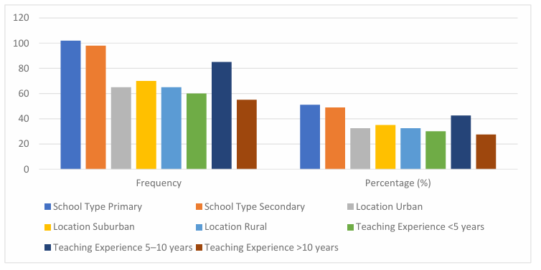
Figure 4.1: Demographic Characteristics of Participants
The 200 teachers were almost equally split between elementary (51%) and high schools (49%). Urban (32.5%), suburban (35%) and rural (32.5%) areas were equally represented. Most teachers had been teaching for 5-10 years (42.5%), with some (30%) teaching for less than five years and others (27.5%) for more than ten years.

4.2 Challenges Faced by Teachers in the Teaching–Learning Process
Table 4.2: Teachers' Perceptions of Challenges in Inclusive Classrooms
Ref. No. | Challenge Area | M | SD
1 | Knowledge of SEN | 3.72 | 0.84
2 | Differentiated Instruction | 3.85 | 0.78
3 | Classroom Management | 4.10 | 0.65
4 | Use of Teaching Resources | 3.40 | 0.90
5 | Institutional Support | 3.20 | 0.95
6 | Attitude toward Inclusion | 4.05 | 0.72
 | Overall Challenges | 3.88 | 0.81

Ratings based on a five-point Likert scale (1 = Strongly Disagree, 5 = Strongly Agree). N = 200.
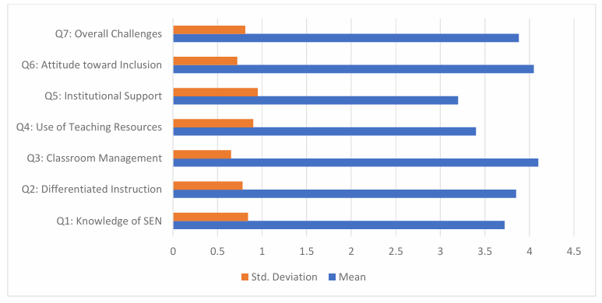
Figure 4.2: Teachers’ Perceptions of Challenges in Inclusive Classrooms
Table 4.2 reveals that classroom management (M = 4.10, SD = 0.65) and attitude toward inclusion (M = 4.05) were the greatest challenges. Figure 4.2 indicates these two priority areas had the highest mean scores, which suggests that while teachers are in favor of inclusive classrooms, classroom management is the most challenging. Teachers perceived institutional support (M = 3.20) and use of teaching resources (M = 3.40) as the least challenging, suggesting key institutional issues that need to be addressed. An overall score of 3.88 confirms that there are generally high levels of challenges across the areas.

4.3 Challenges by School Type
Table 4.3: Differences in Perceived Challenges by School Type: Independent Samples t-Test
Ref. No. | Challenge Area | Primary M | Secondary M | t | p
1 | Knowledge of SEN | 3.80 | 3.63 | 1.72 | .087
2 | Differentiated Instruction | 3.92 | 3.77 | 1.51 | .132
3 | Classroom Management | 4.12 | 4.08 | 0.45 | .654
4 | Use of Teaching Resources | 3.45 | 3.35 | 0.91 | .364
5 | Institutional Support | 3.25 | 3.15 | 0.81 | .421
primary = 102; nsecondary = 98. All p values are two-tailed. No differences were statistically significant at p < .05.
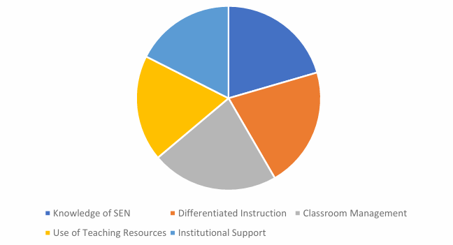
Figure 4.3: Challenges by School Type
The data in Table 4.3 and shown in Figure 4.3 demonstrate that there are no significant differences between primary and secondary school teachers across any challenge area (p > .05). Primary school teachers actually scored slightly higher in some of the areas like knowledge of SEN and differentiated instruction; however, these were not significant. This confirms the inclusion challenges identified are not exclusive to any particular stage, but are systemic and whole-school issues.

4.4 Challenges by Teaching Experience
Table 4.4: Differences in Perceived Challenges by Teaching Experience: One-Way ANOVA
Ref. No. | Challenge Area | < 5 yrs M | 5–10 yrs M | > 10 yrs M | p
1 | Knowledge of SEN | 3.60 | 3.75 | 3.80 | .312
2 | Differentiated Instruction | 3.70 | 3.90 | 3.85 | .256
3 | Classroom Management | 4.20 | 4.05 | 4.00 | .178
4 | Use of Teaching Resources | 3.30 | 3.40 | 3.50 | .392
5 | Institutional Support | 3.10 | 3.25 | 3.30 | .418

n<5yrs = 60; n5–10yrs = 85; n>10yrs = 55. N = 200. No differences were statistically significant at p < .05.

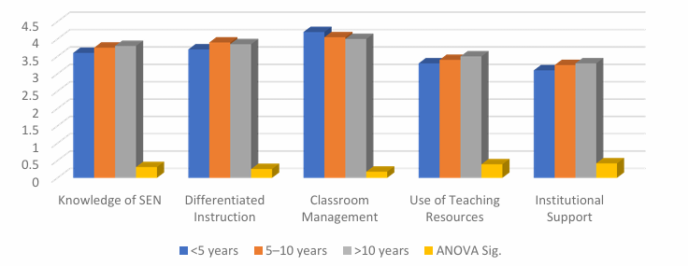
Figure 4.4: Challenges by Teaching Experience
As the results in Table 4.4 and Figure 4.4 indicate, the teachers with less experience cited the greatest difficulty in classroom management (M = 4.20), and it appears that first-year teachers find class diversity most challenging. The data for experienced teachers were slightly higher for SEN knowledge and resource use, indicating learners' resources were being built up over time. But all groups of teachers showed no significant differences (p > .05), demonstrating challenges to inclusive classrooms are common for all teachers.

4.5 Availability and Use of Teaching Resources
Table 4.5: Availability of Teaching Resources in Inclusive Classrooms
Ref. No. | Resource Type | Always % | Sometimes % | Rarely % | Not Available %
1 | Adapted Textbooks | 20 | 50 | 20 | 10
2 | Assistive Devices | 15 | 40 | 30 | 15
3 | ICT / Teaching Aids | 25 | 45 | 20 | 10
4 | Curriculum Guides | 30 | 40 | 20 | 10

Percentages indicate frequency of resource availability as reported by teachers. N = 200.

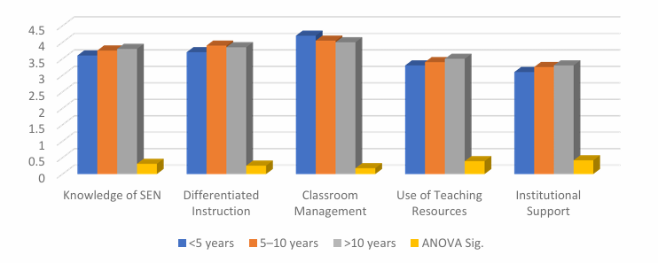
Figure 4.5: Availability and Use of Teaching Resources
Table 4.5 and Figure 4.5 data indicate access to resources to be between 15-30% only for teachers. Teachers are most dramatically under-resourced with assistive devices, as 45% report "never" or "sometimes". The availability of adapted textbooks (70% sometimes or always available) and ICT devices (70% sometimes or always available) is slightly better but even with these, access to resources is still not guaranteed across time. This greatly limits teachers' ability to extend differentiated instruction and is a major obstacle to inclusive practice.

4.6 Qualitative Findings: Thematic Analysis
Ref. No. | Theme | Description | Representative Quote
1 | Classroom Management | Difficulty managing behavioral and academic diversity simultaneously | "It's hard to give attention to all students, especially when some need constant support."
2 | Limited Professional Training | Insufficient pre-service and in-service preparation for inclusive pedagogy | "I feel unprepared for teaching students with special needs."
3 | Resource Constraints | Lack of adapted materials and assistive devices | "We often don't have the materials needed for individual learning support."
4 | Institutional Support | Minimal administrative guidance and mentoring | "There is little support from school management when we face challenges."
5 | Attitudinal Barriers | Peer and parental attitudes creating resistance to inclusion | "Some parents question why their children are in class with special needs students."
Themes derived from thematic analysis of semi-structured interviews (n = 12).
The data presented in Table 4.6 reveal that classroom management and lack of professional development were the most common reasons why teachers resorted to exclusionary practices. Follow-up interviews confirmed a definite improvement in teacher confidence, classroom management and collaboration as a result of the four-week professional development program. Teacher perceptions of teacher support and collaboration highlighted the value of formal capacity support interventions.

5. Discussion
The research was underpinned by Vygotsky's Sociocultural Theory (1978), which provided the basis for understanding the classroom dynamics in terms of the Zone of Proximal Development (ZPD), scaffolding and social interaction. The study has demonstrated that the outcomes of inclusive education are determined by the environment and not just student competence, in line with the social model of disability (Oliver, 1996).

5.1 Classroom Management and Instructional Challenges
The results of this study show the most common challenges for teachers in inclusive classrooms are classroom management, differentiation of instruction and limited knowledge of SEN. Teachers reported knowing inclusive principles but struggled to "put them into practice because of time constraints, class sizes and resource limitations. This is consistent with Loreman et al. (2010), who demonstrated the existence of large instructional demands that surpass typical teacher education in classrooms with behavioral diversity.
5.2 Resource and Institutional Support Deficiencies
This study indicates that institutional support (M = 3.20) and resource availability (M = 3.40) were most urgent needs. Ultimately, we have shown that structural resource limitations - rather than teacher attitudes - are the key limiting factor in creating inclusive classrooms. This echoes Kudagama and Karunarathne's (2018) findings that teachers in Sri Lankan government schools had limited knowledge and resources which had affected the quality of instruction. The lack of significant differences between school types and teaching experience also suggests the systemic nature of the issues.
5.3 Effectiveness of Professional Development Intervention
The key findings for the professional development intervention indicated there was an improvement in teacher self-efficacy, classroom organization and collaboration after a four-week intervention. These results offer evidence in response to the fifth research objective: make recommendations to improve the teaching-learning process. Qualitative findings following the intervention showed professional development can be applied to improve teacher competence and practice. This result confirms Vygotsky's (1978) scaffolding principle in the workplace - collaborative professional development with structured support and practical advice results in greater increases in competence than individual learning. Thus, it can be inferred that an intervention in the form of structured professional development has a positive influence on inclusive classroom teaching.

6. Conclusion
6.1 Professional Training to Address Classroom Challenges
Literature (Sharma et al., 2008) gives support that pre-service and in-service teacher-specific SEN and differentiated instruction training benefits inclusive classroom teaching practices (better classroom resource management, classroom management, and teacher self-confidence). Evidence from sociocultural theory (Vygotsky) also supports the idea that supported professional development with those who are more knowledgeable than us supports quicker professional growth. To address the teaching issues of classroom management problems, lack of SEN knowledge and poor differentiated instruction, it is suggested that all teacher institutions include practice-based inclusive pedagogy modules in the pre-service and in-service teacher education.
6.2 Equitable Resource Distribution
The study has found that most teachers in all school categories and placements have little access to adapted resources and assistive devices. Existing literature (Singal, 2006; Miles & Singal, 2010) demonstrates that a lack of resources in developing countries affects the effectiveness of inclusive teaching. Therefore, in order for education managers to remove these resource inequalities, it is recommended that the provision of adapted textbooks, assistive devices, ICT tools and curriculum guides be equitable and consistent, with particular attention needed in rural and suburban areas.
6.3 Strengthening Institutional Support
The results of the study indicated that more than 65% of teachers felt insufficient support. Existing studies (Florian & Black-Hawkins, 2011) call for the need for positive leadership and partnership structures in school administration for inclusive education to be effective. Thus, it is recommended that school leaders have a mentoring process, shared planning, and evaluation for teachers working in the inclusive classroom.
6.4 Collaborative and Differentiated Practice
As literature describes differentiated instruction (Tomlinson, 2014) - when undertaken in a planned manner - it engages learners, meets individual needs and improves academic and social participation for students with SEN. It also has a positive impact on teacher perceptions and professionalism. Differentiated instruction framework offers collaborative teaching options for teachers to learn about teaching and social skills from their colleagues through observation and co-teaching. So, it is suggested schools institutionalise collaborative teaching arrangements and peer observation protocols to develop inclusive pedagogy practice organically.
6.5 Proposed Framework for Improving Inclusive Teaching–Learning
In this regard, it is recommended that the four pillars of professional development, resource support, institutional accountability, and collaboration be interwoven to tackle challenges of the inclusive teaching–learning process. Teachers' professional development should address their teaching challenges, such as classroom behavior management and differentiation of assessment. This will not only enhance teacher motivation and transfer but also support teacher confidence as the training is relevant to classroom needs. And it is suggested to link Vygotsky's scaffolding with institutional issues to ensure that young teachers get helpful mentoring from experienced teachers. Inclusion of supporting technology and differentiated teaching methods will further enable high-quality inclusive education. Finally, it can be drawn that making inclusive education effective means developing authentic and demand-responsive mechanisms that respond to the challenges of classrooms. Therefore, it is highly important to undertake site-relevant policy reform and continuous teacher capacity building to enable inclusive education to its full extent - and matching Vygotsky's sociocultural theory with a structured institutional support system will make a great difference to the teaching-learning process in inclusive classrooms in Sri Lanka.

References
Ainscow, M. (2005). Developing inclusive education systems: What are the levers for change? Journal of Educational Change, 6(2), 109–124. https://doi.org/10.1007/s10833-005-1298-4
Avramidis, E., & Norwich, B. (2002). Teachers' attitudes towards integration/inclusion: A review of the literature. European Journal of Special Needs Education, 17(2), 129–147. https://doi.org/10.1080/08856250210129056
Booth, T., & Ainscow, M. (2011). Index for inclusion: Developing learning and participation in schools. Centre for Studies on Inclusive Education.
Bronfenbrenner, U. (1979). The ecology of human development: Experiments by nature and design. Harvard University Press.
Creswell, J. W. (2014). Research design: Qualitative, quantitative, and mixed methods approaches (4th ed.). SAGE Publications.
Florian, L., & Black-Hawkins, K. (2011). Exploring inclusive pedagogy. British Educational Research Journal, 37(5), 813–828. https://doi.org/10.1080/01411926.2010.501096
Kudagama, P., & Karunarathne, W. (2018). Challenges of inclusive education in Sri Lanka. Journal of Education and Practice, 9(14), 45–52.
Loreman, T., Deppeler, J., & Harvey, D. (2010). Inclusive education: Supporting diversity in the classroom (2nd ed.). Routledge.
McLeod, S. (2025). Vygotsky's sociocultural theory of cognitive development. Simply Psychology. https://www.simplypsychology.org/vygotsky.html
Miles, S., & Singal, N. (2010). The education for all and inclusive education debate: Conflict, contradiction or opportunity? International Journal of Inclusive Education, 14(1), 1–15. https://doi.org/10.1080/13603110802265125
Ministry of Education, Sri Lanka. (2017). National policy on disability in Sri Lanka. Ministry of Education.
Oliver, M. (1996). Understanding disability: From theory to practice. Palgrave Macmillan.
Shabani, K., Khatib, M., & Ebadi, S. (2010). Vygotsky's zone of proximal development: Instructional implications and teachers' professional development. English Language Teaching, 3(4), 237–248. https://doi.org/10.5539/elt.v3n4p237
Sharma, U., Forlin, C., & Loreman, T. (2008). Impact of training on pre-service teachers' attitudes and concerns about inclusive education. International Journal of Special Education, 23(1), 34–44.
Singal, N. (2006). Adopting an ecosystemic approach to understanding inclusive education. European Journal of Psychology of Education, 21(3), 239–252. https://doi.org/10.1007/BF03173418
Tomlinson, C. A. (2014). The differentiated classroom: Responding to the needs of all learners (2nd ed.). ASCD.
UNESCO. (1994). The Salamanca statement and framework for action on special needs education. UNESCO.
United Nations. (2006). Convention on the rights of persons with disabilities. United Nations.
Vygotsky, L. S. (1978). Mind in society: The development of higher psychological processes. Harvard University Press.
Wijesinghe, C. (2016). Inclusive education practices in Sri Lanka: Urban-rural disparities. Sri Lanka Journal of Education, 5(1), 22–35.

