Artificial Intelligence, Critical Thinking, and Self-Regulated Learning in Education: A Secondary Data Analysis of University Students’ Learning Questionnaire Data

Abstract
Background: Artificial intelligence (AI) is slowly shaping the field of education to support individual learning, feedback, and control by learners. However, educational value of AI is not only based on the technological performance but also on the capability of students to self-rule the learning process, critical thinking and judgment.
Aim: This study has explored the patterns of critical-thinking in self-regulated learning and comment on their potential in AI-supported education.
Methods: The publicly available Figshare dataset by Juřík et al. (2025) comprising questionnaire data of university students who participated in self-regulated learning activities was subjected to a secondary quantitative analysis. The discussion concentrated on the questionnaire items of critical-thinking. Response distribution and pattern stability were analyzed using descriptive statistics, item-level comparison, interpretation based on correlation, and exploratory analysis through recurrence quantification.
Results: It was found that the critical-thinking scores were moderate-to-high, which implied that students tended to report affirmative involvement with reflective and evaluative learning behaviours. Patterns at items were rather balanced in the critical-thinking measures, whereas recurrence-based indicators implied the consistency of the response organization. Nevertheless, due to the fact that the data were obtained using responses of a Likert-scale questionnaire, but not direct results of AI-intervention, the results must be viewed with caution.
Conclusion: This paper holds that critical thinking and self-regulated learning are crucial capabilities of humans in AI-mediated learning. The AI will be able to improve education processes, and its potential lies in the capacity of the learners to analyze information, track their learning, and utilize technological tools in a responsible manner. Longitudinal or experimental studies should be conducted in the future to explore the direct effect of AI tools on creativity, critical thinking, and self-regulated learning outcomes.
Keywords: artificial intelligence in education; generative AI; critical thinking; creativity; self-regulated learning; secondary data analysis; recurrence quantification analysis

1. Introduction
Artificial intelligence (AI) has emerged to be among the most significant drivers of modern education. Generative AI systems are able to summarize information, create explanations, create examples, give feedback and simulate a conversation with learners. These affordances have promoted a perception of AI as a personalization/productivity tool. However, the same affordances pose a significant pedagogical challenge: will AI reinforce learning, or will it only speed up task performance? This question can be raised more particularly in the sphere of higher learning when students have to not only retrieve information but also analyze evidence, support their claims, build arguments, and manage their learning.
Educational value of AI must thus be evaluated based not only on what a system is able to generate but also what it allows the learners to accomplish intellectually. A text-generating tool can facilitate brainstorming and decrease cognitive load, but also can block the effort involved in concept generation and independent review. This tension is depicted in the literature on AI and creativity. Anantrasirichai and Bull (2022) believe that AI has the greatest value in creative fields when it enhances human agency instead of replacing it. Similarly, Habib et al. (2024) demonstrate that generative AI can assist in facilitating creative thinking but at the same time poses a threat to creative confidence and student autonomy. These researches indicate that AI is not educationally neutral. Its impacts are relative to the ways in which learners, teachers, institutions, and assessment systems designed use it.
Self-regulated learning (SRL) is a useful conceptual framework to study this issue. SRL is the ability of learners to establish goals, track progress, choose strategies, regulate motivation and reflect on performance (Zimmerman, 2002). SRL becomes more significant in AI rich learning environment and not less so. Students will have to decide when to consult AI services, how to judge AI produced materials, whether to update or dismiss an output, and how to take responsibility of their knowledge. Markauskaite et al. (2022) contend that the epistemic agency, evaluative judgment, and adaptive expertise are new capabilities in human learning in a world that has AI. This stance is the opposite of the narrow technological optimism which presumes improved tools are automatically the source of improved learning.
The focal point of this debate is critical thinking. Critical thinking in the context of AI-assisted education encompasses the possibility to analyze the credibility of sources, evaluate unsupported arguments, compare explanations, notice bias, and justify. Creativity is also applicable but creativity that lacks critical analysis can turn to the depth of superficial novelty. On the other hand, thinking critically without creative exploration may be conservative and risk averse. Creativity and critique is thus not an option but a combination of the two as the strongest educational model. Such integration can be promoted by AI when it is employed as a dialogic and reflecting partner. It can undermine it when the learners substitute inquiry with AI.
This paper constructs an empirical and critical argumentation on that issue. It explores the distributions and the stability of responses in questionnaire data of critical-thinking among students using a publicly-controlled learning data set. The research does not imply the study directly measures the effect of AI-tools as the original data were not gathered via an AI-intervention study. Rather, the analysis considers critical thinking in SRL as a facilitating characteristic of responsible AI-facilitated education. The research questions are:
- RQ1. What is the distribution of critical-thinking scores in the selected SRL dataset?
- RQ2. How balanced are students’ responses across the critical-thinking questionnaire items?
- RQ3. What exploratory insight can recurrence quantification analysis provide about response-pattern stability?
- RQ4. What implications do these findings have for the design of AI-supported learning environments?

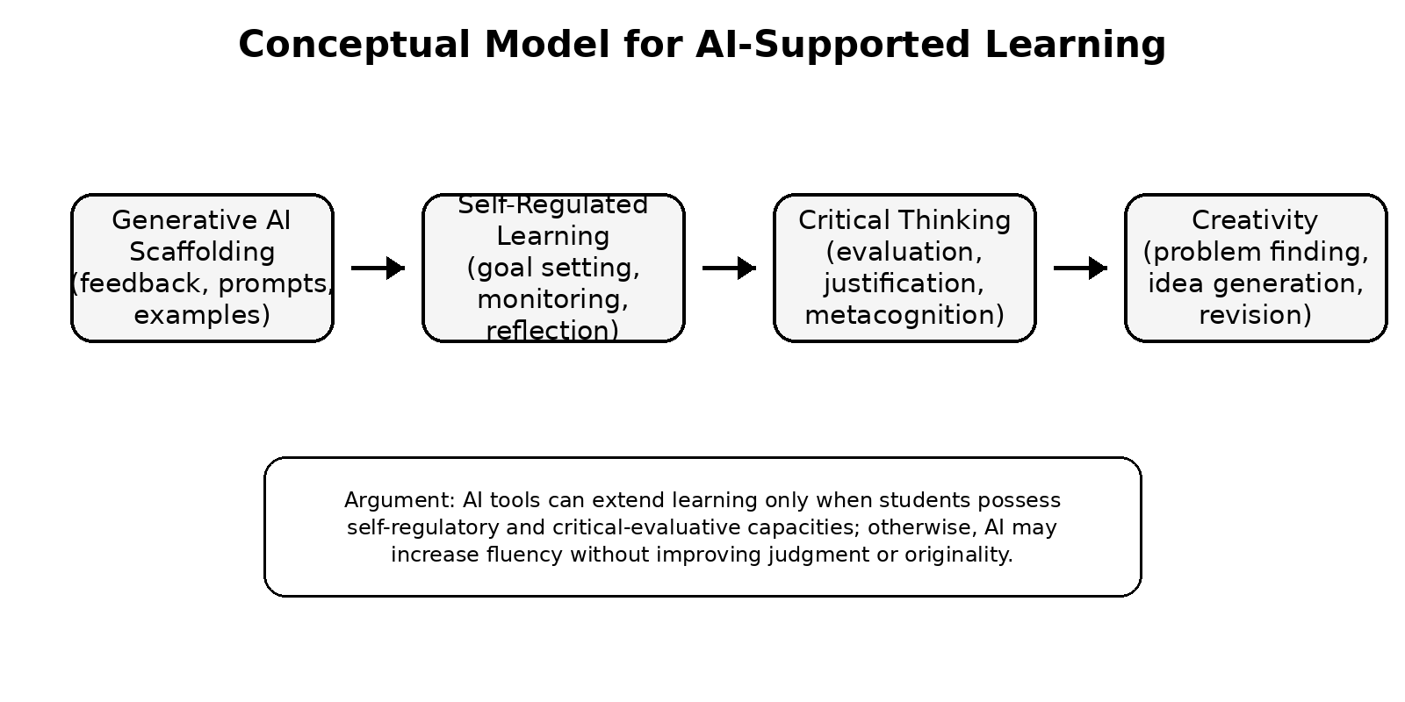
Figure 1. Conceptual model linking generative AI, self-regulated learning, critical thinking, and creativity.

2. Literature Review

2.1 AI in education: productivity, personalization, and dependence
The use of AI in education is often suggested to address the enduring issues of lack of feedback, differentiated needs of learners, and the inability to scale individualized teaching. Generative AI tools are capable of generating explanations, quiz questions, summaries, and examples nearly instantly. According to Kohnke et al. (2023), these tools can facilitate language learning and instructor readiness, whereas Chiu (2024) claims that generative AI will ensnare high education to reconsider the teaching, assessment, and research agenda. Kong and Yang (2024) carry this argument further by suggesting a human-centered model whereby generative AI can be employed to facilitate domain learning and SRL creation.
Nevertheless, the risk of cognitive outsourcing needs to be weighed against the promise of personalization. Students might avoid uncertainty, struggle, and revision that are often required to deep learn by relying on AI giving answers too fast. According to Luckin et al. (2022), teachers are not just to be AI-equipped; rather, they need to be AI-ready. This difference is significant. AI-readiness encompasses the capability to create learning activities where the use of AI is clear, intentional, and pedagogic. AI-equipment, in contrast, can imply adopting tools without paying enough attention to cognition, ethics, or assessment.

2.2 Creativity and critical thinking in AI-supported learning
The correlation between AI and creativity is not that simple. Other researchers present AI as a multiplier of divergent thought since it is capable of producing numerous options in a short time. As an example, habib et al. (2024) state that the fluency and diversity of creative products can be impacted by generative AI. Nonetheless, the same literature also cautions that AI can decrease the confidence of students in their creative abilities. This is a paradox because AI can lead to more ideas generated, but fewer senses of ownership or evaluative responsibility develop in the learner.
Similar conclusion is made by creative industries research. Anantrasirichai and Bull (2022) demonstrate that AI played a strong role in music, image creation, and media creation, but the review also emphasizes that the most fruitful using is human-centered. Wingström et al. (2024) also believe that co-creativity is a more accurate characterization of the relationship between humans and AI than replacement narratives are. When applied to education, this implies that AI ought to be viewed as an aid to deepening research, not as a kind of tool that finishes the process of learning on behalf of a student.
This type of co-creativity education is defended by critical thinking, which contributes to its educational significance. When AI-generated content is not critiqued, it risks acceptance due to its fluency rather than accuracy or sound reasoning. Critique will enable students to compare AI output with evidence, update prompts, determine limitations, and defend their final decision. The issue of AI in education is thus not whether or not students should use AI but how they can use it and at the same time maintain judgment.

2.3 Self-regulated learning as a foundation for AI-era education
SRL is a well-developed theoretical paradigm of explaining the way learners control their cognition, motivation, behavior, and learning setting. According to Zimmerman (2002), self-regulated learners are proactive learners, who plan, monitor, and reflect on their learning. As Pintrich and De Groot (1990) showed, motivational and cognitive elements of learning are closely related to academic performance. These background studies are still pertinent since AI-rich environments require even more, rather than less, learner agency.
It is educative to contrast SRL with AI automation. The information, feedback and suggestions provided by AI systems are also capable of doing, however, they cannot be able to know whether a learner has made a personal meaning out of a concept or not. Neither can they take the role of the learner to judge of sources or to contemplate misconceptions. According to Markauskaite et al. (2022), students in AI-mediated classes should be provided with the skills that will enable them to engage with smart systems without relinquishing epistemic authority. In this sense, SRL is not a non-essential addition to AI-aided learning, but that is where AI becomes educationally fruitful.
Another point of contrast can be made between AI as a technical infrastructure and AI as a learning relation. Technical descriptions usually focus on capacity of model, precision, automation and size. Educational accounts, however, need to raise the question of whether the learner is in a position to be more competent following the use of the system. This distinction is important since an artificially intelligent system with great abilities can still yield poor performance in education due to the absence of the ability to plan, trial, fail, and correct. On the contrary, a less advanced system could be pedagogically useful in case it encourages students to reason, compare alternatives and think about mistakes. Learner, task, teacher, tool, and assessment culture are therefore the sources of quality AI-supported learning: the product of interaction between the learner and the task. This relational perspective aligns with the human-centered scholarship of AI and prevents deterministic assertions that technology completely reshapes education.

3. Methodology

3.1 Research design
The secondary quantitative research design was used in this study. This was not intended as a test of a new AI intervention but as an exploration of critical-thinking data of an already existing SRL dataset and how it is applicable to AI-supported education. A secondary design would be suitable in cases where the research question can be answered through publicly available information and the role of the researcher is reanalysis, reinterpretation or extension of a methodology.

3.2 Dataset and sample
The information was extracted in the form of the publicly available Figshare data that was linked to Juřík et al. (2025), describing an experiment of the eye-tracking activity in self-regulated learning. The original study employed a 2 x 2 factorial study which was controlled, and the focus was on learning processes of university students according to multimedia content and metacognitive prompts. The current paper is limited to the issue of the questionnaire component that deals with critical thinking. The valid analytical sample comprised 109 working responses, which is in line with the values in the analyzed table of the manuscript. Since the data were open and anonymized, no new human-participant data were gathered.

3.3 Variables and measures
Critical thinking in SRL was the focal construct. The questionnaire questions were responses that were of a Likert-type-ordinal response to a seven-point scale. The analysis was conducted on the aggregated critical-thinking distribution and relative contribution of five critical-thinking items. Since Likert-type data are ordinal, a statistical analysis will focus on patterns and tendencies instead of effective causal or parametric inference.

3.4 Data analysis
The statistical aggregated critical-thinking variable was calculated using descriptive statistics, such as count, mean, standard deviation, minimum, quartiles, median, maximum. They compared item-level with the aim of examining whether or not the five critical-thinking items contributed to the construct equally. Recurrence quantification analysis was added as an exploratory procedure of studying response-pattern regularity. Complex, sequential or dynamic data, as well, is typically applied to RQA since it is able to determine recurrent structures and stability of patterns (Marwan et al., 2007). It has been used as well to classify categorical and behavioral sequences in social and cognitive studies (Coco and Dale, 2014).
The application of RQA in the present study is carefully prudent. Questionnaire items are not a natural time series except insofar as their sequence is based on a theoretically interesting order. Thus the RQA findings do not imply to provide direct evidence about cognitive processes. Instead, they are considered as exploratory measures of response-pattern regularities that can inform future work with more detailed sequential data like eye-tracking, log data or interaction traces of AI learning systems.

4. Results

4.1 Descriptive statistics
The descriptive statistics indicated that the mean of the aggregated critical-thinking score was 4.16 and a standard deviation of 1.53 on a seven-point scale. The lowest score was 1 and the highest score was 7. The median was 4 with an interquartile range of 3 to 5. These values indicate that critical-thinking responses of students were focused on moderate standards, and the significant variability in any respondent. The ceiling effect is not reflected in the distribution, as the top score was achieved but the central tendency was close to the scale middle.
A summary of the descriptive profile is presented in Table 1. The findings can be construed as a baseline description of critical-thinking reactions in an SRL environment. They do not show that AI lead to an increase or decrease in critical thinking. Instead, they demonstrate the degree of critical thinking attitude or strategies that are involved in the chosen data, which can be talked about as a topical learner feature in the AI-based learning.

Statistic | Value
Valid cases | 109
Mean | 4.16
Standard deviation | 1.53
Minimum | 1
25th percentile | 3
Median | 4
75th percentile | 5
Maximum | 7
Table 1. Descriptive statistics for the aggregated critical-thinking score.

4.2 Item-level comparison
The five critical-thinking items had fairly balanced contributions of item-means. The relative shares were 18%, 20%, 21%, 22%, and 19%. The pattern indicates that there was no item that prevailed in the aggregate score. A balanced profile of the item is good as it shows that one statement was not the most influential on the critical-thinking construct. Nevertheless, reliability analysis, item-total correlations and confirmatory validation would be essential to producing a complete psychometric interpretation which were not available in the reported statistics.
The distribution of items is shown in Figure 2. The minor variations between the items suggest that the answers of the students were quite similar between the indicators of critical thinking. Consistency is important in AI-assisted education since critical thinking is not a one-time event but a habit of appraisal, justification, and contemplation. However, strong evidence of the validity should not be conflated with item balance. Further studies must document reliability coefficients and questions can be asked whether the items are working in a similar manner across groups of learners.
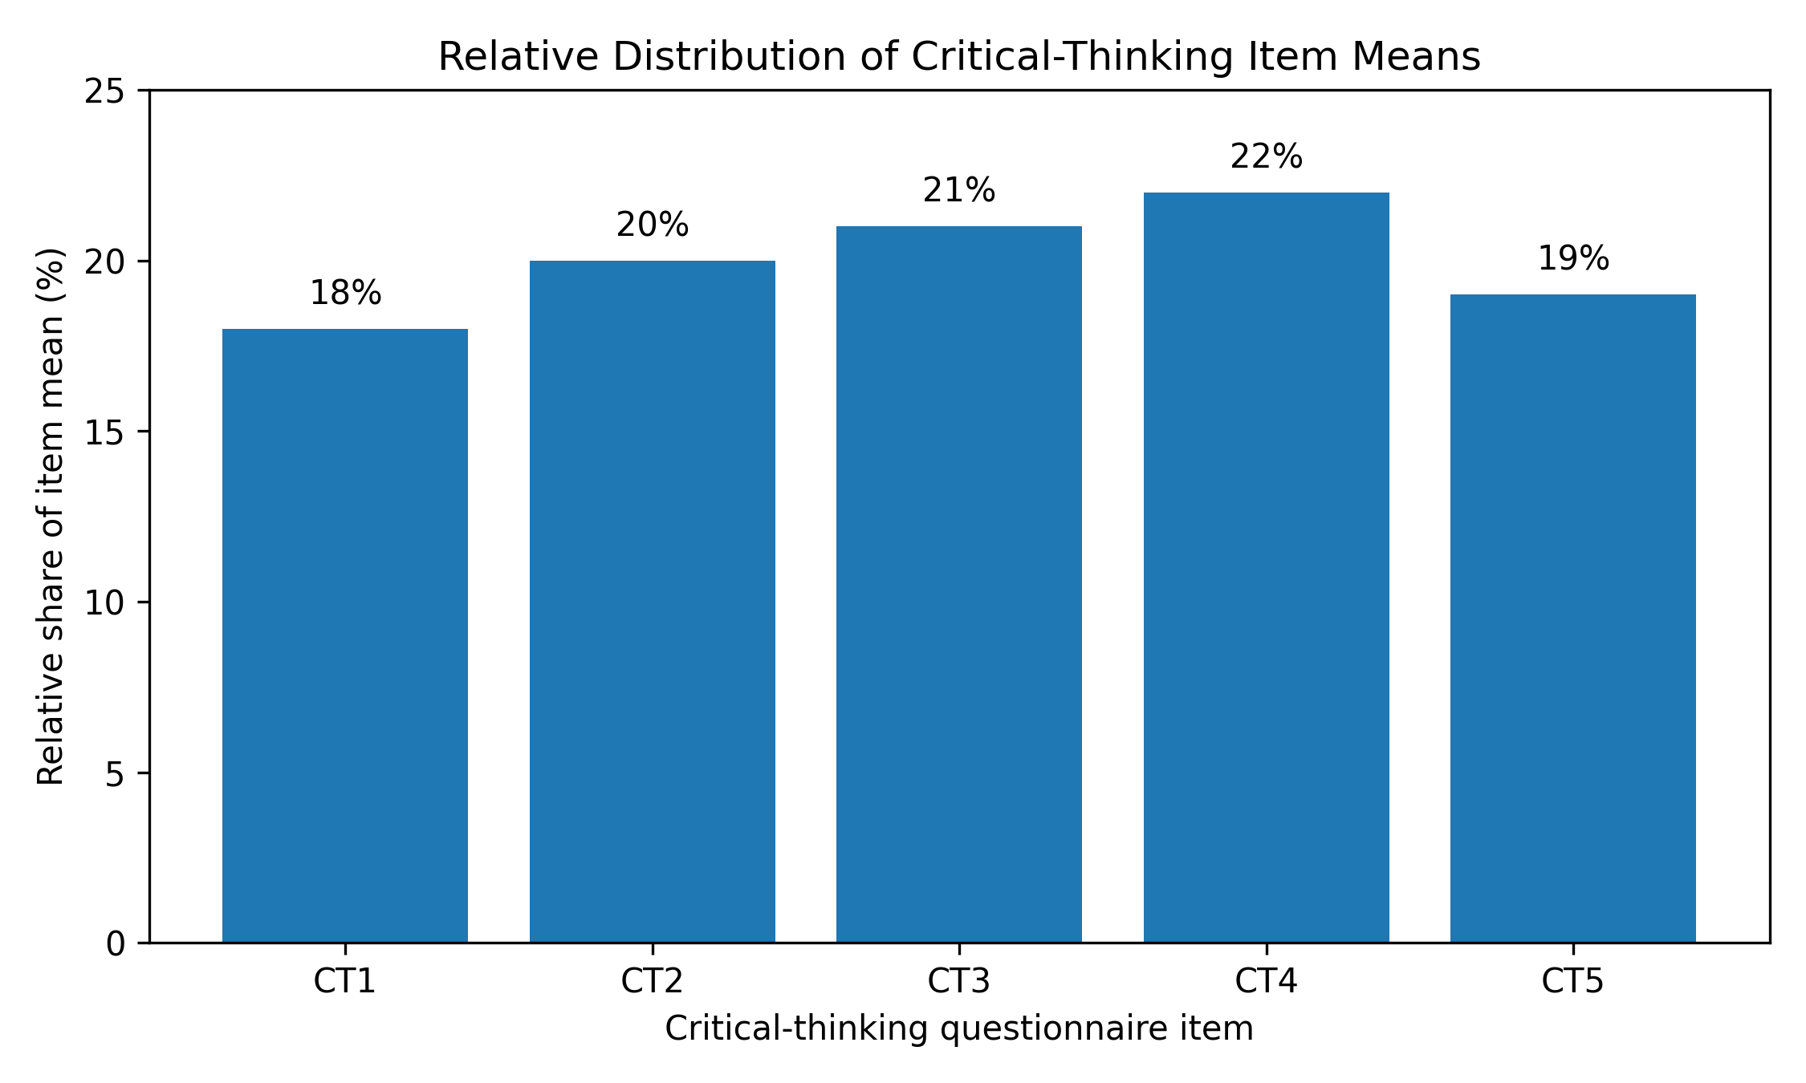
Figure 2. Relative distribution of five critical-thinking item means.

4.3 Recurrence quantification analysis
The score of RQA indicated that the recurrence rate (RR =.927), determinism (DET =.960) and laminarity (LAM =.980) were high. These values indicate a very steady response structure, having a lot of duplicated or formulaic states. The mean length of the diagonal lines was 17.57 and the maximum length of the diagonal line was 64. The difference was.016. These clues may be viewed as some regularity in the sequence of response. The value of the time during which the trapper gets caught (33.67) and the maximum number of vertical lines (40) also indicates the time frames of relative stability.
RQA indicator | Value | Interpretive note
Recurrence rate (RR) | 0.927 | High recurrence of similar response states
Determinism (DET) | 0.960 | Strong patterned structure in the ordered responses
Average diagonal length (L) | 17.575 | Extended repeated structures
Longest diagonal length (Lmax) | 64 | Long uninterrupted pattern
Divergence (DIV) | 0.016 | Low divergence indicator
Laminarity (LAM) | 0.980 | Strong vertical/horizontal stability
Trapping time (TT) | 33.667 | Stable states in the response structure
Longest vertical line (Vmax) | 40 | Longest stable vertical structure
Table 2. Exploratory recurrence quantification analysis indicators.
The results however depend on the nature of the data to determine their meaning. In the study of dynamic systems, recurrence patterns tend to represent time or behavioral processes. The data in this paper are questionnaire answers and thus, the order could be the consequence of item or respondent order. This is why the RQA results can be considered more of an exploratory and methodological than a confirmatory type of research. They show that the recurrence-based techniques might be applicable to future studies of AI-in-education, provided they are used with actual sequential data, e.g. with the interactions of students to AI tutors, revisions of the responses, history of prompts, or track of eye-tracking.

5. Discussion
The results endorse a tentative yet significant claim: critical thinking in SRL is one of the prerequisites of responsible AI-assisted learning. As indicated by the descriptive results, there are moderate scores in critical-thinking, whereas the comparison of the items indicates consistency among critical-thinking signalers. These results are similar to SRL theory which considers good learners to be active observers and controllers of their own cognition (Zimmerman, 2002). They are also in line with Pintrich and De Groot (1990) perception that the use of cognitive strategies and motivation are interdependent during academic learning.
The research is also beneficial in elucidating a gap in certain AI-in-education arguments. Much of the popular debate focuses on what AI can achieve: creating explanations, responding to questions, creating personalised content, and facilitating creativity. This is useful, but not complete. The more critical educational question is what the learners can do with AI. In the case that students do not have the ability to judge output, AI can become a shortcut leading to less intellectual activity. AI can be used as an inquiry, comparison and revision resource in case students are equipped with good SRL and critical-thinking abilities. This tool can thus result in varying educational outcomes based on the regulatory and evaluative abilities of the learner.
Such interpretation is opposed to excessively optimistic ones regarding generative AI as an automatic creativity boosting tool. Habib et al. (2024) demonstrate that AI can facilitate creative production but the same literature demonstrates that creative confidence and reliance are also a cause of concern. On the same note, Anantrasirichai and Bull (2022) highlight the use of augmentation as opposed to substitution in creative sectors. That argument is applied to the present study: AI can be best defenseable on the grounds of assisting human agency, rather than replacing it. Practically it would imply that educators are to create the activities which would entail the students to critique AI-generated output, contrast it with peer-reviewed materials, revise it, and justify their choices.
Methodological implications of the results are also made. The results of the exploratory RQA suggest that learning can be studied as a process, which is patterned and not just as a final score. Particularly in the case of AI-assisted learning, the interaction between students and an AI generates dense sequential traces: prompts, revisions, feedback loop, response times and decision paths. However, this study also has one limitation. Critically, it is only in cases where the sequence has meaning in terms of theory that the application of RQA to questionnaire data can be informative. Recurrence algorithms should be applied in future studies to real data of the actual learning process that incorporates eye tracking, log of clickstreams, or records of AI interactions.
To obtain high-quality AI-in-education research, a more robust empirical design would compare learners who utilize AI in various pedagogical settings. An example is a group of people who use AI without restrictions, a second group prompts AI with critical-evaluation, and a control group will do it without AI. The results may be in the form of creativity, critical thinking, SRL performance quality and confidence. This design would enable researchers to test if AI enhances learning, whether it just enhances fluency or alters the sense of agency among students. Those causal claims are not made in the present article, yet it will give conceptual and empirical foundation to ask them in a more rigorous way.
The comparison between creativity studies and SRL research is particularly important. Research on creativity tends to be interested in the generation of new products whereas research on SRL is interested with how learners plan, monitor, and appraise their work. These two traditions intersect in AI. The generative model allows a student to generate a large number of ideas, the educational value of such ideas rests in the ability of the student to pick, adapt and justify. In that way, the corresponding outcome is originality, as well as, justified originality. Critical thinking, in this capacity, serves as the critical process through which AI-aided idea generation is converted into learning.

6. Implications
The initial implication is pedagogic. AI must be applied to learning activities which involve both evaluation and production. It is possible to ask students to recognize hallucinations, contrast AI output and academic sources, rewrite weak arguments, and defend final decisions. Such activities turn AI into a generator of answers and an incentive of critical inquiry.
The second implication is methodological. The use of AI should not be seen as a mere independent variable by researchers. The quality of AI-assisted learning will rely on the design of tasks, the level of expertise of the learner, feedback, evaluation criteria, and the institutional policy. Combination of process data and outcome measure should hence be employed in future research. Eye tracking, log tracking, think-aloud protocols and prompt-history analysis could be used to show how students actually control learning as they interact with AI.
The third implication is moral. Education based on AI has to maintain transparency, authorship and the responsibility of the learners. In case students use AI tools, they must reveal the manner in which they used the tools, and show their personal comprehension. It is not a compliance issue; it is a component of learning itself. Accountable use of AI entails that students be answerable to the arguments, evidence, and justifications they present.

7. Limitations
These limitations are to be noted. Firstly, the research relied on secondary data, limiting the analysis to its variables and design of the original data. Second, the dataset was not designed to test an AI intervention; thus, the results cannot determine the impact of AI on critical thinking or creativity. Third, the analysis was based on reported values of questionnaires as opposed to complete psychometric re-validation of the instrument. Fourth, the application of RQA was exploratory and cannot be taken to be a statement of real- time cognitive dynamics. Fifth, the learners in the university were analyzed and thus the results might not be applicable to school learners, professional learners and in other cultures.

8. Conclusion
This paper has explored critical thinking in self-regulated learning as a platform of AI-assisted learning. In exploratory RQA, the analysis of secondary data by Juřík et al. (2025) revealed moderate critical-thinking scores, equal item-level responses, and consistent response patterns. The key premise is that speed, personalization, and content creation should not be considered the sole determining factors in AI-assisted education. It must be examined by its ability to increase the ability of learners to monitor, challenge, critique, and defend their own thought.
The paper is a contribution to the AI-in-education literature because it correlates generative AI, SRL, critical thinking and creativity to a wary empirical context. It also points to a methodological direction of future research: the learning environment based on AI should be investigated within the framework of process sensitive designs that will be able to trace the interaction of students with intelligent systems in the course of time. Technology will not decide the future of AI in education. It will rely on how educators create learning environments where students become active, critical, creative, and accountable learners to themselves.

Data Availability Statement
The data used in the present study is in the publicly accessible Figshare, as mentioned by Juřík et al. (2025). The current article utilized the chosen information in questionnaires concerning the self-regulated learning and critical thinking.

Ethics Statement
In this research, the publicly available anonymized secondary data were used. Human participants were not used to gather any new data.

Conflict of Interest Statement
The author declares no conflict of interest.

Funding Statement
No specific funding was received for this study.

References
Anantrasirichai, N., & Bull, D. (2022). Artificial intelligence in the creative industries: A review. Artificial Intelligence Review, 55, 589-656. https://doi.org/10.1007/s10462-021-10039-7
Chiu, T. K. F. (2024). Future research recommendations for transforming higher education with generative AI. Computers and Education: Artificial Intelligence, 6, 100197. https://doi.org/10.1016/j.caeai.2023.100197
Coco, M. I., & Dale, R. (2014). Cross-recurrence quantification analysis of categorical and continuous time series: An R package. Frontiers in Psychology, 5, 510. https://doi.org/10.3389/fpsyg.2014.00510
Elgammal, A., Liu, B., Elhoseiny, M., & Mazzone, M. (2017). CAN: Creative adversarial networks, generating art by learning about styles and deviating from style norms. Proceedings of the 8th International Conference on Computational Creativity, 96-103.
Habib, S., Vogel, T., Anli, X., & Thorne, E. (2024). How does generative artificial intelligence impact student creativity? Journal of Creativity, 34(1), 100072. https://doi.org/10.1016/j.yjoc.2023.100072
Juřík, V., Juhaňák, L., Růžičková, A., Dostálová, N., & Juříková, Z. (2025). Experimental dataset on eye-tracking activity during self-regulated learning. Scientific Data, 12, 1030. https://doi.org/10.1038/s41597-025-05304-1
Juřík, V., Juhaňák, L., Růžičková, A., Dostálová, N., & Juříková, Z. (2025). Experimental dataset on eye-tracking activity during self-regulated learning [Data set]. Figshare. https://doi.org/10.6084/m9.figshare.28304069
Kaplan, A., & Haenlein, M. (2019). Siri, Siri, in my hand: Who is the fairest in the land? On the interpretations, illustrations, and implications of artificial intelligence. Business Horizons, 62(1), 15-25. https://doi.org/10.1016/j.bushor.2018.08.004
Kohnke, L., Moorhouse, B. L., & Zou, D. (2023). Exploring generative artificial intelligence preparedness among university language instructors: A case study. Computers and Education: Artificial Intelligence, 5, 100156. https://doi.org/10.1016/j.caeai.2023.100156
Kong, S.-C., & Yang, Y. (2024). A human-centered learning and teaching framework using generative artificial intelligence for self-regulated learning development through domain knowledge learning in K-12 settings. IEEE Transactions on Learning Technologies, 17, 1588-1599. https://doi.org/10.1109/TLT.2024.3392830
Luckin, R., Cukurova, M., Kent, C., & du Boulay, B. (2022). Empowering educators to be AI-ready. Computers and Education: Artificial Intelligence, 3, 100076. https://doi.org/10.1016/j.caeai.2022.100076
Markauskaite, L., Marrone, R., Poquet, O., Knight, S., Martinez-Maldonado, R., Howard, S., Tondeur, J., de Laat, M., Buckingham Shum, S., Gašević, D., & Siemens, G. (2022). Rethinking the entwinement between artificial intelligence and human learning: What capabilities do learners need for a world with AI? Computers and Education: Artificial Intelligence, 3, 100056. https://doi.org/10.1016/j.caeai.2022.100056
Marwan, N., Romano, M. C., Thiel, M., & Kurths, J. (2007). Recurrence plots for the analysis of complex systems. Physics Reports, 438(5-6), 237-329. https://doi.org/10.1016/j.physrep.2006.11.001
Mazzone, M., & Elgammal, A. (2019). Art, creativity, and the potential of artificial intelligence. Arts, 8(1), 26. https://doi.org/10.3390/arts8010026
Pintrich, P. R., & De Groot, E. V. (1990). Motivational and self-regulated learning components of classroom academic performance. Journal of Educational Psychology, 82(1), 33-40. https://doi.org/10.1037/0022-0663.82.1.33
Susanti, V. D., Krisdiana, I., & Adamura, F. (2020). Students’ mathematical critical thinking reviewed from self-regulated learning. Journal of Physics: Conference Series, 1613, 012008. https://doi.org/10.1088/1742-6596/1613/1/012008
Wingström, R., Hautala, J., & Lundman, R. (2024). Redefining creativity in the era of AI? Perspectives of computer scientists and new media artists. Creativity Research Journal, 36(2), 177-193. https://doi.org/10.1080/10400419.2022.2107850
Zimmerman, B. J. (2002). Becoming a self-regulated learner: An overview. Theory Into Practice, 41(2), 64-70. https://doi.org/10.1207/s15430421tip4102_2

