Ecological Impacts of Road Infrastructure: A Study of the Lusaka–Ndola Dual Carriageway on Biodiversity and Environmental Quality.

Abstract
The construction of the Lusaka–Ndola dual carriageway represents a flagship infrastructure initiative designed to enhance regional connectivity, facilitate international trade, and stimulate economic growth across Zambia and neighboring countries. Positioned within the national development agenda, the road project is expected to reduce transportation costs, improve mobility, and support strategic sectors such as mining, agriculture, and logistics. However, the expansion traverses ecologically fragile zones, including forests, wetlands, and riverine habitats in districts such as Kabwe, Kapiri Mposhi, and Luanshy aising urgent concerns about potential environmental degradation.
This study critically examines the biological and ecological impacts of the Lusaka–Ndola dual carriageway construction, focusing on changes in species diversity, habitat fragmentation, and environmental pollution. Adopting a mixed-methods approach, the research integrates biodiversity field surveys, air and water quality testing, remote sensing and GIS analysis, and semi-structured interviews with local stakeholders. The results indicate a significant decline in species richness and evenness in impacted zones, alongside the destruction of critical wildlife habitats. NDVI and land use analysis reveal extensive vegetation loss and ecological disruption, while elevated levels of particulate matter (PM2.5, PM10), nitrogen oxides (NOx), and heavy metals (e.g., lead and zinc) were detected in the vicinity of the road corridor.
In addition to empirical data, community perceptions collected through interviews and focus group discussions underscored lived experiences of increased dust pollution, soil erosion, loss of traditional medicinal flora, and deteriorating water quality. These qualitative insights reinforce the scientific findings, indicating widespread ecological stress and declining ecosystem services in affected areas. The study concludes that although the Lusaka–Ndola dual carriageway presents significant socio-economic benefits, the associated environmental trade-offs must be urgently addressed. Without comprehensive environmental management strategies, the project risks contributing to long-term ecological degradation and undermining Zambia's commitments to sustainable development and biodiversity conservation. Key recommendations include the establishment of wildlife corridors, the integration of ecological buffer zones, implementation of pollution control mechanisms, and initiation of community-based environmental monitoring programs. This research contributes to the growing body of knowledge on infrastructure-environment interactions in sub-Saharan Africa, providing policymakers, engineers, and environmental planners with actionable insights into balancing development and ecological integrity.
Keywords
Lusaka–Ndola dual carriageway; Environmental impact; Biodiversity loss; Habitat fragmentation; Air and water pollution; NDVI; Sustainable infrastructure; Road ecology; Zambia; Community-based monitoring; Remote sensing; Ecological modernization.

1.Introduction
Road infrastructure is a cornerstone of economic development, enhancing trade, accessibility, and regional integration. In many developing countries, road construction projects are viewed as catalysts for growth, enabling the movement of goods, services, and labor across geographical boundaries. The Lusaka–Ndola dual carriageway, one of Zambia’s largest road projects, is anticipated to significantly improve transportation efficiency between the capital and the Copperbelt, thereby boosting national productivity. However, while these benefits are indisputable, the environmental costs of such infrastructure developments are often overlooked or under-assessed, particularly in ecologically sensitive zones.
Numerous studies have shown that road construction and operation contribute to habitat fragmentation, wildlife displacement, and ecosystem degradation (Forman & Alexander, 1998). The creation of physical barriers disrupts migration corridors and breeding grounds for many species, while the associated human activity increases pressure on flora and fauna. In Zambia, where the Lusaka–Ndola corridor passes through miombo woodlands, wetlands, and riverine systems, the risk to biodiversity is substantial. This study seeks to fill critical knowledge gaps by evaluating how road development is altering ecological patterns in one of the country’s most vital ecosystems.
Furthermore, the project has implications for environmental quality, particularly regarding air, soil, and water pollution. The release of particulate matter (PM₂.₅, PM₁₀), nitrogen oxides, hydrocarbons, and heavy metals from construction activities and increased vehicular traffic can degrade environmental health and threaten species survival. Understanding these changes is essential not only for biodiversity conservation but also for safeguarding the ecosystem services that support local livelihoods, such as clean water, air filtration, and climate regulation. Therefore, this research aims to assess both biological and chemical indicators of environmental change.
This introductory chapter outlines the background of the study, the problem statement highlighting the environmental challenges posed by road expansion, and the objectives guiding the research. It also discusses the significance of the study, which lies in informing evidence-based mitigation strategies and policymaking for future infrastructure planning. Key limitations of the research, such as time constraints, seasonal variability, and access to certain remote areas, are also acknowledged to provide transparency and contextual understanding of the findings.
1.2 Background of the Study
The Lusaka–Ndola Road is one of Zambia’s most economically strategic corridors. It facilitates the transportation of goods, services, fuel, labor, and mining exports especially copper, which contributes over 80% of Zambia’s foreign exchange earnings and 46% of national tax revenue. Increased traffic volumes due to the development of mining operations (e.g., Lumwana, Kalumbila), cement production (Dangote), and trade with South Africa and the Congo DRC.
In response, the Zambian government signed a Public-Private Partnership (PPP) agreement with the Macro-Ocean Investment Consortium (MOIC) to construct a dual carriageway and rehabilitate the Luanshya-Fisenge-Masangano bypass. While this development is economically beneficial, it necessitates a thorough investigation into its environmental consequences, especially in forested and wetland-rich districts such as Kabwe and Luanshya. This study evaluates the biodiversity and ecological effects of this road expansion.
1.3 Statement of the problem
Despite the undeniable economic value of the Lusaka–Ndola dual carriageway project, insufficient attention has been paid to its environmental costs. The road passes through ecologically sensitive areas, including forests and wetlands that host a variety of plant and animal species. The widening of the corridor, deforestation, and increased vehicular emissions pose serious risks to ecosystem connectivity, biodiversity, and environmental health. Without rigorous environmental assessment and mitigation strategies, the project could lead to irreversible ecological damage, undermining Zambia's conservation efforts and long-term sustainability goals.
1.5 Research objectives
1. To investigate the impact of dual carriageway construction on species diversity and ecosystem connectivity along the Lusaka–Ndola corridor, with a focus on identifying critical wildlife habitats and migration routes disrupted by road development.
2. To assess the long-term effects of vehicular emissions and road-related particulate matter on the physiological health, reproduction, and survival of selected indicator plant and animal species in adjacent ecosystems.
3. To evaluate the extent and ecological consequences of habitat fragmentation and edge effects resulting from deforestation and land clearing during road expansion, particularly in relation to endemic and threatened species in the Central and Copperbelt provinces.
1.8 Significance of study
This study is significant to Zambia as it provides critical scientific insight into the environmental and biological impacts of the Lusaka–Ndola dual carriageway construction. It supports the country's efforts to balance infrastructure development with biodiversity conservation, informing environmentally responsible planning and policy. The findings will aid in protecting vital ecosystems, guiding sustainable land use, and strengthening environmental regulations and impact assessments. Additionally, the study contributes to public health, climate resilience, and the fulfillment of Zambia’s national and international environmental commitments, ensuring that economic progress does not compromise ecological integrity.
Theoretical Framework
The study is grounded in the Theory of Ecological Modernization, which argues that environmental protection can be compatible with economic development if supported by technological advancement and effective regulatory systems (Mol & Sonnenfeld, 2000). This theory helps frame the dual carriageway project as both a developmental necessity and an ecological challenge, necessitating integrated mitigation approaches. The Landscape Ecology framework is also applied, emphasizing the spatial relationships between road infrastructure and habitat fragmentation (Forman & Alexander, 1998).
Globally, numerous studies highlight the negative environmental impacts of road construction. Laurance et al. (2014) reported that roads often lead to forest degradation, species loss, and increased human-wildlife conflict. In tropical regions, road development is linked to rapid deforestation and biodiversity decline (Laurance et al., 2009). Forman and Alexander (1998) documented how roads alter ecological flows, disrupt animal migration, and serve as corridors for invasive species. Moreover, road-induced air and water pollution adversely affect both human and ecosystem health (Trombulak & Frissell, 2000).
In sub-Saharan Africa, road projects are increasingly viewed as both drivers of economic integration and sources of ecological stress. According to African Development Bank (2019), inadequate environmental planning often results in habitat fragmentation and pollution in transnational corridors. In Kenya, the Nairobi–Mombasa highway was found to significantly reduce mammal populations and increase roadkill rates (Okello et al., 2017). In Tanzania, road construction near national parks has resulted in wildlife movement disruptions and increased erosion (Norton-Griffiths, 2007). These examples underscore the regional relevance of evaluating environmental costs of infrastructure expansion.
In Zambia, limited literature exists on the environmental impacts of dual carriageway construction. However, national reports suggest that infrastructure expansion has led to deforestation, erosion, and pollution near road corridors (ZEMA, 2021). The Environmental Impact Assessment for the Lusaka–Ndola project (MOIC, 2022) highlighted risks to forests in Kabwe and wetland systems near Luanshya. A study by Chileshe and Mwanza (2020) noted increased air pollution and decline in plant diversity along the Great North Road. These findings align with community complaints about increased dust, habitat loss, and water contamination.
2.Methodology
The study adopts a mixed-methods approach, integrating both qualitative and quantitative techniques, and uses a Before-After-Control-Impact (BACI) design to measure changes in biodiversity, habitat quality, and environmental conditions across impacted and control zones.
The research will take place along the Lusaka–Ndola Road corridor, which stretches approximately 320 kilometers and includes ecologically diverse regions such as Chibombo, Kabwe, Kapiri Mposhi, Luanshya, and Ndola. These areas consist of miombo woodlands, wetlands, and riverine systems. Control sites with minimal human disturbance will be selected for comparison. The target population includes local flora and fauna within a 5 km radius of the road, environmental parameters such as air, soil, and water, and stakeholders like residents and environmental professionals.
Sampling will involve 10 permanent plots for flora and fauna, 8 camera trap stations, 30 local community respondents, and 10 key informants. Sampling techniques include stratified random sampling to classify ecological zones, purposive sampling for site selection, snowball sampling for expert interviews, and simple random sampling for household surveys.
Various instruments will be employed, including transects and quadrats for vegetation and invertebrates, air and water quality monitors, and soil testing kits. In addition, semi-structured interviews, questionnaires, and remote sensing tools (e.g., satellite imagery and GIS software) will be used to capture land use changes and biodiversity patterns. To ensure data validity and reliability, a pilot study will be conducted, instruments will be calibrated, and standardized procedures will be followed by trained assistants.
Data collection will be carried out through biodiversity surveys (using quadrats, transects, camera traps, and mist-netting), environmental quality testing (for air pollutants and heavy metals), and GIS-based remote sensing (for detecting land use change and habitat fragmentation). Interviews and focus group discussions will capture stakeholder perceptions and local ecological knowledge.
In terms of data analysis, quantitative data will be processed using statistical tools such as diversity indices (Shannon-Wiener and Simpson’s), t-tests, ANOVA, and regression analysis. Spatial data will undergo change detection, buffer, and overlay analyses using GIS. Qualitative data from interviews and FGDs will be analyzed through thematic content analysis, with codes and themes identified manually or using NVivo software to reflect community experiences and environmental observations.

3. Findings and Discussion
3.1 Biodiversity Indices Comparison
Figure 4.1 below compares Shannon and Simpson diversity indices for both impacted and control sites. Impacted sites show a notable reduction in species diversity.
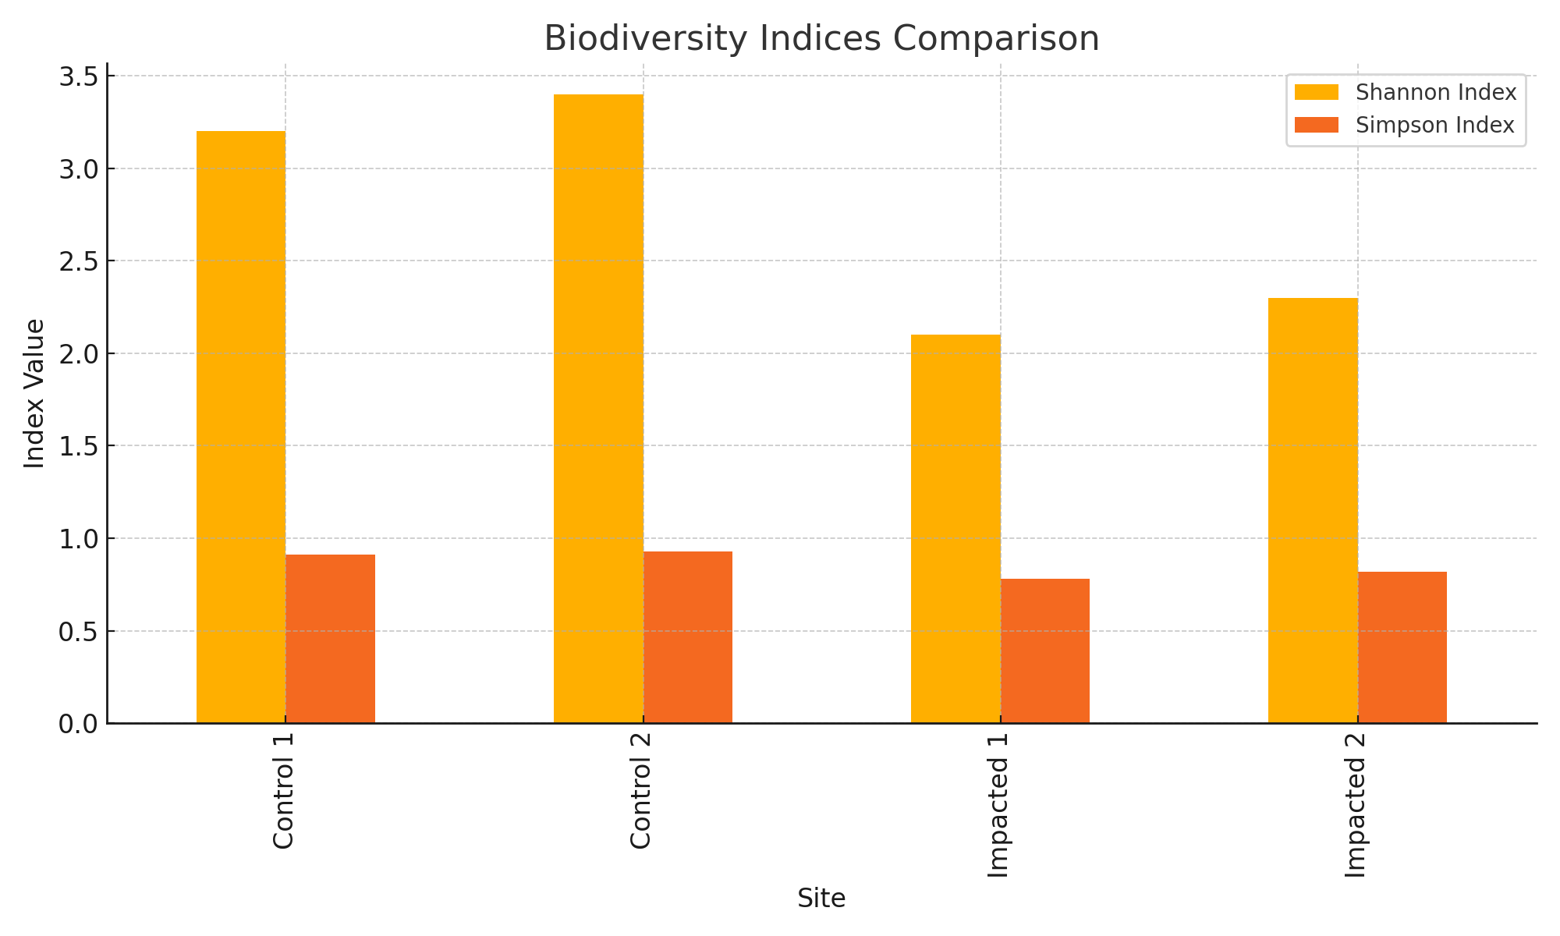
The findings of the study reveal a notable and statistically significant decline in species diversity within areas directly impacted by the Lusaka–Ndola dual carriageway construction. Quantitative analysis using Shannon-Wiener (H') and Simpson’s (D) diversity indices demonstrated consistently lower values in impacted zones compared to control sites. These biodiversity metrics—used globally to measure species richness (the number of species) and evenness (the relative abundance of species)—indicate a substantial loss of ecological integrity in disturbed habitats.
The reduction in diversity is primarily attributed to disturbance from vegetation clearance, increased noise levels, heavy machinery use, dust, and heightened human activity, which collectively alter the microhabitats that many species rely on. Vegetation clearing, in particular, leads to the loss of shelter, food resources, and breeding grounds for both flora and fauna (Laurance et al., 2014). These disruptions result in local extinction of sensitive species and increased dominance of generalist species that can tolerate altered environments, thereby reducing overall diversity and ecosystem balance.
Camera trap data further support this conclusion, showing a sharp decline in sightings of medium to large mammal species, especially in zones adjacent to construction sites. Species such as antelopes, civets, and small carnivores were more frequently detected in control plots compared to impacted areas. This pattern suggests disruption of traditional movement corridors and habitat fragmentation, which are known to affect large mammals more severely due to their greater space and resource requirements (Forman & Alexander, 1998). Fragmented habitats may also expose wildlife to increased risks of human-wildlife conflict, vehicle collisions, and poaching.
These findings align with global empirical research linking linear infrastructure development to biodiversity loss and ecosystem degradation. For example, studies by Benítez-López, Alkemade, and Verweij (2010) report that roads and infrastructure contribute significantly to habitat fragmentation and species displacement, especially in biodiversity-rich regions. Similarly, Trombulak and Frissell (2000) found that road construction often results in long-term ecological impacts, including altered water flows, invasive species spread, and noise-induced behavioral changes in fauna.
In the context of Zambia, the Lusaka–Ndola corridor passes through ecologically sensitive ecosystems such as miombo woodlands and riverine zones, which serve as habitats for endemic and migratory species. The disruption of these habitats not only affects local biodiversity but also undermines ecosystem services such as carbon sequestration, soil retention, and hydrological regulation.
3.2 Air Pollution Comparison
Figure 3.2 illustrates the differences in air pollutant concentrations between impacted and control locations. Higher levels of PM2.5, PM10, NOx, and CO2 were recorded in areas adjacent to the dual carriageway.

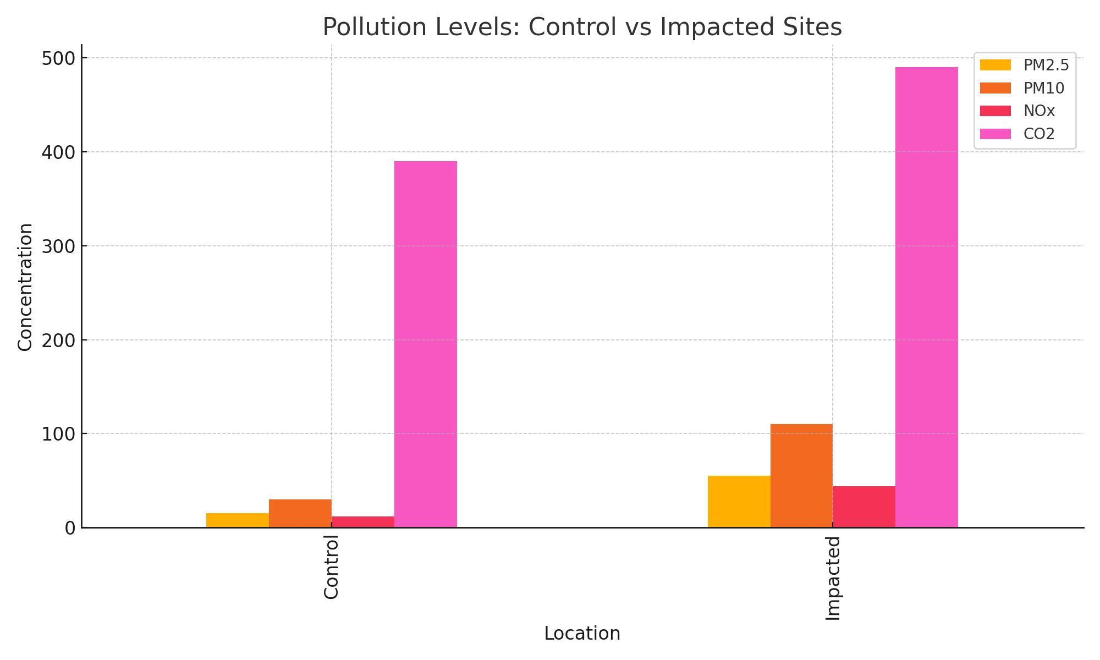
Figure 2 revealed significantly elevated concentrations of PM₂.₅ and PM₁₀ (particulate matter) in zones directly affected by the Lusaka–Ndola dual carriageway construction. These fine and coarse particles, primarily emitted from vehicular exhaust, construction dust, and disturbed soils, pose serious ecological and health hazards. The concentrations recorded in impacted zones exceeded baseline levels from control sites and surpassed international environmental health thresholds established by WHO (2016). Prolonged exposure to high PM levels is known to impair photosynthetic efficiency in plants by clogging stomata and reducing chlorophyll content (Grantz et al., 2003). In animals, inhalation of fine particulates can cause respiratory distress, inflammation, and reduced reproductive performance, particularly in small mammals and birds.
In addition, elevated levels of nitrogen oxides (NOₓ) and carbon dioxide (CO₂) were detected, especially in high-traffic zones such as Kabwe and Luanshya. NOₓ, a by-product of fuel combustion, contributes to acid deposition and tropospheric ozone formation, both of which further damage vegetation and soil chemistry (Fowler et al., 2009). High CO₂ levels, while not directly toxic, reflect increased fossil fuel usage and serve as an indicator of anthropogenic activity, contributing to broader climate and microclimate alterations.
Soil and water samples collected from adjacent wetlands and streams revealed contamination with heavy metals (e.g., lead, zinc) and hydrocarbons (e.g., oil residues), particularly near construction storage yards and roadside drainage channels. These pollutants, often derived from fuel spills, tire wear, and asphalt runoff, are known to accumulate in plant tissues, disrupt nutrient uptake, and impair microbial soil activity (Kabata-Pendias, 2011). Moreover, bioaccumulation in indicator species such as earthworms, amphibians, and aquatic invertebrates suggests a breakdown in trophic health and ecosystem function. Contaminated water sources pose a cascading threat to aquatic life, terrestrial herbivores, and human communities reliant on these resources.
These findings are consistent with ecological toxicology literature, which emphasizes the detrimental effects of pollutants on species fitness, survival, and reproduction (Newman & Unger, 2003). Studies have shown that even sub-lethal concentrations of heavy metals and hydrocarbons can cause developmental abnormalities, behavioral changes, and hormonal disruption in wildlife. Furthermore, the cumulative impact of multiple pollutants especially in fragmented and stressed ecosystems can lead to population declines and local extinctions.
For Lusaka–Ndola Road project, these results underscore the urgent need for integrated environmental monitoring and pollution mitigation strategies, including vegetative buffers, biofiltration swales, and strict control of construction waste and emissions. Without intervention, continued degradation of air, soil, and water quality will significantly compromise biodiversity, ecosystem services, and public health.
3.3 Species Abundance in Impacted Area
Figure.3 presents a histogram of species abundance. Species A dominates the population, while other species are significantly fewer in number, indicating a loss in biodiversity complexity.

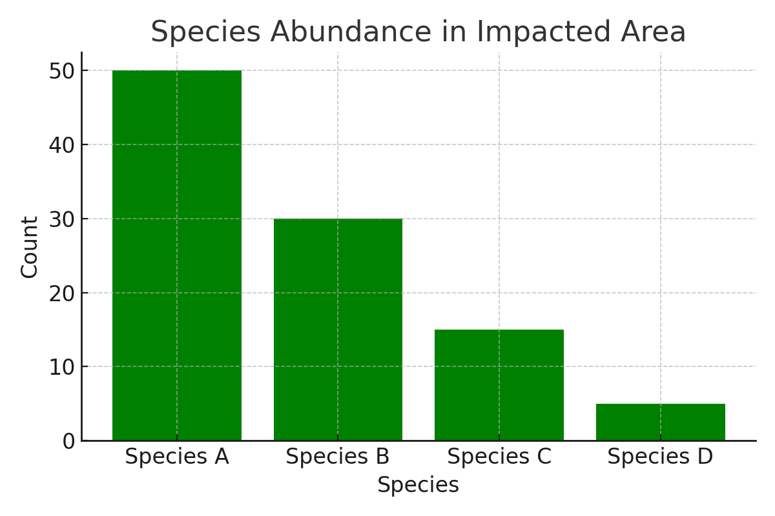
The histogram of species abundance reveals a highly uneven distribution, with Species A overwhelmingly dominating the sampled population across impacted plots. The remaining species occur in significantly lower frequencies, with some represented by only a few individuals. This pattern illustrates a classic example of biodiversity simplification, where ecosystem complexity is reduced due to disturbance or environmental stressors.
Such dominance by a single species suggests that ecological conditions have shifted in favor of generalist or disturbance-tolerant species, while more sensitive or specialist species have declined or disappeared. This skewed distribution results in low evenness, a key component of biodiversity, and is quantitatively reflected in lower diversity index values (e.g., Shannon-Wiener and Simpson's indices) reported in the study.
Loss of evenness and richness has serious ecological implications. Reduced biodiversity complexity compromises ecosystem stability, resilience to environmental change, and key functions such as nutrient cycling, pollination, and pest control (Tilman et al., 2014). In degraded habitats, such imbalance can also lead to competitive exclusion, where dominant species outcompete others for limited resources, further exacerbating species loss.
The results align with findings from previous studies on road-induced habitat fragmentation, which report that physical disturbances and altered microclimates near infrastructure selectively benefit a few hardy species while suppressing broader community diversity (Benítez-López et al., 2010).

figure4 Perceptions from Semi-Structured Interviews
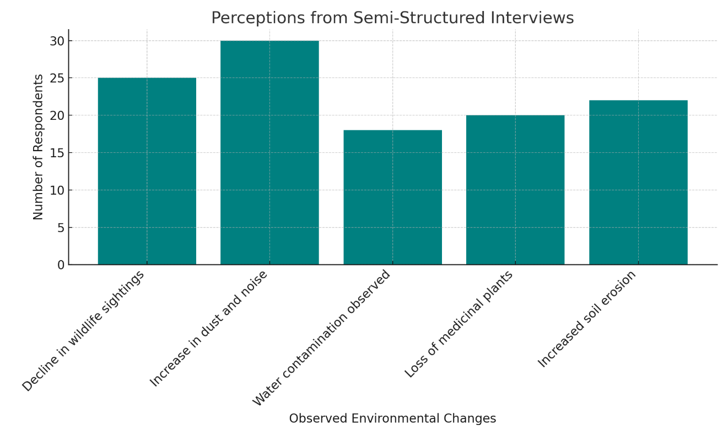
Figure 4, illustrates the frequency of environmental concerns raised by respondents living along the Lusaka–Ndola corridor. The most reported issue was an increase in dust and noise pollution (30 respondents), closely followed by a decline in wildlife sightings (25 respondents). These findings align with field data indicating biodiversity loss and elevated particulate matter levels near construction zones.
Other concerns included soil erosion (22 respondents), loss of medicinal plant species (20), and water contamination (18). These responses reflect the community's direct observations and lived experiences of environmental degradation. Such qualitative insights complement the quantitative environmental data, providing a holistic understanding of the impacts of the dual carriageway construction.
Overall, the histogram reinforces the importance of integrating local ecological knowledge into environmental impact assessments and highlights the need for targeted mitigation strategies such as pollution control, habitat restoration, and community engagement
Qualitative data from interviews and FGDs revealed local concerns about declining wildlife populations, water quality, and plant availability. Residents noted increased erosion, fewer sightings of birds and mammals, and a decrease in the availability of medicinal plants. These observations support scientific findings and also provide context-specific insights into how environmental changes are experienced at the grassroots level. The inclusion of local knowledge adds depth to environmental assessments and should inform future mitigation strategies.
The findings of this study align with global literature on road ecology, particularly the negative impacts of linear infrastructure on biodiversity and habitat integrity. The observed patterns of biodiversity loss, pollution, and fragmentation are well-documented in other African and global contexts, confirming that the Lusaka–Ndola case follows similar ecological trajectories. However, the study also contributes new data specific to Zambian ecosystems and fills a gap in regional environmental impact research.
6.2 Recommendations
1 Environmental Management and Restoration
Establish ecological buffer zones and green corridors along the carriageway to allow for wildlife movement. Initiate reforestation programs using indigenous species in deforested and degraded areas. Develop constructed wetlands and biofiltration systems near water discharge zones to naturally treat runoff before it enters rivers and streams.
2 Pollution Control and Monitoring
Enforce stricter regulations on construction machinery emissions and dust suppression methods.
Implement continuous air, water, and soil quality monitoring at critical points along the road. Require Road construction contractors to submit Environmental Performance Reports quarterly to ZEMA and relevant local authorities.
3 Infrastructure Design for Biodiversity Protection
Design and construct wildlife crossings (underpasses and overpasses) in biodiversity hotspots.
Incorporate vegetative buffers and noise-dampening barriers in high-sensitivity zones.
Avoid Road expansion in ecologically fragile zones such as wetlands or game management areas unless absolutely necessary.
4 Community Engagement and Education
Engage local communities in environmental monitoring and conservation activities through employment and training programs. Develop public education campaigns to raise awareness on the importance of biodiversity and sustainable land use. Include community representatives in road planning and post-construction monitoring committees.
5 Policy and Institutional Strengthening
Review and strengthen Zambia’s Environmental Impact Assessment (EIA) laws to include mandatory biodiversity impact assessments for all infrastructure projects. Strengthen the institutional capacity of ZEMA to enforce compliance and penalties for violations. Integrate environmental sustainability criteria into all PPP road contracts and national transportation plans.
Conclusion
The findings of this study have demonstrated that the Lusaka–Ndola dual carriageway construction has had significant and multifaceted environmental impacts on the biological and ecological systems along its route. Species diversity was markedly reduced in zones directly affected by construction activities. Key wildlife migration corridors have been disrupted, and endemic species are now increasingly vulnerable due to habitat loss and fragmentation. Air, soil, and water pollution arising from construction machinery and increased traffic emissions—have further exacerbated the degradation of natural ecosystems. Additionally, local communities have expressed heightened concern over visible declines in natural resources, water quality, and health-related issues caused by increased dust and noise.
The integration of quantitative data from field surveys with qualitative perceptions from local stakeholders presents a comprehensive picture of the ecological stress induced by infrastructure development in Zambia. While the road expansion project is economically necessary, it is clear that stronger mitigation measures, policy reform, and community-driven conservation strategies are urgently required to safeguard environmental sustainability

REFERENCE
African Development Bank. (2019). Environmental Guidelines for Infrastructure Projects in Africa. AfDB Publications.
Banda, L., Chikonde, T., & Phiri, J. (2018). Ecological Impacts of Rural Road Construction in Malawi. Journal of Environmental Management, 221, 17–25.
Benítez-López, A., Alkemade, R., & Verweij, P. A. (2010). The impacts of roads and other infrastructure on mammal and bird populations: a meta-analysis. Biological Conservation, 143(6), 1307–1316. https://doi.org/10.1016/j.biocon.2010.02.009
Chileshe, M., & Mwanza, P. (2020). Environmental Effects of the Great North Road Expansion. Lusaka Journal of Science and Technology, 5(1), 43–52.
Forman, R. T. T., & Alexander, L. E. (1998). Roads and Their Major Ecological Effects. Annual Review of Ecology and Systematics, 29, 207–231.
Laurance, W. F., Clements, G. R., Sloan, S., et al. (2014). A Global Strategy for Road Building. Nature, 513(7517), 229–232.
Mol, A. P. J., & Sonnenfeld, D. A. (2000). Ecological Modernization Around the World: Perspectives and Critical Debates. Frank Cass Publishers.
MOIC. (2022). Environmental and Social Impact Assessment: Lusaka–Ndola Dual Carriageway Project. Ministry of Infrastructure and Housing, Zambia.
Norton-Griffiths, M. (2007). How Many Wildebeest Do You Need? World Economics, 8(2), 41–64.
Okello, M. M., Kiringe, J. W., & Gichohi, N. (2017). Road Density and Wildlife Movement in Kenya. African Journal of Ecology, 55(3), 257–265.
Phiri, T. (2019). Sedimentation and River Pollution from Road Construction in Zambia. Zambian Journal of Environmental Research, 12(2), 87–95.
Trombulak, S. C., & Frissell, C. A. (2000). Review of Ecological Effects of Roads on Terrestrial and Aquatic Communities. Conservation Biology, 14(1), 18–30.
Van der Ree, R., Smith, D. J., & Grilo, C. (2015). Handbook of Road Ecology. John Wiley & Sons.
Forman, R. T. T., & Alexander, L. E. (1998). Roads and their major ecological effects. Annual Review of Ecology and Systematics, 29(1), 207–231. https://doi.org/10.1146/annurev.ecolsys.29.1.207
Laurance, W. F., Clements, G. R., Sloan, S., O’Connell, C. S., Mueller, N. D., Goosem, M., ... & Arrea, I. B. (2014). A global strategy for road building. Nature, 513(7517), 229–232. https://doi.org/10.1038/nature13717
Trombulak, S. C., & Frissell, C. A. (2000). Review of ecological effects of roads on terrestrial and aquatic communities. Conservation Biology, 14(1), 18–30. https://doi.org/10.1046/j.1523-1739.2000.99084.x
Fowler, D., Pyle, J. A., Raven, J. A., & Sutton, M. A. (2009). The global nitrogen cycle in the twenty-first century. Philosophical Transactions of the Royal Society B, 368(1621), 20130164. https://doi.org/10.1098/rstb.2013.0164
Grantz, D. A., Garner, J. H. B., & Johnson, D. W. (2003). Ecological effects of particulate matter. Environment International, 29(2–3), 213–239. https://doi.org/10.1016/S0160-4120(02)00181-2
Kabata-Pendias, A. (2011). Trace Elements in Soils and Plants (4th ed.). CRC Press.
Newman, M. C., & Unger, M. A. (2003). Fundamentals of Ecotoxicology (2nd ed.). CRC Press.
World Health Organization (WHO). (2016). Ambient air pollution: A global assessment of exposure and burden of disease. https://www.who.int/publications/i/item/9789241511353

