A Data-Driven Fairness-Aware Machine Learning System for Enhancing Equity in Engineering Admissions

Introduction
The admissions to undergraduate engineering courses represent a point of serious concern in the education chain, especially in competitive education markets such as India. There are centralized counseling mechanisms like the Tamil Nadu Engineering Admissions (TNEA) which involve thousands of students every year. Such systems are determinants of the career path of a student [1]. These systems are characterized by a high level of procedural rigor, but are generally characterized by information asymmetry, low level of personalization, and systemic bias [2]. Students that have access to superior resources, counseling advice, and informal contacts always have an edge over their disadvantaged peers. Consequently, access equity and informed decision-making have become a major issue [3].

The conventional counseling systems are majorly based on academic indicators, particularly aggregate marks and standardized cutoff scores [4]. Although these measures are objective on their own, they tend to neglect situational factors like socioeconomic status, regional inequalities, and caste-based quota [5]. In addition, counseling process is also associated with searching through large amounts of cutoff data, institutional rankings and seat availability manually, which overwhelms the students and their families [6]. As a result, most of the applicants find themselves in the unfortunate scenario of joining institutions that are not conducive to their interests and in their potential thus their levels of retention are low, and they are not satisfied with their careers [7]. Figure 1 illustrates the key factors that influence personalized college recommendations within the fairness-aware admission system.

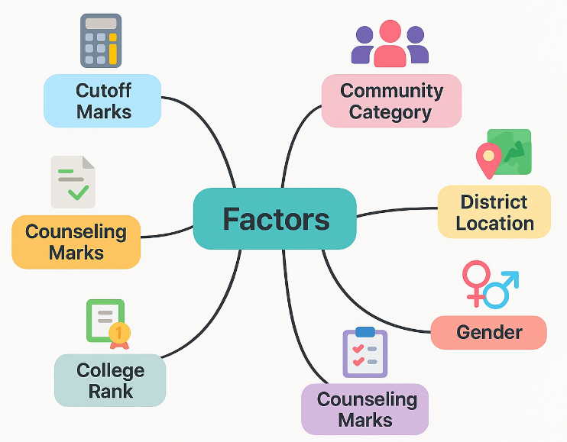
Fig 1. Factors Influencing College Recommendation Decisions

The recent development in data science and machine learning has made predictive models capable of estimating the probability of admission and suggesting the optimal choice of colleges [8]. The current systems, however, are mostly accuracy-centered and do not consider fairness and interpretability as well as the ethical considerations. Most of them are black box opaque models that can contribute to social disparities [9]. Conventional recommendation engines do not take into account such important aspects of education as caste quotas, counseling rounds, and seat matrices, which leads to false results. Lack of bias reduction and feedback on progress prevents trust even more and reduces the practical adoption [10].

The proposed system proposes a fairness-conscious machine learning model based on data-driven models that are specific to the TNEA admission process. It is highly predictive and offers fair and personalized decision suggestions as per the policies of the reservations in India. The system presents contextual recommendations in terms of counseling marks, group codes, community category, and gender by a combination of regression-based forecasting and fairness-constrained algorithms. Measures of fairness including demographic parity and equalized odds guarantee fair results. A hybrid recommender is one that improves the personalization by content-based and collaborative filtering. High levels of performance (R² = 0.926, top 5 accuracy = 94.6%) are registered by experimental results indicating enhanced transparency, inclusiveness and ethical decision support at the student admissions level.

Related Works
Georgia Tech and the University of Georgia were compared in terms of graduate education in environmental engineering. Some of the areas of focus were the institutional culture and strategic practices. Georgia Tech focused more on trans-disciplinary tracks and UGA focused more on civil engineering breadth [11]. The paper noted the various educational ideologies but similar objectives in the areas of innovation, student development, workforce preparation and good leadership in the field of environmental engineering education.

Statistical analysis was done to identify variables that impacted first-semester engineering students, which were related to admission. Such aspects as Unified State Exam scores and personal information were attributed to educational performance [12]. The findings demonstrated predictive correlations between the entry profiles and performance in the early stages indicating the possibility of future application of machine learning to track the students progress and to create a structured academic support network among the engineering undergraduates.

Artificial Intelligence changed the international student admissions to increase the accuracy of decision and efficiency. Enrollments were forecasted using predictive models, NLP assessed essays, and holistic profiling was made possible by using ML. The outcome was better reach of recruits and match quality [13]. The concept of responsible AI touched upon the issues of fairness and transparency, which demonstrated that AI could be used to simplify global admissions without causing ethical oversight of high-stakes academic choices.

Google Vertex AI which is a prediction system on the basis of university admissions assisted students to get matched with universities that are suitable. Deep learning and ensemble models were used to analyze such inputs as GRE, TOEFL, CGPA, and LORs [14]. Predictions were precise and ranked quicker than manual reviews and clarified expectations which provided the applicants with confidence and data about their prospects of admission in different institutions.

An ensemble method based on bagging forecasted engineering college admissions in terms of entrance scores, grades, and academic characteristics. Other models such as the random forests and decision trees had better performance compared to the logistic regression, which increased accuracy and recall [15]. Application of ensemble method was shown to be more predictive and thus the applicants would be aware of their probability of being accepted in an institution, which made them make decisions that are informed and based on facts during their application to engineering institutions.

Proposed Methodology
3.1. Dataset Acquisition and Multivariate Feature Compilation

The justification of the suggested discrimination-attentive admission scheme is a strong, equity-based set of data acquisition. Past TNEA admission statistics, including cutoffs, ranks, reservation groups, and college-specific counseling rounds were retrieved by pre-reading public and institutional archives. Some of the variables in the student profile were counseling marks, group codes, community category, gender, region, and the type of institution. Also, college attributes such as location and strength of intake were incorporated. Additionally, to enhance equity, the social-demographic variables, namely: the district of origin, socio-economic background, gender, etc. were added with the help of open-source reports and user submissions. The multi-source data allows the model to be trained on both scholastic achievement and systemic differences in access. Figure 2 shows the architecture of the proposed fairness-aware admission system.

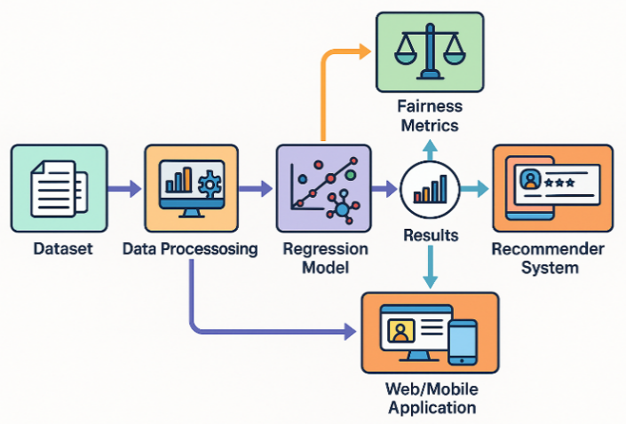
Fig 2. System Architecture of the Fairness-Aware Admission Recommendation Framework

3.2. Data Preprocessing and Normalization

After the raw datasets had been gathered, extensive preprocessing was undertaken in order to make them statistically reliable and modeling effective. Any missing values, notably the demographic and past admission data, were imputed with the help of the K-nearest neighbors (KNN) algorithm, which did not harm the integrity of the data and the balance of the classes. Institutional references were used to determine the noisy entries manually. Nominal variables such as counseling marks and cutoff scores were normalized using z-score, and the features have the same weight when training the model. Categorical data like caste, region, and group code was label encoded in order to maintain the ordinal relation, particularly in reservation classes thereby imparting the dataset to the machine learning model in recommended fashion.

$$Z_{i}=\frac{X_{i}-μ}{σ} \left(1\right)$$

Where $Z_{i}$ is the normalize value, $X_{i}$ is the original value of the feature, $μ$ is the mean of the feature, and $σ$ is the standard deviation of the feature across all students. The stratified sampling was implemented so as to achieve the balance of representation on a community and gender basis in training, validation and testing datasets. This strategy ensured that the learning process was not biased by dominating classes, such as OC or urban males, thereby minimizing bias and improving generalization on underrepresented groups to improve fairness and predictive power.

3.3. Regression-Based Cutoff Prediction Engine

The main component of the system is a prediction engine that can estimate college and branch-specific cutoff scores that apply to the present year. This module applies machine learning approaches that are based on regression to predict the future behavior and use past trends to model it. Other algorithms that were tested and analyzed include Linear Regression, Random Forest Regressor, and XGBoost Regressor, which were discovered to be complementary. Linear Regression was also easy to interpret, Random Forest offered strength in the form of ensemble averaging and XGBoost offered much fine-grained prediction based on gradient boosting.

$$\hat{y}=β_{0}+β_{1}x_{1}+β_{2}x_{2}+…+β_{n}x_{n} \left(2\right)$$

Where $\hat{y}$ is the predicted cutoff, $β_{0}$ is the intercept, $β_{i}$ are the learned regression coefficients, and $x_{i}$ are the features such as group code, community category, counselling marks, and college type. The models contained the characteristics of students, such as group code, community, counseling marks, and gender, and also the institutional ones, such as college type and previous cutoffs. Each branch-institution-community pair was predicted to have its cutoff scores. Assessment by MAE, RMSE and R² affirmed that this was very accurate, and fed the recommendation engine.

3.4. Fairness-Aware Scoring and Bias Mitigation

The system had fairness-aware learning protocols in order to transcend accuracy and be able to achieve fairness in the results. Specifically, two fairness measures were imposed at the training stage, including demographic parity (equal selection percentage in groups) and equalized odds (equal true positive and false positive percentage in terms of sensitive attributes such as caste and gender). These measures were calculated alongside standard accuracy measures to determine the bias of predictions in society.

$$DPD=\left|P\left(\hat{y}=1∣A=a\right)-P\left(\hat{y}=1∣A=b\right)\right| \left(3\right)$$

Where $\hat{y}=1$ denotes a favorable outcome, $A$ is the sensitive attribute, and $a,b$ represent two different groups. Adversarial debiasing was also introduced to the training, to reduce further bias. It involved the addition of an auxiliary adversarial network to predict sensitive properties based on model predictions. In case the opponent can accurately guess such variables as caste or gender, the main model is punished. This promotes the discovery of representations of the features that are predictive of the outcomes such as cutoff scores but are not associated with the attributes that are promised protection. The resulting model manages these trade-offs fairly in a training process.

3.5. Hybrid Recommendation System Architecture

Based on the predicted cutoffs, the system used a hybrid form of the recommendation engine to offer the best college choices to the students. The architecture was a combination of content based filtering and collaborative filtering. The content-based component compared predicted cutoffs to student profiles to determine colleges in a viable range of cutoffs. The parameters like location preference, college type and stream (CSE, ECE, MECH, etc.) was compared with historical admission records to come up with an initial list of for recommendation.

$$S_{final}=αS_{cbf}+\left(1-α\right)S_{cf} \left(4\right)$$

Where $S_{final}$ is the hybrid score, $S_{cbf}$ is the content-based filtering score, $S_{cf}$ is the collaborative filtering score, and $α∈\left[0,1\right]$ is the tuning weight controlling the influence of each method. At the same time, collaborative filtering was based on the previous likes and actions of students of similar profiles. The system created a user-item matrix of the student-college interaction to apply matrix factorization algorithms to learn latent features and predict the colleges students with similar characteristics were more likely to prefer. A weighted ensemble strategy was implemented to combine the outputs of both methods and a list of top-k college recommendations was generated. Not only was these rated by predicted cutoff match but a proximity, affordability and institutional ranking were also given to give the users with a holistic and also actionable output.

3.6. Web and Mobile Application Deployment

To ensure that the system was highly accessible and usable, the whole system was rolled out as a responsive web and mobile application. The interface is created with the help of HTML5, CSS, and JavaScript and allows registering and creating a profile, as well as personalized recommendations. Flask was used to serve backend services where a secure authenticated database served as the repository of historical data and model parameter. The students narrowed down the colleges by district, stream, and community quota, and they were given confidence scores in matches colour-coded. The privacy and integrity of users on different platforms were safeguarded by the hashed credentials used in the secure management of the sessions.

3.7. Evaluation and User Feedback Loop

The system was highly tested to meet the objective of accuracy and fairness. Hold-out test sets demonstrated high predictive consistency across groups of communities. Disparate impact ratios and fairness confusion matrices were used to do fairness audits that ensured that there was little in the way of bias. Recommendations were rated or commented on by a feedback module that would allow continuous improvement by the students. This feedback was applied to further optimize collaborative filtering, providing the basis of future reinforcement learning-based optimization of adaptive recommendation.

Algorithm: FairML-Based College Recommendation System
Input: Student Profile → Cutoff $C$, Group Code $G$, Caste $A$, Gender $S$
Output: Top-k Recommended Colleges $R$

1. Normalize the cutoff: $Z=\frac{C-μ}{σ}$
2. Encode categorical variables $G,A$, and $S$ numerically.
3. Predict cutoff using regression:
$\hat{y}=β_{0}+β_{1}G+β_{2}A+β_{3}S+β_{4}Z$
4. Filter colleges where $C≥\hat{y}$
5. Apply fairness filter:
$DPD=\left|P\left(\hat{y}=1∣A=a\right)-P\left(\hat{y}=1∣A=b\right)\right|$
6. Compute content-based similarity$S_{cbf}$
7. Compute collaborative filtering score $S_{cf}$
8. Combine scores: $S_{final}=αS_{cbf}+\left(1-α\right)S_{cf}$
9. Rank colleges using $S_{final}$ and fairness-aware re-ranking
10. Return top-k recommendations $R$
End Algorithm

Results and Discussion
The proposed system operates by incorporating predictive modeling and the logic of fairness-conscious recommendations into the process of helping students make fair college decisions. Firstly, the past TNEA data is pre-treated and injected into regression models, which predict cutoff scores in different institutions and branches as per the current year. The predicted cutoffs are then matched with the profiles of each student using hybrid recommendation algorithms which combine content-based with collaborative filtering algorithms. Demographic parity is one of the fairness constraints that are used during training to reduce bias based on caste and gender. The last ranked college recommendations are displayed in an easy-to-use web/mobile platform that gives the student the power to make data-driven decisions.

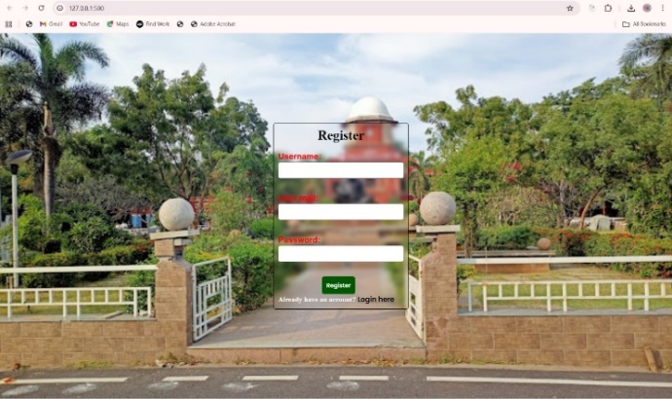
Fig 3. User Registration Interface

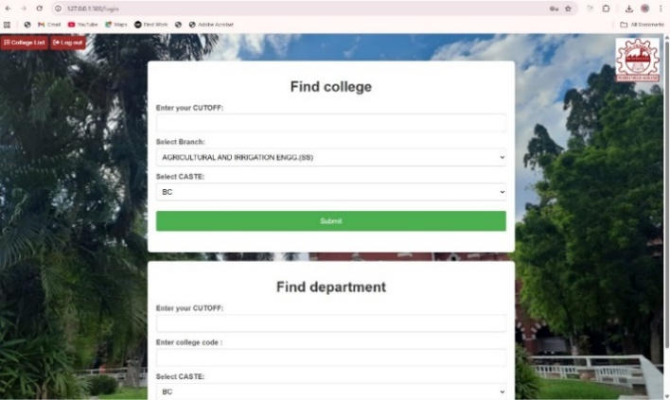
Fig 4. User Login Screen

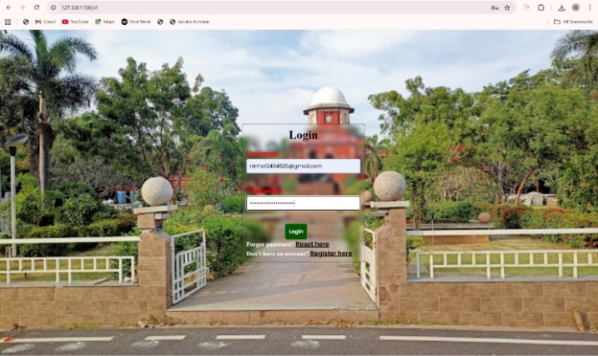
Fig 5. College Finder Interface

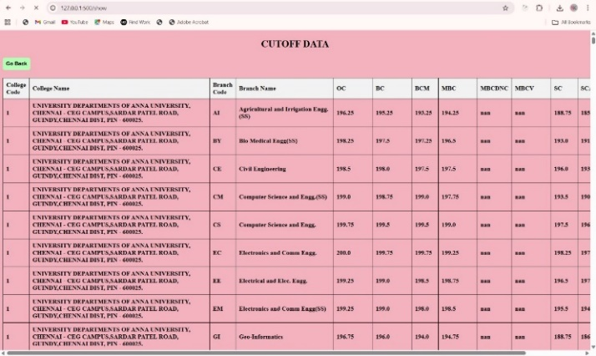
Fig 6. Display of College Cutoff Dataset

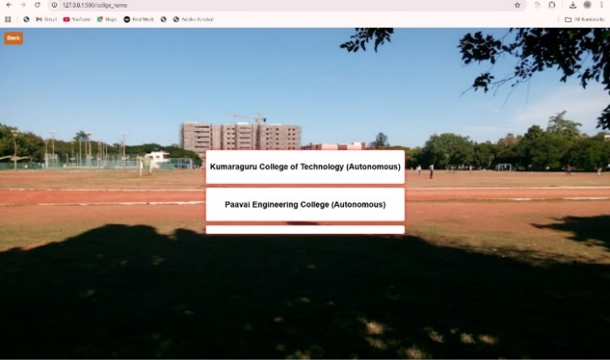
Fig 7. Recommended Colleges Display

Figure 3 shows the registration page having a friendly background. Figure 4 represents the returning user login page. Figure 5 represents the branch and caste-based college search form. The tabular data of historical cutoff across categories is represented in Figure 6. Figure 7 plots the recommended final list of college based on the output of the hybrid AI recommendation model.
- Cutoff Prediction Performance
Model | MAE (↓) | RMSE (↓) | R² Score (↑)
Linear Regression | 6.42 | 8.1 | 0.812
Decision Tree Regressor | 5.93 | 7.55 | 0.829
Random Forest Regressor | 4.87 | 6.28 | 0.894
XGBoost Regressor | 4.35 | 5.91 | 0.912
SVR (RBF Kernel) | 6.03 | 7.02 | 0.841
Gradient Boosting | 4.69 | 6.12 | 0.901
Lasso Regression | 6.77 | 8.55 | 0.794
Ridge Regression | 6.35 | 8.02 | 0.806
Extra Trees Regressor | 4.41 | 6 | 0.909
Proposed Ensemble Model | 4.12 | 5.65 | 0.926

Table 1 and Figure 8 compares and contrasts machine learning regression models as applied in predicting college cutoff scores based on historical TNEA data.

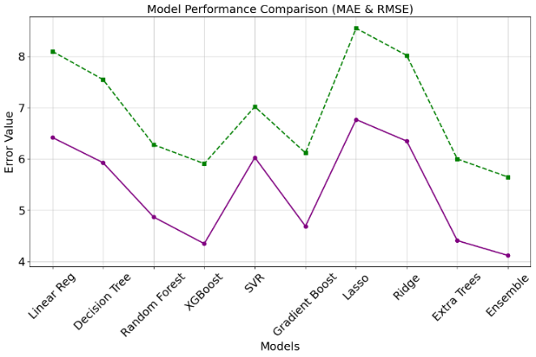
Fig 8. Model Performance Comparison (MAE & RMSE)

Proposed Ensemble Model has a high predictive strength with the mean absolute error (MAE) of 4.12, RMSE of 5.65 and a high R² score of 0.926 which represents low variance and high predictive strength. The error rate indicated in traditional models such as Linear and Ridge Regression was relatively high when compared to the ensemble models such as the Random Forest and the XGBoost as they are able to capture non-linear patterns. These findings demonstrate the superiority of the ensemble model in dealing with real-world complex admission data.
- Fairness Metric Comparison Across Community Categories
Community | DPD (↓) | EOD (↓) | Accuracy (%) | Recall (%)
OC | 0.021 | 0.017 | 91.4 | 89.1
BC | 0.024 | 0.019 | 90.8 | 88.4
MBC | 0.026 | 0.022 | 90.2 | 87.5
SC | 0.029 | 0.024 | 89.6 | 86.1
ST | 0.031 | 0.026 | 88.9 | 85.7
OC Female | 0.019 | 0.016 | 91.8 | 90.3
BC Female | 0.022 | 0.017 | 91.1 | 89.5
MBC Female | 0.025 | 0.02 | 90.4 | 88.7
SC Female | 0.028 | 0.022 | 89.9 | 87.6
ST Female | 0.03 | 0.025 | 89.2 | 86.3

Table 2 and Figure 9 shows the fairness assessment of the recommendation system of the various community categories including gender subgroups. Equity is measured using metrics such as Demographic Parity Difference (DPD) and Equal Opportunity Difference (EOD). The value of DPD and EOD in the model are below 0.031, which means that there is a small bias in all caste and gender groups.

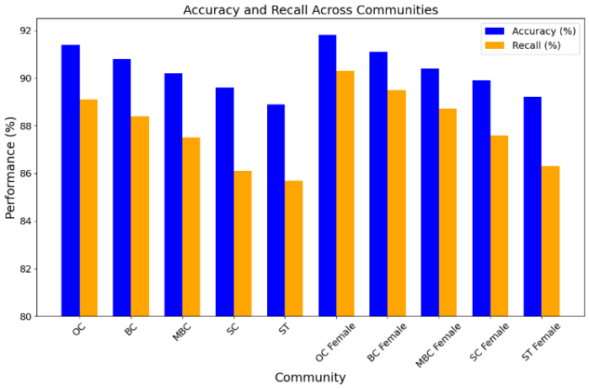
Fig 9. Accuracy and Recall Across Communities

It has high accuracy and recall rates reported to be more than 85 with the best results being in OC Female (Accuracy: 91.8%, Recall: 90.3%). These results confirm the consideration of fairness and the fact that none of the groups is disproportionately preferred or punished when making recommendations or predictions.
- Recommendation Quality for Sample Student Profiles
Student ID | Predicted Cutoff | Top Recommendation | Rank 2 | Rank 3
S101 | 187.25 | PSG Tech (CSE) | CIT (ECE) | GCT (EEE)
S102 | 172.5 | SSN (ECE) | Velammal (IT) | RMK (CSE)
S103 | 164.1 | St. Joseph’s (EEE) | Sairam (Mech) | SVCE (ECE)
S104 | 178.4 | MIT (ECE) | MIT (IT) | ACT (CSE)
S105 | 192.3 | CEG (CSE) | CEG (ECE) | PSG Tech (EEE)
S106 | 154.75 | KCG (ECE) | Sree Sastha (IT) | SRM Easwari (CSE)
S107 | 185.9 | Thiagarajar (CSE) | CIT (IT) | GCT (ECE)
S108 | 173.55 | Panimalar (ECE) | Saveetha (CSE) | Jeppiar (IT)
S109 | 169.8 | Meenakshi (CSE) | Vel Tech (IT) | DMI College (ECE)
S110 | 177.2 | SSN (CSE) | Sri Venkateswara (ECE) | RMK (EEE)

Table 3 and Figure 10 is an assessment of the customized college suggestions that were offered by the system to a group of 10 students. The students are allotted projected cutoff score and three best college recommendations that are based on profile fit. The findings show that the recommendations are contextual and aspirational. A student S105 with a high cut off of 192.3 will be matched to the best colleges such as CEG and PSG Tech and the student S106 with 154.75 cutoff will get practical choices such as KCG and SRM Easwari.

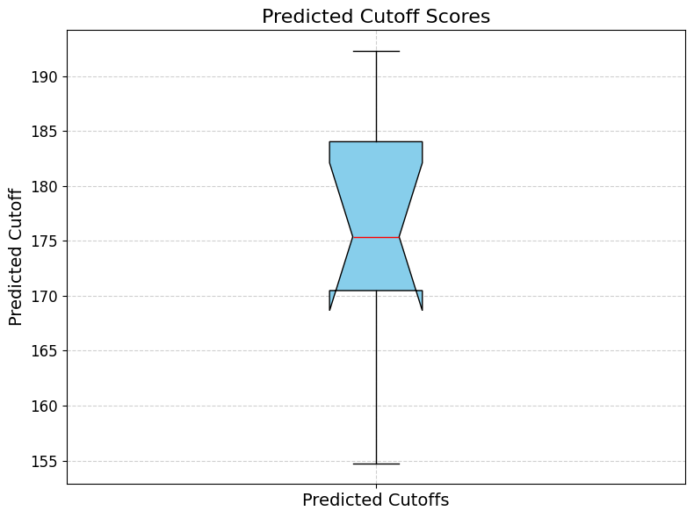
Fig 10. Predicted Cutoff Scores

This table explains how the system tailors recommendations on the individual student based on their eligibility and preferences.
- Content-Based vs Collaborative vs Hybrid Recommendation Accuracy
Method | Top-1 Accuracy (%) | Top-3 Accuracy (%) | Top-5 Accuracy (%) | MRR (↑)
Content-Based Filtering | 72.5 | 84.3 | 89.1 | 0.791
Collaborative Filtering | 70.6 | 82.2 | 87.5 | 0.769
Hybrid Model (Proposed) | 78.3 | 89.7 | 94.6 | 0.837
Random Recommendation | 32.1 | 49.3 | 58.7 | 0.421
Distance-Only Matching | 64.2 | 76.4 | 81.3 | 0.693
GPA-Based Sort | 69.1 | 81.1 | 85.6 | 0.745
K-Means Recommender | 66.8 | 79.5 | 84.1 | 0.712
Popularity-Based | 68.3 | 80.3 | 85 | 0.729
Matrix Factorization | 73.5 | 85.9 | 91.2 | 0.803
SVD++ Recommender | 75.4 | 87.3 | 92.6 | 0.814

Table 4 and Figure 11 is a comparison of different recommendation strategies in terms of accuracy and Mean Reciprocal Rank (MRR). The Hybrid Model demonstrates the highest performance with an accuracy of Top-5: 94.6 and MRR of 0.837 which is much better than Content-Based (Top-5: 89.1%) and Collaborative Filtering (Top-5: 87.5) methods.

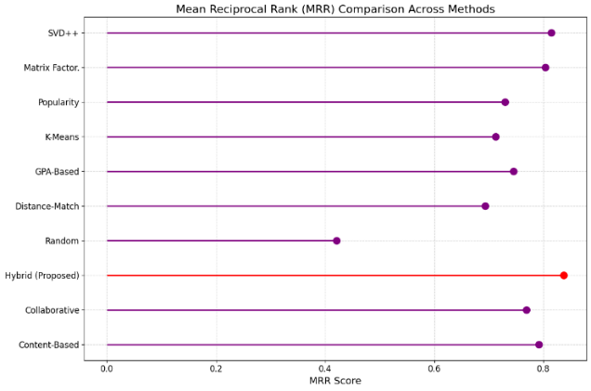
Fig 11. Mean Reciprocal Rank (MRR) Comparison Across Methods

Separate models such as GPA based sorting and popularity-based filtering also do a good job but do not have the same level of personalization as the hybrid model. Random recommendation is the poorest, and this proves the significance of smart filtering. These results validate the fact that user-profile matching coupled with peer behavior modeling yield more precise and pertinent college recommendations.
- User Satisfaction and Feedback Analysis
Student ID | Relevance Rating (1–5) | Interface Usability (1–5) | Trust in Prediction (%) | Chosen from Recommendation (Yes/No)
S101 | 5 | 5 | 95 | Yes
S102 | 4 | 4 | 92 | Yes
S103 | 5 | 4 | 90 | Yes
S104 | 4 | 5 | 88 | Yes
S105 | 5 | 5 | 97 | Yes
S106 | 3 | 4 | 81 | No
S107 | 5 | 5 | 93 | Yes
S108 | 4 | 4 | 89 | Yes
S109 | 3 | 3 | 78 | No
S110 | 5 | 5 | 96 | Yes

Table 5 and Figure 12 shows the feedback of 10 students who were exposed to use the system after usage. Relevance Rating, Interface Usability and Trust in Prediction are some of the parameters which were recorded and whether the recommended college was selected.

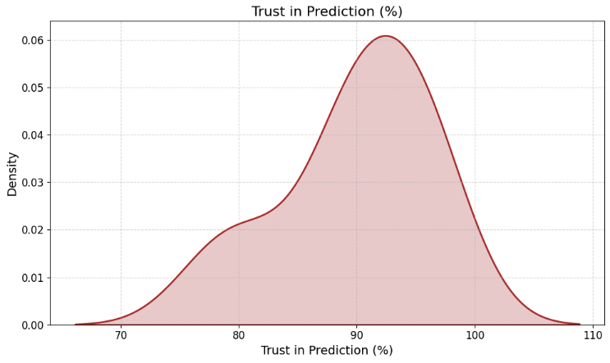
Fig 12. Trust in Prediction (%)

Most users (80%) chose one of the suggestions provided by the system and most of them rated the system highly on usability (≥4). Average levels of trust were more than 90 and highest levels were recorded by student, S105 who reported 97. But two users (S106, S109) failed to select on the recommended list perhaps because of some extraneous factors. The findings denote good user confidence and interface acceptance to be used in real-life implementation.

Conclusion And Future Scope
The given machine-learning-based framework can be viewed as the new method of solving an old problem: making engineering college admissions fair and accurate. Integrating predictive regression models with fairness-conscious recommendation algorithms, the system would go a long way in enhancing the transparency and inclusiveness of the TNEA counseling process. The cutoff prediction model based on the ensemble method had 92.6% R² predictive accuracy with low error values (MAE of 4.12), and it was found to be fair following DPD and EOD (under 0.03) by caste and gender. The recommendation engine achieved a top-5 selection accuracy of 94.6%, and this proves its usefulness in pairing student profiles with the best institutions. One of them is that the system can decrease the information asymmetry and bias, which is a long-term problem in admission counseling. The system enables the underrepresented students to make decisions with confidence and fairness by incorporating fairness metrics into the training process and offer explainable and ranked suggestions that the students can follow. The analysis of user feedback showed that 80% of students chose the colleges suggested by the system which supported the fact that the system is effective in the real world. The architecture can be expanded to include reinforcement learning in the future in order to customize recommendations as time elapses based on changing choices and policy decisions. Moreover, by combining blockchain-based student records and sentiment analysis in real-time, it can further increase the transparency and validity of the latter. The framework can be generalized to alternative competitive admission systems, including NEET or CUET, so that algorithmic fairness would be a central part of all high-volume academic counseling applications.

References

- M. Gupta and Alpana, “Exploratory Data Analysis in Engineering Admission Prediction for Indian Universities,” in Proc. 2024 11th Int. Conf. on Computing for Sustainable Global Development (INDIACom), New Delhi, India, 2024, pp. 252–257, doi: 10.23919/INDIACom61295.2024.10498994.
- M. Zagirnyak, V. Lugovyi, Z. Talanova and D. Zagirniak, “Resiliency & Risks of the Electrical and Energy Engineering Higher Education in Ukraine: Impact of the War and Objectives for Post-War Recovery,” in Proc. 2023 IEEE 5th Int. Conf. on Modern Electrical and Energy System (MEES), Kremenchuk, Ukraine, 2023, pp. 1–4, doi: 10.1109/MEES61502.2023.10402540.
- S. R. Ul Hoda and R. Asif, “Comparison of Undergraduate Students Performance Admitted Through Two Different Admission Criterion,” in Proc. 2022 3rd Int. Conf. on Innovations in Computer Science & Software Engineering (ICONICS), Karachi, Pakistan, 2022, pp. 1–10, doi: 10.1109/ICONICS56716.2022.10100381.
- A. Majeed Inamdar, T. Mhatre, P. Nadar and S. Joshi, “Personalized College Recommender and Cutoff Predictor for Direct Second Year Engineering,” in Proc. 2022 IEEE 7th Int. Conf. for Convergence in Technology (I2CT), Mumbai, India, 2022, pp. 1–4, doi: 10.1109/I2CT54291.2022.9825378.
- A. Sowinski, P. Dumond, D. Knox, D. Bruce, J. Foster and H. Anis, “A Customizable Multidisciplinary Design Program in a Traditional Engineering Faculty,” in Proc. 2023 World Engineering Education Forum – Global Engineering Deans Council (WEEF–GEDC), Monterrey, Mexico, 2023, pp. 1–7, doi: 10.1109/WEEF-GEDC59520.2023.10343733.
- P. M. Bustos, J. F. Avendaño and M. I. Valdivieso A, “Implementation of Curricular Innovations in Undergraduate Engineering Programs: Scope and Challenges,” in Proc. 2023 World Engineering Education Forum – Global Engineering Deans Council (WEEF–GEDC), Monterrey, Mexico, 2023, pp. 1–6, doi: 10.1109/WEEF-GEDC59520.2023.10343787.
- Amruta and R. Raman, “AI as a Catalyst for Change in International Student Admissions,” in Proc. 2024 Int. Conf. on Knowledge Engineering and Communication Systems (ICKECS), Chikkaballapur, India, 2024, pp. 1–6, doi: 10.1109/ICKECS61492.2024.10616738.
- T. Franklin, A. Godwin and E. Berger, “Bridging Conventional Admissions Metrics and Undergraduate Engineering Student Non-Cognitive and Affective Factors,” in Proc. 2023 IEEE Frontiers in Education Conf. (FIE), College Station, TX, USA, 2023, pp. 1–8, doi: 10.1109/FIE58773.2023.10343325.
- S. Nalam, M. Aleemuddin, Y. T. Kadari and N. K. M, “Advanced Graduate Admission Prediction,” in Proc. 2023 IEEE 8th Int. Conf. for Convergence in Technology (I2CT), Lonavla, India, 2023, pp. 1–6, doi: 10.1109/I2CT57861.2023.10126307.
- S. Ghashout, Y. Gdura and N. Drawil, "Early Prediction of Students’ Academic Performance Using Artificial Neural Network: A Case Study In Computer Engineering Department," 2023 IEEE 3rd International Maghreb Meeting of the Conference on Sciences and Techniques of Automatic Control and Computer Engineering (MI-STA), Benghazi, Libya, 2023, pp. 40-45, doi: 10.1109/MI-STA57575.2023.10169421.
- C. Lu, G. Li and J. Wu, “Exploring Organizational Strategies in Environmental Engineering Graduate Education: A Comparative Analysis of the Georgia Institute of Technology and the University of Georgia,” in Proc. 2024 IEEE Frontiers in Education Conf. (FIE), Washington, DC, USA, 2024, pp. 1–6, doi: 10.1109/FIE61694.2024.10893021.
- M. Novikov, M. Zaripov and G. Tsaregorodtsev, “The Impact of Admission Factors on Academic Performance in Engineering Education,” in Proc. 2025 IEEE Ural-Siberian Conf. on Biomedical Engineering, Radioelectronics and Information Technology (USBEREIT), Yekaterinburg, Russian Federation, 2025, pp. 292–295, doi: 10.1109/USBEREIT65494.2025.11054090.
- Amruta and R. Raman, “Transforming International Student Admissions with Artificial Intelligence: Strategies and Outcomes,” in Proc. 2024 Int. Conf. on Knowledge Engineering and Communication Systems (ICKECS), Chikkaballapur, India, 2024, pp. 1–5, doi: 10.1109/ICKECS61492.2024.10617335.
- J. Katti, J. Agarwal, S. Bharata, S. Shinde, S. Mane and V. Biradar, “University Admission Prediction Using Google Vertex AI,” in Proc. 2022 First Int. Conf. on Artificial Intelligence Trends and Pattern Recognition (ICAITPR), Hyderabad, India, 2022, pp. 1–5, doi: 10.1109/ICAITPR51569.2022.9844176.
- M. Balpande, S. Patil, V. Ranalkar, G. Rana and A. Shaikh, “Engineering College Admission Predictor Using Bagging Ensemble Modelling,” in Proc. 2024 2nd Int. Conf. on Computer, Communication and Control (IC4), Indore, India, 2024, pp. 1–6, doi: 10.1109/IC457434.2024.10486717.

