PREVALENCE OF INTESTINAL NEMATODE INFECTIONS IN DOMESTIC CATS (FELIS CATUS) FROM SELECTED HOUSEHOLDS IN BARANGAY DOROLUMAN, ARAKAN, COTABATO USING DEWORMING OBSERVATION

ABSTRACT
This study aimed to determine the prevalence of intestinal nematodes in domestic cats through household deworming observation in a selected household in Doroluman, Arakan, Cotabato. A descriptive observational research design was employed using purposive sampling. Ten domestic cats were selected and administered a Piperazine Dihydrochloride (Pidro Powder) according to the product's recommended dosage. The cats were observed for the presence of expelled intestinal worms after deworming. Results showed that 8 out of 10 cats (80%) expelled roundworms, indicating the presence of intestinal nematodes, while 2 cats (20%) showed no observable worm expulsion. The findings suggest that intestinal nematode infection is common among domestic cats in the selected household of Barangay Doroluman, Arakan, Cotabato. This stresses the importance of regular deworming and parasite monitoring to promote animal health.
Keywords: intestinal nematodes, domestic cats, household deworming, prevalence, Piperazine Dihydrochloride

INTRODUCTION

Domestic cats (Felis catus) are among the most common companion animals worldwide. They are valued for providing companionship and helping control rodent populations. Due to their close interaction with humans, maintaining their health is important for both animal welfare and public health. However, domestic cats are susceptible to various diseases and parasitic infections, particularly intestinal nematodes. These parasites live in the digestive tract and can negatively affect the health and well-being of infected cats. According to Adhikari et al. (2022), gastrointestinal parasites remain common among domestic cats and continue to be a concern in many communities worldwide.
Intestinal nematodes such as Toxocara cati, Ancylostoma spp., and Toxascaris leonina are among the most frequently reported parasites in cats (Symeonidou et al. 2018). These worms may cause diarrhea, vomiting, weight loss, poor body condition, and anemia, especially in young animals. Bărbuceanu et al. (2021) stated that intestinal parasite infections remain significant because some species can also infect humans. Likewise, Chalkowski et al. (2019) found that cats with outdoor access are more likely to acquire parasitic infections due to increased exposure to contaminated environments. These findings indicate that intestinal nematodes continue to affect cat populations despite the availability of deworming treatments. Despite these findings, limited information is available regarding the prevalence of intestinal nematodes in many rural communities. Most studies have focused on urban areas, leaving gaps in knowledge about parasite infections in smaller localities.
In Barangay Doroluman, Arakan, Cotabato, domestic cats are commonly raised as household pets. Many are allowed to roam freely around homes and nearby areas, increasing their exposure to potential sources of parasitic infection. However, there is currently no documented study regarding the prevalence of intestinal nematodes among domestic cats in the locality. The lack of local data makes it difficult to determine the extent of the problem and develop appropriate parasite control measures.
To address this concern, the present study will use household deworming observation as a practical approach to determine the prevalence of intestinal nematodes among domestic cats. Piperazine Dihydrochloride (Pidro Powder) will be administered to selected cats, and observations will be conducted to identify the presence of expelled intestinal worms after deworming. This method provides a simple and affordable way of detecting possible nematode infections, particularly in areas where laboratory facilities may not be readily available.
Specifically, this study aims to administer Piperazine Dihydrochloride (Pidro Powder) to selected domestic cats, observe the presence of expelled intestinal worms after deworming, and determine the percentage of cats infected with intestinal nematodes. The findings of this study are expected to provide baseline information regarding intestinal nematode infections among domestic cats in Doroluman, Arakan, Cotabato. Furthermore, the results may help promote awareness on the importance of regular deworming and responsible pet care.

Objectives of the Study
The study aimed to determine the prevalence of intestinal nematodes in domestic cats using household deworming observation. Specifically, it aims to:
- Administer Piperazine Dihydrochloride (Pidro Powder) to selected domestic cats on Barangay Doroluman, Arakan, Cotabato.
- Observe the presence of expelled intestinal worms after deworming.
- Identify the expelled intestinal nematodes based on their morphological characteristics.
- Determine the percentage of cats infected with intestinal nematodes.

METHODS AND MATERIALS
Research Design
This study employed a descriptive observational research design to determine the prevalence of intestinal nematodes in domestic cats through household deworming observation.

Study Area
The study was conducted in a selected household in Barangay Doroluman, Arakan, Cotabato, where domestic cats were commonly raised and cared for within a household setting (Figure 1).

Sampling Technique
Purposive sampling technique was utilized in selecting the study subjects. Ten (10) domestic cats residing in the selected household were included in the study based on their availability and the owner's consent. Household deworming observation was used to determine the presence of intestinal nematodes following the administration of a deworming agent.

Study Subjects and Deworming Procedure
The study subjects consisted of domestic cats (Felis catus) found in the selected household. All available cats during the observation period were included in the study and subjected to deworming. Prior to the administration of the deworming agent, the cats were observed to ensure that they were suitable for inclusion in the study and that the owner had provided consent. Piperazine Dihydrochloride (Pidro Powder) was then administered according to the dosage instructions indicated on the product label. After deworming, the cats were monitored for the presence of expelled worms in their feces. Observations were recorded by noting whether intestinal worms were present or absent after treatment. The collected data were subsequently tabulated for analysis.

Materials
The materials used in the study were Piperazine Dihydrochloride (Pidro Powder) as the deworming agent, a measuring spoon to prepare the dosage accurately, clean drinking water to give the medication, disposable gloves for sanitary handling, plastic containers or trays to observe the expelled worms, and a recording sheet and pen to record the observations and results.

Identification of Intestinal Nematodes
Expelled intestinal worms were identified through the guidelines of ESCCAP (European Scientific Counsel for Companion Animal Parasites) guideline 2025, 7th edition and (Companion Animal Parasite Council) CAPC guideline.
Data Analysis
Descriptive statistics were employed to analyse the collected data. The prevalence of intestinal nematodes in domestic cats was determined by calculating the number of cats that expelled worms after deworming divided by the total number of observed cats. The prevalence was expressed in percentage using the following formula:

$$Prevalence \left(\%\right)=\frac{Number of infected cats}{Total number of cats examined} x 100$$
Where:
Number of infected cats = the number of cats that expelled intestinal worms after deworming; and
Total number of cats examined = the total number of domestic cats included in the study.

RESULTS AND DISCUSSON
The results showed that 8 out of 10 domestic cats (80%) expelled roundworms following administration of Piperazine Dihydrochloride (Pidro Powder), indicating the presence of intestinal nematode infection. Meanwhile, 2 cats (20%) did not show observable worm expulsion after deworming. The high prevalence observed suggests that intestinal nematode infections are common among domestic cats in the selected household. Factors such as exposure to contaminated environments, outdoor roaming, and irregular deworming practices may contribute to the occurrence of these parasites. The findings of this study revealed an 80% prevalence of intestinal nematodes among domestic cats in the selected household in Doroluman, Arakan, Cotabato. The presence of expelled roundworms after administration of Piperazine Dihydrochloride suggests that intestinal parasite infection is relatively common in the study area.


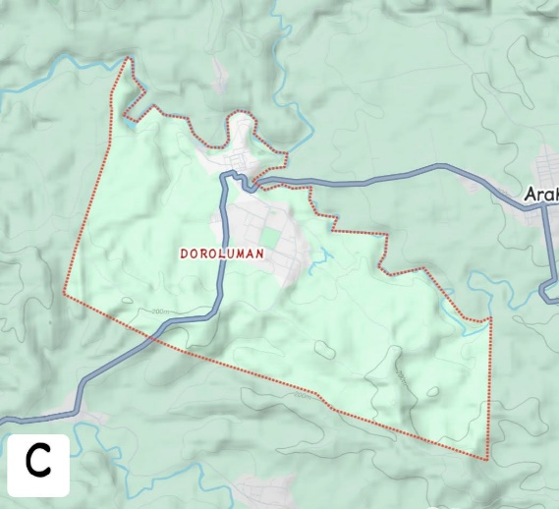

Figure 1. Location map of Barangay Doroluman. A. Map of the Philippines, B. Map of Mindanao Island and C. Sampling routes in Barangay Doroluman, Arakan, Cotabato.

Morphological Identification of Expelled Intestinal Nematodes (Gross Observation)
Expelled intestinal nematodes were collected after deworming and examined based on gross morphological characteristics, including shape and color. Species identification was conducted using standard diagnostic features consistent with the descriptions provided by the European Scientific Counsel Companion Animal Parasites (ESCCAP) and the Companion Animal Parasites Council (CAPC) guidelines.

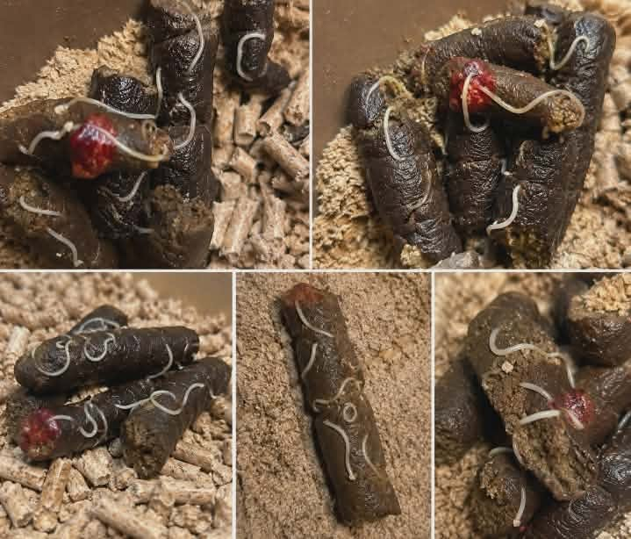
Figure 2. Gross morphology of expelled intestinal nematode Toxocara cati spp (roundworm)

Description: The image shows long, cylindrical worm with a whitish to cream coloration. It has tapered ends on a smooth body surface. The specimen was observed and identified based on CAPC guidelines.

Figure 3. Gross morphology of expelled intestinal nematode Ancylostoma spp. (hookworm) recovered from a domestic cat after deworming.
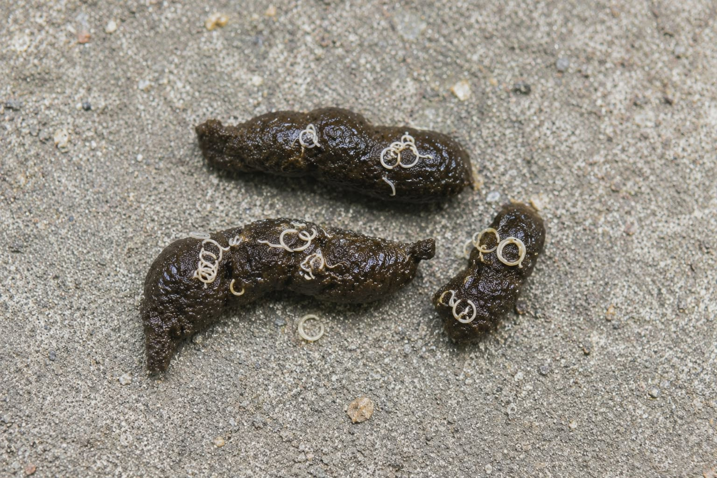

Description: The worms appear as a small, slender nematode with a slightly curved anterior region forming a hook-like shape. The body is comparatively thin and may exhibit a pale to reddish discoloration. The specimen is observed and identified based on CAPC guidelines.

Figure 4. Gross morphology of expelled Toxascaris leonine recovered from a domestic cat after deworming.
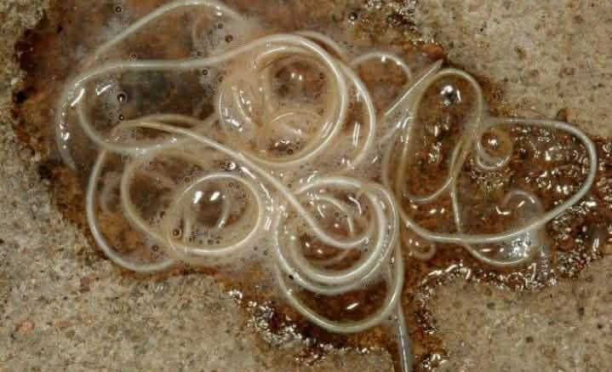

Description: The worms appear as a cylindrical, smooth and uniformly structured body with cream coloration. It is less robust than Toxocara cati and exhibits less pronounced anterior morphological features. The specimen is observed and identified based on ESCCAP guidelines.

Prevalence of Intestinal Nematodes in Selected Households Domestic Cats
Out of the 10 selected domestic cats examined, 8 were observed to have expelled intestinal worms after deworming. The computed prevalence of intestinal nematode infection among the selected domestic cats is 80%, indicating that a high proportion of the sampled cats were infected.

$$Prevalence \left(\%\right)=\frac{Number of infected cats}{Total number pf cats examined} x 100$$

$$Prevalence \left(\%\right)=\frac{8}{10} x 100$$

$$Prevalence \left(\%\right)=80\%$$

CAT ID | DEWORMED | PARASITE FOUND | RESULT
Cat 1 | Yes | Roundworm (Toxocara cati spp.) | Positive
Cat 2 | Yes | Roundworm (Toxocara cati spp.) | Positive
Cat 3 | Yes | None | Negative
Cat 4 | Yes | Ascarid (Toxascaris leonine spp.) | Positive
Cat 5 | Yes | Roundworm (Toxocara cati spp.) | Positive
Cat 6 | Yes | Hookworm (Ancylostoma spp.) | Positive
Cat 7 | Yes | None | Negative
Cat 8 | Yes | Hookworm (Ancylostoma spp.) | Positive
Cat 9 | Yes | Roundworm (Toxocara cati spp.) | Positive
Cat 10 | Yes | Roundworm (Toxocara cati spp.) | Positive
Table 1. Summary of the deworming status, parasite identified, and test results of the domestic cats (Felis catus) included in the study. The table presents the Cat ID, deworming status, parasite detected, and corresponding result (positive or negative) for each sampled cat.

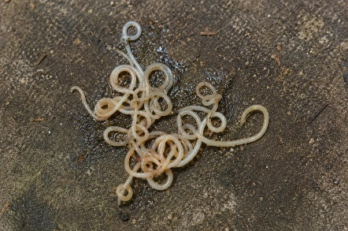
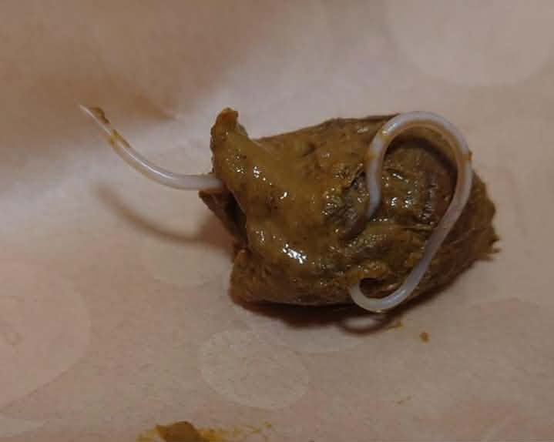
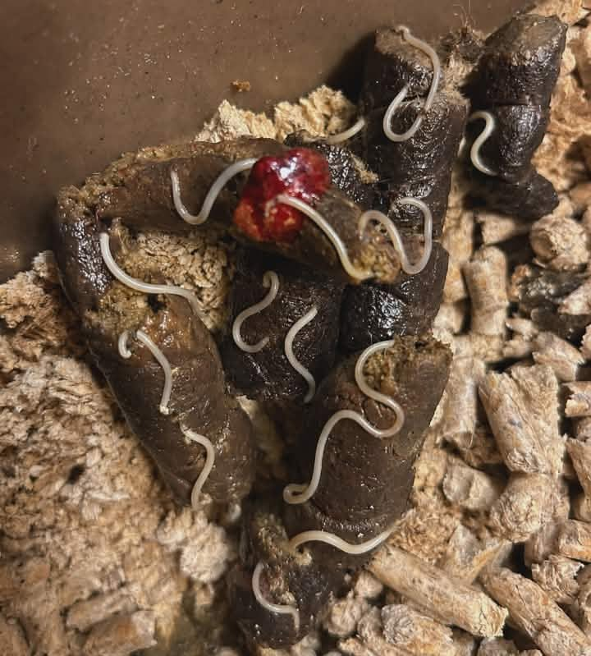

C
B
A
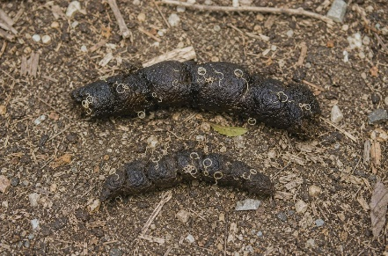
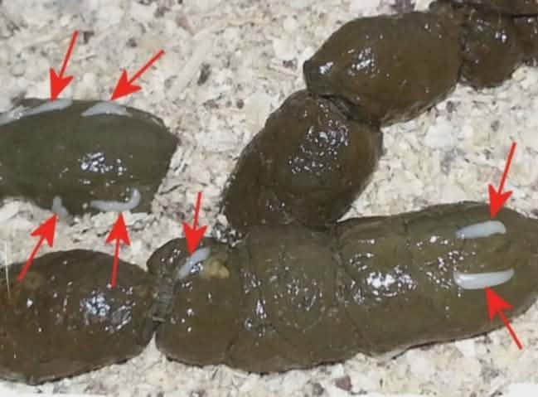
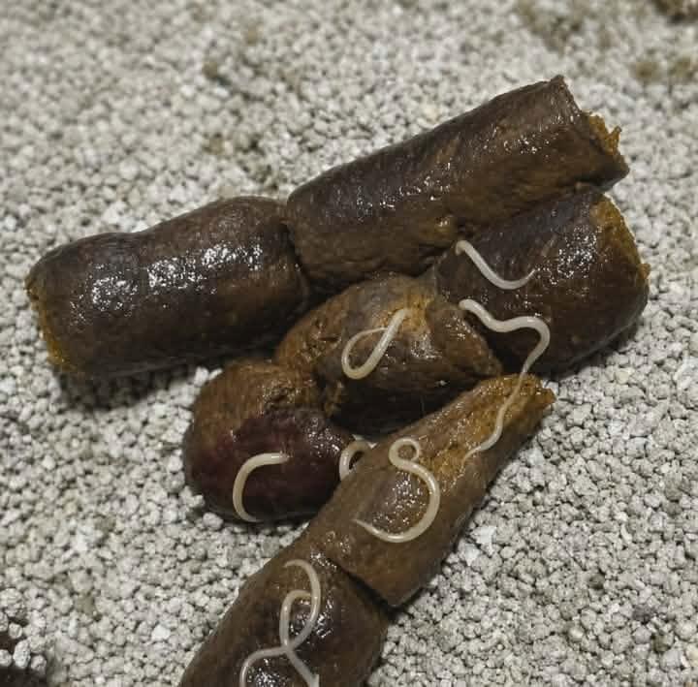

F
E
D
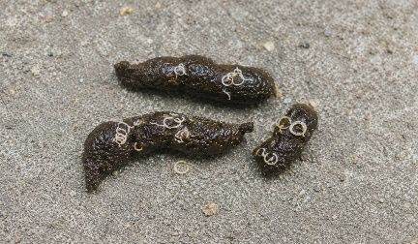

G
H

Figure 5. Composite image of eight (8) expelled nematodes collected from domestic cats after deworming. A. Toxocara cati spp. B. Toxocara cati spp. C. Toxocara cati spp. D. Toxocara cati spp. E. Toxocara cati spp. F. Ancylostoma spp. G. Ancylostoma spp. H. Toxascaris leonine spp.

Roundworms are among the most frequently encountered intestinal parasites in cats and are commonly transmitted through ingestion of infective eggs, contaminated food, or infected prey. Cats that roam freely outdoors are more likely to be exposed to these parasites. The use of household deworming observation provided a practical and inexpensive approach for detecting possible infections. However, this method has limitations because the absence of expelled worms does not necessarily indicate the absence of infection. Laboratory fecal examination would provide a more accurate diagnosis of intestinal parasites.
Despite these limitations, the study demonstrates the importance of routine deworming and monitoring of domestic cats to reduce parasite burden and promote animal health.

Conclusion and Recommendation
Based on the findings of the study, it was concluded that intestinal nematode infection is prevalent among domestic cats from the selected households in Doroluman, Arakan, Cotabato. Out of the ten (10) domestic cats included in the study, eight (8) were observed to have expelled roundworms following household deworming using Piperazine Dihydrochloride (Pidro Powder), resulting in a prevalence rate of 80%. The findings indicate that intestinal nematode infection is common among domestic cats in the study area and emphasize the importance of routine parasite monitoring and deworming practices.
In light of these findings, it is recommended that cat owners implement regular deworming schedules and maintain proper sanitation practices to reduce the risk of parasite transmission. Future studies may involve a larger sample size and include multiple households within Doroluman, Arakan, Cotabato to provide a broader assessment of intestinal nematode prevalence. Furthermore, laboratory fecal examinations are recommended to accurately identify the species of intestinal nematodes present and to validate the findings obtained through household deworming observation.

REFERENCES

Adhikari, R. B., Dhakal, M. A., Ale, P. B., Regmi, G. R., & Ghimire, T. R. (2022). Survey on the prevalence of intestinal parasites in domestic cats (Felis catus Linnaeus, 1758) in central Nepal. Veterinary Medicine and Science, 9(2), 559–571. https://onlinelibrary.wiley.com/doi/10.1002/vms3.999

Bărbuceanu, F., et al. (2021). Toxocara cati and other parasitic enteropathogens in cats. https://doi.org/10.3390/pathogens10020198
Chalkowski, K., et al. (2019). Risk of parasitic infection in indoor versus outdoor domestic cats. https://doi.org/10.1098/rsbl.2018.0840
Council, C. a. P. (2025, April 24). Hookworms. Companion Animal Parasite Council. https://capcvet.org/guidelines/hookworms/
Esccap. (n.d.-c). ESCCAP publishes 7th edition of Guideline 01: Worm Control in Dogs and Cats | News | ESCCAP. ESCCAP. https://www.esccap.org/n/ESCCAP+Publishes+7th+Edition+of+Guideline+01+Worm+Control+in+Dogs+and+Cats/235/
Symeonidou, I., Gelasakis, A. I., Arsenopoulos, K., Angelou, A., Beugnet, F., & Papadopoulos, E. (2018). Feline gastrointestinal parasitism in Greece: emergent zoonotic species and associated risk factors. Parasites & Vectors, 11(1), 227. https://doi.org/10.1186/s13071-018-2812-x

