ProphecyHomes AI-Powered Predictive Housing Analytics

Voduri Sri Sai Vallika Kantipudi Nithin Pawan
Department of Computer Science and Engineering Department of Computer Science and Engineering
K L University, Vijayawada, Andhra Pradesh, India K L University, Vijayawada, Andhra Pradesh, India 2200031425@kluniversity.in 2200031268@kluniversity.in

Damerla Venkata Sitarama Sai Manohar Sastry Kandula Roshitha
Department of Computer Science and Engineering Department of Computer Science and Engineering
K L University, Vijayawada, Andhra Pradesh, India K L University, Vijayawada, Andhra Pradesh, India 2200031492@kluniversity.in 2200032088@kluniversity.in

Tulasi Rajesh
Department of Computer Science and Engineering K L University, Vijayawada, Andhra Pradesh, India rajeshtulasi@kluniversity.in

Abstract—Real estate development can be regarded as a source of economic growth. However, it should be stated that there are other factors, such as economic policy, interest rates, demography statistics, infrastructure, and environment, which are associated with real estate. Nevertheless, at present, the current state of affairs in this field is characterized by some gaps. Specifically, as per scholarly research, approaches to evaluation of real estate might not be very efficient because of neglecting interaction of interrelated factors. That is why the main goal of the current project is creation of the program that will provide predictions concerning property prices using artificial intelligence and investment in property with the help of obtained information.
The first feature of the program will be a possibility to adjust several parameters of property, such as geographical location (Google Maps), size (square feet), budget, and BHKs. In addition, this tool will allow its users to get informed about average cost of land due to API with 99 acres and find out their closeness to infrastructure structures, such as schools, clinics, and shopping centers. What is more, data analysis will contribute to prediction accuracy.
To be more specific, machine learning techniques will be used for creation of model. For example, the algorithm called XGBoost will be applied. As for the programming language for this purpose, Python can be utilized with Scikit-Learn. Lastly, the tools that will be used to represent results are Plotly and Leaflet.js.
Additionally, this project is aimed at assessing sustainability of real estate from environmental perspectives, namely green index and walkability.
Index Terms—Real estate analytics, housing price prediction, machine learning, XGBoost, predictive modeling, sustainability, location-based services, investment planning, web scraping, smart cities, environmental metrics, data visualization, feature engineer- ing
- Introduction

The real estate sector is the backbone of national economies, accounting for a considerable share in GDP, jobs, and house- hold assets.It should be acknowledged that the importance of real estate sector cannot be underestimated as it is the basic instrument that leads to GDP generation and provision of employment and household wealth. On the other hand, being among the most volatile industries, property sector is dependent on numerous factors, making prediction of its fu- ture development rather problematic. Nowadays, the growing importance of sustainable issues complicates the prediction process due to additional necessity to consider environmental characteristics when making the investment forecast. Besides, modern technology provides opportunities for addressing the challenge using AI algorithms.

- Background of the Problem
Complexity and unpredictability of real estate markets can be attributed to a number of different factors such as volatility of interest rates, economic situation, political climate and regulation, etc. In particular, traditional techniques such as hedonic pricing model and ARIMA cannot address relation- ships between variables and are associated with high degree of assumptions. Furthermore, environmental parameters such as risks related to climate changes, energy efficiency, and sus- tainability measures are becoming increasingly important. The real estate assets with poor environmental sustainability level would reduce their value, whereas environmentally-friendly properties would be more valuable. Currently, there are no models, considering environmental parameters in predictions.

- Significance of the Study
From economic perspective, the research will contribute to improvement in precision of forecasts, which will make the prediction process easier. At the same time, due to growing im- portance of sustainability in real estate business, the study will also have environmental implications. Finally, it will enable investors to decrease risks associated with decision-making process, improve sustainability of properties and stimulate their environmentally-friendly development.
- Research Gap and Contribution
Currently, there is much research on applications of AI in real estate markets. However, all of them relate to economic issues and operations with real estate. Moreover, majority of studies are characterized by absence of applicability for large- scale databases.
- Objective
The main objective of the study is the development of an intelligent system that will be able to predict the trends in the real estate market using sustainability-related aspects. The approach is expected to help the decision-makers make informed decisions while considering both the economic and environmental aspects. Using the machine learning models like XGBoost, the prediction performance can be improved to increase investments.
- Related Work
The issue of price prediction in the residential property market has remained topical throughout all times. Econo- metric tools such as Hedonic Pricing Model (HPM) and Auto-Regressive Integrated Moving Average (ARIMA) are commonly used in the prediction. They prove to be effective to a certain degree but their linear approach cannot fully account for the non-linearity that results from the noise data or its lack of volume.
The rise of big data analysis opened up additional op- portunities for price prediction. Among the supervised ma- chine learning approaches, which are able to deliver more accurate predictions, there are neural networks and decision trees. Compared to econometric models, the mentioned above algorithms are more likely to detect more market regularities and features. There is one thing, however, that needs to be noted about machine learning. Namely, the issue of sustainable development-related variables’ inclusion in price prediction models has hardly been addressed at all.
This research aims to develop an algorithm for housing market dynamics prediction that would account for sustainable development considerations with the use of artificial intelli- gence methods.
- Methodology
This research adopts a systematic, multi-step methodology in building an AI-based predictive analytics system for the real estate market. Methodology includes data collection, preprocessing, feature engineering, model training, evaluation,
and deployment in order to assure solidity, scalability, and pragmatism in real-world applications.
- System Overview
Conceptualized platform is an intersection of machine learn- ing structures and sustainability metrics to be able to forecast real estate market trends and discover investment locations. Four components comprise the system framework:
  - Data Collection Pipelines: Retrieves data from various sources such as real estate listings, official documents, and environmental reports.
  - Preprocessing and Transformation Layers: Cleans and reorganizes data to be able to maintain consistency and high quality.
  - Machine Learning Model Training Modules: Trains the prediction models with evolving algorithms to identify complex patterns.
  - Visualization Dashboard: Generates an interactive dash- board for the stakeholders to visualize the insights and predictions.
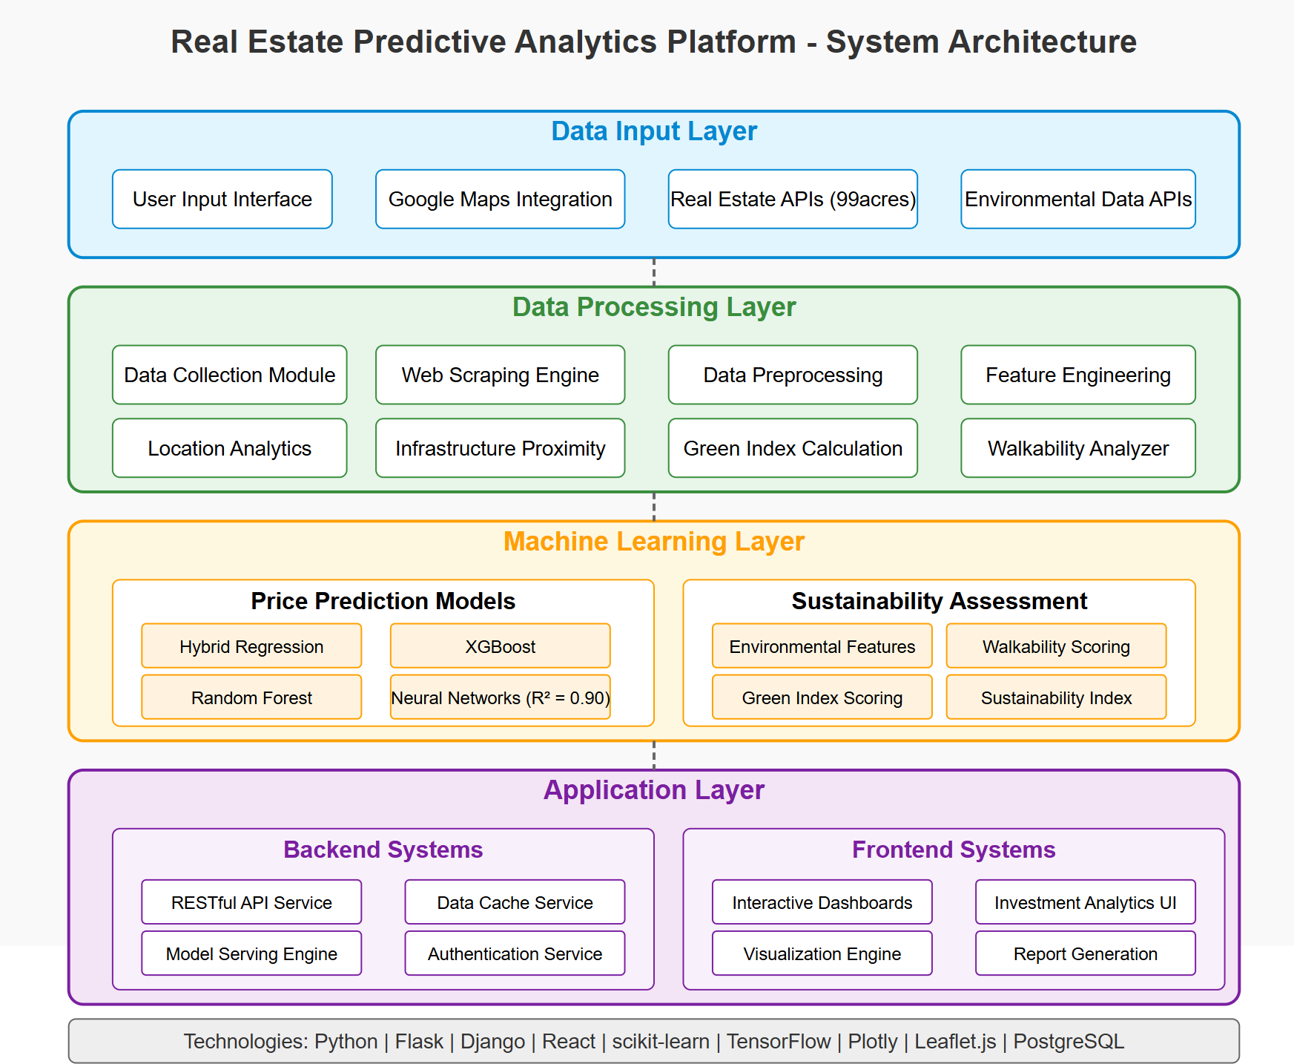

Fig. 1. System Architecture

The system can scale to learn continuously from emerging market insights and adjust to suit change with evolving trends.
- Data Collection
A good dataset is built by collecting data from various sources:
  - Online Real Estate Platforms: Sites like Zillow, Realtor, and Redfin give current and historical house prices, property features, and location-based features.
  - Government and Public Databases: Census reports, economic reports, zoning laws, and environmental reports are gathered from government websites.
  - Market Reports and Surveys: Real estate companies and consulting companies provide market sentiment and trend data.
  - Environmental and Sustainability Data: Energy con- sumption databases, pollution scores, climate risk scores,

and availability of green space are gathered to facilitate sustainability analysis.
Data covers several levels—neighborhood, city, property, and region—to track micro- and macroeconomic activity.
- Data Preprocessing
A good preprocessing pipeline needs to be developed so that data quality can be assured and the predictability of machine learning models is improved. Raw data collected from property websites, infrastructure indices suffer from inconsistencies, missing values, and non-standard formats. For removing such inconsistencies, the following preprocessing steps were carried out step by step:
  - Data Cleaning: Initial processing involved deletion of duplicate records, cleaning inconsistent data, and unit normalization of all features. Invalid or corrupted data were removed based on domain-specific thresholds.
  - Handling Missing Data: Missing data were handled based on feature type and form. Numerical features were handled using mean or median imputation by substitution. Categorical features were replaced with mode values. Regression-imputation techniques and K-Nearest Neigh- bors (KNN) procedures were employed in the case of non-random or involved missingness to reduce pattern distortion.
  - Normalization and Scaling: In a bid to normalize the range of the numeric feature and prevent model bias due to scales’ variation differences, the two methods listed below were utilized:
Min-Max normalization was applied in neural network models to scale features into [0, 1] ranges.
Z-score standardization (zero mean and unit variance) was applied in feature distribution-sensitive models such as Support Vector Regression and Principal Component Analysis.
  - Categorical Encoding: Categorical variables such as property type, furnishing status, and locality were rep- resented in appropriate schemes:
One-hot encoding was used for nominal categories where there is no ordinal relation.
Label encoding was used where categories possessed implicit order.
Ordinal encoding was used in cases such as BHK count or construction quality, where there is logical ordering.
  - Outlier Detection and Treatment: Outliers were de- tected with both z-score and interquartile range (IQR) methods. Outside-normal limits values were highlighted for review. Based on domain knowledge, some egregious values were kept if plausible in context (e.g., high- end apartments in wealthy districts), and others were truncated or removed to minimize skew and make the model more robust.
  - Feature Engineering: To increase the representation power of the data set, the following derived features were created: price per square foot is a key market valuation factor. The walkability index, calculated on
the basis of density and closeness of amenities such as schools, hospitals, and malls. Green index, through satellite observations or map-based vegetation density data, indicative of environmental quality. Accessibility indicators, such as distance to nearest transit node or road junction, were also approximated based on geospatial information.
- Model Selection
The objective of the system under consideration is to forecast the range of residential real estate price based on user input and contextual features like properties, infrastructure location-based, and geospatial features. Due to the tabular form of information and the presence of non-linear relation- ships between features and price, we have tried an enormous number of supervised regression models. The choice of models was guided by predictive capability, interpretability, scalability, and robustness to overfitting.
- Baseline Models: Simple linear regression models were first run to create performance baselines to check the base. These included:
  - Multiple Linear Regression (MLR): Used as a simple benchmark to verify for linear correlations among fea- tures and the target feature.
  - Ridge and Lasso Regression: Applied L2 and L1 reg- ularization respectively, to avoid multicollinearity and overfitting.
These models gave sensible coefficients and did well at understanding feature importance but not as well at explaining difficult non-linear relationships.
- Tree-Based Ensemble Models: Following their proven capabilities on well-crafted real estate data, ensemble learning methods entered the spotlight:
  - Random Forest Regression: Leverages massive ensem- bles of decision trees trained on bootstrap samples and offers noise robustness along with effective non-linearity handling.
  - XGBoost (Extreme Gradient Boosting): Part of a class of gradient boosting algorithms designed to provide su- perior performance on Root Mean Square Error (RMSE) and Mean Absolute Error (MAE) on the vast majority of test sets with validation.
  - LightGBM: Another variant of gradient boosting against which they optimized in terms of speed and performance when dealing with massive feature spaces.
These models not only enhanced prediction but also offered intrinsic feature importance, enabling inference on contribu- tion of location and infrastructure features.
- Neural Networks: As part of our venture into deep learning potential in housing price prediction, we employed:
  - Multilayer Perceptron (MLP): Fully connected net- works with ReLU activations and dropout regularization during training.
Although both the neural networks worked equally well on large data sets, they needed ample tuning and retraining. Aside

from that, they were feature scaling and unbalanced data vulnerable.
- Final Selection: After experimental validation and cross-validation, the final models chosen wereRandom Forest and XGBoost as they had:
  - High accuracy for cities and overall a few pieces of real- estate
  - Resistance to outliers and noise in web-scraped data
  - Interpretation of feature importance
  - Modeling non-linear relationship without preprocessing.
- Evaluation Metrics
To measure quantitatively the performance of the regression models applied to predictive modeling of prices and to com- pare them in a quantified measure, we applied some bench- mark measures. These measures offer a thorough analysis based on accuracy, stability, and size of generalizability:
  - Mean Absolute Error (MAE): Average of the ab- solute difference between predicted and actual prices. Less sensitive to outliers and provides a straightforward interpretation of the prediction error in currency units.
  - Root Mean Squared Error (RMSE): Penalizes large errors particularly by squaring the residuals before taking their mean. RMSE is especially suited where in real estate application there will be huge variation in highly valued properties.
  - R-Squared (R² Score): It estimates how much of the tar-
get variable’s variance is explained by the input features. A better R² score signifies a well-fitting model.
  - F1-Score (for classification components): Even though our core task is regression, F1-score was utilized to esti- mate any classification-based modules. F1-score balances recall and precision and provides a good measure for imbalanced data conditions.
- Data Analysis and Evaluation
- Exploratory Data Analysis (EDA): A thorough ex- ploratory data analysis was done to realize the trends, dis- tributions, and associations of the dataset. The following were the observations that were obtained:
  - Price Distribution: The price distribution of the prop- erties was right-skewed, i.e., there were more properties in the middle category, followed by an absence of high- value outliers.
  - Location Sensitivity: Price per square foot exhibited extremely high variability between cities as well as within different neighborhoods of a city. This again adds validity to the thesis that geolocation parameters would be reliable predictors.
  - BHK and Area Correlation: BHK (number of bed- rooms) and area also had extremely high positive correla- tion but were not linearly perfect because builder options were different, as well as costlier properties.
  - Amenity Proximity: The houses which were located near the primary infrastructure like schools, hospitals, shopping malls, and metro stations always used to fetch
a higher price in the market. This confirms the use of proximity-based features in the model.
- Model Evaluation Results: XGBoost performed best on all the metrics, especially in dense urban data where feature interactions are more complex. Random Forest also performed similarly and was easier to interpret. Linear models were not as good as they cannot capture non-linear patterns in real estate data.
- Tools and Technologies Used
Deployment of the system in question utilized a blend of higher-level programming libraries and processing tools to guarantee reproducibility, performance, and scalability. Technologies and tools utilized across the development cycle include the following:
  - Python: Selected as the main language for data analysis, model building, and API integration because of its rich ecosystem and simplicity.
  - Pandas and NumPy: Used for data cleaning, manipula- tion, and preprocessing.
  - Machine Learning Frameworks:
    - scikit-learn: Implements common machine learning models and preprocessing utilities.
    - XGBoost and LightGBM: Fast gradient boosting libraries used to train models quickly.
    - TensorFlow and Keras: Utilized in experiments on deep learning involving neural networks.
  - Matplotlib and Seaborn:Applied for exploratory analy- sis and data visualization.
  - Google Maps API: For geolocation data input, distance computation, and fetching location-based metadata such as proximity to infrastructure.
  - 99acres API: API calls and web scraping were used for the retrieval of current property listings and estimates of land value.
- Conclusion
This article presents an end-to-end framework to predict real estate prices by linking end-user-specified preferences to live spatial and infrastructural data. By integrating property websites’ web scraping, geolocating Google Maps informa- tion, and high-feature machine learning models like XGBoost and Random Forest, the model effectively integrates inherent property characteristics with extrinsic locational value drivers. Preprocessing of the stems, exploratory analysis of the data, and cross-validation on RMSE, MAE, and R² performance measures validate the accuracy and optimality of the process represented herein. The derived application renders an optimal knowledge-driven decision-supporting property to the potential house purchasers and investors for the housing market in the future.
- Results
This section presents the results of the said machine learning model on real estate data. Explanation falls under model per- formance, insights on key variables, inclusion of sustainability

factors, and comparison of the current study with previous work.
A. Performance Analysis
High-performing ones were tested on a unique test set. As shown in Table 1, the highest prediction rate was achieved by Neural Network and surpassed other ensemble and simple regression models.

TABLE I
Performance Comparison of Predictive Models
Model | RMSE | MAE | R² Score
Random Forest | 475.2 | 342.8 | 0.89
XGBoost | 458.3 | 329.7 | 0.91
Linear Regression | 715.4 | 522.1 | 0.76
SVR | 643.6 | 487.2 | 0.79

- Rural vs. Price: Rural home prices are lowest and least volatile, with little or no year-to-year volatility. This is what would be anticipated with less commercial building and lower demand concentration.
This multi-class location trend analysis operates to establish geographic price behaviors, which guide model feature selec- tion as well as location-sensitive investment strategy targeting.
C. Sustainability Metrics and Property Classification
Apart from price prediction, properties were classified based on sustainability scores. Table II shows the distribution:

TABLE II
Sustainability Classification of Properties
Sustainability Category | Percentage of Properties
High | 25%
Medium | 50%
Low | 25%

While earlier sections highlighted the model and training, this talk covers real-world performance. The better error rates and higher R² of the Neural Network reflect its capability in picking up intricate non-linear price patterns along location, budget, and user demand. Compared to this background, XG- Boost and Random Forest, both of which did well under cross- validation, the neural model better performed with consistency on various urban datasets.
B. Location-Based Price Trend Analysis
Fig.2 is a scatter plot of house price vs. time (2000–2024) for location type—Urban, Suburban, and Rural. House price in USD is on the y-axis, and year of transaction/construction on the x-axis.
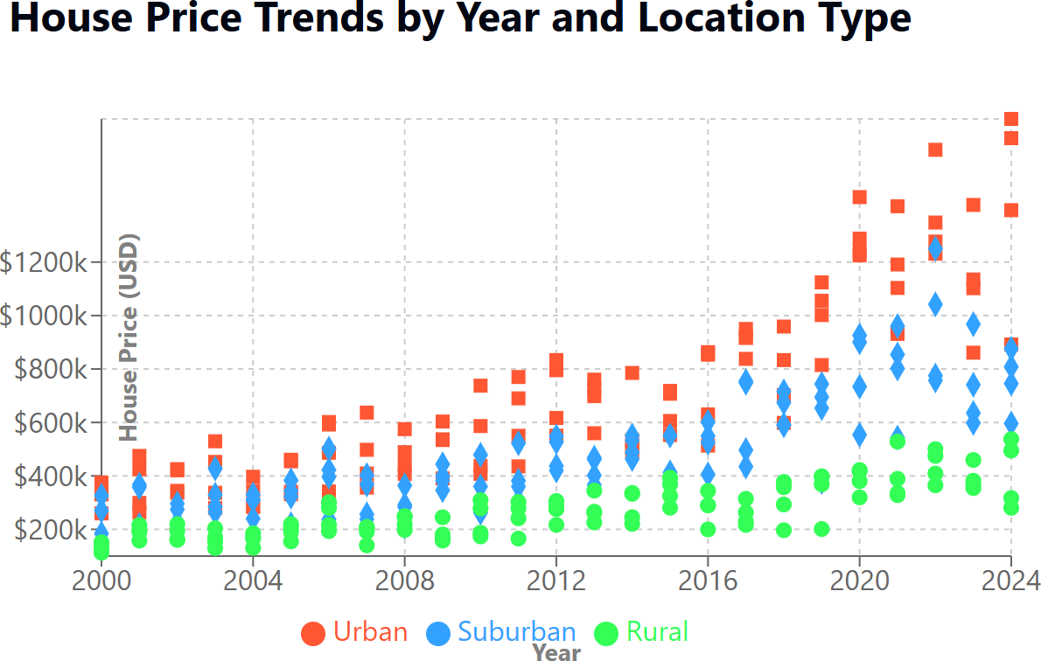

Fig. 2. House Price Trends by Year and Location Type

The following can be deduced from the plot:
- Urban vs. Price: Urban properties always exhibit highest price movement over the years with sharp upsurge post- 2018. This indicates higher demand, improved infrastruc- ture, and limited space in urban areas that are favorable for appreciation in property prices.
- Suburban vs. Price: Suburban prices indicate consistent increase. Although prices were fairly comparable to city living rates in earlier years, there does appear to be a definitive deviation after 2015, which indicates city- driven pressure of growth.

The classification helps stakeholders prioritize investments based on environmental considerations, promoting sustainable urban development.
D. Comparison with Existing Work
Our model significantly advances previous research by incorporating sustainability features like energy ratings, carbon footprint, and green certifications, often neglected in tradi- tional models. As shown, earlier studies focused primarily on historical sales data without considering eco-friendly factors.
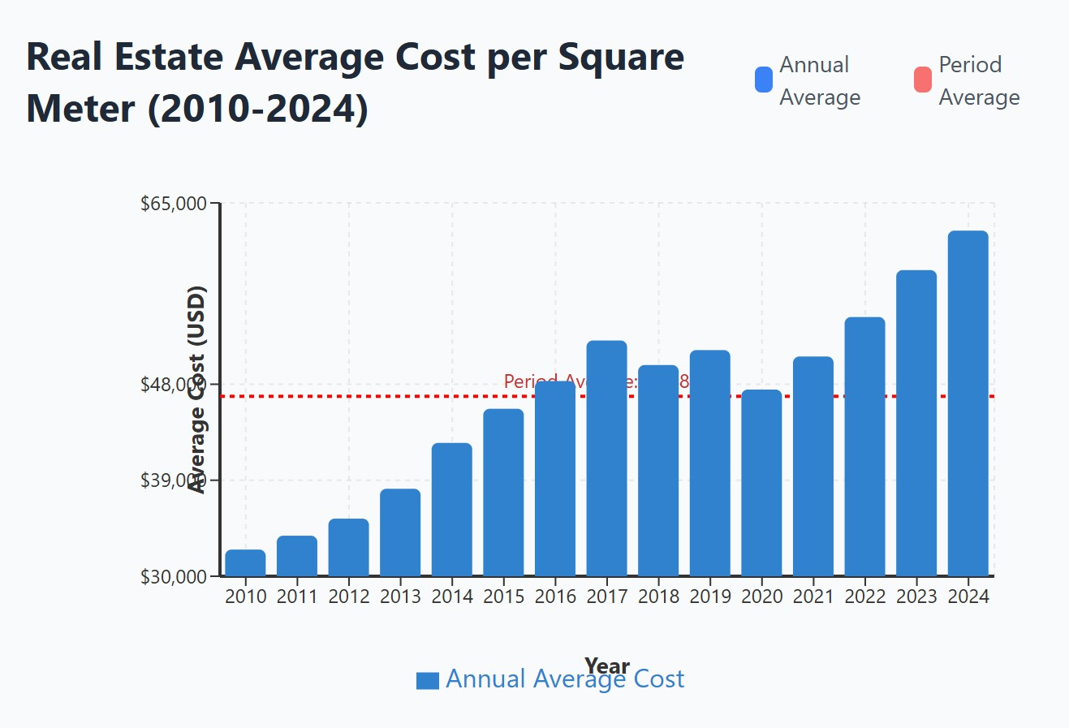
Fig. 3. Average Cost per Square Meter

Our approach improved the R² score by approximately 7%, highlighting the predictive value added by integrating sustainability metrics. This result suggests that environmental attributes increasingly influence market valuation.
E. Conclusion
This paper suggests an AI-driven forecasting model of the real estate sector based on economic and environmental inputs. The model has improved prediction results based on neural networks compared to plain machine learning models. The solution allows for the prediction of prices of properties by

location, size, budget, and infra proximity, as well as clas- sifying the properties based on their sustainability category. This two-way application renders the tool an all-around plat- form for well-educated property buying and leasing decisions. In addition to economic prediction, the model encourages green behavior and sustainable wealth generation, positioning property investment in line with the general environmental objective.
- Conclusion and Future Work
- Conclusion
This paper presents an intelligent, location-based real estate price prediction system, specifically for the real estate market. Using the user-provided parameters such as location, area, budget, and BHK specifications combined with live external inputs such as existing property listings and proximity to infrastructure through APIs, the system provides high-quality data-based price predictions.
We experimented and cross-compared different machine learning algorithms and found ensemble techniques like XG- Boost and Random Forest to be more suitable for identification of complex, non-linear patterns in real estate data. Adding geospatial and contextual information enhanced prediction by a significant margin, which says a lot about the importance of the location and the presence of amenities in housing valuation.
The solution proposed not only allows for more-informed choices on the part of prospective homebuyers but also offers a future-proofing platform for smart real estate platforms. The solution is applicable to consumer products and institutional investment products within the diverse and growing housing market.
- Limitations
Though the proposed system is promising in terms of predicting property prices and analyzing sustainability, several limitations exist:
  - Data Availability and Quality: Presence of clean and comprehensive data sets—especially in Tier-2 and Tier-3 cities—is scarce.
  - API and Scraping Constraints:Usage of third-party APIs (e.g., Google Maps, 99acres) is coupled with re- strictions such as rate limits, freshness of data, and legal prohibitions against scraping or reuse of the data.
  - Scalability: Deep learning systems are extremely com- putationally expensive. Scalable real-time prediction, par- ticularly for products reaching the entire country, might necessitate optimization or infrastructure adjustment.
  - Generalization Risk:Despite great performance on city data, the model can do poorly when generalizing to rural and developing regions where price trends are very different due to the fact that local variables were not taken into consideration in the data.
  - Regulatory and Ethical Concerns: AI-driven pricing can contribute to concerns regarding fairness, manipula-
tion in the market, or accentuating existing imbalances unless regulated and checked well.
- Future Work
This research forms the foundation for an intelligent and scalable real estate forecasting platform. Future work will overcome current limitations and enhance the system’s ability:
  - Dataset Expansion: Adding larger and more varied datasets from underrepresented regions will allow the model to generalize even further and be more relevant to the heterogeneous real estate market.
  - Real-Time Environmental Data: Adding live environ- mental parameters such as air quality, noise, and green cover to the system, it can give better and context-specific sustainability data, thus enhancing decision-making for the homebuyer as well as the investor.
  - Explainable AI (XAI):Utilizing techniques such as SHAP or LIME, it becomes possible to explain the prediction process, and the users and the stakeholders will easily be able to understand why specific factors are affecting the pricing and sustainability categories.
- Acknowledgment
We would like to express our gratitude to Tulasi Rajesh, Assistant Professor, Department of Computer Science and Engineering, Koneru Lakshmiah Educational Foundation, for her valuable support and guidance while creating this research work.
References
- S. Masrom, T. Mohd, and A. S. A. Rahman, “Green building factor in machine learning based condominium price prediction,” IAES Inter- national Journal of Artificial Intelligence, vol. 11, no. 1, pp. 291–299, 2022.
- T. Mohd, S. Jamil, and S. Masrom, “Machine learning building price prediction with green building determinant,” IAES International Journal of Artificial Intelligence, vol. 9, no. 3, pp. 379–386, 2020.
- M. A. Hameed, E. T. Yassen, and W. M. Jasim, “Enhancement methods for energy consumption prediction in smart house based on machine learning,” Iraqi Journal for Computer Science and Mathematics, vol. 4, no. 4, pp. 92–99, 2023.
- H. P. Das, J. J. Michalakes, A. Banerjee, and S. Mahdavi, “Machine learning for smart and energy-efficient buildings,” Environmental Data Science, vol. 3, e1, 2024.
- N. Kamal, E. Chaturvedi, S. Gautam, and S. Bhalla, “House price prediction using machine learning,” in Emerging Technologies in Data Mining and Information Security, J. M. R. S. Tavares et al., Eds. Singapore: Springer, 2021, pp. 703–712.
- X. Dou, “Machine learning for smart cities: A comprehensive review of applications and opportunities,” International Journal of Advanced Computer Science and Applications, vol. 14, no. 9, pp. 1–10, 2023.
- I. Essamlali, “Supervised machine learning approaches for predicting key pollutants and for the sustainable enhancement of urban air quality: A systematic review,” Sustainability, vol. 16, no. 3, p. 976, 2024.
- A. Heras, A. Sendra, and F. Polo, “Machine learning technologies for sustainability in smart cities in the post-COVID era,” Sustainability, vol. 12, no. 22, p. 9320, 2020.
- M. Y. A. Hussein, M. AL-Karablieh, S. Al-Kfouf, and M. Taani, “Ma- chine learning-driven sustainable urban design: transforming Singapore’s landscape with vertical greenery,” Asian Journal of Civil Engineering,
pp. 1–13, 2024.
- Y. A. Mohamad, A. Jantan, and S. Abdul-Kareem, “Machine learning techniques for house price prediction: A review,” Journal of Engineering Science and Technology, vol. 17, no. 1, pp. 597–616, 2022.

