Assessing Housing Quality and Its Impact on Public Health in Rural-Urban Area of Idah Town, Nigeria

Joy Oyiza Obadoba, Centre for Housing and Sustainable Development, University of Lagos joycebenet@gmail.com ORCID ID: 0000-0002-1864-8038 (Corresponding Author)

Abstract:
This paper investigates the state of housing quality and its associated health impacts in the rural-urban region of Idah, Nigeria. Employing a descriptive cross-sectional approach, data were collected from a systematically sampled group of three hundred and fifty households using structured questionnaires. The collected data were subjected to descriptive analysis using statistical tools commonly employed in social science research. The findings reveal a worrying picture of housing and health conditions in Idah. Regarding public health impacts, the study found alarming health challenges among residents. The prevalence of typhoid and malaria cases was notably high, affecting 43% of the surveyed population. Additionally, cases of diarrhoea, malaria only, and undiagnosed illness (which refer to conditions where individuals experience sickness symptoms but do not seek medical testing or hospital care) were reported by 17%, 12%, and 11% of respondents, respectively. However, 62% of respondents lived in rooms that had only one window. Among these, only 23% had windows on both room walls, limiting ventilation and natural light. Furthermore, overcrowding was identified as a critical issue, with 38% of households accommodating more than four individuals in a single room. A significant proportion of the surveyed residents (69%) lacked access to a portable water source. In conclusion, this study underscores the grim reality of poor housing quality in Idah and highlights its significant association with various health issues experienced by the local population. These findings emphasise the urgent need for comprehensive interventions to improve housing conditions and, by extension, public health in the region. The study's implications extend beyond Idah and serve as a valuable reference for policymakers, researchers, international organisations and non-governmental organisations working towards enhancing housing quality and overall well-being in rural and sub-rural areas of emerging nations.
Keywords: Housing quality, home, rural-urban area, Idah, and public health

1 Introduction
Think about your home. It's not just a place; it's where you live, breathe, and spend most of your time. Now, imagine if your home were a source of worry for your health. This is a reality for many people around the world, including in Nigeria.
Scientists have been working extensively on the link between the quality of homes and health (Krieger & Higgins, 2002). It's not just a theory; evidence supports it (Ruonavaara, 2018; Thomson & Thomas, 2015). In countries with well-developed economies, the focus has shifted from crumbling buildings to concerns about indoor air. This can affect our physical health and mental well-being (Spence, 2020).
In Nigeria, especially in rural areas, the story is different. Many people face housing challenges that put their health at risk. This includes insufficient space, proper ventilation, and living in unsanitary conditions. These problems can lead to serious health issues. A significant number of people in these areas don't even have access to clean water in their homes (Ogunkolu et al., 2021). They have to resort to less safe methods for waste disposal, which can spread diseases. Leaky roofs and broken infrastructure are typical, creating conditions that can make people sick (Ogunkolu et al., 2021).
Researchers globally have investigated this issue and found strong evidence that the quality of our homes is directly tied to our health (Krieger & Higgins, 2002; WHO, 2018; Murray et al., 2022). It makes sense if you think about it. We spend most of our time at home, and if our homes aren't safe and healthy, it can affect us in many ways (Payne, 2022).
Therefore, despite efforts to improve housing in Nigeria over the years, many people still live in poor conditions. This is especially true in rural areas, where people may not realise how poor housing can harm their health (Moore, 2019). That's why this study focuses on Idah, Nigeria. We want to understand how housing quality is connected to people's health here. By doing this, we hope to shed light on the issue and find ways to make homes safer and healthier. Our goal is to improve housing quality not just in Idah but also in similar places worldwide. According to international organisations and Nigerian housing policies, everyone deserves a safe and healthy place to call home (Moore, 2019).

2. The Study Area/Methodology
This research was conducted in Idah, a town in the Middlebelt of Nigeria, east of the river Niger, with a land area of 36.42 km² on Latitude 7° 6' 36" north and Longitude 6° 44' 3" east. Idah presents a rare combination of rural and urban characteristics hence ‘rural-urban’. It qualifies as an urban centre due to its population size and administrative functions, yet it also embodies rural life, driven by agriculture, particularly cashew farming and fishing. These activities shape distinct areas within Idah, each reflecting different aspects of its identity. Despite this separation, roads and residents create strong connections between these zones, weaving a unified community. The town's projected population is 107,500, with an annual population change of 1.9% and a population density of 2,952/km² as of 2022 (City Population, 2022). See figure 1.

Figure 1: Map Showing Idah Neighbourhoods
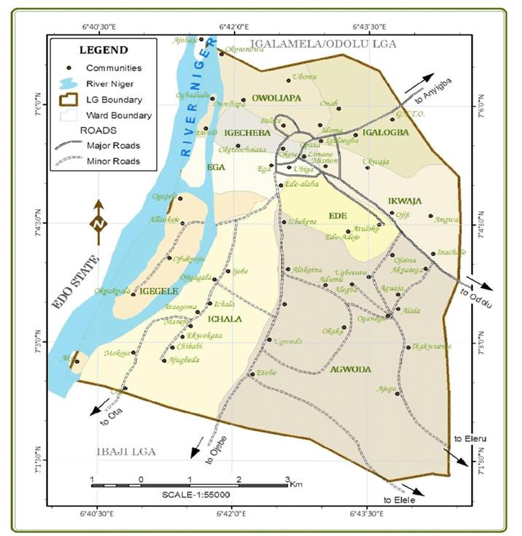
(Tokula, 2019)
To determine the appropriate sample size for this study, Slovin's formula for sample size determination was employed, with a specified error margin of 0.05 and a 95% significance level (Ellen, 2020)
n = N / (1 + Ne^2)
Where:
N = Population size.
n = Sample size.
e = Error margin.

The sampling process employed a simple random sampling technique, selecting five (5) out of the ten (10) political wards in Idah. Within these selected wards, seventy (70) respondents were sampled, resulting in a total sample size of three hundred and fifty participants. A systematic random sampling approach was used to select residential households within the chosen wards, with households selected at intervals of every fourth house.
Data for this study were collected through structured questionnaires administered to the systematically selected 350 households. The questionnaire, specifically designed for this research, aimed to gather information from the residents of Idah regarding housing quality and its health-related implications. Trained study assistants, consisting of final-year and regional planning higher diploma students, facilitated the distribution of survey instruments.
Descriptive analysis of the collected data was performed using the Statistical Tool for Social Sciences (version 20.0). The results were presented using visual representations, including pie charts and bar charts, to facilitate a clear understanding of the findings.
3. RESULTS
3.1. Adequacy of Ventilation
Table 1 reveals that all of the respondents, 100%, had windows in the room, out of which only 23% and 15% had two and three windows on two walls, respectively, for proper ventilation, while a high proportion, 62%, had only one window in the room. This was also common practice in some of the modern houses designed. Modern houses emphasise efficiency, aesthetics, and functionality to meet technological and environmental advances. The houses are constructed using suitable designs, proper ventilation, and durable materials like cement and blocks, unlike traditional homes built with mud and thatched roofs. These older-style houses are predominantly found in Ega, parts of Ofukolo, and the Apatega community. A majority of 69% also reported having a ceiling, 12% have fans in the room, while 19% have neither a ceiling nor a fan. 38% of the respondents reported living in a room with more than four people.

Table 1 shows the presence of windows in various houses.
Number of Windows in a Room | Frequency | Percentage %
One (one side of the wall) | 217 | 62
Two (both sides of the wall) | 81 | 23
Three (both sides of the wall) | 52 | 15
Total respondent | 350 | 100
Facilities in the room | Frequency | Percentage
The ceiling in the room | 242 | 69
Fan in the room | 42 | 12
Without fan | 67 | 19

Figure 2: Frequency of presence of windows and facilities in rooms in the study area.
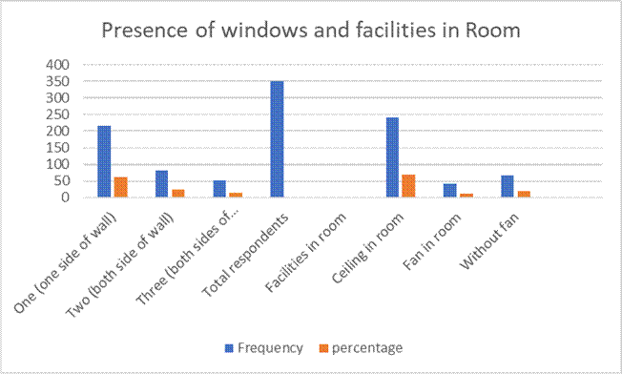
Table 2: Number of persons per habitable room
Number of persons per habitable room | frequency | % of respondents
One | 45 | 13
Two | 70 | 20
3-4 | 102 | 29
More than four people | 133 | 38
Total respondents | 350 | 100
Source: Author's work, 2023

Figure 3: Number of persons per habitable room
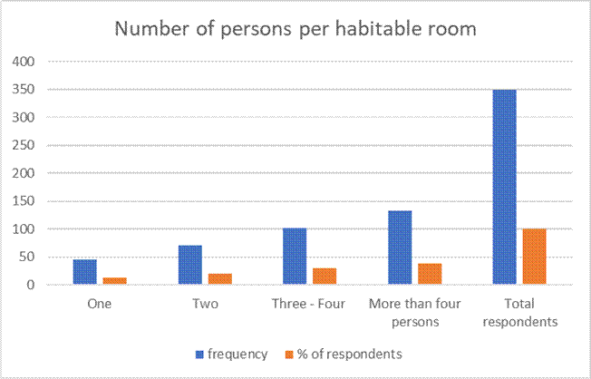

3.2 Housing Condition
In the pursuit of understanding housing conditions among 350 houses, we examined several key parameters related to the state of the houses using a checklist. The analysis demonstrates a mix of housing conditions among the surveyed respondents. While many respondents face challenges such as cracked walls, leaking roofs, and broken or unplastered floors, a notable proportion live in houses with habitable or excellent conditions. The following analysis presents the distribution of respondents across different housing conditions: See Figure 2.
Wall condition: The data reveals that a significant proportion (43%) of respondents reported cracked walls in their houses, indicating a worse housing condition. On the other hand, 25% of the respondents suggested that living conditions were fairly habitable, while 32% reported good conditions, especially in modern houses.
Plastered Walls: Regarding plastered walls, 38% of respondents reported worse conditions, 45% reported fairly habitable conditions, and 17% indicated good conditions with tiled walls. Plastered walls are in better condition compared to cracked walls.
Leaking Roof: The data regarding leaking roofs suggests that 42% of respondents face worse conditions due to roof leakage, while 35% reported fairly habitable conditions. A smaller proportion, 23%, indicated good conditions with tiled or well-maintained roofs.
Floor Condition: We also assessed the condition of the floors, finding that 38% of respondents reported worse conditions, characterised by broken or unplastered floors. Rubber carpets cover these floors, reducing room dust and simplifying sweeping. Additionally, 42% of the houses show fairly habitable conditions, and 20% reported good conditions with tiled or well-maintained floors, as shown in Figure 4.
Figure 4: Condition of houses in Idah
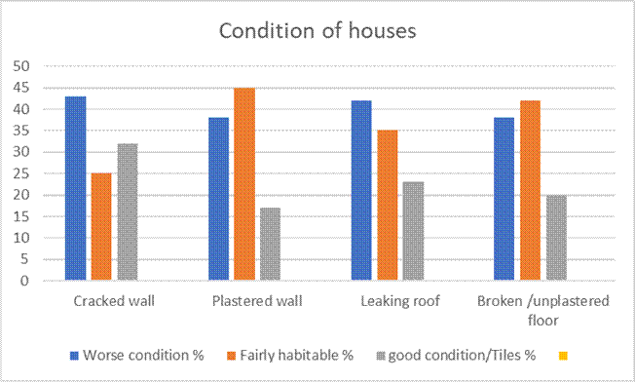
Source: Author's work, 2023
These findings highlight the need for targeted interventions to address housing-related challenges, particularly improving the living conditions of those facing worse housing conditions. Policies and initiatives to enhance housing quality and maintenance are essential so that more households can enjoy habitable and well-maintained living spaces.

3.2 Ventilation in rooms
We examined two crucial variables: the presence and number of windows in a room and specific facilities. Below, we provide a detailed analysis of these variables:
Presence of Window:
The data indicates that most respondents (62%) reported having a single window in their room, typically on one side of the wall. A significant proportion (23%) reported having two windows, evenly distributed on both sides of the room's walls. A smaller percentage (15%) mentioned having three windows on both sides of the room's walls. The presence and number of windows are crucial for room ventilation, with more windows generally contributing to better airflow.
Facilities in the Room:
Regarding the facilities within the room, a substantial majority (69%) of respondents reported having a ceiling in their room. Ceilings can play a pivotal role in room ventilation by helping to control temperature and airflow. In contrast, 12% of respondents mentioned having a fan in their room, which can further enhance ventilation and comfort. However, it is noteworthy that 19% of respondents reported not having a fan in their room. This lack of a fan may influence room ventilation, especially in regions with high temperatures or limited natural airflow.
The analysis highlights the variation in ventilation conditions among the surveyed respondents. While most respondents reported having at least one window in their room, the distribution of windows on one or both sides of the wall varied. Additionally, facilities such as ceilings and fans can significantly impact room ventilation and overall comfort.
Improving ventilation strategies is essential to ensure better indoor air quality and comfort, especially for rooms without fans or with limited windows. This analysis emphasises assessing and addressing ventilation conditions, which is key to ensuring healthy and comfortable living spaces. Further research and initiatives may be necessary to enhance room ventilation, particularly in sub-optimal conditions.
Table 3: Ventilation in rooms
Number of Windows in a Room | Frequency | Percentage %
One (one side of the wall) | 217 | 62
Two (both sides of the wall) | 81 | 23
Three (both sides of the wall) | 52 | 15
Total respondents | 350 | 100
Facilities in the room | Frequency | Percentage %
Ceiling in the room | 242 | 69
Fan in the room | 42 | 12
Without fan | 67 | 19
Source: Author's work, 2023

3.3 Analysis of Waste Disposal Methods, Drainage, Toilet Availability, and Water Sources among Respondents
This analysis examines several critical aspects of waste disposal methods, drainage conditions, toilet availability, and water sources among the surveyed respondents, as shown in Table 3.
Waste Disposal Methods:
The data reveals that 24% of respondents reported having a waste bin in their house to gather waste for disposal. In contrast, a significant majority (65.1%) resorted to open burning, and 38% utilised community refuse dump sites. Open burning can have adverse environmental and health implications due to releasing pollutants into the air. The prevalence of open burning indicates that it requires waste management and disposal education and infrastructure improvement.
Regarding drainage, a concerning 93.1% of respondents reported blocked drainage conditions in their neighbourhoods, signifying a significant problem with water flow management in the surveyed area. Additionally, 100% of the surveyed regions reported that all the drainage systems were open to the surface, which makes it easy for residents to misuse them. The study also observed open sewer lines running along the neighbourhoods. This suggests urgent attention to drainage systems to prevent flooding and improve overall sanitation.
The availability of toilets varied among respondents. Approximately 37.1% reported having water closets (WCs), while 49.1% mentioned using pit toilets. A small proportion (7.7%) resorted to open defecation, highlighting a sanitation issue that requires intervention. Additionally, 6.1% of respondents chose not to disclose their toilet availability status.

Source of Water:
The data indicate diverse sources of water among respondents. A small percentage (4%) mentioned obtaining water from wells. The study also observed that the wells were very deep, about 18–24 metres deep, while 31.2% relied on boreholes. Some respondents also buy water from the borehole owners as their source of drinking water. Additionally, 8.8% reported using river water, which can raise concerns about water quality and safety.
A significant majority (56%) sourced water from water vendors, while public taps are completely absent despite the presence of water works for public water supply. Upon inquiry, the study observed that the public water supply facility has not worked for more than 10 years. The staff of the facility corroborated this. Additionally, the diverse water sources suggest a reliance on multiple water supply options. Water quality and safety across these. Access to clean water sources is essential to prevent waterborne diseases. The absence of respondents using public taps indicates and affirms the issues with public water supply infrastructure.

Table 4 shows Waste Disposal Methods, Drainage, Toilet Availability, and Water Sources among Respondents
Waste Disposal Method | Available practice % | Nos of respondents | Not available % | Nos of respondents
Waste bin | 24 | 84 | 76 | 266
Open Burning | 65.1 | 228 | 34.9 | 122
Community refuse dump site | 38 | 133 | 62 | 217
Drainage
Blocked drainage | 93.1 | 298 | 6.9 | 22
Surface drainage | 100 |  | 0
Toilet Availability | Available practice % | Nos of respondents
Water Closet (WC) | 37.1 | 130
Pit Toilet | 49.1 | 172
Open defecation | 7.7 | 27
Prefer not to say | 6.1 | 21
Source of Water | Available practice % | Nos of respondents
Well | 4 | 14
Borehole | 31.2 | 110
River | 8.8 | 31
Water vendor | 56 | 195
Public Tap | 0 | 0

The analysis highlights critical challenges in waste disposal methods, drainage conditions, toilet availability, and water sources among the surveyed respondents. Open burning and blocked drainage are prevalent issues that require immediate attention to improve environmental quality and public health. The variation in toilet availability points to the need for sanitation infrastructure development and awareness campaigns on environmental sanitation and wellness.
3.4 Analysis of Prevalent Health Challenges among Respondents
This dataset offers explanations for the prevalent health challenges reported by the respondents. The data illustrates the distribution of health conditions within the surveyed population, shedding light on the common health concerns encountered in the table and figure.
Typhoid and Malaria:
Findings from the study show that 43% of respondents (151 individuals) reported experiencing typhoid and malaria concurrently. This finding suggests a notable co-occurrence of these two illnesses within the surveyed population, indicating potential public health implications. This can also be linked to the closeness of the town by the bank of the river Niger, using the river as a source of water.
Malaria Only:
Approximately 12% of the respondents (42 individuals) reported malaria as their sole health challenge. Malaria stands out as a prevalent health issue within this demographic.

Typhoid Only:
A more minor but noteworthy 8% of respondents (27 individuals) reported typhoid as their exclusive health concern. This underscores that typhoid remains a distinct health challenge within the group.
Diarrhoea:
Approximately 17% of respondents (59 individuals) disclosed issues related to diarrhoea. This indicates a considerable proportion of individuals dealing with gastrointestinal problems.
Respiratory Illness:
A minor 3% of respondents (11 individuals) reported respiratory illnesses, which may encompass various conditions affecting the respiratory system. Around 6% of respondents (21 individuals) acknowledged experiencing coughing, a symptom that can manifest in multiple respiratory or infectious disorders. An intriguing 11% of respondents (39 individuals) reported health issues that had not been formally diagnosed. This category suggests a cluster of ailments requiring further investigation and diagnostic evaluation. Further probes indicate that hospital delays and a lack of finances are why patients do not visit the medical facility for a proper check-up and diagnosis.

Table 5: Prevalent Health Challenges
Prevalent health challenges | Percentage of response % | Nos of respondents
Typhoid and malaria | 43 | 151
Malaria only | 12 | 42
Typhoid only | 8 | 27
Diarrhoea | 17 | 59
Respiratory illness | 3 | 11
cough | 6 | 21
Undiagnosed illness | 11 | 39
Total | 100 | 350

Figure 9: Percentage of health challenge respondents
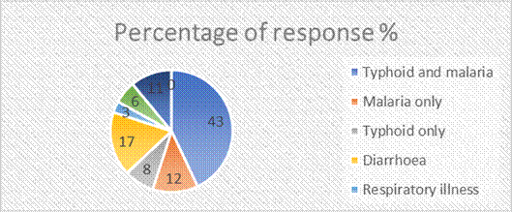
The data provides an in-depth look at prevalent health challenges within the respondent group. While typhoid and malaria, whether considered separately or together, are significant health concerns, other health issues such as diarrhoea, respiratory illnesses, coughing, and undiagnosed conditions also exist but occur with varying frequencies.
4. Discussions and recommendations
The findings from this study provide valuable insights into the state of housing and its associated health impacts faced by the surveyed population. In this discussion, we will study the implications of these findings, drawing on relevant literature to provide context and guidance for addressing these health challenges.
The data on housing conditions reveals significant challenges within the community. Cracked walls, plastered walls, leaking roofs, and broken/unplastered floors are prevalent issues. Poor housing quality is associated with adverse health effects, including respiratory problems, injuries, and mental health issues (Krieger & Higgins, 2002). Addressing these housing deficiencies is imperative to improving the overall living conditions and well-being of the residents.
The information on ventilation in rooms is crucial for understanding indoor air quality. Adequate ventilation reduces indoor air pollution and prevents respiratory problems (WHO, 2018). The data indicates variations in the number of windows and the presence of ceiling fans, suggesting potential differences in indoor air quality within the community. Incorporating these findings into public health and housing policies is essential for addressing the identified challenges. Interventions should encompass housing improvements, vector control measures, healthcare access, sanitation infrastructure development, and water quality monitoring. Collaborative efforts involving government agencies, non-governmental organisations, and local communities are crucial to achieving meaningful change (WHO, 2006). Furthermore, community engagement and health education programmes can empower residents with knowledge and promote healthier practices, such as proper waste disposal, hand hygiene, and safe water usage (WHO, 2021). This holistic approach aligns with the Sustainable Development Goals (SDGs) by addressing health (SDG 3), clean water and sanitation (SDG 6), and sustainable communities (SDG 11) (UN-HABITAT, 2015).
Understanding the distribution of health conditions within a community is essential for designing effective healthcare interventions and public health policies. The substantial co-occurrence of typhoid and malaria, reported by 43% of respondents, is a significant public health concern. Both typhoid fever and malaria are infectious diseases prevalent in many tropical regions, including Nigeria. The coexistence of these two diseases in a significant portion of the population suggests that there are comprehensive vector control measures. Access to clean water and improved sanitation facilities is essential for public health (WHO, 2021).
Moreover, targeted health education programmes can raise awareness about prevention strategies and the early detection of these diseases (Nega et al., 2016). In addition, malaria emerged as a prevalent health challenge, with 12% of respondents reporting it as their sole health issue. Malaria is a well-documented public health issue in sub-Saharan Africa, including Nigeria (FMHN, 2014). Effective malaria control strategies, including the distribution of insecticide-treated bed nets, indoor residual spraying, and access to prompt diagnosis and treatment, are crucial for reducing the burden of this disease (WHO, 2021). The high prevalence of malaria points to the importance of sustained efforts to combat this preventable and treatable illness among households, neighbourhoods and communities. Housing designs must consider residents' health, safety and well-being to avoid preventable diseases.
Furthermore, the quality of water and hygienic food is a significant aspect to consider in the well-being of residents. The 17% of respondents reporting diarrhoea-related issues highlight the prevalence of gastrointestinal problems within the community. Poor sanitation and limited access to clean drinking water are known risk factors for diarrhoeal diseases (Troeger, C., et al., 2018). Promoting improved sanitation practices, such as proper waste disposal and the construction of sanitary facilities, can help reduce the incidence of diarrhoea (WHO, 2019). Additionally, public health campaigns emphasise hand hygiene and safe water sources as essential components for preventing diarrhoea diseases (WHO, 2021). Rural communities are at risk of prevalent health challenges due to inadequate infrastructure. While fewer respondents reported respiratory illnesses (3%) and cough (6%), these findings warrant attention. Respiratory diseases can encompass a range of conditions, including acute respiratory infections and chronic respiratory diseases. Air quality, including exposure to indoor air pollution from cooking fuels and lack of oxygen, plays a significant role in respiratory health (WHO, 2018). Public health efforts should improve indoor air quality through clean cooking technologies, ensuring adequate home ventilation and reducing exposure to environmental pollutants such as open refuse burning (Bruce, N., Pope, D., & Rehfuess, E., 2017). Addressing cough as a symptom is vital, as it can indicate various underlying health issues, including respiratory infections and non-communicable diseases (GOLD, 2021).
The 11% of respondents reporting undiagnosed illnesses highlight health challenges that may not have been formally identified or addressed. This category underscores the importance of strengthening healthcare systems to provide accessible and affordable diagnostic and healthcare services (Kruk, M. E., et.al, 2018). Community health workers and primary healthcare facilities can play a pivotal role in identifying and addressing undiagnosed illnesses, ultimately improving health outcomes (Tulenko, K., 2017).
These discoveries are similar to research findings by Otto et al. (2022), which proved that housing conditions affect residents' health as well. The study found that malaria was the most frequently reported illness, accounting for 67.5% of the perceived health conditions in Ijebu Ode.
This research contributes to the broader understanding of the complicated relationship between housing, health, and overall well-being in emerging economies. It emphasises the need for comprehensive, context-specific interventions to improve living conditions and promote public health in underserved communities while aligning with SDGs 3 – good health and well-being, 6 – clean water and sanitation, and 11 – sustainable communities and cities, respectively.
5. Conclusion
In conclusion, this study reveals a complex landscape of prevalent health challenges and inadequate housing quality within the surveyed population. The findings emphasise the need for a multifaceted approach to housing and public health interventions, including improved sanitation, vector control, access to clean water, and strengthening of the healthcare system. Community-based health initiatives should prioritise raising awareness about the importance of regular hospital visits for medical check-ups. While African Traditional Medicine (ATM) remains widely practiced in Idah, there is a need for further research and advocacy to promote effective health practices and encourage healthier lifestyles. Currently, a significant portion of Idah citizens rely on traditional medicine rather than orthodox medical care.
Additionally, general hospitals face a shortage of trained medical personnel, discouraging many residents from seeking treatment. As a result, staff from the Federal Polytechnic and the College of Health often turn to private clinics, despite these facilities being substandard compared to the general hospital. Addressing the staffing gap in hospitals through capacity training and increasing manpower is essential for improving healthcare access.
Beyond healthcare, increasing the housing supply in Idah presents a valuable investment opportunity. Since Idah is an educational and agricultural town, government intervention in housing development is crucial for its growth and sustainability. This can be achieved through public-private partnership (PPP) projects, cooperative housing initiatives, staff housing programmes, and social housing developments. Such efforts will support the expansion of Idah’s infrastructure and enhance the overall well-being of its residents. Addressing these challenges requires collaboration among healthcare providers, policymakers, urban planners, architects and community stakeholders to implement evidence-based strategies for liveable, sustainable communities and improved health and well-being.
Understanding the spectrum of these health challenges is vital for healthcare professionals and policymakers. It serves as a foundational basis for tailored healthcare interventions that can effectively address the specific health needs of this community. Ultimately, this data can guide healthcare strategies to enhance the overall health and well-being of the respondents and, by extension, the broader population they represent.

References:
Bruce, N., Pope, D., & Rehfuess, E. (2017). WHO indoor air quality guidelines on household fuel combustion: strategy implications of new evidence on interventions and exposure–risk functions. Atmospheric Environment, 178, 196-203.
City Population. (2022). Idah local government area in Nigeria. Population. https://citypopulation.de/en/nigeria/admin/kogi/NGA023007__Idah/
Ellen, S. (2020). Slovin’s formula sampling techniques. Sciencing. https://sciencing.com/slovins-formula-sampling-techniques-5475547.html
Krieger, J., & Higgins, D. L. (2002). Housing and Health: Time Again for Public Health Action. American Journal of Public Health, 92(5), 758–768. https://doi.org/10.2105/AJPH.92.5.758
Moore, E. A. (2019). Addressing housing deficit in Nigeria: Issues, challenges and prospects. Central Bank of Nigeria, 57(4), 201–222.
Murray, C. J. L., Ikuta, K. S., Sharara, F., Swetschinski, L., Robles Aguilar, G., Gray, A., Han, C., Bisignano, C., Rao, P., Wool, E., Johnson, S. C., Browne, A. J., Chipeta, M. G., Fell, F., Hackett, S., Haines-Woodhouse, G., Kashef Hamadani, B. H., Kumaran, E. A. P., McManigal, B., … Naghavi, M. (2022). Global burden of bacterial antimicrobial resistance in 2019: A systematic analysis. The Lancet, 399(10325), 629–655. https://doi.org/10.1016/S0140-6736(21)02724-0
Ogunkolu, A. B., Oyetunji, A. B., Ukwubile, F. O., & Ogbole, M. (2021). Assessment of the water quality of hand-dug wells in Idah, Kogi State, Nigeria. Frontiers in Social Development, 1(1), 22–34.
Otto, E., Ogunyemi, K., & Luyi, O. (2022). Housing Quality and Perceived Health Effects in Ijebu Ode, Nigeria. International Journal of Advances in Life Science and Technology, 6(1), 31–43. https://doi.org/10.18488/72.v6i1.3034
Payne, G. K. (2022). Somewhere to live: Rising to the global urban land and housing challenge. Practical Action Publishing.
Ruonavaara, H. (2018). Theory of housing, from housing, about housing. Housing, Theory and Society, 35(2), 178–192. https://doi.org/10.1080/14036096.2017.1347103
Spence, C. (2020). Senses of place: Architectural design for the multisensory mind. Cognitive Research: Principles and Implications, 5(1), 46. https://doi.org/10.1186/s41235-020-00243-4
Thomson, H., & Thomas, S. (2015). Developing empirically supported theories of change for housing investment and health. Social Science & Medicine, 124, 205–214. https://doi.org/10.1016/j.socscimed.2014.11.043
Tokula, Arome. Emmanuel. (2019). Assessment of Spatial Growth and Residents' Satisfaction with Urban Infrastructure in Idah, Kogi State, Nigeria. Journal of Geography, Environment and Earth Science International, 19(1), 1–10. https://doi.org/10.9734/JGEESI/2019/45686
WHO. (2018). Household crowding. In the WHO Housing and Health Guidelines. The World Health Organisation. https://www.ncbi.nlm.nih.gov/books/NBK535289/
World Health Organisation (2021). Malaria. https://www.who.int/news-room/fact-sheets/detail/malaria
World Health Organisation. (2021). Malaria interventions. https://www.who.int/malaria/areas/interventions/en/
World Health Organisation. (2021). Diarrhoeal disease. https://www.who.int/news-room/fact-sheets/detail/diarrhoeal-disease
World Health Organisation. (2018). Household air pollution and health. https://www.who.int/news-room/fact-sheets/detail/household-air-pollution-and

