INVESTIGATIONS ON THE THEORY OF THE GRAVITINIAN MOVEMENT







ABSTRACT
The bodies of the atomic structures within the gravitinian movement move freely about their axes and reference points of motion, ascribed to the incessant collisions betwixt the body of the graviton particles within the gravitational framework, and the molecules that comprises matter, liquids and gases. Kinetic energy is released via these constant collisions betwixt the gravitons and the atoms in minute, finite packets of energy.
KEY WORDS: Gravitons, Solute, Molecules, Kinetic theory of heat, Gravito-Molecular collisions.

INTRODUCTION
The gravito-molecular collisions, as will be here shown and expressed in this scientific research physics paper shall serve to corroborate the notion that the movements of small atoms and particles suspended in a liquid, solid, or gaseous state, are yielded primarily ascribed to the immutable fact that the gravitons are incessantly colliding with such suspended particles. Building on and extrapolating from Albert Einstein’s 1905 paper on the Brownian movements, facilitates the buttress and cornerstone of our quantum theory.

- ON THE MOVEMENT OF SMALL PARTICLES SUSPENDED IN A STATIONARY LIQUID DEMANDED BY THE MOLECULAR-KINETIC THEORY OF HEAT

In this paper it will be ascertained that according to the molecular-kinetic theory of heat, bodies of microscopically – visible size suspended in a liquid under the influence of gravitons will perform movements of such magnitude that they can be easily observed in a microscope, on account of the gravitinian theory of motion. The momentum p with respect to the acceleration of the molecules suspended in a liquid can be characterized by the equation
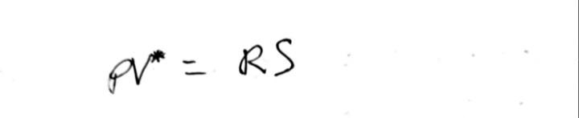

When V*/p is sufficiently great. Then, if there are n suspended particles present in the volume V*, and therefore n/V* = ∆v in a unit of volume, and if neighboring particles are sufficiently separated, there will be a corresponding osmotic pressure p of magnitude given by
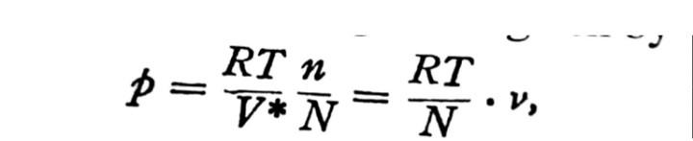
Where N signifies the actual number of molecules contained in the gram-molecule.

- MOVEMENT OF SMALL PARTICLES

A physical system which completely defines the instantaneous condition of the system (for example, the Co-ordinates and velocity components of all atoms of the system), and if the complete system of equations of change of these variables of state is given in the form
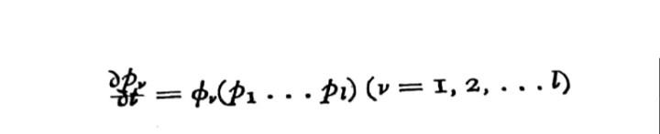
Whence

Then the entropy of the system is given by the expression
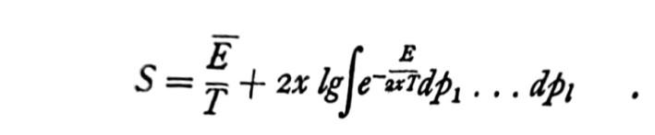
Where T is the absolute temperature, E bar the energy of the system, E the energy as a function of pv. The integral is extended over all possible values of pv consistent with the conditions of the problem. x is connected with the constant N referred to before by the relation 2xN = R. We obtain hence for the free energy F,
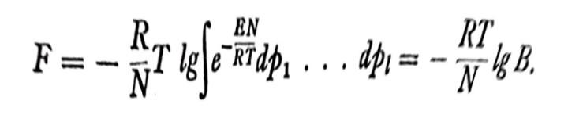

- THEORY OF GRAVITINIAN MOVEMENT
Now let us consider a quantity of liquid enclosed in a volume V ; let there be n solute molecules (or suspended particles respectively) in the portion V* by a semi-permeable partition; the integration limits of the integral B obtained in the expressions for S and F will be affected accordingly. The combined volume of the solute molecules (or suspended particles) is taken as small compared with V*. This system will be completely defined according to the theory under discussion by the variables of condition p1…pl. If the molecular picture were extended to deal with every single unit, the calculation of the integral B would offer such difficulties that an exact calculation of F could be scarcely contemplated. Accordingly, we need here only to know how F depends on the magnitude of the volume V* , in which all solute molecules, or suspended particles are contained.

- KINETIC ENERGY RELEASED VIA THE COLLISIONS OF GRAVITON PARTICLES UPON ATOMS

When the gravitons collide with the atomic structures of the molecules of matter, tiny packets of energy are released in the form of kinetic energy as enunciated in our theory of General Quantum Gravity p1. It is this release of the energy contained therein that exacerbates the movements of the atomic structures within matter, liquids and gases. This mathematically expressed is given as
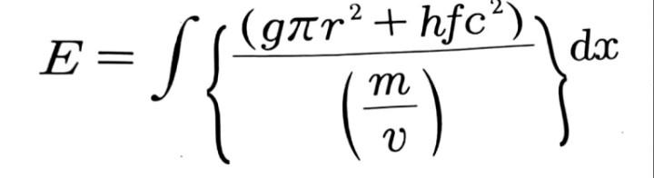
Whence, the Plank’s constant and frequency of the system are given and pronounced. As the gravitons flow through betwixt the gaps in the molecules of matter, liquids and gases, they rub against these molecules. But a different conception is reached from the standpoint of molecular-kinetic theory of heat. According to this theory a dissolved molecule is differentiated from a suspended particle solely by its dimensions, and it is not apparent why a number of suspended particles should not produce the same osmotic pressure as the same number of molecules. We must assume that the suspended particles perform an irregular movement --- even if a very slow one --- in the liquid, account of the molecular movement of the liquid; if they are prevented from leaving the volume V* by the partition just like molecules in solution. We will call x1,y1,z1 the rectangular Co-ordinates of the center of gravity of the first particle, x,, y,, z2 those the second, etc, xn, yn, zn those of the last particle , and allocate for the centers of gravity of the particles the indefinitely small domains of parallelopiped form dx1, dy1, dz2, dy2, dz2,… dxn,dyn, dzn, lying wholly within V*. The value of the integral appearing in the expression for F will be sought , with the limitation that the centers of gravity of the particles lie within a domain defined in this manner. The integral can then be bought into the form
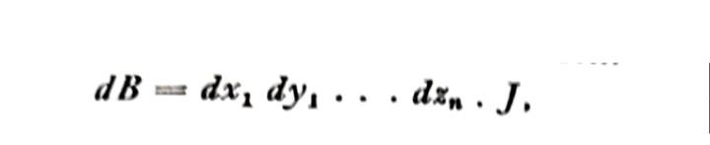
Where J is independent of dx1, dy1, etc, as well as of V* i.e, of the position of the semi-permeable partition. But J is also independent of any special choice of the position of the domains of the centers of gravity and of the magnitude of V*, as will be shown immediately. For if a second system were given, of indefinitely small domains of the centers of gravity of the particles, and the latter designated dx1’, dy1’, dz1’ ; dx2’ , dy2’, dz2’…dxn’, dyn’, dzn’, which domains differ from those originally given in their position but not in their magnitude, and are similarly all contained in V*, an analogous expression holds:---
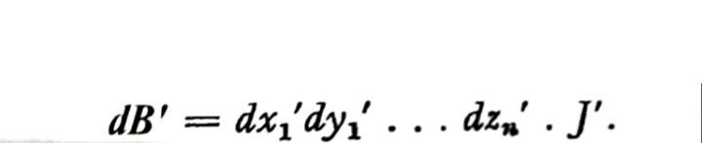
Whence
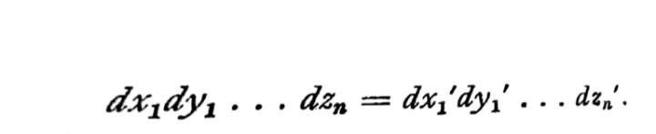
Therefore

Now, if the movements of single particles are independent of one another to a sufficient degree of approximation, if the liquid is homogeneous and exerts no force on the particles, then for equal size of domains the probability of each of the two systems will be equal, so that the following holds:
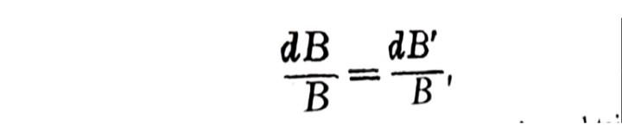
But from this and the last equation obtained it follows that
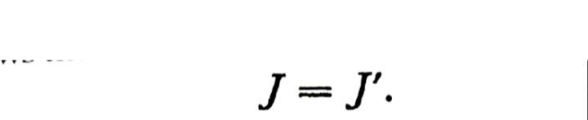
We have thus proved that J is independent both of V* and of x1, y1,… zn. By integration we obtain
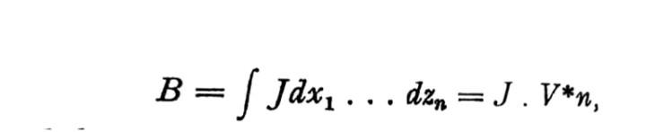
And thence
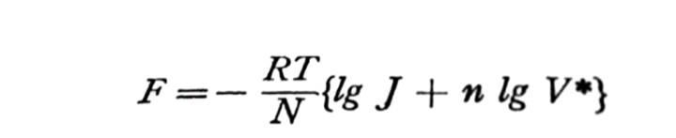
And
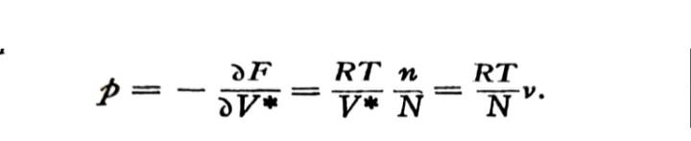
It has been shown by this analysis that the existence of an osmotic pressure can be deduced the molecular-kinetic theory of heat; and that as far as osmotic pressure is concerned, solute molecules and suspended particles are, according to this theory, identical in their behavior at great dilution.

- THEORY OF THE DIFFUSION OF SMALL SPHERES IN SUSPENSION

Suppose there are small particles irregularly dispensed in a liquid. We will consider their state of dynamic equilibrium, on the assumption that a force K acts on the single particles, which force depends on the position , but not on the time. It will be assumed for the sake of simplicity that the force is exerted everywhere in the direction of the x axis. Let v be the number of suspended particles per unit volume; then in the condition of dynamic equilibrium v is such a function of x that the variation of the free energy vanishes for an arbitrary virtual displacement §x of the suspended substance. We have therefore,
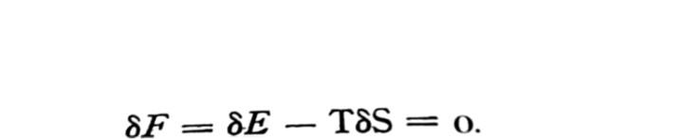
It will be assumed that the liquid area has unit area of cross-section perpendicular to the x axis and is bounded by the planes x =0 and x =l. We have then,
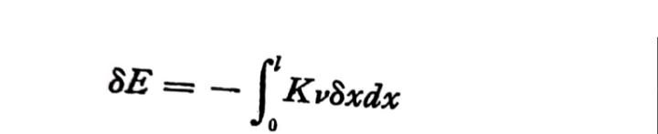
And
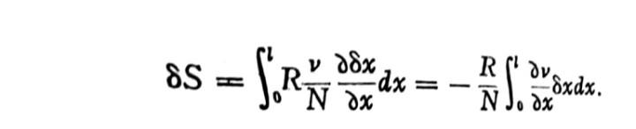
The required condition of dynamic equilibrium is therefore

Or
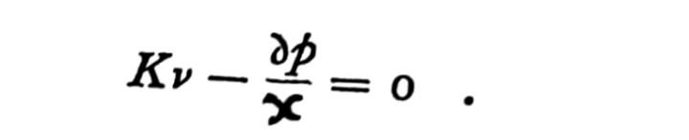
The last equation states that equilibrium with the force K is brought about by osmotic pressure forces. Equation (1) can be used to find the coefficient of diffusion of the suspended substance. We can look upon the dynamic equilibrium condition considered here as a superposition of two processes proceeding in opposite directions, namely ;--- (1) A movement of the suspended substance under the influence of the force K acting on each single suspended particle. (2). A process of diffusion, which is to be looked upon as a result of the irregular movement of the particles produced by the thermal molecular movement. If the suspended particles have spherical form(radius of the sphere = P), and if the liquid has a coefficient of viscosity k, then the force K imparts to the single particles a velocity (*)
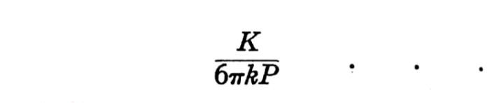
And there will pass a unit area per unit of time

particles. If, further, D signifies the coefficient of diffusion of the suspended substance, and u the mass of a particle, as the result of diffusion there will pass across unit of time,
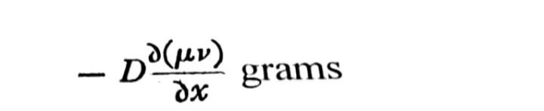
Or
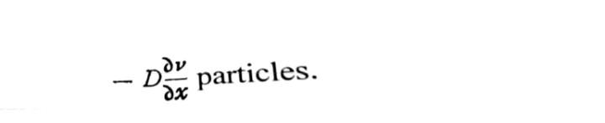
Since gravitons carry kinetic energy in discreet amounts , the kinetic energy carried by gravitons can be measured using the equation
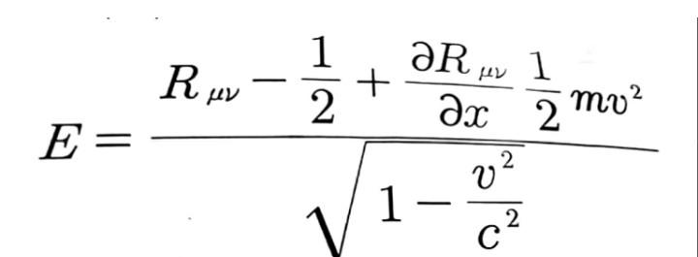
And the momentum p of the moving particle can be measured via
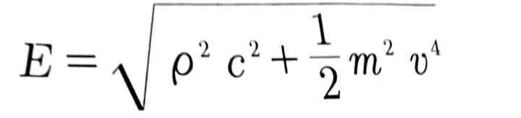
When v/c is small, pc is small compared to mc², whence the determining equation for molecular dimensions is given in the form

Whereby the forces exerted upon the atomic structures may be yielded in the form
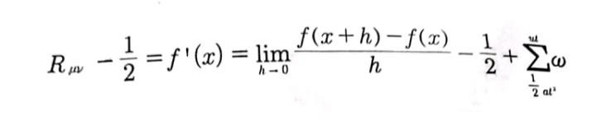
And
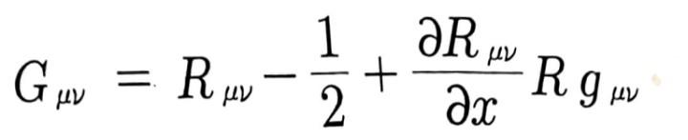
respectively. The orbital of electrons around the nuclei of the atomic structures is given in the form

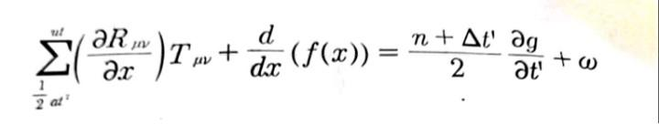
Whereby the graviton’s collisions betwixt the atomic structures is given in the form
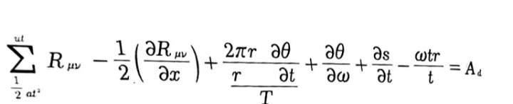
And our original equation’s derivation of forces exerted by the gravitons is given in the form
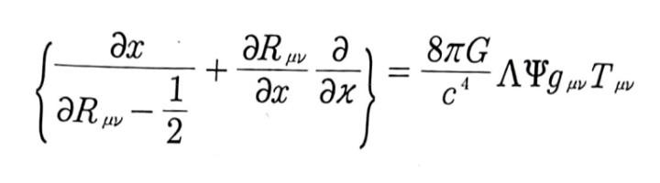

The acceleration of the gravitons is given in the form
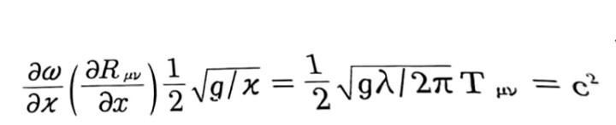

This can be represented on the graph as

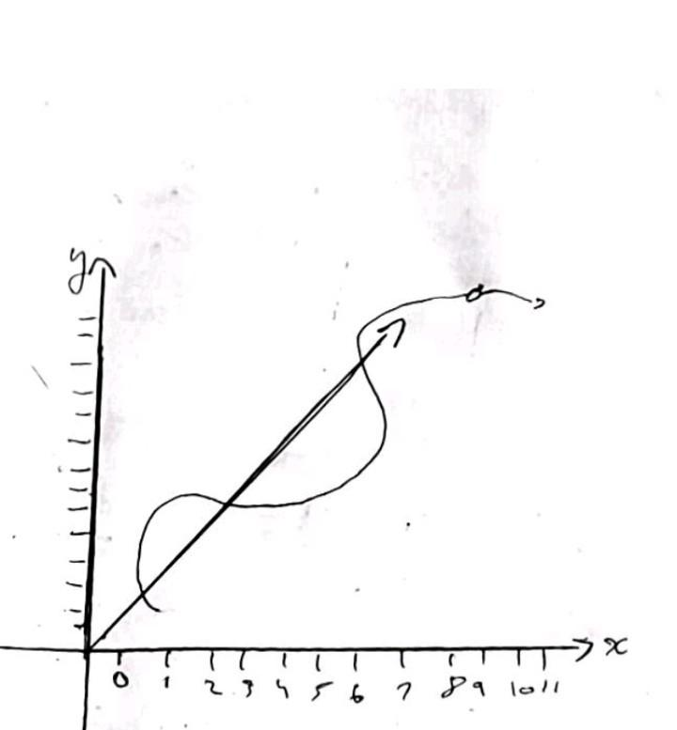

§(6). FORMULA FOR THE MEAN DISPLACEMENT OF SUSPENDED PARTICLES. A NEW METHOD OF DETERMINING THE REAL SIZE OF THE ATOM

We found the coefficient for the diffusion D of a material suspended in a liquid in the form of small spheres of radius P---


Further, we found for the mean value of the displacement of the particles in the direction of the X-axis in time t---

By eliminating D we obtain


This equation shows how lambda x depends on T, k, and P. We will calculate how great lambda x is for one second, in N is taken equal to 6•10²³ in accordance with the kinetic theory of gases, water at 17° C is chosen as the liquid (k= I•35•10²), and the diameter of the particles 0.001 mm. We get


The mean displacement in one minute would be, therefore, about 6u. On the other hand, the relation found can be used for the determination on N. We obtain


§(7) HOW A VERY SMALL SPHERE SUSPENDED IN A LIQUID INFLUENCES ITS MOTION

Let us base our discussion on an incompressible homogeneous liquid with a coefficient of viscosity k, whose velocity components u, v, w are given as functions of the coordinates x, y, z and of time. At an arbitrary point x0 , y0, z0, let us think of the functions u, v, w as functions of x – x0, y—y0 , z—z0 expanded in a Taylor’s series, and of a region G around this point so small that within it only the linear terms of this expansion need to be considered. As is well known, the motion of the liquid within G can be then regarded as a superposition of three motions:

1 A parallel displacement of all particles of the liquid without a change in their relative positions;
2 A rotation of the liquid without a change in the relative positions of the particles of the liquid;

3 A dilational motion in three mutually perpendicular directions (the principal axes of dilation).

Let us now assume that in region G there is a spherical rigid body whose center lies at the point x0, y0, z0 and whose dimensions are very small compared with those types of region G. We further assume that the motion is so slow that the kinetic energy of the sphere as well as that of the liquid can be neglected. We also assume that the velocity components of surface element of the sphere coincide with corresponding velocity components of the adjacent liquid particles, i.e., that contact the layer (imagined to be continuous) also displays a coefficient of viscosity that is not infinitesimally small. It is obvious that the sphere simply takes part in the partial motions 1 and 2 without altering the motion of neighboring particles, since the liquid moves like a rigid body in these partial and since we have neglected the effects of inertia. However, motion 3 does get altered by the presence of the sphere, and our next task will be to investigate the effect of the sphere on the motion of the liquid. If we refer the principal axes of dilation and set
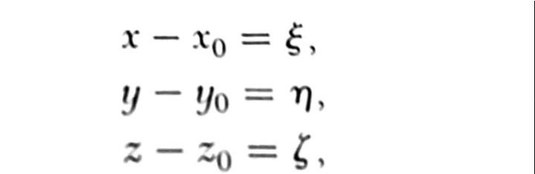
We can describe the above motion, if the sphere is not present, by the equations
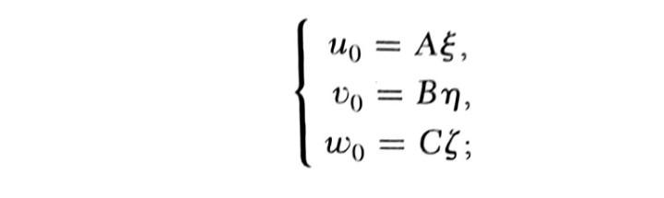
A, B, C are constants that, because the liquid is incompressible satisfy the condition

A+B+C = 0
If we set
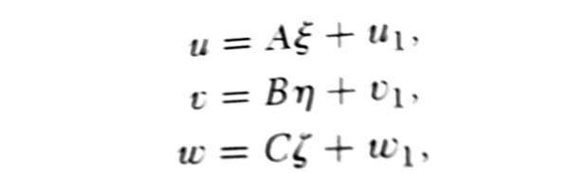

The velocities u1, v1, w1 would have to vanish at infinity, since at infinity ♾️ the motion represented in equations (3) should reduce to that represented by equation (1). The functions u, v, w have to satisfy the equations of hydrodynamics, including viscosity and neglecting inertia. Thus the following equations will hold:
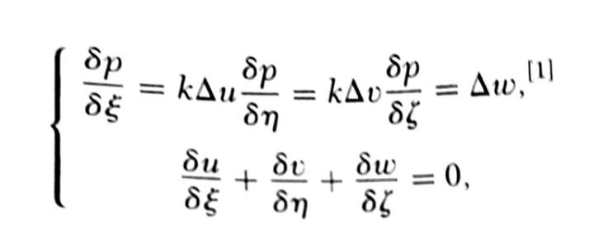

Where ∆ denotes the operator

And p the hydrostatic pressure.
Since equations (1) are solutions of equations (4) and the latter are linear, according to (3) the quantities u1, v1, w1 must also satisfy equation (4). I determined u1, v1, w1, and p by a method that found
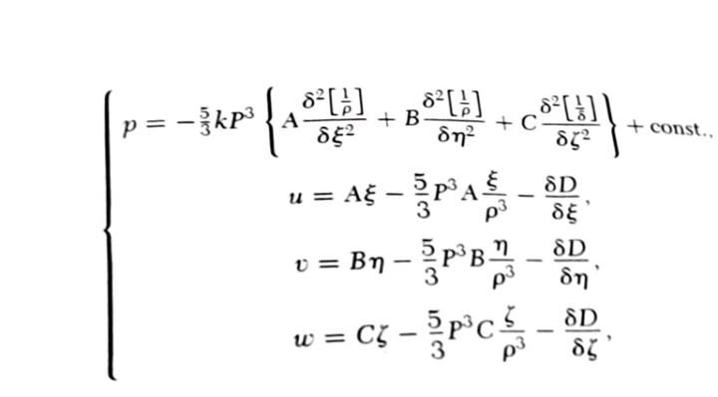
From equations (4) it follows that ∆p = 0.
A sphere suspended at point xv, yv, zv will affect this motion in a way that is evident from equation (6). Since we are choosing the average distance between neighboring spheres to be large compared to their radius, and consequently the additional velocity components arising from all the suspended spheres are very small compared to u0, v0, w0, we obtain for the velocity components u, v, w in the liquid, after taking into account the suspended spheres and neglecting terms of higher orders,
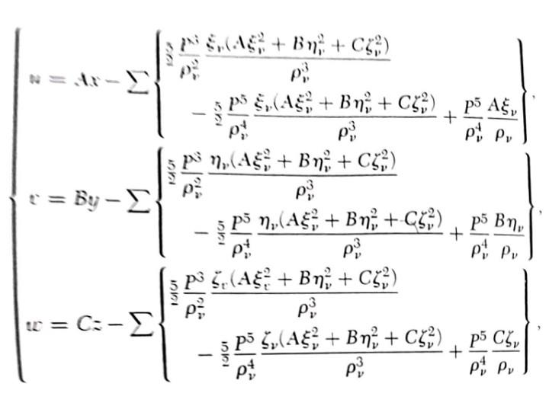
Where the sum is to be extended over all spheres in the region G and where we have set

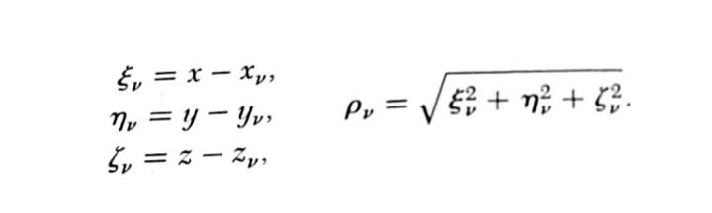
Xv, Yv, Zv are the coordinates of the centers of the spheres. Furthermore, from equations (7) and (7a) we conclude that, up to infinitesimally small quantities of higher order, the presence of each sphere results in a decrease of heat production and that the energy converted to heat in region G has the value

Per unit volume, or



Where phi denotes the fraction of the volume of spheres.

CONCLUSION
In this paper, the size of molecules was ascertained in addition to the determination of the rotations of the molecular structures ascribed to the gravito-molecular collisions via the kinetic theory of heat. It is our hope that this paper enlightens the international scientific community.

REFERENCES
- INVESTIGATIONS ON THE THEORY OF THE BROWNIAN MOVEMENT(A. EINSTEIN 1905)
- A NEW DETERMINATION OF MOLECULAR DIMENSIONS (A. EINSTEIN 1905)

