COMPARATIVE EFFECTIVENESS OF NEURAL MOBILIZATION VERSUS POSITIONAL RELEASE TECHNIQUE IN CERVICAL RADICULOPATHY – AN EXPERIMENTAL STUDY
*Namrata Suryavanshi, **Dr. Deepak Yadav, ***Dr. Asma Parveen
*Researcher, MPT Musculoskeletal Disorders, Department Of Physiotherapy, Dolphin (PG) Institute Of Biomedical And Natural Sciences, Dehradun,
**Guide, Heart-Lungs Transplant Physiotherapist, MPT Cardiopulmonary, Assistant Professor, Department Of Physiotherapy, Dolphin (PG) Institute Of Biomedical And Natural Sciences, Dehradun
***Co-Guide, Cardiopulmonary Physiotherapist, Batra Hospital, New Delhi
Abstract
Background: Cervical radiculopathy is a common condition characterized by nerve root compression, leading to pain, disability, and functional limitations. Physiotherapy interventions such as Neural Mobilization (NM) and Positional Release Technique (PRT) are widely used; however, evidence comparing their combined effectiveness is limited.
Objective: To evaluate and compare the effectiveness of NM, PRT, and their combined application (NM + PRT) in individuals with cervical radiculopathy.
Methods: Forty-five participants were randomly allocated into three groups (n = 15 each): NM, PRT, and combined NM + PRT. Interventions were administered, and outcomes were assessed using the Numeric Pain Rating Scale (NPRS), Neck Disability Index (NDI), and hand grip strength. Data were analyzed using one-way ANOVA and Kruskal–Wallis test with significance set at p ≤ 0.05.
Results: All groups showed significant improvements in pain and disability. The combined NM + PRT group demonstrated the greatest reduction in NPRS (6.93 ± 1.62) and improvement in NDI (13.87 ± 8.55), indicating superior effectiveness. Grip strength improved in all groups; however, no statistically significant difference was observed between them (p > 0.05).
Conclusion: Both NM and PRT are effective in managing cervical radiculopathy, but their combined application provides superior outcomes in reducing pain and improving functional disability. This combined approach can be considered a safe and effective non-invasive treatment option.
Keywords: Cervical radiculopathy, neural mobilization, positional release technique, neck disability, pain, physiotherapy

INTRODUCTION
Cervical radiculopathy is a common condition resulting from compression or irritation of cervical nerve roots, often due to disc herniation, degenerative changes, or osteophyte formation. These changes lead to both mechanical and inflammatory responses, contributing to clinical symptoms.
Patients typically present with radiating neck pain into the upper limb, accompanied by numbness, tingling, and muscle weakness.¹ Symptoms are usually unilateral, and their severity depends on the level of nerve root involvement.² Degenerative changes such as cervical spondylosis and foraminal narrowing are key contributors, with C5–C6 and C6–C7 being the most commonly affected levels.³
Diagnosis involves a combination of clinical examination and imaging. The Wainner test cluster, including Spurling’s test, cervical distraction, cervical rotation, and upper limb tension test, provides high diagnostic accuracy.⁴ MRI is commonly used for confirmation, although imaging findings may not always correlate with symptoms.^{5,6}
Conservative management, particularly physiotherapy, plays a vital role in treatment.⁷ Neural mobilization aims to improve nerve mobility and reduce sensitivity⁸, while positional release technique (PRT) helps decrease muscle tension and pain by placing tissues in a position of comfort.⁹
Although both techniques have shown beneficial effects, comparative evidence is limited. Therefore, this study aims to compare the effectiveness of neural mobilization and positional release technique in individuals with cervical radiculopathy.
METHODOLOGY
Sample Size: 45 subjects
Source of Subjects: PSRI Hospital, Delhi
Method of Sampling: simple random sampling
Research Design: experimental research design.
Inclusion Criteria
- Age between 18 and 65 years
- Acute neck pain with radiating symptoms (< 3 months)
- Positive findings in at least 3 out of 4 clinical tests (Spurling’s test, cervical distraction test, ipsilateral cervical rotation < 60°, upper limb tension test)
- Both males and females
- Unilateral or bilateral upper limb symptoms
Exclusion Criteria
- History of cervical spine surgery
- Use of steroidal anti-inflammatory drugs
- Presence of red flag conditions (tumor, fracture, osteoporosis, etc.)
- Lack of willingness to participate
Outcome Measures
- Numeric Pain Rating Scale (NPRS)
- Neck Disability Index (NDI)
- Hand grip strength
Procedure
Group 1: Neural Mobilization
Neural mobilization was applied to restore normal neurodynamics by improving the mobility and function of neural tissues. Participants were positioned supine, and specific nerve mobilization techniques (median, radial, and ulnar nerves) were performed. Each movement was adjusted to a tolerable level of symptoms (mild tension, numbness, or tingling without discomfort), held for 10 seconds, and repeated for 10 repetitions.
Group 2: Positional Release Technique (PRT)
Participants were treated using PRT in a supine position with the cervical spine in neutral. Trigger points were identified and marked. The therapist positioned the patient into a position of maximum comfort (reducing pain by approximately 80%) using gentle cervical movements. Each position was held for 90 seconds before returning to neutral.
Group 3: Combined PRT and Neural Mobilization
Participants received both PRT and neural mobilization. Initially, PRT was applied to release trigger points (held for 90 seconds per point, repeated for multiple points). After a 5-minute rest period, neural mobilization techniques were performed as described in Group 1.
Post-treatment
All groups received a hot pack application for 15 minutes following the intervention.
STATISTICAL ANALYSIS
Data were analyzed using IBM SPSS version 26. Normality was assessed with the Shapiro–Wilk test. NPRS and NDI were normally distributed (p > 0.05) and analyzed using one-way ANOVA, while grip strength was analyzed using the Kruskal–Wallis test. The significance level was set at p ≤ 0.05.
RESULTS
A total of 45 patients with cervical radiculopathy were recruited from the physiotherapy OPD and equally distributed into three groups (n = 15 each).
Comparison of NPRS Scores (Pre–Post Improvement)
Group 1 (Neural Mobilization) showed a mean reduction in NPRS score of 5.87 ± 1.81. Group 2 (Positional Release Technique) demonstrated a mean reduction of 3.87 ± 1.36. Group 3 (combined Neural Mobilization and Positional Release Technique) showed the greatest improvement, with a mean reduction of 6.93 ± 1.62. Overall, the combined intervention group exhibited superior pain reduction compared to the other groups.
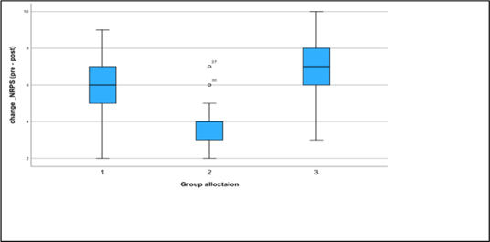
Fig.1: Change in NPRS (Pre – Post) Scores Among All Group 1,2 & 3
Comparison of Neck Disability Index (NDI)
All groups showed improvement in NDI scores. Group A (Neural Mobilization) demonstrated a mean improvement of 9.73 ± 4.61 (95% CI: 7.18–12.28). Group B (Positional Release Technique) showed a mean improvement of 10.00 ± 5.14 (95% CI: 7.15–12.85). Group C (combined intervention) exhibited the greatest improvement, with a mean change of 13.87 ± 8.55 (95% CI: 9.13–18.60), indicating better functional recovery.
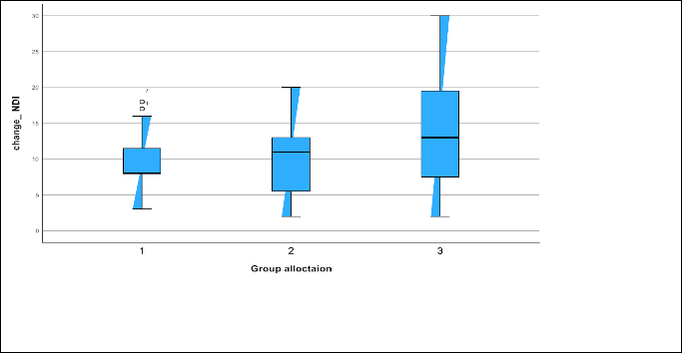
Fig. 2: Change in Neck Disabilty Index Scores (Pre – Post)
Comparison of Grip Strength
The change in grip strength across the three groups was analyzed using the Kruskal–Wallis test, which showed no statistically significant difference (H = 2.115, df = 2, p = 0.347). This indicates that improvements in grip strength were comparable across all groups.
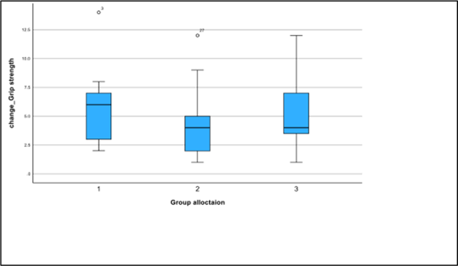
Fig. 3: Change in Grip Strength (Pre – Post)
Post-hoc Analysis
Bonferroni-adjusted pairwise comparisons revealed no statistically significant differences between groups:
- Group A vs Group B (p = 0.475)
- Group A vs Group C (p = 1.000)
- Group B vs Group C (p = 0.936)
DISCUSSION
The present study compared Neural Mobilization (NM), Positional Release Technique (PRT), and their combined application in cervical radiculopathy using pain, disability, and grip strength outcomes. All interventions reduced pain; however, the combined NM + PRT group showed the greatest improvement, indicating superior effectiveness. This may be due to the combined effect of improved neural mobility and reduced muscle tension, addressing both neural and myofascial components of pain.
All groups also demonstrated improvement in neck disability, with the combined group showing the most significant change. This may be attributed to reduced pain, improved cervical mobility, and decreased neural irritation, supporting the benefit of a multimodal approach.
Grip strength improved in all groups, but no significant between-group difference was observed, likely because the interventions focused on pain relief rather than strengthening.
Overall, while NM and PRT are effective individually, their combined application provides better outcomes in pain reduction and functional improvement. These findings align with previous studies by Rafiq S., Zafar H., and Sweety Charles Carvalho, further supporting the effectiveness of a combined treatment approach.
CONCLUSION
The study concludes that Neural Mobilization, Positional Release Technique, and their combination are effective in managing cervical radiculopathy. The combined intervention showed superior results in reducing pain and improving disability, while grip strength improvements were similar across groups. These findings support the use of a combined, safe, and non-invasive approach for better clinical outcomes.
LIMITATIONS AND FUTURE RESEARCH
The study was limited by a small sample size, short duration, lack of follow-up, limited outcome measures, and no control group, which may affect generalizability. The absence of a strengthening protocol may explain the non-significant grip strength results.
Future studies should include larger samples, longer follow-up, control groups, additional outcomes, and incorporate varied dosages and strengthening approaches to enhance clinical applicability.
References
- Rafiq S, Zafar H, Gillani SA, Waqas MS, Zia A, Liaqat S, et al. Effectiveness of neural mobilization on pain, range of motion, and disability in cervical radiculopathy: A randomized controlled trial. 2021.
- Iyer S, Kim HJ. Cervical radiculopathy. Curr Rev Musculoskelet Med. 2016;9(3):272–280. doi:10.1007/s12178-016-9349-4
- Sambyal S. Comparison between nerve mobilization and conventional physiotherapy in patients with cervical radiculopathy. IJC. 2013.
- Wainner RS, Fritz JM, Irrgang JJ, Boninger ML, Delitto A, Allison S. Reliability and diagnostic accuracy of the clinical examination and patient self-report measures for cervical radiculopathy. Spine (Phila Pa 1976). 2003;28(1):52–62.
- Waldrop MA. Diagnosis and treatment of cervical radiculopathy using a clinical prediction rule and a multimodal intervention approach: A case series. 2006.
- Wei X, Wang S, Li J, Gao J, Yu J, Feng M, et al. Complementary and alternative medicine for the management of cervical radiculopathy: An overview of systematic reviews. Evid Based Complement Alternat Med. 2015;2015.
- Childs JD, Cleland JA, Elliott JM, Teyhen DS, Wainner RS, Whitman JM, et al. Neck pain: Clinical practice guidelines linked to the International Classification of Functioning, Disability, and Health. J Orthop Sports Phys Ther. 2008;38(9):A1–A34.
- Shacklock M. Clinical neurodynamics: A new system of musculoskeletal treatment. Elsevier Butterworth-Heinemann; 2005.
- D’Ambrogio KJ, Roth GB. Positional release therapy: Assessment and treatment of musculoskeletal dysfunction. Mosby; 1997.

