A Hybrid Trusted Computing Framework for Mobile Cloud Computing Using Authentication and Authorization

Abstract
In the recent era, mobile devices' tremendous development motivated user choice from traditional laptops and mobile phones to tablets and smart phones. The mobile technology provides rich applications to end-users with enhanced portability, capacity, long-term evaluation networks, seamless network access, and widespread 3G/4G long-term evaluation networks and WiFi access. Thus, most of the global IP traffic is anticipated by the traffic coming from mobile devices. However, from the computational perspective, mobile devices cannot handle heavy computational overhead as resources constrain them. The design aim of mobile cloud computing (MCC) is to resolve the issues of constrained mobile devices, and recently it has gained significant attention.
A proposed work aims to design the trusted computing environment for MCC by authentication, authorization, and accurate and efficient computing. The proposed work achieves trusted computing by developing a novel hybrid approach, i.e., Efficient Computation, Authentication & Authorization in a Mobile Cloud Environment (ECAAMC). Authentication between communicating entities is accomplished by password-based authenticated key agreement with Chaotic Maps. Authorization among the users is achieved by the role and trust of the users. Further, the computing is enabled by probabilistic unigram computing.
Performance evaluation of EC-AAMC carried out with real-time data using XAMPP (Cross-Platform, Apache, MySQL, PHP, and Perl). The proposed mechanism significantly outperforms MCC's existing trusted computing mechanisms regarding authentication, authorization, accuracy, and efficiency. The authentication scheme requires only 84.08 ms to perform mutual authentication between communicating entities, and it is also robust to man-in-the-middle attack. The authorization accurately detects and removes malicious users. Further, probabilistic unigram computing extends the computing efficiency.

Mobile cloud computing Introduction
The mobile computing paradigm is an emerging technology and recently gains significant attention. However, it is suffering from resource on strained issues. The resource-constrained challenges of mobile computing can be overcome by introducing the technology of cloud computing into mobile computing. Cloud computing is the distributed computing model. Combining two technical contributions such as cloud computing and resource-constrained computing has introduced a novel and better technological computation approach. The chapter describes the concept of mobile cloud computing in terms of architecture, characteristics, and challenges. The chapter also discuss the motivation behind the research objective, and further, it describes the organization of the thesis.
Mobile cloud computing (MCC) is the process of computation over the cloud by mobile devices. It is the combination of two technical contributions, such as mobile computing and cloud computing [1]. Cloud computing is a ubiquitous model where resources are provided to the users on-demand with less management effort [2]. Mobile computing is the concept of performing computation within mobile devices, where mobile devices consist of constrained resources. Integrating cloud computing technology with mobile computing has introduced a novel and better technological computation approach.

Mobile computing
Concerning recent literature [4], users prefer to use mobile devices rather than desktop computers. Thus, computing through mobile devices dominates computing through immobile desktop computers and occupies most of the global IP traffic [5]. The requirement of computing through mobile devices is carried out with the help of mobile computing technology. Mobile computing is the process of performing computation over the distributed mobile devices that are connected via dynamic network topologies and communicated by mobile communication protocols.
Mobile computing is the concept of performing computation within mobile devices, and it is a feasible approach compared to the conventional computing approach, i.e., computing through desktop computers. However, from the computational point of view, mobile devices cannot effort the heavy computational overhead as they are constrained with respect to resources. The resource-constrained computing paradigm is an emerging technology and recently gains significant attention [6]. The challenges of mobile computing can be overcome by introducing the cloud concept, which is the distributed computing model.

Mobile Cloud Computing:
Cloud computing is a hub for service-oriented computing, which maintains a pool of services where resource-constrained devices get generous support to overcome their limitation of computing power, battery problem, bandwidth restriction, software cost, and memory. Thus, the mobile devices' constrained resources issues regarding communication have been solved by introducing the cloud computing technology in the constrained mobile devices communication environment, i.e., mobile cloud computing (MCC) . Where an internet service provider plays a vital role, which acts as an interface between the network provider and cloud computing. Network providers provide required services to control constrained resources by facilitating a better network. Constrained Mobile Devices Communication Environment.
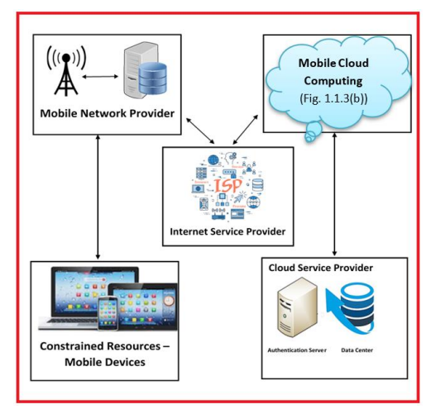

MCC is the process of computation over the cloud by mobile devices. Here, data uploads to or downloads from the cloud via mobile devices. Data centres have lot of services. In our proposed work, we consider DBMS as one of the data services. MCC enables mobile users to perform the computation over resources of different clouds regardless of location and time. Further, MCC regulates and controls the distribution and elastic resources of various clouds [14]. MCC provides all types of services on-demand to the user's such as: software, hardware, and platform. MCC is elastic in nature and allows the user to scale-up and scale-down the resource, through which the users can manage their resources according to their requirements. Further, the users' utilization of resources and services has been increasing as the cloud facilitates metered services. Finally, the cloud environment's user activities are controlled and monitored by the cloud, and specifically, it has been done by the cloud service provider.
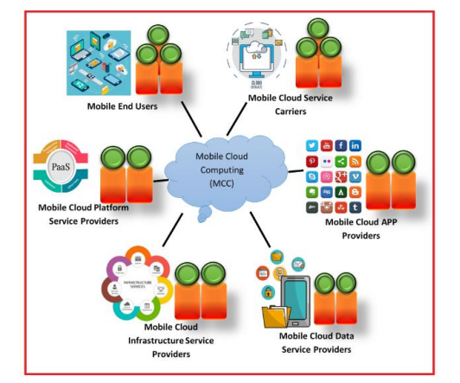
The MCC components are shown in above Figure . The components such as mobile cloud service carriers, mobile cloud APP providers, mobile cloud data service providers, mobile cloud infrastructure providers, mobile cloud platform service providers and mobile end users.

Mobile Cloud Computing Applications:
Mobile users are allowed to access the services on demand by adopting MCC technology, which resolves mobile computing resource constraints. Mobile device usage on the cloud has been increased in the recent era. Most of the users prefer to use new generation technologies because they are convenient to use, portable, and easy to operate. MCC consists of many applications [18], such as Mobile commerce, Mobile learning, Mobile gaming, and Mobile patient monitoring. The various applications of MCC are shown in figure 1.3 (a). The detailed description of the MCC applications is explained as follows: 1. Mobile commerce Mobile cloud computing allows its users to perform all electronic commerce utilities through mobile devices by enabling computation and storage inside the cloud. Thus, users can perform e-commerce activities from anywhere with mobile devices, i.e., MCC provides e-commerce capabilities in users' hands. 2. Mobile learning The drawbacks of traditional learning, such as limited educational resources and high cost, are overcome by introducing online education with mobile devices. MCC facilitate the learners to access learning resources remotely and social and content interactions. Mobile learning allows mobility to its users and learning through portable learning technologies. 3. Mobile gaming MCC allows the user to install and/or store the game at cloud database either entirely or partially, which reduces the computational and storage burden at the user end, as game execution consumes the high power and buffer. MCC facilitates game players to access game learning resources remotely and provide animated interactions. The portable mobile gaming facility improves user’s thinking capability and allows them to learn innovative techniques, which interns help the user to develop new applications to test and deploy on the cloud. Further, MCC allows the rendering adaptation method; with its help, one can change game rendering factors dynamically based on user demand and constrained resources.

Trusted Computing in MCC
Mobile cloud computing provides plenty of ideas and various applications in different fields, but still, MCC faces some challenges that need to be addressed [19]. One of MCC's significant challenges is trusted computing, which is raised due to mobile devices' uncertain behaviour. Trust of a system belongs to the reliability and goodness. One can trust the system whenever it works according to the user's expectations. Trust in MCC is a considerable vital metric, as mobile devices access and store the resources remotely through the communication network. Trusted computing is the concept in which the user has a certain level of assurance about the computing system behaviour as expected [20]. Predicting system behaviour in the mobile cloud computing environment is difficult due to the rapid increment in the utilization of online digitized data, the rapid increase in mobile devices, and the user's dynamic and uncertain behaviour. According to recent work [21], the MCC does not provide the required level of assurance to the constrained mobile devices regarding its behaviour as expected. This requirement is fulfilled by trusted computing. Trusted computing refers to a computer system for which an entity has some level of assurance that the computer system is behaving as expected. The level of assurance is vary based on the nature of entity, and environment.
Security in MCC:
One of the ways to achieve trusted computing is by securing the computation and communication of MCC. In MCC, mobile users store as well as access the data to/from remote cloud servers, where remote cloud servers are located far from the location of the mobile devices. Mobile users do not have direct control over stored data in the remote cloud servers. Further, tremendous growth in mobile web users creates the chance of malicious activates in the MCC environment. Thus, securing the MCC environment is the most vital design issue. The security solutions of resource-constrained computing environment must cope with low-end devices and computationally as well as storage wise efficient. To organize security most significant, modest, and suitable pre-requisites is authentication and access control with confidentiality.

Confidentiality in MCC:
MCC has many advantages. Apart from benefits, the significant primary issue is to provide privacy to the outsourced files [30]; files like government data, tender data, institutional data, industrial data, health records, and emails may be leaked by unauthorized users [31]. Insider attackers and outsider attackers may attack the privacy of sensitive information from the open cloud. Cloud service providers [CSP] provide security to outsourced files by various security mechanisms. In MCC, the data owner outsources data to the cloud for various reasons, such as overcoming constrained resources problems, minimizing maintenance cost, and accessing the stored data ubiquitously. However, providing security to outsourced data is a challenging task. One of the security goals is confidentiality, which assures that the message's content or information is only accessible by authorized entities. One of the natural ways to provide secrecy to sensitive data is encryption that protects the data from illegal access, and it is achieved in MCC by searchable encryption. In searchable encryption, the data owners encrypt the sensitive data before outsourcing, and data users access the data with appropriate searching mechanisms and then decrypt it. In literature [28], various searchable encryption (SE) mechanisms have been designed based on encryption to assure the privacy of outsourced data. To enable confidentially in the MCC environment, recently, search over encrypted data-based encryption algorithms have been designed under symmetric encryption schemes [32-40] and asymmetric encryption approaches [41-48]. These mechanisms enable the users to access the encrypted data with the help of a trapdoor. Most of these approaches allow the users to search over the encrypted data either by Boolean or ranked search methods. Thus, searchable encryption schemes provide confidentiality by storing encrypted data in the cloud. The above discussion on search over encrypted data-based encryption schemes of MCC concludes the following: 1. Existing SE mechanisms, the clients encrypt the sensitive data before outsourcing it into the cloud, and the data user retrieves the data back by keyword search and then decrypt. 2. All these schemes are designed by the assumption that data users are authorized and reputed to access the data. 3. However, the assumption, i.e., data users are authorized in not correct in a hostile environment, such as MCC. 4. Further, the assumption, i.e., authorized data users, create more security threats as users need to access the cloud from various locations through an un-trusted network. 5. There is no proper way to establish the identity and authority of the communicating users.

Authentication in MCC:
. Confidentiality alone cannot achieve security in MCC, as unauthorized users who access the cloud from various locations through the un-trusted network create more security threats. Thus, mutual authentication is required in MCC. Data users access the data from a cloud service provider through the installed web application or cloud service application. Therefore, in MCC, the web application or cloud service application must perform mutual authentication between data user and CSP with the client's help. Further, the mutual authentication process must be secured to prevent sensitive data from illegal access [49-52]. Additionally, the authentication process must be less overhead as mobile devices are constrained in computation, and constrained resources characterize MCC. In literature, various protocols have been developed to offer authentication between computing entities in MCC. Designing a secure computation environment in MCC is challenging due to its constrained resource characteristics. The most significant, convenient, and easy precondition is to enable MAKA between computing entities to provide security in any computing and communicating environment. In recent literature, several key agreement mechanisms have been designed with the help of various cryptographic practices. Most of them are based on RSA, ECC, and Diffie-Hellman [58-60]. These existing key agreement mechanisms are further classified as password, token, biometric, and timestamp based on the attribute. The significant distinction among these mechanisms is finding the system's weakness and resolving the identified defect using novel extensions. Two-party authenticated key agreement mechanisms have been designed widely in the recent era with either RSA or ECC. However, from the computational point of view, these mechanisms offer heavy computational overhead, and due to which they are not suitable for MCC.

Authorization in Mobile Cloud Computing
Authorization is one of the design goals to provide security, along with confidentiality and authentication. Access control mechanisms are used to enable authorization in any computing environment, including MCC. The mobile users' uncertain behaviour enforces the design of suitable access control mechanisms in MCC with less computational overhead. The only authentication is insufficient to provide security but needs to provide access control among the users, as the authenticated users in MCC may behave maliciously. In literature, authenticated key agreement mechanisms [66] have been designed to address the security issues, as authenticated key agreement is the simple vital process to incorporate security in computing technologies. However, there is a demand to consider the users' authorization, as the authenticated users may behave maliciously. Apart from authentication, access control is the primary and critical key technique to provide security in MCC. Access control consists of a set of rules and conditions that are used to protect the computing environment from illegal access. It monitors and controls the user activities to restrict the unauthorized user's access to the computing environment. The design of access control is based on various methods, models, and administrative abilities. Traditional IT environments majorly restrict users' access in two ways, i.e., based on identity and trust. The algorithm designed based on identity and trust is known as identity-based and Trust-based access.

CONCLUSION :
Mobile technology provides rich applications to end-users that motivate the user preferences from traditional devices to mobile devices. Thus, most of the global IP traffic is anticipated by the traffic coming from mobile devices. However, mobile devices are constrained devices and cannot effort the heavy computational overhead. Mobile cloud computing (MCC) is designed to resolve constrained mobile devices' resources. However, it does not provide the required level of assurance to mobile users regarding its behaviour as expected, and this requirement is fulfilling by trusted computing. Trusted computing is achieving in any computing environment by two significant contributions, i.e., security and efficient computing. It is challenging MCC due to users' dynamic, uncertain behaviour, and rapid increment in online digitized data utilization. Thus, in this thesis, we designed a trusted computing environment for Mobile Cloud Computing. To conclude the thesis, an extensive literature review of the existing proposed mechanisms was presented to provide trusted computing for the MCC environment. The resulting literature review analysis provided a way to design and develop a novel trusted mobile cloud computing by authentication, authorization, accurate, and delay-sensitive computing.
The experiment results indicate that the designed, trusted computing mechanism can extend the system's performance concerning the accuracy, efficiency, and computing delay. The performance results are compared with existing trusted computing algorithms designed for MCC in an identical computing environment. MCC can be concluded from the results that the designed, trusted computing mechanism would provide the foundation for secure and efficient communication

