Future Trends in Supply Chain Management: Innovation, AI, Omnichannel Strategies, and Human-Centric Transformation
Thakur Abhinav Amar^{1[0000-0001-7776-0807]} Ashok Kumar Mishra^{2[0000-000-26089-0960]}
¹Department of Production & Industrial Engineering, BIT Mesra Ranchi
²Department of Mechanical Engineering, SRM University, Delhi-NCR, Haryana, India
Corresponding author email id: abhinav.amar@bitmesra.ac.in
Abstract: The evolution of supply chain management (SCM) is accelerating toward a human-centric, technology-driven paradigm - Supply Chain 5.0 shaped by artificial intelligence (AI), predictive analytics, and sustainability imperatives. This review synthesizes contemporary research across five key areas: future trends, innovation and analytics, omnichannel retailing, adaptive models, and AI-driven service ecosystems. It explores how digital twins, blockchain, and big data enable predictive, resilient, and transparent networks, while IoT and automation redefine logistics and last-mile delivery. The paper further highlights the strategic role of generative AI in decision-making and personalization in hospitality and tourism. Critical challenges such as data privacy, workforce skills, and ethical AI governance are discussed, along with future research directions for interdisciplinary collaboration. The findings underscore that next-generation supply chains must integrate technology, sustainability, human creativity, and adaptive intelligence to deliver competitive advantage and societal value in an increasingly complex and volatile global environment.
Graphical Abstract:
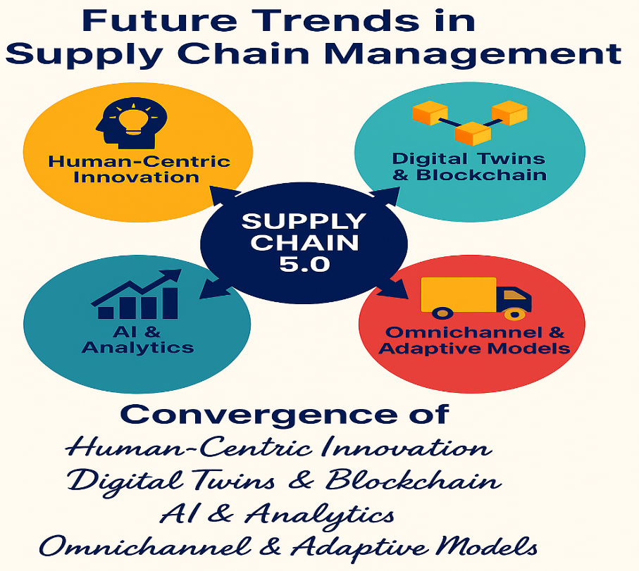

Keywords: Supply Chain 5.0, Artificial Intelligence (AI) in Supply Chain Management, Omnichannel Retailing and E-commerce, Innovation and Predictive Analytics in SCM, Adaptive and Resilient Supply Networks, Smart Logistics and Hospitality Applications
Abbreviations: SCM - Supply Chain Management, AI - Artificial Intelligence, IoT - Internet of Things, BDA - Big Data Analytics, CPS - Cyber-Physical Systems, IR 4.0 / IR 5.0 - Industrial Revolution 4.0 / 5.0, RFID - Radio Frequency Identification, ERP - Enterprise Resource Planning, ML - Machine Learning, AR/VR - Augmented Reality / Virtual Reality, ICT - Information and Communication Technology, KPI - Key Performance Indicator, 3PL - Third-Party Logistics, DSS - Decision Support System, SCMI - Supply Chain Management Innovation, SCI - Supply Chain Innovation

1. Introduction

1.1 Background and Significance of SCM Evolution
Supply Chain Management (SCM) has evolved from a functional logistics activity into a strategic, technology-driven, and innovation-centric discipline, shaping the competitive capabilities of organizations across industries. Traditionally, SCM focused on the movement and storage of goods from suppliers to customers. However, the advent of globalization, digitalization, and Industry 4.0 has transformed supply chains into highly integrated, data-driven ecosystems that create value through collaboration, analytics, and customer-centric approaches (Zijm and Klumpp, 2016).

The evolution of SCM can be divided into distinct phases - from logistics optimization (SCM 1.0) and integrated planning (SCM 2.0) to digital connectivity (SCM 3.0) and intelligent, autonomous networks (SCM 4.0 and 5.0). The current transition to Supply Chain 5.0 emphasizes human-centric, adaptive, and sustainable networks, merging advanced technologies such as artificial intelligence (AI), cyber-physical systems (CPS), Internet of Things (IoT), and big data analytics (BDA) with strategic decision-making (Frederico, 2021; Witkowski, 2017).

This transformation is not only technological but also strategic. Supply chains are now expected to support real-time decision-making, resilience against disruptions, and circular economy principles, while also driving customer experience and personalization in sectors like e-commerce, retail, and tourism (Wong et al., 2024; Wu et al., 2016). As digital technologies blur the boundaries between physical and digital networks, SCM becomes a crucial enabler of organizational agility and competitiveness in a volatile global landscape (Büyüközkan and Göçer, 2018).

1.2 Objective and Scope of this Review
The objective of this review is to synthesize and critically analyze contemporary research on the evolving landscape of supply chain management, focusing on five key thematic areas:
- Future Trends in SCM: Transition towards Supply Chain 5.0, sustainability, resilience, and the integration of emerging technologies.
- Innovation and Analytics: Role of predictive analytics, BDA, and digital platforms in decision-making and optimization.
- Omnichannel and E-commerce: Structural and strategic shifts in retail and logistics networks driven by omnichannel integration.
- Adaptive Models: Development of flexible, responsive, and data-driven SCM frameworks to address uncertainty and volatility.
- AI in Hospitality and Tourism: Applications of intelligent technologies in enhancing service delivery, personalization, and operational efficiency in service supply chains.

This paper aims to provide a comprehensive yet concise review that captures the state-of-the-art developments and identifies gaps, challenges, and future research directions across these dimensions. The insights will benefit both academic researchers and industry practitioners seeking to design adaptive, sustainable, and human-centric supply chains.

1.3 Research Methodology and Sources
This review adopts a systematic literature synthesis approach, analyzing 49 peer-reviewed journal articles, books, and conference papers published between 2003 and 2025. Sources were selected based on their relevance to digital transformation, innovation, analytics, omnichannel strategies, and AI applications in SCM, hospitality, and tourism.
The methodology involved three key stages:
- Literature Collection: Articles were identified through academic databases and verified against recent thematic relevance.
- Thematic Categorization: Literature was categorized into five core themes (SCM trends, analytics, omnichannel, adaptive models, and AI in services).
- Integrative Analysis: Findings were synthesized to develop a holistic perspective on current trends, challenges, and research gaps.
This staged evolution (Table 1) illustrates how SCM has evolved from operational efficiency to strategic enablement and is now transitioning towards human-machine collaboration and resilience. Figure 1 illustrates the transformation of SCM over five decades — from traditional logistics networks to intelligent, human-centric ecosystems. The trajectory underscores the growing importance of integrating technology, predictive analytics, and collaborative innovation in shaping future-ready supply chains.

Table 1: Evolution of Supply Chain Management Phases (Adapted from Zijm and Klumpp 2016; Witkowski 2017; Frederico 2021; Wong et al. 2024)

Phase | Period | Key Features | Strategic Focus | Technologies
SCM 1.0 | 1960–1980 | Basic logistics and inventory control | Cost reduction, efficiency | MRP, ERP
SCM 2.0 | 1980–2000 | Integrated supply chain planning | Coordination, lean practices | EDI, barcoding
SCM 3.0 | 2000–2015 | Global networks and collaboration | Agility, outsourcing | RFID, cloud
SCM 4.0 | 2015–2025 | Digital, smart, data-driven SCM | Real-time optimization, visibility | IoT, BDA, CPS
SCM 5.0 | 2025–Future | Human-centric, sustainable, adaptive networks | Resilience, personalization, sustainability | AI, digital twins, blockchain

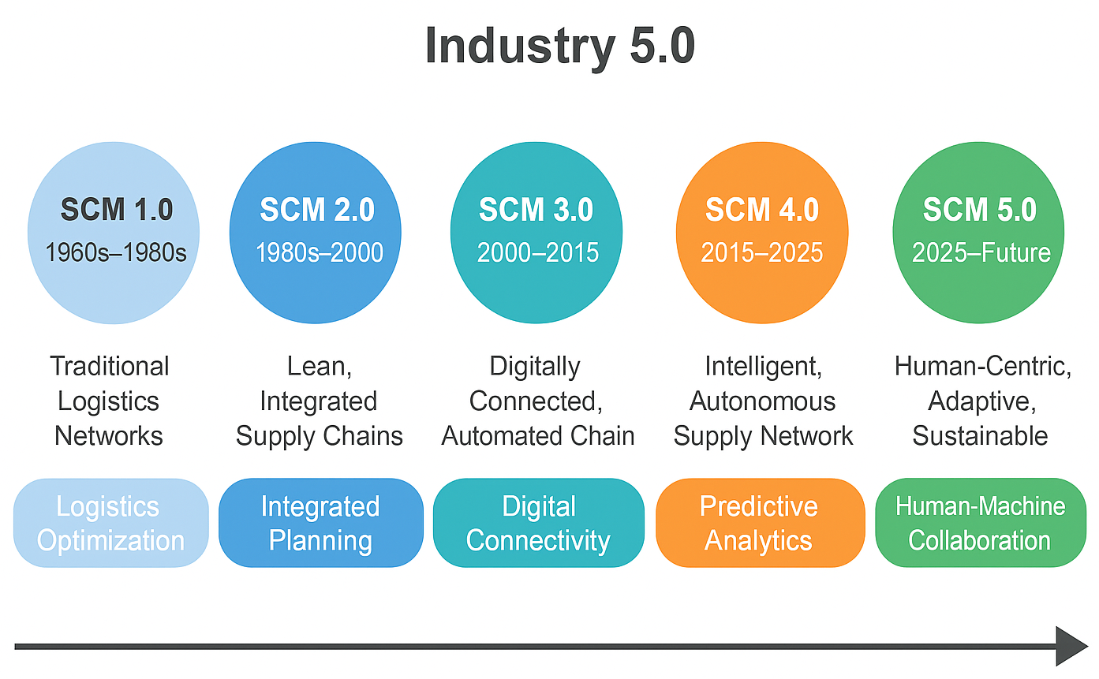
Figure 1: Conceptual Model of Supply Chain Evolution towards Industry 5.0
The evolution of supply chain management from traditional logistics to intelligent, human-centric networks reflects its growing strategic importance in a volatile global landscape. This review aims to synthesize emerging advancements - including digitalization, analytics, sustainability, and AI - shaping future-ready supply chains. Drawing on an extensive literature base, it explores technological, strategic, and operational transformations across industries. By defining the review’s scope and methodology, this section sets the foundation for a comprehensive analysis of trends, challenges, and innovations driving the transition toward Supply Chain 5.0.

2. Future Trends in Supply Chain Management
The rapid convergence of digital technologies, sustainability imperatives, and human-centric innovation is reshaping the strategic direction of global supply chains. The transition from Industry 4.0 to Industry 5.0 is no longer merely about automation and efficiency it is about building resilient, adaptive, and intelligent networks that integrate technology with human creativity, sustainability, and ethical considerations (Frederico, 2021; Wong et al., 2024). These future-ready supply chains embrace predictive capabilities, collaborative platforms, circular practices, and disruptive technologies to remain competitive in increasingly volatile and uncertain environments.

2.1 From Supply Chain 4.0 to 5.0: Human-Centric Innovation
Supply Chain 4.0 was characterized by the integration of cyber-physical systems (CPS), IoT, artificial intelligence (AI), and big data analytics to improve visibility, decision-making, and operational efficiency (Witkowski, 2017). These technologies enabled real-time tracking, demand forecasting, predictive maintenance, and automation of logistics operations (Wu et al., 2016). However, the paradigm is now shifting towards Supply Chain 5.0, which emphasizes the coexistence of human intelligence and machine capabilities to achieve strategic goals beyond efficiency - including resilience, sustainability, ethics, and personalization (Frederico, 2021).
Supply Chain 5.0 focuses on creating adaptive, human-in-the-loop systems where technology augments decision-making rather than replaces it. Human-centric innovation is evident in collaborative robots (“cobots”), ethical AI systems, and personalized logistics solutions that combine automation with contextual human judgment (Zijm and Klumpp, 2016). This transition also promotes cross-sector collaboration and interdisciplinary innovation, enhancing agility and responsiveness in complex ecosystems.

2.2 Sustainability, Circular Economy, and Resilience
Sustainability has shifted from a peripheral concern to a core strategic priority in SCM. Future supply chains must not only deliver products efficiently but also minimize carbon footprints, reduce waste, and enable resource recirculation (Lahane et al., 2020; Le et al., 2022). The concept of the circular supply chain - designed around the principles of reuse, remanufacturing, and recycling - is central to this transformation. These networks focus on closed-loop systems that retain value across the product lifecycle while addressing regulatory pressures and consumer demand for sustainable practices (Leising et al., 2018).
At the same time, resilience has become a fundamental design principle. Disruptions such as the COVID-19 pandemic, geopolitical conflicts and climate-related risks have exposed the vulnerabilities of global supply chains (Gunasekaran et al., 2015). Building resilience involves multi-sourcing, nearshoring, modular network design, and predictive risk management, supported by AI and data analytics (Chari et al., 2022). The integration of sustainability and resilience creates supply chains that are not only environmentally responsible but also strategically robust against disruptions.

2.3 Digital Twins, Blockchain, and Smart Contracts
Emerging technologies such as digital twins, blockchain, and smart contracts are redefining visibility, trust, and collaboration in modern supply chains.
- Digital twins — virtual replicas of physical assets and processes — enable real-time simulation, optimization, and scenario planning, significantly improving decision-making and risk management (Ganesan et al., 2009). They allow supply chain managers to test responses to disruptions, optimize flows, and evaluate sustainability impacts before implementing changes physically (Druehl et al., 2018).
- Blockchain technology enhances transparency, traceability, and trust by providing immutable records of transactions across the supply network (Rahmanzadeh et al., 2023). Its decentralized nature eliminates the need for intermediaries, reduces fraud, and ensures data integrity, particularly in industries like food, pharmaceuticals, and luxury goods.
- Smart contracts, self-executing agreements encoded on blockchain, automate key supply chain processes such as payments, customs clearance, and compliance checks, reducing delays and costs while enhancing trust between partners (Büyüközkan and Göçer, 2018).

Table 2 illustrates how emerging digital technologies are shifting SCM from reactive decision-making to proactive, data-driven orchestration. They form the technological backbone of future supply chains, enabling real-time visibility, autonomous execution, and trustless collaboration.

Table 2: Emerging Digital Technologies and Their Strategic Impact on SCM (Adapted from Druehl et al. 2018; Rahmanzadeh et al. 2023; Büyüközkan and Göçer 2018)

Technology | Core Function | Strategic Impact
Digital Twins | Virtual simulation and optimization | Enhanced decision-making and risk scenario testing
Blockchain | Immutable, decentralized ledger | Transparency, traceability, fraud reduction
Smart Contracts | Automated transaction execution | Cost reduction, efficiency, compliance automation

2.4 Transportation 4.0 and Logistics Transformation
Transportation is the backbone of supply chain networks, and its digital transformation — termed Transportation 4.0 - is integral to future SCM strategies. This transformation is driven by automation, electrification, IoT-enabled fleet management, and AI-based route optimization (Wong et al., 2024). Technologies like autonomous vehicles, drone deliveries, and real-time tracking systems enhance delivery speed, reliability, and cost-efficiency while reducing environmental impact (Yaqiong et al., 2018).
Transportation 4.0 also aligns closely with sustainability objectives. Smart routing algorithms and predictive maintenance significantly cut fuel consumption and emissions. Additionally, collaborative logistics platforms facilitate shared transportation networks, reducing empty miles and optimizing asset utilization (Facchini et al., 2019). As logistics operations evolve towards Transportation 5.0, the focus will shift toward human-centric, socially responsible, and carbon-neutral transport ecosystems.
Figure 2 visualizes the interconnected pillars shaping future SCM. At the intersection of human intelligence, sustainable practices, digital infrastructure, and smart mobility, organizations can build adaptive, ethical, and future-ready supply networks.
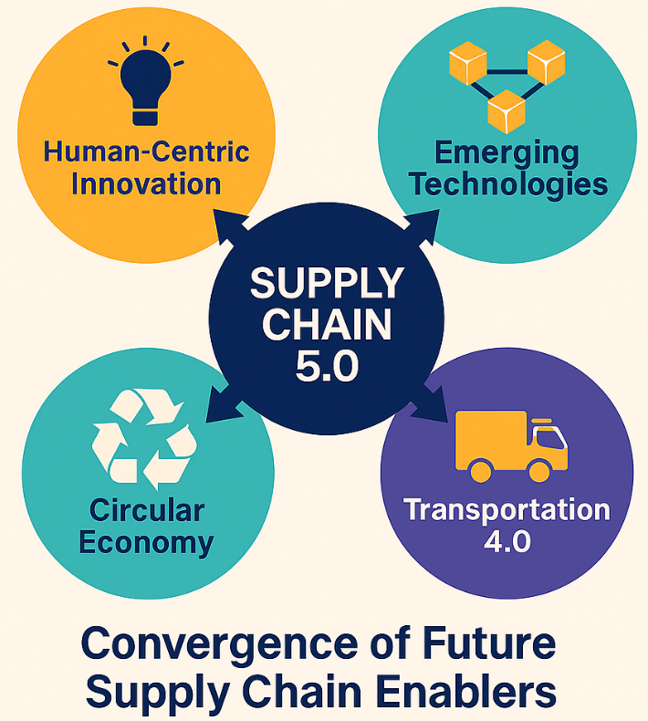
Figure 2: Convergence of Future Supply Chain Enablers
The future of supply chain management is defined by synergy - a convergence of technology, sustainability, human collaboration, and resilience. Moving beyond efficiency and cost, tomorrow’s supply chains will prioritize adaptability, ethical value creation, and societal impact. By integrating advanced technologies with circular models and human-centric design, organizations can create supply chains that are not only more intelligent but also more inclusive, sustainable, and future-proof.

3. Innovation and Analytics in SCM
Innovation and analytics have become the strategic backbone of modern supply chains, enabling companies to transform data into actionable intelligence, foster collaboration, and build competitive advantage. As supply chains become more complex, distributed, and dynamic, organizations are increasingly relying on predictive analytics, big data, digital platforms, and collaborative networks to achieve responsiveness, visibility, and innovation across the value chain (Maheshwari et al., 2021; Büyüközkan and Göçer, 2018).

3.1 Role of Predictive Analytics and BDA in Decision-Making
The explosion of digital data from IoT sensors, RFID tags, e-commerce transactions, and logistics platforms has transformed supply chain management into a data-driven discipline. Big Data Analytics (BDA) is now pivotal in converting vast, unstructured data into predictive insights that guide strategic, tactical, and operational decisions (Maheshwari et al., 2021).
Predictive analytics enables organizations to anticipate demand fluctuations, inventory requirements, supplier risks, and transportation bottlenecks, thereby reducing uncertainty and improving decision quality. Advanced machine learning models and AI algorithms can forecast demand with greater accuracy, optimize production schedules, and support dynamic pricing strategies (Ferreira et al., 2025). Furthermore, predictive risk modeling assists companies in proactively identifying vulnerabilities such as supplier insolvencies, weather disruptions, or geopolitical risks and devising mitigation strategies before disruptions occur (Witkowski, 2017).
Table 3 illustrates how predictive analytics enhances decision-making across the supply chain, converting raw data into strategic insights that improve efficiency, agility, and customer responsiveness.
Table 3: Key Applications of Big Data Analytics in Supply Chains (Adapted from Maheshwari et al. 2021; Ferreira et al. 2025; Witkowski 2017)

Functional Area | BDA Application Example | Strategic Impact
Demand Planning | Predictive demand forecasting | Reduced stockouts and overproduction
Inventory Management | Dynamic safety stock optimization | Lower carrying costs and higher service levels
Procurement | Supplier risk analytics | Better sourcing decisions and cost control
Transportation | Route optimization and predictive maintenance | Improved efficiency and reduced downtime
Customer Engagement | Personalized recommendations and fulfillment | Enhanced satisfaction and retention

3.2 Smart Supply Chains and Real-Time Visibility
The concept of smart supply chains represents a paradigm shift from linear, reactive systems to connected, intelligent, and autonomous networks. These systems integrate IoT, cyber-physical systems (CPS), and cloud-based platforms to enable real-time visibility and adaptive decision-making (Wu et al., 2016).
Smart supply chains continuously capture and analyze data from products, assets, and processes from raw material sourcing to last-mile delivery offering a “single source of truth” for stakeholders across the network. This visibility enables immediate detection of disruptions, improved demand-supply alignment, and enhanced customer service levels (Yaqiong et al., 2018). For example, IoT-enabled sensors can track shipment conditions, blockchain solutions can verify product provenance, and AI-powered control towers can orchestrate dynamic logistics decisions in real time (Wong et al., 2024).
Moreover, smart supply chains are inherently self-learning and adaptive, leveraging data feedback loops to continuously optimize network performance. This evolution is fundamental to achieving Supply Chain 5.0 objectives, agility, personalization, and sustainability in increasingly complex business ecosystems.

3.3 Digital Procurement and Collaborative Platforms
Procurement, traditionally a transactional function, is being revolutionized by digital technologies and collaborative platforms. The emergence of Procurement 4.0, characterized by AI-driven sourcing, cloud-based supplier networks, and blockchain enabled contract management, allows organizations to build more transparent, strategic, and collaborative supplier relationships (Bienhaus and Haddud, 2018).
Digital procurement platforms provide end-to-end visibility into supplier performance, automate tendering processes, and facilitate real-time collaboration across global supply networks. AI-powered analytics tools can assess supplier risks, predict price fluctuations, and identify innovation partners (Chari et al., 2022). Moreover, smart contracts automate agreements coded on blockchain streamline payment, compliance, and quality assurance processes, enhancing trust and reducing transaction costs (Rahmanzadeh et al., 2023).
Collaboration platforms also extend beyond sourcing. They enable co-innovation, where buyers and suppliers jointly design new products, develop sustainable materials, and optimize logistics processes. This collaborative approach accelerates innovation cycles and builds resilience by diversifying supplier ecosystems.

3.4 Innovation Networks and Scientific Collaboration
In the era of rapid technological change, innovation is no longer confined within organizational boundaries. Innovation networks collaborative ecosystems involving firms, research institutions, governments, and startups are emerging as critical enablers of supply chain transformation (Yuan et al., 2019).
These networks facilitate knowledge sharing, joint R&D, and cross-sector innovation, creating new business models and technologies that individual organizations might struggle to develop alone (Bustinza et al., 2019). Collaborative R&D in areas such as additive manufacturing, green logistics, and AI-based forecasting enhances the scalability and applicability of innovations (Melander and Pazirandeh, 2019).
Moreover, scientific collaboration strengthens supply chain resilience and adaptability by integrating cutting-edge research into practical solutions. For example, partnerships between logistics firms and universities have led to breakthroughs in autonomous vehicle deployment, predictive risk modeling, and sustainability-driven product design (Yuan et al., 2019).
Figure 3 illustrates how innovation and analytics converge to create future-ready supply chains. Predictive analytics drives decision-making, real-time visibility enables agility, digital procurement fosters collaboration, and innovation networks sustain continuous transformation together forming the foundation of Supply Chain 5.0.
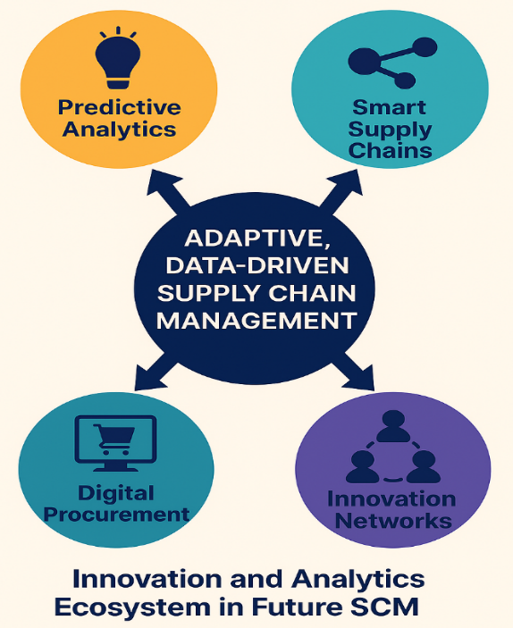
Figure 3: Innovation and Analytics Ecosystem in Future SCM
Innovation and analytics are at the heart of the next generation of supply chain management. Predictive analytics and big data empower decision-making with foresight, smart supply chains enable real-time adaptability, digital procurement fosters collaborative value creation, and innovation networks ensure continuous evolution. Together, these capabilities enable organizations to build data-driven, intelligent, and resilient supply chains that thrive amid complexity and change.

4. Omnichannel Retailing, E-Commerce, and Adaptive Models
The rapid digitalization of commerce, coupled with changing consumer expectations for speed, personalization, and convenience, has fundamentally redefined supply chain structures. Traditional linear logistics systems are increasingly being replaced by omnichannel and adaptive supply chain models that seamlessly integrate physical and digital channels, enabling real-time responsiveness and customer-centric operations (Jocevski et al., 2019; Iglesias-Pradas et al., 2022). In this context, supply chains are no longer mere conduits for goods but strategic enablers of experience-driven commerce, where agility, visibility, and personalization are competitive imperatives.

4.1 Evolution from Traditional Logistics to Omnichannel SCM
The evolution of retail supply chains has followed a progressive transformation from single-channel, linear logistics systems to multi-channel and finally to omnichannel networks. Traditional logistics focused primarily on cost minimization and bulk transportation from warehouses to retail stores. However, the rise of e-commerce, mobile commerce, and customer-centric retailing models has disrupted this paradigm, necessitating integrated, dynamic, and data-driven networks (Ganesan et al., 2009).
Omnichannel supply chain management (SCM) goes beyond simply selling across multiple platforms; it synchronizes inventory, order fulfillment, marketing, and customer service across online and offline touchpoints, delivering a seamless and consistent customer experience (Jocevski et al., 2019). Central to this transformation is the integration of real-time data analytics, predictive forecasting, and AI-driven decision-making, which align logistics operations with fluctuating consumer demand patterns (Mishra et al., 2021). Table 4 illustrates the strategic evolution of retail logistics from efficiency-oriented models to omnichannel ecosystems centered on agility, personalization, and customer experience.

Table 4: Evolution of Retail Supply Chains (Adapted from Jocevski et al. 2019; Iglesias-Pradas et al. 2022; Mishra et al. 2021)

Phase | Characteristics | Strategic Focus | Technologies Enablers
Traditional Logistics | Centralized, store-focused distribution | Cost minimization, efficiency | ERP, barcoding
Multi-Channel | Independent online & offline channels | Channel expansion, reach | E-commerce platforms, CRM
Omnichannel | Integrated customer journey, unified view | Seamless experience, agility, visibility | AI, IoT, predictive analytics, cloud

4.2 IoT-Driven Last-Mile Delivery and Real-Time Order Fulfillment
The last mile, the final leg of product delivery to the consumer, is one of the most critical and cost-intensive components of omnichannel SCM. The deployment of IoT technologies, real-time tracking systems, and AI-powered delivery optimization has transformed last-mile operations into a strategic differentiator (Kembro et al., 2018).
Smart devices and IoT sensors enable continuous visibility of shipments, while predictive analytics optimize delivery routes and schedules based on traffic conditions, weather, and customer preferences (Lim and Srai, 2018). Additionally, drones, autonomous vehicles, and crowdsourced delivery platforms are increasingly employed to reduce costs and accelerate delivery times (Wong et al., 2024).
Moreover, real-time order fulfillment systems allow dynamic allocation of inventory from warehouses, stores, or even supplier locations to meet immediate demand. This approach minimizes lead times and enhances service levels, which are vital for sectors like fashion, electronics, and groceries where speed is a key competitive factor (Yaqiong et al., 2018).

4.3 Adaptive and Demand-Responsive Supply Chain Models
The shift to omnichannel retailing has also accelerated the emergence of adaptive, demand-responsive supply chain models dynamic systems capable of adjusting operations based on real-time market signals. Unlike traditional push-based supply chains, these models rely on continuous data inputs from customer behavior, social media trends, and demand forecasts to tailor production, inventory, and logistics decisions (Pereira et al., 2018).
AI and machine learning play a pivotal role in predictive replenishment, enabling companies to forecast demand surges and automate restocking decisions (Risberg, 2023). Adaptive supply chains also support mass customization, allowing products to be configured closer to delivery time based on customer preferences (Iglesias-Pradas et al., 2022). This not only reduces waste but also enhances responsiveness to rapidly changing consumer expectations.

4.4 Integration of Physical and Digital Channels in Retail
At the heart of omnichannel transformation is the seamless integration of physical and digital retail ecosystems, often referred to as phygital commerce. This integration blurs the boundaries between online and offline experiences, for example, enabling customers to order online and pick up in-store (BOPIS), return e-commerce purchases in physical stores, or receive personalized promotions in real time while shopping in-store (Mishra et al., 2021).
Advanced technologies such as AI-driven personalization engines, augmented reality (AR) interfaces, and blockchain-based inventory tracking are key enablers of this integration (Iglesias-Pradas et al., 2022). Furthermore, unified commerce platforms consolidate customer data across touchpoints, providing retailers with a 360-degree view of consumer behavior and preferences (Jocevski et al., 2019). Figure 4 visualizes the structural integration of technologies and processes that enable omnichannel SCM. By combining physical infrastructure, digital intelligence, adaptive capabilities, and real-time logistics, organizations can deliver consistent, personalized, and frictionless customer experiences.

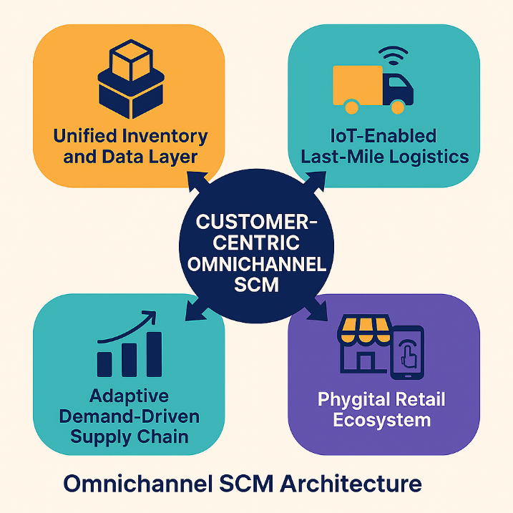

Figure 4: Omnichannel SCM Architecture
The evolution of supply chains into omnichannel, adaptive ecosystems marks a fundamental shift from operational efficiency to customer experience orchestration. IoT-driven logistics, demand-responsive models, and the convergence of physical and digital retail channels form the foundation of this transformation. As consumer expectations for immediacy and personalization continue to rise, future supply chains must embrace real-time intelligence, flexibility, and integration to remain competitive in a rapidly evolving commerce landscape.

5. AI Applications in Supply Chain, Hospitality, and Tourism
Artificial Intelligence (AI) has emerged as a transformative force across industries, driving operational efficiency, strategic intelligence, and customer-centric innovation. In supply chain management (SCM), hospitality, and tourism, AI is enabling organizations to predict demand, optimize logistics, personalize services, and build adaptive, data-driven ecosystems (Ferreira et al., 2025; Daios et al., 2025). The convergence of AI with other Industry 4.0 technologies such as big data, IoT, and blockchain is accelerating the shift towards autonomous, resilient, and hyper-personalized networks, redefining both industrial operations and customer experiences.

5.1 AI and Automation in Logistics and Demand Forecasting
AI plays a crucial role in transforming logistics operations by enhancing forecast accuracy, routing efficiency, and inventory management. Traditional forecasting models often struggle with demand volatility, seasonality, and rapid market changes. AI-driven algorithms, however, analyze vast data streams including historical sales, market signals, social trends, and weather conditions to generate highly accurate demand forecasts (Maheshwari et al., 2021).
In logistics, AI-powered optimization tools enhance supply chain visibility and operational efficiency. For instance, machine learning (ML) models optimize route planning by integrating real-time data such as traffic, fuel prices, and weather conditions (Wong et al., 2024). Autonomous guided vehicles (AGVs), drones, and robotic warehouse systems further automate transportation and fulfillment processes, reducing human error and accelerating order delivery (Wu et al., 2016).
Moreover, AI-driven predictive maintenance systems can anticipate equipment failures before they occur, minimizing downtime and reducing maintenance costs. This predictive capability significantly enhances supply chain resilience, a critical factor in today’s volatile global environment (Ganesan et al., 2009). Table 5 highlights the strategic roles of AI across supply chain functions, showcasing how predictive capabilities and automation together enhance responsiveness and resilience.

Table 5: Key Applications of AI in Supply Chain and Logistics (Adapted from Ferreira et al. 2025; Maheshwari et al. 2021; Wong et al. 2024)

Application Area | AI Functionality | Strategic Benefit
Demand Forecasting | ML-based predictive modeling | Improved accuracy, reduced stockouts
Transportation Planning | AI route optimization | Lower costs, faster deliveries
Warehouse Operations | Robotic automation, AGVs | Increased throughput, reduced labor costs
Predictive Maintenance | Equipment failure prediction | Reduced downtime, higher asset utilization

5.2 Generative AI for Strategic Decision-Making
Generative AI (GenAI), capable of producing new data, solutions, and strategies, is increasingly shaping the future of SCM and business decision-making. Unlike traditional AI, which analyzes historical data, GenAI can simulate future scenarios, design optimized networks, and generate strategic recommendations based on evolving market dynamics (Onotole et al., 2022).
In supply chain strategy, GenAI models integrate diverse data sources - from supplier performance metrics to geopolitical risk assessments to recommend procurement strategies, sourcing diversification, and risk mitigation plans (Rahmanzadeh et al., 2023). This proactive approach enables businesses to shift from reactive to anticipatory decision-making, strengthening competitive positioning.
Furthermore, GenAI is revolutionizing product design and service innovation by simulating customer preferences, optimizing pricing strategies, and even generating synthetic data for testing new business models (Aishwarya Shekhar, 2023). In complex global supply networks, these capabilities significantly reduce uncertainty, enhance agility, and support strategic foresight.

5.3 AI-Driven Personalization in Hospitality and Travel Services
AI’s transformative potential extends beyond industrial supply chains into hospitality and tourism, where it drives hyper-personalization, operational efficiency, and enhanced customer experience. By analyzing guest preferences, booking histories, social media behavior, and contextual data, AI systems deliver personalized recommendations, dynamic pricing, and tailored services (Ferreira et al., 2025).
For example, recommendation engines in travel platforms provide customized itineraries, while AI Chabot’s offer real-time assistance and multilingual customer support (Daios et al., 2025). Machine learning algorithms also power dynamic pricing models, adjusting room rates or travel packages based on demand, competition, and user behavior in real time (Aishwarya Shekhar, 2023).
AI further enables predictive guest experience management by anticipating service needs, such as suggesting amenities or scheduling maintenance before customer complaints arise. In tourism logistics, AI optimizes crowd control and transport flows, improving visitor satisfaction and sustainability (Pereira et al., 2018).

5.4 Case Studies: Adaptive AI Systems in Service Supply Chains
The integration of AI into service-oriented supply chains is already delivering measurable benefits across industries.
- Hospitality: Global hotel chains leverage AI-driven predictive analytics to optimize room occupancy, forecast demand, and personalize guest interactions. Marriott, for instance, uses AI-powered platforms to match customer preferences with available inventory, improving both revenue and satisfaction (Ferreira et al., 2025).
- Airline Industry: Airlines deploy AI algorithms to predict maintenance schedules, optimize flight paths, and offer personalized booking recommendations, enhancing efficiency and profitability (Daios et al., 2025).
- Tourism Platforms: Online travel agencies (OTAs) such as Expedia and Booking.com utilize AI chatbots and recommendation engines to deliver tailored travel experiences and improve conversion rates (Aishwarya Shekhar, 2023).
These cases demonstrate how AI capabilities from forecasting and automation to personalization and simulation are creating adaptive, resilient, and customer-centric supply chain ecosystems. Figure 5 visualizes how AI operates at multiple levels: operational, strategic, experiential, and adaptive, to transform both product-oriented and service-oriented supply chains. This multi-layered approach enables firms to optimize resources, enhance decision-making, and deliver hyper-personalized value to end users.

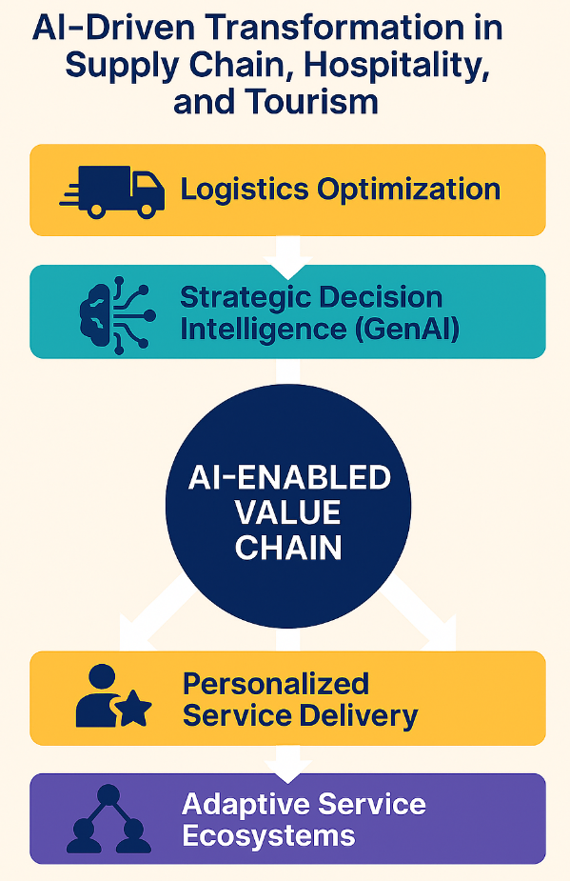

Figure 5: AI-Driven Transformation in Supply Chain, Hospitality, and Tourism
AI is not merely an operational tool; it is a strategic enabler reshaping supply chains, logistics networks, and service ecosystems. From predictive forecasting and autonomous logistics to generative decision intelligence and hyper-personalized experiences, AI unlocks new possibilities for efficiency, adaptability, and customer engagement. As AI technologies continue to evolve, their integration across industrial and service supply chains will become central to achieving resilience, competitiveness, and customer-centric growth.

6. Challenges and Future Research Directions
While digital transformation, AI, and data-driven innovation are revolutionizing supply chain management (SCM), omnichannel retailing, and service industries, these advancements are accompanied by critical challenges. As organizations transition toward Supply Chain 5.0 characterized by human-centric innovation, sustainability, and hyper-connectivity, they must address complex issues related to data security, workforce readiness, ethics, and interdisciplinary collaboration. Addressing these challenges is vital to ensuring that future supply chains are not only technologically advanced but also responsible, inclusive, and sustainable (Zijm and Klumpp, 2016; Wong et al., 2024).

6.1 Data Privacy, Cybersecurity, and Ethical Considerations
One of the most pressing challenges in the era of digital supply chains is the protection of data privacy and cybersecurity. The extensive use of IoT, cloud platforms, blockchain, and AI means that supply chains now generate, store, and share vast amounts of sensitive data across multiple stakeholders (Witkowski, 2017). While this data enables predictive analytics, real-time visibility, and automation, it also increases the risk of cyberattacks, data breaches, and unauthorized surveillance (Büyüközkan and Göçer, 2018).
Moreover, the ethical use of AI and data has become a major concern. Algorithmic bias, lack of transparency in AI decision-making, and the potential misuse of personal or operational data can lead to discriminatory outcomes and reputational damage (Rahmanzadeh et al., 2023). To mitigate these risks, organizations must adopt robust cybersecurity frameworks, ethical AI governance models, and data sovereignty regulations, while ensuring compliance with global standards such as GDPR and ISO/IEC 27001 (Aishwarya Shekhar, 2023).

6.2 Bridging Human–Machine Collaboration in Industry 5.0
The transition from Industry 4.0 to Industry 5.0 introduces a paradigm where human intelligence and machine capabilities work synergistically to drive innovation and decision-making. However, achieving effective human-machine collaboration presents both technological and organizational challenges (Frederico, 2021).
Organizations must balance automation with human oversight, ensuring that workers remain in control of strategic and ethical decisions while machines handle repetitive and data-intensive tasks. Collaborative robots (cobots), AI-driven decision support systems, and human-in-the-loop interfaces are essential for this balance (Zijm and Klumpp, 2016). Additionally, there is a need to address employee resistance to automation, foster trust in AI systems, and design interfaces that enhance rather than replace human capabilities (Melander and Pazirandeh, 2019). Table 6 highlights the main barriers to achieving seamless human–machine collaboration and suggests strategic responses to overcome them.

Table 6: Key Barriers to Effective Human–Machine Collaboration (Adapted from Frederico 2021; Melander and Pazirandeh 2019; Rahmanzadeh et al. 2023)

Challenge | Implication | Strategic Response
Resistance to automation | Reduced adoption and trust | Change management and stakeholder engagement
Algorithmic opacity | Lack of explainability in decision-making | Use of explainable AI (XAI) frameworks
Skill–technology mismatch | Limited workforce capability | Targeted training and upskilling programs
Ethical and governance concerns | Risk of biased or harmful outcomes | Ethical AI policies and continuous auditing

6.3 Skill Gaps and Workforce Transformation
As supply chains become increasingly automated, digitalized, and AI-driven, the workforce must undergo a significant transformation. There is a growing skills gap in areas such as data science, machine learning, robotics, and cybersecurity (Maheshwari et al., 2021). Traditional logistics and procurement skills are no longer sufficient; instead, future supply chain professionals must be equipped with hybrid competencies that combine technical expertise, analytical thinking, and strategic decision-making (Bustinza et al., 2019).
In addition, organizations must invest in lifelong learning, reskilling, and cross-disciplinary training to prepare workers for evolving roles. Academic institutions, industry associations, and governments must collaborate to develop curricula and certification programs that align with the needs of Industry 5.0 supply chains (Wong et al., 2024). The workforce transformation is not merely about technical skill acquisition it is also about fostering digital literacy, ethical awareness, and collaborative problem solving.

6.4 Future Opportunities for Interdisciplinary Research
Future research in supply chain management, innovation, and service ecosystems must adopt a holistic, interdisciplinary approach. The convergence of technologies such as AI, blockchain, quantum computing, and digital twins opens new avenues for predictive modeling, decision intelligence, and autonomous operations (Ferreira et al., 2025). At the same time, social sciences, behavioral economics, and ethics offer crucial insights into designing trustworthy, human-centered systems (Yuan et al., 2019).
Emerging research opportunities include:
- AI Governance and Responsible Innovation: Frameworks for ethical, transparent, and accountable AI systems in supply chains.
- Digital Twin-Enabled Resilience Modeling: Integrated models for proactive disruption management and sustainability planning.
- Behavioral Human–AI Interfaces: Studies on trust, adoption, and collaborative intelligence in hybrid decision-making.
- Sustainability and Circularity Analytics: Quantifying and optimizing environmental and social impacts of digital supply networks.

Figure 6 visualizes the research roadmap for future supply chain ecosystems, highlighting the critical intersections of technology, ethics, human collaboration, and sustainability. These pillars will define the next decade of research and innovation in global SCM.

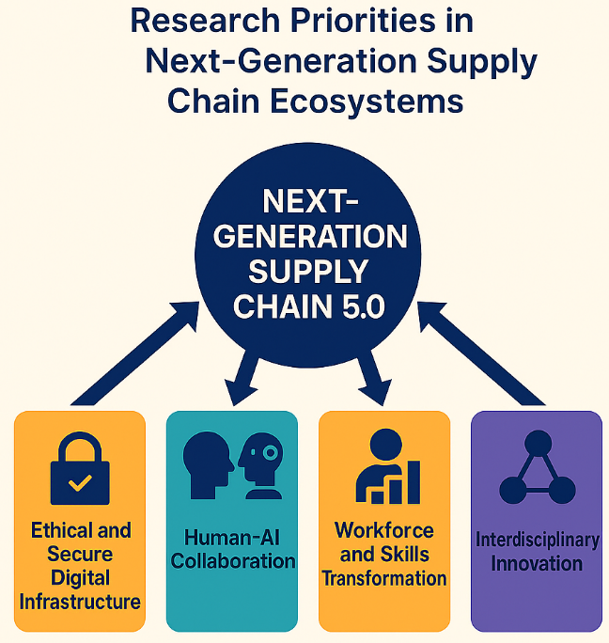

Figure 6: Research Priorities in Next-Generation Supply Chain Ecosystems

While supply chain innovation, AI, and omnichannel ecosystems offer transformative potential, they also pose significant challenges related to security, governance, workforce readiness, and interdisciplinary integration. Addressing these issues requires a concerted effort from academia, industry, and policymakers. By focusing on ethical innovation, human-centric design, workforce empowerment, and cross-disciplinary collaboration, the next generation of supply chains can achieve not only technological excellence but also societal trust, inclusivity, and long-term sustainability.

7. Conclusion

7.1 Summary of Key Findings
The global landscape of supply chain management (SCM) is undergoing a profound transformation, driven by rapid technological advancements, evolving consumer expectations, sustainability imperatives, and geopolitical complexities. This review has explored how emerging trends such as Supply Chain 5.0, AI and analytics, omnichannel integration, and adaptive models are redefining operational, strategic, and service dimensions across industries (Zijm and Klumpp, 2016; Wong et al., 2024).
Key findings from the review highlight four central paradigms shaping the future of SCM:
- Human-Centric Innovation and Industry 5.0: Future supply chains will prioritize synergy between humans and machines, focusing on ethical AI, personalization, and collaborative intelligence (Frederico, 2021).
- Sustainability and Circular Economy: Environmental stewardship, resource efficiency, and resilience are becoming strategic imperatives, embedding circular practices into global supply networks (Lahane et al., 2020).
- Data-Driven Decision-Making: Predictive analytics, big data, digital twins, and generative AI are enabling real-time visibility, proactive planning, and strategic foresight (Ferreira et al., 2025).
- Service Personalization and Omnichannel Experience: Seamless integration of physical and digital retail ecosystems, coupled with AI-driven personalization, is reshaping consumer experiences and service supply chains (Iglesias-Pradas et al., 2022).
Together, these trends represent a shift from linear, cost-focused supply chains to intelligent, sustainable, customer-centric ecosystems designed to thrive amid complexity and uncertainty.

7.2 Implications for Academia, Industry, and Policymakers
The future of SCM extends beyond corporate strategy it holds profound implications for research, industry practices, and policy formulation.
For Academia: There is a growing need for interdisciplinary research integrating operations management, AI, sustainability science, and behavioral studies. Future scholarship must address pressing challenges such as ethical AI governance, data privacy, circular supply chains, and human–AI collaboration (Yuan et al., 2019; Rahmanzadeh et al., 2023).
For Industry: Firms must invest in digital infrastructure, workforce upskilling, and collaborative innovation networks to remain competitive. Strategic capabilities such as predictive analytics, digital procurement, and adaptive logistics will differentiate leaders from laggards in the new supply chain landscape (Büyüközkan and Göçer, 2018).
For Policymakers: Governments play a crucial role in establishing regulatory frameworks around data protection, sustainability reporting, and cross-border digital trade. Public–private partnerships and innovation ecosystems will be essential to scale emerging technologies and address systemic challenges such as supply chain resilience and ethical AI deployment (Carter and Easton, 2011). Table 7 outlines how academia, industry, and governments must collaborate to build resilient, ethical, and human-centric supply chains that serve broader societal goals.

Table 7: Strategic Implications Across Key Stakeholders (Adapted from Carter and Easton 2011; Rahmanzadeh et al. 2023; Wong et al. 2024)

Stakeholder | Strategic Imperatives | Key Priorities for Action
Academia | Interdisciplinary research, ethical frameworks, behavioral AI | Develop new theories, models, and experimental platforms
Industry | Digital transformation, collaborative innovation | Invest in AI, IoT, analytics, and workforce reskilling
Policymakers | Data governance, circular economy policies, trade facilitation | Enact regulations, fund public–private innovation hubs

7.3 Strategic Roadmap for Future Supply Chains
Designing future-ready supply chains requires a holistic approach that integrates technology, sustainability, governance, and human capital. The roadmap below offers a vision for the next decade of SCM evolution:
- Embed Ethical and Sustainable Principles: Incorporate environmental, social, and governance (ESG) metrics into all stages of the supply chain, from sourcing to delivery (Le et al., 2022).
- Accelerate Digital Transformation: Deploy AI, digital twins, blockchain, and advanced analytics for visibility, traceability, and predictive decision-making (Druehl et al., 2018).
- Foster Human–Machine Collaboration: Design systems where AI augments human creativity, ensuring transparency, trust, and inclusivity (Melander and Pazirandeh, 2019).
- Develop Resilient Ecosystems: Build modular, adaptive, and multi-sourced networks capable of responding to disruptions and shifting global dynamics (Gunasekaran et al., 2015).
- Strengthen Global Partnerships: Promote collaboration across industries, academia, and governments to tackle shared challenges and harness collective innovation (Bustinza et al., 2019).

Figure 7 visualizes a forward-looking roadmap for SCM evolution. By integrating sustainability, digital intelligence, human collaboration, resilience, and global cooperation, organizations can create agile, future-proof supply chains aligned with societal and economic priorities.

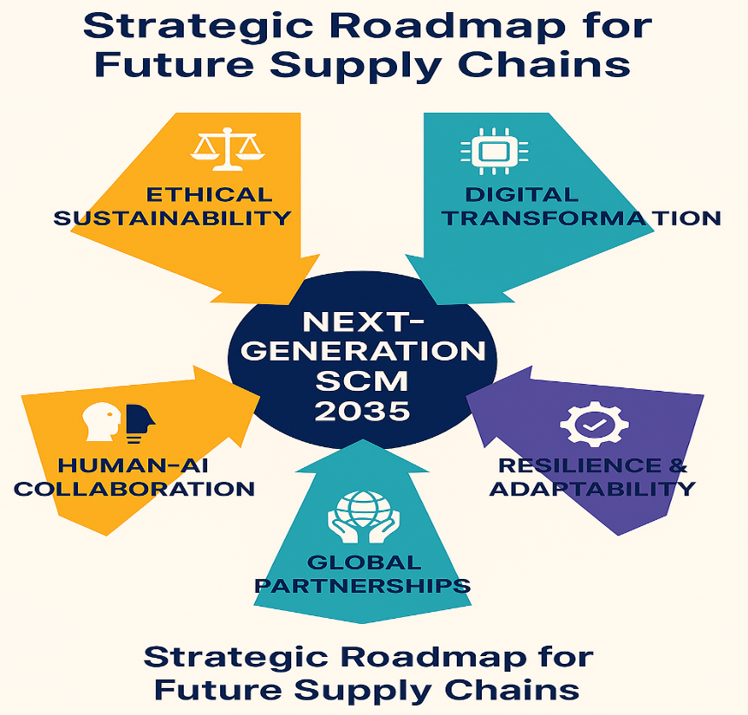

Figure 7: Strategic Roadmap for Future Supply Chains
The transition to Supply Chain 5.0 marks a fundamental reimagining of how supply networks create value not just for businesses, but also for society. Future supply chains will be intelligent, sustainable, adaptive, and deeply human-centered. They will leverage AI and analytics to anticipate demand, collaborate across ecosystems, and deliver personalized, ethical, and resilient solutions. As technology and humanity converge, the supply chain will no longer be a cost center it will be a strategic catalyst for innovation, sustainability, and global prosperity.
Acknowledgments. A third level heading in 9-point font size at the end of the paper is used for general acknowledgments, for example: This study was funded by X (grant number Y).
Disclosure of Interests. It is now necessary to declare any competing interests or to specifically state that the authors have no competing interests. Please place the statement with a third level heading in 9-point font size beneath the (optional) acknowledgments, for example: The authors have no competing interests to declare that are relevant to the content of this article. Or: Author A has received research grants from Company W. Author B has received a speaker honorarium from Company X and owns stock in Company Y. Author C is a member of committee Z.

References
Ageron, B., Bentahar, O., Gunasekaran, A., 2020. Digital supply chain: challenges and future directions. Supply Chain Forum: An International Journal 21, 133–138. https://doi.org/10.1080
/16258312.2020.1816361
Aishwarya Shekhar, E.Al., 2023. Generative AI in Supply Chain Management. IJRITCC 11, 4179–4185. https://doi.org/10.17762/ijritcc.v11i9.978
Bienhaus, F., Haddud, A., 2018. Procurement 4.0: factors influencing the digitisation of procurement and supply chains. BPMJ 24, 965–984. https://doi.org/10.1108/BPMJ-06-2017-0139
Bustinza, O.F., Gomes, E., Vendrell-Herrero, F., Baines, T., 2019. Product–service innovation and performance: the role of collaborative partnerships and R&D intensity. R &amp; D Management 49, 33–45. https://doi.org/10.1111/radm.12269
Büyüközkan, G., Göçer, F., 2018. Digital Supply Chain: Literature review and a proposed framework for future research. Computers in Industry 97, 157–177. https://doi.org/10.1016/j.compind.2018.02.010
Carter, C.R., Liane Easton, P., 2011. Sustainable supply chain management: evolution and future directions.International Journal of Physical Distribution & Logistics Management 41, 46–62. https://doi.org/10.1108/09600031111101420
Chari, A., Niedenzu, D., Despeisse, M., Machado, C.G., Azevedo, J.D., Boavida-Dias, R., Johansson, B., 2022. Dynamic capabilities for circular manufacturing supply chains—Exploring the role of Industry 4.0 and resilience. Bus Strat Env 31, 2500–2517. https://doi.org/10.1002/bse.3040
Daios, A., Kladovasilakis, N., Kelemis, A., Kostavelis, I., 2025. AI Applications in Supply Chain Management: A Survey. Applied Sciences 15, 2775. https://doi.org/10.3390/app15052775
Druehl, C., Carrillo, J., Hsuan, J., 2018. Technological Innovations: Impacts on Supply Chains, in: Moreira, A.C., Ferreira, L.M.D.F., Zimmermann, R.A. (Eds.), Innovation and Supply Chain Management, Contributions to Management Science. Springer International Publishing, Cham, pp. 259–281. https://doi.org/10.1007/978-3-319-74304-2_12
Febriani, A., Sopha, B.M., Arif Wibisono, M., 2025. Dynamic capabilities for omnichannel transformation in MSMEs: A comparative case study of fashion and furniture sectors. Journal of Open Innovation: Technology, Market, and Complexity 11, 100498. https://doi.org/10.1016/j.joitmc.2025.100498
Ferreira, A.C.A., Francisco, M.B., Pinho, A.F.D., 2025. The Use of Artificial Intelligence in Supply Chain Management: Systematic Literature Review and Future Research Directions. IEEE Access 13, 157828–157841. https://doi.org/10.1109/ACCESS.2025.3603866
Fornasiero, R., Sardesai, S., Barros, A.C., Matopoulos, A. (Eds.), 2021. Next Generation Supply Chains: A Roadmap for Research and Innovation, Lecture Notes in Management and Industrial Engineering.
Springer International Publishing, Cham. https://doi.org/10.1007/978-3-030-63505-3
Ganesan, S., George, M., Jap, S., Palmatier, R.W., Weitz, B., 2009. Supply Chain Management and Retailer Performance: Emerging Trends, Issues, and Implications for Research and Practice. Journal of Retailing 85, 84–94. https://doi.org/10.1016/j.jretai.2008.12.001
Gunasekaran, A., Subramanian, N., Rahman, S., 2015. Supply chain resilience: role of complexities and strategies. International Journal of Production Research 53, 6809–6819. https://doi.org/10.1080/00207543.2015.109366
Iglesias-Pradas, S., Acquila-Natale, E., Del-Río-Carazo, L., 2022. Omnichannel retailing: a tale of three sectors. Economic Research-Ekonomska Istraživanja 35, 3305–3336. https://doi.org/10.1080/1331677X.2021.1991825
Jajja, M.S.S., Asif, M., Shah, S.A.A., Chatha, K.A., 2020. Supply chain innovation research: content analysis based review. BIJ 27, 666–694. https://doi.org/10.1108/BIJ-09-2018-0297
Jocevski, M., Arvidsson, N., Miragliotta, G., Ghezzi, A., Mangiaracina, R., 2019. Transitions towards omni- channel retailing strategies: a business model perspective. IJRDM 47, 78–93. https://doi.org/10.1108/IJRDM-08-2018-0176
Johnson, G.I., Hofman, P.J., 2004. Agriproduct Supply-Chain Management in Developing Countries.
Kembro, J.H., Norrman, A., Eriksson, E., 2018. Adapting warehouse operations and design to omni-channel logistics: A literature review and research agenda. IJPDLM 48, 890–912. https://doi.org/10.1108/IJPDLM-01-2017-0052
Kemppainen, K., Vepsäläinen, A.P.J., 2003. Trends in industrial supply chains and networks. International Journal of Physical Distribution & Logistics Management 33, 701–719. https://doi.org/10.1108/09600030310502885
Lahane, S., Kant, R., Shankar, R., 2020. Circular supply chain management: A state-of-art review and future opportunities. Journal of Cleaner Production 258, 120859. https://doi.org/10.1016/j.jclepro.2020.120859
Lambert, D.M., Enz, M.G., 2017. Issues in Supply Chain Management: Progress and potential. Industrial Marketing Management 62, 1–16. https://doi.org/10.1016/j.indmarman.2016.12.002
Le, T.T., Vo, X.V., Venkatesh, V.G., 2022. Role of green innovation and supply chain management in driving sustainable corporate performance. Journal of Cleaner Production 374, 133875. https://doi.org/10.1016/j.jclepro.2022.133875
Leising, E., Quist, J., Bocken, N., 2018. Circular Economy in the building sector: Three cases and a collaboration tool. Journal of Cleaner Production 176, 976–989. https://doi.org/10.1016/j.jclepro.2017.12.010
Liao, S.-H., Hu, D.-C., Ding, L.-W., 2017. Assessing the influence of supply chain collaboration value innovation, supply chain capability and competitive advantage in Taiwan’s networking communication industry. International Journal of Production Economics 191, 143–153. https://doi.org/10.1016/j.ijpe.2017.06.001
Lim, S.F.W.T., Srai, J.S., 2018. Examining the anatomy of last-mile distribution in e-commerce omnichannel retailing: A supply network configuration approach. IJOPM 38, 1735–1764. https://doi.org/10.1108/IJOPM-12-2016-0733
Maheshwari, S., Gautam, P., Jaggi, C.K., 2021. Role of Big Data Analytics in supply chain management: current trends and future perspectives. International Journal of Production Research 59, 1875–1900. https://doi.org/10.1080/00207543.2020.1793011
Melander, L., 2018. Customer and Supplier Collaboration in Green Product Innovation: External and Internal Capabilities. Bus Strat Env 27, 677–693. https://doi.org/10.1002/bse.2024
Melander, L., Pazirandeh, A., 2019. Collaboration beyond the supply network for green innovation: insight from 11 cases. SCM 24, 509–523. https://doi.org/10.1108/SCM-08-2018-0285
Mishra, R., Singh, R.K., Koles, B., 2021. Consumer decision-making in omnichannel retailing: Literature review and future research agenda. Int J Consumer Studies 45, 147–174. https://doi.org/10.1111/ijcs.12617
Onotole, E.F., Ogunyankinnu, T., Adeoye, Y., Osunkanmibi, A.A., Aipoh, G., Egbemhenghe, J., 2022. The Role of Generative AI in developing new Supply Chain Strategies- Future Trends and Innovations.
IJMRGE 3, 638–646. https://doi.org/10.54660/.IJMRGE.2022.3.1-638-646
Pereira, M.M., De Oliveira, D.L., Portela Santos, P.P., Frazzon, E.M., 2018. Predictive and Adaptive Management Approach for Omnichannel Retailing Supply Chains. IFAC-PapersOnLine 51, 1707–1713. https://doi.org/10.1016/j.ifacol.2018.08.210
Pfohl, H.-C., Yahsi, B., n.d. The Impact of Industry Supply Chain.
Pietrobelli, C., Marin, A., Olivari, J., 2018. Innovation in mining value chains: New evidence from Latin America. Resources Policy 58, 1–10. https://doi.org/10.1016/j.resourpol.2018.05.010
Rahmanzadeh, S., Pishvaee, M.S., Govindan, K., 2023. Emergence of open supply chain management: the role of open innovation in the future smart industry using digital twin network. Ann Oper Res 329, 979–1007. https://doi.org/10.1007/s10479-021-04254-2
Risberg, A., 2023. A systematic literature review on e-commerce logistics: towards an e-commerce and omni-channel decision framework. The International Review of Retail, Distribution and Consumer Research 33, 67–91. https://doi.org/10.1080/09593969.2022.2089903
Roy, S., Sivakumar, K., Wilkinson, I.F., 2004. Innovation Generation in Supply Chain Relationships: A Conceptual Model and Research Propositions. j acad market sci 32, 61–79. https://doi.org/10.1177/0092070303255470
Sallam, K., Mohamed, M., Wagdy Mohamed, A., 2023. Internet of Things (IoT) in Supply Chain Management: Challenges, Opportunities, and Best Practices. Sustain. Mach. Intell. J. 2. https://doi.org/10.61185/SMIJ.2023.22103
Storer, M., Hyland, P., Ferrer, M., Santa, R., Griffiths, A., 2014. Strategic supply chain management factors influencing agribusiness innovation utilization. The International Journal of Logistics Management 25, 487–521. https://doi.org/10.1108/IJLM-02-2013-0026
Tebaldi, L., Bigliardi, B., Bottani, E., 2018. Sustainable Supply Chain and Innovation: A Review of the Recent Literature. Sustainability 10, 3946. https://doi.org/10.3390/su10113946
Vivona, R., Demircioglu, M.A., Audretsch, D.B., 2023. The costs of collaborative innovation. J Technol Transf 48, 873–899. https://doi.org/10.1007/s10961-022-09933-1
Wieland, A., Handfield, R.B., Durach, C.F., 2016. Mapping the Landscape of Future Research Themes in Supply Chain Management. J of Business Logistics 37, 205–212. https://doi.org/10.1111/jbl.12131
Witkowski, K., 2017. Internet of Things, Big Data, Industry 4.0 – Innovative Solutions in Logistics and Supply Chains Management. Procedia Engineering 182, 763–769. https://doi.org/10.1016/j.proeng.2017.03.197
Wong, C.Y., Wong, C.W.Y., Boon-itt, S., 2020a. Effects of green supply chain integration and green innovation on environmental and cost performance. International Journal of Production Research 58, 4589–4609. https://doi.org/10.1080/00207543.2020.1756510
Wong, W.P., Anwar, M.F., Soh, K.L., 2024. Transportation 4.0 in supply chain management: State-of-the-art and future directions towards 5.0 in the transportation sector. Oper Manag Res 17, 683–710. https://doi.org/10.1007/s12063-024-00471-7
Wu, L., Yue, X., Jin, A., Yen, D.C., 2016. Smart supply chain management: a review and implications for future research. The International Journal of Logistics Management 27, 395–417. https://doi.org/10.1108/IJLM-02-2014-0035
Yaqiong, L., Lei, T., Lee, C.K.M., Xin, T., 2018. IoT based Omni-Channel Logistics Service in Industry 4.0, in: 2018 IEEE International Conference on Service Operations and Logistics, and Informatics (SOLI). Presented at the 2018 IEEE International Conference on Service Operations and Logistics, and Informatics (SOLI), IEEE, Singapore, pp. 240–243. https://doi.org/10.1109/SOLI.2018.8476708
Yuan, C.-H., Wu, Y.J., Tsai, K., 2019. Supply Chain Innovation in Scientific Research Collaboration. Sustainability 11, 753. https://doi.org/10.3390/su11030753
Zijm, H., Klumpp, M., 2016. Logistics and Supply Chain Management: Developments and Trends, in:
Zijm, H., Klumpp, M., Clausen, U., Hompel, M.T. (Eds.), Logistics and Supply Chain Innovation, Lecture Notes in Logistics. Springer International Publishing, Cham, pp. 1–20. https://doi.org/10.1007/978-3-319-22288-2_1

If EquinOCS, our proceedings submission system, is used, then the disclaimer can be provided directly in the system.

