School Library Network Design: Infrastructure, Topology, and Floor Plan Development

ABSTRACT
Modern school libraries increasingly rely on digital technologies to support services such as internet access, database management, RFID-based book tracking, printer sharing, and public access terminals. To ensure the efficient delivery of these services, a reliable and scalable network infrastructure is essential. This study proposes the design and simulation of a Local Area Network (LAN) for a school library using Star Topology. The primary objective of the study is to develop a network design that supports library operations while ensuring functionality, scalability, security, and ease of maintenance.
The proposed network consists of computers, a database server, printer, router, switch, access point, and RFID reader interconnected through a central switch. Cisco Packet Tracer was utilized to simulate the network and evaluate the connectivity and communication among network devices, while SweetHome 3D was used to develop the library floor plan and determine the optimal placement of network components. The design process included network requirement analysis, topology selection, and floor plan development
Results of the simulation demonstrated that the proposed network design can effectively support internet connectivity, resource sharing, database access, RFID services, and communication among network devices. Furthermore, the Star Topology provided a reliable and manageable network structure with the flexibility to accommodate future expansion. The study concludes that the proposed LAN design is a suitable solution for modern school library environments and may serve as a reference for future network planning and implementation in educational institutions.
Keywords: Local Area Network (LAN), Star Topology, School Library, Cisco Packet Tracer, RFID System, Network Design, SweetHome 3D.
INTRODUCTION
Modern libraries no longer rely only on books and manual record keeping. These days, a lot of libraries use computer networks to support digital services like database management, RFID-based book tracking, online catalog access, internet services, and printer sharing. Because of this, maintaining the effectiveness, security, and dependability of library operations requires a well-designed network architecture. This study presents the proposed network design for a school library that includes public access terminals, RFID systems, a database server, printer sharing services, and internet access control. The network aims to provide fast communication between devices while maintaining centralized management and security. According to Cisco Networking Academy (2017), a properly designed Local Area Network (LAN) improves resource sharing, communication, and network performance within an organization. Similarly, Cisco Systems emphasizes that campus and building networks should be designed using a structured and scalable approach to support future growth and easier maintenance.
The Star Topology was found by the researchers to be the best network topology for the school library in this project. All devices are linked to a central switch in a star topology, which facilitates effective data transfer between PCs, servers, printers, RFID readers, and internet services. This topology provides better fault isolation, more scalability, and easier than bus or ring topologies. The network normally even if a single device fails. According to Athuraliya (2026), star topology simplifies network administration and makes it easier to add or remove devices without affecting the system as a whole. According to Omnisecu (n.d.), star topology is frequently utilized in Ethernet-based LAN setups due to its dependability and simplicity of upkeep.
In addition to being easy to connect to, the star topology also makes the network usable for the day-to-day operation of the library. It allows devices to operate without "bottlenecking" each other, such as multiple patrons conducting research at the same time without causing lag or interruption to background tasks such as the RFID reader. Due to each device having its own connection to the switch, collisions do not occur unlike older bus topologies where every device shared the same connection. If something goes wrong with a workstation not connecting to the network, it also makes it easier for library techs to figure out which cable or port on the switch isn't working, as opposed to having to disconnect the entire library from the network to figure out why one computer is down.
This type of implementation involves using reliable hardware devices according to the needs of our particular traffic and security demands. The heart of the system that we implemented consists of a 24-Port Gigabit Ethernet Switch, which gives plenty of room for the eight PC or the Public Access terminal as well as other devices in addition to providing enough space for further development. Each computer contains an Intel Core i5 (10th Gen) processor with 8GB RAM in order to ensure that students are able to use their computing device for multiple purposes. The fast 300Mbps Fiber Internet connectivity system has been connected to this network in such a way that it allows the Database Server (powered by an Intel Core i7) to synchronize with the RFID Reader in real time.

Problem Statement

The modern school libraries depend on digital services such as internet access, database management, RFID tracking of books, and printing facility. The effective provision of all these services requires a sound networking structure to facilitate efficient communication. In the absense of an appropriate network architecture, connectivity problems, performance problems, and network management problems can occur. Thus, the objective of the research is to propose a scalable and efficient LAN design for a school library based on the star topology through the use of Cisco Packet Tracer simulation tool.

- What network topology is most suitable for the proposed school library network?
- How can a LAN be designed to support internet access, RFID services, database management, printer sharing, and public access terminals?
- How can Cisco Packet Tracer be used to simulate and evaluate the proposed network design?

General Objectives

To design and simulate a reliable, scalable, and efficient Local Area Network (LAN) for a school library using Star Topology and Cisco Packet Tracer to support modern library services and resource sharing.

- To identify the network requirements needed to support the operations and services of the school library.
- To develop a Local Area Network (LAN) design and floor plan using Star Topology for efficient communication and resource sharing.
- To simulate and evaluate the proposed network design in terms of functionality, scalability, and maintainability.

Significance of the Study

This study is significant as it presents a proposed Local Area Network (LAN) design for a school library aimed at enhancing the efficiency, reliability, and accessibility of library services. The proposed network design supports essential library operations, including internet access, database management, RFID-based system, and resource sharing among network devices. Furthermore, the study contributes to the effective integration of information technology in educational environments and may serve as a valuable reference for future network planning, development, and implementation initiatives in schools and other academic institutions.

Scope and Delimitation

This study focuses on the design and simulation of a Local Area Network (LAN) for a school library using Cisco Packet Tracer and SweetHome 3D. The proposed network includes devices such as computers, a server, a printer, an access point, a router, a switch, and an RFID reader connected through a Star Topology. The study is limited to the conceptual design, simulation, and evaluation of the network's functionality, scalability, security, and maintainability. Actual hardware installation, network deployment, and real-world performance testing are not included in the scope of the study.

METHODOLOGY
A simulation of the proposed network was carried out using the Cisco Packet Tracer software. The simulation was employed in the design of the floor since it provided a visual representation of the layout of the network infrastructure. Simulation was also applied to evaluate the interconnection of the different network components such as the router, switch, server, printer, access point, RFID reader, and computers. Besides that, the simulation was instrumental in assessing the network connectivity between the different network devices before implementing the proposed network design.
The design of the Local Area Network (LAN) at the school library followed a specific method. The first step was to analyze the requirements for the LAN. These requirements include internet access, database management, using RFID to track books, accessing printers, and providing public computers.
The following step involved selecting the right kind of topology based on the network requirements. After conducting the analysis, it was decided that the Star Topology would be the best option because of its centralized nature, which makes it easy to manage and reliable.
The next step was designing the layout of the network based on the 2D and 3D designs of the library. At this stage, the SweetHome 3D application software was used to develop the floor layout of the library, thus providing a basis for determining the most appropriate positioning of computers, printers, RFID reader, and the other devices, as well as the database server.
The conceptual implementation of the network design was realized through the connection of all the devices to a central switch using Ethernet cables. Such an implementation allows one to provide secure data transfer and communication within the network.
To ensure that the proposed network design would meet the operational needs of the school library, the network components were configured and tested within the simulation environment. Device configurations such as IP addressing, connectivity settings, and communication between network devices were verified to ensure proper functionality. Network testing was conducted to confirm that users could access shared resources, connect to the database server, utilize the RFID system, and communicate with peripheral devices such as printers. In addition, the proposed network design was developed with future expansion in mind. The design considered the possibility of adding more computers, network devices, and library services without requiring major modifications to the existing infrastructure. This approach ensures that the network can adapt to the growing technological and operational needs of the school library.
Finally, the performance of the network design concept was assessed from several aspects, including its functionality, scalability, security, and maintainability.
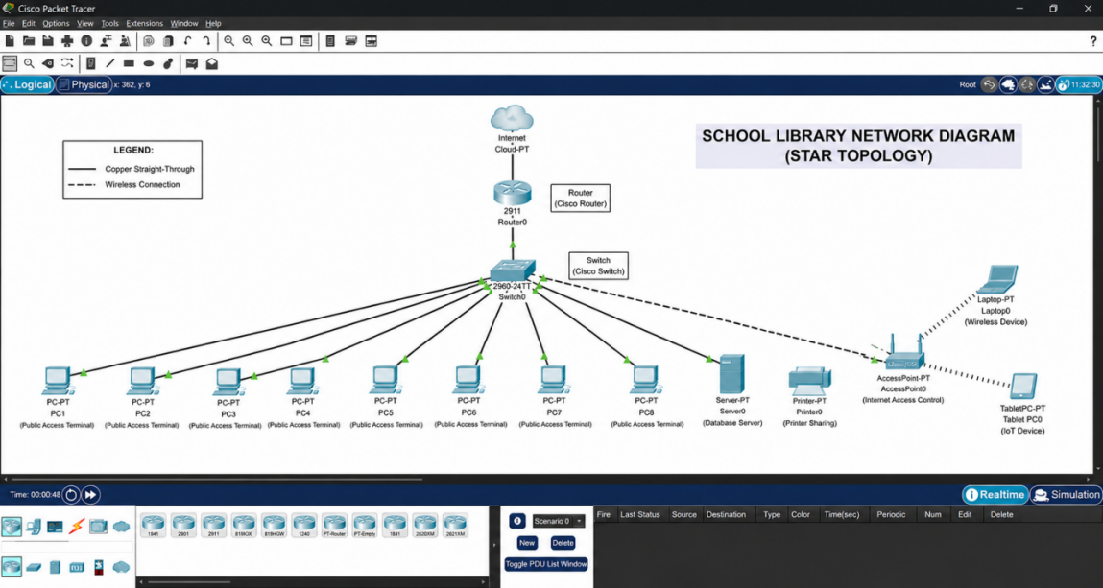
Figure 1. Cisco Packet Tracer connection.

LEGEND | DESCRIPTION
Ethernet Cable-Wired Connection | The Internet connects down into the Router (Router0).
Ethernet Cable-Wired Connection | The Router connects down into the central Switch (Switch0).
Ethernet Cable-Wired Connection | The Switch then acts as the central hub, splitting lines out to everything else:
Ethernet Cable-Wired Connection | 8 Public Computers (PC1 through PC8) are plugged directly into the switch.
Ethernet Cable-Wired Connection | 1 Database Server (Server0) is plugged directly into the switch.
Ethernet Cable-Wired Connection | 1 Network Printer (Printer0) is plugged directly into the switch.
Wireless | 1 Wireless Access Point (AccessPoint0) is plugged directly into the switch.
Table 1. Cisco Packet Tracer LAN Design

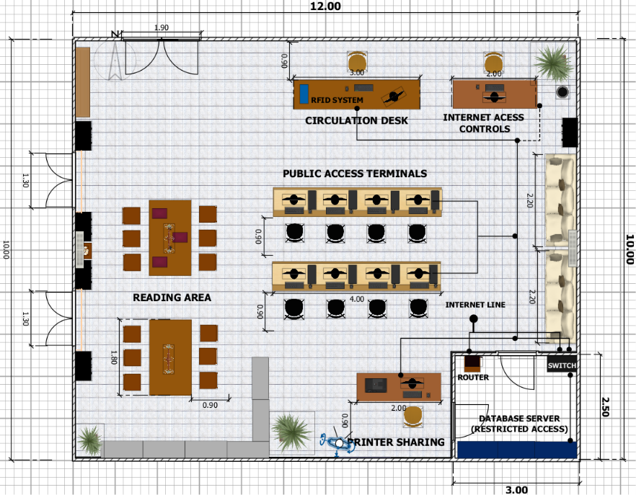
Figure 2. 2D floor plan with LAN Design

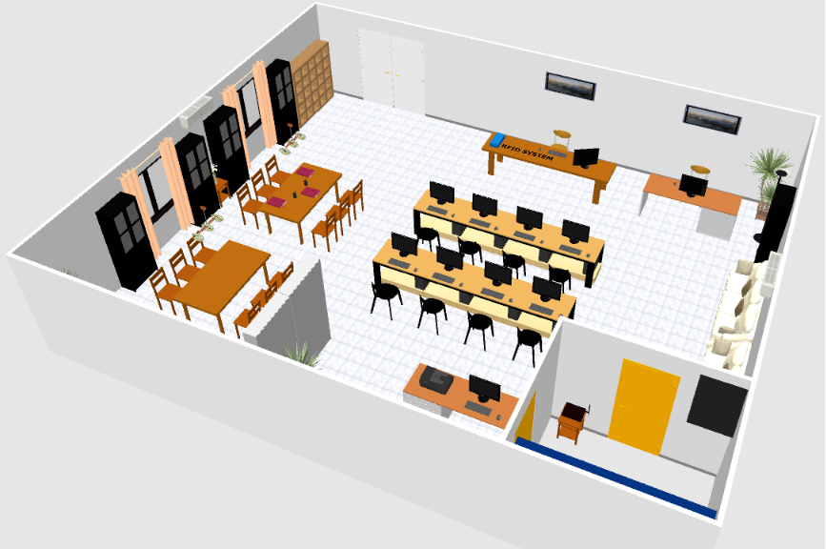
Figure 3. 3D Aerial view

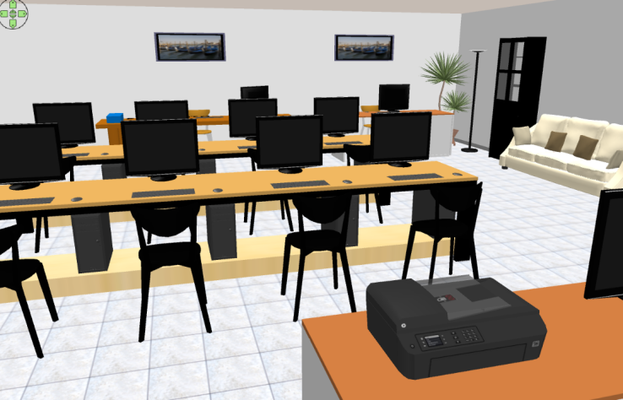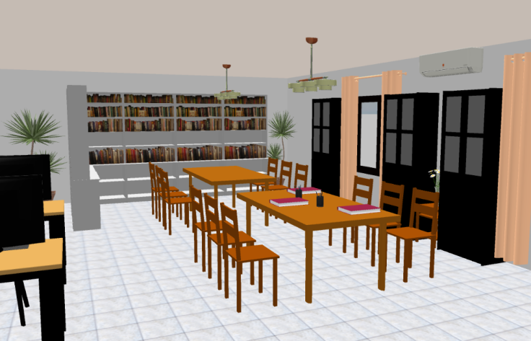
Figure 4. Public Access Terminals Figure 5. Reading Area

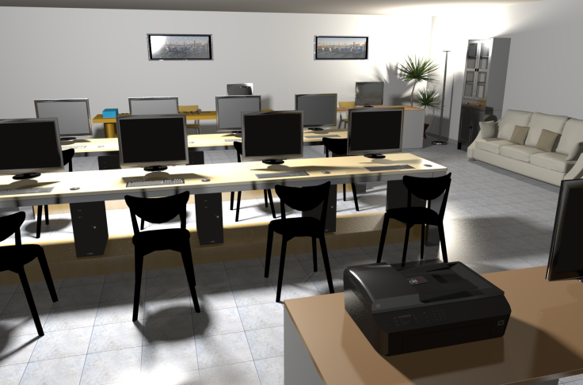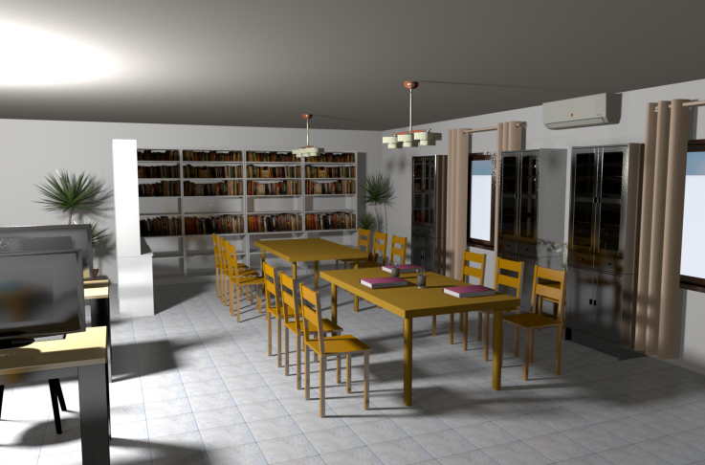
Figure 6. Rendered Public Access Terminals Figure 5. Rendered Reading Area

FURNITURE | QUANTITY | SIZE | DISTANCE
Entrance Door  (Double door) | 1 | Width: 1.80 m  Depth: 0.05 m  Height: 2.10 m | Min. of 1.50 m front clearance
Chairs  (Reading Area) | 12 | Width: 0.45 m  Depth: 0.45 m  Height: 0.90 m | 0.90 m pull-out clearance
Tables  (Reading Area) | 2 | Width: 1.80 m  Depth: 1.00 m  Height: 0.75 m | Passable circulation space provided
Chairs  (Workstation)  (Internet Access)  (Printer sharing) | 11 | Width: 0.45 m  Depth: 0.45 m  Height: 0.85 m | 0.90 m pull-out clearance
Tables  (Workstation) | 2  (4m each) | Width: 4.00 m  Depth: 0.70 m  Height: 0.75 m | Passable circulation space provided
Desk  (Internet Access)  (Printer sharing) | 1 each | Width: 2.00 m  Depth: 0.70 m  Height: 0.75 m | 1.20 m front working clearance
PC (Monitor)  (CPU)  (Public access terminals) | 8 | About 24 inches screen size.  CPU  Width: 0.25 m  Depth: 0.45 m  Height: 0.45 m | 1.20 m circulation clearance
Table 2. List of Furniture, Quantity, Sizes, and Clearance

FURNITURE | QUANTITY | SIZE | DISTANCE
Window | 2 | Width: 1.20 m  Depth: 0.15 m  Height: 1.20 m | Centered
Database area door | 2 | Width: 0.90 m  Depth: 0.05 m  Height: 2.10 m | Accessible and passable circulation path
Cabinets | 5 | Width: 0.60 m  Depth: 0.40 m  Height: 1.80 m | Passable circulation space provided
Bookshelves | 6 | Width: 1.00 m  Depth: 0.45 m  Height: 2.10 m | 1.00 m circulation clearance
3 seater Sofa | 2 | Width: 2.20 m  Depth: 0.85 m  Height: 0.85 m | 1.20 m front clearance
Table 3. Additional Furniture for Interior

AREA | SIZE
Database Server Room | 7.5 Sqm
Net Usable Area | 112.5 Sqm
Total Floor Area | 120 Sqm
Wall | 2.50 m tall
Table 4. Measurement of the Library

RESULTS

The suggested network diagram for the 120 square meter school library successfully addressed the stated network requirements (internet, RFID readers, database access, printer sharing and public computers). The implementation of a Star Topology network where the main server, RFID devices, printers and computers connect directly to the network through a central switch allows for high speed communication and resource sharing among all devices.

The simulation of the proposed LAN using Cisco Packet Tracer was also crucial to the successful implementation of the proposed network design. In the simulation the proposed design was observed for accuracy of connection between devices, configuration errors and visualization of the entire network system before being implemented on actual. The simulation confirmed the successful communication between devices in the LAN such as routers, switch, server, printer, RFID reader, access point and public workstations. Connectivity between these devices and access to resources like the internet, database server and printer shareability from all the workstations was confirmed using this simulation. The simulation helped the researcher identify design errors and minimize the risk involved during implementation, which in return would increase the reliability of the proposed network design.

The organization and arrangement of the devices on the network is easy to access by students and staff and allows the effective use of the library and its services. The suggested design features a total of 8 public access terminals, shared printers, RFID readers and a dedicated database server connected in a centralized LAN. This design will permit a dependable connection with minimized effort for maintenance and allows for potential growth of the network.

NETWORK COMPONENT | SPECIFICATION
Network Topology | Star Topology
Central Switch | 24-Port Gigabit Ethernet Switch
Database Server | Intel Core i7, 16GB RAM, 512GB SSD
Public Access Workstation (8 units PC) | Intel Core i5 (10th Gen or higher), 8GB RAM, 256GB SSD
RFID Reader | Ethernet-enabled RFID Reader
Network Printer | Shared Laser Printer with Ethernet Connectivity
Internet Connection | Fiber Internet (300Mbps or Higher)
Network Cabling | Cat6 UTP Ethernet Cable
Operating System | Windows 10/11 Professional
Estimated Network Capacity | Up to 30 Connected Devices
Table 5. Network Component and Specifications

DISCUSSION

The project proposed the design of a Local Area Network (LAN) for a school library in order to offer modern library services such as database storage and management, RFID tracking of books, on-line book catalogs, internet connectivity, and sharing of printing services. All of these modern library services would need reliable and well-organized networking equipment to make communication easier, centralized administration easier, and access to resources secure as discussed in the introduction.

The researchers chose to implement a Star Topology for the network design because every device is connected to a central switch. With the Star Topology it's easier to diagnose a problem when a specific device isn't communicating. Network maintenance and troubleshooting is easier with this topology because problems are easy to locate and there are simpler procedures for repairing the problem. If a network problem occurs to one of the devices then only that specific device will cease to function without causing the rest of the system to fail as would be the case with a ring topology. The Star Topology is the best solution for fault isolation and ease of maintenance; consequently the most scalable solution is this configuration.

The Cisco Packet Tracer simulation proved to be valuable in helping to build and verify the proposed network. This simulation was used to view the proposed network design in Cisco Packet Tracer. Then it was used to determine if all the devices would communicate with each other correctly including the router, the switch, the server, the RFID reader, printer, access point, and public workstations. If the network had configuration problems, they could be identified and fixed early by examining the simulation.

The results showed that the proposed LAN could provide all the previously identified services and capabilities for the school library network. This was shown by the internet service, the database connection, RFID operation, printer service and public access workstations using a centralized network architecture. It was verified using simulation that each and every device could communicate to the next device thereby displaying that the design worked.

The hardware specification used is also very suitable for modern library operation. Eight public access workstations are all equipped with an Intel Core i5 CPU, 8GB RAM and 256GB of SSD storage. These are all adequate to serve modern public libraries for tasks such as researching and information finding using web sites, searching the library database, and working on basic tasks like document creation. The database server itself will be equipped with an Intel Core i7, 16GB RAM and 512GB of SSD storage. The switch used would be an 24-Port Gigabit Ethernet Switch and the network will have access to the internet via 300 Mbps of fiber speed to make library operations efficient.

Overall the study proved that the proposed design is a valid, dependable, and scalable way of building a Local Area Network for a school library and the use of Cisco Packet Tracer was successful in testing all the required functions of the proposed network infrastructure.

REFERENCES

1. Athualiya, A. (2026). Star topology: A complete guide with examples. Creately.
https://creately.com/guides/star-topology/

2. Cisco Networking Academy. (2017). Campus wired LAN designs. Cisco Press.
https://www.ciscopress.com/articles/article.asp?p=2832408&seqNum=4

3. Cisco Systems. (2020). Campus LAN and wireless LAN solution design guide. Cisco.
https://www.cisco.com/c/en/us/td/docs/solutions/CVD/Campus/cisco-campus-lan-wlan-design-guide.html

4. Omnisecu. (n.d.). What is star topology, advantages and disadvantages of star topology. Omnisecu.
https://www.omnisecu.com/basic-networking/network-topologies-star-topology.php

5. ScienceDirect. (n.d.). Star topology. Elsevier.
https://www.sciencedirect.com/topics/computer-science/star-topology

6. Dimensions.com.
https://www.dimensions.com

7. Neufert Architects' Data (4th Edition).
https://www.scribd.com/document/666623824/Neufert-Architects-Data-Fourth-Edition-PDF-Room

8. Time-Saver Standards for Building Types (3rd Edition).
https://www.scribd.com/document/666104401/Time-Saver-Standards-for-Building-Types-3rd-Edition

ABOUT THE AUTHORS

Nielo Glen R. Beloria is a college student pursuing a Bachelor of Science in Computer Engineering at Eulogio “Amang” Rodriguez Institute of Science and Technology (EARIST). He has a strong interest in electrical and electronic equipment, such as Arduino, and enjoys exploring and experimenting with new technologies.

Christian Jay C. Centismo is currently a 3rd-year Bachelor of Science in Computer Engineering student at the Eulogio “Amang” Rodriguez Institute of Science and Technology (EARIST). He is interested in technology, computer systems, networking, programming, and system development. He is eager to continuously expand his knowledge and skills in the field of computer engineering.

Chena Ann V . Dela Cruz is an aspiring Computer Engineering student at Eulogio “Amang” Rodriguez Institute of Science and Technology (EARIST) – Manila. She has a strong interest in coding and software development and is motivated to continuously improve her programming skills through learning and hands-on experience.

Chriscian Reeve R. Falle is a Bachelor of Science in Computer Engineering student at the Eulogio "Amang" Rodriguez Institute of Science and Technology (EARIST). He is interested in microcontroller-based systems, electronics troubleshooting, programming, and embedded system development. He is eager to continuously enhance his technical knowledge and practical skills in the field of computer engineering and technology.

Kellyprince Josch D. Gapol is a third-year Computer Engineering student at the Eulogio 'Amang' Rodriguez Institute of Science and Technology (EARIST). Driven by a deep curiosity about how technology operates from the inside out, Kellyprince focuses on bridging the gap between hardware architecture and software development. Through academic projects and hands-on technical exploration, they work to design integrated systems that seamlessly connect physical components with digital logic, aiming to engineer practical, scalable solutions for real-world challenges.

Althea M. LLave is an aspiring Computer Engineer currently pursuing a Bachelor of Science in Computer Engineering at Eulogio “Amang” Rodriguez Institute of Science and Technology (EARIST) – Manila. Driven by a passion for
innovation, she is particularly interested in Solidworks and Circuit Design and aims to contribute to the evolving
landscape of technology through continuous learning and technical excellence.

Klarenze Naive J. Nervez is a dedicated Computer Engineering student at the Eulogio “Amang” Rodriguez Institute of Science and Technology (EARIST) in the Philippines. He is passionate about technology, innovation, and the continuous development of his skills in the field of computer engineering. His academic interests include embedded systems, computer networks, cybersecurity, software development, and emerging technologies that contribute to solving real-world problems.

Cazzandra Joyce C. Sagun is a Computer Engineering student at Eulogio “Amang” Rodriguez Institute of Science and Technology (EARIST) – Manila. She is passionate about technology, programming, and computer systems. Dedicated to continuous learning, she strives to improve her technical skills and gain valuable experience in the field of computer engineering.

Engr. Minerva C. Zoleta, a Professional Computer Engineer, is a dedicated Computer Engineering Professor at the Eulogio “Amang” Rodriguez Institute of Science and Technology in the Philippines, specializing in Embedded Systems, Operating Systems, and Computer Network and Security. With a strong background in academia and industry. She has been instrumental in shaping the next generation of Engineers through innovative teaching methods and hands-on research. Engr. Zoleta holds a Master’s degree in Electrical Engineering major in Computer Engineering at Technological University of the Philippines, Manila and is pursuing her doctorate degree in Engineering with specialization in Computer Engineering at Technological Institute of the Philippines. She has presented published research on topics such as Embedded System, IoT applications, and wireless communication international conferences and journals. . Passionate about technology-driven solutions, She has led various projects integrating smart systems into real-world applications, contributing to the advancement of local and international engineering communities.

