Decentralized Migrant Worker Protection and Local Governance Capacity: An Integrated Protection Model from Indonesia

ABSTRACT
This article examines how Indonesian Migrant Worker (PMI) protection is implemented at the subnational level and explains why a gap persists between formal regulation and practical service delivery in West Bandung Regency. The study aims to assess the extent to which local regulation has been translated into an integrated protection system and to develop a governance model for strengthening decentralized migrant worker protection. A qualitative case study design was applied using policy documents, institutional records, interviews, field observations, focus group discussions, and NVivo 12-assisted thematic analysis. Coding was organized deductively through Van Meter and Van Horn’s implementation variables and inductively through emerging themes such as the absence of a one-stop integrated service, data fragmentation, village-level prevention, informal recruitment, coordination barriers, and post-return reintegration. The findings show that Regional Regulation No. 5 of 2018 provides a formal legal basis for protection, but its implementation remains largely administrative. Migrant worker protection is constrained by weak regulation-to-service translation, limited institutional resources, reactive inter-organizational coordination, fragmented implementing agencies, socio-economic pressures, and uneven implementor commitment. The evidence also indicates that non-procedural migration and protection cases continue to increase, while village-based literacy, integrated PMI data, and reintegration support remain insufficient. The article concludes that decentralized migrant worker protection depends not only on legal mandates, but also on local governance capacity, institutional integration, collaborative coordination, evidence-based data systems, and sustainable reintegration. It proposes an Integrated Local Migrant Protection Governance Model that links regulation, LTSA-based services, cross-sector collaboration, village prevention, data governance, and post-return support within a continuous protection cycle.
Keywords: Migrant Worker Protection; Local Governance; Policy Implementation; Decentralization; Indonesia

1. INTRODUCTION
International labour migration is a central feature of contemporary development, particularly in countries where uneven economic opportunities, limited employment absorption, household vulnerability, and global labour demand intersect. Recent global migration reports also show that cross-border mobility is increasingly shaped by labour market inequality, demographic change, conflict, and uneven access to safe and regular migration pathways [1, 2]. For many households, migration is not merely an individual mobility decision; it is a livelihood strategy through which families seek income security, social mobility, and access to opportunities that are not sufficiently available in local labour markets. At the same time, migrant labour is embedded in governance arrangements that extend across origin communities, sending regions, national regulatory systems, recruitment networks, transit spaces, and destination-country labour regimes.
Indonesia is one of Asia’s major migrant-sending countries. Indonesian Migrant Workers, widely referred to as Pekerja Migran Indonesia (PMI), contribute to household welfare, local consumption, and national remittance flows. However, these contributions coexist with persistent vulnerability. Migrant workers may encounter unpaid wages, contract substitution, excessive recruitment fees, violence, psychological abuse, trafficking, document manipulation, unilateral termination of employment, and limited access to justice. These risks are particularly acute among workers in domestic work, care work, informal services, and other sectors where labour inspection and social protection tend to be weak [1, 3].
Indonesia’s Law No. 18 of 2017 on the Protection of Indonesian Migrant Workers marked an important shift from a placement-oriented paradigm to a rights-based protection framework. The law distributes responsibility across national, provincial, district/municipal, and village governments, and covers protection before, during, and after employment, including integrated one-stop services, social security, and legal, social, and economic protection [4, 5]. In this legal architecture, district governments are not merely administrative extensions of the central government. They are expected to provide information, facilitate registration, prevent non-procedural migration, support case handling, strengthen safe migration education, and contribute to reintegration after return. This makes migrant worker protection an important lens through which to examine decentralization, local governance capacity, and public administrative accountability within the dynamics of modern state administration [6].
Yet a legal mandate does not automatically generate effective protection. In decentralized governance systems, the practical effectiveness of migrant worker protection depends on whether local governments can translate legal obligations into operational services, budget allocations, institutional coordination, data systems, standard operating procedures, village-level prevention, and measurable accountability mechanisms. Therefore, the gap between formal legal protection and actual service delivery is not simply an administrative problem; it is a governance problem.
Existing studies on migrant worker protection have largely focused on national regulation, recruitment governance, transnational exploitation, destination-country vulnerability, and the role of private placement agencies. Less attention has been paid to how migrant worker protection is operationalized at the district level, particularly in decentralized states where local governments possess formal obligations but often face limited resources, fragmented data, weak coordination, and uneven institutional capacity. This article addresses that gap by examining how a local regulation on migrant worker protection is implemented in West Bandung Regency, Indonesia.
West Bandung Regency is a theoretically relevant and empirically important case. The regency has issued Regional Regulation No. 5 of 2018 on the Placement and Protection of Indonesian Migrant Workers, demonstrating formal legal commitment at the local level. However, documentary and field evidence indicate that the regulation has not yet been converted into a fully integrated protection system. The absence of a One-Stop Integrated Service (Layanan Terpadu Satu Atap/LTSA), fragmented inter-agency coordination, weak village-level safe migration literacy, the absence of an integrated PMI database, and limited reintegration support for returnees indicate a substantial implementation gap.
The urgency of this case is reinforced by changing migration patterns and growing protection problems. Placement data from West Bandung Regency show fluctuating and increasing destination-country flows between 2020 and 2023, including a sharp rise in placements to Saudi Arabia and Turkey. At the same time, recorded problem cases involving unpaid wages, violence and exploitation, trafficking, and non-procedural migration increased from 450 cases in 2020 to 635 cases in 2024. These patterns suggest that mobility and vulnerability have expanded faster than the local government’s protection capacity.
This article asks: How is the policy for protecting Indonesian Migrant Workers implemented by the local government of West Bandung Regency, and what factors explain the gap between regulation and practice? The article contributes to the literature on policy implementation and migration governance by developing an Integrated Local Migrant Protection Governance Model. The model argues that decentralized migrant protection requires the alignment of legal mandates, integrated service institutions, collaborative coordination, village-based prevention, data governance, and sustainable post-return reintegration. In doing so, the article reframes migrant worker protection not as a narrow labour-administration issue, but as a test of local governance capacity in a decentralized policy system.

2. LITERATURE REVIEW

2.1 Migrant Worker Protection as Rights-Based Migration Governance
Migrant worker protection is multidimensional because it involves labour rights, human security, legal identity, social protection, access to information, fair recruitment, complaint handling, case resolution, return, and reintegration. Contemporary migration literature emphasizes that labour migration is shaped by the interaction of household livelihood strategies, recruitment markets, public institutions, and destination-country labour regimes. Therefore, protection cannot be reduced to placement administration; rather, it must be understood as a continuous rights-based governance process covering the entire migration cycle [1, 2, 7].
A rights-based approach requires governments to ensure that migrant workers have access to reliable information, transparent recruitment, legal documentation, social protection, complaint mechanisms, and remedies for rights violations. The ILO fair recruitment framework highlights that preventing abusive recruitment practices and reducing migration-related costs are essential for protecting workers from trafficking, debt bondage, document manipulation, and other forms of exploitation [8]. In the Indonesian context, Law No. 18 of 2017 formally expands protection across the pre-placement, placement, and post-placement stages, including information provision, integrated services, social security, legal protection, and economic reintegration [4].
For local migrant-sending regions, this literature suggests that protection must be operationalized through accessible services, trusted public information, village-level prevention, data-based monitoring, and post-return support. When these components are weak, the formal rights-based mandate may remain symbolic rather than substantive, underlining the critical importance of subnational collaborative governance in formulating and implementing grassroots village regulations [9]. Thus, the study of West Bandung Regency is relevant because it examines how a local regulation can legally exist while still facing difficulties in becoming an integrated and measurable protection system.

2.2 Decentralization and Subnational Capacity
Decentralization is frequently associated with improved responsiveness because local governments are closer to citizens and are better positioned to understand local socio-economic conditions, service barriers, and community-level risks. In migrant-sending areas, district and village governments can identify prospective migrants, verify documents, map high-risk communities, provide safe migration literacy, coordinate with families, and detect non-procedural recruitment at an early stage. However, decentralization does not automatically improve protection; it can also produce uneven policy performance when local mandates are not supported by adequate budgets, trained personnel, institutional design, data infrastructure, and political commitment [10, 11], which is heavily influenced by the dynamic shifts in local governance and local-level decentralization policies [12].
The subnational dimension is especially important because many risks begin before departure. Prospective migrant workers may encounter informal sponsors, unverified brokers, misleading job information, recruitment debt, or incomplete documentation before they interact with national-level institutions. When official services are fragmented, poorly communicated, or administratively distant, informal actors may become more influential than public institutions. This makes local governance capacity a decisive factor in determining whether national protection standards can be translated into meaningful protection at the village and district levels [13, 14].
Migration governance literature also emphasizes the need for policies and institutions that support safe, orderly, and regular migration across multiple levels of government. The Migration Governance Indicators framework, for example, views migration governance as a set of policies, institutional arrangements, coordination mechanisms, and service systems rather than as a single regulation. This perspective supports the argument that West Bandung Regency requires not only a local regulation, but also operational standards, inter-agency coordination, local databases, village outreach, and reintegration mechanisms [15].

2.3 Policy Implementation Gap in Multi-Level Governance
The implementation gap refers to the distance between formal policy design and actual policy performance. Classic implementation studies show that well-intended regulations may fail when policy goals are unclear, resources are insufficient, institutional responsibilities are fragmented, implementation procedures are weak, or street-level actors face conflicting demands [13, 16]. In multi-level governance systems, this gap becomes more complex because responsibilities are distributed across central, provincial, district, and village institutions.
This article uses the policy implementation framework developed by Van Meter and Van Horn. Their model identifies six variables that influence implementation performance: policy standards and objectives, resources, inter-organizational communication, characteristics of implementing agencies, economic, social, and political conditions, and implementor disposition [17]. These variables are relevant to migrant worker protection because the effectiveness of protection depends not only on the existence of a legal mandate, but also on whether local institutions can convert that mandate into services, budgets, information flows, monitoring systems, and accountability mechanisms.
In the context of migrant worker protection, implementation gaps often appear in the form of weak socialization, incomplete databases, limited field officers, reactive case handling, fragmented service pathways, and insufficient reintegration support. These problems reflect more than technical administrative weaknesses; they indicate limitations in governance capacity and street-level policy delivery. Therefore, the analytical focus should not only examine whether a regulation exists, but also whether it has been translated into operational instruments that shape day-to-day administrative practices [14, 17].

2.4 Collaborative Governance and Integrated Protection
Migrant worker protection is inherently cross-sectoral. It requires collaboration among manpower offices, migration protection agencies, village governments, social affairs institutions, population and civil registration offices, law enforcement actors, training providers, financial institutions, civil society organizations, migrant communities, and families. Collaborative governance theory explains that complex public problems require shared problem definition, joint decision-making, mutual trust, institutional design, and the capacity for collective action [18, 19].
Cross-sector collaboration is difficult to sustain when roles are unclear, funding is uncertain, leadership is weak, or accountability mechanisms are absent. Bryson et al. [20] argue that effective collaboration requires formal structures, committed leadership, shared resources, and agreed-upon performance expectations. Within public administration, these structures must bridge the gap between abstract policies and service networks to produce public value [21]. In migrant worker protection, these requirements are reflected in the need for integrated services, routine coordination, referral mechanisms, shared databases, and case-handling protocols that connect district agencies with village institutions and national protection bodies.
Integrated service delivery is particularly important because prospective migrant workers often have to navigate multiple administrative requirements. The absence of a One-Stop Integrated Service (Layanan Terpadu Satu Atap/LTSA) increases transaction costs, weakens supervision, and creates opportunities for informal brokers. In this sense, LTSA is not merely a service counter; it is an institutional mechanism for aligning registration, verification, information provision, social protection, complaint handling, and referral services in accordance with Indonesia’s migrant worker protection framework [4, 8].

2.5 Analytical Framework
The analytical framework of this article combines Van Meter and Van Horn’s implementation variables with local governance and collaborative governance perspectives. The framework assumes that a policy may be normatively clear but still fail when standards are not operationalized, resources are insufficient, inter-organizational communication is weak, agencies work sectorally, socio-economic pressures remain high, and implementor disposition is not supported by institutional capacity [13, 17].
Building on the literature on migration governance and decentralization, the framework further argues that district-level migrant worker protection requires three additional governance components: village-based prevention, integrated data governance, and sustainable post-return reintegration. These components are necessary because migration vulnerability is not confined to formal placement procedures; it begins in origin communities, continues during employment abroad, and often re-emerges when returnees lack economic reintegration support [2, 10, 15].
Accordingly, this article positions West Bandung Regency as a case for examining whether decentralized migrant worker protection has moved beyond legal commitment toward operational governance capacity. The framework guides the analysis of policy standards, resources, coordination, implementing agencies, socio-economic and political context, and implementor disposition, while also assessing whether local protection is supported by integrated services, village-level prevention, data systems, and reintegration mechanisms.

3. METHODOLOGY
This article uses a qualitative case study design to examine the implementation of migrant worker protection in West Bandung Regency, a migrant-sending district that has adopted a formal regulation but has not yet developed an integrated protection system [22]. The unit of analysis is the local governance system, involving government agencies, village actors, BP2MI/BP3MI-related institutions, civil society organizations, PMI, returnee PMI, prospective PMI, and migrant worker families. Data were collected through document study, interviews, field observations, and focus group discussions. NVivo 12 was used to organize, code, and visualize the data through deductive coding based on Van Meter and Van Horn’s implementation variables, as well as inductive coding derived from emerging themes such as LTSA, data fragmentation, village-level prevention, informal recruitment, reintegration, and coordination barriers. The analysis involved identifying policy standards, coding empirical data, and interpreting patterns to explain the gap between legal mandates and protection practices, guided by interactive qualitative analysis procedures [23]. Validity was strengthened through source triangulation, method triangulation, and theoretical triangulation.
Table 1. Summary of Research Methodology
Component | Description
Research design | Qualitative case study with governance-oriented implementation analysis
Case | West Bandung Regency, Indonesia
Policy focus | Regional Regulation No. 5 of 2018 on the Placement and Protection of Indonesian Migrant Workers
Analytical framework | Van Meter and Van Horn policy implementation variables, complemented by local governance and collaborative governance perspectives
Data sources | Policy documents, institutional records, interviews, field observations, focus group discussion, and NVivo-coded qualitative data
Main actors | Manpower Office, regional planning and financial institutions, village governments, BP2MI/BP3MI-related actors, civil society organizations, PMI, returnee PMI, prospective PMI, and families
Analysis tool | NVivo 12 for data organization, thematic coding, case classification, word cloud visualization, and hierarchy chart analysis
Publication note | Insert exact number of participants, interview period, and ethics statement before submission

4. RESULTS

4.1 Migration Placement Trends and Protection Problems
Placement data show that international labour migration remains an important socio-economic strategy for PMI from West Bandung Regency. Migration flows vary by destination country and are influenced by global labour demand, recruitment networks, destination opportunities, and local economic pressures. Saudi Arabia remains the dominant destination, while Turkey has grown rapidly as a new major destination. These trends indicate that district-level protection must be adaptive to changing migration risks, rather than relying only on routine administrative procedures.
Table 2. PMI Placement Trends by Destination Country, 2020–2023
Destination country | 2020 | 2021 | 2022 | 2023 | Trend
Saudi Arabia | 1,926 | 727 | 4,676 | 6,310 | Sharp increase; highest destination in 2023
Kuwait | 75 | 10 | 718 | 425 | Fluctuating
Oman | 65 | 37 | 115 | 102 | Relatively low and stable
Poland | 837 | 1,195 | 1,879 | 1,524 | Increased until 2022, then declined
Qatar | 43 | 219 | 848 | 307 | Fluctuating
Turkey | 47 | 874 | 1,489 | 2,289 | Significant increase
United Arab Emirates | 104 | 94 | 112 | 976 | Strong increase in 2023
Jordan | 2 | 33 | 126 | 46 | Low and fluctuating
Source: Compiled from BP2MI/KP2MI placement data for West Bandung Regency for 2020-2023.
Protection cases also increased from 450 in 2020 to 635 in 2024. Non-procedural migration consistently represented the largest category, rising from 200 cases in 2020 to 270 cases in 2024. This suggests that local policy has not yet generated sufficient preventive capacity. The increase in cases of unpaid wages, violence and exploitation, and trafficking further indicates that vulnerability is not limited to departure procedures, but continues throughout the migration cycle.
Table 3. PMI Protection Cases in West Bandung Regency, 2020–2024
Year | Unpaid wages | Violence and exploitation | Trafficking | Non-procedural PMI | Total  cases
2020 | 120 | 85 | 45 | 200 | 450
2021 | 135 | 90 | 50 | 210 | 485
2022 | 150 | 100 | 55 | 230 | 535
2023 | 165 | 110 | 60 | 250 | 585
2024 | 185 | 120 | 65 | 270 | 635
Source: Compiled from BP2MI/KP2MI problem-case data and the author-processed study dataset for 2020-2024

4.2 NVivo-Assisted Coding and Thematic Structure
The qualitative data were analyzed using NVivo 12 to support thematic analysis. The data included policy documents, institutional records, field notes, interviews, and focus group discussions. Coding was guided by Van Meter and Van Horn’s implementation variables, while also allowing new themes to emerge from the data. The analysis identified six main themes: policy standards and objectives, resources, inter-organizational communication, characteristics of implementing agencies, socio-economic and political context, and implementor disposition.
Table 4. NVivo Coding Themes, Dominant Issues, and Interpretive Meanings
NVivo theme/node | Dominant issues | Interpretive meaning
Policy standards and objectives | Regulatory alignment; clarity of objectives; planning; budgeting; socialization; empowerment; reintegration | Policy goals are normatively clear but require operational translation into programs, budgets, SOPs, and measurable indicators.
Resources | Human resources; budget availability; information; facilities; operational support | Protection depends on adequate staff, budget, service infrastructure, technical capacity, and data support.
Communication | Coordination; information exchange; communication patterns; problem-solving practices | Communication exists but tends to be reactive and case-based rather than routine, preventive, and institutionalized.
Characteristics of implementing agencies | Bureaucratic structure; apparatus competence; OPD performance; internal control; service design | Agency design and administrative capacity shape how regulation becomes actual service.
Socio-economic-political context | Socio-economic pressures; public awareness; local political support; informal recruitment networks | Migration pressure is linked to household economy, limited local employment, and unequal access to trustworthy information.
Implementor disposition | Service commitment; innovation; attitude toward PMI protection; institutional constraints | Implementors show commitment, but commitment alone is insufficient without resources and coordination mechanisms.
To enhance transparency in the qualitative analysis, this section presents original NVivo 12 screenshots showing the data import process, node and case structures, and visual outputs, including word clouds and hierarchy charts. These visuals serve as supporting analytical evidence that helps clarify the coding process and strengthen the interpretation of the implementation gap.

Figure 1. Original NVivo 12 source-file import view
The source-file import view indicates that the empirical corpus was built from multiple types of materials rather than a single data stream. This strengthens the audit trail of the qualitative analysis because policy documents, field notes, interview materials, and stakeholder evidence were organized in one NVivo project before coding. In analytical terms, the figure supports the credibility of the findings by showing that the interpretation of the implementation gap was grounded in a triangulated evidence base.
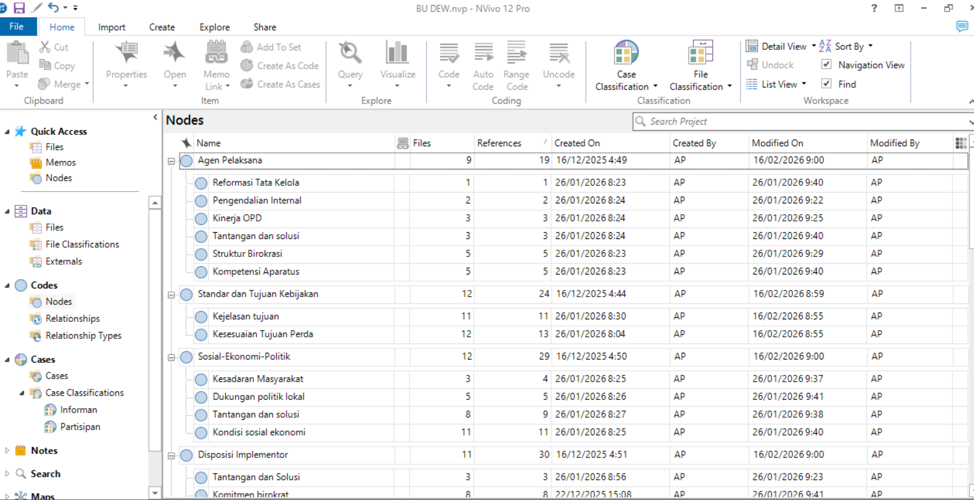
Figure 2. Original NVivo 12 node and coding structure
The node and coding structure shows how the analytical framework was operationalized into concrete empirical categories. The main nodes reflect the implementation variables of Van Meter and Van Horn, while the subnodes capture field-based issues such as LTSA absence, fragmented coordination, weak village-level prevention, data fragmentation, and limited reintegration. This visual therefore demonstrates that the article does not rely only on descriptive narration; it links field evidence to a systematic coding architecture.

Figure 3. Original NVivo 12 case classification of informants and institutions
The case classification display shows the diversity of actors included in the analysis, including government institutions, village actors, supporting stakeholders, PMI, returnee PMI, prospective PMI, and families. This classification strengthens source triangulation by enabling comparisons of perspectives across institutions and beneficiaries, rather than relying solely on a single bureaucratic viewpoint
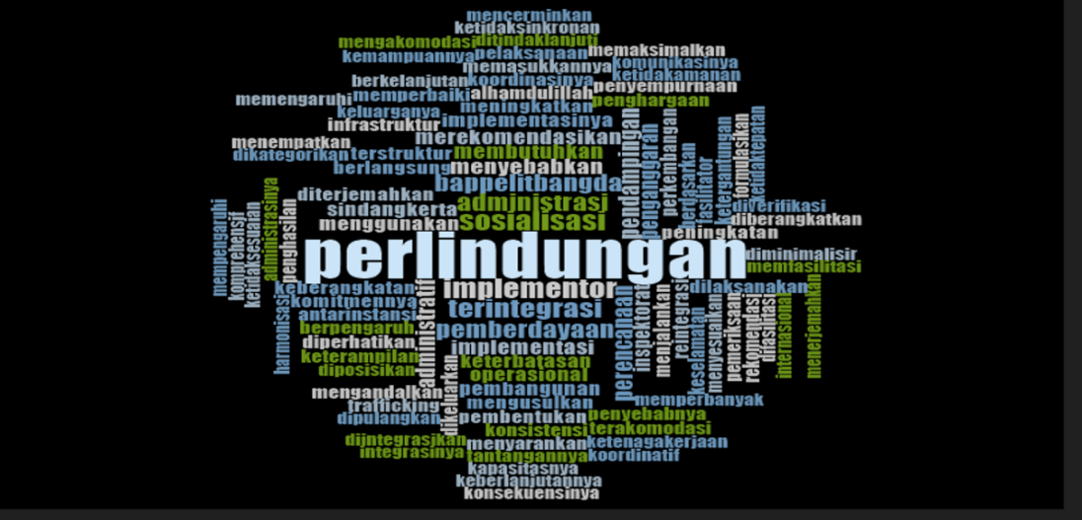
Figure 4. Original NVivo 12 word cloud of implementation-policy themes
The word cloud provides an initial overview of the dominant terms in the coded materials, including policy, protection, implementation, government, coordination, data, village, and migrant workers. These terms indicate that the key issue is not only individual migration behavior, but also the capacity of local governance institutions to translate regulation into practical protection. Therefore, the word cloud supports the thematic analysis by highlighting the concentration of discourse around institutional performance and protection gaps
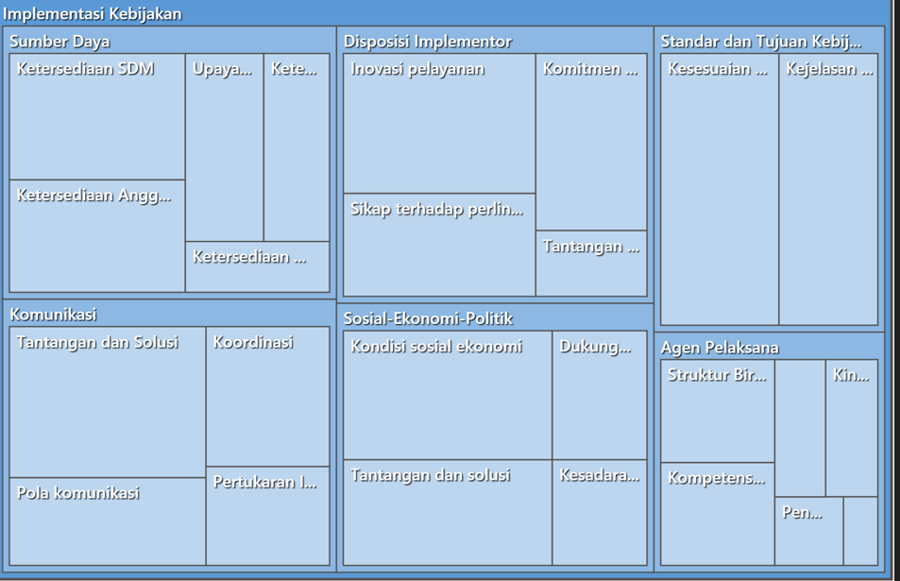
Figure 5. Original NVivo 12 hierarchy chart of implementation-policy themes
The hierarchy chart shows that the dominant themes—policy standards, resources, coordination, agency characteristics, socio-economic context, and implementor disposition—are interconnected dimensions of the same implementation problem. This indicates that the implementation gap in West Bandung Regency results from the interaction of regulatory, institutional, resource-based, and community-level constraints, rather than from a single isolated factor.
Overall, Figures 1–5 demonstrate that the NVivo outputs support the article’s main argument. They confirm systematic data organization, coding structure, actor triangulation, dominant empirical themes, and coding density. Collectively, these findings strengthen the argument that migrant worker protection in West Bandung Regency requires an integrated local governance model rather than a fragmented administrative approach.
Table 5. NVivo-Based Evidence Synthesis of Key Implementation Gaps
NVivo theme | Core empirical signal from Draft Gabung 1-5 | Interpretive contribution to the article
Regulation-to-service translation | Local regulation is normatively aligned with national law, but operational guidance, budget indicators, and service standards remain weak. | Explains why formal legal commitment has not yet become substantive protection.
Data and communication | PMI data are not synchronized across agencies; village reporting mechanisms and real-time data are limited. | Supports the argument that protection cannot be evidence-based without integrated data governance.
Village-level prevention | Safe migration socialization and training are uneven, and prospective migrants often rely on informal information networks. | Shows why prevention must begin at village and family levels.
Reintegration and disposition | Returnee support, incentives, and institutionalized commitment are still limited despite positive attitudes among actors. | Strengthens the need for sustainable reintegration and accountability mechanisms.

4.3 Regulation Exists, but Substantive Protection Remains Weak
West Bandung Regency Regulation No. 5 of 2018 provides a formal legal basis for PMI protection [26]. However, the findings show that the regulation has not yet functioned as a comprehensive protection instrument. Its implementation remains largely administrative, focusing on documentation and recommendations rather than establishing an integrated protection cycle from pre-departure to post-return.
The absence of LTSA is the clearest indicator of this gap. Without a one-stop integrated service, prospective migrant workers must deal with fragmented procedures across different institutions. This condition increases transaction costs, weakens supervision, and creates space for informal intermediaries. It also shows that PMI protection has not yet been fully institutionalized as a local governance priority.

4.4 Coordination Remains Reactive and Case-Based
The findings show that inter-agency coordination in PMI protection exists, but remains incidental and reactive. Coordination usually occurs only after cases are reported by families, villages, or external agencies. The absence of a routine cross-sector forum, standardized reporting mechanisms, a shared case database, and an integrated monitoring system weakens prevention, as institutions tend to respond after problems occur rather than preventing risks in advance.
Table 6. Synthesis of Actor-Based Findings and Policy Implications
Actor group | Main finding | Policy implication
Regional planning institution | Cross-OPD communication exists but is not yet routine or operational | A dedicated PMI coordination forum and routine planning mechanism are needed.
Financial/administrative unit | Information is often administrative and does not always reflect field-level protection needs | Budget planning should be linked to field data, risk mapping, and service targets.
Manpower Office | Coordination is mostly case by case | SOPs and monitoring protocols are needed for prevention, referral, and case handling.
Village governments | Villages often learn about cases after problems emerge | Village-level reporting and safe migration literacy must be institutionalized.
Civil society actors | Formal socialization is less influential than informal recruitment networks | Community-based and repeated socialization models are needed.
Regional leadership | Data and coordination are not yet synchronized | Integrated data governance and cross-sector accountability should be developed.

4.5 Village-Level Safe Migration Literacy Is Insufficient
Villages are strategically positioned to prevent non-procedural migration because they are closest to prospective migrant workers and families. However, village governments have not yet received a strong operational mandate, standardized tools, or regular capacity-building to conduct safe migration education, early detection, or systematic registration. This weakens prevention at the source community level.
Without accessible and trusted public information, prospective migrants may rely more on informal sponsors than on official channels, increasing exposure to trafficking, document manipulation, debt, and unsafe placement. This indicates a critical need for participatory models that involve village apparatus and communities in formulating village-level protection policies [27].

4.6 Integrated Data and Post-Return Reintegration Remain Limited
The absence of integrated data is another major implementation weakness. PMI data are scattered across the Manpower Office, villages, BP2MI/BP3MI-related systems, and other institutions. This fragmentation makes it difficult for the local government to map high-risk villages, identify returnee needs, monitor destination-country risks, or evaluate policy performance. Post-return reintegration is also weak. Returnee PMI may return with debt, psychological stress, limited savings, or unstable employment prospects. Without skills training, business support, access to finance, psychosocial assistance, and local economic programs, returnees may migrate again through risky channels. This shows that protection has not yet become a sustainable cycle.

5. DISCUSSION
The West Bandung case demonstrates that the core problem lies not in the absence of regulation, but in the limited capacity of local governance to translate regulation into effective protection. Regional Regulation No. 5 of 2018 has symbolic and normative value; however, the protection system remains fragmented. This finding confirms a central argument in policy implementation studies: policy performance depends on operational capacity, not merely on formal legality.
Viewed through Van Meter and Van Horn’s framework, the implementation gap can be explained by six interrelated variables. First, policy standards and objectives are normatively clear but have not been sufficiently operationalized. Second, resources remain inadequate, particularly in relation to integrated services, trained personnel, data infrastructure, and reintegration programs. Third, inter-organizational communication remains reactive rather than preventive. Fourth, implementing agencies continue to operate sectorally without a cohesive institutional design. Fifth, socio-economic pressures continue to push residents toward migration, including through non-procedural channels. Sixth, implementor disposition is generally positive, but commitment alone cannot compensate for weak structures and limited resources.
This case also reveals the limits of decentralization. Local governments are close to migrant-sending communities and therefore have the potential to prevent unsafe migration before it occurs. However, decentralization can produce uneven protection when local authority is not accompanied by adequate capacity, budget, data systems, and coordination mechanisms. In this sense, migrant worker protection becomes a test of whether decentralized governance can deliver rights-based public services to vulnerable citizens.
The findings extend conventional implementation analysis by showing that migrant worker protection requires more than compliance with policy standards. It requires an integrated local protection architecture that connects regulation, service delivery, coordination, village-level prevention, data governance, and reintegration. This is particularly important because migrant vulnerability does not occur at a single point in time. Rather, it is produced across the migration cycle: before departure, during recruitment, while working abroad, during case handling, and after return.

5.1 Integrated Local Migrant Protection Governance Model
The main contribution of this article is the Integrated Local Migrant Protection Governance Model, which reframes migrant worker protection as an integrated local governance system rather than merely an administrative placement function. The model demonstrates that protection failure results from interconnected challenges, including weak institutional integration, reactive coordination, limited village-level literacy, fragmented data, and inadequate reintegration support. It consists of six key components: regulation-to-implementation alignment, LTSA-based institutional integration, collaborative coordination, village-based safe migration literacy, integrated PMI data governance, and sustainable post-return reintegration. Together, these components strengthen local protection by translating regulations into operational services, reducing institutional fragmentation, enhancing village-level prevention, supporting evidence-based decision-making, and ensuring that returnee migrant workers receive adequate social and economic reintegration support.
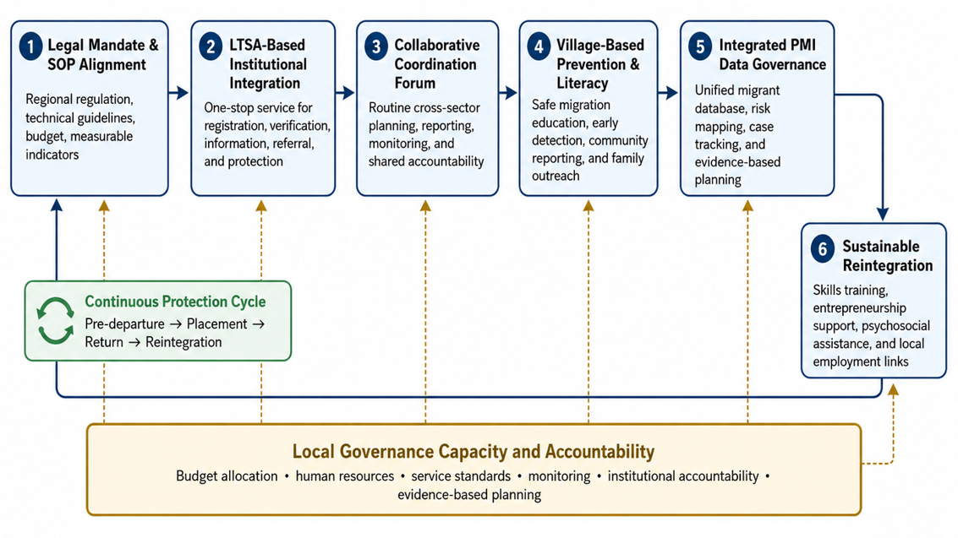
Figure 6. Integrated Local Migrant Protection Governance Model
The model contributes to migration governance literature by showing that decentralized migrant worker protection requires an end-to-end governance chain. It also contributes to implementation theory by demonstrating that the gap between regulation and practice is not only a matter of resources or implementor disposition, but also a matter of institutional integration and community-level prevention.

5.2 Governance-Based Improvement Agenda
Table 7. Governance-Based Improvement Agenda
Implementation dimension | Empirical gap | Recommended improvement
Policy standards and objectives | Regulation exists but operational guidance is limited | Develop technical guidelines, SOPs, measurable indicators, and annual protection targets.
Resources | Limited budget, staff, facilities, and data infrastructure | Allocate dedicated budget, strengthen staff capacity, and build integrated service infrastructure.
Communication | Coordination is case-based and not routine | Create a routine cross-sector PMI forum and shared reporting protocols.
Implementing agencies | Sectoral work patterns and unclear accountability | Define institutional roles and integrate service workflows through LTSA.
Socio-economic-political context | Migration is driven by poverty, limited employment, and informal networks | Connect protection policy with local employment, vocational training, and empowerment programs.
Implementor disposition | Commitment exists but requires stronger institutional support | Reward service innovation, strengthen monitoring, and provide continuous capacity-building.

6. CONCLUSION
This article concludes that the implementation gap in migrant worker protection in West Bandung Regency is mainly caused by limited local governance capacity, rather than the absence of legal regulation. Although Regional Regulation No. 5 of 2018 provides a formal legal basis, protection remains largely administrative due to the absence of LTSA, weak inter-agency coordination, limited village-level migration literacy, fragmented data, and inadequate reintegration support. NVivo-assisted analysis confirms these issues as dominant themes in the qualitative evidence. Theoretically, this article contributes by proposing the Integrated Local Migrant Protection Governance Model, which emphasizes regulation, integrated services, collaborative coordination, village-based prevention, data integration, and post-return reintegration as a continuous governance chain. Practically, it recommends establishing LTSA, strengthening cross-sector coordination, developing village-based prevention, integrating PMI data systems, and improving reintegration programs.

ETHICAL CONSIDERATIONS
This study involved human participants. Ethical approval was obtained from Universitas Langlangbuana Research Ethics Committee, approval number 104/UNLA/REC/2025. All participants were informed about the study objectives and provided consent before data collection.

CONFLICT OF INTEREST
The authors declare that they have no conflict of interest related to this article.

DATA AVAILABILITY
The data supporting the findings of this study are not publicly available because they contain institutional and participant information. Access to anonymized data may be requested from the corresponding author, subject to ethical approval and institutional permission.

COPYRIGHT AND LICENSING
Upon publication, this article will be distributed under the Creative Commons Attribution License (CC BY 4.0), which permits use, sharing, and reproduction in any medium, provided that proper attribution is given to the original work.

REFERENCES
- International Labour Organization (ILO). (2021). ILO global estimates on international migrant workers: Results and methodology. Geneva: ILO.
- International Organization for Migration (IOM). (2024a). World migration report 2024. Geneva: IOM.
- Badan Pelindungan Pekerja Migran Indonesia/Kementerian Pelindungan Pekerja Migran Indonesia (BP2MI/KP2MI). (2025). Data penempatan dan pelindungan Pekerja Migran Indonesia. Jakarta: BP2MI/KP2MI.
- Government of Indonesia. (2017). Law No. 18 of 2017 on the Protection of Indonesian Migrant Workers.
- Government of Indonesia. (2021). Government Regulation No. 59 of 2021 on the Implementation of Indonesian Migrant Worker Protection.
- Saputra, G. W., Zairusi, Andhani, D., Triadi, R., Suarha, C., & Kurniawati. (2026). Sistem Administrasi Negara Indonesia: Konsep, Dinamika, dan Praktik Tata Kelola Pemerintahan Modern. Solok: Mafy Media Literasi Indonesia.
- Castles, S., de Haas, H., & Miller, M. J. (2014). The age of migration: International population movements in the modern world. New York: Palgrave Macmillan.
- International Labour Organization (ILO). (2019). General principles and operational guidelines for fair recruitment and definition of recruitment fees and related costs. Geneva: ILO.
- Andhani, D., Rachmawati, E., Saputra, G. W., Yusri, A., Mulyasana, D., & Santosa, P. (2025). Kolaborasi Governance dalam Penyusunan Regulasi Desa Tentang Pelindungan Pekerja Migran Indonesia di Kecamatan Ngamprah. Jurnal Pengabdian Tri Bhakti, 7(2), 66-77.
- OECD. (2023). Government at a glance 2023. Paris: OECD Publishing.
- United Nations Department of Economic and Social Affairs (UN DESA). (2023). World public sector report 2023. New York: United Nations.
- Saputra, G. W., Nurwanda, A., Sahadi, Susilawati, & Kurniawati. (2025). Desentralisasi dan Dinamika Pemerintahan Lokal. Solok: Mafy Media Literasi Indonesia.
- Hill, M., & Hupe, P. (2022). Implementing public policy: An introduction to the study of operational governance. London: SAGE.
- Lipsky, M. (1980). Street-level bureaucracy: Dilemmas of the individual in public services. New York: Russell Sage Foundation.
- International Organization for Migration (IOM). (2024b). Migration Governance Indicators: A global perspective. Geneva: IOM.
- Pressman, J. L., & Wildavsky, A. (1984). Implementation: How great expectations in Washington are dashed in Oakland. Berkeley: University of California Press.
- Van Meter, D. S., & Van Horn, C. E. (1975). The policy implementation process: A conceptual framework. Administration & Society, 6(4), 445-488.
- Ansell, C., & Gash, A. (2008). Collaborative governance in theory and practice. Journal of Public Administration Research and Theory, 18(4), 543-571.
- Emerson, K., Nabatchi, T., & Balogh, S. (2012). An integrative framework for collaborative governance. Journal of Public Administration Research and Theory, 22(1), 1-29.
- Bryson, J. M., Crosby, B. C., & Stone, M. M. (2015). Designing and implementing cross-sector collaborations: Needed and challenging. Public Administration Review, 75(5), 647-663.
- Saputra, G. W., Kurniawati, Susilawati, Suarha, C., & Triadi, R. (2024). Administrasi Publik. Solok: Mafy Media Literasi Indonesia.
- Yin, R. K. (2018). Case study research and applications: Design and methods. Thousand Oaks, CA: SAGE.
- Miles, M. B., Huberman, A. M., & Saldana, J. (2014). Qualitative data analysis: A methods sourcebook. Thousand Oaks, CA: SAGE.
- Badan Pelindungan Pekerja Migran Indonesia (BP2MI). (2023). Data penempatan dan pelindungan Pekerja Migran Indonesia. Jakarta: BP2MI.
- Badan Pelindungan Pekerja Migran Indonesia (BP2MI). (2024). Laporan kinerja dan statistik pelindungan Pekerja Migran Indonesia. Jakarta: BP2MI.
- Pemerintah Kabupaten Bandung Barat. (2018). Peraturan Daerah Kabupaten Bandung Barat Nomor 5 Tahun 2018 tentang Penempatan dan Pelindungan Pekerja Migran Indonesia.
- Saputra, G. W. (2025). Model Pengabdian Partisipatif Untuk Perumusan Kebijakan Perlindungan Pekerja Migran Di Tingkat Desa: Studi Lapangan Di Kecamatan Ngamprah. Inspira: Jurnal Pengabdian Masyarakat, 1(1), 40-47.

