Hydroponic Monitoring System for Tomato Cultivation using IoT Devices
Md Monowar Hossain  Department of CSE  Jahangirnagar University  Dhaka, Bangladesh  mhossainadb@gmail.com | Md Shahidul Islam  Department of CSE  Jahangirnagar University  Dhaka, Bangladesh  masum25m@gmail.com | Mahfujul Haque Mahedi  Department of CSE  Hamdard University Bangladesh  Munshiganj, Bangladesh  mhmilki@gmail.com

Abstract: This thesis describes a hydroponic monitoring system for tomato cultivation based on IoT devices. The system uses a network of sensor nodes to collect real-time data on characteristics such as temperature, motion detection, pH, and water level. The technology communicates wirelessly with a central hub, allowing cultivators to monitor and control their systems from a remote location. The technology generates actionable insights for improving plant growth and resource utilization. Experiments revealed that the system provided accurate and timely data on irrigation schedules, nutrient dosage, and environmental conditions, increasing resource efficiency, tomato growth, and lowering the likelihood of disease outbreaks or plant stress. This study contributes to the progress of hydroponic tomato farming by utilizing IoT technology for intelligent and sustainable monitoring.
Keywords: Hydroponic, Sensors, IoT, Blynk app, Microcontroller.
  - Introduction:
Hydroponic cultivation, a method of growing plants without soil, has gained considerable attention in recent years for its potential to revolutionize agriculture. Among the crops benefiting from hydroponics, tomatoes stand out as one of the most popular choices due to their widespread consumption and economic importance. Hydroponic tomato cultivation offers numerous advantages over traditional soil-based methods, including enhanced nutrient uptake, optimized water usage, and greater control over environmental conditions. Tomatoes are one of the most widely cultivated and consumed vegetables globally, prized for their versatility, nutritional value, and culinary appeal. This method offers several advantages over traditional soil-based cultivation, including more efficient nutrient uptake, precise control over growing conditions, and higher yields in smaller spaces.
According to the Bangladesh Bureau of Statistics, tomato production in Bangladesh was around 4.4 million metric tons in 2020, making it the fourth most produced vegetable in the country after potato, onion, and brinjal [24]. The cultivated area under tomato in Bangladesh is 6.81%, average yield of 5451 kg/acre, and a total production of 368000 tons. (BBS, 2016), which is very low compared to other countries like India (15.67 t/ha), Japan (52.82 t/ha), USA (65.22 t/ha), China (30.39 t/ha), Egypt (34.00 t/ha) and Turkey (41.77 t/ha) (FAO, 2008).

1.2 Objectives of the Thesis:
The primary objective is to design and deploy a monitoring system that is specifically intended for hydroponic tomato plant growing using IoT technology. The goal of this study is to examine any potential advantages of growing summer maize next to tomato plants in a hydroponic system utilizing the companion planting theory.
2. Literature Review:
Hydroponic tomato cultivation has garnered significant interest among researchers and agricultural experts, leading to numerous related works that delve into various aspects of this innovative farming method. These studies have explored different elements of hydroponics, ranging from nutrient solutions and growing systems to plant growth, yield, and fruit quality. The researchers discovered that hydroponically grown tomatoes exhibited higher yields, larger fruit sizes, and improved nutritional quality compared to those grown in traditional soil-based methods. This finding highlights the potential of hydroponics in optimizing plant growth and enhancing the overall quality of tomato produce. In the quest to optimize hydroponic tomato cultivation, Choudhary et al. (2018) focused on refining the nutrient solution composition [3]. Using the Deep Flow Technique (DFT) hydroponic system, they sought to determine the most suitable concentration of nutrients to achieve optimal tomato production. This research sheds light on the importance of fine-tuning nutrient solutions to maximize plant health, growth, and yield in hydroponic environments.
Bharti et al. (2019) suggested a hydroponic tomato monitoring system that sends temperature and plant size data to the cloud via message queuing telemetry transport (MQTT) utilizing a microcontroller. It may also check the saved data using an Android app [1].
Huang W. et al (2014) developed a plant disease detection scheme using leaf images of chili plants. They applied chemicals to diseased plants, ensuring their health. Image processing using MATLAB, Fourier filtering, edge detection, and morphological operations is used. Computer vision is also used [3].
Hamdi A.et al (2019) present an effective machine vision system specifically designed for date fruit harvesting robots. This framework consists of three classification models that are intended to classify date fruit photos in real-time according to factors including type, ripeness, and harvest appropriateness. The authors used deep convolutional neural networks (CNNs) with transfer learning and fine-tuning on pre-trained models to create robust classification models capable of reliably evaluating date fruit photos. This research makes a significant contribution to the advancement of automated date fruit harvesting by delivering a sophisticated machine vision solution capable of accurate real-time classification, hence increasing efficiency and automation in date fruit harvesting procedures [4].
Lu T. et al conducted a (2022) study on the effects of nutrient solution concentrations on the physiology, yield, and fruit quality of cherry tomatoes. The study divided the tomato growth cycle into three stages, irrigated with nutrient solutions with different electrical conductivities (ECs). The results showed that T2 and T4 treatments had the strongest growth and best leaf photosynthetic performance. They also significantly improved fruit quality, with total soluble solids and maturity improved. The study suggests that nutrient solution EC management can improve fertilizer use efficiency and fruit quality [5].
B.N Mohapatra et al (2022) focused on research on handling crop information and user commands for better crop management, promoting research and exploration in electronics and internet technology in agriculture [6].

Summary of the Current Approaches
Reference | Summary of the current approaches | Results/Accuracy
Bharti et al.  [1], 2019 | The article proposes machine learning algorithms for optimizing control systems and envisioned an Android application that integrates with government services and uses TensorFlow image processing. The authors emphasize that hydroponic farming offers superior resource management and higher crop yields compared to traditional methods. The integration with IoT and Android applications facilitates research and improvement across diverse regions. | Plant germination and growth rate 100%, reduced water usage to 60%, and improved plant height and yield quality significantly.
Chaudhary A. et al. [2], 2018 | This study demonstrates that replacing refined wheat flour with whole yellow pea flour in processed vegetarian foods significantly reduces their carbon footprint while improving nutritional quality. The benefits, proportional to pea flour levels used, support sustainability and health goals, offering valuable insights for policy-makers. However, the study did not account for nutrient bioavailability, protein quality, or other environmental impacts | Incorporating whole yellow pea flour in pan bread, breakfast cereal, and pasta significantly improves their nutritional quality and reduces their carbon footprint, increasing the NCFS by 15%, 90%, and 35% respectively.
Huang W. et al.  [3], 2014 | The article discusses the development of new spectral indices (NSIs) using hyperspectral data to improve crop disease identification and differentiation. Hyperspectral NSIs detected specific plant diseases effectively, surpassing indices sensitive to abiotic stress, but early-stage detection methods require development. | Fruits classification models acquire accuracies of 99.01%, 97.25%, 98.59% with times of 20.6, 20.7, and 35.9 msec for the type, maturity, and harvesting decision, respectively.
Hamdi A. et al.  [4], 2019 | A real-time machine vision framework for date fruit harvesting robots in orchards utilized deep learning, employing transfer learning with fine-tuning of pre-trained CNN models (AlexNet and VGG-16). While achieving high accuracies, the study lacks evaluation under diverse environmental conditions and varying orchard settings, potentially limiting generalizability. | The models achieved final accuracies of 99.01% for date type classification, 97.25% for date maturity classification, and 98.59% for harvesting decision.
Lu T. et al.  [5], 2019 | The study examined the impact of nutrient levels on cherry tomato growth and quality. It was shown that while higher nutrient levels, particularly after ripening, enhanced taste, increased fruit yield, and decreased fertilizer waste, lower nutrient levels in the early stages promoted growth and photosynthesis. But there is a lack of detailed analysis on potential environmental impacts and long-term sustainability of nutrient management strategy. | The yields for T2 and T4 increased by 7.3% and 13.4%, respectively, due to larger fruit size, and the partial fertilizer productivity improved by 2% to 14% in treatments T1, T2, and T4.​

2.2 Hydroponic Agriculture:
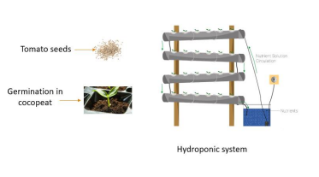
Hydroponic agriculture is a method of growing plants that does not use soil and delivers nutrients straight to the plant's roots using a water-based nutrition solution. Here is a summary of some important characteristics and benefits of hydroponic farming like water efficiency, nutrient control, space efficiency reduced pest and disease pressure, reduced environmental impact etc.
2.3 Model of Hydroponic Tomato Cultivation: Tomato cultivation in hydroponics involves growing tomatoes without soil, using a nutrient-rich water solution to provide the necessary minerals and elements. This method allows for controlled and efficient cultivation, leading to higher yields and better plant health. Here are the essential steps and methods for tomato cultivation in hydroponics: selecting tomato varieties, setting up the Hydroponic system, preparing the nutrient solution, germination and seedling stage, transplanting seedlings, monitoring and maintaining nutrient solution, light and temperature, pruning and training, pollination and harvesting.
Figure: 2.3 Hydroponic systems for tomato cultivation
2.4 Hydroponic Nutrient Solution: A hydroponic nutrient solution is a specially formulated mixture of essential elements and minerals required for plant growth in hydroponic systems. In hydroponics, plants are grown without soil, and instead, their roots are directly exposed to a nutrient-rich water solution that provides all the necessary nutrients for their growth and development. Component of the nutrients solutions are Macronutrients (include nitrogen (N), phosphorus (P), potassium (K), calcium (Ca), magnesium (Mg), and sulfur (S)), Micronutrients also known as trace elements (include iron (Fe), manganese (Mn), copper (Cu), zinc (Zn), molybdenum (Mo), boron (B), and chlorine (Cl), pH adjusters, and growth enhancers (include beneficial microbes, vitamins, amino acids, and plant hormones) etc.
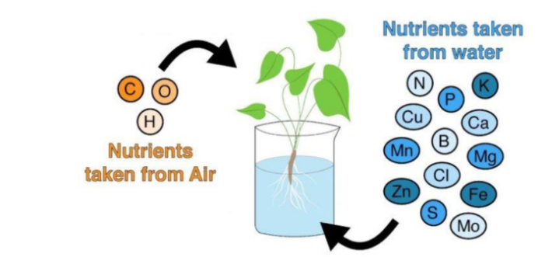
Figure: 2.2: Nutrients of Hydroponic system
2.5 Methodology
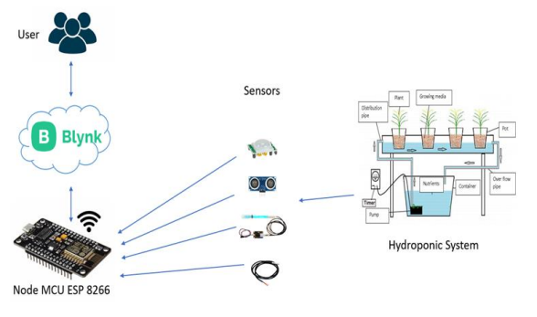
The system integrates with IoT technology using NodeMCU ESP8266 and the Blynk platform.Sensors monitor environmental conditions and system parameters.This sensors are connected to the NodeMCU ESP8266 microcontroller, which processes the data and transmit it to the Blynk cloud via Wi-Fi.Through the Blynk platform, users can access real-time data and remotely control the hydroponic system using a mobile app or web dashboard. The user interface allows monitoring of all critical parameters, receiving alerts for any deviations, and making adjustments to actuators like pumps and timers to maintain optimal conditions for plant growth. This integration allows efficient and remote management of the hydroponic system, ensuring consistent and optimal growing conditions while minimizing the need for manual intervention. The methodology enhances the reliability and productivity of the hydroponic system, making it more user-friendly and effective.
Figure: 2.5 Block diagram of the proposed system

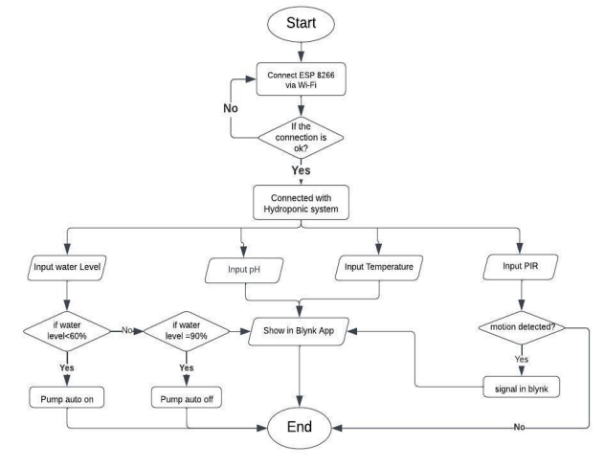
Figure: 2.51 Flow chart of the proposed system

- Proposed System:
The Blynk cloud app and web dashboard serve as centralized platforms for accessing and visualizing the data collected by the hardware components, they give farmers the ability to remotely monitor important factors including pH, temperature, water level, mobility, and nutrient concentration. Users may quickly assess the data and come to well-informed judgments thanks to how the app and dashboard convey this information. Farmers can set up personalized alerts and notifications depending on criteria or conditions through the Blynk cloud app and web dashboard. By doing this, customers are guaranteed rapid notification of any hydroponic system irregularities or problems, enabling them to take immediate action. This degree of control enables the tomato plants' growing circumstances to be optimized, ultimately improving quality and production. This system enables farmer to efficiently monitor and manage their tomato production process by providing real-time insights, control options, and data visualization.

Figure: 3.1 Blynk Homepage for the proposed system
3.1 Dashboard: The dashboard serves as a centralized hub where growers can monitor and analyse the collected data from sensors placed throughout the hydroponic setup. Through intuitive graphs, charts, and customizable dashboards, growers can easily track the performance of their hydroponic tomato cultivation and make data-driven decisions.
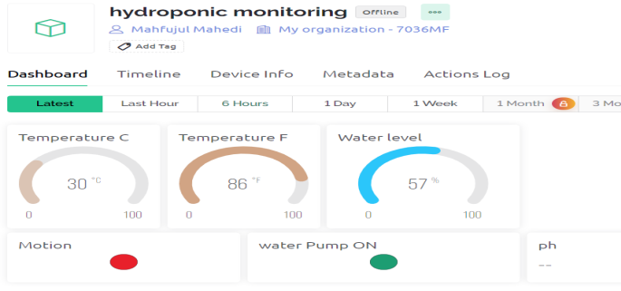
Figure: 3.2 Web Dashboard of the proposed system
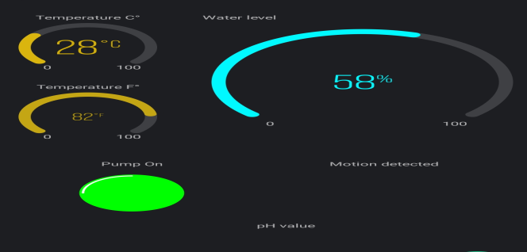
Figure: 3.3 Mobile Dashboard of the proposed system
The hydroponic solution's present nutrient concentrations are visible to growers, who can also track trends over time. The appropriate mix of nutrients must be provided to the plants for them to grow healthily, and this knowledge makes it possible to determine the best nutrient dosing. The dashboard also offers real-time data on environmental factors like humidity and temperature. It is accessible on iOS and Android devices, with key aspects including a customizable dashboard, virtual pins and widgets, motion detection widgets, water temperature, water level, pH value widgets, and water pump control widgets. Users can add widgets like buttons, sliders, gauges, graphs, displays, and notifications to monitor various functionalities. The app also provides real-time pH values and allows users to manually turn on or off the water pump [18].
4 Analyses and Discussion:
The hydroponic monitoring system for tomato cultivation aims to optimize plant growth through intelligent and data-driven environments. The system integrates hardware components like the ESP8266 microcontroller, temperature, pH, and EC sensors collecting real-time data on environmental parameters. Automated control mechanisms, such as water pumps and nutrient delivery systems maintain optimal conditions throughout the cultivation process. The results are presented, highlighting the system's real-time monitoring capabilities and the benefits of remote access and timely intervention. The results and discussion section contribute to the advancement of precision agriculture and underscore the importance of data-driven solutions in modern farming practices.
4.1.1 Sensor’s Readings: Readings from sensors play a vital role in hydroponic monitoring systems, enabling precise control and optimization of the hydroponic environment. In such a controlled environment, sensors are employed to monitor various parameters critical to plant growth and health.
4.1.2 pH in Hydroponic Tomato Cultivation: pH is extremely important in hydroponic tomato cultivation because it directly influences the availability and uptake of vital nutrients by tomato plants. Keeping the pH level of hydroponic plants that are grown without soil and getting their nutrients from a fertilizer solution just right is essential to promoting strong growth and maximum harvests. The following are the main justifications for why pH matters in hydroponically grown tomatoes. The ideal pH range for hydroponic tomato cultivation typically falls between 6.0 to 6.5, slightly acidic to near neutral. By carefully managing the pH of the nutrient solution, hydroponic tomato growers can optimize nutrient uptake, promote healthy root development, prevent nutrient imbalances, and ultimately achieve higher yields of high-quality tomatoes. The uptakes of pH from the sensor are shown in Figure 4.3.
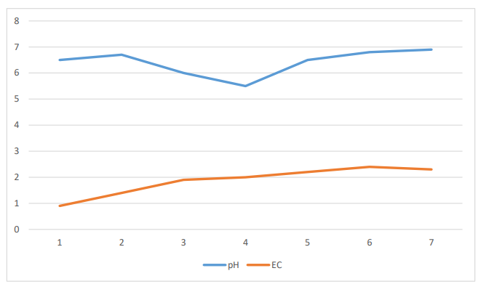
Figure: 4.3 pH & EC readings from the sensors
4.1.3 Electric conductivity (EC): In hydroponic tomato cultivation, EC is an essential parameter used to measure the concentration of total dissolved salts, primarily the nutrients, in the hydroponic nutrient solution. Electrical Conductivity is a crucial tool for monitoring and maintaining the nutrient balance in the system, ensuring optimal growth and yield of tomato plants. The readings are shown in above figure 4.3.
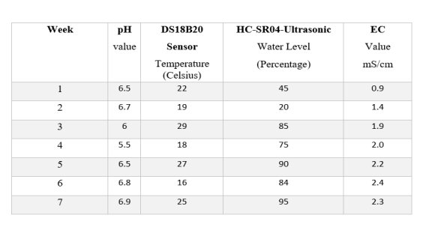
Optimal EC Levels for Tomato Cultivation: The optimal EC levels for tomato cultivation in hydroponics can vary depending on the growth stage of the plants. Generally, the following EC ranges are recommended:
i. Seedling Stage: 0.8 to 1.2 mS/cm or 800 to 1200 µS/cm
ii. Vegetative Growth Stage: 1.2 to 2.0 mS/cm or 1200 to 2000 µS/cm
iii. Flowering and Fruiting Stage: 2.0 to 3.0 mS/cm or 2000 to 3000 µS/cm
Regular monitoring and maintenance: It's essential to monitor the EC regularly, at least once a day, and adjust the nutrient solution accordingly. Factors such as temperature, humidity, and plant uptake can influence nutrient levels, making consistent monitoring vital for optimal plant In conclusion, Electrical Conductivity (EC) is a critical parameter in hydroponic tomato cultivation as it helps maintain the right nutrient balance, ensuring healthy growth and maximizing yield potential.
4.1.4 Temperature and Water Level: Temperature and water levels are important factors in hydroponic tomato cultivation because they promote growth and productivity. Temperature affects photosynthesis and respiration rates, as well as nutritional availability, disease prevention, and water conservation, all of which contribute to optimal development conditions. It is critical for optimal growth and development to maintain a temperature range of 21°C to 27°C (70°F to 82°F) [21]. Water levels are also important in fertilizer delivery, preventing root stress, and conserving water. By closely monitoring and controlling temperature and water levels, hydroponic tomato growers can create a stable environment for their plants, maximizing growth, yields, and overall crop quality. This level of precision and control contributes to more efficient and sustainable agricultural practices.
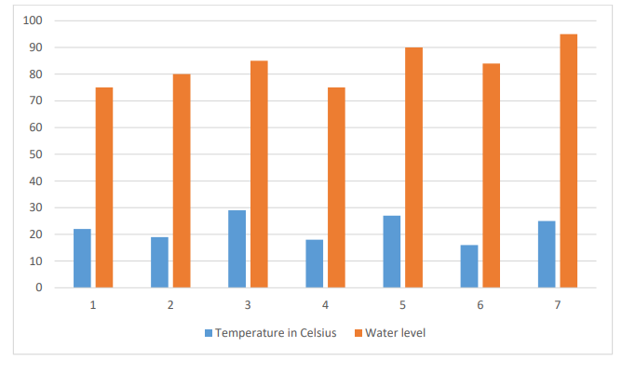
Figure: 4.4 Temperature & water level readings from sensors
Summary of the proposed approaches:
The strength and the weakness are explained below:
Strength:
This thesis demonstrates innovative use of IoT technology in hydroponic tomato cultivation, enabling real-time monitoring and control, which significantly advances precision agriculture. It employs a comprehensive data collection system with various sensors to optimize environmental conditions precisely. The system's remote accessibility through web and mobile applications enhances usability and flexibility for growers. Additionally, by promoting sustainable and efficient cultivation practices.
Weakness:
The thesis identifies challenges with sensor accuracy, data transmission reliability, and automated control mechanisms, which can impact the system's operation and data collection. User feedback, crucial for system improvement, may be inconsistent and variable, affecting the feedback loop's effectiveness. Limited testing environments and conditions may restrict the generalizability of results to different hydroponic setups or crops.
5 Conclusion:
In conclusion, the Hydroponic Tomato Cultivation Monitoring System that utilizes IoT devices offers a comprehensive solution for monitoring and controlling the growing conditions of tomato plants in a hydroponic setup. By integrating hardware components such as the Node-MCU ESP8266 WIFI Module, breadboard, jumper wires, pH sensor, temperature sensor, HC-SR04 Ultrasonic Sonar Sensor, water pump, relay module, PIR motion sensor, and EC sensor, farmers can gather real-time data on crucial parameters like pH levels, temperature, water level, motion, and nutrient concentration. These hardware components work together to ensure optimal conditions for tomato growth, promoting improved yield and quality. The Node-MCU ESP8266 acts as the central controller, facilitating communication between the sensors and the cloud or server. The breadboard and jumper wires provide a flexible platform for circuit prototyping and interconnection. The pH sensor monitors the acidity or alkalinity of the nutrient solution, while the temperature sensor tracks the ambient temperature. The HC-SR04 Ultrasonic Sonar Sensor measures the water level, and the water pump enables automated irrigation. The relay module controls external devices, the PIR motion sensor detects movement, and the EC sensor measures nutrient concentration. Additionally, the software aspect of the system, such as the Blynk cloud app and web dashboard, allows farmers to access and visualize the collected data, set up alerts, and remotely monitor and control the hydroponic system. These software tools provide a user-friendly interface for data analysis and decision-making. Overall, the Hydroponic Tomato Cultivation Monitoring System using IoT devices enables farmers to optimize the growing conditions of tomato plants in a hydroponic setup. It enhances productivity, resource management, and control over the cultivation process. By leveraging real-time data and remote monitoring capabilities, this system contributes to sustainable and efficient tomato cultivation practices.

REFERENCES:
[1] | Bharti N.K. Dongargaonkar M. Kudkar I.B. Das S. and Kenia M. (2019). Hydroponics System for Soilless Farming Integrated with Android Application by Internet of Things and MQTT Broker. 1-5. 10.1109/PuneCon46936.2019.9105847.25.
[2] | Chaudhary A, Marinangeli CPF, Tremorin D, Mathys A. Nutritional Combined Greenhouse Gas Life Cycle Analysis for Incorporating Canadian Yellow Pea into Cereal-Based Food Products. Nutrients. 2018; 10(4):490. https://doi.org/10.3390/nu10040490.
[3] | Huang W. Guan Q. Luo J. Zhang J. Zhao J. Liang D. Huang L. Zhang D. (2014). New Optimized Spectral Indices for Identifying and Monitoring Winter Wheat Diseases’ Journal of Selected Topics in Applied Earth Observations and Remote Sensing, 7(6), 2516–2524. 10.1109/JSTARS.2013.2294961.
[4] | Hamdi A. Alsulaiman M. and Muhammad G. "Date Fruit Classification for Robotic Harvesting in a Natural Environment Using Deep Learning," in IEEE Access, vol. 7, pp. 117115-117133, 2019, doi: 10.1109/ACCESS.2019.2936536.
[5] | Lu T. Yu H. Wang, T. Zhang, T. Shi C. Jiang W. Influence of the Electrical Conductivity of the Nutrient Solution in Different Phenological Stages on the Growth and Yield of Cherry Tomato. Horticulture 2022, 8, 378. https://doi.org/10.3390/horticulturae8050378.
[6] | Mohapatra B. N. Jadhav R. V., and Kharat K. S. “A Prototype of Smart Agriculture System Using Internet of Things Based on Blynk Application Platform”, j.electron.electromedical.eng.med.inform, vol. 4, no. 1, pp. 24-28, Jan. 2022.
[7] | Nigussie E. Olwal T. Musumba,G. Tegegne T. Lemma A. and Mekuria F. “IoT-based irrigation management for smallholder farmers in rural sub-Saharan Africa,” Procedia Computer Science. Volume 177,2020, Pages 86-93.
[8] | Park S. & Jongwon K. (2021). Design and Implementation of a Hydroponic Strawberry Monitoring and Harvesting Timing Information Supporting System Based on Nano AI-Cloud and IoT-Edge. Electronics. 10. 1400.10.3390/electronics10121400.
[9] | Wu J. Zhang B. Zhou J. Xiong Y. Gu B. and Yang X. ‘‘Automatic recognition of ripening tomatoes by combining multi-feature fusion with bi-layer classiﬁcation strategy for harvesting robots,’’ Sensors, vol. 19, no. 3, pp. 1–22, Feb. 2019.
[10] | Arduino libraries from: https://github.com/arduino-libraries.
[11] | Arduino IDE knowledge; https://en.wikipedia.org/wiki/Arduino.
[12] | Blynk app Console; https://blynk.io/getting-started.
[13] | EC sensor is available at, https://techshopbd.com/detail/2576/EC_Sensor.
[14] | Growing Hydroponic Tomatoes: https://igworks.com/blogs/growing-guides/growing-hydroponic-tomatoes-in-your
[15] | Learn about hydroponics; https://en.wikipedia.org/wiki/Hydroponics.
[16] | Learn about electronics; at https://how2electronics.com.
[17] | Learn about wire connection; https://wiring.org.co/learning/tutorials.
[18] | Learn about monitoring system IoT based; https://youtu.be/PTJ9sAk2c21.
[19] | Learn about connecting with the Blynk app; https://www.viralsciencecreativity.com/post/blynk-iot-smart-plant-monitoring-system.
[20] | Learn about ph. for tomato hydroponics; https://hydroponicsdaily.com/best-ph-for-hydroponic-tomatoes.
[21] | Learn about water temperature for tomato hydroponics; https://www.leaffin.com/hydroponic-tomatoes.
[22] | pH sensor available at, https://techshopbd.com/detail/2576/PH_Sensor.
[23] | Sonar Sensor (HC-SR04); https://techshopbd.com/detail/1343/Sonar_Sensor_(HC-SR04)_techshop_bangladesh.
[24] | Tomato Cultivation in Bangladesh; https://en.banglapedia.org/index.php/Tomato

