HYDROGEOCHEMICAL ASSESSMENT OF GROUNDWATER QUALITY IN MAKARFI AND ENVIRONS, KADUNA STATE, NIGERIA

ABSTRACT
Groundwater serves as a vital and often primary source of drinking and domestic water, particularly in the rural areas of northwestern Nigeria. Despite its critical importance, the quality of this essential resource is frequently inadequately characterized. This study undertakes a comprehensive assessment of the hydrogeochemical characteristics and overall groundwater quality within Makarfi and its surrounding areas in Kaduna State. To achieve this, five (5) groundwater samples were systematically collected from both hand-pump boreholes and open wells. These samples were subsequently subjected to rigorous analysis for various physicochemical parameters, a suite of selected major ions (Na⁺, K⁺, NO₃-, SO₄²⁻, HCO₃-, Cl-), and crucially, potentially hazardous heavy metals (Pb²+, As³⁺). The Analytical results revealed that the concentrations of most major ions were generally within the permissible limits established by the World Health Organization (WHO) for drinking water. Specifically, sodium concentrations ranged from 9.2 to 32.0 mg/L, potassium from 2.5 to 9.1 mg/L, nitrate from 0.007 to 0.025 mg/L, and chloride from 0.7 to 3.0 mg/L. However, a significant concern emerged regarding the heavy metals: Lead (Pb₂⁺) concentrations, ranging from 0.023 to 0.922 mg/L, and Arsenic (As³⁺) concentrations, ranging from 0.017 to 0.077 mg/L, consistently exceeded the WHO permissible limits in the majority of the analyzed samples. This alarming finding strongly indicates potential health risks for the local population relying on these water sources. The hydrogeological context of the study area indicates that groundwater occurrence is predominantly controlled by the weathered and fractured basement rocks, which include coarse-grained granite, migmatite gneiss, and laterite. Furthermore, the hydrogeochemical facies analysis identified the water as predominantly Na-HCO₃ and NaCl types, suggesting that rock weathering and precipitation are the primary controlling factors influencing the groundwater chemistry. Based on these findings, the study strongly recommends regular monitoring of groundwater quality and the implementation of appropriate treatment measures before consumption to safeguard public health.
Keywords: Groundwater quality, hydrogeochemistry, basement complex, heavy metals, Makarfi, Nigeria

INTRODUCTION
Groundwater represents a critical component of the global freshwater supply, accounting for approximately two-thirds of these vital resources. Its significance is particularly pronounced in semi-arid regions, where surface water sources are often ephemeral and unreliable (Chapman & Kimstach, 1996; Zeinolabedini & Esmaeily, 2015). In the context of Nigeria, specifically within its Basement Complex terrains, groundwater is typically found within the weathered overburden and intricate networks of fractured bedrock. However, the confluence of rapid population growth, intensified agricultural practices, and inadequate waste management strategies has progressively raised serious concerns regarding the quality and sustainability of these crucial groundwater resources (Edet & Okereke, 2014).
The Makarfi area and its environs, situated in Kaduna State, exemplify a region heavily dependent on groundwater for various uses. Despite this profound reliance, a comprehensive hydrogeochemical assessment of its groundwater resources has, to date, been conspicuously absent. Recognizing this critical knowledge gap, the present study was designed with the following overarching objectives:
- To accurately map and characterize the local geological formations that influence groundwater occurrence and movement.
- To thoroughly evaluate the suitability of the groundwater in the study area for drinking purposes, in accordance with established international standards.
- To identify and elucidate the dominant hydrogeochemical processes and controlling factors that govern the chemical composition of the groundwater.
STUDY AREA
Makarfi is strategically located in the northern part of Kaduna State, Nigeria, precisely delineated by latitudes 11°21'00''–11°25'00''N and longitudes 7°52'00''–7°56'00''E (Fig 1). The region experiences a characteristic Sudano-Sahelian climate, marked by a distinct single rainy season extending from May to October, during which annual precipitation typically ranges between 800mm and 1200 mm. This is contrasted by a prolonged dry season that spans from November to April. Ambient temperatures in the area exhibit a considerable range, fluctuating from a minimum of 15°C to a maximum of 40°C. The prevailing vegetation type is characteristic of the Sudan Savanna, adapted to these climatic conditions. Geologically, the Makarfi area is underlain by rocks of the Precambrian Basement Complex, which are integral to the broader geological framework of Nigeria. The dominant lithological units identified in the region include migmatite gneiss, coarse-grained granite, and laterite.
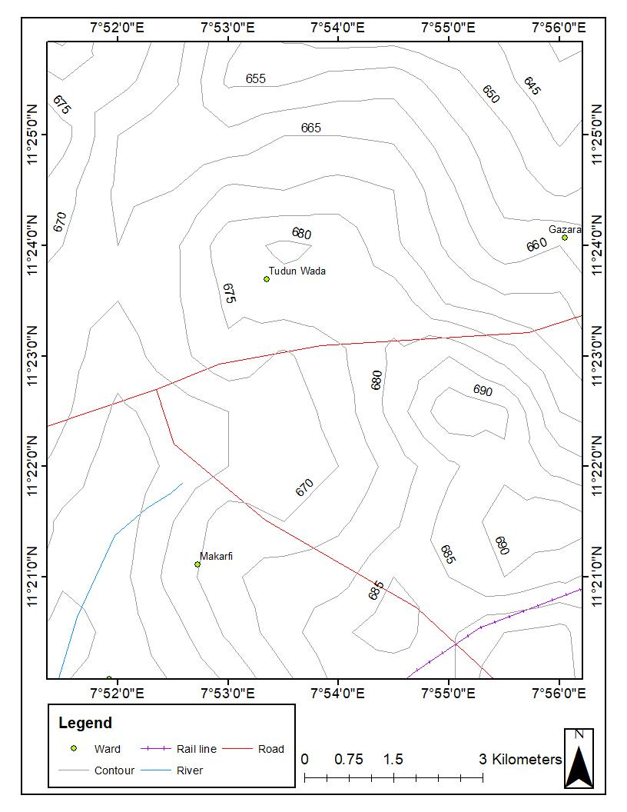
Figure 1: Topographic Map of the Study area
These geological formations play a crucial role in defining the hydrogeological characteristics and groundwater potential of the area, influencing both the occurrence and movement of subterranean water resources. Nigeria's geology (Fig 2) is characterized by three (3) major rock types: Crystalline (Igneous and Metamorphic) and Sedimentary rocks, occurring in roughly equal proportions. The Crystalline rocks form the Precambrian-Palaeozoic Basement Complex, extending across the eastern, north-central, and northeastern parts of the country. The Sedimentary Basins comprise seven (7) inland basins (Niger Delta, Anambra Basin, Benue Trough, Chad Basin, Sokoto Basin, Bida-Nupe Basin, and Dahomey Basin), filled with sediments ranging in age from Cretaceous to recent.
Geology of Kaduna State
The geology of Kaduna State (Fig. 3) is predominantly underlain by the Nigerian Basement Complex, with minor occurrences of sedimentary rocks. The Basement Complex comprises Precambrian rocks which include migmatites, gneisses, schists, and older granites, which underlie the vast majority of the state (Wright, 1985). A distinctive feature of Kaduna's geology is the extensive exposure of Jurassic Younger Granites, which form a series of ring complexes and highland plateaus across the central and northern parts of the state. These Younger Granites are predominantly biotite granites and rhyolites, and they are often associated with valuable mineralizations, including cassiterite (tin ore) and columbite (Olofin, 1987).
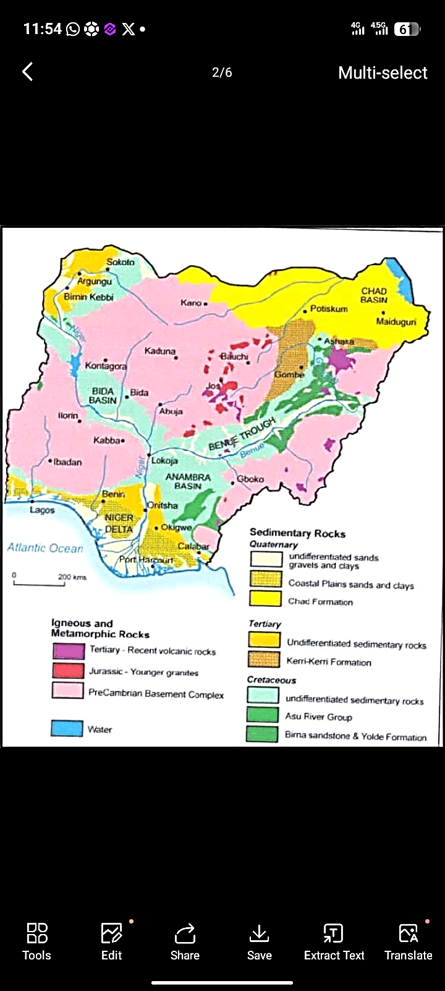
Figure 2: Map of Nigeria showing the major geological components (Macdonald, 2000).
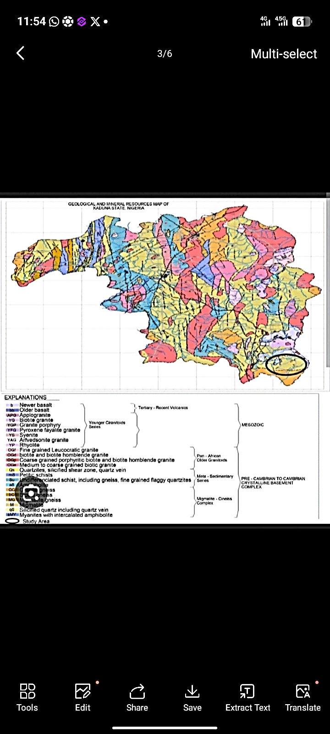
Figure 3: Geological map of Kaduna State (NGSA, 2008).
Hydrogeology of Kaduna
Mohammed (1984) presented that the aquifers of the Basement Complex area of Kaduna State are the weathered (saprolite) and fractured bedrock zones in which groundwater exists under water table conditions. The hydrogeology of the state is to a large extent controlled by its geologic settings and climatic conditions. Groundwater occurrence within the Basement Complex areas is predominantly limited to these fractures and the weathered overburden (Yakudima, 2009). Within the sedimentary basins, such as those found in the northern and southern parts of the state, groundwater occurs within the sedimentary strata that make up the upper-level sandy horizons. Generally, the water table in the Basement Complex area is relatively shallower than in the deeper sedimentary aquifers. In the Basement Complex areas, water levels generally vary from 8 m to 30 m, and in some rare cases may reach up to 60 m in deeper fracture zones. Within the sedimentary formations, in contrast, the water table typically ranges from 25 m to over 70 m (WRECA, 1987).
Groundwater Quality
The quality of water is of vital concern for mankind since it is directly linked with human welfare. Ranjana (2010) presented that the quality of public health depends to a greater extent on the quality of groundwater. Though groundwater quality is believed to be quite good compared to surface water, its quality is the sum of natural influences (geology of the environment) and anthropogenic influences (withdrawal, land use change, and solid waste dumping) (Chapman & Kimstach, 1996). Water quality parameters reflect the level of contamination in water resources and show whether water is suitable for human consumption. Contaminated water is unacceptable due to health effects, poor taste, and low aesthetic value to consumers (Suthra et al., 2009). This is particularly relevant in Kaduna State, where a significant portion of the population relies on boreholes and wells. Although groundwater in the state is generally considered good compared to surface water, its quality is the sum of both natural influences such as the geology of the Basement Complex and Younger Granite rocks, which can influence concentrations of fluoride, iron, and other minerals and anthropogenic influences. These human activities include intensive withdrawal, agricultural land use (with associated fertilizer and pesticide runoff), industrial discharge, and improper solid waste dumping, especially in urban areas like Kaduna metropolis (Chapman & Kimstach, 1996). In Kaduna, common quality concerns include bacteriological contamination from shallow pit latrines, high nitrate levels from agriculture, and natural salinity in some sedimentary areas.
Hydrogeochemistry in Kaduna
Groundwater is a vital source of drinking water in Kaduna State, contributing significantly to water supply for domestic, agricultural, and industrial purposes. However, rapid population growth, urbanization, industrialization, and inadequate waste management practices have resulted in increased contamination of groundwater sources, making hydrogeochemical assessment critical (Adamu et al., 2013). These assessments help identify potential contamination sources, understand the health risks associated with groundwater pollutants, and guide effective water management strategies. Studies on groundwater have been conducted in different parts of the State for various purposes. An investigation into the aquifer characteristics within the Basement Complex found that borehole yield and water quality vary significantly with the thickness of the weathered layer and fracture density (Emmanuel et al., 2011). Aliyu et al. (2016) studied the water supply situation in Kaduna State and discovered a heavy reliance on groundwater, especially in areas where surface water is polluted or seasonal. Adamu (2017) assessed the groundwater potential of parts of Kaduna metropolis using Vertical Electrical Sounding (VES) and recognized that most of the areas have high to moderate groundwater prospects, but the study highlighted the need to integrate water quality data to assess suitability. Boyi (2017) undertook a preliminary hydrogeochemical assessment of various water sources in Kaduna metropolis. The study revealed that while surface water is highly contaminated, groundwater also shows elevated levels of heavy metals and nitrate in industrial and high-density residential areas. Rilwanu (2014) mapped groundwater potential for rural water supply in Kaduna State using an integrated method, identifying several potential zones.
Hydrogeochemical control on Groundwater availability
The availability and chemical suitability of groundwater are intrinsically linked to the geological framework. The state is underlain predominantly by Basement Complex rocks, with significant intrusions of Younger Granites and minor sedimentary formations. These geological units dictate not only the quantity of water stored but also the hydrogeochemical processes that control its quality. Research has revealed that groundwater occurrence and its resultant chemistry are most favorable in the fractured zones of the Younger Granites and the weathered mantle of the Basement Complex. The regolith aquifers in the Basement Complex are typically shallow and discontinuous, leading to highly variable borehole yields and water chemistry. Water in these shallow, weathered zones is often of the calcium-bicarbonate type, reflecting the dissolution of silicate minerals like feldspars, but is also more vulnerable to surface-derived contamination. In contrast, the extensively fractured Younger Granites often form more productive aquifers (Freeze & Cherry, 1979). In urban areas like Kaduna metropolis, intensive groundwater exploitation through numerous boreholes has significant hydrogeochemical implications (Foster & Hirata, 1988). While groundwater is often a more reliable and initially potable alternative to surface water, heavy abstraction can alter the natural hydrogeochemical regime. Over-pumping can induce vertical leakage from shallow, contaminated aquifers or draw in pollutants from nearby sources, a process known as induced infiltration. The sustainability concerns, therefore, extend beyond mere water level decline. They encompass the risk of geogenic contamination (e.g., from the natural dissolution of minerals) and anthropogenic contamination (e.g., from agricultural runoff, industrial effluents, and inadequate waste disposal). These factors underscore the necessity for comprehensive hydrogeochemical studies to ensure the sustainable management and protection of groundwater resources.

Materials and Methods
Field Sampling
A preliminary reconnaissance survey was conducted across the study area to gain an initial understanding of the geological and hydrogeological settings. This was followed by detailed geological mapping along predetermined traverses to delineate the various rock units and structural features. For the hydrogeochemical assessment, a total of five (5) groundwater samples were collected at different locations (Fig 4). These samples were sourced from three (3) hand pump and two (2) from open well, strategically selected to represent the spatial distribution of groundwater abstraction points within Makarfi and its environs. The specific locations and types of wells sampled are detailed in Table 1.
Before sample collection, all wells were thoroughly purged to ensure that representative groundwater, free of stagnant water, was obtained. Sampling bottles were meticulously rinsed multiple times with the groundwater to be collected before filling. For samples designated for heavy metal analysis, a critical step was acidification with concentrated nitric acid (HNO₃) immediately after collection. This acidification is essential to prevent the precipitation of metal ions and to maintain their stability until laboratory analysis.
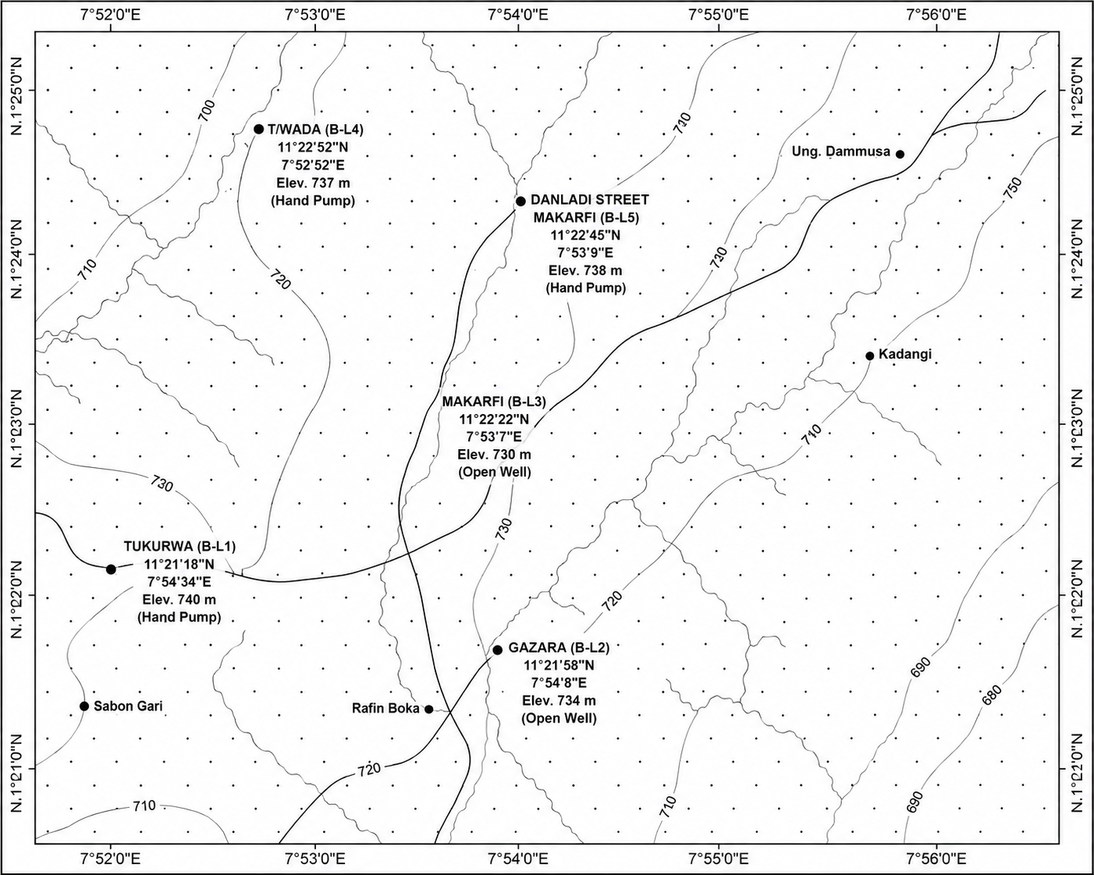
Figure 4: Sample Location Map of the Study area showing the distribution of sampling points (B-L1 to B-L5)
Table 1: Sampling Locations
Location Code | Latitude (N) | Longitude (E) | Well Type
Tukurwa B-L1 | 11°21′18″ | 7°54′34″ | Hand pump
Gazara B-L2 | 11°21′58″ | 7°54′8″ | Open well
Makarfi B-L3 | 11°22′22″ | 7°53′7″ | Open well
T/Wada Makarfi B-L4 | 11°22′52″ | 7°52′52″ | Hand pump
Danladi Street B-L5 | 11°22′45″ | 7°53′9″ | Hand pump
Laboratory Analysis
All collected groundwater samples were transported to the laboratory under controlled conditions to minimize any potential changes in their chemical composition. The analysis of Sodium (Na⁺), Potassium (K⁺), Lead (Pb₂⁺), and Arsenic (As³⁺) concentrations was performed using Atomic Absorption Spectrophotometer (AAS), a highly sensitive and accurate method for trace metal determination. Bicarbonate (HCO₃⁻) concentrations were quantified through titration with hydrochloric acid (Hcl), while chloride (Cl⁻) concentrations were determined using the argentometric titration method. Sulfate (SO₄²⁻), and nitrate (NO₃⁻) concentrations were measured using spectrophotometric techniques. Throughout the analytical process, stringent quality control measures were implemented to ensure the reliability and accuracy of the results. The obtained hydrogeochemical data were subsequently compared against the established guidelines for Drinking-Water Quality (DWQ) published by the World Health Organization (WHO, 2022) to assess the suitability of the groundwater for human consumption.
Results and Discussion
Geology of the Study Area
The geological mapping revealed that the study area is predominantly covered by lateritic rock, accounting for approximately 70% of the surface geology. This is followed by coarse-grained granite, which constitutes about 20%, and migmatite gneiss, making up the remaining 10% of the exposed rock units (Fig 5). The presence of pegmatite dykes and numerous fractures, which are structurally related to the Pan-African orogeny, are significant. These geological features play a crucial role in controlling the storage and flow of groundwater within the Basement Complex aquifer system, acting as conduits and reservoirs for subterranean water.
Hydrogeology
The hydrogeological assessment confirmed that the aquifers in the Makarfi area are fractured and weathered basement type. Measurements of water table depths in the open wells indicated relatively shallow levels, ranging from 6.6 to 7.1 meters below the ground surface. The elevations of the hand-pump wells were found to vary between 456 and 480 meters above sea level. Analysis of these hydrological parameters suggests a general groundwater flow direction from areas of higher topography to those of lower topography, typically perpendicular to the water level contours. This understanding of groundwater flow dynamics is essential for predicting contaminant transport and managing water resources effectively.
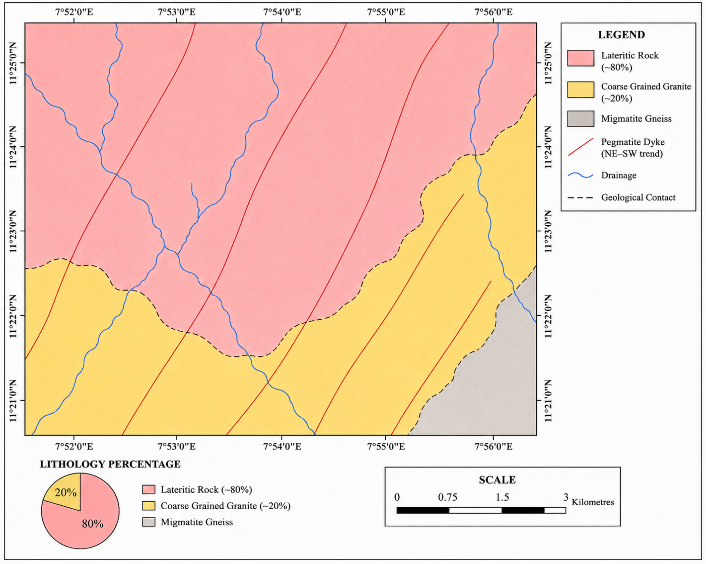
Figure 5: Geological map of the Study area.
Groundwater Quality
Table 2 presents a comprehensive summary of the hydrogeochemical parameters analyzed in the groundwater samples, alongside their respective minimum, maximum, and mean concentrations, and a comparison with the World Health Organization (WHO, 2022) permissible limits for drinking water. This comparative analysis is crucial for evaluating the suitability of the groundwater for human consumption.
Table 2: Hydrogeochemical Parameters (mg/L) compared with WHO (2022) limits
Parameter | B-L1 | B-L2 | B-L3 | B-L4 | B-L5 | Min–Max | Mean | WHO Limit
Na⁺ | 15.00 | 9.20 | 9.60 | 32.00 | 26.00 | 9.2–32.0 | 18.36 | 50–60
K⁺ | 2.60 | 2.50 | 3.10 | 9.10 | 7.90 | 2.5–9.1 | 5.04 | 12
NO₃⁻ | 0.011 | 0.007 | 0.025 | 0.010 | 0.014 | 0.007–0.025 | 0.013 | 40–50
SO₄²⁻ | 11.29 | 0.94 | 7.29 | 1.65 | 1.65 | 0.94–11.29 | 4.56 | 200–250
HCO₃⁻ | 0.20 | 1.40 | 1.00 | 1.40 | 1.60 | 0.2–1.6 | 1.12 | 125–350
Cl⁻ | 0.70 | 0.80 | 0.90 | 2.90 | 3.00 | 0.7–3.0 | 1.66 | 200–600
Pb²⁺ | 0.086 | 0.023 | 0.347 | 0.578 | 0.922 | 0.023–0.922 | 0.391 | 0.01
As³⁺ | 0.027 | 0.075 | 0.070 | 0.077 | 0.017 | 0.017–0.077 | 0.053 | 0.01

Discussion
Major Ions
The analysis of major ions (Na⁺, K⁺, NO₃⁻, SO₄²⁻, HCO₃⁻, and Cl⁻) revealed that their concentrations in all sampled groundwater were consistently within the permissible limits set by the World Health Organization (WHO) standard for drinking water. This observation suggests a relatively limited degree of mineral dissolution from the aquifer matrix and indicates low levels of contamination from agricultural activities or domestic waste. The notably low concentrations of nitrate (NO₃⁻) further support this, implying minimal impact from synthetic fertilizers or domestic sewage.
Heavy Metals
In stark contrast to the major ions, the concentrations of Lead (Pb²⁺) and Arsenic (As³⁺) presented a significant concern, as they exceeded the World Health Organization (WHO) guidelines for drinking water in the majority of the analyzed samples. Elevated lead concentrations, with values reaching up to 0.922 mg/L, could potentially originate from several sources, including the corrosion of older plumbing materials, improper disposal of refuse, or natural geogenic sources within the underlying geology. Similarly, arsenic concentrations, observed up to 0.077 mg/L, are particularly alarming due to the chronic health risks associated with long-term exposure, such as skin lesions, various cancers, and other challenging health issues. These findings are consistent with previous studies conducted in similar basement terrains, where the weathering of sulfide minerals can lead to the natural release of trace metals into groundwater systems.
Water Types and Controlling Factors
Hydrogeochemical facies analysis indicated that the groundwater in the study area is predominantly characterized by Na-HCO₃ and NaCl types. This classification suggests that rock weathering and precipitation are the primary geochemical processes controlling the overall water chemistry, a concept well-established by Gibbs (1970). The prevalence of Na-HCO₃ type water often points to the dissolution of silicate minerals and the influence of carbonic acid derived from atmospheric CO₂ and soil respiration. In some locations, the presence of NaCl-type water suggests minor contributions from surface-water intrusion or localized anthropogenic influences. Furthermore, evidence of reverse ion exchange was observed, in which bicarbonate (HCO₃⁻) is favored over sulfate (SO₄²⁻) and chloride (Cl⁻), indicating complex interactions between the groundwater and the aquifer materials.

Conclusion, Summary and Recommendation
This comprehensive hydrogeochemical assessment of groundwater quality in Makarfi and environs has yielded several key conclusions:
- The study area is geologically characterized by the Precambrian Basement Complex, with dominant lithologies including laterite, coarse-grained granite, and migmatite gneiss.
- Groundwater primarily occurs within fractured and weathered zones of these basement rocks, with a relatively shallow water table observed at depths of 6–7 meters in open wells.
- Concentrations of major ions (Na⁺, K⁺, NO₃⁻, SO₄²⁻, HCO₃⁻, and Cl⁻) were found to be within the permissible limits for drinking water as stipulated by the World Health Organization (WHO).
- Crucially, Lead (Pb²⁺) and Arsenic (As³⁺) concentrations significantly exceeded World Health Organization (WHO) allowable limits in the majority of the analyzed samples, indicating a substantial health risk to the consumers.
- The groundwater is predominantly classified as Na-HCO₃ and NaCl types, with its chemical composition primarily controlled by natural rock weathering processes and atmospheric precipitation (Gibbs, 1970).
Summary
In summary, while the groundwater in Makarfi and its environs is moderately suitable for drinking with respect to major ions, the pervasive presence of elevated lead and arsenic levels necessitates urgent attention. Therefore, appropriate treatment measures, particularly for the removal of these heavy metals, and regular monitoring are strongly recommended to ensure the safety and well-being of the local population.
Recommendation
Based on the findings of this study, the following recommendations are put forth to mitigate the identified risks and ensure sustainable management of groundwater resources in Makarfi and environs:
- Periodic Groundwater Quality Monitoring (GQM): Government agencies, in collaboration with local communities, should establish and implement a program for regular and systematic monitoring of groundwater quality, with a particular focus on heavy metal contamination.
- Strategic Well Siting: Strict guidelines should be enforced to avoid the drilling of new wells or the continued use of existing wells in close proximity to potential contamination sources such as septic tanks, refuse dumps, and agricultural fields where pesticides and fertilizers are heavily used.
- Detailed Geochemical and Geophysical Investigations: Further detailed geochemical and geophysical studies are recommended to precisely map the extent and sources of heavy metal contamination zones within the aquifer system. This will aid in targeted remediation efforts.
- Public Health Awareness and Education: Comprehensive public health awareness campaigns should be initiated to educate the local population about the health risks associated with consuming untreated groundwater, especially concerning lead and arsenic, and to promote safe water handling and treatment practices.
Acknowledgement
The authors express their sincere gratitude to the Department of Geology, Federal University Dutsinma, Katsina State, for providing the necessary facilities and support for this research. Special thanks are also extended to the staff of the Laboratory, Department of Geology, Ahmadu Bello University Zaria for their invaluable technical assistance during the sample analysis phase.
Reference
Adamu, G. K. (2017). Assessment of groundwater potential of parts of Kaduna metropolis using vertical electrical sounding (VES) [Unpublished manuscript].
Adamu, G. K., Aliyu, Y. A., & Rilwanu, M. (2013). Hydrogeochemical assessment in Kaduna State [Unpublished manuscript].
Aliyu, Y. A., et al. (2016). Water supply situation in Kaduna State [Unpublished manuscript].
Boyi, H. (2017). Preliminary hydrogeochemical assessment of various water sources in Kaduna metropolis [Unpublished manuscript].
Chapman, D., & Kimstach, V. (1996). Water quality assessments: A guide to the use of biota, sediments and water in environmental monitoring (2nd ed.). CRC Press.
Edet, A., & Okereke, C. (2014). Hydrogeologic framework of the shallow aquifers in the Ikom–Mamfe Embayment, Nigeria using an integrated approach. Journal of African Earth Sciences, 92, 25–44. https://doi.org/10.1016/j.jafrearsci.2014.01.004
Emmanuel, et al. (2011). Aquifer characteristics within the Basement Complex of Kaduna State [Unpublished manuscript].
Foster, S. S. D., & Hirata, R. (1988). Groundwater pollution risk assessment: A methodology using available data. World Health Organization.
Freeze, R. A., & Cherry, J. A. (1979). Groundwater. Prentice Hall.
Gibbs, R. J. (1970). Mechanisms controlling world water chemistry. Science, 170(3962), 1088–1090. https://doi.org/10.1126/science.170.3962.1088
Macdonald, R. (2000). Map of Nigeria showing the major geological components [Unpublished manuscript].
Mohammed, S. (1984). Aquifers of the Basement Complex area of Kaduna State [Unpublished manuscript].
Nigerian Geological Survey Agency (NGSA). (2008). Geological map of Kaduna State [Map].
Olofin, E. A. (1987). Younger granites and mineralizations in Kaduna State [Unpublished manuscript].
Ranjana. (2010). Groundwater quality and public health [Unpublished manuscript].
Rilwanu, M. (2014). Groundwater potential mapping for rural water supply in Kaduna State [Unpublished manuscript].
Suthra, S., et al. (2009). Water quality parameters and consumer acceptance [Unpublished manuscript].
World Health Organization (WHO). (2022). Guidelines for drinking-water quality (4th ed., incorporating the first and second addenda). WHO Press. https://www.who.int/publications/i/item/9789240045064
WRECA. (1987). Water table levels in Basement Complex and sedimentary formations of Kaduna State [Unpublished manuscript].
Wright, J. B. (1985). Geology of the Nigerian Basement Complex in Kaduna State [Unpublished manuscript].
Yakudima, I. A. (2009). Groundwater occurrence in fractures and weathered overburden of Kaduna State [Unpublished manuscript].
Zeinolabedini, M., & Esmaeily, A. (2015). Groundwater potential assessment using GIS and AHP techniques in the central part of Iran. ISPRS - International Archives of the Photogrammetry, Remote Sensing and Spatial Information Sciences, XL-1-W5, 769–774. https://doi.org/10.5194/isprsarchives-XL-1-W5-769-2015

