Cost efficient storage and swift time-bound access revocation using attribute-based encryption in untrusted cloud environments"

Abstract
With the rapid growth of cloud computing, it becomes important to ensure security, privacy and efficiency when it comes to data exchange. In this framework we proposed enhanced Key Policy Attribute-Based Encryption
(TB-KP-ABE) with time bound keys which provides dynamic user revocation without the need of complete key redistribution or data re-encryption which significantly improves the adaptability of ABE. Proposed a framework integrates TB-KP-ABE for encryption and Discrete Cosine Transform (DCT) for image compression, which can provide both cost-efficient storage and swift time bound access revocation in untrusted cloud environments. Framework provides two layers of security at first layer data is divided into chunks and in second layer data is encrypted and saved over cloud. Framework provides fine-grained access control based on users attributes for secure data exchange. Usage of DCT minimizes data storage overhead and cost by compressing data which enhances storage efficiency without significantly compromising data quality. Additionally our framework provide time based access revocation which is crucial for minimizing risks associated with unauthorized access. Evaluated result and analysis depicted

Introduction
Cloud computing offers a framework that allows seam-less, on-demand access to a shared collection of various computing assets, such as networks, servers, storage, and software, with minimal effort for management or provider intervention [1–3]. As cloud computing con-tinues to gain traction, more businesses and individuals

are moving their data over cloud which led to the transfer of significant amount of sensitive information, including corporate or personal financial records, files of govern-ment entities over cloud [5]. Despite its benefits trusting external servers with sensitive data introduces serious challenges related to security and privacy and controlling who can access the information.
Cloud infrastructure generally falls into two main types: public and private clouds. Utilizing public cloud services requires users to upload their data to commercial cloud providers, who are often viewed as partially trustworthy. This implies that, while these providers adhere to agreed protocols, they may still attempt to gather confidential details from the users’ data, particularly in untrusted cloud environments where the data security and confi-dentiality is a huge concerns [6–9].
A practical way to address these challenges is through the use of data access control techniques such as ABE schemes [10]. Data owners should encrypt all sensitive data before uploading it over any cloud environment. Using data access control schemes allow only those users who has right attributes ensuring data is accessible only to authorize users who are permitted to view the data [11, 12].
Another problem with cloud is its increasing storage cost.
As more organizations use cloud storage to suffice their growing data needs, managing increasing data storage costs has become a major issue [13]. Without proper cost management, operational costs can be more than allot-ted budget, diminishing the financial advantages that cloud storage is supposed to offer. One of the solution to address this problem is that a data owner can compress data and reduces the storage size of data before upload-ing it over cloud [14–17]. Selection of data compres-sion algorithms is based on type of data which will be uploaded over cloud.

Contributions
We are enhancing standard KP-ABE [44] framework pro-posed by V. Goyal et. al.
In traditional KP-ABE, once user receives a secrete key it remain valid and usable indefinitely even if user’s role along with permissions changes or user’s attributes becomes invalid, users can still access the encrypted data. In order to stop users from accessing the data, the whole data needs to be re-encrypted which is costly and impractical. To tackle this problem paper presented an efficient revocation mechanism with time-bound keys. Proposed approach supports dynamic user revocation without the need of complete key redistribution or data re-encryption which significantly improves the adapt-ability of ABE. Proposed approach is used in a presented framework which provides secure and cost efficient data storage.
Presented framework primarily focuses on addressing below key objectives:
Reducing data storage cost by implementing a DCT compression algorithm that reduces data size by half in this case data is any type of image file, while compress-ing image file, The algorithm maintains image’s quality by using compression with a carefully chosen quality factor. A multi-layer security framework where in first layer data will be stored in pieces making data unreadable and user needs to join this pieces in order to access the data. Sec-ond layer of security is provided using time-based revo-cable KP-ABE scheme which will provide controlled data
access and revocation. Only users with the right attri-butes can access specific pieces of information.
Security analysis and storage efficiency analysis is pro-vided. The results shows that the proposed framework not only reduces data storage cost by half but also pro-vide multi layered data security with less computational complexity

Related works
A Cloud Secure Storage Mechanism (CSSM) is pro-posed by H. Song et.al. in [1] to prevent data breaches in cloud storage by integrating data dispersion and dis-tributed storage techniques. CSSM combines hierar-chical management and secret sharing tied with user passwords to safeguard cryptographic materials. Paper demonstrated effective prevention of data leakage at the storage layer with minimal time overhead (e.g., upload-ing a 5GB file took 646 seconds). The mechanism effec-tively balances security and usability. In [2] Y. Ming et. al. proposed Multi-Authority ABE (RMA-ABE) is pro-posed which is based on elliptic curve cryptography. Introduced version keys for attribute revocation and achieved collusion resistance using unique identifiers tied to secret keys. It has improved resource efficiency and practicality of multi-authority ABE systems for cloud storage. Hybrid SSE and ABE Encryption Scheme is pre-sented in [3] where author A. Bakas et.al. developed a hybrid encryption scheme combining SSE and ABE to leverage the strengths of both methods. Incorporated Intel SGX to provide cryptographically agnostic revoca-tion and access control mechanisms. Paper has enabled privacy-preserving data sharing and efficient access rights management in untrusted cloud environments. Highlighted potential for privacy-preserving computa-tions on encrypted data. Two-Factor Protection is used in [4] with Attribute-Based Access Control which pro-poses a multi-authority access control with constant-size ciphertext and user-level revocation. Author X. Li et. al. has combined attribute secret keys with authoriza-tion keys for enhanced security. Paper has managed to reduce communication overhead and computation cost while supporting efficient attribute-level and user-level revocation. In [5] O. A. Khashan presented OutFS as a user-side encrypted file system which is designed by combining symmetric and asymmetric encryption for file and key security. Integrated identity-based encryp-tion (IBE) for secure file sharing. It has achieved efficient throughput (8.8 MB/s for writing, 10.5 MB/s for reading) and robustness against various attacks. Revocable Lat-tice-Based CP-ABE (RL-ABE) is introduced in [6] by S. Zhao et.al. which is designed to safeguard from quantum attacks and enabling efficient attribute revocation. Secu-rity relies on the computational difficulty of the Ring-Learning with Errors (R-LWE) problem.

Design goals
In this research, our objective is to develop an efficient storage cost framework that enables users to securely store and share their data in untrusted cloud environ-ments. The design of our system is intended to meet the following key objectives:

Data storage, processing & transfer cost
In current methods, the outsourcing algorithm consumes a significant amount processing time, with the file size directly impacting the outsourcing duration. To address this, focus is on minimizing that time to milliseconds by compressing the data before any further processing. This compression reduces the file size by over 50% while maintaining the integrity and quality of the data. After reducing file size data storage cost and transfer cost will be automatically get reduced enhancing overall system efficiency.

Data security
Most private cloud offers tools to encrypt data at server level for example AWS encrypt data using AES-256 encryption algorithm but when it comes to public cloud storage systems it stores unencrypted data on the cloud, which poses significant risks. If unauthorized individu-als gain access, they can easily read the information. The proposed framework offers a more secure solution by splitting the data into smaller chunks (sharding) before storing it on the cloud. Even if a malicious entity inter-cepts these chunks, the data remains unreadable and secure, making unauthorized access virtually impossible [39, 41, 42].

Proposed design & implementation
As illustrated in Fig. 1, the proposed architecture consists of five core components:
Cloud service provider (CSP): It facilitates different services as per demand. Here the cloud is publically avail-able but the access is restricted through authentication based protocols. It also generate and maintains billing by monitoring resource usage. In proposed framework role of CSP is to store the data as per proposed method and enforce access policies [21].
Admin: When a new user registers to the system in order to use the framework, their access rights are not automatically granted. Instead, admin review and validate registration request [22–24]. User can gain access to the framework only after getting approval from admin. This process helps to ensure that only trusted and authorized individuals can access the cloud environment, prevent-ing unauthorized users from accessing sensitive informa-tion. This gatekeeping of admin provide additional layer of security which strengthens overall data privacy and integrity.
Data owner: Data owners are individual or organiza-tion those who are responsible for creating and uploading and sharing files, and they are responsible for paying the cost associated with sharing those files [25–28]. Unlike other systems, the data owner in our framework is not required to remain online continuously.
Data user/consumer: An individual who can request access to data but only those who has right attributes which satisfy the access policy and time conditions can decrypt the data [25]. Before accessing data user needs to get authenticated from admin in the registration phase.
Attribute authority: Employs time-bound KP-ABE Scheme. This encryption technique is employed to ensure that data can be decrypted by only those users whose attributes meets the criteria of access policy defined by the data owner. This component generates secret Master key which in turn used to create user key which are cru-cial for decrypting data [30–32].
The proposed framework encompasses two primary processes: the data owner’s process and the data user’s process. These processes are briefly described below.

Data owner process
The Data Owner Process involves compressing images using the DCT algorithm and Haar Wavelet Transform filters to halve storage requirements while maintain-ing quality. The compressed image is then divided into shards during the data sharding phase, with a metadata log created to record shard details for reassembly. User-specific public and private keys are generated through time-bound KP-ABE, utilizing a master key and attribute sets to ensure secure access. Finally, the metadata log is encrypted using public parameters and an access policy, protecting shard reconstruction details and ensuring only authorized users can access the data.

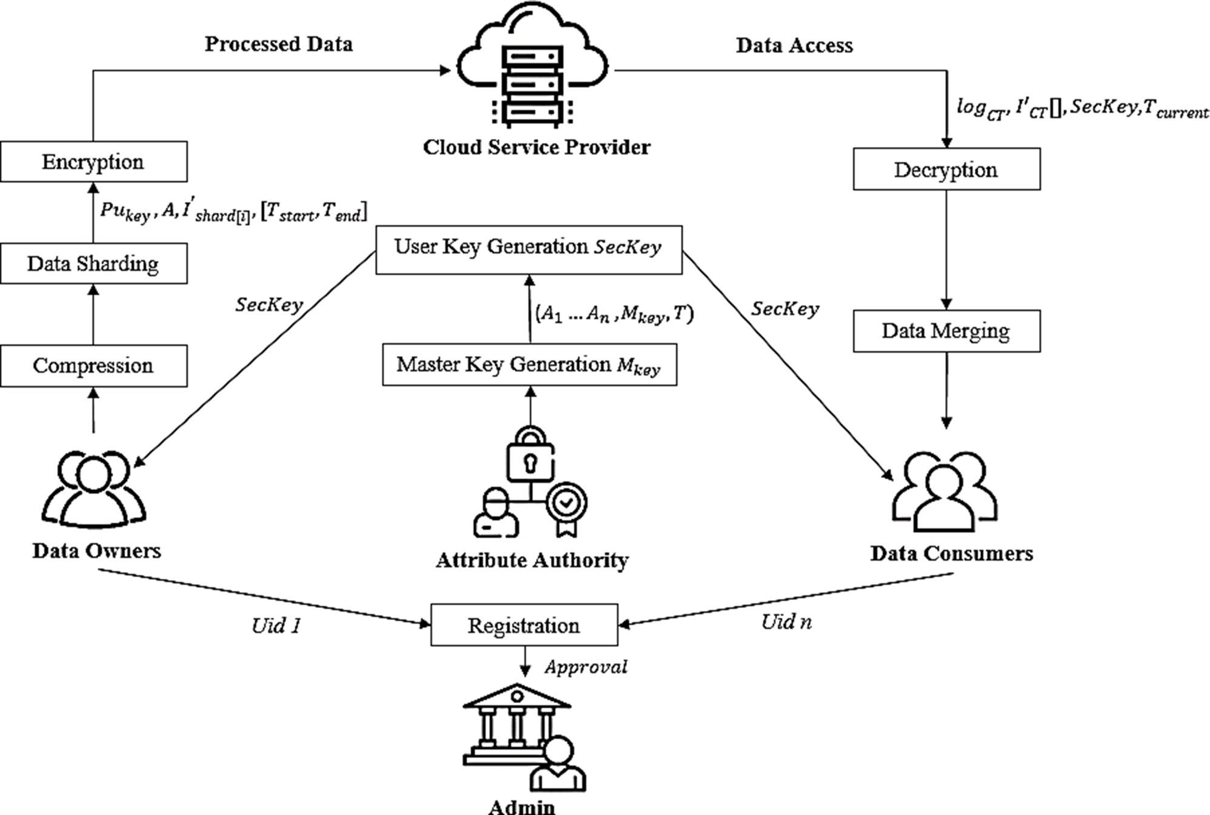
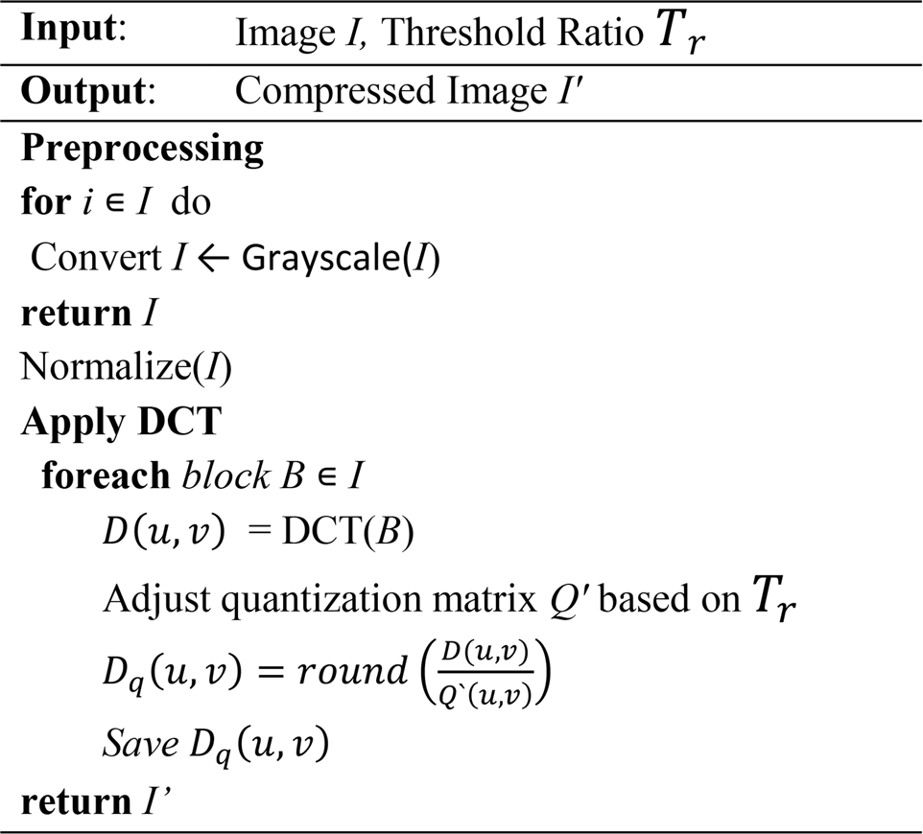
Fig. 1 Proposed secured data exchange framework

but while compressing it ensures not to degrade image quality in a great length, to ensure this it uses quality threshold ratio. Here we have utilize DCT due to its com-putational simplicity, it allows separate transformations of rows and columns, and also it has ability to effectively concentrate signal energy into fewer coefficients. This “power integration” characteristic makes it highly effi-cient for compression tasks.
In pre-processing color image I is converted into greyscale which normalizes pixel values within the range of [0,1]. After converting image to grayscale, 2D DCT is applied where image is divided into 8 × 8 non-overlapping blocks. For each block B DCT coefficients are computed at frequency indices (u, v) using Eq. (1) and
[ ]
16

Performance analysis
As illustrated in Table 3, we begin by comparing existing data-sharing frameworks with our proposed solution to assess its efficiency. The results demonstrate that the pro-posed system incorporates all key features of data shar-ing. The simulation of our scheme was performed on a Windows machine equipped with an Intel Core i5 pro-cessor running at 3.60 GHz and 8GB of RAM.

Cost efficiency and processed data quality analysis Computational complexity of proposed time-bound KP-ABE In key generation operation for each attribute in users attribute set |S_{A}|, the hash function H(A_{i}) maps attri-butes to group elements. One exponentiation in G₁ for every attribute component in secret key SecKey and additional computations requires for time-bound con-straint T_{valid} to integrate time into key component. Com-plexity for keygen can be defined as 2 (|S_{A}| + 3) E, where 2 |S_{A}| + E are two exponentiations α, β components per attribute. 3E is an additional exponentiations for global setup g^{α} and g^{β}. During encryption access policy com-plexity |I| size of access tree effect computation. H(A_{i}) maps attributes to group elements. Exponentiation in G₁ compute components for every attribute during encryp-tion and Pairing Operations E_{T} evaluate paring during encryption. Computational complexity can be defined as (7 |I| + 4) E + 2E_{T} Where 7 |I| E represents exponenti-ation operations per access policy component, Additional global operations 4E and 2E_{T} is a pairing computation for encryption.
During decryption access policy matching |I| evalu-ate the access policy tree. For each attribute in cipher-text Pairing Operations E_{T} pairs ciphertext components with user’s secret key components. G₁ compute decryp-tion elements and P match user attributes to the policy. Computationl complexity for decryption can be evalu-ated as as 2 |I| E + (|I| + 1) E_{T} + (2 |I| + 3) P where 2 |I| E represents exponentiations in decryption process. (|I| + 1) E_{T} is a policy enforcement pairing operations and (2 |I| + 3) P is policy evaluation.

Processed data quality analysis
Figure 2 describes the performance of DCT image com-pression model across different file sizes and image dimensions. For each original image size, the table provides the dimensions (height × width), the result-ing compressed size, the reduction percentage, and the compression time in milliseconds. As depicted in Table 4, Figs. 2 and 3 Compression percentages vary between 65.9% and 79.05%, showing that larger images generally have slightly lower compression ratios. Compression time increases with the file size, ranging from around 500 ms for smaller images to about 2600 ms for the larg-est. Larger files require more processing time, though the reduction percentage tends to decrease as the file size increases.
Table 5 , Figs. 4 and 5 outlines performance metrics related to the process of sharding and merging data for images of various sizes and dimensions.
As depicted in Fig. 4 the sharding times range from around 80 ms to 114.99 ms, with no direct correlation to the size of the image. Larger images don’t always require more sharding time, indicating that the sharding process depend on other factors such as the image’s complexity and dimension.
The processed parts need to be merged back together during downloading process. As shown in Fig. 5 Data merging times range from 28.99 ms to 149.99 ms. Larger images tend to require more time for merging, with the largest image (9990 KB) taking almost 150 ms.
Figure 6 presents a detailed comparison of image com-pression results, showcasing the relationship between the original file size, the compressed size, and the Peak Signal-to-Noise Ratio (PSNR), a common metric used to assess the quality of compression.

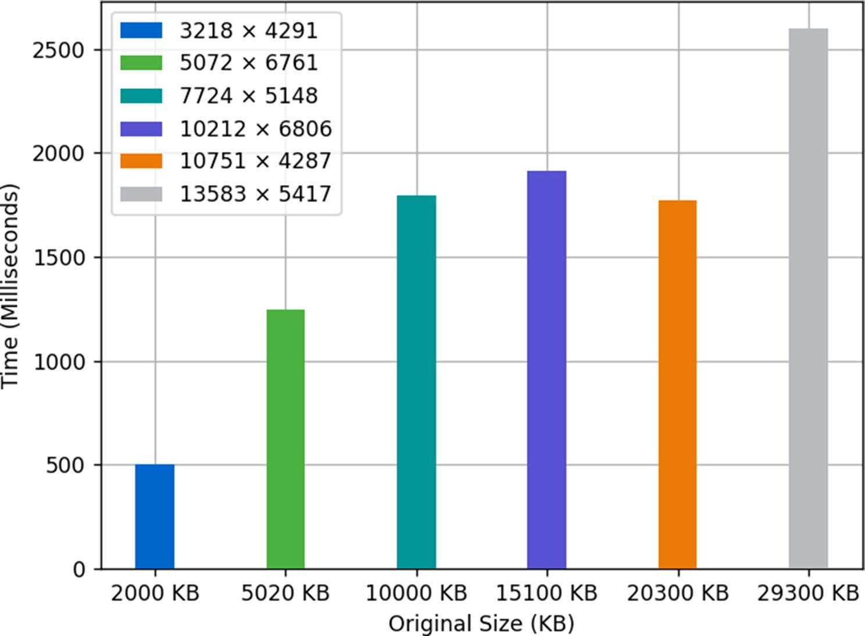

Fig. 2 Comparison of image compression time with increasing image size
Table 4 Comparative analysis original image size, compressed size and image compression time with increasing image size and resolution
Resolution | Original Size (KB) | Compressed Size (KB) | Time (ms)
3218 × 4291 | 2000 | 419 | 502.57
5072 × 6761 | 5020 | 1060 | 1248.31
7724 × 5148 | 10000 | 3270 | 1798.02
10212 × 6806 | 15100 | 4880 | 1911.99
10751 × 4287 | 20300 | 6800 | 1969.99
13583 × 5417 | 29300 | 9990 | 2599.14

From Table 6 the compression ratio can be calculated as the ratio between the original and compressed sizes. Example: For the first row, 2000 KB to 419 KB results in a compression ratio of approximately 4.77:1 (2000/419). Here the 4.77:1 compression ratio indicates that for every 4.77 KB in the original file, only 1 KB remains after compression.
As the original size increases, the compressed size also increases, but the compression ratio decreases slightly. Larger images tend to retain more data even after com-pression, though they still achieve significant reductions. For instance, the largest image of size 29,300 KB is com-pressed to 9990 KB, which is a ratio of approximately 2.93:1, much lower than for smaller files.
PSNR is a key measure of how much information is retained after compression. Higher PSNR values gener-ally reflect better quality images post-compression. Val-ues above 40 dB are considered excellent for most visual applications, indicating minimal loss in image quality. For
smaller images (2000 KB and 5020 KB), the PSNR values are quite high, at 42.51 dB and 42.73 dB, respectively. This suggests that the compression has preserved the image quality well, despite the significant reduction in size. As the original file size increases, PSNR tends to decrease. For example: At 10,000 KB, the PSNR drops to 38.15 dB, indicating a moderate quality loss.
For the largest image (29300 KB), the PSNR reaches its lowest value of 36.14 dB, signifying noticeable degrada-tion in quality.

Security analysis
Figures 7, 8, 9 presents performance metrics for TB-KP-ABE which are evaluated in terms of key generation time, encryption time, and decryption time, each measured in milliseconds (ms) and compared it with other existing KP-ABE based schemes.
As the number of attributes grows, the key generation time also increases linearly, which suggests that generat-ing a key becomes progressively more complex as more attributes are involved. The system performs additional computations and checks to ensure that the key reflects all the attributes and conditions.
For example, for TB-KP-ABE generating a key for 5 attributes takes 32 ms, but for 20 attributes, it takes 130 ms, almost four times as long. This indicates that the key generation process grows more complex with each added attribute. In APR-ABE [45] policies are redefined and delegated which requires extra structure in secrete

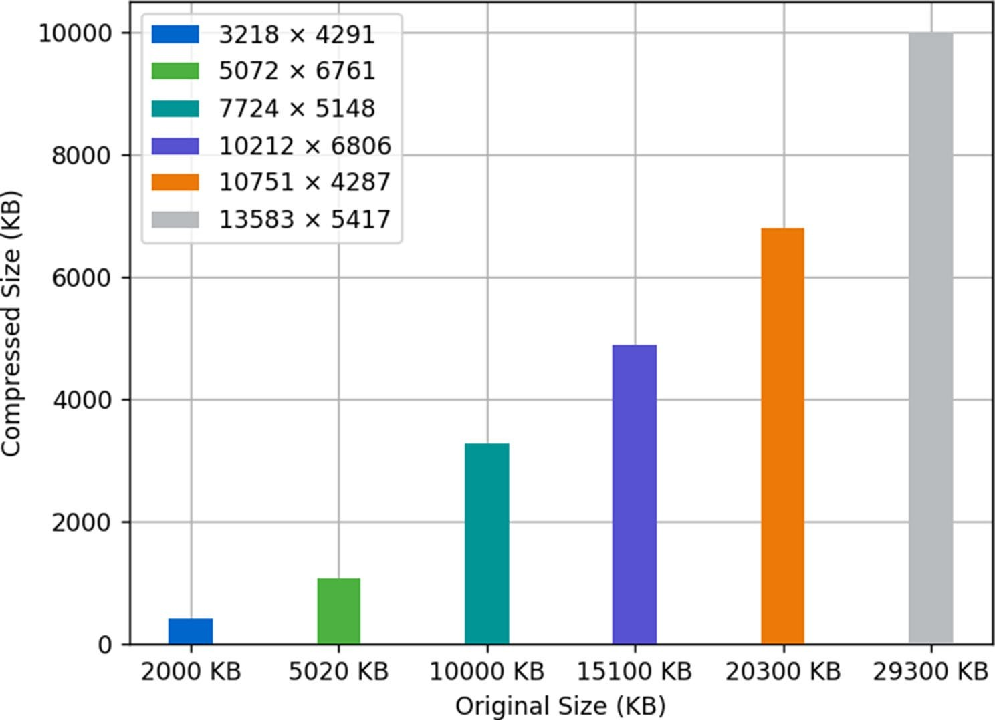

Fig. 3 Comparison of image compression size reduction with various image sizes

Conclusion

The proposed framework provides comprehensive solu-tion addressing critical challenges of cost efficiency, data security, and controlled access in untrusted cloud environments. It integrates Discrete Cosine Transform (DCT) for image compression and Time-Bound Key-Policy Attribute-Based Encryption (TB-KP-ABE) for fine-grained access control and swift access revocation. The compression technique efficiently reduces storage
costs by reducing the size of image files while preserv-ing their quality using a threshold ratio. To further secure the data, the framework employs a sharding process that divides data into multiple chunks, stores them separately
align with the specified access policy. Using a master key to generate user-specific keys that enhance both secu-rity and flexibility in access control. Additionally, imple-ments a robust mechanism for log decryption and data merging, enabling seamless reassembly of the original files while preserving the integrity and confidentiality of the data. Performance evaluations demonstrate the effi-ciency of the framework, showcasing reduced storage costs by 50% and streamlined encryption, decryption, and access control processes. Moreover, the framework’s layered approach to security, combining data compres-sion, sharding, and attribute-based encryption ensures that even in the event of data interception, unauthorized access is virtually difficult. The results confirm the viabil-ity of this framework as a scalable, efficient, and secure solution for data storage and exchange in untrusted cloud environments. Future efforts will focus on adapting this architecture to handle diverse data formats, including videos, audio files, PDFs, and other documents.
on the cloud along with log file (metadata) for recon-struction. This log is encrypted to ensure it remains inac-cessible to unauthorized users. KP-ABE guarantees that data can only be decrypted by users whose attributes

References
- Song H, Li J, Li H (2021) A cloud secure storage mechanism based on data dispersion and encryption. IEEE. https://doi.org/10.1109/ACCESS.2021.30753 40
- Ming Y, He B, Wang AC (2021) Efficient revocable multi-authority attribute-based encryption for cloud storage. IEEE. https://doi.org/10.1109/ACCESS.202 1.3066212
- Bakas A, Dang H-V, Michalas A, Zalitko A (2020) The cloud we share: access control on symmetrically encrypted data in untrusted clouds. IEEE. https://do i.org/10.1109/ACCESS.2020.3038838
- Li X, Tang S, Xu L, Wang H, Chen J (2017) Two-factor data access control with efficient revocation for multi-authority cloud storage systems. In: IEEE Access, vol 5. pp 393–405. https://doi.org/10.1109/ACCESS.2016.2609884

- Khashan OA (2020) Secure outsourcing and sharing of cloud data using a user-side encrypted file system. In: IEEE Access, vol 8. pp 210855–210867. htt ps://doi.org/10.1109/ACCESS.2020.3039163
- Zhao S, Jiang R, Bhargava B (2022) RL-ABE: a revocable lattice attribute based encryption scheme based on R-LWE problem in cloud storage. In: IEEE Trans-actions on Computers, vol. 71, no. 1, pp. 1026–1035. https://doi.org/10.1109/ TSC.2020.2973256
- Chen N, Li J, Zhang Y, Guo Y (2022) Efficient CP-ABE scheme with shared decryption in cloud storage. In: IEEE transactions on computers, vol. 71, no. 1, pp 175–184. https://doi.org/10.1109/TC.2020.3043950
- Edemacu K, Jang B, Kim JW (2020) Efficient and expressive access control with revocation for privacy of PHR based on OBDD access structure. In: IEEE Access, vol 8. pp 18546–18557. https://doi.org/10.1109/ACCESS.2020.296807
8
- Kanchanadevi P, Raja L, Selvapandian D, Dhanapal R (2020) An attribute based encryption scheme with dynamic attributes supporting in the hybrid cloud. In: 2020 Fourth International Conference on I-SMAC (IoT in Social, Mobile, Analytics and Cloud) (I-SMAC), Palladam, India, pp 271–273. https://d oi.org/10.1109/I-SMAC49090.2020.9243370
- Li J, Chen N, Zhang Y (2021) Extended file Hierarchy access control scheme with attribute-based encryption in cloud computing. In: IEEE Transactions on Emerging Topics in Computing, vol. 9, no. 2, pp 983–993. https://doi.org/10.1 109/TETC.2019.2904637
- Wang S, Zhang D, Zhang Y, Liu L (2018) Efficiently revocable and searchable attribute-based encryption scheme for mobile cloud storage. In: IEEE Access, vol 6, pp 30444–30457. https://doi.org/10.1109/ACCESS.2018.2846037
- Ma Z, Zhang J (2023) Efficient, traceable and privacy-aware data access control in distributed cloud-based IoD systems. In: IEEE Access, vol 11, pp 45206–45221. https://doi.org/10.1109/ACCESS.2023.3272484
- Velmurugan S, Prakash M, Neelakandan S (2024) Provably secure data selec-tive sharing scheme with cloud-based decentralized trust management systems. J Cloud Comp 13:86. https://doi.org/10.1186/s13677-024-00634-8
- Liao Y, Zhang G, Chen H (2020) Cost-efficient outsourced decryption of attribute-based encryption schemes for both users and cloud server in green cloud computing. In: IEEE Access, vol 8. pp 20862–20869. https://doi.org/10.1 109/ACCESS.2020.2969223
- Kapusta K, Qiu H, Memmi G “Secure data sharing with fast access revocation through untrusted clouds” 978-1-7281-1542-9/19/$31.00 ©2019 IEEE

