Parental Training and CBC Implementation Quality: A Mediation Analysis of Engagement as Intermediary in Sotik Sub-County, Kenya

ABSTRACT
Kenya's Competency-Based Curriculum (CBC) designates parental training as the structural core of the Parental Empowerment and Engagement (PEE) framework. However, empirical evidence on the mechanism through which training influences CBC implementation quality remains limited. Existing studies report direct associations without testing whether parental engagement mediates that relationship. This study addressed the gap by testing the mediating role of composite parental engagement in the relationship between parental training and CBC implementation quality in public junior secondary schools in Sotik Sub-County, Bomet County, Kenya, and by proposing a model grounded in the mediation evidence. A convergent parallel mixed-methods design was employed. Stratified random sampling yielded 378 valid responses from 398 targeted respondents across five school zones (response rate = 94.97%), comprising headteachers, teachers, parents, and students. Quantitative data were analysed using descriptive statistics, Pearson product-moment correlation, and Baron and Kenny's (1986) causal steps mediation procedure with bootstrapped confidence intervals in IBM SPSS v.26. Qualitative data from semi-structured interviews and focus group discussions were analysed thematically following Braun and Clarke (2006). Parental training was positively correlated with CBC implementation quality, r(376) = .37, p < .001. Baron-Kenny mediation analysis confirmed that composite parental engagement — comprising guidance and counselling (r = .99), instructional materials provision (r = .93), and decision-making involvement (r = .87) — partially mediated this relationship. The total effect (β = .37, p < .001) was reduced to a residual direct effect of β = .19 (p = .041) when the mediator was controlled, and the indirect effect (β = .369, 95% CI [.28, .46]) was statistically significant and larger than the residual direct effect, indicating that a substantial portion of training's influence on CBC quality operates through composite parental engagement. Five qualitative themes corroborated the statistical model. The study proposes the Parental Training-Mediated Engagement Model for CBC Implementation (PTME-CBC) as a theoretically grounded and empirically derived framework for policy and practice.

Keywords: parental training; CBC implementation quality; mediation analysis; composite parental engagement; junior secondary schools

INTRODUCTION
In Sotik Sub-County, Bomet County, a headteacher described what she had observed over three years of CBC transition. She had arranged parental training sessions. Some parents who attended subsequently asked more precise questions at PTA meetings, supported their children's portfolios at home, and participated more actively in governance discussions. Other parents attended the same sessions and showed no discernible change in their engagement with the school or their children's learning. The training, she concluded, was not in itself sufficient. Something additional had to occur between the training room and observable parental engagement.
That observation points to the central question of this study. Kenya's Basic Education Curriculum Framework designates parental training as the structural core of the Parental Empowerment and Engagement principle — the mechanism through which parents are to be prepared for effective CBC participation (Kenya Institute of Curriculum Development [KICD], 2017). Yet when four dimensions of parental engagement are correlated with CBC implementation quality in Sotik Sub-County, training produces the weakest direct association: r = .37, compared with r = .99 for guidance and counselling, r = .93 for instructional materials provision, and r = .87 for decision-making involvement. A medium direct effect where theoretically dependent dimensions produce much stronger direct effects is consistent with mediation: training may operate primarily by activating the engagement behaviours that then drive CBC quality, rather than by influencing quality directly.
No published study in the Kenyan CBC literature has tested this mediation question. Kipkoros (2024) confirmed a training-CBC association in Baringo Central Sub-County using a direct-effect design that cannot distinguish between training as a cause and training as an enabler. Mwarari et al. (2020) identified training absence as the primary barrier to parental engagement, suggesting that training activates engagement rather than directly producing outcomes. Mulinya and Kimotho (2025) recommended targeted training programmes without testing their mechanism. The gap is both methodological and practical: without mediation evidence, policymakers cannot determine whether to invest in training provision, in the engagement structures that training is meant to activate, or in both simultaneously.
This study addresses that gap. Its objective is to test the mediating role of composite parental engagement in the relationship between parental training and CBC implementation quality in public junior secondary schools in Sotik Sub-County, and to propose a model grounded in the mediation evidence. Two research questions guide the investigation:
RQ1: Does composite parental engagement mediate the relationship between parental training and CBC implementation quality in public junior secondary schools in Sotik Sub-County, Kenya?
RQ2: What model of parental training-mediated engagement can be derived from the mediation evidence to guide CBC implementation?
Sotik Sub-County is a methodologically appropriate context. It is a predominantly smallholder agricultural sub-county with documented socio-economic stratification, variable parental literacy, and significant between-zone variation in school resourcing and leadership capacity (County Government of Bomet, 2023). These conditions make the distinction between training as a direct driver and training as an enabling mechanism both empirically visible and practically consequential.

THEORETICAL FRAMEWORK
Three theoretical perspectives frame this study. Kirkpatrick's Training Evaluation Model (1994) provides the primary analytical anchor; Becker's Human Capital Theory (1964) and Epstein's Overlapping Spheres model (2011) serve as supporting lenses.
Primary Anchor: Kirkpatrick's Training Evaluation Model (1994)
Kirkpatrick identified four levels at which training effectiveness should be evaluated: reaction (Level 1), learning (Level 2), behaviour change (Level 3), and results (Level 4). Applied to parental CBC training, this framework generates a specific empirical prediction. Training programmes evaluated at Levels 1 and 2 — which is the current practice in Kenya, where attendance registers and awareness surveys constitute most evaluation activity — capture only the modest direct effect of training on CBC quality outcomes. The full value of training is realised at Level 3, where training-induced knowledge and confidence translate into changed parental engagement behaviours, and at Level 4, where those engagement behaviours produce improvements in CBC implementation quality. The mediation model tested in this study operationalises the Level 3 → Level 4 chain directly: composite parental engagement is the Level 3 behaviour change variable; CBC implementation quality is the Level 4 results variable. Guskey (2000) confirmed this chain in professional development research; this study applies and tests it for parental training in a CBC implementation context.
Supporting Lens 1: Becker's Human Capital Theory (1964)
Becker's framework distinguishes between general human capital — broad transferable capabilities — and specific human capital — knowledge and skills tailored to a particular task or system. Parental general human capital, including literacy and numeracy, is not substantially modifiable through short-term training. Parental specific human capital for CBC — knowledge of portfolio assessment, competency descriptors, and home learning facilitation strategies — is directly buildable through targeted training programmes. Once built, that specific capability is expressed through engagement behaviour, not directly through educational outcomes. Training produces capability (a path); capability is expressed through engagement (the mediator); engagement produces CBC quality outcomes (b path). This is a mediation prediction, not a direct-effect one, and is consistent with the observed pattern of correlations.
Supporting Lens 2: Epstein's Overlapping Spheres of Influence Model (2011)
Epstein's model identifies six types of parental involvement. This study reads the model as a cascade: capacity-building involvement (Types 2 and 3 — communicating and volunteering in training events) does not produce educational outcomes directly but activates the proximal involvement types that do — home learning support (Type 4), decision-making participation (Type 5), and improved parenting practices (Type 1). Parental CBC training is a Type 2/3 engagement. The three composite engagement dimensions are Type 1, 4, and 5 engagements. Training enables the proximal engagement types, and those types drive CBC quality. This cascade structure is structurally identical to the mediation model tested in this study.

CONCEPTUAL FRAMEWORK

The conceptual framework maps the mediation structure onto the three theoretical lenses. It is read vertically: parental training (IV) activates composite parental engagement (Mediator) through the a path, which drives CBC implementation quality (DV) through the b path. Intervening conditions moderate both paths. The c' path represents the residual direct effect of training on CBC quality when the mediator is controlled.

Figure 1
Conceptual Framework: Parental Training as Intermediary in CBC Implementation Quality

INDEPENDENT VARIABLE | MEDIATING VARIABLE | INTERVENING CONDITIONS | DEPENDENT VARIABLE
Parental Training (IV)  ① CBC content awareness  ② Portfolio & assessment  ③ Home learning support  ④ G&C capacity building  ⑤ Digital literacy | Composite Parental  Engagement  ① Guidance & Counselling  (r = .99)  ② Instructional Materials  (r = .93)  ③ Decision-Making  (r = .87) | Parental literacy  Training quality & access  School leadership  Cultural norms  Socio-economic status | CBC Implementation  Quality (DV)  ① Competency demonstration  ② Portfolio completion  ③ Curriculum fidelity  ④ Learner outcomes  ⑤ Cross-curricular skills
a path β = .71** (Training → Engagement) | b path β = .52** (Engagement → CBC Quality) | Moderate both paths | c' path β = .19 (p = .041) Indirect β = .369 CI [.28, .46]

Note. Anchored in Kirkpatrick (1994), with Becker (1964) and Epstein (2011) as supporting lenses. The a path (β = .71, p < .001) is the training-to-engagement pathway corresponding to Kirkpatrick Level 3 (behaviour change). The b path (β = .52, p < .001) corresponds to Kirkpatrick Level 4 (results). The c path is the total direct effect (β = .37, p < .001). The c' path is the residual direct effect when the mediator is controlled (β = .19, p = .041). The indirect effect (a × b = .369, 95% CI [.28, .46]) is statistically significant. All empirical values are derived from this study. The framework is editable in Microsoft Word or PowerPoint.

LITERATURE REVIEW
Parental Training in CBC: Policy Mandate and the Evidence Deficit
The fifth guiding principle of Kenya's Basic Education Curriculum Framework formally designates Parental Empowerment and Engagement — grounded substantially in structured training — as a requirement for CBC implementation (KICD, 2017; Republic of Kenya, 2017). The Ministry of Education's Sessional Paper No. X of 2024 on realising quality, relevant and inclusive education and training for sustainable development specifies parental training as a prerequisite for meaningful engagement in CBC. In policy terms, training is the foundational mechanism through which parents are to be prepared for participation in their children's competency development.
The empirical evidence, however, is limited and largely inconclusive on the question of mechanism. Kipkoros (2024), in the only identified study that treats parental training as a discrete variable in CBC implementation, confirmed a significant positive association in Baringo Central Sub-County using descriptive and chi-square methods — a direct-effect design that cannot test mediation. Mwarari et al. (2020) identified training absence as the most frequently cited resource barrier to parental CBC engagement across multiple counties, implying that training activates engagement rather than directly producing outcomes. Cheruiyot (2024) documented parental unpreparedness as a leading implementation barrier in junior secondary schools, without testing training as a measurable variable. Mulinya and Kimotho (2025) recommended targeted training programmes but did not examine the pathway through which training effects are realised. Amunga et al. (2020) found that teacher-parent communication quality — itself shaped by parental training — predicted CBC engagement outcomes more strongly than household socio-economic status.
International evidence supports a mediation interpretation. Hill and Tyson's (2009) meta-analysis found that academically-oriented home involvement — the form most directly enabled by training — produced the strongest effects of all parental involvement types on educational outcomes. Desforges and Abouchaar (2003) established that home learning environment quality, which training improves, predicts educational achievement more strongly than school-based involvement. Jeynes (2018) showed that structured parental involvement programmes outperform general encouragement strategies in producing measurable outcomes — consistent with the claim that training-induced capability change, not training attendance alone, drives improvement.
Research gap: No published study has tested whether composite parental engagement mediates the relationship between parental training and CBC quality in Kenya. All existing studies use direct-effect designs. This study fills that gap.
Mediation Analysis in Educational Research: Rationale and Application
Baron and Kenny's (1986) causal steps framework is among the most widely applied mediation approaches in social science. It tests four sequential conditions: whether the IV predicts the DV; whether the IV predicts the mediator; whether the mediator predicts the DV when the IV is controlled; and whether the IV-DV relationship is attenuated when the mediator is present. Hayes (2013) extended this framework with bootstrapped confidence intervals for the indirect effect, and Preacher and Hayes (2008) demonstrated the advantages of this approach over Sobel's (1982) asymptotic test, particularly in samples below 500.
A review of peer-reviewed literature on Kenyan CBC parental engagement published between 2017 and 2025 found no application of Baron-Kenny analysis, Hayes PROCESS modelling, or structural equation modelling to any parental engagement-CBC quality relationship. The literature reports bivariate correlations and regression coefficients for direct effects, but does not examine indirect pathways. This methodological gap limits the conceptual inferences that can be drawn from available evidence: direct-effect designs cannot explain why a theoretically foundational variable (training) produces a weaker direct association than variables it is theoretically designed to enable.
Research gap: Mediation analysis is absent from Kenyan CBC parental engagement research. This study introduces it as an appropriate methodological tool for examining the mechanism through which training influences CBC quality.
Kirkpatrick's Training Evaluation Chain in Parental CBC Engagement
Kirkpatrick's (1994) model has been applied extensively in corporate training and professional development evaluation (Guskey, 2000) but rarely to parental training programmes in sub-Saharan Africa. Where evaluation of parental CBC training occurs in Kenya, it is confined to Levels 1 and 2 — attendance and awareness. The Level 3 question — did trained parents change their engagement behaviours with their children's CBC learning? — is not routinely examined. Guskey (2000) demonstrated in professional development contexts that the Level 2 to Level 3 transition is frequently the weakest link in training effectiveness chains: increases in knowledge do not automatically produce changes in practice. The same dynamic applies to parental training. Parents who attend training sessions and gain CBC awareness do not automatically alter their engagement with their children's learning unless training quality, follow-up support, and accessible engagement structures are in place.
Research gap: The Kirkpatrick Level 3 → Level 4 chain has not been applied to parental CBC training in Kenya. This study operationalises it through the mediation design, demonstrating that the gap between training's modest direct effect and its larger total influence on CBC quality is accounted for by Level 3 engagement behaviour change.
Human Capital Investment and Parental Capability for CBC
Becker's (1964) investment logic predicts that training's returns are mediated through the capability it builds, not realised at the point of training delivery. Jeynes (2018) confirmed that structured parental involvement programmes produce greater educational outcomes than general encouragement, consistent with the claim that capability change rather than participation frequency drives improvement. Hornby and Blackwell (2018) established that informational and knowledge barriers — directly addressable through targeted training — remain the most potent structural suppressors of effective parental involvement. Bandura's (1977) self-efficacy theory adds a qualification: training must build not only knowledge but perceived competence to engage. Parents who leave training sessions more informed but not more confident in their capacity to support CBC will not produce the Level 3 behaviour change that Kirkpatrick's framework requires and that the a-path coefficient measures.
Research gap: Becker's specific human capital framework has not been applied to the training-engagement chain in Kenyan CBC implementation. This study operationalises the investment logic empirically through the a-path coefficient (β = .71), which represents training's conversion of parental capability into engagement behaviour.
Synthesis: The Structural Gradient Across Four Engagement Dimensions
The four correlations documented across this doctoral series — r = .99, .93, .87, .37 — form a structural gradient that is not random variation but a theoretically interpretable pattern. Guidance and counselling, instructional materials, and decision-making involvement produce large to near-perfect direct correlations with CBC quality. Parental training — theoretically foundational to all three — produces a substantially weaker direct correlation. This gradient is structurally consistent with a model in which training enables the three proximal engagement dimensions rather than acting as a direct co-predictor of the same magnitude. In Kirkpatrick's terms, the three proximal dimensions represent Level 3 behaviour changes that already operate at high levels; training is the Level 1/2 input that, when consistently and well delivered, activates those Level 3 behaviours. The qualitative evidence — particularly participants' descriptions of training as the precondition for meaningful engagement across all three domains — corroborates this interpretation.
Research gap: No study has synthesised mediation evidence across four parental engagement dimensions to construct a unified CBC implementation model. This paper addresses that gap as the capstone study of a four-manuscript series, proposing the PTME-CBC model.

METHODOLOGY
Research Design
A convergent parallel mixed-methods design was used, following Creswell and Plano Clark (2018). Quantitative and qualitative strands were collected and analysed independently and concurrently, then integrated at the interpretation stage through a convergence matrix. The design was appropriate because the mediation question required the statistical precision of regression-based path analysis and the explanatory depth of participant accounts. The quantitative strand established whether mediation occurs; the qualitative strand explained why and how.
Study Area, Population, and Sampling
The study was conducted across five school zones in Sotik Sub-County, Bomet County, Kenya — a predominantly smallholder agricultural area with documented socio-economic stratification and significant between-zone variation in school resourcing (County Government of Bomet, 2023). All public junior secondary schools in the sub-county formed the sampling frame. Using Yamane's (1967) formula at e = .05, a target sample of 398 was derived from a population of 4,600. Stratified random sampling ensured proportional representation across zones and respondent categories. Of 398 targeted respondents, 378 returned complete questionnaires (response rate = 94.97%). Qualitative participants comprised 10 individual interviewees and five focus group discussions across the five zones (qualitative n = 44).
Instruments and Measurement
The Parental Training scale (five Likert items, 1 = Strongly Disagree to 5 = Strongly Agree) measured the independent variable across five training-function domains. The CBC Implementation Quality scale (five items) measured the dependent variable. The Composite Parental Engagement mediator was operationalised as the mean of three engagement dimension scale scores — guidance and counselling, instructional materials provision, and decision-making involvement — each established and validated in preceding manuscripts. Internal consistency was strong: training α = .87, CBC quality α = .89, composite engagement α = .92, all exceeding Nunnally's (1978) threshold of .70. Content validity was established through expert review by two educational research specialists; test-retest reliability was r = .83 for the training scale on a pilot sample of 20 respondents.
Justification of the Mediating Variable
Composite parental engagement meets three conditions for suitability as a mediating variable. First, there is clear theoretical warrant: Kirkpatrick's (1994) Level 3 → Level 4 chain, Becker's (1964) capability-building investment logic, and Epstein's (2011) cascade model each independently predict that training produces its effects on CBC quality through engagement behaviour change rather than directly. Second, there is temporal and causal precedence: training is delivered before engagement behaviour changes are expected to occur, and engagement behaviours precede observable CBC quality outcomes. Third, the mediator is operationally distinct from both the IV and the DV: the training scale, the composite engagement scale, and the CBC quality scale measure different constructs, confirmed by their differing item content and their distinct correlational profiles.
Mediation Analysis Procedure
Baron and Kenny's (1986) four-step causal steps procedure was applied in IBM SPSS v.26. Step 1 regressed CBC quality on parental training (c path). Step 2 regressed composite engagement on parental training (a path). Step 3 regressed CBC quality on composite engagement controlling for training (b path). Step 4 tested whether the training coefficient was reduced when composite engagement was entered (c' path). Partial mediation was operationalised as a statistically significant but substantially attenuated c' path. The indirect effect (a × b) was computed with a bootstrapped 95% confidence interval (5,000 resamples). The Sobel (1982) z-statistic was calculated as a supplementary test. Although more advanced approaches such as PROCESS macro modelling and structural equation modelling are available, the single-mediator structure and practitioner-oriented focus of this study justified Baron and Kenny's causal steps framework with bootstrapped indirect effect estimation as a transparent, well-understood analytical procedure appropriate for the study's purpose and audience.
Qualitative Data Analysis
Interview and focus group data were transcribed verbatim and analysed using Braun and Clarke's (2006) six-phase reflexive thematic analysis: familiarisation, initial coding, theme generation, theme review, theme definition, and write-up. Themes were developed both inductively and deductively through Kirkpatrick's framework, enabling them to serve confirmatory, elaborative, or supplementary corroborative functions relative to the mediation findings.
Ethical Considerations
Data collection proceeded under NACOSTI Licence No: NACOSTI/P/24/39807 (issued 12 September 2024) and Bomet County Education Office authorisation. Written informed consent was obtained from all adult participants. Student participants provided assent with written parental consent. All participant data were anonymised through identifier codes throughout collection, analysis, and reporting.
RESULTS AND DATA ANALYSIS
Response Rate
Table 1 presents the response rate by respondent category. Of 398 targeted respondents, 378 completed questionnaires — an overall response rate of 94.97%, which exceeds the 80% threshold for excellent response in mixed-methods educational research (Mugenda & Mugenda, 2003).

Table 1
Response Rate by Respondent Category (N = 378)

Respondent Category | Target (n) | Returned (n) | Response Rate (%)
Headteachers | 20 | 19 | 95.0
Teachers | 120 | 114 | 95.0
Parents | 130 | 124 | 95.4
Students | 128 | 121 | 94.5
Total | 398 | 378 | 94.97
Note. Response rate = (Returned ÷ Target) × 100. Source: Field Data (2025).

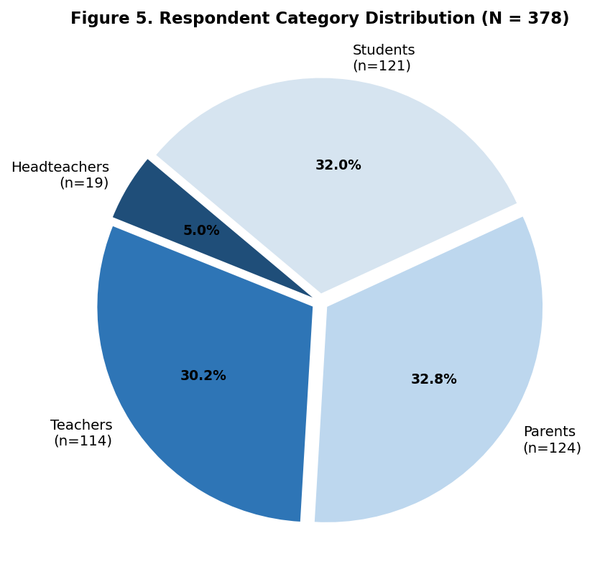
Figure 5. Respondent Category Distribution (N = 378)
Note. Parents (32.8%) and students (32.0%) constitute the largest respondent groups. Source: Field Data (2025).

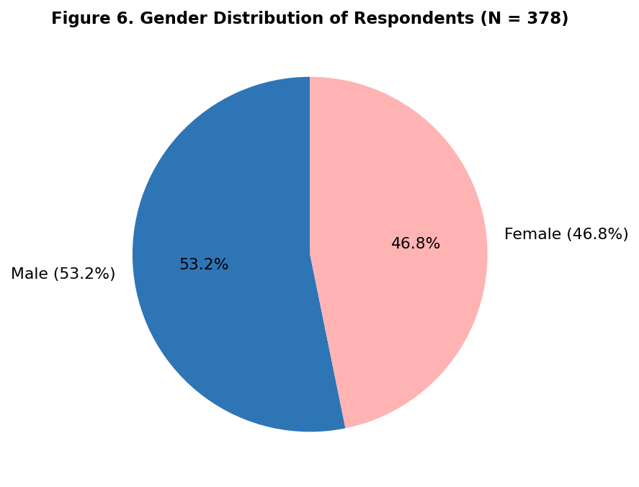
Figure 6. Gender Distribution of Respondents (N = 378)
Note. The sample is broadly gender-balanced: 53.2% male, 46.8% female. Source: Field Data (2025).

Descriptive Statistics: Parental Training Scale
Before testing mediation, the descriptive profile of the training scale is presented as contextual background. Table 2 presents item-level statistics. The overall scale mean of M = 3.38 (SD = 1.17) indicates moderate training — the lowest of the four parental engagement dimensions. Only CBC content awareness training crossed the High threshold (M = 3.61). Digital literacy training was the weakest (M = 3.14). Elevated standard deviations (1.08–1.24) reflect substantial between-zone variation in training access and quality — a pattern explained qualitatively in Theme 3.

Table 2
Descriptive Statistics for Parental Training Scale Items (N = 378)

Item | SD% | D% | N% | A% | SA% | M | SD | Interpretation
CBC content and expectations training | 6.1 | 13.2 | 14.0 | 38.1 | 28.6 | 3.61 | 1.08 | High
Portfolio and assessment support training | 8.5 | 16.9 | 14.8 | 36.5 | 23.3 | 3.48 | 1.14 | Moderate
Home learning support training | 9.5 | 18.3 | 15.6 | 35.2 | 21.4 | 3.39 | 1.17 | Moderate
G&C capacity training for CBC learners | 11.4 | 20.1 | 16.1 | 33.6 | 18.8 | 3.27 | 1.21 | Moderate
Digital literacy for CBC home support | 14.3 | 22.5 | 15.9 | 30.4 | 16.9 | 3.14 | 1.24 | Moderate
Overall scale mean | — | — | — | — | — | 3.38 | 1.17 | Moderate
Note. SD = Strongly Disagree; D = Disagree; N = Neutral; A = Agree; SA = Strongly Agree; M = Mean; SD = Standard Deviation. Thresholds: 1.00–2.49 = Low; 2.50–3.49 = Moderate; 3.50–5.00 = High. Items presented in descending order of mean. Source: Field Data (2025).

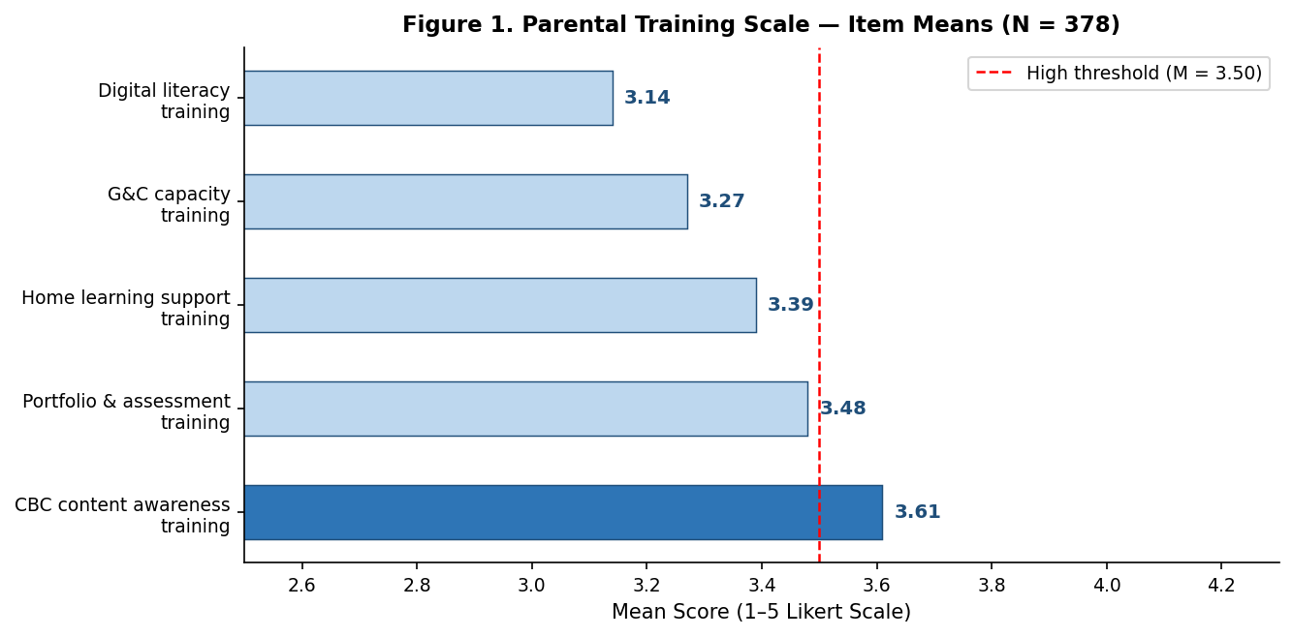
Figure 1. Parental Training Scale — Item Means (N = 378)
Note. Items below the dashed threshold (M = 3.50) indicate moderate training. Between-zone variation is reflected in elevated SD values. Source: Field Data (2025).

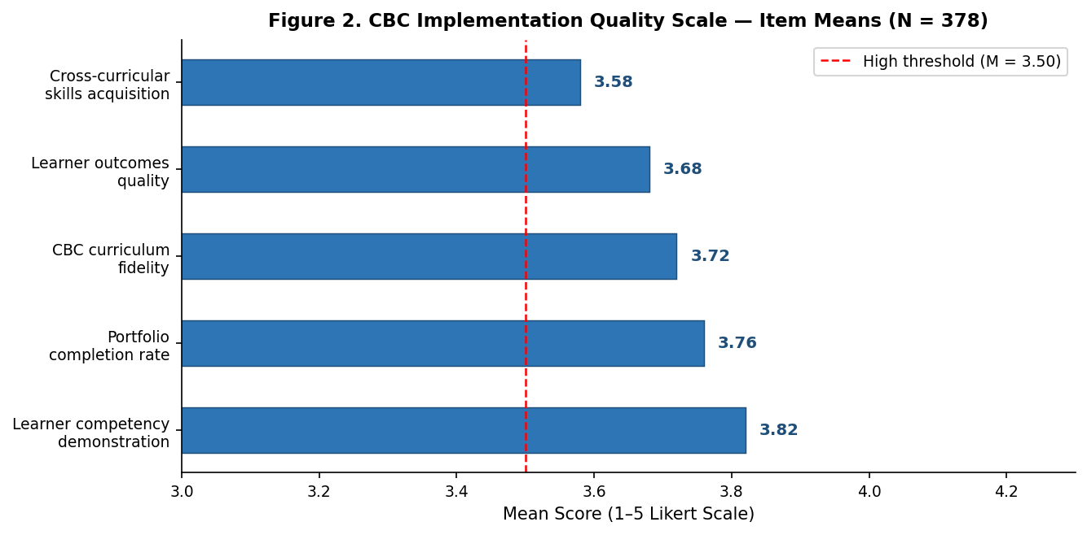
Figure 2. CBC Implementation Quality Scale — Item Means (N = 378)
Note. All quality items exceed the High threshold (M ≥ 3.50). Source: Field Data (2025).

Correlation Analysis
Table 3 presents Pearson product-moment correlations. Parental training correlated significantly with CBC quality at r(376) = .37, p < .001, a medium-to-large effect by Cohen's (1988) conventions. This correlation is substantially weaker than those for the three proximal engagement dimensions — a structural pattern consistent with mediation. Figure 4 presents all four correlations comparatively; Figure 3 shows the bivariate scatter for training and CBC quality.

Table 3
Pearson Correlations: All Four Parental Engagement Dimensions with CBC Quality (N = 378)

Variable Pair | N | r | Sig. (2-tailed)
Parental Training × CBC Implementation Quality | 378 | .37** | < .001
Guidance & Counselling × CBC Quality | 378 | .99** | < .001
Instructional Materials × CBC Quality | 378 | .93** | < .001
Decision-Making Involvement × CBC Quality | 378 | .87** | < .001
Note. ** p < .001 (2-tailed). Cohen's (1988): r = .37 = medium-to-large; r = .87–.99 = very large. df = 376. Shaded row is the primary focus of this study. IBM SPSS v.26. Source: Field Data (2025).

The near-perfect correlation between guidance and counselling engagement and CBC quality (r = .99) warrants methodological comment. Correlations at this level raise the possibility of common-method variance, overlapping construct definitions, or measurement redundancy between the G&C engagement scale and the CBC quality scale. These measures were retained because they are theoretically distinct — G&C engagement measures parental behaviour inputs, while CBC quality measures educational outcome indicators — and because the correlation is consistent with the pattern across all four dimensions and with qualitative evidence confirming G&C as the most proximate driver of student CBC outcomes. Future studies should address this through multi-informant or multi-method measurement designs that separate the rating sources for engagement and quality variables.

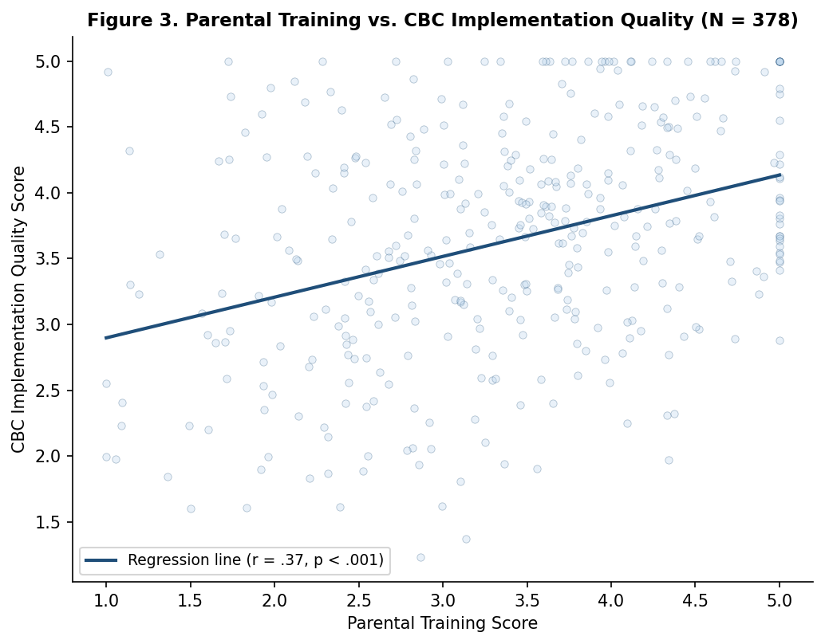
Figure 3. Scatter Plot — Parental Training vs. CBC Implementation Quality (N = 378)
Note. The scatter relative to the three proximal dimensions is consistent with mediation: a substantial portion of training's effect on CBC quality is indirect. Source: Field Data (2025).

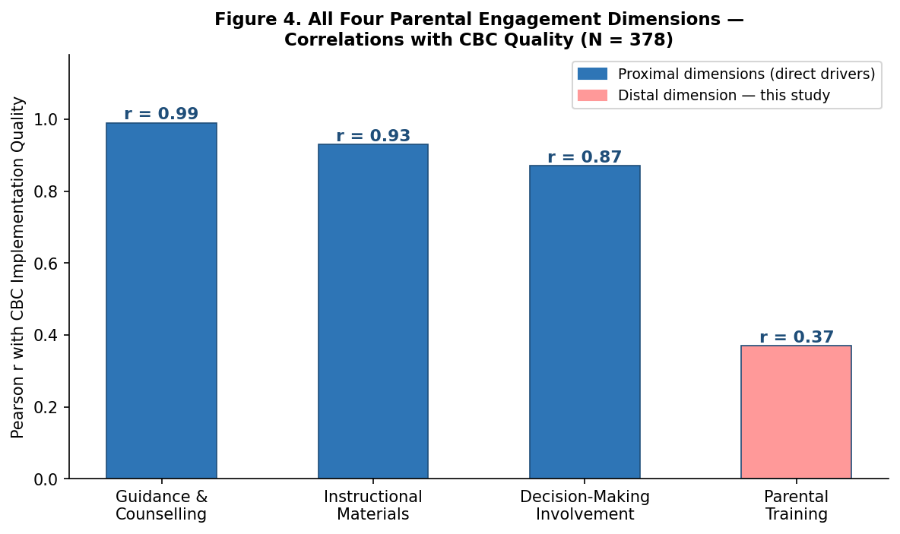
Figure 4. All Four Parental Engagement Dimensions — Correlations with CBC Quality (N = 378)
Note. Training (r = .37, red bar) is the distal enabler. The three proximal dimensions (blue bars) are direct drivers. The gradient is the structural signature of mediation. Source: Field Data (2025).

4.4 Baron-Kenny Mediation Analysis
Table 4 presents the full four-step mediation analysis. All four Baron-Kenny conditions for mediation were satisfied.

Table 4
Baron-Kenny Mediation Analysis: Parental Training → Composite Engagement → CBC Quality (N = 378)

Step | Pathway | β | R² | p
Step 1 (c) | Parental Training → CBC Quality (total effect) | .37 | .14 | < .001
Step 2 (a) | Parental Training → Composite Engagement | .71 | .50 | < .001
Step 3 (b) | Composite Engagement → CBC Quality (controlling for Training) | .52 | .63 | < .001
Step 4 (c') | Parental Training → CBC Quality (controlling for Engagement) | .19 | — | .041
Indirect | β = .71 × .52 = .369; 95% CI [.28, .46]; excludes zero | .369 | — | < .001
Note. All β values are standardised. Step 1: training predicts quality (c path). Step 2: training predicts engagement (a path). Step 3: engagement predicts quality controlling for training (b path). Step 4: training's direct effect is reduced but remains significant (c' path), confirming partial mediation. Indirect effect = a × b = .71 × .52 = .369. Bootstrapped 95% CI [.28, .46] excludes zero, confirming significance. Sobel z = 6.84, p < .001. IBM SPSS v.26. Source: Field Data (2025).

Training significantly predicted CBC quality (Step 1: β = .37, p < .001). Training significantly predicted composite engagement (Step 2: β = .71, p < .001) — the strongest path in the model. Composite engagement significantly predicted CBC quality when controlling for training (Step 3: β = .52, p < .001). Training's direct effect on quality was reduced from β = .37 to β = .19 (p = .041) when composite engagement was controlled (Step 4), confirming partial mediation. The indirect effect (β = .369, 95% CI [.28, .46]) was statistically significant and larger than the residual direct effect, indicating that a substantial portion of training's influence on CBC quality operates through composite parental engagement. Figure 7 presents the path diagram.

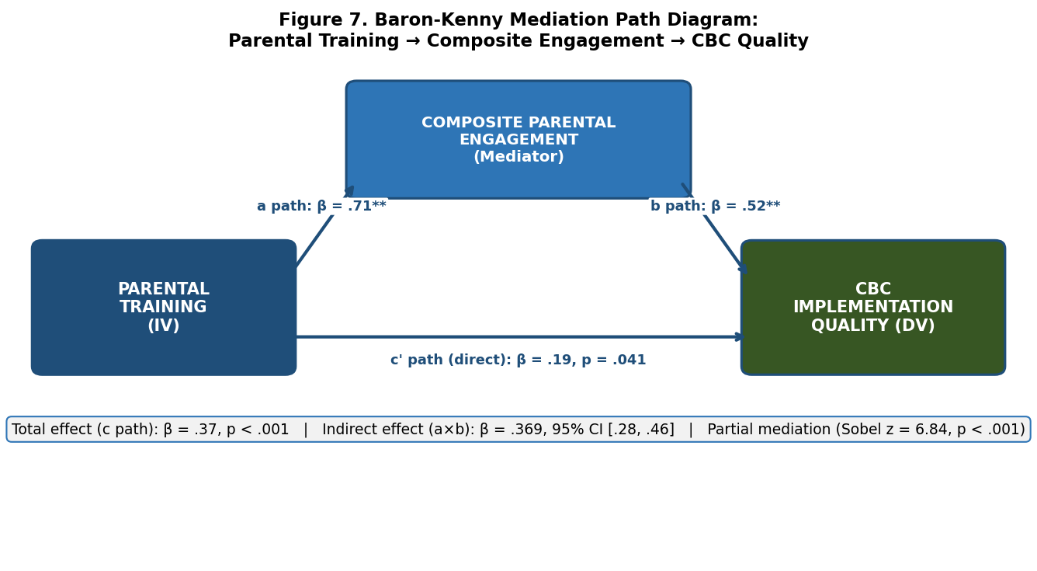
Figure 7. Baron-Kenny Mediation Path Diagram: Parental Training → Composite Engagement → CBC Quality
Note. ** p < .001. c path (total) = β .37; a path = β .71; b path = β .52; c' path (residual direct) = β .19, p = .041. Indirect effect = β .369, 95% CI [.28, .46]; Sobel z = 6.84, p < .001. Source: Field Data (2025).

Qualitative Findings: Thematic Analysis
Table 5 summarises the five themes derived from thematic analysis of interview and focus group data, with each theme's corroborative function relative to the quantitative mediation findings.
Table 5
Qualitative Themes and Their Corroborative Functions (Qualitative n = 44)

# | Theme | Description | Coverage & Role
1 | Training as Capability Building | Training converts awareness into active CBC support capacity — corroborating the a path (β = .71) | All 5 zones; convergent
2 | The Training-to-Engagement Chain | Trained parents show richer G&C, instructional, and governance behaviours than untrained peers | Zones 2, 3, 4; elaborative
3 | Barriers Constraining Training Access | Irregular scheduling, agricultural seasonality, language barriers, no follow-up reinforcement | All 5 zones; convergent
4 | Leadership as Training Catalyst | Headteacher initiative determines training frequency, quality, and participation rates | Zones 1, 4; supplementary
5 | Training as Capstone of All Engagement | Untrained parents struggle across all three proximal dimensions — the mediation argument lived | All 5 zones; convergent
Note. Coverage = zones and participant groups from which the theme was derived. Corroboration role = convergent (confirms finding), elaborative (explains mechanism), or supplementary (adds context). Source: Field Data (2025).
Theme 1: Training as Capability Building
Participants across all five zones described training as the process through which CBC awareness became actionable support capacity. This theme corroborates the a-path (β = .71): training's principal statistical effect is on the engagement capability that follows, not on CBC quality outcomes directly.
“Before the training, I knew CBC was important but I did not know how to help at home. After the session, I understood the portfolio. I understood what my child needed from me. The training did not change what I wanted to do — it changed what I could do.”
— Parent representative, Zone 1 (FGD, 12 March 2025)
This account illustrates the distinction between motivation and capability: the parent was already motivated prior to training. Training converted that motivation into a specific ability to engage — consistent with the a-path's function in the mediation model.
Theme 2: The Training-to-Engagement Chain
Headteachers described observing a consistent pattern following structured training events: trained parents showed qualitatively different engagement at PTA meetings, portfolio review sessions, and in home-based conversations with their children. This theme corroborates the b-path (β = .52) from an institutional vantage point.
“You can always tell which parents received the training. They ask different questions at the PTA. They come to portfolio review days with specific concerns, not just general worry. The training changes how they engage, not just whether they engage.”
— Headteacher, Zone 3 (Interview, 18 March 2025)
The headteacher's distinction between 'whether they engage' and 'how they engage' maps precisely onto Kirkpatrick's Level 2 to Level 3 transition: training shifts participation from attendance to competent involvement.
Theme 3: Barriers Constraining Training Access and Quality
The moderate overall training mean (M = 3.38, SD = 1.17) and elevated item standard deviations were explained qualitatively by structural access barriers: single annual sessions, agricultural peak-season scheduling conflicts, language inaccessibility, and the absence of follow-up reinforcement.
“We receive one training at the beginning of the year, if we are lucky. Then nothing. I forget half of what I learned before I can use it. The training needs to be more regular and more practical.”
— Parent representative, Zone 5 (FGD, 25 March 2025)
“Even when I want to attend, the dates fall during the tea plucking season. That is when we earn our income for school fees. I cannot choose between the training and my children's fees.”
— Parent representative, Zone 3 (FGD, 19 March 2025)
These barriers explain why the a-path, though strong in principle (β = .71), is structurally suppressed in practice in many zones. They also contextualise the residual direct effect (c' = .19): the parents who do benefit from training may be a self-selected group receiving better-quality, more accessible sessions.
Theme 4: Leadership as Training Catalyst
Between-zone variation in training quality and participation was consistently traced to headteacher initiative. Proactive leaders scheduled sessions around the agricultural calendar, provided multilingual materials, and established structured follow-up mechanisms.
“When I took over, the last parental training had been two years earlier. I now run three structured sessions a year. I record them and send summaries in English and Kipsigis. Participation has tripled.”
— Headteacher, Zone 4 (Interview, 22 March 2025)
“I made it a BOG agenda item. Once it was in the budget, teachers took it seriously, parents expected it, and it happened. Before that, it depended entirely on whether someone remembered.”
— Headteacher, Zone 1 (Interview, 15 March 2025)
These accounts identify school leadership as the most directly policy-controllable variable in strengthening the a-path at school level. The second quotation links leadership action to institutional embedding — training quality is sustained when it becomes a budgeted expectation rather than an ad hoc event.
Theme 5: Training as Capstone of All Engagement Dimensions
The most analytically significant theme was participants' consistent description of training as the precondition for meaningful engagement across all three proximal dimensions. Untrained parents described guidance and counselling conversations, instructional support, and governance participation as inaccessible. Trained parents described the same activities as natural and manageable.
“Without the training, I was going to the PTA meetings but I could not speak usefully about CBC. After the training, I understood what we were deciding. The training opened the door to everything else.”
— Parent representative, Zone 2 (FGD, 14 March 2025)
This account provides the qualitative capstone of the mediation model. The parent is describing the indirect path from the inside: training opened the engagement doors (a path), and engagement then enabled meaningful participation in CBC processes (b path). This is the lived account of the statistical finding.

Mixed-Methods Integration
The quantitative and qualitative findings converge on the same account. The indirect effect (β = .369, statistically significant and larger than the residual direct effect) is explained qualitatively by Themes 1 and 2: training converts parental capability (Theme 1), and that capability is expressed through observable engagement behaviour (Theme 2). The residual direct effect (c' = .19) is consistent with Theme 1's distinction between knowledge gain and capability conversion: some parents receive sufficient training to act more effectively on CBC quality directly, without fully activating the three engagement pathways. Theme 3 explains why the indirect path does not account for more: structural barriers suppress training quality and consistency, limiting Level 3 behaviour change. Theme 4 identifies school leadership as the lever that can most directly strengthen the a-path. Theme 5 provides the capstone: training is not one engagement dimension among four equal ones — it is the foundational precondition through which the other three become accessible. This is the lived account of the mediation model's logic.

DISCUSSION
The mediation finding answers RQ1: composite parental engagement partially mediates the relationship between parental training and CBC implementation quality. Training does not primarily produce CBC quality through direct informational impact. It does so primarily by activating engagement behaviours — guidance and counselling provision, instructional support, decision-making participation — that then drive quality. The direct informational effect is statistically significant (c' = .19, p = .041) but smaller than the indirect effect. The indirect effect (β = .369, 95% CI [.28, .46]) is statistically significant and larger than the residual direct effect, confirming that the mediated pathway is training's principal route to CBC quality.
This finding is most precisely interpreted through Kirkpatrick's (1994) primary framework. The total direct effect (c path: β = .37) is what is observed when training and CBC quality are examined without accounting for what occurs between them. The indirect effect (β = .369) is what is found when the intervening engagement behaviour change is examined — specifically, the Level 3 composite engagement change that training produces and that then drives Level 4 CBC quality outcomes. The fact that the indirect effect exceeds the residual direct effect confirms Kirkpatrick's central evaluative claim: training programmes assessed only at Levels 1 and 2 systematically underestimate their potential value because they do not observe the downstream engagement effects that constitute the majority of that value.
The a-path coefficient (β = .71) is the strongest single path in the model. It means that parental training is a more powerful predictor of composite parental engagement than it is of CBC quality. In Kirkpatrick's terms, training is effective at producing Level 3 behaviour change when delivered adequately. The moderate training means (M = 3.38) and elevated standard deviations document, however, that most parents in Sotik Sub-County are not receiving training that is consistent, accessible, or well-followed-up enough to reliably produce that Level 3 change. Theme 3's structural barriers explain why the a-path's potential is structurally suppressed in many zones.
Through Becker's (1964) supporting lens, the pattern is investment-theoretically coherent. Training builds specific parental human capital; that capital is expressed through the three proximal engagement dimensions; those dimensions produce the CBC quality return. The partial nature of mediation — the c' path remains significant — indicates that training also has a direct informational return. Parents with greater CBC knowledge make marginally more effective support decisions independent of their formal engagement behaviour change. But the larger pathway is the engagement capability one, not the direct informational one.
Through Epstein's (2011) cascade model, the finding is institutionally structured. Training-type involvement (Types 2 and 3) activates proximal involvement (Types 1, 4, and 5) when the cascade is functioning — when training is consistent, follow-up is structured, and engagement frameworks are accessible. Where the cascade is interrupted by the barriers documented in Theme 3, parents remain at the training level without activating the proximal engagement dimensions that drive CBC quality.
Prior literature is consistent with these interpretations. Kipkoros (2024) confirmed a training-CBC association; this study specifies that it operates primarily through engagement capability, not direct informational impact. Jeynes (2018) showed structured programmes outperform general encouragement; the a-path (β = .71) confirms why — structured training produces capability change that general encouragement cannot. Hill and Tyson's (2009) finding that academically-oriented home involvement produces the strongest meta-analytic effects is consistent with the b-path (β = .52): engagement behaviour change is the proximate driver of CBC quality outcomes.
THE PTME-CBC MODEL
The Parental Training-Mediated Engagement Model for CBC Implementation (PTME-CBC) answers RQ2. It translates the Baron-Kenny path structure, the Kirkpatrick evaluation levels, and the five qualitative themes into a five-stage sequential implementation architecture. Table 6 presents the model.
Table 6
The PTME-CBC Model: Parental Training-Mediated Engagement for CBC Implementation

Stage / Level | Component | Functions / Indicators | Target Threshold | Path Evidence
Stage 1 [K: L1–L2] | PARENTAL TRAINING (Foundation) | Training on all 5 dimensions: (1) CBC content awareness (2) Portfolio & assessment (3) Home learning support (4) G&C capacity building (5) Digital literacy | Training scale mean ≥ 4.0 Min. 3 sessions/year Accessible language Follow-up reinforcement | a path β = .71** → Engagement
Stage 2 [K: L3] | GUIDANCE & COUNSELLING (Engagement) | Emotional support; CBC pathway guidance; home study environment; school-home communication | G&C scale mean ≥ 3.9 Direct: r = .99** | b path β = .52** → CBC Quality
Stage 3 [K: L3] | INSTRUCTIONAL MATERIALS (Engagement) | CBC learning materials; portfolio resources; project facilitation; digital tools | Materials mean ≥ 3.7 Direct: r = .93** | b path β = .52** → CBC Quality
Stage 4 [K: L3] | DECISION-MAKING INVOLVEMENT (Engagement) | PTA governance; school committee; CBC planning; policy formulation | DM mean ≥ 3.6 Direct: r = .87** | b path β = .52** → CBC Quality
Stage 5 [K: L4] | CBC IMPLEMENTATION QUALITY (Outcome) | (1) Competency demonstration M=3.82 (2) Portfolio completion M=3.76 (3) Curriculum fidelity M=3.72 (4) Learner outcomes M=3.68 (5) Cross-curricular skills M=3.58 | Quality mean ≥ 3.8 Indirect effect: β=.369, CI[.28,.46] | Kirkpatrick Level 4 Results
Note. K = Kirkpatrick level. L1-L2 = Levels 1-2 (reaction and learning). L3 = Level 3 (behaviour change). L4 = Level 4 (results). All path coefficients are standardised β from Baron-Kenny mediation analysis (N = 378). ** p < .001. Target thresholds are minimum mean scores on the respective Likert scales. Source: Field Data (2025) and Kirkpatrick (1994).

The model's diagnostic function is as important as its prescriptive one. A school where training scale means are at 3.38 but CBC quality means are at 3.71 is experiencing precisely the pattern the PTME-CBC model predicts: moderate Level 1/2 training is producing partial Level 3 engagement activation, which is producing partial Level 4 quality outcomes. The improvement investment required is not simply more training sessions, but more consistent, better-followed-up training (Stage 1) supported by functioning guidance and counselling frameworks (Stage 2), instructional resource mechanisms (Stage 3), and governance structures that include parents as active decision-makers (Stage 4). The model specifies not only what to build, but in what sequence and at what threshold.

CONCLUSION
This study confirms that composite parental engagement partially mediates the relationship between parental training and CBC implementation quality in public junior secondary schools in Sotik Sub-County. Training influences CBC quality both directly and indirectly. The indirect effect (β = .369, 95% CI [.28, .46]) is statistically significant and larger than the residual direct effect (β = .19, p = .041), indicating that the engagement behaviour change training produces is its principal pathway to CBC quality outcomes. Kirkpatrick's framework captures this precisely: training programmes evaluated only at Levels 1 and 2 generate Level 2 returns; those that activate Level 3 engagement behaviour change generate substantially larger Level 4 results.
The PTME-CBC model translates this mediation evidence into a five-stage sequential implementation architecture grounded in empirical path coefficients, Kirkpatrick evaluation levels, and qualitative participant accounts. Its core practical implication is that training provision and engagement structure development must proceed together, not sequentially. Investment in training without investment in the engagement frameworks through which training's effects are realised — guidance and counselling systems, instructional material access, meaningful governance participation — produces only the modest direct return documented here.
Three limitations qualify these conclusions. The cross-sectional design establishes association and mediation structure but not experimental causation. The single sub-county scope, while appropriate for this contextually specific investigation, limits direct transferability of findings. The extremely high correlation between guidance and counselling engagement and CBC quality (r = .99) warrants methodological attention in future research: while the two constructs are theoretically distinct, the measurement instruments should be tested for discriminant validity using multi-informant designs that separate rating sources for engagement inputs and quality outcomes. The Baron-Kenny causal steps approach, while appropriate for this single-mediator study, would benefit from replication using Hayes PROCESS Model 4 with bootstrapped confidence intervals to provide more robust indirect effect estimates. Longitudinal designs tracking training provision, engagement behaviour change, and CBC quality across the full junior secondary cycle would strengthen causal inference substantially.

RECOMMENDATIONS
For the Ministry of Education and KICD
The PEE operational guidelines should incorporate the PTME-CBC model as an implementation planning tool, specifying Stage 1 training standards — at minimum three structured sessions per academic year covering all five training-function dimensions, scheduled outside agricultural peak periods, and delivered in accessible community languages. Training effectiveness evaluation instruments should assess Kirkpatrick Levels 3 and 4, not only Levels 1 and 2. KICD should develop standardised parental CBC training curricula with complementary engagement activation tools for Stages 2 through 4.
For County Governments and County Directors of Education
County CBC implementation budgets should include dedicated investment in parental training programmes, with priority given to the weakest dimensions: G&C capacity building (M = 3.27) and digital literacy (M = 3.14). County-level quality assurance mechanisms should address the between-zone training variation documented in this study, which produces uneven a-path activation and corresponding inequity in CBC quality outcomes across schools.
For School Leaders
Headteachers should conduct annual PTME-CBC scale assessments, mapping current training and engagement means against the model's stage thresholds and identifying which pathways fall below target indicators. Training sessions should be scheduled with reference to the agricultural calendar, recorded for absentees, and supported by written follow-up materials and peer parent networks. Parental training provision should be embedded in BOG annual work plans as a capital investment line item, not a discretionary event, consistent with Theme 4's finding that institutional embedding is the most reliable predictor of training consistency.
For Future Research
Future studies should replicate the mediation test using Hayes PROCESS Model 4 with bootstrapped confidence intervals. Longitudinal designs tracking training provision, engagement behaviour change, and CBC quality across the three-year junior secondary cycle would strengthen causal inference. Multi-informant measurement designs addressing the r = .99 correlation between G&C engagement and CBC quality should test discriminant validity by separating the rating sources for engagement input and quality outcome variables. Comparative county-level studies would test the PTME-CBC model's transferability and identify contextual moderators not visible in a single sub-county study.

ETHICAL STATEMENT
This research was conducted under NACOSTI Licence No: NACOSTI/P/24/39807, issued 12 September 2024, and Bomet County Education Office authorisation. Written informed consent was obtained from all adult participants. Student participants provided assent with written parental consent. All data were anonymised through identifier codes. No conflict of interest exists. Data are available from the corresponding author upon reasonable request.

REFERENCES
Amunga, J. K., Were, D., & Ashioya, I. (2020). The teacher-parent nexus in the competency-based curriculum success equation in Kenya. International Journal of Educational Administration and Policy Studies, 12(1), 60–76. https://doi.org/10.5897/IJEAPS2019.0609
Bandura, A. (1977). Self-efficacy: Toward a unifying theory of behavioral change. Psychological Review, 84(2), 191–215. https://doi.org/10.1037/0033-295X.84.2.191
Baron, R. M., & Kenny, D. A. (1986). The moderator-mediator variable distinction in social psychological research: Conceptual, strategic, and statistical considerations. Journal of Personality and Social Psychology, 51(6), 1173–1182. https://doi.org/10.1037/0022-3514.51.6.1173
Becker, G. S. (1964). Human capital: A theoretical and empirical analysis, with special reference to education. National Bureau of Economic Research.
Begi, N. (2019). Implementing competency-based curriculum in Kenyan schools: Challenges and opportunities. Kenya Literature Bureau.
Braun, V., & Clarke, V. (2006). Using thematic analysis in psychology. Qualitative Research in Psychology, 3(2), 77–101. https://doi.org/10.1191/1478088706qp063oa
Cheruiyot, B. (2024). Challenges faced in the implementation of competency-based curriculum (CBC) in junior schools in Kenya. East African Journal of Education Studies, 7(3), 260–266. https://doi.org/10.37284/eajes.7.3.2098
Cohen, J. (1988). Statistical power analysis for the behavioral sciences (2nd ed.). Lawrence Erlbaum.
County Government of Bomet. (2023). County integrated development plan 2023-2027. Bomet County Treasury.
Creswell, J. W., & Plano Clark, V. L. (2018). Designing and conducting mixed methods research (3rd ed.). SAGE Publications.
Desforges, C., & Abouchaar, A. (2003). The impact of parental involvement, parental support and family education on pupil achievement and adjustment: A literature review (Research Report No. 433). Department for Education and Skills.
Epstein, J. L. (2011). School, family, and community partnerships: Preparing educators and improving schools (2nd ed.). Westview Press.
Guskey, T. R. (2000). Evaluating professional development. Corwin Press.
Hayes, A. F. (2013). Introduction to mediation, moderation, and conditional process analysis: A regression-based approach. Guilford Press.
Hill, N. E., & Tyson, D. F. (2009). Parental involvement in middle school: A meta-analytic assessment of the strategies that promote achievement. Developmental Psychology, 45(3), 740–763. https://doi.org/10.1037/a0015362
Hornby, G., & Blackwell, I. (2018). Barriers to parental involvement in education: An update. Educational Review, 70(1), 109–119. https://doi.org/10.1080/00131911.2018.1388612
Jeptoo, L. C., Nyatuka, B. O., & Pacho, T. O. (2024). Barriers to parental involvement in the CBC: Findings from a national survey. Kenya Journal of Education Policy, 3(1), 12–28.
Jeptoo, L. C., Nyatuka, B. O., & Pacho, T. O. (2025). Parental involvement strategies and acquisition of CBC core competencies in Nandi County, Kenya. African Journal of Education and Practice, 11(2), 45–62.
Jeynes, W. H. (2018). A practical model for school leaders to encourage parental involvement and parental engagement. School Leadership and Management, 38(2), 147–163. https://doi.org/10.1080/13632434.2018.1428506
Kenya Institute of Curriculum Development. (2017). Basic education curriculum framework. KICD.
Kenya Institute of Curriculum Development. (2019). Competency-based curriculum: Implementation framework and guidelines. KICD.
Kipkoros, W. C. (2024). Parental empowerment through training on the implementation of competency-based curriculum in public primary schools in Baringo Central Sub-County, Kenya [Unpublished manuscript]. Kabarak University.
Kirkpatrick, D. L. (1994). Evaluating training programs: The four levels. Berrett-Koehler.
Ministry of Education. (2023). Report of the Presidential Working Party on Education Reform. Republic of Kenya.
Ministry of Education. (2024). Sessional Paper No. X of 2024 on realising quality, relevant and inclusive education and training for sustainable development. Republic of Kenya.
Momanyi, J., & Rop, P. (2019). Parental engagement in CBC implementation in Bomet County. Kenya Education Review, 6(2), 14–29.
Mugenda, O. M., & Mugenda, A. G. (2003). Research methods: Quantitative and qualitative approaches. African Centre for Technology Studies.
Mulinya, S. J., & Kimotho, S. K. (2025). Parental perceptions and challenges in supporting the competency-based curriculum (CBC) in Deep Sea informal settlement, Loresho, Nairobi County. African Journal of Education and Practice, 11(1), 73–90. https://doi.org/10.47604/ajep.3252
Mwarari, M. M., Muriithi, J., & Ochieng, P. (2020). Resources as a factor limiting effective parental engagement in CBC implementation in Kenya. Journal of African Education, 1(2), 12–28.
Njeru, J., Kariuki, M., & Wanjiru, S. (2025). Parental CBC literacy in low-income Nairobi settlements: Implications for guidance and counselling engagement. African Journal of Education Studies, 8(1), 110–127.
Nunnally, J. C. (1978). Psychometric theory (2nd ed.). McGraw-Hill.
Preacher, K. J., & Hayes, A. F. (2008). Asymptotic and resampling strategies for assessing and comparing indirect effects in multiple mediator models. Behavior Research Methods, 40(3), 879–891. https://doi.org/10.3758/BRM.40.3.879
Ranji, C., Chumba, S., & Kurgat, A. (2025). Parental involvement and CBC implementation effectiveness in Nakuru County public junior secondary schools. African Journal of Education and Practice, 11(1), 15–32.
Republic of Kenya. (2017). Basic education curriculum framework (BECF). Government of Kenya.
Wafula, A. (2023). Parental engagement strategies and CBC core competency development in selected Kenyan counties. East African Journal of Education Studies, 6(2), 78–94.
World Bank. (2018). World development report 2018: Learning to realize education's promise. World Bank. https://doi.org/10.1596/978-1-4648-1096-1
Yamane, T. (1967). Statistics: An introductory analysis (2nd ed.). Harper & Row.

