Article
EC Link: A Digital Platform for Enhancing Student Concern Management in Higher Education

Abstract: This research study introduces EC Link, a Digital Platform for Enhancing Student Concern Management in Higher Education, designed to improve the delivery and responsiveness of general support services across campus. Recognizing the gap in timely and systematic stakeholder feedback, the system leverages digital tools such as QR codes, Google Worksheet, and Google Forms, to allow students, faculty, and staff to report service-related issues in real time. The research adopted a Participatory Action Research (PAR) framework involving planning, implementation, evaluation, and refinement of the system. A stratified random sample of 337 participants across students, teaching, and non-teaching personnel evaluated the system’s usability. Results showed that users found the system fairly to very satisfactory in terms of accessibility, interface clarity, and functionality. However, areas such as system responsiveness and feedback acknowledgment were identified for improvement. Based on these findings, the system was revised, and recommendations were proposed for future scalability and integration. The study concludes that EC Link effectively supports transparency, shared accountability, and continuous service improvement, aligning with the University’s goals for organizational excellence.



1. Introduction
Efficient and responsive services are essential to the smooth operation of any university. These services ranging from physical plant and facilities to health and security directly influence the overall educational experience, health, safety, and satisfaction of stakeholders. However, many institutions face challenges in monitoring the quality and timeliness of these services due to the lack of real-time, systematic feedback from stakeholders (Ali et al., 2021).
To address these gaps, this action research introduces EC Link, a University Real-Time Concern Monitoring System designed to enhance the delivery and management of general services across the
University. Real-time feedback mechanisms, especially those leveraging mobile technologies have been shown to significantly improve responsiveness and institutional transparency (Rao et al., 2020; Jiang & Li, 2023).
By applying an action research framework, this study implemented the system in a pilot phase, gathered and analyzed feedback data, and assessed its usability in improving service responsiveness. Furthermore, it aimed to cultivate a culture of transparency, shared accountability, and continuous improvement in university service delivery.
This project ultimately supports the University’s broader goals for Organizational Excellence and stakeholder satisfaction by integrating technology, feedback culture, and service management into one cohesive monitoring strategy the end of the document for further details on references.
2. Materials and methods
This study adopted a Participatory Action Research (PAR) design, which is increasingly utilized for service delivery improvements in higher education (Carvalho & Brito, 2021). The iterative Plan–Act–Observe–Reflect–Replan cycle aligns with institutional quality assurance goals, making it suitable for evaluating technology-driven interventions like EC Link (Fernández & Torres, 2020).
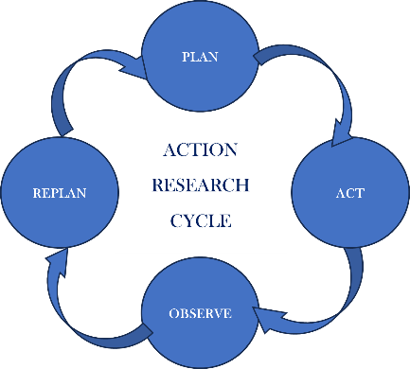
Figure 1. Action Plan Research Cycle
Development and Implementation of the EC Link used a digital reporting tool, called Google Forms and QR Code. Digital tools such as Google Forms and QR codes have become effective, low-cost methods for engaging stakeholders and collecting feedback (Zhou et al., 2022). The interface is designed with simplicity which is accessible via QR codes and campus Wi-Fi. Posters and awareness materials were distributed and posted to promote use. After two weeks of implementation, survey questions are distributed to the participants to evaluate the usability of the developed system.
Survey question is designed for this study and validated using Cronbach Alpha which has a value of .905, Cronbach Alpha score of 0.905 indicates strong internal consistency in survey measures, meeting standards for usability research (Nguyen & Du, 2020), this suggests that the items on the scale are highly correlated and consistently measuring the same concept. The following scale is used in the study:
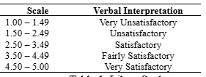
Table 1. Likert Scale
The survey is designed and floated using Google Forms, responses are collected and subjected for data analysis. Descriptive statistics, frequency, mean, and standard deviation are used to analyze quantitative data.
Participants who are part of the University during the second semester of school year 2024 – 2025 were included in the study. These are a diverse group of stakeholders like, students from various departments and year levels, faculty and academic staff, and non-teaching personnel. Since the population of the participants is not equal, stratified random sampling is used. This method was used because the population was divided into categories or strata, such as students, academic or teaching staff, and non-teaching staff, with different numbers of populations. Stratified random sampling aided to get the proportion to its size or enrolment. With this technique, the error of getting too many or too few samples were avoided. The foregoing table summarizes the population and sample size of the participants.
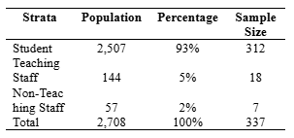
Table 2. Participants’ Population and Sample Size
3. Results and discussion
The study used a Participatory Action Research (PAR) design. Phase 1 which is Plan stage, includes identification of service issues and design of the EC Link. Researchers identified the problem as the lack of real-time and systematic feedback from stakeholders. Because of this issue, a feedback system is designed to gather feedback from stakeholders and provide immediate response on the issues. The system is designed using Google Form and linked to QR code. The design is simple to provide ease of use to the intended users. Mobile phones can be used to scan the QR code and access the system. Further, the system responded quickly without errors or delays and that users received acknowledgment or follow-up after submitting feedback. To ensure the legitimacy of the users, only email addresses under the domain name of the University will be accepted.
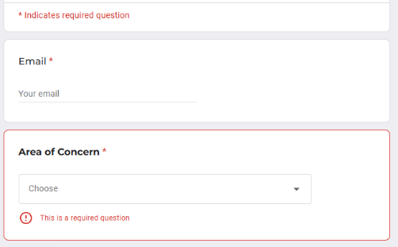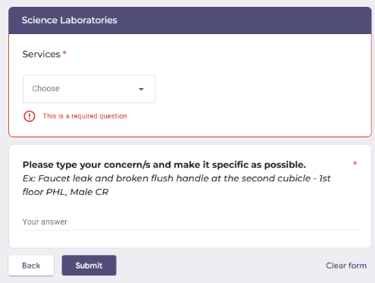
Figure 1. Sample Screenshot of EC Link
The next phase of the research is the Act stage, where launch and promotion of the system took place. QR Codes were posted strategically in the University to ensure visibility. A video tutorial and infographics on how to use the system step by step were also disseminated via email blasts and group chats of the stakeholders.
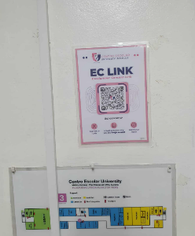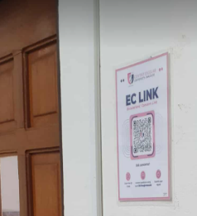
Figure 2. Sample QR Codes Posted in Strategic Location

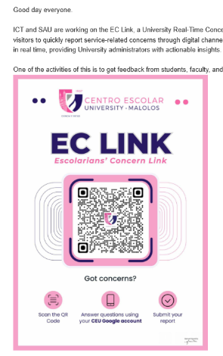
Figure 3. Email Sent to the Community
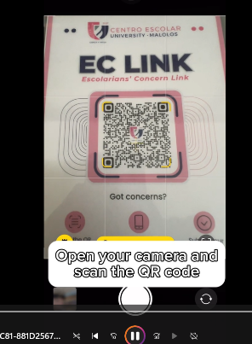
Figure 4. Video Tutorial Shared to the Community
The third phase is observed, where collection and monitoring of feedback and responses were executed. Designed survey questions were floated via Google forms and data were collected and analyzed. The foregoing table summarizes the responses of the participants.
4. Discussion
The evaluation employed a structured feedback collection approach using Google Forms during the "observe" phase, representing a systematic effort to gather quantitative user experience data.
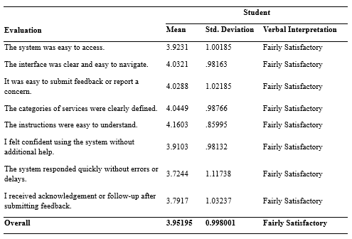
Table 3. Evaluation Result for Student
Table 3 shows the evaluation result from the students, their responses reveal a generally positive but measured assessment of the system. The satisfactory to very satisfactory ratings across all stakeholder groups are consistent with recent studies showing that user-centered system design enhances stakeholder engagement and satisfaction in campus service platforms (Bashir et al., 2021). This variation likely reflects diverse technological competencies, usage patterns, and expectations among students.
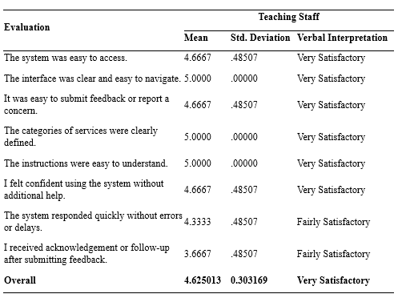
Table 4. Evaluation Result for Teaching Staff
Teaching staff demonstrated remarkably high satisfaction levels, with multiple perfect 5.0 scores and extremely low standard deviations (0.00-0.49). This consensus suggests the system aligns well with faculty workflow requirements and teaching staff appreciate the system's design for their specific use cases.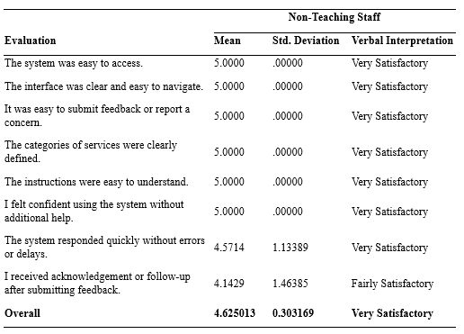
Table 5. Evaluation Result for Non-Teaching Staff
Despite the smaller sample size, non-teaching staff showed unanimous satisfaction across most criteria. Their perfect 5.0 scores on usability metrics suggest the system effectively serves its functions and aligns with the non-teaching staff’s needs.
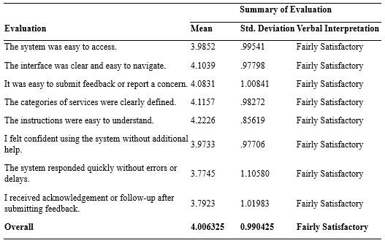
Table 6. Summary of Evaluation Result
Table 6 summarizes the evaluation from the three groups of users, accessibility and navigation, consistently scoring high scores for system access (3.92-5.00) and interface navigation (4.03-5.00), this indicates successful implementation of user-centered design principles. The low standard deviations suggest these elements work well across different user types and technical skill levels. The strong performance in service categorization (4.04-5.00) and instruction clarity (4.16-5.00) demonstrates effective information architecture. This suggests the researchers successfully anticipated user mental models and organized content accordingly. Notably, system responsiveness and acknowledgment of feedback were rated slightly lower, mirroring trends in digital service adoption challenges identified in campus-based reporting systems (Zhang & Chen, 2022). Response times and error handling represent the most significant improvement areas across all user groups.
The last phase is replan, where refinement of the system and processes for long-term integration were observed. Based on the feedback gathered in the survey, questions, suggestions, comments, and recommendations were collected. These served as the basis for the researchers in the enhancement of the developed system. Table 6 summarizes the said feedback from the participants.
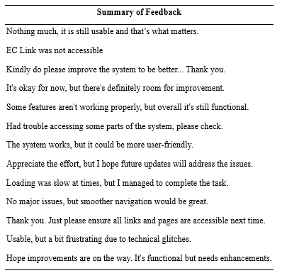
Table 7. Summary of Feedback
Table 7 summarizes feedback of users who demonstrated commitment to the system while clearly articulating improvement needs. Their balanced perspective and acknowledging functionality while requesting enhancements, provides a roadmap for development priorities that could significantly improve user satisfaction and system adoption. These help the researchers to identify the possible improvement of the system to ensure long-term success and user satisfaction.
Improvement in this system is integrated based on the suggestions of the users including the following:
- The system link has been distributed to all users via their registered email accounts.
- The link has been restructured to ensure all pages load and function correctly.
- The system was redesigned with accessibility in mind, ensuring ease of access for all users.
- Activating the email response receipt feature in Google Forms to confirm submission is integrated. Zhou et al., 2022 study mentioned the importance of automated feedback in increasing user confidence and strengthening communication between users and administrators.
5. Conclusion
The following conclusions were drawn from the study.
- The implementation of the system is driven by the goal of fostering a culture of transparency, shared accountability, and continuous improvement in the University’s service delivery. By integrating technology, feedback mechanisms, and service management into a unified monitoring strategy, this project directly supports the University’s broader commitment to Organizational Excellence and stakeholder satisfaction.
- The evaluation results from students, teaching staff, and non-teaching staff indicate a generally positive evaluation of the system. All participant groups evaluated Fairly Satisfactory or Very Satisfactory that the system was accessible, user-friendly, and functionally clear. The teaching and non-teaching staff expressed a high level of satisfaction, with consistent responses of "Very Satisfactory" across most criteria. Students also responded favorably, though with slightly more variability in their ratings, especially in areas such as system responsiveness and receiving follow-up after submitting feedback. Overall, the system is deemed satisfactory and effective in its current form. However, feedback suggests that improvements can be made, particularly in enhancing system responsiveness and ensuring consistent acknowledgment or follow-up to user concerns.
- Feedback suggestions were systematically collected, organized, and analyzed. The insights gathered from this process were used as the foundation for enhancing the system’s functionality, interface, and overall user experience. These improvements aimed to address specific concerns raised by users and ensure the system better meets their needs.
Conflict of interest: Declare conflicts of interest or state “The authors declare no conflict of interest.” Authors must identify and declare any personal circumstances or interest that may be perceived as inappropriately influencing the representation or interpretation of reported research results.
References
- Al-Fraihat, D., Joy, M., & Sinclair, J. (2020). Evaluating E-learning systems success: An empirical study. Computers in Human Behavior, 102, 67–86.
- Ali, S., Sharma, M., & Warraich, M. (2021). Real-time feedback systems and institutional accountability. Education and Information Technologies, 26(4), 4567–4583.
- Bashir, H., Siddiqui, Z., & Farooq, M. (2021). A usability evaluation of mobile applications in academic settings. International Journal of Human-Computer Studies, 149, 102611.
- Carvalho, L., & Brito, C. (2021). Participatory Action Research in Higher Education: Empowering stakeholders. Research in Education, 110(1), 24–39.
- Fernández, J., & Torres, E. (2020). Action research as a strategy for institutional improvement. Journal of Educational Change, 21(3), 415–437.
- Jiang, T., & Li, K. (2023). Mobile feedback apps and student engagement in campus service delivery. Interactive Technology and Smart Education, 20(1), 55–72.
- Nguyen, N., & Du, J. (2020). Improving online surveys using adaptive and responsive design techniques. Computers in Human Behavior Reports, 2, 100024.
- Patel, M., & Bansal, A. (2021). Designing scalable web applications for institutional feedback systems. International Journal of Emerging Technologies in Learning, 16(15), 25–33.
- Pereira, R., Macedo, L., & Silva, R. (2021). The effectiveness of QR codes in engaging users: A usability study. International Journal of Human–Computer Interaction, 37(18), 1704–1714.
- Rao, D., Singh, R., & Banerjee, A. (2020). Digitally enabled service quality in higher education. International Journal of Educational Management, 34(6), 1149–1166.
- Zhang, L., & Chen, Y. (2022). Investigating delays and follow-up inefficiencies in digital campus systems. Education and Information Technologies, 27(2), 2549–2565.
- Zhou, F., Song, W., & Ren, J. (2022). Enhancing user feedback systems with automation: Implications for system improvement and user satisfaction. Journal of Usability Studies, 17(1), 15–28.

