ELECTRICAL CONDUCTIVITY STUDY OF CONDUCTING POLYMER, POLYANILINE: AN OVERVIEW

ABSTRACT
Polyaniline an important conducting polymer because of its controllable electrical conductivity. Polyaniline has emerged as a promising candidate with great potential for practical application such as light-emitting diodes, transparent electrodes, electromagnetic radiation shielding, corrosion protection of metals, gas and humidity sensing, and battery applications. The paper reviewed the conductivity of conducting, polyaniline. It has found that the polyaniline synthesis method, temperature, nature of dopants, concentration of dopant and reaction time both affect it’s the electrical conductivity. The maximum conductivity of polyaniline achieved so far is up to 300+/- 30 Scm⁻¹. However it has noted that polyaniline suffers from poor processability because it is infusible and insoluble in common solvents. Solubility improvement would allow evaluating the use of the compounds, for instance, in the development of electronic devices.
Key word; Polyaniline, electrical conductivity, bond, polymer, and dopants
- INTRODUCTION
The Polyaniline family of polymers has been recognized as an interesting and unusual member of the class of π-electron containing conducting polymers [1]. Unlike many other members of this class such as; polyacetylene, polypyrrole, and polythiopene whose electronic properties are well understood based solely their conjugated carbon backbones. Polyaniline is known to be crystalline, and a highly conducting state is accomplished by simple protonation of the imine nitrogen atoms in the emeraldine base backbone. M. M. Gvozdenovi explained that the conductivity mechanism of polyaniline differs from other conducting polymers, because of the presence of nitrogen atom which is involved in the formation of radical cation, unlike most of the conducting polymers whose radical cation is formed at carbon [2]. Polyaniline can be transformed through four different oxidation states, each oxidation state having different electronic and optical properties. The different forms of Polyaniline are determined by the fraction of amine (-NH=) nitrogen atoms per 4-ring repeat unit, which is labeled 1-y. Where 1-y is equal to 0.5, 0 and 1 for half-oxidized (emeraldine), fully reduced (leucoemeraldine) and fully oxidized (pemigraniline) forms, respectively. The emeraldine base (EB) insulating form of Polyaniline is the most important form, because it can be doped to high conductivity. Emeraldine can be converted from an insulating to a metallic state if protons are added to the -N= sites while the number of electrons on the chain is held constant [3]. It is known that polyaniline is in the group of conjugated polymers, and as such in its undoped state it does not conduct electric current, that is, it is an insulator or semiconductors [4]. With various procedures, and one of them is the method of doping, polyaniline in a non-conducting state can be transformed into a conducting state. More recently, very intensive researches have been carried out in order to obtain polyaniline which would be a good conductor of electricity. It is generally doped in order to considerably increase its electrical conductivity, improving its conductivity [5].
- METHODOLOGY
This study uses a literature survey approach. This methodology allows the inclusion of studies conducted by different researchers and stressing the polyaniline and also at different conditions such as PH, temperature, and dopants. By considering different studies, a good overview of how polyanaline can be improved from insulator to electrical conductivity was be obtained.
3. RESULTS AND DISCUSSION
3.1 Electrical conductivity of a pure Polyaniline
The electrical conductivity of PANI is attributed to the presence of conjugated double bonds along the polymer backbone. Every double bond also contains a weaker, less strongly localized “pi” (π) bond (when the lobe of one atom orbital overlaps another). This electronic delocalization provides the “highway” for charge mobility along the backbone of the polymer chain [4-5]. However, the π-bond allows the electron delocalization which provide charge motion the electrical conductivity is very low, the pure Polyaniline has conductivities in the range from 10^{–4} to 10⁻¹ in S.cm⁻¹ [6].

Table 1. Forms of PANI and their electrical properties [7]
Forms | Oxidation state | Electrical properties | Energy gap
Emeraldine base (EB) | Half-oxidized | Can be doped to high conductivity | 3.6eV
Emeraldine salt (ES) | Half-reduced | Conducting | 0
Leucoemeraldine base | Fully-reduced | Insulating | 3.6eV
Pernigraniline base | Fully-oxidized | Insulating | 2.3eV

The electrical conductivity of the Polyaniline prepared from electrochemical synthesis is affected by PH and current density. The best electrical conductivity is found at pH (4.2) and current density 0.3mA/cm² [8]. The conductivity of the protonation Polyaniline increases with the increase in temperature as that of pure Polyaniline, representing the semiconducting nature of the protonation Polyaniline. The increase in the conductivity is due to the increase of efficiency of charge transfer by contribution of polaron and bipolaron bands and to the effect of dopant ions [9]. The electrical conductivity of the emeraldine salt of polyaniline obtained from stirring reaction is eight times higher than those obtained from non-stirred polymerization [10]. However the electrical conductivity of Emeraldine base (EB) can be improved by doping.
3.2 Effect of Synthesis Methods on Electrical Conductivity of PANI
Polyaniline is commonly polymerized in two ways; chemical synthesis method and electrochemical method. Polyaniline produced via electrochemical synthesis tends to exhibit higher electrical conductivity, better structural uniformity, and enhanced electroactive properties compared to chemically synthesized polyaniline [11]. The result also agreed by Al-Ghamdi, A. A., et al. (2024). Studied “Influence of synthesis route on morphology and conductivity of polyaniline films”. J. Vivekanandan et al. in 2011 studied the electrochemical and chemical oxidative synthesis of polyaniline using K₂Cr₂O₇ as an oxidant and H₂SO₄ as dopant. The comparison showed that the electrochemical synthesized polyaniline had higher conductivity than chemically synthesized polyaniline [12]. O.A. Nunoo et al. synthesized polyaniline by electrochemical method and then doped with HCI. The result after measuring the electrical conductivity was 3.424 Scm⁻¹ [13]. N. Colak & B. Sokmen synthesized polyaniline by chemical method and then doped with HCI. The result after measuring the electrical conductivity was 1.14 Scm⁻¹ [14]. E.C. Gomes and M.A.S. Oliveira studied polyaniline by synthesizing it using chemical method and doped with hydrochloric (HCI). The electrical conductivity obtained was 0.143 Scm⁻¹. The value obtained from electrochemically synthesized polyaniline and doped by HCI is greater than those got from chemically synthesized method [15]. I. Gazdic et al. were measured electrical conductivity of samples obtained from chemical method by doping thin films of polyaniline with sulfuric (PANI-H₂SO₄) and hydrochloric acid (PANI-HCl) was 0.05$×$10⁻³Scm⁻¹ and 0.06$×$10⁻³ Scm⁻¹ respectively. N. M. Obaid et al. synthesized protonation of polyaniline with H₂SO₄ by electro-chemical oxidative polymerization of aniline with acidity of H₂SO_{4.} The maximum electrical conductivity of measurements was 1.08×10⁻¹ Scm⁻¹ [16]. The results of the research done on the chemical and electrochemical is tabulated as in the table 2.
Table 2 Comparison of electrical conductivity by synthesis method.
Monomer | Dopants | Chemical method  (Scm⁻¹) | Electrochemical method  (Scm⁻¹)
PANI | Pure | 7.59x10⁻⁶ | 1.2×10⁻³
PANI | K₂Cr₂O₇ | 0.27 | 1.23
PANI | HCI | 1.14 | 3.424
PANI | H₂SO₄ | 0.05$×$10⁻³ | 1.08×10⁻¹
From the table 2 it has been observed that the maximum values of electrical conductivity achieved from doped polyaniline with same dopant are different for different synthesis method. It has been discovered that polyaniline synthesized through electrochemical method have greater electrical conductivity than the polyaniline synthesized through chemical method.

3.3 Effects of doping on electrical conductivity of conducting polyaniline
Polyaniline is made conductive by doping or oxidizing through chemically or electrochemically. Doping of polyaniline results in the enhancement of its electrical conductivity [17]. Polyaniline can be doped by two ways/types redox doping or and acid-base doping. A.N.J. Al-Daghman discovered that the doped polyaniline has higher conductivity than undoped polyaniline; the conductivity reported for undoped PANI was 7.59x10⁻⁶ Scm⁻¹ and for doped polyaniline was 1.2x10⁻⁴ Scm⁻¹ with dopant HCl. The conductivity increases because of the contribution of polarons, which are moving along shorter distances in the polymer chain [18]. A. A. Syed in 1991 reported that the conductivity of undoped polyaniline emeraldine salt was 8679.00 µScm⁻¹. But, after doping with HCIO₄ the electrical conductivity of polyaniline reported 33104 µScm⁻¹ which is greater than that of undoped polyaniline [19]. M. Hafeez demonstrated that the difference in conductivity of doped and undoped conducting polymer (CPs). Experimental results showed that the direct electrical conductivity of undoped polyaniline had 3 Scm⁻¹ and the direct electrical conductivity of doped polyaniline with hydrochloric acid was 50 Scm⁻¹. It was explained that protonation of polyaniline believed to be in the emeraldine oxidation state leads to a dramatic change in conductivity [20]. A.N. Jarad in 2017 studied the effect of doping on electrical conductivity of polyaniline. The results showed that the highest value of direct electric conductivity of PANI was 2.98x10⁻⁴ Scm⁻¹ with sulphuric acid compared with undoped polyaniline which had electrical conductivity of 1.4x10⁻⁷ Scm⁻¹. The concentration and electronic nature of dopants are the prime factors affecting the electrical properties obtained in polyaniline. [21]. The reviewed results on the comparison of electrical conductivity of undoped and doped polyaniline are summarized in the table 3.
Table 3 Conductivity of undoped and doped polyaniline
Electrical conductivity (Scm⁻¹) of |  | Dopant | Researcher
Undoped polyaniline | Doped polyaniline | Dopant | Researcher
7.59x10⁻⁶ | 1.2x10⁻⁴ | HCl | A.N.J. Al-Daghman
8679 x10⁻⁶ | 33104 x10⁻⁶ | H₃PO₄ | A. A. Syed
3 | 50 | HCl | M. Hafeez
1.4x10⁻⁷ | 2.98x10⁻⁴ | H₂SO₄ | A.N. Jarad
1.2×10⁻³ | 1.08×10⁻¹ | H₂SO₄ | N. M. Obaid et al
Table 3, infer the electrical conductivity behavior of dopant on monomer in comparison with undoped polyaniline. The results shows there was increase in the conductivity when the polyaniline was doped as compared with the electrical conductivity of undoped polyaniline. The doping process injects the additional charge carriers in form of extra electrons or holes in polyaniline. Hence it increase the electrical conductivity of polyaniline. The redox reaction creates the charge carriers in the form of polaron (radical ion), bipolaron and solitons [22].
3.4 Electrical conductivity of polyaniline with different dopants
M.M. Gvozdenovic stated that electrical conductivity of doped polyaniline depends on the nature of dopants, covering practically whole range from insulator, semiconductor to conductor regime [23]. E.C. Gomes and M.A.S. Oliveira in 2012 studied polyaniline which was doped by hydrochloric (HCI) and formic acid (HCOOH). The results showed that the electrical conductivity of the prepared polyaniline were 0.143 Scm⁻¹ and 7.51 Scm⁻¹ for hydrochloric (HCI) and formic acid (HCOOH) respectively [15]. O.A. Nunoo et al. in 2019 studied the effect of primary dopants on the conductivity of polyaniline. Polyaniline was doped by compound such as HCL, HNO₃, H₂SO₄ and CH₃COOH. After measuring the conductivity values for PANI-H₂SO₄, PANI-HCl, PANI-HNO₃ and PANI-CH₃COOH were found to be 2.967 Scm⁻¹, 3.424 Scm⁻¹, 1.006 Scm⁻¹ and 1.002 Scm⁻¹ respectively [13]. Based on the experimental results, done by Izet Gazdic et al. comparing the electrical conductivity of samples obtained by doping thin films of polyaniline with sulfuric (PANI-H₂SO₄) and hydrochloric acid (PANI-HCl) was 0.05$×$10⁻³Scm⁻¹ and 0.06$×$10⁻³Scm⁻¹ respectively [24]. N. Colak and B. Sokme in 2002 doped the emeraldine base with different acids like HF, HBr, HI, H₂C₂O₄, Citric acid, Tartaric acid, C₁₀H₁₅OSO₃ and benzoic acid. The electrical conductivity was measures using two probe method and the results were 7.02 Scm⁻¹, 27.04 Scm⁻¹, and 26.12 Scm⁻¹, 5.76x10⁻⁶ Scm⁻¹, 4.49 Scm⁻¹, 3.23 Scm⁻¹, 300 Scm⁻¹, and 0.11 Scm⁻¹ for PANI-HF, PANI-HBr, PANI-HI, PANI-H₂C₂O₄, PANI-Citric acid, PANI-Tartaric acid, PANI-C₁₀H₁₅OSO₃ and PANI-benzoic acid respectively [25]. On the basis of the results mentioned, the finding has been tabulated in table form in the Table 4.
Table 4 Electrical conductivity values of different doped polyanilines
Synthesized doped PANI | Dopant agent | Conductivity( Scm⁻¹) | Source
PANI –HCI | HCl | 0.143 Scm⁻¹ | E. C. Gomes & M. A. S. Oliveira
PANI –HCOOH | (HCOOH) | 7.51 Scm⁻¹ | E. C. Gomes & M. A. S. Oliveira
PANI-HCI | HCI | 2.967 Scm⁻¹, | O. A. Nunoo
PANI- HNO₃ | HNO₃ | 3.424 Scm⁻¹, | O. A. Nunoo
PANI – H₂SO₄ | H₂SO₄ | 1.006 Scm⁻¹ | O. A. Nunoo
PANI- CH₃COOH | CH₃COOH | 1.002 Scm⁻¹ | O. A. Nunoo
PANI-H₂SO₄ | H₂SO₄ | 0.05$×$10⁻³Scm⁻¹ | I. Gazdic et al
PANI-HCI | HCI | 0.06$×$10⁻³Scm⁻¹ | I. Gazdic et al
PANI- HBr | HBr | 27.04 Scm⁻¹ | N. Colak and B. Sokme
PANI- HF | HF | 7.02 Scm⁻¹ | N. Colak and B. Sokme
PANI- HI | HI | 26.12 Scm⁻¹ | N. Colak and B. Sokme
PANI- H₂C₂O₄ | H₂C₂O₄ | 5.76x10⁻⁶ | N. Colak and B. Sokme
PANI- Citric acid | Citric acid | 4.49 Scm⁻¹ | N. Colak and B. Sokme
PANI- Tartaric acid | Tartaric acid | 3.23 Scm⁻¹ | N. Colak and B. Sokme
PANI- benzoic acid | benzoic acid | 0.11 Scm⁻¹ | N. Colak and B. Sokme
PANI- C₁₀H₁₅OSO₃ | C₁₀H₁₅OSO₃ | 300 Scm⁻¹ | Holland et al.
The reviewed papers in the table 4 shows that when the dopant agent is changed the electrical conductivity also changes. This shows that each dopant agent achieve different electrical conductivity value when doped to polyaniline. The reviewed papers shows that the maximum electrical conductivity of 300$±$30 Scm⁻¹ was achieved by Holland et al. in 1996. Preparation of polyaniline film used dopant comphorsulphonic acid (CSA) and m-cresol solution processing with doping level in the range 10% to 90%.
  - Effects of temperature on electrical conductivity of conducting polyaniline
One of the factor that affect the electrical conductivity of doped polyaniline is temperature. F. Yilmaz investigated the effect of temperature by synthesizing polyaniline at -25 ºC, 0 ºC and 25 ºC and it was found the conductivity of polyaniline synthesized at 25 ºC was measured as 1.96x10⁻³ Scm⁻¹ and increased up to 1.40x10⁻² Scm⁻¹ when the polymerization temperature was reduced to 0 ºC. However, the conductivity was decreased to 5.64x10⁻³ Scm⁻¹ when the same polymer prepared at -25 ºC [26]. A.N.J Al-Daghman demonstrated that the conductivity of PANI-HCl which was made by doping with HCl with temperatures (in kelvins) 293, 313, 333, 353, 373, and 383. The results shows the electrical conductivity 7.59x10⁻⁶ Scm⁻¹, 1.61x10⁻⁵ Scm⁻¹, 3.12x10⁻⁵ Scm⁻¹, 5.63x10⁻⁵ Scm⁻¹, 9.5x10⁻⁵ Scm⁻¹ and 1.2x10⁻⁴ Scm⁻¹ for doped polyaniline respectively [14]. The results of A.N.J Al-Daghman has been tabulated into graph shown in figure 1. Hassan, N., Ahmed, S., & Khan, M. (2022). Investigated on the Temperature-dependent DC conductivity of doped polyaniline composites [27]. It was found that the conductivity of PANI composites increases with increase in temperature as well as with increasing Tantalum pentaoxide (Ta₂O₅) content. The results presented in the graph as shown in figure 2 [28]. Further, A. Kapil et al. in 2009 synthesized the polyaniline doped with p-toluene sulfonic acid (p-TSA). Measurements of the D.C. conductivity of p-TSA doped polyaniline in the pellet form were carried out in the temperature range 30–300k. The result were used to come up with the graph as shown on figure 3 [29]. C. Basavaraja synthesized PANI in the presence of DBSA using the initiator of ammonium persulfate, which was called PANI-DP and that with ferric chloride was called PANI-DF. He reported the temperature dependent D.C. electrical conductivity of PANI-DP and PANI-DF. The results obtained were presented in the graph as shown in the figure 4 [30]. N.M Obaid et al. in 2017 synthesized pure polyaniline salt, and protonation polyaniline by H₂SO₄. Electrical conductivity of pure and protonation PANI by H₂SO₄ were measured by four probe method. The finding were presented in graph as shown in figure 5[31].

Figure 1 Electrical conductivity of PANI-HCl at different temperature

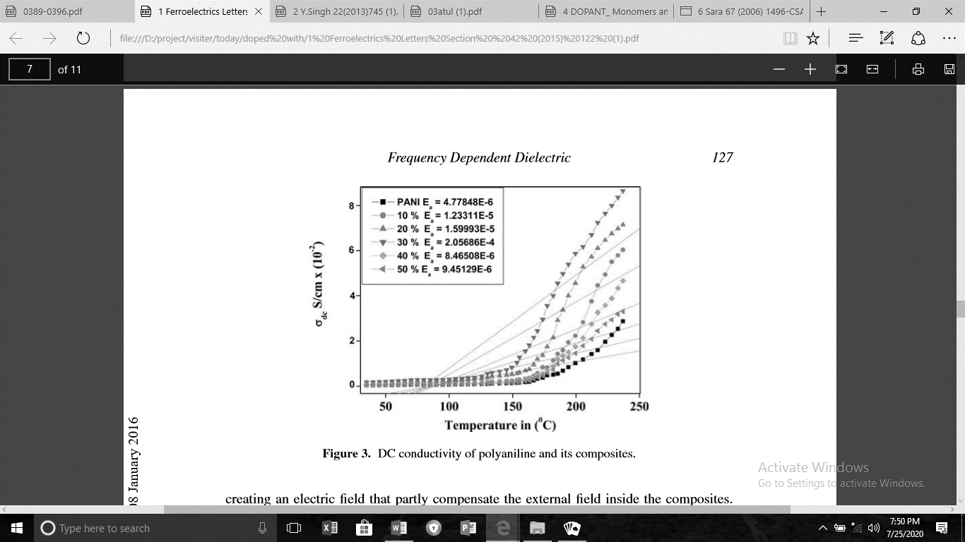
Figure 2 Electrical conductivity of PANI-Ta₂O₅ composites at different temperature [26].

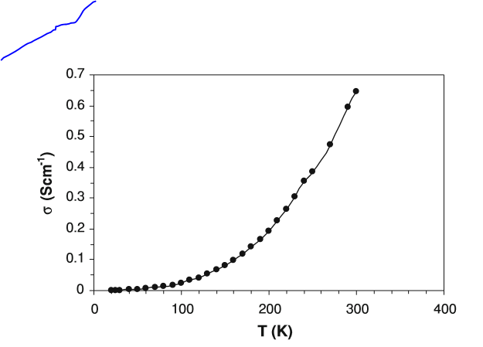
Figure 3 Electrical conductivity of PTSA-doped polyaniline at different temperatures [29].

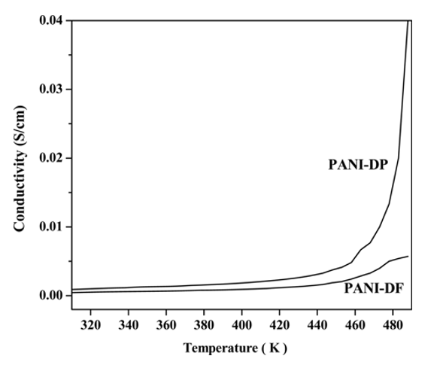
Figure 4 Temperature dependent conductivity of PANI-DP and PANI-DF composites [30]

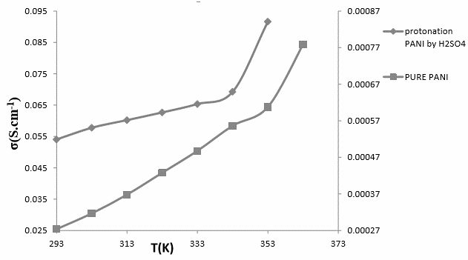

Figure 5 Electrical conductivity of pure and protonation PANI by H₂SO₄ [31].
The results shown in figure 1, figure 2, figure 3, figure 4 and figure 5 shows that as the temperature increases, the electrical conductivity also increase. At low the electrical conductivity of the pure polyaniline and doped polyaniline remains constant due to insufﬁcient activation energy that can cause hopping of charges from one localized site to another [32]. At middle temperature the electrical conductivity increases gradually due to the hopping of charge carriers in short range order [33-34]. At high temperature the electrical conductivity suddenly increases due to hopping of charge carriers in long range order. N.M. Obaid et al. explained that the increase in the conductivity is due to the increase of efficiency of charge transfer by contribution of polaron and bipolaron bands and to the effect of dopant ions [31].
CONCLUSION
In order for conducting polymer to conduct electricity they must possess charge carries and orbital system that allows the charge carriers to move. The conjugate structure that is in conducting polymer provides orbital system that allows the charge carries to move. Unlike other conducting polymers, polyaniline in its fully oxidized states are not conducting. Polyaniline becomes conducting when moderately oxidized state are protonated and charge carries are generated. This process makes the polyaniline unique and they can be transformed from insulators to conductors.
It has found that the polyaniline synthesized through electrochemical method have greater electrical conductivity than chemically synthesized polyaniline. Proton assisted, doping-induced conductivity in polyaniline is a remarkable phenomenon. The review has affirmed that the doping of polyaniline increases it’s the electrical conductivity. The study also reviews the factors that affect the conductivity of doped polyaniline are temperature and nature of the dopants The study has observed that each dopant agent achieve different electrical conductivity of polyaniline. The maximum conductivity of polyaniline that has recently achieved is 79 Scm⁻¹, however in 1996 E.R. Holland et al. achieved a conductivity up to 300$±$30 Scm⁻¹.

REFERENCE
[1] Y. Atassi, M. Tally and M. Ismail. Electronic properties of the conducting form of polyaniline 457(2002) 45
[2] P. Fedorko, M.Trznadel, A.Pron, D. Djurado, J. Planès & J Travers. New analytical approach to the insulator–metal transition in conductive polyaniline. Synthetic Metals, 160, (2010), 1668-1671,
[3] R. Holze, J. Stejskal, Chemical Papers (2013), 67, 769.
[4]. I. Gazdić, and A. M. Šahbazović, Testing of Electrical Conductivity of Thin Films of Polyaniline Doped with Phosphoric AciVo-6 (2016) 2250-0758
[5] Zhao, H., Liu, Y., & Chen, S. (2021). Charge transport mechanisms in proton-doped polyaniline. Polymer, 230, 124065.
[6] V. M Mzenda, Characterization of the electrical properties of Polyaniline in the temperature 30-450K, University of Pretoria (2001) 3-77
[7]. K. M Ziadan and W. T sadon Study of the electrical characteristics of Polyaniline” (2012) 3 www.sciencedirect.com
[8] Z.A. Boeva and V.G. Sergeyev, “Polyaniline: Synthesis, properties, and Application”, Polymer Science, 56, (2014) 144-153.
[9] Wang, L., Sun, X., & Zhang, D. (2023). Polaron and bipolaron transport in conducting polymers. Journal of Applied Polymer Science, 140(18), e53642.
[10] Rahman, M. M., & Lee, J. J. (2022). Conducting polymers for advanced electronic applications: A review. Synthetic Metals, 287, 117047
[11] Kumar, S., Singh, R., & Verma, A. (2022). Comparative study of electrochemically and chemically synthesized polyaniline for enhanced conductivity. Materials Today: Proceedings, 49, 3221–3226
[12] J. Vivekanandan V. Ponnusamy, A. Mahudeswaran and P. S. Vijayanand. Synthesis, characterization and conductivity study of polyaniline prepared by chemical oxidative and electrochemical methods 3 (2011) 147-153
[13] O. A. Nunoo, J. A.Awuah, E. K. K. Abavare and K. Singh. Effect of primary dopants on the conductivity of polyaniline synthesized by electrochemical polymerization 10 (2019) 157-163
[14] N. Colak and B. Sokme, Designed Monomers and Polymers, Vol. 3(2000) 1568-5551
[15] E. C. Gomes and M. A. S. Oliveira Chemical Polymerization of Aniline in Hydrochloric Acid (HCl) and Formic Acid (HCOOH) Media. Differences between the Two Synthesized Polyanilines 2 (2012) 5-13
[16] M. N. Obaid and S. M. Hassan, D.C electrical conductivity of prepared pure and doped polyaniline salt. Journal of Physics, Baghdad, Iraq Vol.15, (2017)5
[17]. El-Ghazaly, M., Hassan, M., & Omar, A. (2021). Effect of inorganic and organic acid dopants on electrical conductivity of polyaniline. Results in Physics, 26, 104363.
[18] F. Dogan, H. Hadavinia, S. J. Barton and P. J. Mason, Applications of Intrinsically Conducting Polymers, 3(2010)174-182
[19]. A. A. Syed and M. K. Dinesan, conducting polymers, polyaniline, 38, 815–837 (1991)
[20] M. Hafeez, M. Faheem, Z. Ul Abdin, K. Ahmad, S. Fazil, and B. A. Khan, Synthesis and characterization of polyaniline-based conducting polymer and its anti-corrosion application, Vol. 12,( 2017), 707 – 717
[21] Patil, D. S., & Shirsat, M. D. (2023). Enhanced electrical conductivity of CSA-doped polyaniline for flexible electronics. Materials Chemistry and Physics, 302, 127681
[22] Zhao, H., Liu, Y., & Chen, S. (2021). Charge transport mechanisms in proton-doped polyaniline. Polymer, 230, 124065.
S. M. Hamm, Effect of Acidic Dopants properties on the Electrical Conductivity of Poly aniline 17 (2012)
[23] D.I. Mac, M.A. Druy, P.J. Nigrey, D.P. Nairns, A.G. MacDiarmid and A.J. Heeger, J. Chem. Soc. Chem. Commun. 317 (1981)80.
[24] I. Gazdic, A. M. Sahbazovic, S. Sulejmanovic, Analysis of Specific Electric Conductivity of thin Films of Polyaniline Doped with Sulfuric and Hydrochloric Acid, 5 (2016)38–43
[25] X. Y. Peng, X. X. Liu, P. J. Hua, D. Diamond and K.T. Lau, J. Solid State
Electrochemical. 14 (2010) 13.
[26] Hassan, N., Ahmed, S., & Khan, M. (2022). Temperature-dependent DC conductivity of doped polyaniline composites. Journal of Electronic Materials, 51, 4483–4492.
[27] F. Yilmaz, Polyaniline: Synthesis, Characterization, Solution Properties and Composites (2007)1
[28] D. C Sindhimeshram and M. C Gupta. Transport properties of Substituted derivatives of poly (aniline) 34A (1995)260-267
[29] A. Kapil, M. Taunk and S.Chan. Preparation and charge transport studies of chemically synthesized polyaniline. 21 (2009) 399–404
[30] C. Basavaraja. R. Pierson, and D. S. Huh. Studies on Properties of Polyaniline-Dodecylbenzene Sulfonic Acid Composite Films Synthesized Using Different Oxidants. Vol. 17, No. 8, (2009) 609-615
[31] M. N. Obaid and S. M. Hassan, D.C electrical conductivity of prepared pure and doped polyaniline salt. Journal of Physics, Baghdad, Iraq Vol.15, (2017)5
[32] K.E. Ziemelis, A.T. Hussain, D.D.C. Bradley, R.H. Friend, J. Rilhe and W. Wegner, Phys. Rev. Lett. 66, (1991) 2231.
[33] Hassan, N., Ahmed, S., & Khan, M. (2022). Temperature-dependent DC conductivity of doped polyaniline composites. Journal of Electronic Materials, 51, 4483–4492.
[34] Rahman, M. M., & Lee, J. J. (2022). Conducting polymers for advanced electronic applications. Synthetic Metals, 287, 117047.

