Systematic Literature Review of Expectancy Values Theory in Higher Education: Implications for Yoga Instruction

Abstract: Learning motivation is a key determinant of students’ engagement, achievement, and sustained participation in physical education. However, research on learning motivation in higher education physical education remains theoretically fragmented. Guided by Expectancy-Value Theory (EVT), this systematic review synthesizes empirical studies examining learning motivation in higher education physical education and related contexts published between 2004 and 2025. Following a structured review process, 15 empirical studies were identified and analyzed in terms of research characteristics, methodological approaches, theoretical applications, and key findings. The results reveal that existing research primarily focuses on behavioral participation and learning processes, relies heavily on quantitative questionnaire-based designs, and pays limited attention to higher education populations. The review further highlights the value of EVT for understanding students’ participation decisions, enhancing classroom motivation, strengthening perceived course value, and informing motivation-oriented instructional evaluation. These findings provide theoretical and empirical support for the development of motivation-oriented instructional design and pedagogical reform in university yoga courses.
Keywords: Expectancy-Value Theory; learning motivation; higher education; physical education; yoga instruction; systematic review
1 Introduction
Learning motivation has been widely recognized as a key psychological mechanism influencing university students’ learning engagement, learning outcomes, and sustained participation behaviors (Luo et al., 2022)。A substantial body of research in educational psychology and higher education indicates that learning motivation is not only directly associated with students’ effort, persistence, and affective experiences during the learning process, but also exerts a profound influence on learning outcomes and long-term development through its effects on learning engagement and self-regulated behaviors. In the context of higher education physical education, the role of learning motivation appears to be particularly salient (Beymer & Weast-Knapp, 2024; Brown & Putwain, 2022; Ehrmantraut et al., 2020).
Specifically, within higher education physical education courses, learning motivation is closely related not only to the development of students’ sport-specific skills and physical fitness, but also to their understanding of course value, the quality of their learning experiences, and the formation of lifelong physical activity awareness (Chen & Liu, 2008). For university physical education courses represented by yoga, which typically integrate physical skills, psychological regulation, health awareness, and aesthetic experience, students’ sustained engagement in practice, active classroom participation, and the development of stable and positive learning attitudes largely depend on the structure and level of their learning motivation(Zhou et al., 2023).
However, existing research on learning motivation in higher education physical education demonstrates a certain degree of fragmentation in terms of research perspectives, theoretical frameworks, and variable conceptualization (Song & Choi, 2025). On the one hand, studies have been conducted based on diverse theoretical perspectives, such as self-determination theory, achievement goal theory, interest theory, or instructional motivation models, which makes it difficult to directly compare or integrate findings across studies due to differences in conceptual usage and explanatory pathways (Hu et al., 2025)；On the other hand, at the level of variable operationalization, substantial inconsistencies exist in how learning motivation and its influencing factors are defined and measured, particularly with regard to constructs such as “interest,” “value,” “self-efficacy,” or “learning experience”(Chen & Liu, 2008; Hu et al., 2025). This theoretical and conceptual heterogeneity has constrained the cumulative development of research findings and highlights the lack of a systematic synthesis grounded in a unified theoretical framework within higher education physical education motivation research.
Expectancy-Value Theory (EVT) provides a well-established and highly explanatory framework for understanding the formation mechanisms of learning motivation. According to EVT, individuals’ motivation to engage in learning tasks is primarily determined by two core psychological judgments: their expectations for success in completing the task (expectancy beliefs) and the subjective value they assign to the task (task values). Furthermore, task values can be differentiated into multiple dimensions, including intrinsic value, utility value, attainment value, and perceived cost (Hu et al., 2025; Rudhumbu & Du Plessis, 2021; Wong & Chapman, 2024).
In the context of higher education physical education, students’ learning motivation is typically shaped by the combined influence of individual cognitive characteristics, course content attributes, instructional design approaches, and learning contextual factors(Shang et al., 2023; Wang & Xue, 2022). These factors interact with the components of EVT in complex and multilayered ways. For example, instructional design may enhance students’ expectancy beliefs by strengthening perceptions of competence or increase task values by improving perceived relevance and interest. Therefore, adopting EVT as a unified theoretical framework facilitates the systematic classification and integration of dispersed variables across studies, thereby enabling a clearer understanding of the mechanisms underlying learning motivation in higher education physical education(Lui, 2024; Rubach et al., 2023).
Against this background, the present study adopts Expectancy-Value Theory (EVT) as its core theoretical framework and employs a systematic review methodology to synthesize empirical research on learning motivation grounded in EVT within the field of higher education. Specifically, the study first conducts a systematic synthesis and comparative analysis of sample characteristics in existing research to identify the populations, educational contexts, and methodological features in which EVT has been applied to learning motivation research in higher education, thereby outlining the overall distribution and developmental trends of the field. Second, drawing on the expectancy and task value components of EVT, the study integrates empirical findings to identify key influencing factors and pathways that enhance learning motivation in higher education physical education courses, elucidating how instructional, individual, and contextual factors influence students’ motivation through expectancy and value judgment mechanisms. Finally, based on the synthesized evidence, the study further distills the implications of EVT for yoga instruction in higher education physical education, with particular emphasis on its application to course goal design, instructional content organization, instructional strategy selection, and learning experience optimization, aiming to provide a systematic theoretical foundation and empirical support for motivation-oriented instructional design and pedagogical reform in university yoga courses.
Through the achievement of these research objectives, this study seeks to deepen the theoretical understanding of EVT applications in higher education physical education and, at the practical level, to offer an evidence-based and systematic reference framework for enhancing university students’ learning motivation and instructional quality in physical education courses. Guided by these objectives and adopting EVT as the central analytical perspective, the present systematic review addresses the following research questions:
RQ1: What are the sample characteristics of learning motivation research based on Expectancy-Value Theory in the field of physical education?
RQ2: What implications does Expectancy-Value Theory offer for yoga instruction in higher education physical education?
2 Methodology
A systematic review is a research synthesis approach designed to identify and retrieve scientific evidence relevant to a specific topic and to analyze and integrate retrieved findings to inform future research directions (Parums, 2021). This approach is particularly suitable for examining how Expectancy-Value Theory has been empirically applied with the support of structured coding frameworks and data synthesis procedures (Yaprak, 2025). At the same time, it is possible to determine the educational background in an orderly manner from the year of publication, education level, discipline and learning environment. In addition, it is also helpful to analyze the teaching objectives, teaching content, teaching methods, teaching strategies, teaching resources, teaching evaluation and learning outcomes in the dimension of teaching design. role and theoretical framework in the dimension of theoretical framework; and measuring version and reliability in the tool dimension(Shi et al., 2025).
Accordingly, the present study adopts a systematic review design, using Expectancy-Value Theory (EVT) as a unified analytical framework, to systematically retrieve, screen, code, and synthesize empirical studies that examine learning motivation based on EVT within the domain of higher education physical education. Systematic reviews emphasize transparency, reproducibility, and methodological rigor, allowing for the integration of fragmented empirical evidence to reveal overall research characteristics, key influencing mechanisms, and theoretical implications. This approach is therefore well suited to the study’s objective of comprehensively evaluating theoretical applications and empirical evidence.
2.1 Literature Search Strategy
A systematic search strategy was employed using two widely recognized and influential academic databases: Web of Science and Scopus. Searches were conducted across all available fields (including titles, abstracts, keywords, and full metadata) to ensure comprehensive coverage of relevant studies. Search terms were constructed around three core conceptual categories and combined using Boolean operators: theoretical terms (Expectancy-Value Theory, expectancy value, task value); research topic terms (learning motivation, academic motivation); and contextual terms (physical education, higher education, college, university, yoga, fitness courses). No restrictions were imposed on research methodology to include quantitative, qualitative, and mixed-methods studies. To further enhance coverage and minimize the risk of missing relevant literature, supplementary searches were conducted using Google Scholar and Sc Space.
Clear inclusion and exclusion criteria were established to ensure research quality and relevance. Inclusion criteria were as follows: (1) explicit use of Expectancy-Value Theory or its core constructs as the analytical framework; (2) participants drawn from educational contexts, with a focus on higher education; (3) research conducted in physical education or sport- and health-related contexts; (4) empirical studies employing quantitative, qualitative, or mixed-methods designs; and (5) publication in peer-reviewed journals or academic theses. Exclusion criteria included: (1) studies not explicitly linked to EVT or its core constructs; (2) studies outside the educational domain; (3) studies unrelated to physical education or sport; (4) purely theoretical or conceptual papers; and (5) conference abstracts, non-academic reports, or duplicate publications.
The literature screening process consisted of four stages. First, database searches yielded 427 records from the Web of Science Core Collection and one record from Scopus. Supplementary searches via Google Scholar and SciSpace identified an additional 52 records. After removing four conference papers, one book chapter, one data file, two retracted articles, and 15 early-access publications, a total of 458 records were retained. Second, title and abstract screening excluded 393 records that clearly did not meet the inclusion criteria. Third, eight reports that could not be retrieved were excluded, resulting in 57 records eligible for full-text assessment. Fourth, full-text screening excluded 24 studies outside the scope of physical education and 18 studies unrelated to EVT, yielding a final sample of 15 studies included in the systematic review.
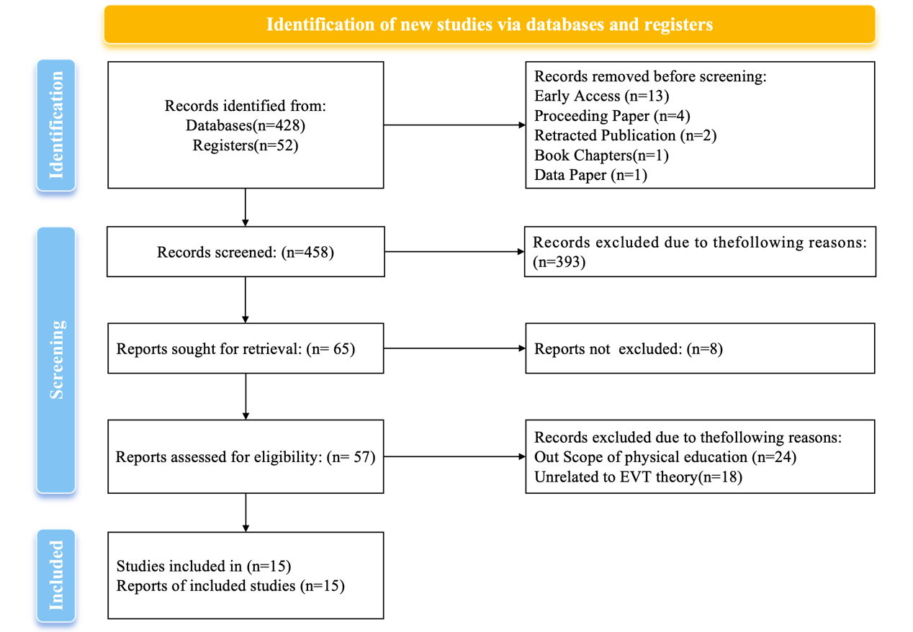
The review process followed the Preferred Reporting Items for Systematic Reviews and Meta-Analyses (PRISMA) guidelines (Moher et al., 2009), as illustrated in Figure 1. All screening procedures were conducted independently by the researcher. In cases of ambiguity, decisions were made through repeated examination of research objectives, theoretical frameworks, and variable definitions to ensure accuracy and consistency throughout the screening process.
Figure 1 PRISMA Flowchart
3 Data Analysis
3.1 Coding Framework and Analytical Strategy
To ensure methodological rigor and transparency, this systematic literature review adopted a structured coding framework grounded in prior SLR standards in educational research. Based on the research questions and theoretical focus, all included studies were coded across three major dimensions: (A) publication information, (B) research design and methodology, and (C) research participants. This multi-dimensional coding scheme enabled both descriptive and analytical synthesis of the literature. Details are as shown in Table 1.
Table 1 Criteria/Codes
code | First author | Published year | Published journals | Keyword | country | research method | Sample
A1 | Jihyun Song | 2025 | Frontiers in Psychology | motivation, expectancy beliefs, task values, physical activity, meta-analysis | Korea | Hybrid Research | Unspecified
A2 | Shen Bo | 2024 | Journal of Teaching in Physical Education | motivation, engagement, choice, fitness | China | Quantitative research | 251
A3 | Jiling Liu | 2023 | International Journal of Environmental Research and Public Health | expectancy beliefs; task values; at-risk; physical activity; health | United States | Quantitative research | 107
A4 | Kanagarajah Rarujanai | 2022 | International Journal of Environmental Research and Public Health | sportspersonship attitude; expectancy beliefs; subjective task values; field hockey | Malaysia | Quantitative research | Unspecified
A5 | Laura O. Gallardo | 2020 | nternational Journal of Environmental Research and Public Health | physical activity; intention to be physically active; teasing; competence; appearance;stress; enjoyment; friend support | Spain and Chile | Quantitative research | 862
A6 | Ove Østerliea | 2019 | Measurement in Physical Education and Exercise Science | physical education, expectancy-belief, f, task value, EVQ, factor analysis, dimensionality, reliability, construct validity | Norway | Quantitative research | 228
A7 | Xiangli Gu | 2014 | Applied Research in Quality of Life | Motivation . Physical activity. Health-related quality of life . Adolescents | United States | Quantitative research | 282
A8 | Sami Yli-Piipari | 2014 | Journal of Teaching in Physical Education | motivation, elementary school, middle school | Finland | Quantitative research | 763
A9 | Haiyong Ding | 2013 | Journal of Teaching in Physical Education | accelerometry | Chinese students | middle school | structural equation modeling | China | Quantitative research | 346
A10 | Senlin Chen | 2012 | Journal of Teaching in Physical Education | motivation | learning | physical education | United States | Quantitative research | 195
A11 | Xihe Zhu | 2012 | Measurement in Physical Education and Exercise Science | measurement invariance | expectancy belief | task value | physical education | China | Quantitative research | 1714
A12 | Evelyn S. Chiang | 2011 | Health Education & Behavior | expectancy-value theory, physical activity, motivation | United States | Quantitative research | 220
A13 | Ang Chen | 2008 | Res Q Exerc Sport | curriculum; fitness education; motivation | United States | Hybrid Research | 298
A14 | Ang Chen | 2008 | Journal of Physical Activity and Health | task values, choice decisions, motivation specificity | China | Quantitative research | 368
A15 | Marios Goudas | 2004 | Perceptual and Motor Skills | physical education; motivation to participate; expectancy theory; intrinsic motivation; Motivational indicators | Greece | Hybrid Research | 763

All coding categories were defined a priori, and a coding manual was developed to ensure consistency. The coding process was conducted independently and iteratively, with discrepancies resolved through discussion to enhance reliability.
3.2 Analysis of Publication Characteristics (Dimension A)
The first stage of analysis focused on the basic publication information of the included studies, including title, authorship, keywords, journal source, and year of publication (2004–2025). Descriptive statistics were used to examine the temporal distribution of studies, revealing trends in publication volume across years.
Keyword analysis was conducted to identify high-frequency research themes and evolving conceptual emphases. Journal distribution analysis was used to assess disciplinary concentration and publication outlets, providing insight into how the research topic has been positioned within education, physical education, and related interdisciplinary fields.
3.3 Analysis of Research Design and Methodology (Dimension B)
The second analytical layer examined research design and methodological characteristics, which is a core requirement of systematic reviews in educational research.
3.3.1 Research Methods
Each study was classified as employing quantitative, qualitative, or mixed methods approaches. Frequencies and proportions were calculated to identify dominant methodological paradigms and to assess the extent to which methodological triangulation has been adopted in the field.
3.3.2 Data Collection Instruments
Data collection tools were coded into six categories: questionnaires, interviews, observations, experiments, tests, and literature reviews. Studies employing multiple instruments were coded accordingly. This analysis enabled an assessment of methodological diversity and the balance between self-reported, behavioral, and performance-based data.
3.3.3 Research Focus and Theoretical Orientation
To capture the substantive focus of the literature, qualitative content analysis was conducted on three coding items: research topic characteristics, theoretical characteristics, and methodological characteristics. These items were coded using open-ended text fields and later synthesized through thematic clustering.
This process allowed for the identification of dominant theoretical frameworks, emerging research themes, and methodological innovations, as well as gaps such as under-theorized constructs or over-reliance on single-method designs.
3.4 Analysis of Research Participants (Dimension C)
The third dimension focused on sample-related characteristics, including sample size, participant group, and country of study. Sample sizes were categorized into four ranges (1–200, 201–500, 501–1000, and 1001–2000) to examine the scale of empirical evidence across studies. Participant groups were classified as primary education, secondary education, higher education, or unclear, allowing for an assessment of population focus within the literature.
In addition, the geographical distribution of studies was analyzed based on the country or region in which the research was conducted. This analysis highlighted regional concentrations and potential cultural or contextual biases in the existing evidence base.
3.5 Data Synthesis and Presentation
Quantitative data derived from categorical coding were summarized using frequency counts and percentages and presented in tabular form to facilitate comparison across dimensions. Qualitative data from open-text coding were synthesized through thematic analysis to support interpretive discussion.
By integrating descriptive statistics with qualitative thematic synthesis, this review provides a comprehensive overview of research trends, methodological patterns, and evidence gaps, laying a robust foundation for subsequent results interpretation and discussion.
4. Discussion
Based on a systematic coding and comprehensive analysis of 15 included articles, this study systematically reviews the current application status of Expectancy-Value Theory (EVT) in physical education-related research from multiple dimensions, including publication characteristics, research design, methodological approaches, sample structure, and theoretical application methods. This section will comprehensively discuss key aspects such as literature distribution characteristics, methodological orientation, theoretical application models, and research coverage, and provide an overall interpretation of the current research landscape using charts and graphs.
4.1 Publication Sources and Disciplinary Distribution Characteristics
From the perspective of journal distribution, the 15 studies were published in 10 different peer-reviewed journals. Table 2 shows that this research topic has not yet formed a highly concentrated core publication platform. The Journal of Teaching in Physical Education has the most publications (n ​​= 4), indicating that this topic has high academic relevance in the field of physical education teaching research. Measurement in Physical Education and Exercise Science (n = 2) and the International Journal of Environmental Research and Public Health (n = 2, with duplicate entries due to index differences) reflect the extension of research in the interdisciplinary field of measurement and public health.
Table 2 Publication Sources and Disciplinary Distribution Characteristics
Journal publications | Quantity
Applied Research in Quality of Life | 1
Frontiers in Psychology | 1
Health Education & Behavior | 1
International Journal of Environmental Research and Public Health | 2
Journal of Physical Activity and Health | 1
Journal of Teaching in Physical Education | 4
Measurement in Physical Education and Exercise Science | 2
Nternational Journal of Environmental Research and Public Health | 1
Perceptual and Motor Skills | 1
Res Q Exerc Sport | 1

Other journals, such as Frontiers in Psychology, Health Education & Behavior, Journal of Physical Activity and Health, Applied Research in Quality of Life, Perceptual and Motor Skills, and Research Quarterly for Exercise and Sport, each only appeared once, indicating that the application of the expectancy value theory in physical education exhibits a clear interdisciplinary and dispersed characteristic, rather than being concentrated in a single academic community. This distribution pattern suggests that the research topic has been absorbed into different disciplines with different problem awareness and methodological orientations, but it may also weaken the systematic accumulation of research results and theoretical dialogue.
4.2 Time Distribution and Evolution of Research Design
From the time dimension of Table 3, relevant studies were published between 2004 and 2025, but the overall distribution shows a clear unevenness. The number of studies was relatively small between 2004 and 2014, exhibiting a sporadic distribution; the number of studies increased after 2019, but still did not result in a sustained high-density output. Combined with the statistical results in the charts, this field has not yet entered a stable phase of rapid development but rather appears to be intermittently attracting renewed attention from different researchers.
Table 3 Time Distribution and Evolution of Research Design
Year of publication | Quantitative research | qualitative research | mixed research
2004 | - | - | 1
2008 | 1 | - | 1
2011 | 1 | - | -
2012 | 2 | - | -
2013 | 1 | - | -
2014 | 2 | - | -
2019 | 1 | - | -
2020 | 1 | - | -
2022 | 1 | - | -
2023 | 1 | - | -
2024 | 1 | - | 1
2025 | - | - | 1

In terms of research design, quantitative research dominates. Of the 15 studies, most explicitly employed quantitative research designs; mixed-method studies appeared only in a few years (2004, 2008, and 2024–2025), and in limited numbers; no studies explicitly employing purely qualitative research designs were found. This trend indicates that the field heavily relies on quantifiable psychometric and statistical modeling approaches in its methodological choices, while paying insufficient attention to the subjective experience of learning motivation, meaning construction processes, and contextual interpretation.
4.3 Centralized Characteristics of Data Collection Tools
The analysis of data collection tools further reinforces the above-mentioned methodological orientation. As shown in Figure 2, the statistical results indicate that questionnaires were the primary data collection tool (n = 12), significantly higher than other methods. Testing tools (n = 4) were mainly used to measure physical fitness, learning outcomes, or knowledge acquisition, while interviews, observations, experiments, and literature reviews were used only once each.
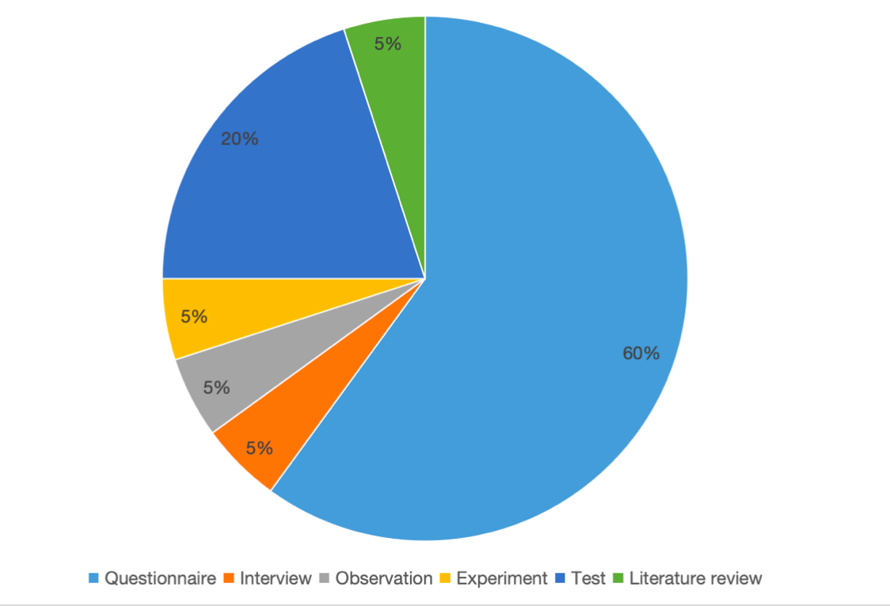
Figure 2 Number of data collection tools used
Although some studies have employed a combination of tools, multi-method data integration has not become the norm in this field overall. This research model, heavily reliant on self-report questionnaires, is helpful to the comparative analysis of motivational structures in large samples to some extent, but it may also limit a deeper understanding of the dynamic, contextual, and process-oriented nature of learning motivation.
4.4 Sample Size and Evidence Basis Characteristics
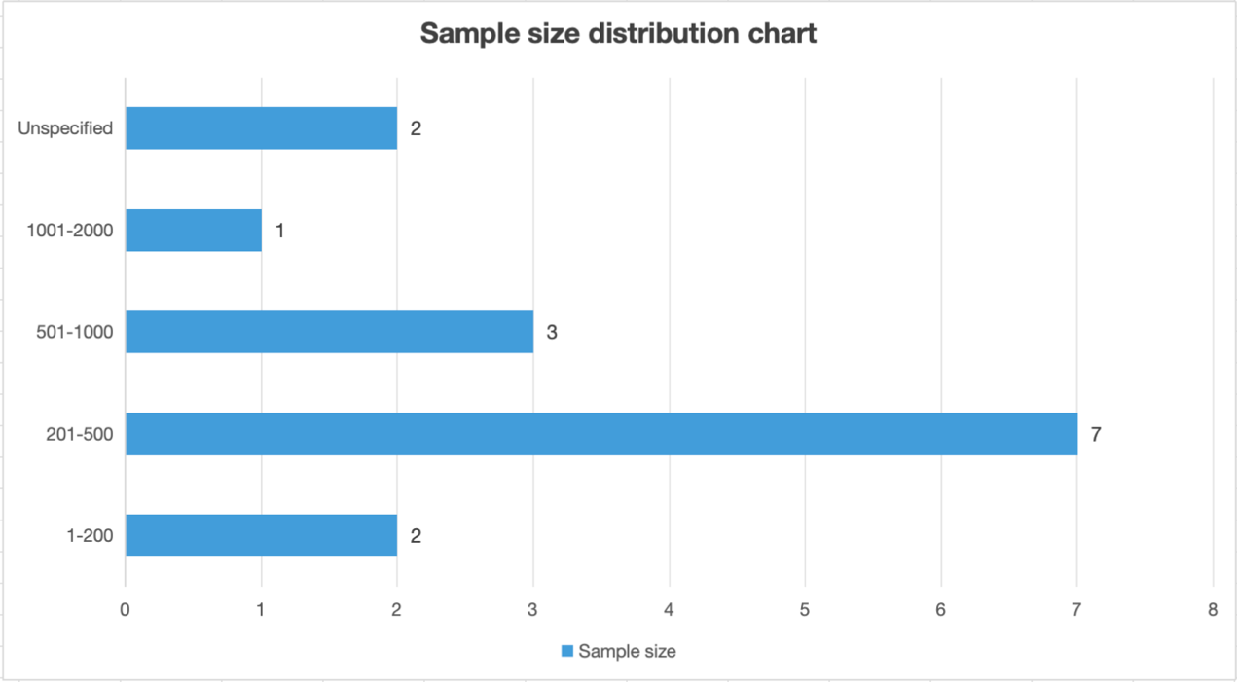
Figure 3 shows the sample size distribution results, indicating that medium-sized samples (201–500 people) are the most common (n = 7), followed by samples of 501–1000 people (n = 3). Small sample studies (1–200 people) and large sample studies (1001–2000 people) are relatively rare, and some studies still do not explicitly report sample size.
Figure 3 Sample size distribution chart
This structure indicates that current research evidence is primarily based on medium-sized samples and possesses a certain degree of statistical stability, but it remains relatively insufficient in terms of large-scale representative studies across regions and populations. This also limits the potential for extrapolating research conclusions into broader educational contexts.
4.5 Participant Group and Educational Stage Bias
From the perspective of participant composition, the research subjects are clearly concentrated in primary and secondary school students. As shown in Table 4, primary and secondary school students dominate the sample classification, while university students appear only once, and some studies do not clearly define the educational stage.
This distribution is closely related to the research themes of "physical education," "physical activity," and "learning motivation," but it also reveals a structural gap: although some research objectives or discussions involve higher education or adult learners, at the empirical level, the higher education group is significantly underrepresented in EVT-related physical education research.
4.6 Geographical Distribution and Contextual Concentration
Regarding geographical distribution, the 15 studies cover 8 countries or regions, but the sample sources are highly concentrated in a few countries. Details are shown in Table 4. The United States (n = 5) and China (n = 4) together account for more than half of all studies, while the remaining countries or regions (Finland, South Korea, Malaysia, Norway, Greece, Spain/Chile) each appear only once.

Table 4 Geographical Distribution
Country | number of sample groups | Unspecified | Primary education | secondary education | university
Finland | 1 | 1 | - | - | -
South Korea | 1 | 1 | - | - | -
Malaysia | 1 | 1 | - | - | -
United States | 5 | 1 | 2 | 2 | -
Norway | 1 | 1 | - | - | -
Spain and Chile | 1 | 1 | - | - | -
Greece | 1 | - | - | 1 | -
China | 4 | 1 | - | 2 | 1
Total | 15 | 7 | 2 | 5 | 1

This pattern indicates that although the research has a certain international distribution, the evidence base is still mainly based on specific cultural and educational systems, and there is a lack of systematic comparison of the applicability of EVT motivation mechanisms under different educational systems, curriculum structures, and cultural values.
4.7 Systematic Review of Research Topic Characteristics
Below is an English translation rewritten in a systematic literature review style, with formal academic tone, clear structure, and precise terminology.
Based on the thematic classification results presented in Table 6, the 15 included studies can be grouped into three overarching thematic orientations: “Behavior and Participation,” “Learning and Classroom Processes, “and “Psychological and Social Well-being. “This classification reflects variations in the outcome levels emphasized in the application of EVT within physical education and physical activity research.
First, studies categorized under “Behavior and Participation “constitute a relatively prominent group, including A1, A5, A11, A12, A14, and A15. These studies primarily focus on individuals’ participation-related behaviors and decision-making outcomes in physical education or physical activity contexts. Research themes typically center on whether individuals participate, their intention to participate, or observable participation behaviors, reflecting a research orientation oriented toward tangible behavioral outcomes. Within this category, EVT is mainly employed to explain the association between motivational judgments and participation-related behaviors. However, the original sources do not further differentiate specific measurement approaches for participation behaviors or address characteristics such as behavioral persistence, as such details are not explicitly reported.
Second, the “Learning and Classroom Processes “category also represents a substantial proportion of the included studies, encompassing A2, A6, A8, A9, A10, and A13. In contrast to behavior-oriented studies, this group extends the analytical focus from discrete behavioral outcomes to learning processes within classroom contexts. Key research concerns include learning engagement, classroom performance, and learning-related outcomes. This thematic orientation places greater emphasis on the processual characteristics of learning activities, highlighting the applicability of EVT in examining mechanisms underlying classroom learning and instructional processes.
Third, studies classified under “Psychological and Social Well-being” are comparatively limited in number, including only A3, A4, and A7. These studies move beyond classroom or behavioral outcomes and extend the scope of analysis to psychological, social, or health-related outcomes, demonstrating the potential for broader applications of EVT. However, as the figures do not provide detailed information on specific outcome variables or analytical pathways, the operationalization of psychological and social well-being indicators is not explicitly described in the original studies.
Overall, the thematic distribution reveals a progressive expansion of research focus from concrete behavioral outcomes to classroom processes and, subsequently, to more generalized outcome domains. Nevertheless, the distribution across themes is uneven, with a clear predominance of behavior- and learning-oriented research.
4.8 Systematic Analysis of Theoretical Characteristics
From the perspective of theoretical characteristics, the included studies can be classified into three types of theoretical application: “Theory as an explanation of behavioral choice and participation motivation,” “Theory as a predictor of behavioral, health, or fitness outcomes, “and “Theory for measurement modeling and structural validation. “This classification highlights the diverse functional roles that EVT assumes across different studies.
Studies categorized as “Theory as an explanation of behavioral choice and participation motivation” include A1, A4, A12, A13, A14, and A15. These studies focus primarily on motivational judgments themselves, emphasizing the roles of expectancy beliefs and task values in explaining participation intentions, behavioral choices, or motivational orientations. The central concern in this group is addressing the question of why individuals choose to participate, rather than tracking subsequent behavioral changes or outcome variables.
The largest group falls under “Theory as a predictor of behavioral, health, or fitness outcomes, “encompassing A2, A3, A5, A7, A8, A9, and A10. In these studies, EVT constructs are treated as antecedent variables used to predict behavioral outcomes, learning performance, or health-related indicators. EVT is typically embedded within relational or structural models to examine the explanatory power of motivational constructs with respect to outcome variables, underscoring the theory’s predictive function.
The “Theory for measurement modeling and structural validation “category includes only A6 and A11. These studies do not primarily aim to explain or predict behavioral outcomes; instead, they focus on examining the measurement structure and model stability of EVT core constructs, with particular attention to scale dimensionality and structural validity. Although limited in number, this theoretical orientation provides essential measurement foundations that support subsequent empirical research.
Taken together, existing studies demonstrate a clear emphasis on the explanatory and predictive functions of EVT, while comparatively limited attention has been devoted to the structural validation of the theory’s core constructs.
4.9 Systematic Analysis of Methodological Characteristics
With respect to methodological characteristics, the data analysis approaches employed in the included studies can be categorized into “Correlation and regression analysis,” “Structural equation modeling and path analysis,” and “Measurement model validation analysis. “This methodological classification closely parallels the theoretical orientations identified above.
Studies employing “Correlation and regression analysis” include A1, A2, A4, A7, A12, A13, A14, and A15. These studies typically adopt relatively basic statistical techniques to examine associations between motivational variables and behavioral or outcome variables. While methodologically straightforward and suitable for exploratory or relational research, this approach offers limited capacity for testing complex theoretical structures.
The “Structural equation modeling and path analysis” category includes A3, A5, A8, A9, and A10. These studies use more advanced modeling techniques to test theoretical frameworks involving multiple motivational and outcome variables simultaneously, enabling the examination of multiple relational pathways. This methodological orientation aligns closely with studies that employ EVT for predicting behavioral, health, or performance-related outcomes.
Finally, “Measurement model validation analysis “is represented only by A6 and A11. These studies primarily use measurement models or multi-group analyses to test scale structures and model fit, focusing on the psychometric properties and applicability of EVT-based instruments. Although limited in number, such studies play a foundational methodological role by providing validated measurement tools for subsequent empirical investigations.
In summary, the methodological profile of the reviewed literature is characterized by a strong reliance on statistical modeling and predominantly cross-sectional data analyses, whereas methodological diversity and variation in research design remain relatively limited. Details are as shown in Table 5.
Table 5 Systematic Analysis of Methodological Characteristics
Classification | Content | Research Codes
Research Topic Characteristics | Behavior and Participation | A1,A5,A11,A12,A14,A15
Research Topic Characteristics | Learning and Classroom Processes | A2,A6,A8,A9,A10,A13
Research Topic Characteristics | Psychological and Social Health | A3,A4,A7
Research Theoretical Characteristics | Theoretical Explanation of Behavioral Choice and Participation Motivation | A1,A4,A12,A13,A14,A15
Research Theoretical Characteristics | Theories for Predicting Behavioral, Health, or Physical Outcomes | A2,A3,A5,A7,A8,A9,A10
Research Theoretical Characteristics | Theories for Measurement Models and Structural Validation | A6,A11
Research Methodological | Correlation and Regression Analysis | A1,A2,A4,A7,A12,A13,A14,A15
Research Methodological | Structural Equation Modeling and Path Analysis | A3,A5,A8,A9,A10
Research Methodological | Measurement Model Validation Analysis | A6,A11

5 Conclusion
This systematic literature review adopted Expectancy–Value Theory (EVT) as a unifying analytical framework to comprehensively examine and synthesize 15 empirical studies in the field of physical education published between 2004 and 2025. Through systematic coding and comparative analysis across multiple dimensions, including publication characteristics, research design, methodological approaches, sample structures, and modes of theoretical application, this review provides a coherent overview of the existing body of evidence.
Overall, the reviewed studies demonstrate that EVT has been widely applied to explain students’ behavioral participation, classroom learning processes, and health-related outcomes in physical education contexts. Across different studies, EVT constructs exhibit strong applicability and explanatory potential. However, from the perspective of a systematic review, the field also reveals distinct structural characteristics and limitations.
First, at the methodological level, quantitative research designs and questionnaire-based measurements overwhelmingly dominate the literature, whereas longitudinal designs, experimental studies, and qualitative approaches remain scarce. As a result, existing evidence largely remains at the level of correlational relationships and structural models, offering limited insight into the causal mechanisms and process-oriented dynamics underlying the formation and evolution of learning motivation.
Second, about research populations and contexts, most studies focus on students at the elementary and secondary school levels, with higher education populations being markedly underrepresented. This imbalance contrasts with discussions in some studies that emphasize the importance of higher education or adult physical education, indicating considerable scope for future research expansion in terms of participant selection.
Third, in terms of theoretical application, EVT has primarily been employed in three ways: explaining participation motivation and behavioral choice, predicting behavioral or health-related outcomes, and supporting measurement modeling and structural validation. The first two orientations predominate in the literature, while studies addressing measurement equivalence and structural validation are relatively limited in number, despite their fundamental methodological significance.
Based on these findings, this review suggests that future applications of EVT in physical education, particularly in higher education and authentic curricular contexts, should further diversify research methods, broaden research populations, and strengthen cross-contextual and cross-cultural comparisons while maintaining theoretical coherence. By incorporating longitudinal designs, mixed-method approaches, and instructional intervention studies situated in real teaching contexts, EVT has the potential not only to deepen understanding of motivational mechanisms but also to provide more actionable empirical support for motivation-oriented curriculum design and instructional reform.
In summary, through systematic integration of existing empirical evidence, this systematic literature review clarifies the application landscape of EVT in physical education research and offers a clear directional reference for future theoretical refinement and methodological innovation.
6 Revelation
Based on the preceding findings, Expectancy–Value Theory has primarily been applied in physical education research to explain learners’ behavioral participation, classroom learning processes, and selected psychological and health-related outcomes. This pattern of theoretical application provides clear motivation-oriented insights for yoga course instruction in higher physical education, particularly with respect to course participation, classroom organization, the presentation of course value, and approaches to instructional evaluation. Drawing on the available evidence, these insights can be summarized in four key points.
First, at the level of curriculum design, yoga courses in higher physical education should treat students’ participation decisions as a central concern. Existing studies indicate that EVT constructs are mainly used to explain whether learners choose to participate in physical activity and whether they maintain sustained participation. This suggests that yoga instruction should attend to students’ judgments regarding their likelihood of success and their overall perception of course value, thereby supporting positive participation choices by emphasizing attainability and learning significance.
Second, at the level of classroom organization, yoga instruction should prioritize motivational support throughout the learning process rather than focusing exclusively on final learning outcomes. Prior research shows that EVT is frequently used to explain classroom engagement, effort, and learning performance, indicating that students’ learning experiences largely depend on sustained participation and involvement during instruction. In practice, yoga teaching should support students’ positive success expectations and learning engagement through progressive content sequencing and a stable instructional pace.
Third, with respect to instructional content and course presentation, the clear construction of course value represents a critical lever for motivating learning. Many existing studies treat task values as key predictors of behavioral and learning outcomes, suggesting that students’ understanding and recognition of course value are directly linked to their engagement and willingness to participate. Accordingly, yoga instruction should help students articulate the significance of the course for their learning development or personal experience, thereby strengthening their subjective judgments of course value.
Fourth, at the level of instructional evaluation, motivation-oriented feedback holds potential significance. A small number of studies focus on the measurement structure and stability of EVT constructs, suggesting that when student learning experiences are interpreted through a motivational framework, instructional evaluation and feedback should align with that framework as closely as possible. However, current research remains largely at the level of measurement modeling and has yet to provide empirical evidence on the concrete implementation of motivation-oriented evaluation practices in classroom settings. Further research is therefore required to support such applications.
The above insights are derived from the existing patterns of EVT application in physical education research and represent theoretical implications rather than direct empirical conclusions regarding the instructional effectiveness of yoga courses in higher physical education.
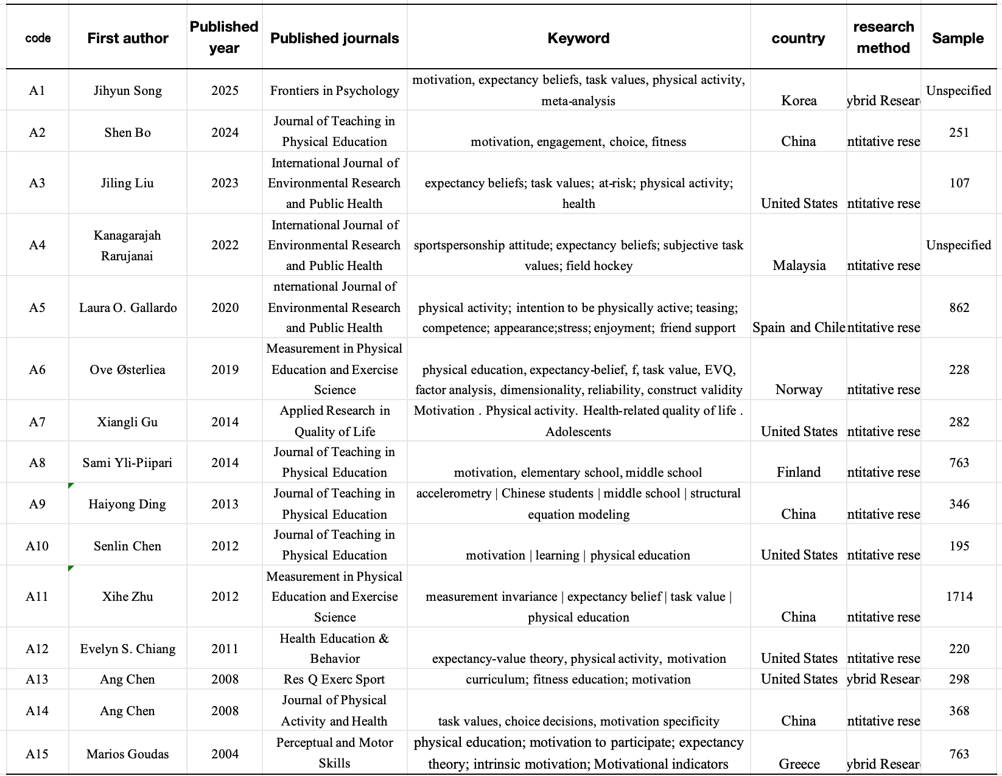
References
Beymer, P. N., & Weast-Knapp, J. A. (2024). Examining interactions between baseline expectancy beliefs and task values on weekly motivation in an introductory statistics course. Learning and Motivation, 88, 102068. https://doi.org/10.1016/j.lmot.2024.102068
Brown, C., & Putwain, D. W. (2022). Socio-economic status, gender and achievement: The mediating role of expectancy and subjective task value. Educational Psychology, 42(6), 730–748. https://doi.org/10.1080/01443410.2021.1985083
Chen, A., & Liu, X. (2008). Expectancy Beliefs and Perceived Values of Chinese College Students in Physical Education and Physical Activity. Journal of Physical Activity and Health, 5(2), 262–274. https://doi.org/10.1123/jpah.5.2.262
Ehrmantraut, L., Pinger, P., & Stans, R. (2020). The Expected (Signaling) Value of Higher Education. SSRN Electronic Journal. https://doi.org/10.2139/ssrn.3699846
Hu, C., Zhang, Z., Cai, Y., Chen, P., He, X., Duan, Y., Wu, X., & Hu, D. (2025). The Evolution and Hotspots of Expectancy-Value Theory Research. Journal of Scientometric Research, 14(2), 573–586. https://doi.org/10.5530/jscires.20251601
Lui, Y. (2024). A Research on the Impacts and Strategies of Undergraduate English Writing Motivation under the Expectancy Theory. Advances in Education, 14(06), 1181–1191. https://doi.org/10.12677/ae.2024.1461060
Luo, X., Liu, L., & Li, J. (2022). The Effects of ARCS Motivational Instruction in Physical Education on Learning Cognition and the Health-Related Physical Fitness of Students. Frontiers in Psychology, 13. https://doi.org/10.3389/fpsyg.2022.786178
Moher, D., Liberati, A., Tetzlaff, J., Altman, D. G., & for the PRISMA Group. (2009). Preferred reporting items for systematic reviews and meta-analyses: The PRISMA statement. BMJ, 339(jul21 1), b2535–b2535. https://doi.org/10.1136/bmj.b2535
Parums, D. V. (2021). Editorial: Review Articles, Systematic Reviews, Meta-Analysis, and the Updated Preferred Reporting Items for Systematic Reviews and Meta-Analyses (PRISMA) 2020 Guidelines. Medical Science Monitor, 27. https://doi.org/10.12659/MSM.934475
Rubach, C., Dicke, A.-L., Safavian, N., & Eccles, J. S. (2023). Classroom transmission processes between teacher support, interest value and negative affect: An investigation guided by situated expectancy-value theory and control-value theory. Motivation and Emotion, 47(4), 575–594. https://doi.org/10.1007/s11031-023-10013-6
Rudhumbu, N., & Du Plessis, E. (2021). Utilizing the Expectancy Value Theory to Predict Lecturer Motivation to Apply Culturally Responsive Pedagogies in Universities in Botswana. International Journal of Learning, Teaching and Educational Research, 20(7), 192–209. https://doi.org/10.26803/ijlter.20.7.11
Shang, C., Moss, A. C., & Chen, A. (2023). The expectancy-value theory: A meta-analysis of its application in physical education. Journal of Sport and Health Science, 12(1), 52–64. https://doi.org/10.1016/j.jshs.2022.01.003
Shi, Y., Lin, Y., & Yu, Z. (2025). Is need-thwarting instruction really harmful? A systematic review of its associations with students’ learning motivation and malfunction. Learning and Motivation, 90, 102117. https://doi.org/10.1016/j.lmot.2025.102117
Song, J., & Choi, W. (2025). Expectancy-value theories applied in Korean physical activity contexts: A meta-analysis. Frontiers in Psychology, 16, 1678503. https://doi.org/10.3389/fpsyg.2025.1678503
Wang, Q., & Xue, M. (2022). The implications of expectancy-value theory of motivation in language education. Frontiers in Psychology, 13. https://doi.org/10.3389/fpsyg.2022.992372
Wong, W. H., & Chapman, E. (2024). Development and validation of an instrument to measure expectancy for success and subjective task value constructs in the context of higher education. Journal of Applied Learning & Teaching, 7(1). https://doi.org/10.37074/jalt.2024.7.1.20
Yaprak, A. (2025). Motivation to learn German as a foreign language: A systematic literature review. Social Sciences & Humanities Open, 12, 101741. https://doi.org/10.1016/j.ssaho.2025.101741
Zhou, M., Yang, Y., & Liu, Y. (2023). Teaching Design of Yoga Courses in Higher Vocational Colleges Based on BOPPPS Effective Teaching Mode. International Journal of New Developments in Education, 5(5). https://doi.org/10.25236/ijnde.2023.050501

