Urban Flooding in Patna: Causes, Challenges, and Resilient Solutions from Global Best Practices

Abstract
Urban flooding has been recognized as one of the important issues faced by emerging nations with high urbanization rates. Patna, the capital city of Bihar state in India, has been subjected to numerous instances of urban flooding. This paper seeks to identify the multifaceted aspects of urban flooding in Patna by analyzing the history of flood occurrences, the causes of rapid urbanization, inadequate drainage systems, changes in land use patterns, lack of coordination among authorities, and institutional challenges. This paper also seeks to identify evidence-based solutions by referencing global best practices. The research draws information from various literature sources of flood-resilient cities across the world. The sources of information include Rotterdam, Singapore, Tokyo, and Wuhan. This research paper offers an adaptation strategy to urban flooding in Patna. The adaptation strategy will involve short-term, medium-term, and long-term policy reforms. This research paper will contribute to the expanding body of knowledge on urban flood resilience in Indian cities. This research paper will also offer important recommendations to policymakers, urban planners, and authorities dealing with disaster management in Patna and other urban flood-prone areas.

Keywords: Urban flooding, Patna, flood resilience, disaster management, drainage infrastructure, land-use change, nature-based solutions, climate adaptation, sustainable urban drainage, flood-resilient cities

1. Introduction
Urban flooding has been recognized as one of the important issues faced by emerging nations with high urbanization rates. Patna, the capital city of the state in India, has been subjected to numerous instances of urban flooding. This paper seeks to identify the multifaceted aspects of urban flooding in Patna by analyzing the history of flood events, the causes of rapid urbanization, inadequate drainage systems, changes in land-use patterns, lack of coordination among authorities, and institutional challenges. This paper also seeks to identify evidence-based solutions by referencing global best practices. The research draws on various sources of literature on flood-resilient cities worldwide. The sources of information include Rotterdam, Singapore, Tokyo, and Wuhan. The literature offers important insights into possible solutions to urban flooding. This research paper offers an adaptation strategy to urban flooding in Patna. The adaptation strategy will involve short-term to medium-term solutions and long-term policy reforms. This research paper will contribute to the expanding body of knowledge on urban flood resilience in Indian cities while offering important recommendations for policymakers, urban planners, and authorities dealing with disaster management in Patna and other urban flood-prone areas.

2. Literature Review

2.1 Urban Flooding: Definitions and Global Context
Urban flooding arises when the capacity of urban drainage systems is exceeded by either rainfall runoff or riverine inundation, thereby impacting urban infrastructure [1], [2]. Dharmarathne et al., in their comprehensive examination of climate change-induced urban flooding, highlighted the promise of sophisticated technologies, including modeling, remote sensing, and AI for enhancing the prediction, monitoring, and management of urban flooding events [11]. Furthermore, green infrastructure and urban planning are increasingly recognized as essential elements of urban flooding adaptation strategies across diverse urban environments.

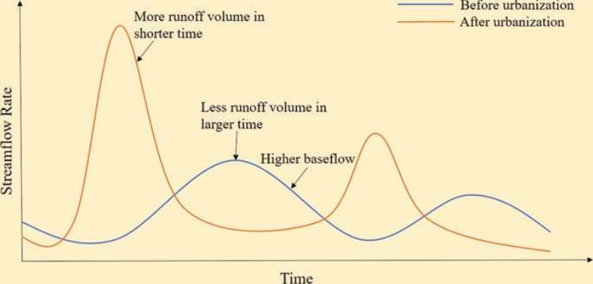
Fig.1 Changes in the hydrological response of a catchment due to urbanization
Rashiq et al., "Urban floods: A case study of Patna floods 2019–Natural or anthropogenic?"
doi:10.1007/978-3-031-21618-3_4
At the global level, urban flooding has increased in recent years due to the coincidence of climate change-induced events of extreme precipitation and urbanization-induced increased impervious surface areas that exceed urban drainage capabilities [3]. Sörensen et al. call for a paradigm shift in urban flood management, from resistance-based methods (like levees and channeling) to adaptive infrastructure and water-sensitive urban design. [12]. This is a result of the realization that urban flooding is a complex issue that cannot be addressed by traditional urban infrastructure-based approaches.

2.2 Urban Flooding in Patna: Historical and Contemporary Research
Floods that occurred in 2019 have been accompanied by more studies related to the vulnerability of Patna. The case study conducted by Ojha on the floods that hit Patna in 2019 is useful for disaster management as its findings reveal that constant efforts must be made in order to improve disaster preparedness, cooperation among stakeholders, and mitigation [4]. This specific study emphasizes the need to implement flood early warning systems, improve drainage facilities, build flood-resistant structures, and map out the flood-prone areas.
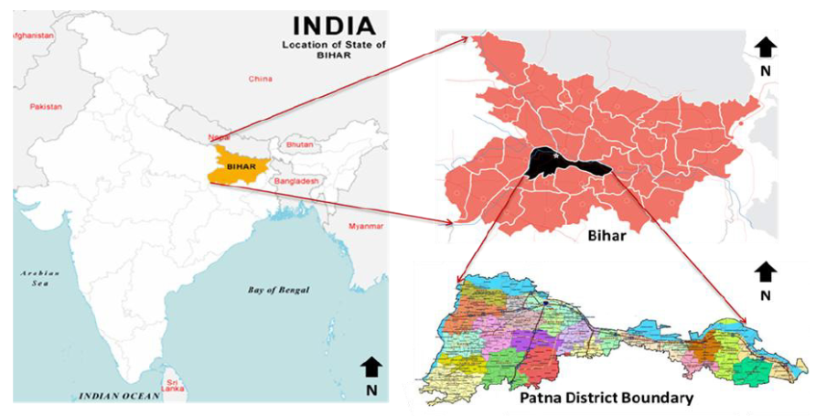
Fig.2: Location map for the research area
Gaurav et al., "Delineation of Groundwater, Drought and Flood Potential Zone Using Weighted Index Overlay Analysis and GIS for District Patna, Bihar, India," Nature Environment and Pollution Technology, 2022,https://doi.org/10.46488/NEPT.2022.v21i02.046h

In their study, Rashiq et al. attempt to establish the cause of the Patna floods in 2019, whether
they were caused naturally or anthropogenically, along with a timeline of events and the difficulties encountered by the management [10]. In their case study, they show that the causality of urban flooding is highly complex in nature; natural disasters combined with human vulnerabilities create disaster results. Many researchers have used GIS-based multicriteria analysis to analyze flood vulnerability in Patna. For example, Sarkar et al. apply the frequency ratio method and Shannon's
entropy technique to prepare flood vulnerability maps for Patna district, which indicates that about 16.35% (frequency ratio model) and 9.98% (Shannon's entropy model) of the total area is highly flood vulnerable, especially the southeastern and northwestern parts [17]. Again, Gaurav et al. conduct weighted index overlay analysis to identify flood potential zones, such as Kankarbagh and Rajendra Nagar, which are highly susceptible to flooding in four classes: no risk (2.89%), low risk (62.35%), medium risk (31.16%), and high risk (3.60%) [18].

3. Methodology
This study utilizes the mixed methodology framework, which includes a systematic literature review, comparative analysis, and evidence-based policy analysis to develop holistic recommendations for flood resilience in the context of Patna, an urban area. The methodological framework for this investigation is delineated into the following four distinct phases:

3.1 Data Sources and Analysis
For this investigation, a range of data sources were employed, which include:
Remote Sensing and GIS Data – A range of studies included in the corpus of this investigation employed Sentinel-1 Synthetic Aperture Radar (SAR) data, which were analyzed using Google Earth Engine (GEE), for delineating flood extent and its temporal dynamics [6], [16]. The authors employed the Otsu thresholding technique for determining flood extent, followed by spline interpolation, which provided accurate results validated using PlanetScope data with accuracy levels greater than 93% [6].
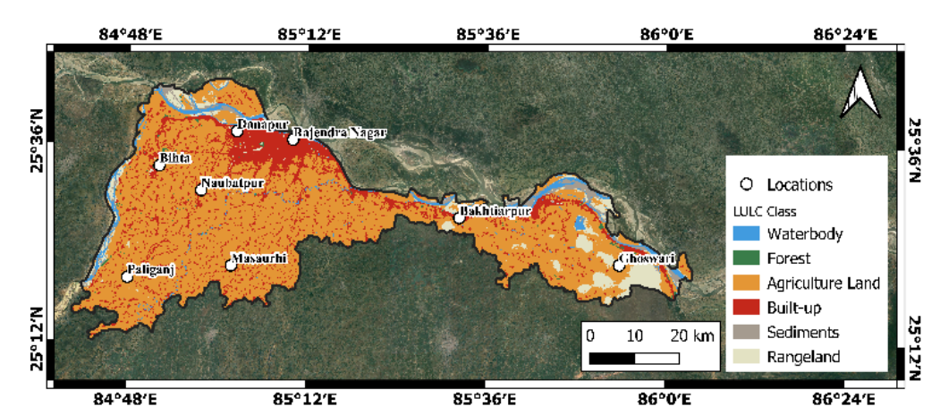
Fig.3 Study area map of Patna District
Soudagar et al., "Quantifying Spatiotemporal Variability of Patna's 2023 Monsoon Flood Using Sentinel-1 SAR Data and Moran's Index," The international archives of the photogrammetry, remote sensing and spatial information sciences, 2025,https://doi.org/10.5194/isprs-archives-XLVIII-G-2025-1367-2025

Land Use and Hydrological Data – The authors employed Digital Elevation Models (DEMs), land use/land cover data derived using IRS 1B LISS III and LANDSAT TM satellite data, soil data, drainage density data, and precipitation data using the Bhukosh platform, NASA ORNL DAAC, FAO GeoNetwork, Climatic Research Unit (CRU), etc. The authors employed the SCS-CN method for determining runoff using land use change data [8].
Vulnerability Assessment Data – The authors employed data collected at the household level and the ward level for vulnerability assessment using Principal Component Analysis (PCA), which provided the Composite Vulnerability Index (CVI) using the multicriteria decision analysis approach [7].
Soil Characteristics – The authors employed laboratory analysis of soil samples collected from ten urban sites in the city of Patna, which included texture, water content, specific gravity, and field capacity, which were analyzed using the soil water retention curve, Brooks & Corey, Campbell, and Van Genuchten models [21].

3.2 Comparative Case Study Analysis
Criteria for selecting the cities include their known leadership in flood resilience and their diversity of methods, which are as follows:
Table 1. Comparative Analysis
No. | Urban flood resilient cities | Selection criteria
1. | Rotterdam, Netherland | Selected for adaptive water management in a below-sea-level delta city context
2. | Singapore | Selected for integrated stormwater management in a tropical, high-density urban environment
3. | Tokyo, Japan | Selected for large-scale underground flood infrastructure in a megacity context
4. | Wuhan, China | Selected for the sponge city approach, combining nature-based solutions with urban development
Generated by the author
For each city, the analysis focused on:
- Flood resilience strategies and infrastructure options;
- Policies and governance systems;
- Difficulties and success factors in implementation;
- Applicability to the Patna situation.

3.3 Evidence-Based Policy Synthesis
The last stage of the process entailed synthesizing the results obtained from the literature and the case studies in order to come up with a phased implementation framework for Patna. The process of synthesis included:
1. Identification of gaps through a comparison between current flood management strategies in Patna and those practiced internationally.
2. Adapting international approaches in line with the applicability, affordability, and appropriateness within the context of Patna.
3. Prioritization of interventions based on impact, practicality, and cost.
4. Development of an implementation framework for the immediate, mid-term, and long-term periods (0-2, 2-6, and beyond years, respectively).

3.4 Limitations
Certain limitations need to be highlighted as well. Firstly, the present study is largely based on secondary data and published literature; carrying out primary research in Patna would have added to the reliability of the findings. Secondly, though carrying out comparative case studies is beneficial for arriving at certain conclusions, the applicability of the solutions is restricted due to variations in economic, institutional, and socio-political aspects of the areas under consideration. Thirdly, due to the dynamic nature of urban development in Patna, certain data might not be entirely accurate or up-to-date, as older studies might not have been conducted or might not be applicable in the present scenario. Fourthly, the technical and institutional aspects of flood resilience have been discussed at length; however, the social aspects of flood resilience need to be addressed as well.

4. Causes and Challenges of Urban Flooding in Patna
The urban flooding crisis in Patna results from a complex interplay of physical, environmental, and institutional factors. This section examines the primary causes of flood vulnerability and the challenges that impede effective flood management.

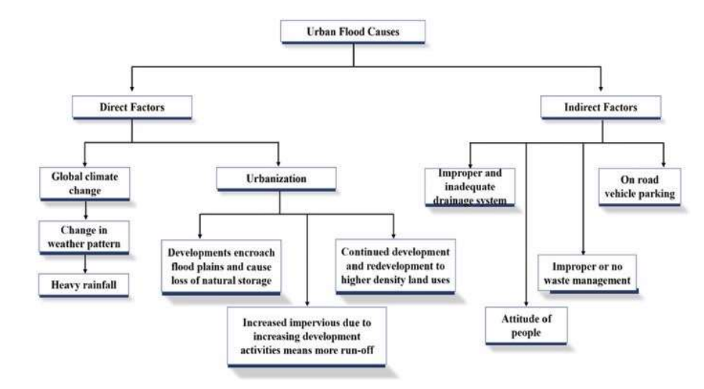
Fig.4: Cause of Urban Flood
Rashiq et al., "Urban floods: A case study of Patna floods 2019–Natural or anthropogenic?"
doi:10.1007/978-3-031-21618-3_4

4.1 Rapid Urbanization and Land Use Changes
Rapid urbanization, often of an unplanned nature, has emerged as the major anthropogenic cause of increased flood vulnerability in Patna. Several studies offer quantitative data on the extent of urbanization and its hydrological impact.
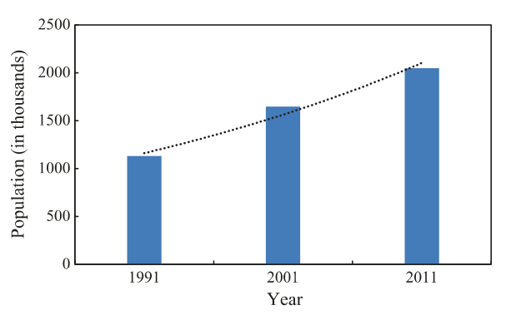
Fig.5 Population of Patna City 1991-2011
Rashiq et al., "Urban floods: A case study of Patna floods 2019–Natural or anthropogenic?"
doi:10.1007/978-3-031-21618-3_4
Ranjan et al. offer quantitative data on the dramatic changes in land use from 2005 to 2019. They found a 22.82% increase in built-up areas and a corresponding 15.48% decline in agricultural areas during this period [8]. Such changes from agricultural land to built-up areas are a major cause of increased flood vulnerability. They also employed the SCS-CN method (Soil Conservation Service Curve Number) to quantify the impact of urbanization on surface runoff. They found that during 2010-2015, the surface runoff increased from 16.8% to 23.72%, showing a 41% increase in surface runoff during a five-year period. Such a dramatic increase in surface runoff characteristics means that the same rainfall event today generates a considerably higher surface runoff than it did a decade ago.
Complementary evidence is offered by Abhinay et al., using GIS-based cause-effect time series mapping, showing a 3.87% increase specifically between the 2007 and 2019 flood events [5]. Although this may seem a low percentage, it equates to considerable actual area, given the size of Patna, and the location of this newly urbanized area, often in low-lying areas or drainage channels, increases its hydrological effect beyond this figure.
The methods used by Mishra et al. include remote sensing and GIS techniques for monitoring urban spatial expansion, directly linking this expansion with urban flooding and water logging on a large scale [19]. This study shows how urban expansion has led to a reduction in natural drainage capabilities within Patna through the filling of wetland areas, drainage channels, and permeable areas being replaced by impervious surfaces. This study shows how urban areas have grown without a comparable increase in drainage systems. This highlights a growing difference between how much runoff is produced and how well it can be drained.

The methods by which urbanization contributes to flood risk are well established within the literature, with Ranjan et al. identifying three distinct methods by which urbanization contributes to flood risk within urban areas, namely through reduced open spaces previously providing informal water retention, through illegal construction hindering drainage channels, and through drainage channels being clogged, unable to cope with increased runoff generation [8]. These factors work together synergistically, with illegal construction often being a feature within drainage channels, thus affecting both runoff generation and drainage capability simultaneously.

4.2 Inadequate Drainage Infrastructure
Patna's drainage system could not match the pace of development and urbanization, resulting in an insufficient drainage system capacity issue. It is widely reported in previous research that the poor drainage system is considered one of the major factors of urban floods in Patna.
In particular, according to Soudagar et al., the drainage problem is recognized as the key reason for the spatiotemporal dynamics of the monsoon flood that occurred in 2023, together with rainfall patterns and ineffective flood management upstream [6]. In addition, the analysis provided by Soudagar et al. suggests that the drainage system lacks sufficient capacity for water removal from inundated areas since it took 17 days for floodwaters to decrease to zero levels after peak inundation that was recorded within an area of 484.13 km2.
It is essential to emphasize that the hydrophysical properties of the soil of Patna's city play a significant role in increasing the problem of flooding. Two articles addressing the issue of soil moisture variability to mitigate the effects of urban floods indicated that the dominant soils of the city included silt-clay. The field capacity varied from 9% to 21.41%, meaning that the soils have very poor water storage capability.

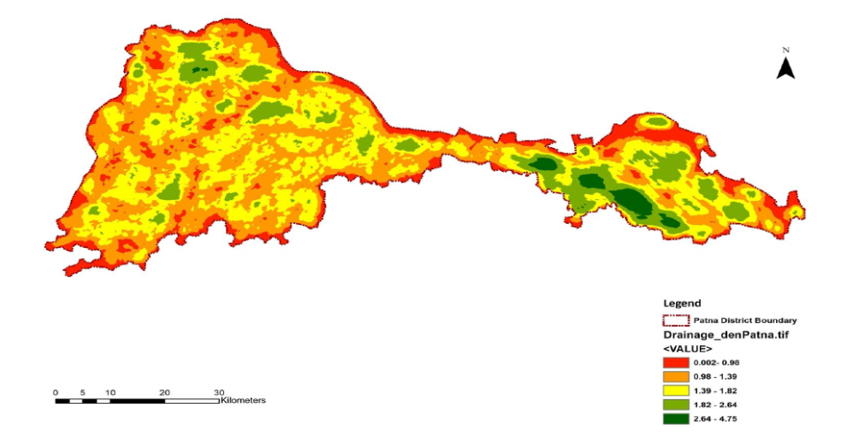
Fig.6: Drainage density map, Patna
Gaurav et al., "Delineation of Groundwater, Drought and Flood Potential Zone Using Weighted Index Overlay Analysis and GIS for District Patna, Bihar, India," Nature Environment and Pollution Technology, 2022,https://doi.org/10.46488/NEPT.2022.v21i02.046

4.3 Topographical and Hydrological Factors
The anthropogenic elements are the leading causes of modern floods; it is the natural landscape and hydrology of Patna that make it susceptible to flooding, an aspect that has been worsened by urbanization. The geographical location of Patna within the Indo-Gangetic Plain, at the southern edge of the Ganges River, is enough to place the city in a location where it is prone to experiencing floods. According to Gaurav et al., several factors, such as low elevations, high rainfall, and geomorphology, make floods happen; specifically, the flood susceptibility in the eastern region is higher, while it is lower or none in the western and central regions [18]. Using a weighted index map overlay technique, four flood susceptibility zones were created, namely no risk (2.89%), low risk (62.35%), moderate risk (31.16%), and high risk (3.60%).
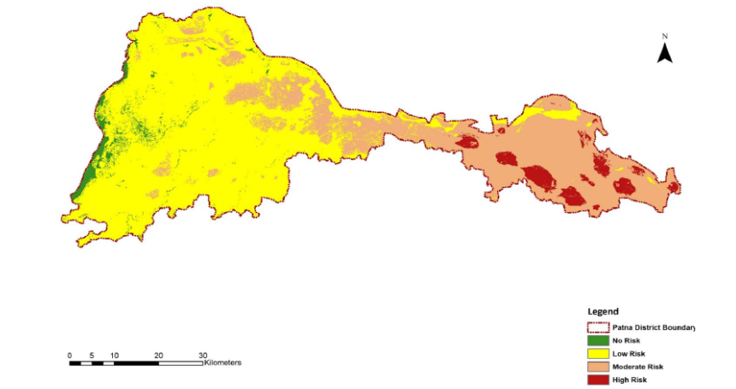
Fig.7: Flood potential zone map, Patna
Gaurav et al., "Delineation of Groundwater, Drought and Flood Potential Zone Using Weighted Index Overlay Analysis and GIS for District Patna, Bihar, India," Nature Environment and Pollution Technology, 2022,https://doi.org/10.46488/NEPT.2022.v21i02.046

According to Quadir et al., about 30% of Northern Patna undergoes floods every year, with at least one flood taking place annually [22]. This consistent occurrence is a result of the low-lying nature of the location and its proximity to the Ganges River and its tributaries. Since the floods take place every year, moderate rainfall may be sufficient to cause flooding in the region. According to Ranjan et al., the drainage system can be described as being choked, implying that the problem lies with both capacity and maintenance issues [8]. Inefficient drainage systems due to a lack of proper maintenance mean that even without the increased capacity caused by urbanization, there would be problems.

4.4 Institutional and Coordination Challenges
In addition to physical and environmental challenges, institutional weakness and failure to coordinate are other barriers that hinder flood management in Patna. Such governance-related issues tend to be harder to resolve than technological issues, but they are just as important as the former. There are many agencies involved in flood management in Patna, ranging from municipalities, disaster management authorities at the state level, and irrigation departments, among others. There is a deficiency of coordination mechanisms, which results in late response, inefficiency, and incomplete coverage when there is a flood incident.
Lack of monitoring and mapping capacities – According to Ahmed, continuous remote sensing, timely inundation mapping, and flash-flood monitoring are vital capacities that are lacking in Patna [16]. There are no real-time flood monitoring and early warning systems in place to give vulnerable people timely alerts.
to give vulnerable people timely alerts.
Infrastructural deficits – Infrastructure deficits, either as a cause of floods or hindering resilience, are mentioned in the literature on more than one occasion. Ojha argues that drainage infrastructure should be improved, flood-resistant construction should take place, and flood-prone areas should be mapped [4].
Lack of proper planning and regulatory enforcement – Ranjan et al. highlight illegal construction as another factor contributing to flood susceptibility, thereby implying the lack of proper enforcement of building codes and land use regulation [8]. There is a trend of development in areas like drainage corridors, wetlands, and other flood-prone areas despite the known hazards associated with such activities, which implies either the lack of an effective regulatory framework or poor enforcement of the already existing ones. As was highlighted by Sharma et al., there is a need for integrating flood risk and damages to urban development within the framework of urban planning in order to ensure proper physical planning of urban development, considering the expected level of damage [16].
Information and data management – The technical capabilities to monitor floods have increased; however, there is still no systematic approach to collecting, managing, and analyzing data to improve flood preparedness. The studies by Gaurav et al. and Sarkar et al. prove that GIS-based analysis of different datasets can be extremely valuable for decision-making, but there are no such approaches in practical work.

5. Global Best Practices: Lessons from Flood-Resilient Cities
Reviewing the case studies of resilient cities across the globe would serve as an invaluable source of inspiration while making decisions regarding adaptation in Patna. In this regard, this paper discusses strategies adopted by Rotterdam, Singapore, Tokyo, Copenhagen, and Wuhan cities.

5.1 Rotterdam, Netherlands: Adaptive Water Management
Rotterdam is known as an innovative city in terms of adaptive water management,
changing from a place that struggles with water to a city that works with water. Situated at a lower elevation than the sea-level position in the Rhine Meuse delta region, Rotterdam shares similar challenges related to flooding as Patna, but with much more resources.
Some resilient adaptation solutions include: In its strategy, Rotterdam focuses on providing
space for water and implementing blue-green infrastructures across the city. According to Vliet et al., Rotterdam is pursuing non-structural adaptive actions aimed at reducing the impacts of floods in unembanked regions through finding alternatives to raising all such areas to an extreme height of a once-in-4000-years event [23]. Currently implemented solutions make it possible to introduce some non-structural actions, including dry-proofing structures, yet enforcement can be quite difficult. Increased communication about the flood hazard can lead to improved implementation of adaptive measures.
Examples of innovative infrastructure technologies can be seen through the design of water plazas, which are areas that can retain water during rainfall while providing recreational opportunities during non-rainfall seasons. Penning-Rowsell et al. discuss how water plazas, underground water retention technologies, and green roof strategies have been implemented in Rotterdam through adaptive management and the protection norm principle [30]. An example is the Benthemplein water plaza, which is an area as large as a football field that retains water during rainy seasons and then slowly releases it into the ecosystem.
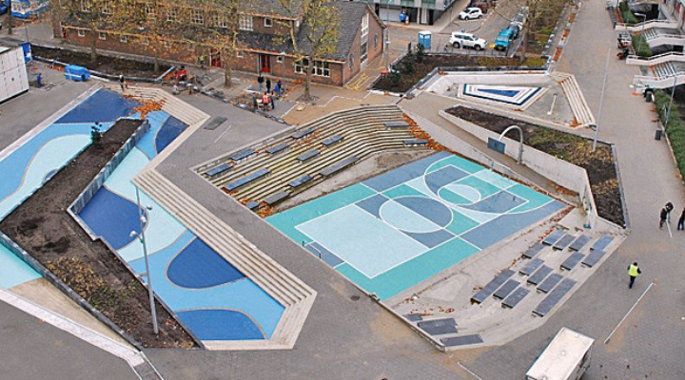
Fig.8: The Water Square, a large urban plaza designed to hold 1,700 m3 https://www.aquatechtrade.com/water-stories/urban-water/5-cities-leading-the-way-in-water-resilience
The combination of green roofs, which serve as insulators, act as absorbers of pollutants and CO2, and increase biodiversity, with blue roof systems, which collect water and control its flow, preventing flooding while at the same time regulating the urban climate, is referred to as the Blue-Green Roof design.
Another characteristic of Rotterdam's resilience strategy in water management is the use of floating infrastructure. As part of the water-oriented urban planning, Rotterdam has adopted several floating constructions, including the Floating Pavilion, which consists of recycled materials, provides its own energy, and heats up through solar power. In line with rising sea levels, cities along the coast should adapt rather than oppose water.
Governance and Implementation – One important factor that has contributed to the success of Rotterdam is proper governance, as well as collaboration within and outside of the city. The city entered into strategic partnerships with other cities and international organizations, such as the 100 Resilient Cities project and the EU, and received funds to implement innovative projects [23].
Application in Patna - There are various implications for Patna from the adaptive strategy of Rotterdam. The idea of developing infrastructure for multipurpose use – managing floods as well as other activities like recreational activities – can be useful in motivating investments in resource-constrained environments. Water plazas and blue-green roofs could be designed in line with the conditions prevailing in Patna. But the strategy employed by Rotterdam demands considerable investments upfront, good institutional capacity, and continued political commitment, all of which could be difficult in the case of Patna.

5.2 Singapore: ABC Waters Program
Singapore, the country, enjoys worldwide recognition due to its implementation of the ABC (Active, Beautiful, Clean) Waters initiative, whereby stormwater management and aesthetics of the urban environment go hand in hand. There are several similarities between Singapore's urban environment, characterized by high density, and that of India.
One key aspect of Singapore's approach to water management is that it entails planning and designing the system from scratch, rather than integrating the solution into an already built-up urban area. Thus, drains, canals, and reservoirs are turned into beautiful and clean rivers and streams, providing recreational areas for communities and contributing to the overall aesthetics of the environment.[23]
Relevance to Patna – There can be some learnings for Patna from the fact that Singapore has successfully combined stormwater management with the provision of urban amenities. Instead of focusing on drainage works for purely utilitarian purposes, Patna might also look into the possibilities of creating community amenities around drainage structures. Nonetheless, the implementation of the Singaporean example involves advanced levels of design and considerable expenditure. Yet, the lesson that proper water management has to start from the initial stages of urban planning is very relevant to Patna's development.

5.3 Tokyo, Japan: Underground Infrastructure
To mitigate problems caused by heavy rains and flooding in rivers, Tokyo has put in place a highly efficient underground flood management system. According to Su, Tokyo is characterized by a system of underground regulating reservoirs and a very large underground flood water discharge system [23]. One of the greatest underground flood water discharge facilities in the world is the Metropolitan Area Outer Underground Discharge Channel, referred to as G-Cans.
The system involves six and a half kilometers of underground tunnels and storage pools capable of storing up to 630,000 cubic meters of water. When there is excess rain in the area, the water is directed into underground pools through the tunnels. It has twin pools called Meguro Gawa and Edogawa with a storage capacity of about 500,000 cubic meters. In case of natural disasters, the network sends alerts for the gradual release of water.
Since its creation over two decades ago, the system has successfully protected the area against flooding over twelve times, protected thirty-two areas from sinking, and, according to the Tokyo Metropolitan Government, has also prevented fifty billion dollars worth of damage caused by the water. In addition, the system helps the environment by limiting heat islands and better management of rainwater; rainwater that can later be used for gardening or washing purposes.
Applicability to Patna – While Tokyo's extensive underground facilities represent a very expensive approach that uses a lot of technology that would probably be hard to implement in Patna, costing around twenty seven hundred million dollars, it is still the idea of water storage that is important here. Rather than creating a complex network of underground facilities, like in Tokyo, Patna should consider creating smaller underground facilities strategically placed around the city, or alternatively build above-ground retention and detention basins.

5.4 Wuhan, China: Sponge City Approach
Wuhan is one of the prime examples of China’s “sponge city” concept, which seeks to strengthen the resilience of cities against floods using nature-based approaches that mimic natural water management. Sponge cities are cities that have been designed to allow absorption of water and manage water through stormwater management systems [23].
Wuhan has initiated 389 separate sponge city projects covering 38.5 square kilometers of the city, including urban gardens, parks, and green spaces designed to allow water to infiltrate during regular precipitation and direct water away from urban areas during flooding. Other projects include artificial lakes that draw water away from populated areas and water channels that can safely handle large volumes of water during flooding.
The city's nature-based approach to resilience was more than $600 million cheaper than upgrading its drainage system through conventional means. Significant co-benefits include improved local air quality, biodiversity and conservation benefits, health and lifestyle benefits, and increased land value.
Srivastava et al. discuss the sponge city concept as an example of ecological resilience through nature-based solutions, emphasizing increased natural wetland storage capacity, green roofs for residential buildings, and Sustainable Urban Drainage Systems (SUDS) using infiltration basins and swales [21]. The approach represents a transition from engineering-based resistance (like dykes and flood walls) to ecological resilience that works with natural processes.
The following are key components that can be utilized for Patna:
1. Creation and restoration of urban wetlands and water bodies for flood storage.
2. Increasing permeability in parks, parking lots, and other suitable locations.
3. Use of green roofs and rain gardens in new development.
4. Design of streets and public space for temporary water retention.
5. Protection and improvement of existing natural drainage systems.
This focus on distributed nature-based solutions seems to fit perfectly with Patna’s
requirement of affordable methods that can be done in a piecemeal manner.

5.5 Synthesis: Common Principles and Transferable Lessons
The principles imply that for Patna, the way forward would include:
- Using nature-based interventions that offer multiple benefits and can be carried out progressively;
- Distributing efforts across the city rather than concentrating efforts in a few large-scale projects.
- Integrating flood mitigation strategies into the process of urban development and planning;
- Managing surface water as far as possible
- Enhancing governance structures and mechanisms.
Even though Patna may not be able to afford to emulate the elaborate systems of Tokyo and Singapore at a high cost, it is definitely possible to use similar principles for their benefit.

6. Conclusion
The analysis reveals that the root cause of Patna’s flood problem is the combination of fast
and frequently uncontrolled growth of the city, coupled with poor infrastructure development
and a lack of coordination between various stakeholders. The inability to coordinate the efforts of various stakeholders, poor monitoring capacity, lack of adequate early warning systems, poor enforcement of building regulations, and weak community participation are institutional barriers to efficient flood management.
The suggested strategy for addressing floods in Patna consists of three horizons of actions.
Short-term (0-2 years) activities include improved monitoring and early warning capacity,
improved drainage, institutional coordination, and community preparedness; the mentioned
actions can be achieved fairly soon through the available capabilities. Medium-term
Interventions (2-6 years) are aimed at solving underlying causes of vulnerability by means of
drainage improvements, nature-based solutions, catchment-level planning, and adaptive building codes. Long-term policy and governance reforms tackle institutional and regulatory challenges through integrated planning, strengthened capacity, sustained community engagement, innovative financing, and adaptive management.
The path forward for Patna is challenging but not insurmountable. However, with sustained commitment to the comprehensive strategy outlined in this paper, Patna can chart a different course—one that builds resilience, protects vulnerable populations, and creates a more livable, sustainable city. The choice between these futures rests with policymakers, urban planners, and citizens of Patna. The knowledge and tools exist; what remains is the collective will to act.

References
- Ojha, "Bihar urban flood 2019 and disaster management: A case study," Journal of Statistics and Management Systems, 2023, doi:10.47974/JSMS-1064
- Rashiq et al., "Urban floods: A case study of Patna floods 2019–Natural or anthropogenic?"doi:10.1007/978-3-031-21618-3_4
- "Impact of Climate Change and Land Use on Urban Flooding: Insights from Hydrological Modelling," 2024, doi:10.5281/zenodo. 13861697
- Abhinay et al., "Cause-Effect Time-Series Mapping of Urban Floods Using GIS for Patna, India," Advances in 21st century human settlements, 2024,https://doi.org/10.1007/978-981-97-8370-0_4
- Soudagar et al., "Quantifying Spatiotemporal Variability of Patna's 2023 Monsoon Flood Using Sentinel-1 SAR Data and Moran's Index," The international archives of the photogrammetry, remote sensing and spatial information sciences, 2025,https://doi.org/10.5194/isprs-archives-XLVIII-G-2025-1367-2025
- Kumari et al., "Localising vulnerability assessment to urban floods: A comparative analysis of top-down and bottom-up geospatial approaches in Patna City, India," International Journal of Disaster Risk Reduction, 2024,https://doi.org/10.1016/j.ijdrr.2023.104230
- Ranjan et al., "Impact of Land Use Changes on Urban Flooding in Patna City," 2023, https://doi.org/10.1007/978-981-99-1890-4_20
- Rashiq et al., "Urban floods: A case study of Patna floods 2019–Natural or anthropogenic?"DOI:10.1007/978-3-031-21618-3_4
- Dharmarathne et al., "Adapting Cities to the Surge: A Comprehensive Review of Climate-Induced Urban Flooding," Results in Engineering, 2024, doi:10.1016/j.rineng.2024.102123
- Sörensen et al., "Re-thinking urban flood management—time for a regime shift," Water, 2016, doi:10.3390/w8080332
- Ahmed, "Monitoring and mapping of flash flood of Patna city using Sentinel-1 images: a case of India's most flood-prone state."https://doi.org/10.20935/AL1349.
- Sarkar et al., "GIS-based frequency ratio and Shannon's entropy techniques for flood vulnerability assessment in Patna district, Central Bihar, India," International Journal of Environmental Science and Technology,2021,https://doi.org/10.1007/s13762-021-03627-1
- Gaurav et al., "Delineation of Groundwater, Drought and Flood Potential Zone Using Weighted Index Overlay Analysis and GIS for District Patna, Bihar, India," Nature Environment and Pollution Technology, 2022,https://doi.org/10.46488/NEPT.2022.v21i02.046
- Mishra et al., "Spatial monitoring of urban expansion using remote sensing and GIS: A case study of Patna Municipal Corporation."UGC Care Group I Journal ISSN: 0974-0066 Vol-83 No. 14, January – June: 2023
- "Assessment of Soil Moisture Variability for Urban Flood Risk Mitigation," 2025, doi: https://doi.org/10.5281/zenodo.15390324
- Sharma et al., "Development strategies for flood-prone areas, case study: Patna, India," Disaster Prevention and Management, 2001, doi:.http://dx.doi.org/10.2139/ssrn.4813165
- Vliet et al., "Adaptation to climate change in urban water management – flood management in the Rotterdam Rijnmond Area," 2015.DOI:10.1007/978-94-017-9801-3
- Dolman et al., "Achieving a Water-Resilient Rotterdam: Past, Present and Future Perspectives," 2024, doi:https://doi.org/10.58981/bluepapers.2024.1.13
- Penning-Rowsell et al., "The realities of managing uncertainties surrounding pluvial urban flood risk: an ex post analysis in three European cities," Journal of Flood Risk Management, 2019, https://doi.org/10.1111/jfr3.12467
- Shao et al., "Sponge City As A Civil Engineering Solution To Climate Change That Improves Urban Flood Resilience," 2022, doi: 10.1109/EHB55594.2022.9991281.
- Srivastava et al., "From Safety Against Floods to Safety at Floods*: Theory of Urban Resilience to Flood Adaptation and Synergy with Mitigation, "Anthropocene Science (2023) 2:190–196 https://doi.org/10.1007/s44177-023-00064-2
- Quadir et al., "River Health Monitoring and Mapping for Environmental Sustainability Using Geospatial Techniques: A Case of River Ganga in Patna," Environmental Science and Engineering, 2025, doi: https://doi.org/10.1007/978-3-031-82311-4_18
- Aquatech Europaplein 24, 1078 GZ Amsterdam, The Netherlands aquatech@rai.nl https://www.aquatechtrade.com/water-stories/urban-water/5-cities-leading-the-way-in-water-resilience#5-rotterdam-the-netherlands

