Synthesis and characterization of jatropha oil based epoxy resins and their composites with graphene oxide

ABSTRACT
In this present work we have studied the synthesis, characterization and properties of jatropha oil based epoxy resins and their nanocomposites with graphene oxide (GO). Nanocomposites with different wt% of GO (1, 2, and 3 wt%) were prepared by solution intercalation method. Citric acid (CA) was used as curing agent for the epoxy resins and acetone as the solvent. In all the cases, the ratio of the epoxy equivalent and carboxylic equivalent was taken as 1:1. The structural and performance characteristics of the prepared nanocomposites were investigated using Fourier transform infrared spectroscopy (FT-IR), thermogravimetric analysis (TGA), and universal testing machine (UTM). The chemical resistance of the nanocomposites were tested by monitoring the weight loss at a definite period of time. The results showed that the incorporation of GO significantly improved the performance characteristics of the jatropha oil based epoxy resins. It was observed that the nanocomposite with 3 wt% of GO showed best balance of thermal and mechanical properties. The gloss of cured films was measured by digital gloss meter and showed gratifying gloss.

Key words: jatropha oil, citric acid, graphene oxide, nanocomposite, tensile strength, thermal stability.

INTRODUCTION
To meet the ever increasing challenges incurred by immense technological progress, we need to replace the fossil resources by efficient renewable resources. This is the polymeric era and conventionally polymers are synthesized from fossil resources. Plant oil, which is one of the most efficient renewable resources, can be a potential alternative for fossil resources. A number of successful research activities in this regard are reported in recent past. Although, sunflower oil, soybean oil etc. are synthesized in epoxydized form; still its wide application in synthesizing polymer may affect the food industry. As such non edible oil is preferable resources for polymer synthesis. In this research work, jatropha oil is investigated as an efficient resource for polymer synthesis.
The double bond present in the vegetable oil can be functionalized according to the requirement. Different polymeric resin like epoxy, alkyd, urethane etc. can be obtained by modification of the vegetable oil. Among the various type of modification epoxidation is one of the most important chemical modification.¹Epoxy is most significantly used in our daily life like in coating, packaging, electrical equipment, adhesive etc. Due to this fact it is drawing significant attention of the scientific community in recent years.²The bio-based epoxy resin can form strong thermoset when cured by suitable curing agent like acid, amine, amide etc.³It was reported that the bio-based hardener like citric acid can also be used as curing agent for vegetable oil based epoxy resin.⁴
During recent years, many investigations are carried out globally in the field of bionanocomposites. Bionanocomposites are the material in which bio based polymer matrix is reinforced with certain organic or inorganic nano filler. It is getting wider applicability due to its biodegradability and biocompatibility in various applications like agricultural, drug release etc. The mechanical, thermal and the electrical properties of the bionanocomposites are being tailored efficiently by using nano fillers such as graphite, carbon nanotubes, fullerenes etc. Among the various nanomaterial, graphene is one of the most effective nano filler drawing notable attention of researchers in recent years.⁵
Graphene is a mono layer of sp² carbon atoms, first isolated in the year of 2014.^{6,7} It is the toughest material ever known. It has 130 GPa breaking strength and Young’s modulus is 1 TPa.⁷Graphene can be used in both thermosetting and thermoplastic polymer matrix as reinforcing agent in the similar way as the incorporation of other filler like carbon nano tube, clay etc.⁶
But there are some difficulties in the use of graphene as reinforcing filler due to the strong van der Wall forces between its layers. This makes graphene prone to aggregate.⁸To overcome this difficulties modification in graphene structure is required. The graphene oxide (GO) is the modified form of the graphene which is obtained by the oxidation of graphene. In the surface of GO, hydroxyl, carbonyl and the epoxy groups are present. These functional groups resist the aggregation of graphene layers and make it compatible to the polymer.
The functional groups present on the surface of the GO makes it easier to be dispersed in polar solvent as well as impart strong interaction with the polymer molecule to form GO- intercalated or exfoliated composites.
Several investigations on the improvement of thermal, electrical and chemical properties of GO/epoxy composite are reported in last few years. S.I. Abdullah et al. studied the improvement of mechanical properties of the epoxy resin by incorporation of GO in to it. It is reported that the impact and tensile strength of the composite gradually increases with increasing GO content but after addition of 6 wt% of GO the strength of the composite starts decreasing. So homogeneity of the filler in the composite is very important.⁹
Influenced by the above, we used jatropha oil based epoxy resin and GO for preparing epoxy/GO nanocomposite. In this research work we have used bio based epoxy as polymer matrix and GO as nano filler. Pristine thermoset of the epoxy resin are developed along with three other composite by using different amount of GO (1 wt%, 2 wt% and 3 wt%) cured by citric acid and acetone as solvent. The performance characteristics of the bionanocomposites like gloss, thermal stability, tensile strength, chemical resistance etc are investigated.

EXPERIMENTAL
Materials and methods
The seeds of jatropha were collected from the local area of Tezpur and the oil from the was extracted by solvent extraction method using acetone as solvent. The citric acid monohydrate (C₆H₈O₇·H₂O; ≥ 99.5%), hydrogen peroxide (H₂O₂), formic acid (HCOOH), sulphuric acid (H₂SO₄), and hydrochloric acid (HCl) were purchased from Merck, India. Graphite powder was purchased from Aldrich (particle size of 150 µm and purity of 99.9%). All other solvent and materials were of analytical grade and used without further purification.
Preparation of epoxidized jatropha oil
For preparing epoxidized jatropha oil first we take 100 gm of jatropha oil in a 500 ml rbf and 4.6 gm of formic acid was added into it. Formic acid was used as a catalyst. Raise the temperature of the mixture upto 65°C. Then, 115.6 gm of 30% H₂O₂ was added gradually in to the above mixture with the help of a dropping funnel and the stire the mixture vigorously using a mechanical stirrer. The complete addition of the H₂O₂ required 4h after complete addition of the hydrogen peroxide the mixture was kept at the same reaction condition for another 5 hrs. after completion of the reaction the mixture was cooled upto room temperature and washed with distilled water in a separating funel. Afterward it was wahed with sodium bicarbonate solution until attained the neutral point (pH 7). The oily phase was removed from the funnel and collected over anhydrous sodium sulphate. Pictorial representation of the epoxydation scheme is given in Fig. 1. The physicochemical properties of jatropha oil and the epoxidized oil are summarized in Table 1.
Fig. 1: Schematic for the epoxidation of the jatropha oil.
Table 1: Physicochemical properties of the epoxidized jatropha oil (EJO)
Sample | Acid value  (mg of KOH/g) | Iodine value  (g I₂/100g) | Epoxy equivalent weight (g/eq) | Viscosity at 25 ºC (Pa.s) | Average functionality
JO | 2.36 | 105 | --- | 0.548 | ---
EJO | 3.25 | 17 | 410 ± 5 | 0.612 | 3.18

Preparation of Graphene oxide (GO)
GO was prepared from the neutral graphite powder by modified Hummers method. In this method, first graphite (5gm) and NaNO₃ (2.5 gm) were taken in a 500 ml beaker containing 120 ml concentrated H₂SO₄. The mixture was stirred for 30 min with the help of a magnetic stirrer. 15 gm of KMnO₄ was then gradually added to the above mixture at a temperature below 20°C.¹⁰ Then the mixture was kept for 10 hrs under stirring condition at room temperature. 150ml of of distilled water was added to the above mixture after 12 hrs and kept it under same condition for another 20 hrs. A dark brown coloured suspension was obtained. After that we gradually add 30% H₂O₂ solution to the above mixture and after obtaining the yellow coloured suspension stop the further addition of the H₂O₂. Finally the suspended particles were washed with 5% HCl to remove excess Mn present in the mixture. Afterward, the mixture was washed with distilled water upto pH 7. Finally filter the mixture and the residue was dried in an oven.
Preparation of epoxy/GO bionanocomposite
The GO was first dispersed in 15ml of acetone by assisting ultrasonication. Then a concentrated solution of citric acid was prepared by mixing citric acid in acetone. The required amount of EJO was then added to the citric acid solution and after that the dispersed GO was added to the mixture and raised the temperature of the mixtures up to 90°C. The whole mixture was then kept under continuous stirring for 1 hour. In all the cases stoichiometric ratio of carboxylic acid equivalents and epoxy equivalent were taken as 1:1 for the completion of the reaction. The composition of the epoxy resin, GO and the curing agent are summarized in the Table 2.
Table 2: Composition of prepared nanocomposites
Sample code | EJO (g) | GO (g) | Citric acid (g)
PJO | 5 | 0 | 0.77
JGO1 | 5 | 0.05 | 0.77
JGO2 | 5 | 0.10 | 0.77
JGO3 | 5 | 0.15 | 0.77
*GO = graphene oxide. EJO = epoxidized jatropha oil. The number in the sample code denotes the wt% of GO in the nanocomposites.
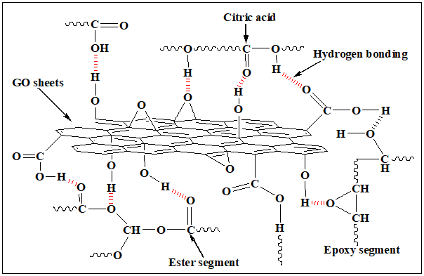
Scheme 1: Plausible interaction of GO with the polymer matrix.
CHARACTERIZATION
Fourier transform infrared spectroscopy (FT-IR)
To obtain the information about the structure of the prepared biocomposites, FT-IR was done at the frequency range 4000-400 cm⁻¹ at room temperature by using Nicolet, impact 410 FT-IR spectrophotometer.
Thermo gravimetric analysis (TGA)
The thermal stability of the biocomposites were determined by using Shimadzu TG 50 thermogravimetric analyser in the temperature range 30°-600°C with heating rate of 10°C/min under nitrogen atmosphere.
Scanning electron microscope (SEM)
The surface morphology and the composition was studied by using SEM (JSM-6390LV, JEOL, Japan) at accelerating voltage of 5-15 kV.
X-ray diffraction (XRD)
The crystalline structure of the bionanocomposites was studied by using a X-ray diffractometer (Miniflex, Rigaku Japan) with Cu Kα radiation (λ = 0.154 nm) at 30 kV and scanning rate of 0.005° s⁻¹ in a 2θ range of 10° to 70°.
Tensile strength
The tensile strength and the elongation at break of the prepared biocomposites were obtained by using universal testing machine (UTM, Zwick, Z010) at room temperature. The thickness and the width of the film were 0.5mm and 10mm respectively. The sample length was 4.5cm the cross head speed of the apparatus was 50mm/min.
Gloss
The surface smoothness was determined by using a digital gloss meter (S.C. Dey & Co) at an angle of incidence 60°.
Limiting oxygen index (LOI)
The flammability test of the composite was determined by using following equation
$$LOI=\frac{\left[O_{2}\right]}{\left[O_{2}\right]+\left[N_{2}\right]}×100$$
Chemical resistance
The chemical resistance test for the bionanocomposite films was performed to study the effect of chemicals like water, ethanol (25%, aq.), NaOH (2%, aq.), and HCl (10%, aq.). Small pieces of the bionanocomposite films were kept in 100 mL amber glass bottles containing the aforesaid medium at 30 °C. The percent weight loss of the samples was measured after three weeks of the test by following equation:
where, W_{o} and W_{t} are weight of the specimen at time, t = 0 and t = 15 days of the test respectively.
Results and discussions
The typical iodine value of jatropha oil, which indicates unsaturation or double bonds content, is about 105 g I₂/100 g. The decreasing of iodine value (17 g I₂/100 g) for the epoxydized jatropha oil indicates the breakdown of the double bond during epoxidation and the epoxy equivalent weight obtained is indicating the successful epoxidation of the oil. The iodine value and the epoxy equivalent weight (410 ± 5 g/eq) of the jatropha oil and EJO are given in the Table 1.
Rheological study of the biocomposites
It is observed that the viscosity of the biocomposites increases gradually with increasing GO concentration as shown in Table 3. The viscosity of the epoxidized oil is found to be 0.529 Pa.s and bionanocomposites with 1, 2, and 3 wt % GO is 4.67 Pa.s, 5.83 Pa.s , and 6.86 Pa.s respectively. The fact is that due to the incorporation of GO and strong interaction between the resins matrix and GO decreases the fluidity of the biocomposites and hence results in significant increase in the viscosity of the biocomposites with increased wt% of GO.

FT-IR study
The FT-IR spectrum of jatropha oil and the nanocomposites with different wt% of GO are shown in the Fig 1. In the FT-IR spectrum of jatropha oil (Supporting information), absorption bands near at 2925 and 2856 cm⁻¹ are assigned to the −CH symmetric and asymmetric stretching vibrations of −CH₂ groups, respectively. An intense peak at 1740 cm⁻¹ is due to the C=O stretching vibration. The peaks at 1466 and 718 cm⁻¹ are attributed to −CH₂ bending and rocking vibrations, respectively. The peak associated with C−O−C stretching vibration of ester group is observed at 1161 cm⁻¹. The disappearance of the peak at 1645 cm⁻¹ due to the alkene double bond and appearance of a new peak at 825 cm⁻¹ indicates the successful formation of epoxy group in EJO. During the epoxidation process, a side reaction such as oxirane ring opening may occur with water and/or acid leading to the formation of by-product hydroxyl group which is evident from the peak at 3478 cm⁻¹.⁴ The peak at 829 cm⁻¹ which was assigned to epoxy group disappeared in the FTIR spectrum of bionanocomposites and a new peak appeared at 1163 cm⁻¹ due to the formation of C−O−C (β-hydroxyester). This implies that complete reaction of epoxy ring has taken place in the formation of the bionanocomposites.
In the FT-IR spectrum of GO (Supporting information) the broad peak at 3410 cm⁻¹ and peak at 1627 cm⁻¹ can be attributed to -OH stretching and C=O stretching respectively. The presence such functionalities can facilitate the physical and chemical interactions with the polymer matrix. The peaks at 1175 and 1068 cm⁻¹ are assigned to ring stretching and the peak at about 718 cm⁻¹ is assigned to symmetric ring deformation of epoxy group present in the GO. As -OH stretching and C-OH stretching peaks are sensitive to hydrogen bond, shifting of peak at 3450 and 1740 cm⁻¹ to lower wave number in the bionanocomposites (Fig. 1) indicates the interactions of the GO nano-sheets with the polymer matrix through hydrogen bonding or other polar-polar interactions (Scheme 1). Another similar change in the FT-IR spectrum the bionanocomposite is also observed for the peak corresponding to the C-OH stretching at about 1163 cm⁻¹, indicating hydrogen bonding between the -OH groups in GO nano-sheets and the oxygenated groups in polymer matrix.^{12,13} Thus, the FT-IR study shows successful formation of the jatropha oil based epoxy resins and their nanocomposites with graphene oxide (GO).
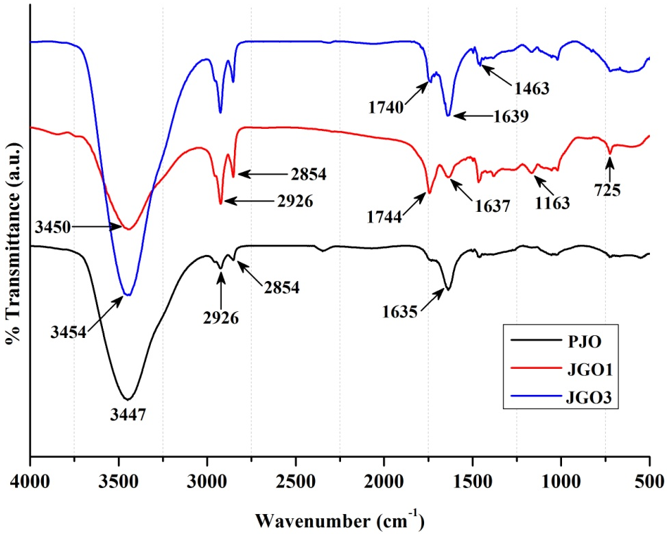
Fig. 1: FT-IR spectra of the nanocomposites with different wt% GO.
XRD study
The crystalline structure of the prepared bionanocomposites was studied by XRD and the diffraction patterns are shown in Fig. 2. The pristine polymer shows no diffraction peak in the 2Ө range from 15 to 25° indicating that the cured resin has no ordered structure but shows a weak and a broad diffraction peak at 40° indicating the amorphous nature of the cured resin. From the X ray diffraction patterns it is clear that the peak at 20.55° with 1 wt% GO loading is shifted to towards lower diffraction angle 19° with 3 wt% GO loading. This indicates that the layers in GO was delaminated during the mixing process by the polymer chains and forms an intercalated bionanocomposite structure.^{14,15}
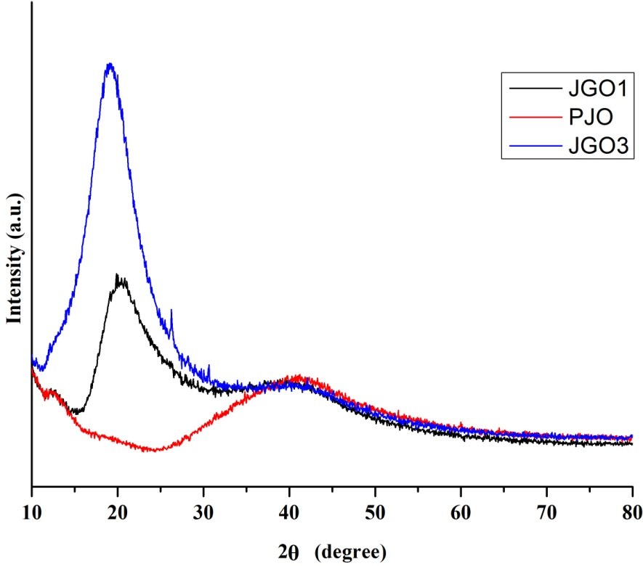
Fig. 2: XRD pattern of the nanocomposites with different wt% GO.
Surface morphology (SEM analysis)
The interfacial interactions between the resin matrix and GO nano-sheets are investigated by scanning electron microscope (SEM) study and the micrographs are shown in Fig. 3. The smooth surface morphology of the pristine polymer is characterized the SEM image Fig. 3a. However, the fracture surface morphology of the bionanocomposites after tensile testing is different from that of the polymer (Fig. 3b & c). Here the fact is that the surface morphology of the bionanocomposites is affected by the exfoliation of GO sheets.
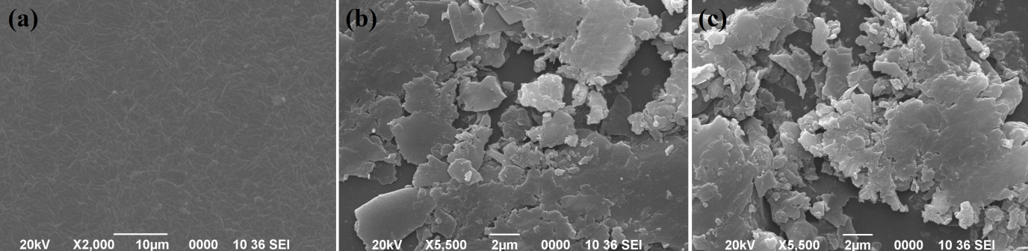
Fig. 3: SEM micrographs of the pristine polymer and the nanocomposites.
Performance characteristics of the nanocomposites
The curing characteristics of the bionanocomposites are summarized in Table 3. It is observed that the curing time decreases gradually with increasing wt% of GO. According to Arrhenius theory, the reaction rate constant depends on reaction temperature, collision frequency, and activation energy. In this study, the incorporation of GO into the polymer matrix is assumed to restrict the diffusion of reactive species for cross-linking due to filler-filler interactions within the GO sheets. This restriction increases the collision frequency of reactive species in the cross-linking system, leading to a reduced curing time.^{16,17} The increase in tensile strength of the bionanocomposites with GO content can be attributed to the increased cross-linking density of the polymer networks. In addition, the strong electrostatic and H-bonding interactions of the polar functional groups (like hydroxyl, epoxy, carbonyl, ether, etc.) of the polymer networks and GO sheets help to increase the rigidity of the cured films. As a result the overall performance, including the tensile strength, elongation at break, and hardness of the blend is increased.⁴
Table 3: Performance characteristics of the nanocomposites
Properties | GO content (wt %)
Properties | 0 | 1 | 2 | 3
curing time (min) |  | 90 | 80 | 65
scratch hardness (kg)* | - | 2.3 | 2.9 | 3.6
tensile strength (MPa) | - | 1.6 | 1.9 | 4.1
elongation at break (%) | - | 75 | 54 | 41
Viscosity (Pa.s) | 0.529 | 4.67 | 5.83 | 6.86
gloss | 65 | 80 | 85 | 92
LOI | 17 | 23 | 28 | 36
* Limit of the instrument for scratch hardness was 10.0 kg (highest). #Limit of the instrument for impact strength was 100 cm (highest).
Mechanical properties
The tensile strength and elongation at break of the prepared biocomposites are given in the Table 3. The stress-strain curve for the bionanocomposite films are shown in Fig. 4. The tensile strength of the biocomposites is significantly increased from the pristine form of the bio based epoxy resin. The tensile strength of the biocomposites containing 3 wt % of GO is more than 10 times of the pristine epoxy matrix. But the elongation at break is gradually decreased with increased GO content (Table 3). This increment in tensile strength indicates the homogeneous dispersion of GO and strong interaction between the epoxy matrix with the GO. The strong interaction between the epoxy matrix with the GO also facilitates the transfer of mechanical energy from the matrix to high strength filler increases significantly. The decrease in elongation at break with increased GO content can be ascribed to the high aspect ratio of GO nano sheets as well as strong interaction between the components of the composites which reduces the mobility of the polymer chain.¹⁸
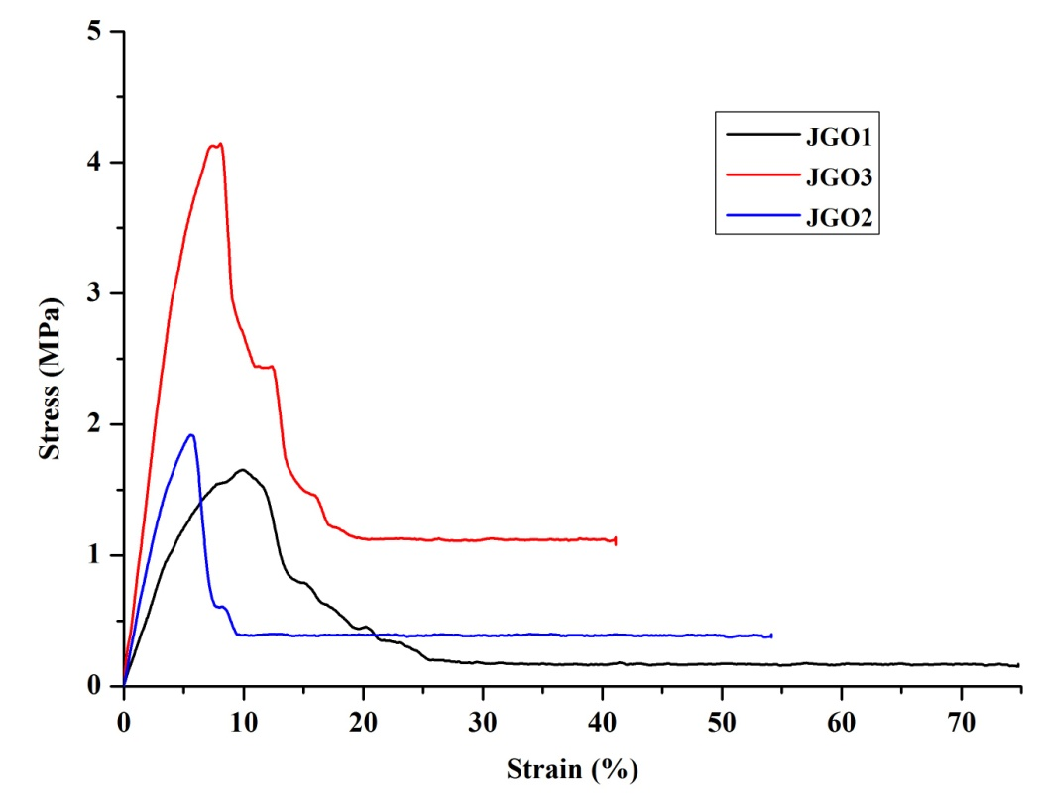
Fig. 4: Stress-strain curve for the nanocomposite films.
Thermogravimatric analysis
The thermal behaviour of the bionanocomposites was investigated by TGA analysis. The TGA thermogram of the biocomposites is shows in the Fig. 5 and the data are summarized in Table 4. The weight loss was recorded in the temperature range 30°-600°C. From the TGA thermograms it was observed that the incorporation GO significantly improved the thermal stability of the polymer and it increases linearly with increasing GO wt%. For instance, for the nanocomposites containing 1 and 3 weight percent GO, the major degradation step is shifted to a higher temperature by roughly 15 and 45°C, respectively. The thermal degradation of the bionanocomposites occurs in single step which is mainly due to the degradation of cross-linked polymer network. The improved thermal stability of the bionanocomposites may be due to the reduced mobility of the polymer chains in the bionanocomposite which confines the radical transfer chain reaction.¹⁹ In addition, the homogeneous dispersion and strong interfacial interaction between the exfoliated GO sheets and the polymer matrix resulted in the improved thermal stability of the nanocomposites. The addition of GO within the polymer matrix acts as a mass transport barrier to the volatile products generated during degradation process and improves the overall thermal stability of the bionanocomposites.¹⁸
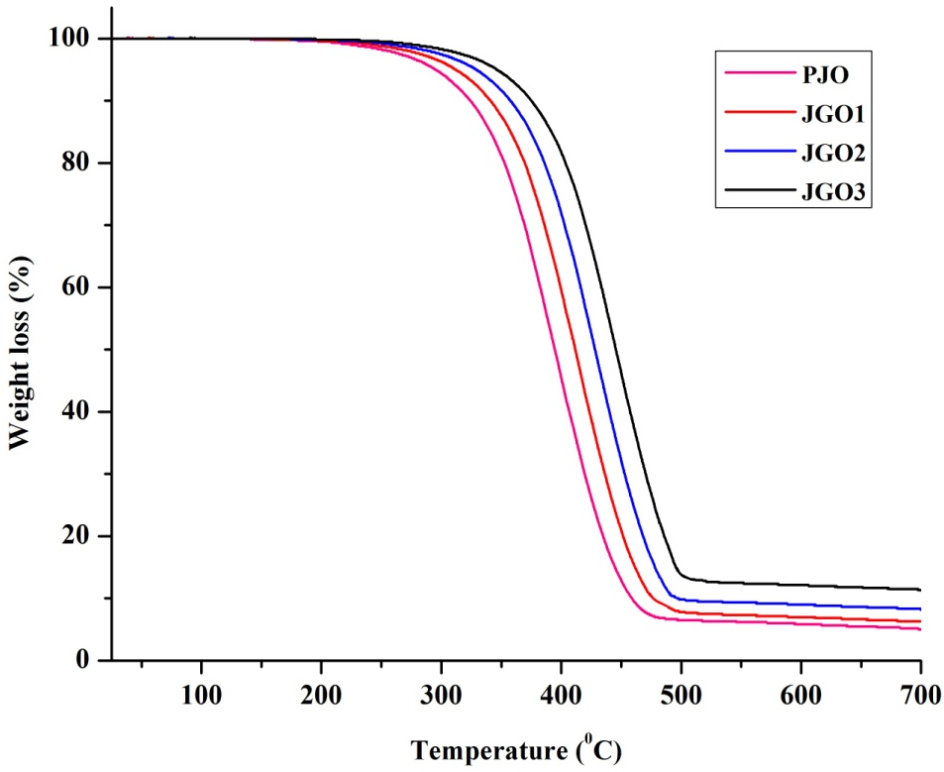
Fig. 5: TGA thermogram for the nanocomposite films.
Table 4: TGA data for the epoxy/GO nanocomposite films
Sample code | T_{i} (°C) | T_{m} (°C) | Weight loss (%) at temperature (°C) |  |  |  | Char (%) at 600 °C
Sample code | T_{i} (°C) | T_{m} (°C) | 200 | 300 | 400 | 500 | Char (%) at 600 °C
PJO | 279 | 330-500 | 1.66 | 8.5 | 54.67 | 93.5 | 5.18
JGO1 | 286 | 330-500 | 0.8 | 5.61 | 40.67 | 92.17 | 6.27
JGO2 | 298 | 330-500 | 0.82 | 2.59 | 28.17 | 90.17 | 8.35
JGO3 | 326 | 330-500 | 0.4 | 1.67 | 18.34 | 85.84 | 11.33
*T_{i} = initial degradation temperature. T_{m} = major degradation temperature.
Limiting Oxygen Index (LOI)
The flame retardant property of the prepared composites is listed in the Table 3. The LOI value of the biocomposites is significantly increased when nano filler is incorporated into the pristine polymer matrix. This may be due to the highly crosslink and compact structure of the GO loaded bionanocomposites. So it can be concluded that the GO is an efficient filler to increase flame retardant property of the jatropha oil based epoxy resin.

Chemical resistance
The chemical resistance test of the thermosets is carried out in water, NaOH(1%), HCl(10%), and ethanol(25%). The cured films have shown excellent solvent (water, ethanol) and acid resistance but its alkali resistance is poor. The chemical resistance of the films in different environment are listed in the Table 5.
Table 5: Percentage weight loss of the cured polymer in different chemical environment
Sample code | Water | HC l(10%) | Ethanol (25%) | NaOH (1%)
PJO | 0 | 0 | 0 | Peel off
JGO 1 | 0 | 0 | 0 | 43.84
JGO 2 | 0 | 0 | 0 | 24.56
JGO 3 | 0 | 0 | 0 | 20

The alkali resistance of the polymer is poor, may be due to the presence of hydrolysable ester linkage in the structure. However the composite showed better alkali resistance than the pristine form. This is due to the highly cross linked and rigid structure of the nanocomposite which is facilitated by the strong H-bonding interactions between the polymer matrix and exfoliated GO sheets.
Gloss
The gloss of the prepared biocomposites with different wt % of GO is shown in the Table 3. From the table it is observed that the gloss of the biocomposites films increases with increasing GO content. The gloss of the biocomposites films is due the smoothness of the surface and the good dimensional stability of the composite which shows good compatibility of the resin matrix with GO. The presence of polar functionalities like –OH, –COOH, –O–, –COOR, epoxy group etc. in the resin matrix as well as in the GO facilitates the strong interactions between them.
CONCLUSION
Epoxy resin was prepared from jatropha oil and used as resin matrix for the preparation of composite material. The solution intercalation method was able to prepare the GO based nanocomposite successfully. The use of bio-based epoxy hardener i.e., citric acid offers a number of advantages like environment friendly, low cost, catalyst free, easy processing to the prepared nanocomposites. It was observed that GO significantly improved the performance characteristics of the pristine polymer. The results obtained in this study showed that nanocomposite with 3 wt% of GO showed best balance of thermal and mechanical properties. From the various property analyses, it was observed that the prepared nanocomposites may find suitable applications in surface coating industry.

REFERENCES
- Gogoi, P. et al Industrial Crops and Products, 76 (2015) 346–354.
- Li, K.Y. Materials Chemistry and Physics 146 (2014) 354-362.
- Sharmina, E. et al. Industrial Crops and Products 76 (2015) 215–229.
- Gogoi, P. et al. ACS Sustainable Chemistry & Engineering, 2015, 3, 261−268.
- Wan, Y.J. et al. Carbon 69 ( 2014 ) 467 –480.
- Naebe, M et al. Scientific reports 4:4375 DOI: 10.1038/srep04375.
- Kausar,A et al, Polymer-Plastics Technology and Engineering, DOI:10.1080/03602559.2015.1098700.
- Tang, J et al. Journal of Nanomaterials, doi.org/10.1155/2014/696859.
- Abdullah, S.I. et al.doi.org/10.13140/2.1.1069.1848.
- Hummers, W.S. & Offeman, R.E. J. Am. Chem. Soc. 80 (1958), 1339-1339.
- Pavia, D.L., et al. Introduction to Spectroscopy, Harcourt College Publishers, Philadelphia, PA, 2001.
- Martini, D.S., et al. Polymer 50 (13) (2009) 2919−2925.
- Martini, D.S., et al. Polymer 50 (13), (2009) 2919−2925.
- Zhang, L., et al. Ind. Crop. Prod. 52, (2014) 380−388.
- Roudsari, G.M., et al. ACS Sustainable Chem. Eng. 2 (9), ((2014) 2111−2116.
- Wang, X., et al. Eur. Polym. J. 48 (6), (2012) 1034-1041.
- Sriloy, N., et al. Macromol. Res. 18 (4), (2010) 372-379.
- Gogoi, P., et al. Prog. Org. Coat. 77 (1), (2014) 87-93.
- Mbhele, Z.H., et al. Chem. Mater. 15 (26), (2003) 5019-5024.

Supporting information

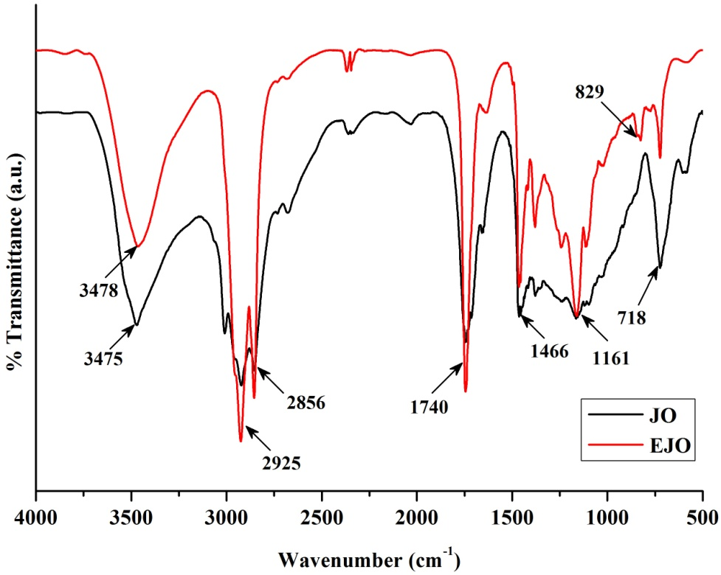
S1: FTIR spectra of jatropha oil (JO) and the epoxidized oil (EJO).

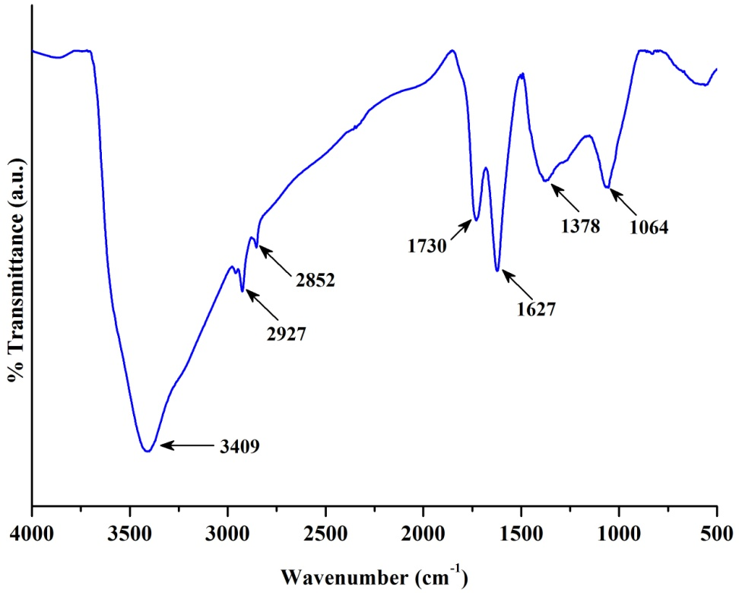
S2: FTIR spectra of graphene oxide (GO).
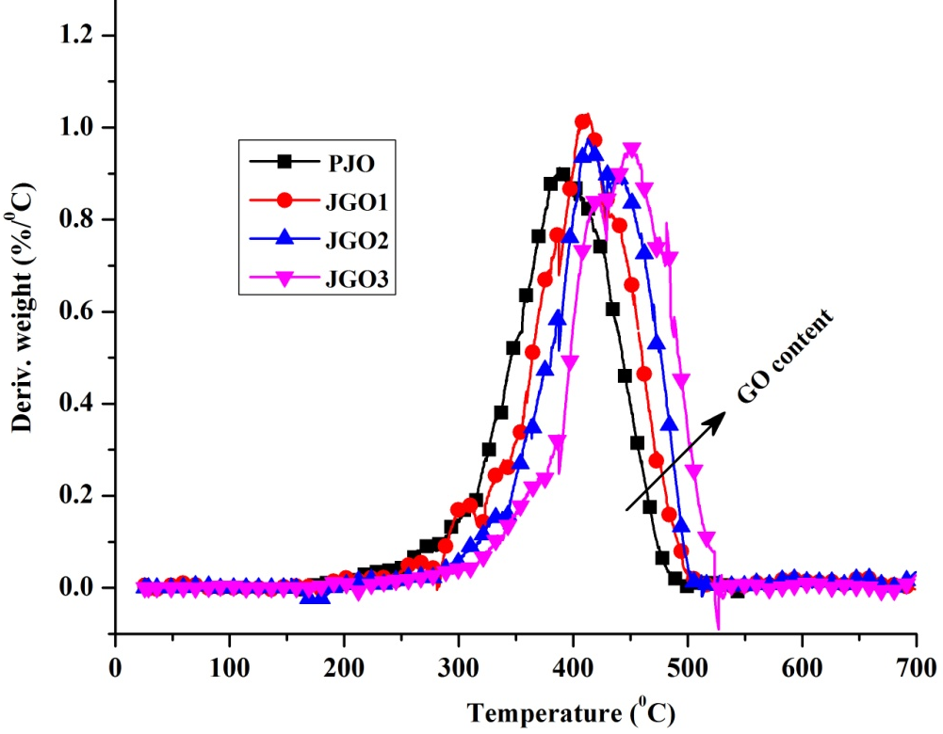
S3: DTG curve for the nanocomposites.

