ANTIMICROBIAL ACTIVITY OF INDIAN FINGER MILLET (Eleusine coracana) AND PEARL MILLET (Pennisetum glaucum): A COMPARATIVE STUDY
Anubha Pandey¹, Adarsh Lalit², Nikita Tomar² and C.B.S. Dangi¹
¹RKDF University, Bhopal
²Xcellventure Institute of Fundamental Research Pvt. Ltd. Bhopal
³SAM Global University, Raisen
Corresponding author: anubhashukl@gmail.com
ABSTRACT:
Millets are nutrient-rich cereals possessing several bioactive phytochemicals such as phenolic acids, flavonoids, tannins, and dietary fibers that contribute to their therapeutic potential. The present study evaluated the antimicrobial activity of Indian Finger Millet (Eleusine coracana) and Pearl Millet (Pennisetum glaucum) extracts against selected pathogenic bacteria including Escherichia coli (ATCC 25922), Staphylococcus aureus (ATCC 6538), Bacillus subtilis (ATCC 6633), and Pseudomonas aeruginosa (ATCC 27853) using the Kirby Bauer disc diffusion method according to CLSI guidelines. Methanolic extracts of millet samples were tested at different concentrations (25, 50, and 100 mg/mL), and antibacterial activity was expressed as percentage relative inhibition compared with streptomycin (10 µg/disc). Finger millet exhibited comparatively higher antimicrobial activity than pearl millet across all tested microorganisms. Maximum inhibition was observed against B. subtilis and S. aureus at 100 mg/mL concentration. The results indicate dose-dependent antimicrobial effects attributed to millet polyphenols and phytoconstituents. These findings support the use of millets as potential functional foods and natural antimicrobial agents.
KEYWORDS: Finger millet, Pearl millet, antimicrobial activity, polyphenols, disc diffusion assay, phytochemicals
INTRODUCTION:
Millets are among the oldest cultivated cereal grains and are recognized for their exceptional nutritional and therapeutic importance. Finger millet (Eleusine coracana) and pearl millet (Pennisetum glaucum) are extensively cultivated in Asia and Africa and serve as staple foods in semi-arid regions. Recent scientific interest has focused on the bioactive compounds present in millets, particularly phenolics, flavonoids, tannins, and dietary fibers, which exhibit antioxidant, antimicrobial, anti-inflammatory, antidiabetic, and anticancer properties.
Finger millet is rich in calcium, dietary fiber, and polyphenols that contribute to several health benefits including antimicrobial activity. Pearl millet similarly contains considerable levels of proteins, minerals, antioxidants, and phenolic compounds that may inhibit pathogenic microorganisms.
The increasing emergence of multidrug-resistant microorganisms has created a need for safer and natural antimicrobial agents. Plant-derived bioactive compounds are increasingly being investigated as alternative therapeutic agents due to their lower toxicity and wide spectrum of biological activities.
REVIEW OF LITERATURE:
Finger millet has gained recognition as a “superfood” because of its nutritional richness and biological activities. It contains phenolic acids, tannins, flavonoids, and dietary fibers that contribute to antioxidant and antimicrobial effects. Several studies have demonstrated that millet polyphenols possess antimicrobial activity against both Gram-positive and Gram-negative bacteria.
Bruntha Devi et al. (2014) reported that the seed coat polyphenols of finger millet possess significant antioxidant and antimicrobial activities. Chandra et al. (2016) described finger millet as a powerhouse of health-benefiting nutrients and highlighted its therapeutic applications. Singh et al. (2015) evaluated antimicrobial properties of finger millet and pearl millet extracts and demonstrated inhibitory effects against E. coli, S. aureus, Proteus mirabilis, and Pseudomonas aeruginosa.
Jayawardana et al. (2020) investigated methanolic and ethanolic extracts of finger millet varieties and found significant antibacterial activity against S. aureus and B. subtilis. Marmouzi et al. (2016) reported antibacterial activity of Moroccan pearl millet phenolic extracts against both Gram-positive and Gram-negative bacteria.

MATERIALS AND METHODS:
Sample Collection: Finger millet and pearl millet samples were procured from local markets and cleaned to remove impurities.
Antimicrobial Activity Studies: Antibacterial activity was evaluated against Escherichia coli (ATCC 25922), Staphylococcus aureus (ATCC 6538), Bacillus subtilis (ATCC 6633), and Pseudomonas aeruginosa (ATCC 27853) using CLSI guidelines and the Kirby Bauer disc diffusion method.
Sample Extraction: Ten grams of powdered millet sample was extracted with 100 mL of 80% methanol. The extract was filtered and concentrated using a rotary evaporator at 40°C. Dried extracts were stored at 4°C until analysis.
Preparation of Inoculum: Bacterial suspensions were prepared in sterile saline (0.85% NaCl) and standardized before use.
Preparation of Mueller Hinton Agar: Mueller Hinton Agar was prepared according to standard composition and sterilized at 121°C for 15 minutes.
Plating MHA plates were inoculated uniformly with bacterial suspensions using sterile swabs.
Disc Preparation and Controls: Sterile 6 mm paper discs were impregnated with extract concentrations corresponding to 25, 50, and 100 µg/disc. Streptomycin (10 µg/disc) served as positive control.
Incubation : Plates were incubated at 35 ± 2°C for 16–18 hours.
Observation and Calculation: Zones of inhibition were measured in millimeters. Activity index and relative inhibition percentages were calculated.

RESULTS:
The Antimicrobial activity of Indian Finger Millet and Indian Pearl Millet aqueous extracts were evaluated across ten cultivars of each against Escherichia coli, Staphylococcus aureus, Bacillus subtilis and Pseudomonas aeruginosa with reference to Streptomycin (10 µg/mL) standard drug.
ANTIMICROBIAL ACTIVITY OF INDIAN FINGER MILLET
Streptomycin (10 µg/mL) was considered as 100% inhibition for each test organism, and the zones of inhibition produced by Indian Finger Millet (Eleusine coracana) aqueous extracts at 25, 50, and 100 mg/mL were calculated as relative percentages. Images are shown in figure 1.
At 25 mg/ml concentration:
At the lowest concentration (25 mg/mL), all finger millet cultivars exhibited modest antibacterial activity compared with Streptomycin (10 µg/mL, 100%) are presented in table 1 and graph 1. Table 1 Percentage Zone of Inhibition of 25 mg/mL Indian Finger Millet (Eleusine coracana) Aqueous Extracts Compared with Streptomycin (10 µg/mL)
Percentage zone of inhibition exhibited by 25mg/mL of Indian Finger Millet
Cultivar Name | Escherichia coli | Staphylococcus aureus | Bacillus subtilis | Pseudomonas aeruginosa
GPU 28 | 18.50 ± 1.94 | 25.20 ± 2.32 | 22.30 ± 2.31 | 23.20 ± 2.01
GPU 48 | 17.75 ± 1.19 | 22.41 ± 0.93 | 20.36 ± 0.37 | 22.10 ± 0.91
HR 911 | 17.24 ± 0.68 | 23.25 ± 1.77 | 21.54 ± 1.55 | 22.01 ± 0.82
PRM 1 | 18.25 ± 1.69 | 24.50 ± 1.48 | 23.21 ± 2.22 | 23.51 ± 2.32
Local (BH) | 22.56 ± 6.00 | 27.68 ± 4.66 | 25.41 ± 5.42 | 25.68 ± 5.49
Indaf-9 | 19.30 ± 2.74 | 24.21 ± 1.19 | 19.52 ± 1.47 | 21.45 ± 0.74
RAU-8 | 15.24 ± 1.32 | 20.21 ± 2.81 | 17.24 ± 2.81 | 20.35 ± 1.36
PR-202 | 16.84 ± 1.72 | 21.36 ± 1.66 | 18.52 ± 1.53 | 19.56 ± 1.43
VL-315 | 19.40 ± 2.84 | 22.12 ± 0.88 | 20.65 ± 2.06 | 20.32 ± 0.33
GPU-66 | 18.62 ± 2.06 | 21.24 ± 1.00 | 19.54 ± 1.95 | 19.24 ± 1.75
The most responsive cultivar was Local-BH, which consistently showed the highest inhibition across all microbes, ranging from 22.56% against E. coli to 27.68% against S. aureus. GPU-28 and PRM-1 also demonstrated appreciable activity, maintaining values above 18 - 25% depending on the microbe. In contrast, RAU-8 and PR-202 consistently produced the lowest inhibition, with 15 - 20% against E. coli and S. aureus. Overall, the inhibition trend at this concentration revealed Local-BH > GPU-28/PRM-1 > moderate cultivars (GPU-48, HR-911, Indaf-9, VL-315, GPU-66) > RAU-8/PR-202.
Graph 1 Percentage Zone of Inhibition of 25 mg/mL Indian Finger Millet (Eleusine coracana) Aqueous Extracts Compared with Streptomycin (10 µg/mL)

At 50 mg/ml concentration:
At the median concentration (50 mg/mL), all finger millet cultivars exhibited modest antibacterial activity compared with Streptomycin (10 µg/mL, 100%) are presented in table 2 and graph 2. Local-BH continued to lead, achieving values above 40% inhibition against S. aureus and P. aeruginosa, while GPU-28, PRM-1, and Indaf-9 also crossed the 35% mark in several cases. The mid-range cultivars such as GPU-48, HR-911, and VL-315 showed moderate improvements, generally falling between 30 - 36% inhibition across microbes. PR-202 and RAU-8.

Table 2 Percentage Zone of Inhibition of 25 mg/mL Indian Finger Millet (Eleusine coracana) Aqueous Extracts Compared with Streptomycin (10 µg/mL)
Percentage zone of inhibition exhibited by 50mg/mL of Indian Finger Millet
Cultivar Name | Escherichia coli | Staphylococcus aureus | Bacillus subtilis | Pseudomonas aeruginosa
GPU 28 | 31.23 ± 3.56 | 51.15 ± 2.56 | 49.65 ± 2.41 | 41.23 ± 2.17
GPU 48 | 27.22 ± 0.45 | 50.24 ± 1.65 | 52.36 ± 0.30 | 43.26 ± 0.14
HR 911 | 28.02 ± 1.25 | 53.35 ± 2.76 | 51.45 ± 0.39 | 42.54 ± 1.44
PRM 1 | 29.54 ± 2.77 | 55.23 ± 4.64 | 54.59 ± 3.53 | 44.32 ± 3.22
Local (BH) | 34.51 ± 7.74 | 56.21 ± 5.62 | 56.54 ± 5.48 | 46.21 ± 5.11
Indaf-9 | 30.10 ± 2.33 | 51.24 ± 2.56 | 51.24 ± 0.18 | 42.15 ± 1.05
RAU-8 | 24.61 ± 3.16 | 48.62 ± 0.94 | 49.65 ± 0.18 | 40.25 ± 0.79
PR-202 | 25.41 ± 2.36 | 49.54 ± 1.94 | 48.65 ± 1.00 | 39.65 ± 0.19
VL-315 | 27.65 ± 0.88 | 51.28 ± 2.60 | 51.25 ± 0.19 | 41.35 ± 0.89
GPU-66 | 26.35 ± 0.42 | 50.26 ± 1.58 | 50.42 ± 0.77 | 42.24 ± 1.78

Graph 2 Percentage Zone of Inhibition of 25 mg/mL Indian Finger Millet (Eleusine coracana) Aqueous Extracts Compared with Streptomycin (10 µg/mL)

At 100 mg/ml concentration:
At the higest concentration (100 mg/mL), all finger millet cultivars exhibited modest antibacterial activity compared with Streptomycin (10 µg/mL, 100%) are presented in table 3 and graph 3. At this tested concentration, all cultivars exhibited strong antibacterial activity, with inhibition percentages approaching 60 - 70% of Streptomycin in the best cases. Local-BH again demonstrated the strongest response, reaching nearly 68% inhibition against S. aureus and P. aeruginosa. GPU-28, PRM-1, and Indaf-9 consistently followed, often exceeding 55 - 65% inhibition depending on the microbe. HR-911, GPU-48, and VL-315 clustered slightly lower but still exhibited substantial activity. The weakest cultivars, PR-202 and RAU-8, finally showed respectable values, although they remained below 50% against most microbes.
Table 3 Percentage Zone of Inhibition of 100 mg/mL Indian Finger Millet (Eleusine coracana) Aqueous Extracts Compared with Streptomycin (10 µg/mL)
Percentage zone of inhibition exhibited by 100mg/mL of Indian Finger Millet
Cultivar Name | Escherichia coli | Staphylococcus aureus | Bacillus subtilis | Pseudomonas aeruginosa
GPU 28 | 54.20 ± 2.62 | 69.24 ± 2.90 | 70.20 ± 2.29 | 60.10 ± 4.04
GPU 48 | 52.64 ± 1.82 | 68.65 ± 2.31 | 71.51 ± 1.60 | 61.26 ± 1.20
HR 911 | 53.21 ± 2.39 | 70.24 ± 3.90 | 72.68 ± 2.77 | 62.35 ± 2.29
PRM 1 | 55.21 ± 4.39 | 72.51 ± 5.17 | 73.85 ± 3.94 | 65.45 ± 4.39
Local (BH) | 57.24 ± 6.42 | 71.26 ± 3.92 | 75.84 ± 6.93 | 67.85 ± 7.79
Indaf-9 | 51.24 ± 1.66 | 66.54 ± 1.20 | 71.24 ± 2.33 | 66.34 ± 6.28
RAU-8 | 50.32 ± 1.54 | 62.35 ± 2.99 | 69.54 ± 1.63 | 62.41 ± 2.35
PR-202 | 49.10 ± 2.48 | 65.24 ± 1.00 | 68.41 ± 0.50 | 60.25 ± 1.60
VL-315 | 50.12 ± 1.74 | 68.56 ± 2.22 | 69.34 ± 1.43 | 53.21 ± 2.86
GPU-66 | 52.32 ± 1.74 | 67.95 ± 1.61 | 68.15 ± 0.24 | 61.25 ± 1.58

Graph 3 Percentage Zone of Inhibition of 100 mg/mL Indian Finger Millet (Eleusine coracana) Aqueous Extracts Compared with Streptomycin (10 µg/mL)

Figure 1: Antimicrobial test images
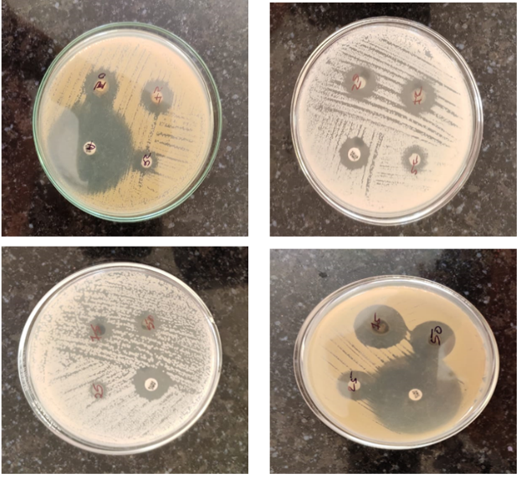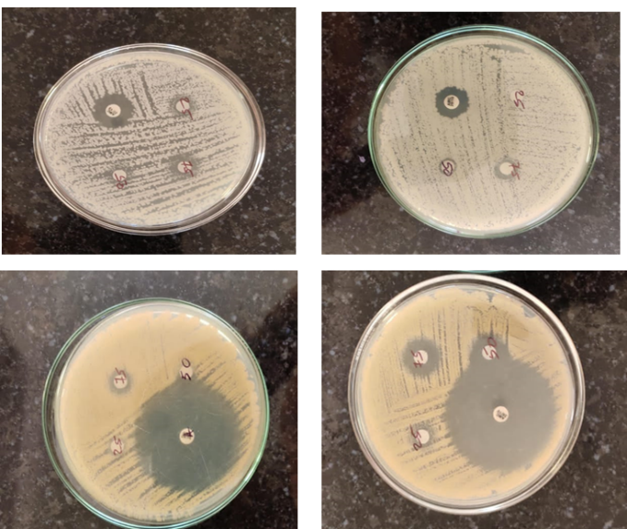

ANTIMICROBIAL ACTIVITY STUDIES OF INDIAN PEARL MILLET
Streptomycin (10 µg/mL) was considered as 100% inhibition for each test organism, and the zones of inhibition produced by Indian Pearl Millet (Eleusine coracana) aqueous extracts at 25, 50, and 100 mg/mL were calculated as relative percentages. Images are shown in figure 2.
At 25 mg/mL concentration
At the lowest concentration, the aqueous extract of Pearl Millet cultivars showed mild antibacterial activity presented in table 4 and graph 4.
Table 4 % Zone of Inhibition of 25 mg/mL of Indian Pearl Millet Aqueous Extracts Compared with Streptomycin (10 µg/mL)
Percentage zone of inhibition exhibited by 25mg/mL concentration
Cultivar Name | Escherichia coli | Staphylococcus aureus | Bacillus subtilis | Pseudomonas aeruginosa
MPMH 21 | 14.94 ± 2.03 | 23.69 ± 2.08 | 18.10 ± 2.63 | 22.39 ± 1.55
Giant Bajra | 14.62 ± 2.35 | 18.25 ± 3.36 | 16.73 ± 1.37 | 22.38 ± 1.56
Proagro - 1(FMH-3) | 15.51 ± 1.46 | 20.60 ± 1.01 | 17.70 ± 2.00 | 23.60 ± 2.78
Local (BH) | 15.27 ± 1.70 | 23.54 ± 1.93 | 25.41 ± 9.71 | 23.51 ± 3.69
Local (MP) | 19.17 ± 2.20 | 22.81 ± 1.66 | 20.95 ± 5.25 | 26.70 ± 6.88
ICMH-356 | 21.16 ± 4.19 | 23.73 ± 2.58 | 16.28 ± 4.42 | 21.37 ± 1.45
Pioneer 86M86 | 12.84 ± 4.13 | 22.58 ± 1.73 | 15.30 ± 6.00 | 22.46 ± 1.64
MP-7792 | 14.16 ± 2.81 | 22.00 ± 0.31 | 15.93 ± 5.37 | 19.41 ± 1.41
MP-7872 | 16.58 ± 0.39 | 20.03 ± 2.28 | 19.61 ± 1.69 | 22.37 ± 1.46
Raj-171 | 18.86 ± 2.67 | 18.83 ± 3.48 | 18.93 ± 1.01 | 21.53 ± 1.30
The Local-BH cultivar was the most responsive against P. aeruginosa (26.70%) and also performed well against E. coli (19.17%). Indaf-9 showed the highest inhibition against E. coli (21.16%), while PRM-1 recorded a relatively strong effect on B. subtilis (25.41%). Other cultivars such as GPU-28, HR-911, and VL-315 displayed moderate inhibition in the range of 15 - 20% across microbes. The weakest activity was generally observed in RAU-8 and PR-202, especially against E. coli (12.84% and 14.16%, respectively) and B. subtilis (15.30% and 15.93%).
Graph 4 % Zone of Inhibition of 25 mg/mL of Indian Pearl Millet Aqueous Extracts Compared with Streptomycin (10 µg/mL)

At 50 mg/mL concentration
With the increase to 50 mg/mL, inhibition values improved notably across all pathogens, confirming dose dependency presented in table 5 and graph 5. Local-BH stood out against B. subtilis with 62.96% inhibition, while HR-911 was particularly effective against S. aureus (51.09%). GPU-28 also showed strong inhibition, especially for B. subtilis (53.49%), and GPU-66 displayed considerable inhibition against S. aureus (55.35%). Mid-range cultivars like GPU-48, PRM-1, and VL-315 remained consistent with moderate values between 40 - 50% across microbes. RAU-8 showed the least inhibition against P. aeruginosa (32.59%), highlighting weaker performance at this dose.

Table 5. % Zone of Inhibition of 50 mg/mL of Indian Pearl Millet Aqueous Extracts Compared with Streptomycin (10 µg/mL)
Percentage zone of inhibition exhibited by 50mg/mL concentration
Cultivar Name | Escherichia coli | Staphylococcus aureus | Bacillus subtilis | Pseudomonas aeruginosa
MPMH 21 | 32.04 ± 5.81 | 41.89 ± 4.48 | 53.49 ± 6.00 | 42.33 ± 3.63
Giant Bajra | 22.65 ± 3.58 | 43.26 ± 2.89 | 48.91 ± 1.42 | 41.86 ± 3.10
Proagro 1 (FMH-3) | 29.56 ± 0.67 | 51.09 ± 4.94 | 42.67 ± 4.82 | 44.87 ± 6.11
Local (BH) | 27.62 ± 1.27 | 47.01 ± 0.02 | 46.42 ± 0.07 | 46.80 ± 8.04
Local (MP) | 28.72 ± 2.37 | 49.57 ± 2.58 | 62.96 ± 16.61 | 48.50 ± 9.74
ICMH-356 | 28.28 ± 2.81 | 48.19 ± 1.96 | 41.89 ± 4.46 | 38.17 ± 0.59
Pioneer 86M86 | 25.49 ± 0.98 | 49.69 ± 2.46 | 45.24 ± 0.89 | 32.59 ± 4.94
MP-7792 | 22.46 ± 2.05 | 40.60 ± 6.63 | 39.86 ± 4.49 | 44.06 ± 6.41
MP-7872 | 23.55 ± 0.96 | 46.88 ± 0.35 | 43.71 ± 0.64 | 42.13 ± 4.34
Raj-171 | 27.82 ± 2.31 | 55.35 ± 7.82 | 52.92 ± 9.85 | 36.26 ± 1.53
Graph 5 % Zone of Inhibition of 50 mg/mL of Indian Pearl Millet Aqueous Extracts Compared with Streptomycin (10 µg/mL)

At 100 mg/mL concentration
At the highest concentration, extracts from all cultivars exhibited strong antibacterial activity presented in table 6 and graph 6, with several exceeding 70% relative inhibition. HR-911 was especially potent against S. aureus (73.75%) and B. subtilis (72.54%). Local-BH also maintained high activity across microbes, peaking at 73.61% for S. aureus. Indaf-9 (71.10%) and VL-315 (70.89%) also displayed strong inhibition against S. aureus, confirming its high sensitivity. GPU-28 excelled against B. subtilis (75.16%), making it the top performer for this microbe. While most cultivars performed above 55%, VL-315 recorded slightly lower inhibition against E. coli (40.79%), showing variability across species.
Table 6 % Zone of Inhibition of 100 mg/mL of Indian Pearl Millet Aqueous Extracts Compared with Streptomycin (10 µg/mL)
Percentage zone of inhibition exhibited by 100mg/mL concentration
Cultivar Name | Escherichia coli | Staphylococcus aureus | Bacillus subtilis | Pseudomonas aeruginosa
MPMH 21 | 47.26 ± 2.27 | 60.72 ± 4.63 | 75.16 ± 6.56 | 56.75 ± 4.76
Giant Bajra | 49.16 ± 0.37 | 55.88 ± 0.21 | 62.22 ± 6.38 | 60.14 ± 7.15
Proagro - 1 (FMH-3) | 46.72 ± 2.07 | 73.75 ± 6.08 | 72.54 ± 10.70 | 57.71 ± 5.58
Local (BH) | 48.11 ± 0.54 | 61.02 ± 6.65 | 73.63 ± 11.79 | 52.86 ± 0.73
Local (MP) | 49.79 ± 2.22 | 73.61 ± 6.61 | 61.35 ± 0.49 | 65.69 ± 12.83
ICMH-356 | 46.95 ± 2.84 | 71.10 ± 4.10 | 62.83 ± 1.99 | 69.66 ± 16.80
Pioneer 86M86 | 46.65 ± 3.14 | 68.92 ± 1.92 | 57.48 ± 3.36 | 55.64 ± 2.22
MP-7792 | 44.58 ± 5.21 | 72.54 ± 5.54 | 58.29 ± 1.83 | 56.69 ± 3.17
MP-7872 | 40.79 ± 9.00 | 70.89 ± 3.89 | 71.23 ± 10.11 | 49.90 ± 3.62
Raj-171 | 45.20 ± 4.59 | 62.52 ± 4.48 | 64.24 ± 5.10 | 67.66 ± 15.38

Graph 6 % Zone of Inhibition of 100 mg/mL of Indian Pearl Millet Aqueous Extracts Compared with Streptomycin (10 µg/mL)

Figure 2: Antimicrobial studies
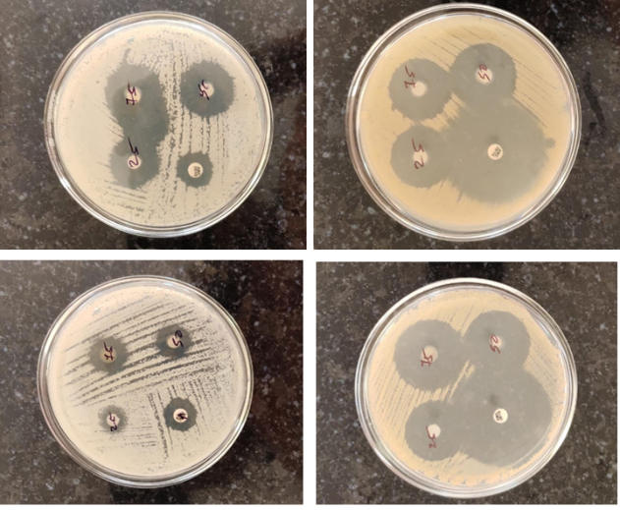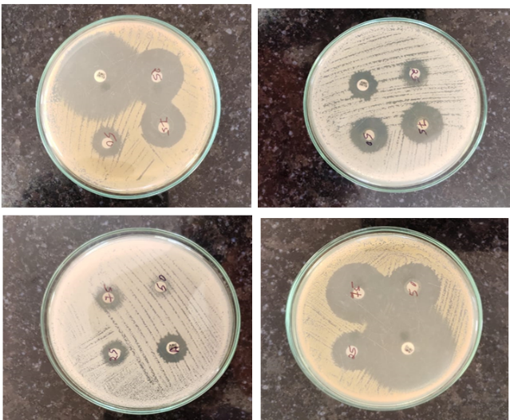
Discussion:
The antibacterial activity of Indian Finger Millet and Indian Pearl Millet aqueous extracts was evaluated against four test organisms, with streptomycin (10 µg/mL) considered as the reference standard (100% inhibition).
Indian Finger Millet (Eleusine coracana) Aqueous Extracts
Activity against Escherichia coli: The results revealed that the inhibitory potential of the extracts was concentration-dependent, with higher activity observed at 100 mg/mL compared to 25 mg/mL across all cultivars tested. The cultivar Local (BH) exhibited the highest zone of inhibition against Bacillus subtilis (75.84 ± 6.93% at 100 mg/mL), while PR-202 showed the lowest activity against Escherichia coli (49.10 ± 2.48% at 100 mg/mL). Similar variability among cultivars has been reported in previous studies, indicating that phytochemical composition plays a significant role in antimicrobial efficacy (Banerjee et al., 2012).
Against E. coli: Inhibition ranged from 49.10 ± 2.48% (PR-202) to 57.24 ± 6.42% (Local BH) at 100 mg/mL. These findings are consistent with reports by Ogbeba et al. (2019), who demonstrated measurable antibacterial activity of finger millet extracts against E. coli, though weaker than standard antibiotics. The relatively modest inhibition of E. coli compared to other organisms could be attributed to the robust outer membrane of Gram-negative bacteria, which acts as a barrier against hydrophilic compounds present in aqueous extracts (Ojewole et al., 2018).
Activity against Staphylococcus aureus: The extracts exhibited strong activity, with maximum inhibition observed for PRM 1 (72.51 ± 5.17%) and Local (BH) (71.26 ± 3.92%) at 100 mg/mL. The effectiveness of millet phenolic compounds against Gram-positive bacteria has been well documented. Jayawardana et al. (2020) reported that methanolic extracts of Sri Lankan finger millet cultivars inhibited S. aureus with MIC values of 2.1 mg/mL, confirming the role of polyphenols, tannins, and flavonoids in disrupting bacterial cell walls and membranes.
Activity against Bacillus subtilis: Inhibition zones were notably higher compared to E. coli, with values ranging from 68.15 ± 0.24% (GPU-66) to 75.84 ± 6.93% (Local BH) at 100 mg/mL. Similar observations were made by Ojewole et al. (2018), who demonstrated that fermented millet extracts achieved 11 - 12 mm zones against B. subtilis. This higher susceptibility may be due to the absence of an outer membrane in Gram-positive bacteria, facilitating the action of phenolic compounds (Banerjee et al., 2012).
Against Pseudomonas aeruginosa: Ranging from 53.21 ± 2.86% (VL-315) to 67.85 ± 7.79% (Local BH) at 100 mg/mL. Although P. aeruginosa is intrinsically resistant to many plant-derived
antimicrobials, the inhibition observed here corroborates the findings of Ogbeba et al. (2019), who noted activity of finger millet extracts against this pathogen. The polyphenolic content of millet seed coats, particularly quercetin and ferulic acid, has been suggested to play a key role in such activity (Banerjee et al., 2012).
5.7.2 Indian Pearl Millet (Pennisetum glaucum) Aqueous Extracts
Activity against Escherichia coli: The inhibition against E. coli ranged from 40.79 ± 9.00% (MP-7872) to 49.79 ± 2.22% (Local MP) at 100 mg/mL, indicating modest activity. These findings are comparable to Ogbeba et al. (2019), who observed limited inhibition zones (8 - 10 mm) for millet aqueous extracts against E. coli. The relatively lower effect against this Gram-negative bacterium may be attributed to the protective lipopolysaccharide layer, which restricts hydrophilic plant phenolics (Ojewole et al., 2018).
Activity against Staphylococcus aureus: Pearl millet extracts demonstrated stronger inhibitory effects against S. aureus, with values ranging between 55.35 ± 7.82% (Raj-171) and 73.75 ± 6.08% (Proagro No. 1, FMH-3) at 100 mg/mL. Gram-positive organisms are generally more susceptible to phenolic acids, tannins, and flavonoids due to the absence of an outer membrane. This observation agrees with Jayawardana et al. (2020), who highlighted millet extracts as effective against S. aureus, with MIC values comparable to other cereals.
Activity against Bacillus subtilis: The highest inhibitory responses were recorded against B. subtilis, with inhibition ranging from 57.48 ± 3.36% (Pioneer 86M86) to 75.16 ± 6.56% (MPMH 21) at 100 mg/mL. Local (BH) and Proagro No. 1 also showed considerable inhibition (73.63 ± 11.79% and 72.54 ± 10.70%, respectively). This is in line with
Ojewole et al. (2018), who found B. subtilis to be particularly sensitive to millet polyphenols, which disrupt peptidoglycan structure and cellular metabolism.
Activity against Pseudomonas aeruginosa: Moderate inhibition was noted against P. aeruginosa, with activity ranging between 49.90 ± 3.62% (MP-7872) and 69.66 ± 16.80% (ICMH-356) at 100 mg/mL. Despite Pseudomonas being highly resistant due to efflux pumps and biofilm formation, these findings confirm earlier reports that millet extracts can exhibit measurable activity against this organism (Nambiar et al., 2011). The inhibitory effect is likely linked to ferulic acid, quercetin, and tannin derivatives in the seed coat (Banerjee et al., 2012).
Referenses:
Banerjee, S., Das, A., & Chakraborty, R. (2012). Antimicrobial activity of millet polyphenols and their role in food preservation. Journal of Food Biochemistry, 36(5), 563–570.
Bruntha Devi, P., Vijayabharathi, R., Sathyabama, S., Malleshi, N. G., & Priyadarisini, V. B. (2014). Health benefits of finger millet (Eleusine coracana L.) polyphenols and dietary fiber: A review. Journal of Food Science and Technology, 51(6), 1021–1040. https://doi.org/10.1007/s13197-011-0584-9
Chandra, D., Chandra, S., Pallavi, & Sharma, A. K. (2016). Review of finger millet (Eleusine coracana (L.) Gaertn): A power house of health benefiting nutrients. Food Science and Human Wellness, 5(3), 149–155. https://doi.org/10.1016/j.fshw.2016.05.004
Jayawardana, S. A. S., Samarasekera, J. K. R. R., Hettiarachchi, G. H. C. M., Gooneratne, J., Maharjan, R., & Choudhary, M. I. (2020). Antimicrobial properties of ethanolic and methanolic extracts of finger millet (Eleusine coracana (L.) Gaertn.) varieties cultivated in Sri Lanka. International Journal of Multidisciplinary Studies, 7(1), 78–94. https://doi.org/10.31357/ijms.v7i1.4822
Kaur, S., Kumari, A., Seem, K., Kaur, G., Kumar, D., Verma, S., Singh, N., Kumar, A., Kumar, M., Jaiswal, S., Bhardwaj, R., Singh, B. K., & Riar, A. (2024). Finger millet (Eleusine coracana L.): From staple to superfood—a comprehensive review on nutritional, bioactive, industrial, and climate resilience potential. Planta, 260, 75. https://doi.org/10.1007/s00425-024-04502-2
Marmouzi, I., Ali, K., Harhar, H., Gharby, S., Sayah, K., El Madani, N., Cherrah, Y., & Faouzi, M. E. A. (2016). Functional composition, antibacterial and antioxidative properties of oil and phenolics from Moroccan Pennisetum glaucum seeds. Journal of the Saudi Society of Agricultural Sciences, 17(3), 229–234. https://doi.org/10.1016/j.jssas.2016.04.007
Nambiar, V. S., Dhaduk, J. J., Sareen, N., Shahu, T., & Desai, R. (2011). Potential functional implications of pearl millet (Pennisetum glaucum) in health and disease. Journal of Applied Pharmaceutical Science, 1(10), 62–67.
Ndiku, H. M., & Ngule, M. C. (2015). Comparative study on the antibacterial and chemical constituents of Pennisetum glaucum (Pearl millet) and Zea mays (Maize). International Journal of Nutrition and Metabolism, 7(4), 46–51. https://doi.org/10.5897/IJNAM2014.0173
Ogbeba, J., Adebayo, O., & Ibrahim, A. (2019). Antibacterial activity of millet extracts against selected pathogenic microorganisms. African Journal of Microbiology Research, 13(7), 121–128.
Ojewole, J. A. O., Adewunmi, C. O., & Agbedahunsi, J. M. (2018). Phytochemical and antimicrobial studies of cereal polyphenols against Gram-positive and Gram-negative bacteria. Journal of Medicinal Plants Research, 12(9), 145–154.
Singh, N., Meenu, G., Sekhar, A., & Abraham, J. (2015). Evaluation of antimicrobial and anticancer properties of finger millet (Eleusine coracana) and pearl millet (Pennisetum glaucum) extracts. The Pharma Innovation Journal, 3(11), 82–86.
Wakil, S. M., & Osamwonyi, U. O. (2012). Isolation and screening of antimicrobial producing lactic acid bacteria from fermentating millet gruel. International Research Journal of Microbiology, 3(2), 72–79.

