Artificial Intelligence and Emotional Intelligence


"Decoding the Heartbeat of Humanity" Can Artificial Intelligence Truly Feel Emotions?"

Abstract:
This study explores the relationship between Artificial Intelligence (AI) and Emotional Intelligence (EI), examining whether AI can replace human thinking in cognitive processes. A survey of 81 respondents revealed no significant difference in opinions between males and females on AI's ability to replace human thinking. The results suggest that AI can assist and enhance human thinking, but not replace it. Human cognition involves complex processes like intuition, reflection, and creativity, which AI systems currently cannot replicate. The study concludes that combining human intelligence with AI capabilities can achieve better decision-making and problem-solving.
Key Words: Emotional Intelligence, Artificial Intelligence, Technologies, human Thinking and Human Cognition.
INTRODUCTION
Emotional Intelligence means understanding emotions of human being. This is strongly related to human consciousness and is based on social interactions. The recent development in Technologies and discovery of AI has taken a prominent place in the society. Know the human instinct has gone so far that we are trying to replace the AI with human emotions. We are almost trying AI it replace it with brain and to read all emotions and also act like humans in the normal situation. As Ai has become more sophisticated technology we are trying to integrate AI with human emotions. This has become an extremely new subject area of interest for academicians. This has become a subject for the future degree holders. Though still sufficient research work to be done we are trying to develop skills among the students to develop Ai to that levels where it can interpret human emotions and feelings.

REVIEW OF LITERATURE
Ajit Pal Singh (2024)
Artificial Intelligence (AI) struggles to understand human emotions. To improve this, researchers want to study the connection between Emotional Intelligence (EI) and AI. They face challenges like detecting emotions accurately and dealing with cultural biases. Future research aims to create more empathetic and culturally sensitive AI systems.
Sahiti S. Magapu (2019)
Artificial Intelligence (AI) has improved technology and solved many problems. However, AI still needs to learn and understand human intelligence. To make AI more human-like, Emotional Intelligence (EI) can be added to it. EI-equipped AI can provide advanced solutions to complex problems. Emotional AI can impact fields like medicine, education, and more, and create new opportunities. This paper explores the role of EI in AI and its applications and impact on society.
Pragati Pandey (2023)
Emotional Intelligence (EI) is becoming crucial in today's workplaces due to automation and Artificial Intelligence (AI). As machines take over logical tasks, EI skills will become essential for all employees. EI helps people understand and respond to human emotions, which AI struggles with.Research shows that EI is important for all jobs, not just management. However, many companies don't prioritize EI, especially for non-managerial employees.The good news is that anyone can learn to improve their EI skills, leading to better social interactions and a higher chance of success.In conclusion, as automation changes the workforce, companies must focus on developing EI in all employees to ensure success and resilience.
INTRODUCTION TO TOPIC
Emotional Intelligence (EI) in Artificial Intelligence (AI) helps machines understand and respond to human emotions. AI with EI can recognize emotions from text, voice, and facial expressions. It also understands the context and situation, and responds in a friendly and natural way. To develop EI in AI, advanced algorithms and data processing techniques are used. AI systems are trained on large datasets to improve their ability to recognize and interpret emotions accurately.
Artificial Intelligence (AI) can help us understand emotions better by analyzing large datasets. AI can identify patterns and trends in human behavior that are not easily seen. The use of AI for emotional intelligence is growing, with investments expected to reach $110 billion by 2024. However, there are concerns about the authenticity of emotions expressed by AI systems, as they don't truly experience emotions like humans do.
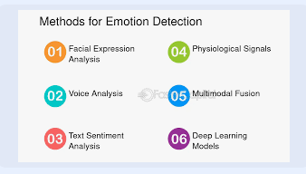
Source: (https://www.google.com/search?q=various+methods+to+detect+and+analyze+emotions)
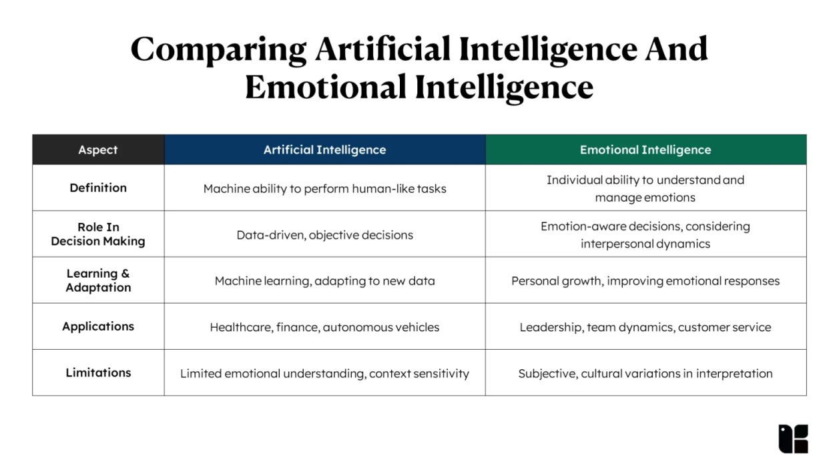
(source: https://kapable.club/blog/emotional-intelligence/artificial-intelligence-and-emotional-intelligence/)
1. Nature of Intelligence
- AI: Artificial Intelligence is when machines can do things that usually require human intelligence, like reasoning and learning.
- EI: Emotional Intelligence is when people can understand and manage their own emotions and the emotions of others.
2. Role in Decision Making
- AI: AI is good at making decisions based on data and rules. It can process a lot of information quickly and objectively.
- EI: Emotional Intelligence helps people make decisions that consider their own emotions and the emotions of others.
3. Learning and Adaptation
- AI: AI systems learn and get better over time through machine learning and deep learning.
- EI: People can develop their Emotional Intelligence through self-awareness, self-regulation, empathy, and social skills.
4. Applications
- AI: AI is used in many areas, such as healthcare, self-driving cars, language processing, and recommendation systems.
- EI: Emotional Intelligence is useful in leadership, team building, conflict resolution, customer service, and personal development.
5. Limitations
- AI: AI may struggle to understand human emotions and context.
- EI: Emotional Intelligence can be subjective and may vary across different cultures and social contexts.
CHALLENGES IN INTEGRATING EI &AI
1. Emotion Recognition: AI struggles to accurately recognize human emotions through facial expressions and voice tone.
2. Bias in AI: AI systems can be biased, which affects their ability to interpret emotions fairly and accurately.
BENEFITS OF INTEGRATING AI&EI
1. Better Customer Service: AI systems with EI can provide empathetic and personalized support to customers.
2. Personalized Learning: AI-powered educational platforms with EI can offer personalized tutoring and emotional support.
3. Mental Health Support: AI tools with EI can help diagnose and treat mental health issues by monitoring emotional states.
APPLYING EI IN AI POWERED SOLUTIONS
1. AI-powered virtual assistants like Siri and Alexa are becoming more emotionally intelligent to improve user interactions.
2. Emotional AI helps personalize customer interactions, increasing satisfaction and building stronger business relationships.
3. AI is being used in mental health to develop tools that support emotional well-being and provide timely help.
DIFFERENT OPINIONS ON AI REPLACING EMOTIONAL INTELLIGENCE
1. AI won't replace emotional intelligence, but rather complement it.
2. AI can mimic emotional understanding, but it's not a substitute for human emotions.
3. The goal of AI is to enhance human interactions and decision-making, not replace human emotional intelligence.
RESEARCH METHODOLOGY
Research type: the Research is basically descriptive in nature.
Research Design: Qualitative method
Population: 120
Sample: 81
Research Tool used: Frequency tables, mean and chi-square with SPSS package
Data collection: Primary Data is collected by using questionnaire in securing the opinions of the respondents and Secondary data to validate the opinions through articles and journals.
Dependent Variable: Emotional Intelligence
Independent Variable: Artificial Intelligence
Objective of the Study:
To understand the role of AI & EI in human life.
To interpret the benefits and challenges in EI integrating with AI
To analyze whether the AI can read and replace human emotions and Intelligence.
Hypothesis of the study
H0: There is no significant difference in the proportion of males and females who think AI systems can replace human thinking in all cognitive processes.
H1: There is a significant difference in the proportion of males and females who think AI systems can replace human thinking in all cognitive processes.
H0: There is no significant association between gender and the opinion on whether AI systems can replace human thinking in all cognitive processes.
H1: There is a significant association between gender and the opinion on whether AI systems can replace human thinking in all cognitive processes.
.

DATA ANALYSIS

AI has the potential to effectively replace human emotional responses in various applications (e.g., customer service, therapy, personal assistants)
 |  | Frequency | Percent | Valid Percent | Cumulative Percent
Valid | 1. Strongly Disagree | 8 | 9.9 | 9.9 | 9.9
Valid | 2. Disagree | 13 | 16.0 | 16.0 | 25.9
Valid | 3. Neutral | 39 | 48.1 | 48.1 | 74.1
Valid | 4. Agree | 19 | 23.5 | 23.5 | 97.5
Valid | 5. Strongly Agree | 2 | 2.5 | 2.5 | 100.0
Valid | Total | 81 | 100.0 | 100.0
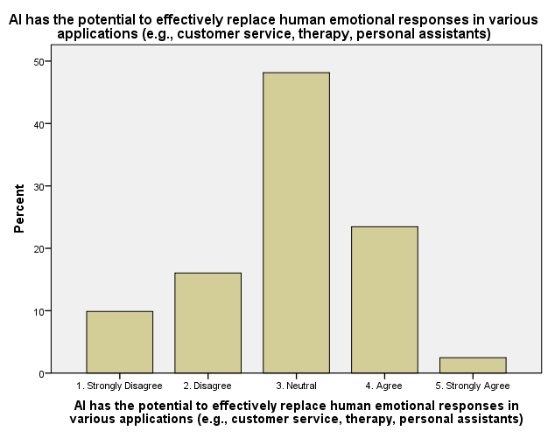

Can AI systems replace human thinking in all cognitive processes?
 |  | Frequency | Percent | Valid Percent | Cumulative Percent
Valid | No | 77 | 95.1 | 95.1 | 95.1
Valid | Yes | 4 | 4.9 | 4.9 | 100.0
Valid | Total | 81 | 100.0 | 100.0
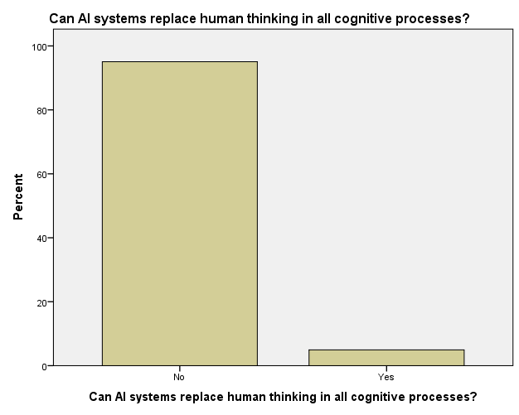

Gender
 |  | Frequency | Percent | Valid Percent | Cumulative Percent
Valid | Female | 57 | 70.4 | 70.4 | 70.4
Valid | Male | 24 | 29.6 | 29.6 | 100.0
Valid | Total | 81 | 100.0 | 100.0

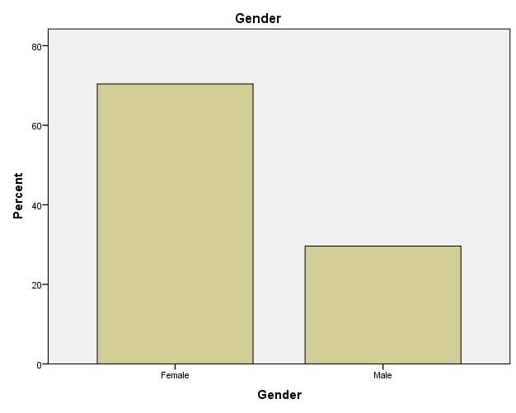

Case Processing Summary
 | Cases
 | Valid |  | Missing |  | Total
 | N | Percent | N | Percent | N | Percent
Can AI systems replace human thinking in all cognitive processes? * Gender | 81 | 100.0% | 0 | 0.0% | 81 | 100.0%

Can AI systems replace human thinking in all cognitive processes? * Gender Cross tabulation
Count
 |  | Gender |  | Total
 |  | Female | Male | Total
Can AI systems replace human thinking in all cognitive processes? | No | 48 | 19 | 67
 | Yes | 9 | 5 | 14
Total |  | 57 | 24 | 81

Can AI systems replace human thinking in all cognitive processes? * Gender Cross tabulation
Count
 |  | Gender |  | Total
 |  | Female | Male | Total
Can AI systems replace human thinking in all cognitive processes? | No | 48 | 19 | 67
 | Yes | 9 | 5 | 14
Total |  | 57 | 24 | 81

Hypotheses
H0: There is no significant difference in the proportion of males and females who think AI systems can replace human thinking in all cognitive processes.
H1: There is a significant difference in the proportion of males and females who think AI systems can replace human thinking in all cognitive processes.
Statistical Test
We can perform a Chi-Square test to determine if there is a significant association between gender and the response to the question.
χ2 = 0.55
p-value = 0.46
Since the p-value is greater than 0.05, we fail to reject the null hypothesis.
Conclusion
Based on the analysis, we accept H0, which states that there is no significant difference in the proportion of males and females who think AI systems can replace human thinking in all cognitive processes
Case Processing Summary
 | Cases
 | Valid |  | Missing |  | Total
 | N | Percent | N | Percent | N | Percent
AI has the potential to effectively replace human emotional responses in various applications (e.g., customer service, therapy, personal assistants) * Gender | 81 | 100.0% | 0 | 0.0% | 81 | 100.0%

. AI has the potential to effectively replace human emotional responses in various applications (e.g., customer service, therapy, personal assistants) * Gender Cross tabulation
Count
 |  | Gender |  | Total
 |  | Female | Male | Total
AI has the potential to effectively replace human emotional responses in various applications (e.g., customer service, therapy, personal assistants) | 1. Strongly Disagree | 3 | 5 | 8
 | 2. Disagree | 10 | 3 | 13
 | 3. Neutral | 27 | 12 | 39
 | 4. Agree | 15 | 4 | 19
 | 5. Strongly Agree | 2 | 0 | 2
Total |  | 57 | 24 | 81

Chi-Square Tests
 | Value | df | Asymptotic Significance (2-sided)
Pearson Chi-Square | 5.950ª | 4 | .203
Likelihood Ratio | 6.114 | 4 | .191
N of Valid Cases | 81
a. 4 cells (40.0%) have expected count less than 5. The minimum expected count is .59.

Null Hypothesis (H0)
There is no significant association between gender and the opinion on whether AI systems can replace human thinking in all cognitive processes.
Alternative Hypothesis (H1)
There is a significant association between gender and the opinion on whether AI systems can replace human thinking in all cognitive processes.
Conclusion
Based on the Chi-Square test results (p-value = 0.203), we fail to reject the null hypothesis (H0). Therefore, we conclude that:
There is no statistically significant association between gender and the opinion on whether AI systems can replace human thinking in all cognitive processes.
In other words, the opinion on AI replacing human thinking does not differ significantly between males and females.
FINAL CONCLUSION
AI can assist and enhance human thinking, but it cannot replace it. Human cognition is complex and involves intuition, reflection, and creativity, which AI systems currently cannot replicate. AI is best used as a complementary tool to provide data-driven insights and automate routine tasks, freeing humans to focus on higher-level thinking. By combining human intelligence with AI capabilities, we can achieve better decision-making and problem-solving.
BIBILOGRAPHY
Web links
https://tau.edu.zm/blog/ai-and-emotional-intelligence-human-feelings
https://kapable.club/blog/emotional-intelligence/artificial-intelligence-and-emotional-intelligence/
Journals
Ajit Pal Singh a(2024).” The Human Touch in the Age of Artificial Intelligence: A Literature Review on the Interplay of Emotional Intelligence and AI”. Asian Journal of Current Research Volume 9, Issue 4, Page 36-50, 2024; Article no.AJOCR.12358 ISSN: 2456-804X.
Sahiti S. Magapu (2019) “The Study of Emotional Intelligence in Artificial Intelligence” Volume 4, Issue 1, January – 2019 International Journal of Innovative Science and Research Technology ISSN No:-2456-2165.
Pragati Pandey(2023) “Emotional Intelligence Skills in the Age of AI:” International Journal for Multidisciplinary Research (IJFMR) E-ISSN: 2582-2160 ● Website: www.ijfmr.com ● Email: editor@ijfmr.com. IJFMR23057196 Volume 5, Issue 5, September-October 2023.

