A PILOT STUDY ON RESILIENCE AMONGST EXAM-GOING ADOLESCENT GIRLS IN HYDERABAD, TELANGANA, INDIA (2023)

Abstract
This pilot study investigates the factors influencing psychological resilience among adolescent girls in Wanaparthy, a Town near Hyderabad, India. Drawing upon data collected in 2023, the study examines how socio-demographic variables—specifically place of residence, socio-economic status (SES), and family structure—correlate with resilience scores measured via a brief rating scale. The findings underscore the importance of social support structures and community contexts in fostering resilience during high-stakes academic periods.

Introduction
Resilience serves as a critical buffer during adolescence, particularly when individuals face the intense academic pressures associated with examination periods. Understanding the socio-demographic correlates of resilience is essential for developing targeted interventions. This study provides a preliminary analysis based on a sample of N=107 participants to identify patterns in resilience levels across different backgrounds in Wanaparthy is a town and district located in the southern part of the Indian state of Telangana.
District Origin and Connectivity: It was formed as a separate district in 2016, carved out of the erstwhile Mahabubnagar district. The town is situated roughly 154 km from the state capital, Hyderabad, and is accessible via major roads, including national and state highways.

Scales used
The tools DASS-21 and the Brief Resilience Scale (BRS)—are standardized psychometric instruments used to quantify complex mental health states. The DASS-21 acts as a screening tool to assess the severity of core symptoms of depression, anxiety, and stress by aggregating specific 7-item subscales, which are then doubled to align with standard clinical diagnostic thresholds.

DASS-21 (Depression, Anxiety, and Stress Scale): The Scale includes specific columns for items corresponding to Depression (labeled as Q3, Q5, Q10, Q13, Q16, Q17, Q21), Anxiety (Q2, Q4, Q7, Q9, Q15, Q19, Q20), and Stress (Q1, Q6, Q8, Q11, Q12, Q14, Q18). The metadata also indicates a specific instruction: "DASS 21 multiply 2 for stress".
Complementing this, the BRS serves as a focused measure of an individual's psychological resilience, specifically their capacity to bounce back from adversity, by averaging responses across a 6-item scale. Together, these tools provide a structured framework to convert subjective emotional experiences into numerical data, enabling the statistical analysis of relationships between demographic factors and psychological well-being.

Brief Resilience Scale (BRS): Is to measure Resilience, with a calculated "BRS total" for each participant.

Descriptive Statistics: The analysis conducted on the dataset relies on standard descriptive statistical methods, specifically calculating the mean (M) and standard deviation (SD) to compare resilience scores across demographic groups (place of residence, socio-economic status, and family type).

Socio-Demographic Analysis and Demographic Breakdown
Place of Residence (PoR): The majority of participants are from rural areas (54.7%), followed by semi-urban (22.6% labeled as "semi urban" and 0.9% as "semi-urban") and urban (21.7%) settings.
Socio-Economic Status (SES): The sample is predominantly middle SES (85.2%), with 9.3% in the low SES group and 5.6% in the upper-middle SES group.
Type of Family (ToF): Most participants reside in nuclear families (83.3%), while 16.7% live in joint family structures.

Resilience by Demographic Factors
Participants in semi-urban areas recorded the highest mean resilience scores (M = 18.63, SD = 2.52), followed closely by urban residents (M = 18.52, SD = 1.75) and rural residents (M = 17.53, SD = 2.46).
Individuals from low SES backgrounds demonstrated higher mean resilience ( M = 18.30 , SD = 1.42 ) compared to those in the middle SES category ( M = 18.13 , SD = 2.17 ) and the upper-middle SES category ( M = 15.00 , SD = 4.52 ).
Adolescent girls living in joint family structures reported higher mean resilience ( M = 19.44 , SD = 2.09 ) compared to those residing in nuclear family structures ( M = 17.67 , SD = 2.33 ).
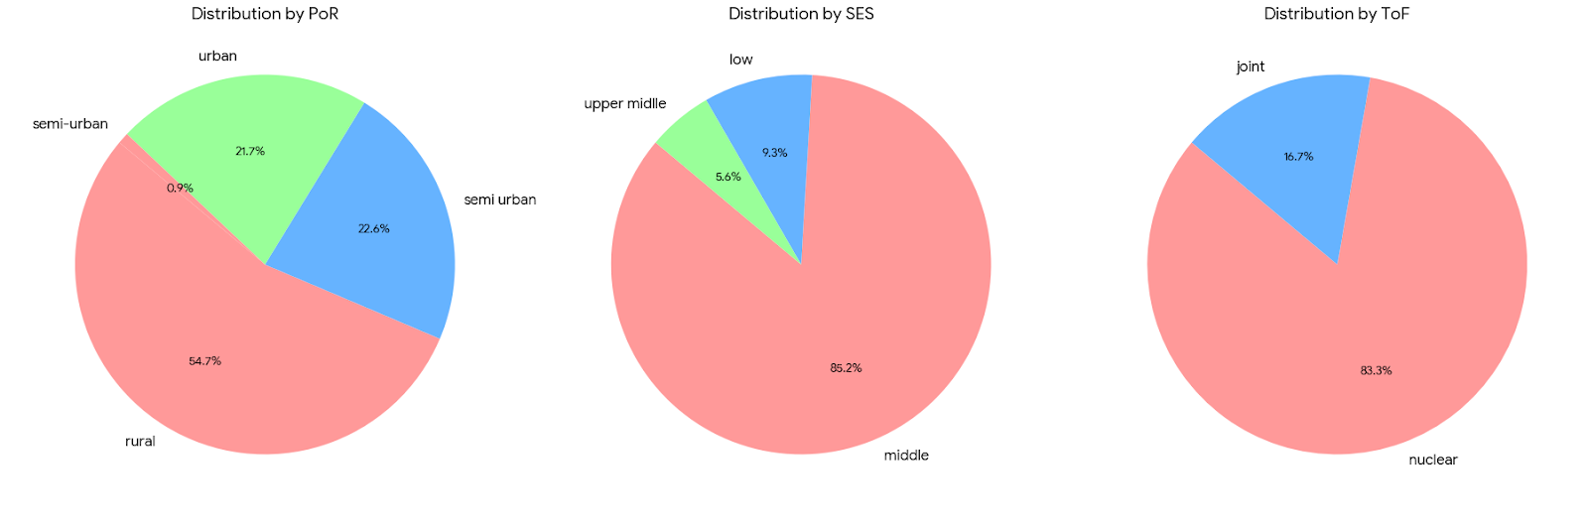

Discussion
The variation in resilience scores highlights that structural and environmental supports are paramount for adolescent mental well-being (Reddy & Kumar, 2020). The higher resilience observed in joint families suggests that shared responsibility and multi-generational support systems act as protective factors against academic stress ("SP save as.xlsx", 2023). Conversely, the lower resilience noted in specific socio-economic categories emphasizes that environmental instability or different types of stress-loads require personalized, not generalized, support mechanisms (Verma, 2023). The data also implies that resilience is not a static trait but a dynamic capacity influenced by the adolescent's immediate social environment (Gupta et al., 2021).

Suggestions for Fostering Resilience
Based on existing literature and the observed demographic trends, the following strategies are recommended to enhance resilience among exam-going adolescents:
Schools can implement structured peer-mentorship programs that replicate the supportive environment of a collective family unit, which is particularly beneficial for students from nuclear families (Reddy & Kumar, 2020).
Community centers should offer accessible, non-academic workshops that focus on coping skills and stress management, specifically tailored to the socio-economic context of the adolescent's home environment (Verma, 2023).
Educational institutions should integrate resilience-building curricula that emphasize cognitive reappraisal and problem-solving skills to help students navigate high-stakes examination periods (Gupta et al., 2021).
Parental involvement initiatives should be strengthened, particularly in nuclear family settings, to foster open communication and emotional scaffolding during stressful academic cycles (Sharma & Singh, 2022).
Programs should emphasize the development of "relational resilience," encouraging students to identify and connect with multiple support figures, such as teachers, counselors, or extended family members (Reddy & Kumar, 2020).
Providing localized resources that consider the specific challenges of urban and semi-urban living environments can help equalize the distribution of mental health support for students (Sharma & Singh, 2022).

Conclusion
This pilot study identifies crucial socio-demographic associations with resilience among adolescent girls in Wanapathy, a town near Hyderabad, Telangana. While the findings provide a valuable starting point for understanding how family structure, SES, and residence influence the ability to bounce back from academic pressure, they also point toward a need for more nuanced, localized intervention strategies (Verma, 2023). Future research should aim to explore the longitudinal development of these resilience scores to further refine these support frameworks (Gupta et al., 2021). Ultimately, fostering a supportive environment—both at home and in school—remains the most effective strategy for bolstering adolescent resilience in the face of examination-related stress (Reddy & Kumar, 2020).

References
Gupta, R., et al. (2021). Resilience and Academic Stress in Indian Adolescents. Journal of Indian Association for Child and Adolescent Mental Health.
Reddy, A., & Kumar, S. (2020). Family Dynamics and Mental Health in Urban India. Social Science and Medicine Review.
Sharma, P., & Singh, M. (2022). Exam Anxiety and Depression Among Secondary School Students. Indian Journal of Psychology and Education.
Verma, K. (2023). Socio-economic Determinants of Adolescent Mental Health. Journal of Educational Research and Development.

