KNOWLEDGE MANAGEMENT (KM) INFORMATION SYSTEM FOR LAGUNA STATE POLYTECHNIC UNIVERSITY - SANTA CRUZ CAMPUS

BADILLO, JERAHMEEL A.¹  College of Computer Studies Laguna State Polytechnic University Laguna, Philippines jerahmeelbadillo2@gmail.com | CALAPAO, JAN REINNEN S.²  College of Computer Studies Laguna State Polytechnic University Laguna, Philippines renzcalapao12@gmail.com | REBONG, DEXTER D.³  College of Computer Studies Laguna State Polytechnic University Laguna, Philippines dimanrebong41@gmail.com | VILLARICA, MIA V.⁴  College of Computer Studies Laguna State Polytechnic University Laguna, Philippines mia.villarica@lspu.edu.ph

ABSTRACT - Documents in any institution have been outnumbered and scattered in various repositories, hindering efficient information retrieval and threatening institutional memory. This study developed a web-based Knowledge Management Information System for Laguna State Polytechnic University - Sta. Cruz Campus that consolidates core institutional documents such as research outputs, policies, course materials and extension documents into a centralized, secure, and searchable platform. Employing a Developmental and Experimental Research Design, KMIS engineered four core intelligent components: Role-Based Access Control centralized repository, Retrieval Augmented Generation pipeline that uses vector embeddings to utilize semantic search and LLM-generated summaries from natural language queries. Lastly, the automated QPRO analysis engine. The developed KRA text classification model achieved an overall accuracy of 98% and automatically categorized institutional reports against the 22 Key Result Areas from the 2025-2029 LSPU Strategic Plan.

Keywords: Knowledge Management, Centralized Repository, Role-based Access Control, Semantic Search, Retrieval Augmented Generation, LLM, Transformers

INTRODUCTION
Knowledge is a core asset in universities, supporting teaching, research, and administration. The World Bank notes that digital systems enable higher education institutions to organize and use information more effectively, enhancing services and decision-making. At Laguna State Polytechnic University – Sta. Cruz Main Campus, a Knowledge Management Information System (KMIS) can consolidate scattered files and practices into a secure, searchable platform that streamlines daily operations. Knowledge at the campus is currently spread across offices, personal google drives, and separate systems, which makes it hard to find, reuse, and maintain important documents. This leads to repeated work, outdated references, and loss of institutional memory when personnel or institutional employees change. A campus-wide knowledge management information system aims to reduce these problems by serving as a
central hub for institutional files and reports such as research outputs, syllabi, policies, and extension reports with clear access rules and consistent structures.
According to Taherdoost (2023), artificial intelligence can improve knowledge management by making search more accurate and by adding useful tags to content. In practice for universities, intelligent search helps users ask natural questions and get relevant results, while automated tagging keeps metadata consistent without placing a heavy burden on contributors. Focusing on these two features first is both realistic and valuable for LSPU – Sta. Cruz Main Campus, while analytics and chatbots can be treated as future enhancements rather than immediate commitments.
An ideal knowledge management information system designed for the campus should be accessible, secure, and mapped to roles like administrators, faculty, personnel, and students. It should support clear upload workflows, standard tags, and reliable retrieval so knowledge can flow seamlessly between people and units.

RESEARCH OBJECTIVES
The objective of this study is to design and develop a web-based Knowledge Management Information System (KMIS) for Laguna State Polytechnic University – Sta. Cruz Main Campus that consolidates institutional knowledge into a single, secure, and searchable platform, emphasizing role-based access, intelligent search to improve daily teaching, research, and administration. Specifically, this study sought to achieve the following:
- To design and implement a centralized repository with role-based access controls for core assets or institutional documents such as research outputs, course materials, campus policies, and extension documents, ensuring secure storage and consistent organization across units.
- To implement a semantic search functionality capable of processing natural language queries to optimize information discovery and improve search precision while streamlining data retrieval workflows.

- To develop an automated quarterly progress report on objectives analysis engine that intelligently evaluates strategic plan progress through AI-powered document analysis, providing real-time insights into key result areas and key performance indicator achievement across organizational units.
- To design and train a text classification model for the automated categorization of institutional accomplishments into specific key result areas (KRAs) and to evaluate the performance of the trained model using standard metrics such as accuracy, precision, recall, and F1-score.

RELATED LITERATURE
The previous studies have been reviewed by the research team themselves and used as references for concept, approach, strategy, and technique direction to fulfill the intended objectives for centralized KMIS implementation. The goal of Knowledge Management is to implement a systematic method to create, capture and share intellectual assets. Alvarenga et al. (2020) describe digital transformation as "an essential change that modifies how knowledge is created and stored in the higher education system so that it becomes more efficient and effective to meet demands." Putri et al. (2023) state that without implementing such a system, knowledge stored within the institution will always be someone's individual "company knowledge" rather than university's shared knowledge, causing undocumented information and repetition of work. For technical implementation, Che et al. (2024) found that RAG and hierarchical context augmentation is effective when working with large-scale scientific documents. As the university will be inputting manuals and research papers, allowing the model to learn and store structural knowledge such as abstracts having relation to the main body of paper is more useful than simple keyword match. Tinh and Phuong (2025) stresses the importance of "heading-aware chunking" to better understand the context of information the university will be inputting. In other words, letting the model know that there are nested heading and directory levels within each University manual and research. Lastly, various studies have been conducted to utilize LLMs for information retrieval. Xu (2024) proved that LLaMA2 achieves higher precision and recall than conventional machine learning based classifiers in sorting academic documents. Similarly, Wang and Pei (2024) conducted a study on LLM-based query expansion to better suit what the user is looking for, even if the querier provides insufficient information. HEIs must align with digital transformation by making KM adaptable to remain relevant with ever-changing technology and information. Alvarenga et al. (2020) noted that universities should manage knowledge assets to enhance intellectual capacity, innovation, knowledge creation, and the institution’s vision and mission. Mehta (2021) defined KM as “processes to gather and
analyze data to enable students and staff to share information that provides insight, creates strategies and innovative ideas”. Organizations use KM principles to improve performance through best practices and efficient processes. Galgotia & Lakshmi (2022) explained KM helps organizations respond to issues quickly, make informed decisions, learn new skills, reduce duplication of work, save money, and cut errors by implementing policies and programs and accessing information faster. Today’s concern with KM is people’s notion that knowledge belongs to an individual. Putri et al. (2023) found issues in KM included inadequate documentation, lack of immediate updated content across platforms, reliance on verbal sharing instead of written, duplicated processes in IT operations, lack of online user guides, and humans making errors that add incorrect data. The studies describe KM as a strategic asset for institutions like HEIs to operate efficiently and help them stay competitive. Documentation and knowledge sharing are some issues mentioned that KMIS aims to address in Laguna State Polytechnic University by semantic segmentation and deep learning. This dissertation will focus on creating a system where documents can be stored in one place for users to easily share and retrieve knowledge. Repositories help preserve and increase access to knowledge in higher education using metadata and open data. Mosha & Ngulube (2023) used Scopus, Web of Science, and Google Scholar with Boolean Operators on metadata as keywords to search literature from 2003 to 2023 about academic repositories. Their literature review discussed the role of repositories in sharing research data after the open data movement. Dube (2025) stated institutional repositories provide a secured platform for researchers that allow scholars to manage the entire lifecycle of their research data by making it FAIR -findable, accessible, interoperable, and reusable. Faculty and institutional repositories focus on collecting all types of resources in one place for easy access and efficiency.

RESEARCH METHODOLOGY

Research Design
The proposed Knowledge Management Information System was systematically designed, developed, and implemented using the developmental research design. This strategy concentrated on evaluating LSPU's current information management procedures, determining system needs, creating the system architecture, and creating essential features such a centralized knowledge repository, AI-powered search, automated tagging, and recommendation tools. System development, integrating of machine learning components, and ongoing improvement based on usability and usefulness were all part of the developmental design. Since the main goal of the project is to develop a useful, institution-specific KM Information System that improves knowledge storage, retrieval, and sharing inside the university, this design is suitable (Clark-Plaskie et al., 2022). In addition to

that, an experimental research design was applied to evaluate the performance of the developed system. This section of the study involved controlled testing to evaluate the accuracy of the semantic search functionality, the relevance of generating document insights and recommendations, and the overall usability and reliability of the system. By analyzing system outputs and user interactions, the researchers were able to determine whether the implemented KMIS features effectively improve information accessibility and user experience within the LSPU academic environment. The use of experimental research allowed the researchers to examine the influence of system features on knowledge retrieval efficiency and system performance (Zubair, 2022).
According to Clark-Plaskie et al. (2022), developmental research designs are effective for studies focused on system creation and improvement because they allow researchers to observe changes and enhancements throughout the development process. Meanwhile, Zubair (2022) explained that experimental research involves controlled testing of variables to determine their effects on outcomes. In this study, combining developmental and experimental research designs ensured that the proposed KM Information System was not only properly developed but also systematically evaluated in terms of functionality, performance, and user satisfaction.

Applied Concepts and Techniques
As the study progressed on, the concepts and methods that were put to use show how the Knowledge Management Information System was developed in order to address the problems associated with unorganized information storage and retrieval. In this study, the following concepts and techniques were used:

Knowledge Management (KM)
Knowledge Management is the systematic method of gathering, storing, organizing, sharing, and retrieving knowledge inside an institution, and is the fundamental concept used in this study. This contains academic materials, research findings, administrative records, and institutional policies in the context of Laguna State Polytechnic University. Through a centralized repository, the KMIS is intended to support fundamental knowledge management (KM) functions such as knowledge generation, storage, sharing, and reuse.

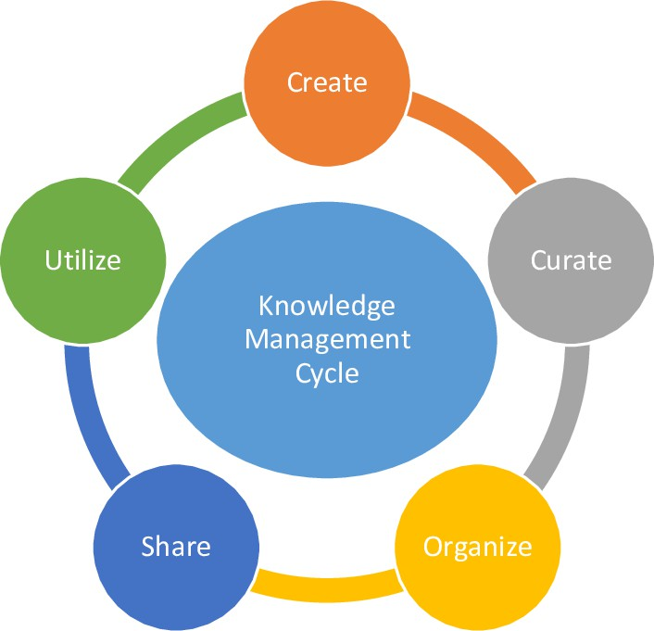
Figure 4. Knowledge Management Cycle (Manjunatha, 2023)
Figure 4 depicts the cyclical process central to this study's framework for institutional knowledge handling at Laguna State Polytechnic University. The diagram shows four interconnected phases which are capture, store, organize, and share which are arranged in a continuous loop to emphasize the iterative nature of knowledge management. Arrows between phases highlight the dynamic flow. Knowledge is first captured from sources like strategic plans and operational reports, then stored in centralized repositories, organized for accessibility and retrieval, and shared among stakeholders to support decision making and performance alignment.

Machine Learning
Machine learning provides computer systems the ability to learn patterns from data and make predictions without explicit programming. In this study, machine learning enables automatic classification of institutional text into the 22 Key Result Areas (KRAs) from LSPU's Strategic Plan 2025–2029, transforming unstructured strategic documents and QPRO reports into structured, actionable insights for performance monitoring and alignment.

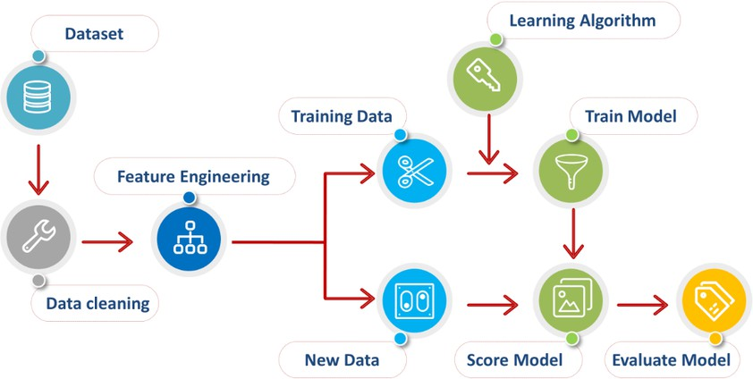
Figure 5. Machine learning process diagram (Al-Saad et al. 2023)
Figure 5 illustrates the operational flow of machine learning algorithms applied in this study. The process begins with a Dataset sourced from institutional documents like QPRO reports or accomplished PDO forms and the LSPU Strategic Plan. This feeds into data cleaning to remove inconsistencies, followed by feature engineering to prepare structured inputs.

Retrieval Augmented Generation
Retrieval Augmented Generation (RAG) enhances LLMs by integrating real-time retrieval from external knowledge bases. It enables the system to generate contextually accurate responses grounded in current, domain-specific documents. In this study, RAG powers the institutional knowledge repository by supporting semantic search across all uploaded document types such as PDFs, Word files, spreadsheets, and reports regardless of format or structure.
Once documents are uploaded to the centralized repository, they undergo automated

processing: text extraction, semantic embedding generation using transformer models, and indexing in a vector database for efficient similarity matching. User queries trigger a retrieval phase where the system identifies and ranks the most semantically relevant document chunks based on cosine similarity of embeddings. These retrieved segments are then injected as contextual prompts to the generative model, which synthesizes precise answers while citing source locations.
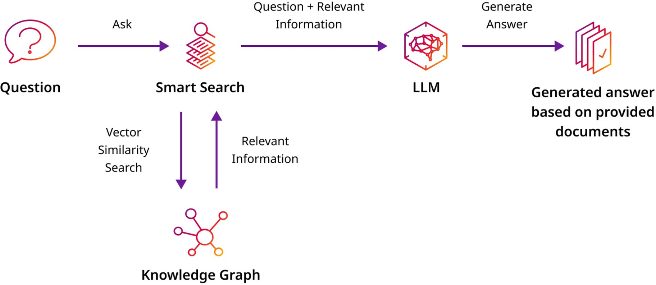

Figure 6. Retrieval Augmented Generation Diagram (DataStax, 2024)
Figure 6 illustrates the architecture of the Retrieval Augmented Generation pipeline implemented in the institutional knowledge management information system. A user Question initiates Smart Search via Vector Similarity matching against embeddings in the Knowledge Graph, retrieving Relevant Information from uploaded documents. This context is augmented with the query and fed to a Large Language Model, which generates answer output grounded in the retrieved provided documents.

Tokenization
In this study, the distilbert-base-uncased tokenizer from Hugging Face Transformers was applied to segment extracted text from the LSPU Strategic Plan 2025–2029 and QPRO reports into subword tokens, preserving semantic meaning while handling out of vocabulary terms through WordPiece algorithms.

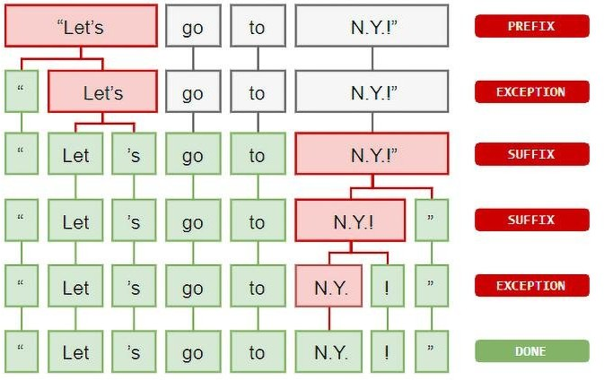
Figure 7. Tokenization Method (Hashem et al., 2021)
Figure 7 shows an example of the tokenization method which breaks down a phrase, sentence, paragraph, or complete text document into smaller components, such as individual words or phrases. Each smaller component is called a token (Hashem et al., 2021).

Large Language Model
Large Language Models (LLMs) are transformer-based neural networks trained on massive text structures, enabling advanced natural language understanding, generation, and reasoning capabilities. In this study, LLMs enhance semantic search by refining user queries, generating contextually precise answers from retrieved document segments, and producing prescriptive analysis from QPRO reports. Specifically, the model synthesizes insights across Key Result Areas (KRAs), identifies performance gaps between operational data and strategic targets, and generates actionable recommendations such as resource reallocation suggestions or priority interventions for planning officers, transforming raw institutional documents into strategic decision support.
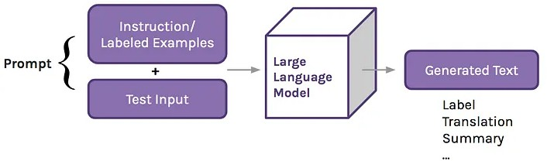
Figure 8. How Large Language Model Work (Anees., 2024)
Figure 8 shows the core inference mechanism of the LLM in the semantic search system. It is an instruction prompt containing labeled examples and test input is constructed and fed into the Large Language Model. The model processes this structured input to produce generated text, which undergoes label translation to yield final outputs such as Key Result Areas (KRAs) classifications or prescriptive insights. Algorithm Analysis
The proponents employed techniques for analyzing the algorithms that can help the researchers to identify the most appropriate for the development of an AI-based system for institutional document classification and Key Result Area (KRA) mapping in the Knowledge Management Information System (KMIS) application. To address this, the researchers examined multiple natural language processing (NLP) transformer models found in existing literature, especially those used in text classification and knowledge organization. By testing and comparing these models, the researchers aim to identify which algorithm delivers the best accuracy, speed, and reliability for categorizing university assets into their respective KRAs.

DistilBERT
The researchers chose distilbert because of its light transformer model trained by distilling BERT base. It is designed to reduce the size of a BERT model by 40% while retaining 97% of its language understanding capabilities and being 60% faster. It utilizes a process called knowledge distillation, where a smaller "student" model is trained to mimic the behavior of a larger "teacher" model. This makes it ideal for environments where computational power is

limited but high-quality text classification is still required (Sanh et al., 2019).

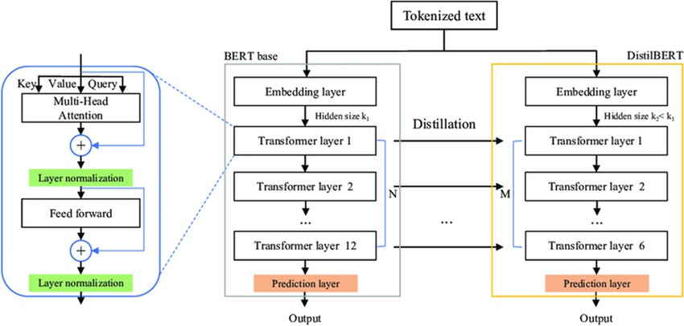
Figure 9. DistilBERT Architecture (Kinger et al., 2024)
Figure 9 illustrates the DistilBERT architecture utilized for KRA text classification. It tokenizes text from QPRO reports and strategic plan segments enters the model, where a BERT Embedding Layer produces contextual representations. These pass through 6 Transformer Layers, each are using multi-head attention mechanisms for capturing semantic meaning and feed-forward networks for non-linear transformations. Layer normalization stabilizes training, while Multi-Head Attention enables parallel focus on different text aspects. The final output layer produces predicted KRAs, enabling accurate alignment of operational data with strategic objectives. DeBERTa-V3
According to He et al., (2023) DeBERTa-V3 or Decoding-enhanced BERT with Disentangled Attention Version 3 shows remarkable changes over original Transformer models by integrating ELECTRA-style pre-training with a disentangled attention mechanism. While standard BERT models combine content and position information into a single vector, DeBERTa itself represents them separately, allowing the model to analyze how the meaning of administrative terms changes based on their relative distance from one another.
Report" (KRA 5) and a "Financial Report for Research" (KRA 22), leading to the high accuracy and precision required for institutional data management.

MiniLM
According to Wang et al., (2020) MiniLM is a highly efficient lightweight pre-trained model that focuses on distilling the "self-attention" distributions of deep Transformer networks. Unlike other models that distill the output of layers, MiniLM focuses on the relations between tokens. This allows the model to capture the complex structure of a sentence even with a much smaller number of parameters, resulting it as one of the best choices for high-speed automated tagging and real-time search functionality in information systems.
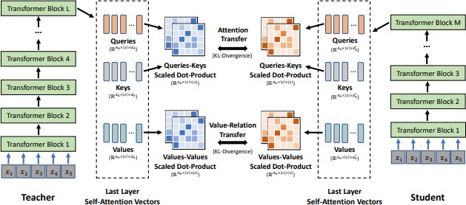
Figure 11. MiniLM Self-Attention Distillation (Wang et al., 2020)
Figure 11 shows how MiniLM processes text by distilling the "Self-Attention" maps from the teacher model. The researchers utilize a deep self-attention distillation approach where the student model mimics the attention values and the "Value-Relation" between tokens. This ensures that the model keeps the most important linguistic features needed to classify the 22 KRAs of the university.

Data Collection Methods
As per Pulkit (2025), data collection methods is the process of collecting and evaluating information or data from multiple sources to find answers to research problems, answer questions, evaluate outcomes, and forecast trends and probabilities. Cote (2021) added that data collection is the methodological process of gathering information about a specific subject.

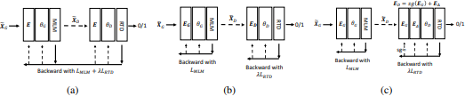
Figure 10. DeBERTa-V3 Disentangled Attention and RTD Mechanism
As shown in Figure 10, the core architecture uses a Replaced Token Detection (RTD) objective instead of traditional masking. In this setup, a generator model replaces some words with reasonable fakes, and the DeBERTa discriminator must identify which words are real. This makes the model much more sensitive to subtle differences in administrative language. By treating these relationships independently, the KMIS AI model can better distinguish between a "Research
The researchers’ study titled "Knowledge Management Information System (KMIS) for Laguna State Polytechnic University - Santa Cruz Campus" compiles detailed institutional documents and knowledge assets gathered from institutional units. These materials, including accomplishment reports, research outputs, and administrative files, were consolidated through systematic collection across Laguna State Polytechnic University units such as the Planning Office. The researchers conducted formal data gathering by personally visiting various LSPU offices, the College of Computer Studies, and administrative facilities to seek assistance and validate the dataset's relevance for the development of KMIS. They also coordinated internally with faculty experts

and department heads to ensure access to comprehensive records supporting AI model training, testing, and system implementation for prescriptive insights generation, search, and knowledge sharing.
The dataset for this study consists entirely of institutional documents, such as accomplishment reports, faculty/staff training & seminar reports, reports of alumni employment, licensure examination results, reports of scholarships and financial assistance, reports of graduates, status of publication researchers reports, status of presentation researchers reports, status of completed researchers reports, and status citation reports collected from several departments of Laguna State Polytechnic University - Santa Cruz Campus.

Data Model Generation
In this study, the researchers include data collection, pre-processing, splitting and balancing, testing and validation, data evaluation, model training and model evaluation, model selection, and integration. Hence, it replicates within the scope of the data information that was being generated.
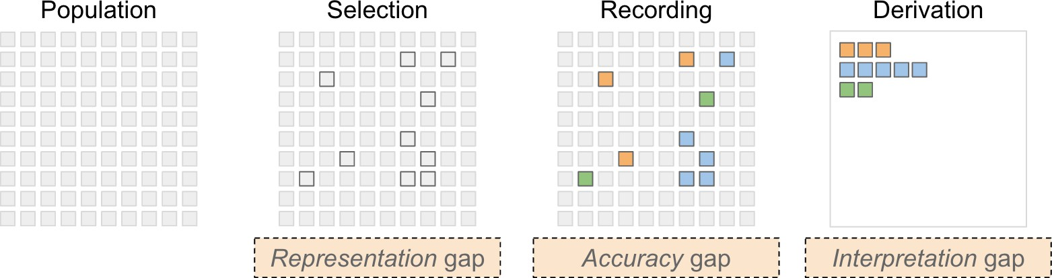
Figure 12. Data generation process (Bertini, 2024)
Figure 12 states that the data generation process involves four key stages, population, selection, recording, and derivation. Each of which can introduce specific types of gaps or biases. The representation gap occurs during the selection phase when only a subset of the population is chosen, which may not accurately reflect the whole. The accuracy gap arises in the recording phase due to errors in the collected data. Lastly, the interpretation gap happens during derivation, where incorrect or oversimplified conclusions may be drawn from biased data.

Data Preparation
The QPRO documents from each campus unit were gathered, organized, and formatted uniformly, then designated as the test dataset to examine whether the operational performance of the university meets the requirements and performance targets as stated in the strategic plan. The reports were reviewed to verify completeness, consistency of reporting periods, and comparability of indicators, ensuring that only validated entries were retained for upcoming analysis.
The LSPU Strategic Plan 2025–2029 undergoes data cleaning to remove narrative sections and other contents that were not directly relevant to the assessment of institutional performance. Only essential components, specifically the Key Result Areas (KRAs) and their corresponding Key Performance Indicators (KPIs) were retained and encoded in a structured format to serve as the primary reference framework. These KRAs and KPIs were then mapped to the
corresponding indicators in the QPRO dataset, enabling a logical and objective comparison between actual operational data and the strategic performance standards of the university.

Data Pre-processing
Data preprocessing in this study was performed on the LSPU Strategic Plan 2025–2029, which was provided as a PDF document. The goal of this stage was to convert the unstructured textual content into a machine-readable format suitable for input to the trained chosen model through a series of extraction, cleaning, balancing, and tokenization procedures.
For data extraction and labeling, the text was first broken down from the PDF using a Python-based PDF processing library. A rule-based labeling scheme was then applied to associate each text segment with its corresponding Key Result Area (KRA). Specifically, the document was read consecutively, and whenever a KRA marker was encountered, all subsequent lines were tagged with that KRA label until the next KRA marker appeared, thereby resulting in a labeled corpus organized by KRA.
The extracted content was cleaned to remove noise introduced by the PDF layout and formatting. Non-informative elements such as headers, footers, labels, and administrative phrases were filtered out using predefined stop-phrases and regular-expression patterns. Bullets, numbering conventions, and other typographical symbols were stripped, very short text fragments were discarded, and exact duplicate entries were removed to avoid redundancy and potential data leakage during model training.

Data Splitting and Balancing
Initial observations revealed class imbalance across the 22 KRAs. Random Oversampling addressed this by identifying the KRA with maximum samples and upsampling minority classes with replacement until all achieved equal representation. The balanced dataset was then structured into training (80%) and testing (20%) subsets to maintain proportional KRA distribution across splits, ensuring robust model evaluation.

Data Testing and Validation
The test dataset, containing 20% of the balanced and tokenized corpus, was reserved for final model evaluation to provide an unbiased assessment of its performance. During validation, the DistilBERT model was evaluated on held-out subsets from the training split using metrics such as accuracy, precision, recall, F1-score, and macro-averaged scores to account for multi-class (22 KRAs) balance. Cross-validation was applied on the training set to tune hyperparameters and detect overfitting, with early stopping implemented.
Model predictions on the test set were compared against true KRA labels to generate a confusion matrix, enabling detailed analysis of per-class performance and identification of misclassifications between similar KRAs. Statistical

meaning of results was verified through bootstrap resampling of test predictions, confirming robustness across the dataset. All validation procedures stick to best practices for NLP classification, ensuring reliable insights into how well the model aligns extracted text segments with strategic plan objectives.

Data Evaluation
Data evaluation occurs after completing the testing and validation processes to confirm the accuracy and reliability of the prepared dataset. This assessment uses analytical methods focused on the dataset's predictive support for decision-making, including checks for missing values, outlier detection, and consistency verification against the original LSPU Strategic Plan and QPRO documents.
To avoid errors or misleading patterns, data quality was analyzed using descriptive statistics, distribution plots, and cross-referencing techniques to derive valid insights. The format and sources of the data were reviewed to ensure the quality and reliability of the information used in the analysis.

Model Integration
Before full integration, the model’s performance was carefully evaluated during the model selection phase. This included checking key metrics such as accuracy, precision, and overall effectiveness of the selected algorithms. Any issues identified during this stage were addressed to ensure that the model would function correctly and deliver accurate results once deployed in the application.

RESULTS AND DISCUSSION
This chapter presents the comprehensive results and detailed discussion relating to the development and evaluation of the Knowledge Management Information System (KMIS) for Laguna State Polytechnic University – Santa Cruz Campus.
Research Objective 1: To design and implement a centralized repository with role-based access controls for core assets or institutional documents such as research outputs, course materials, campus policies, and extension documents, ensuring secure storage and consistent organization across units.
To obtain a centralized repository with role-based access controls for core assets of institutional documents, The researchers implement a centralized institutional document repository in which all core documents are stored under a unified database-backed document model, ensuring standard metadata, versioning, and traceability. The repository is consistently organized across institutional units through a dedicated unit entity and explicit unit-document linkage, enabling structured grouping and retrieval while maintaining a single source of truth. To ensure secure storage and controlled access, the researchers integrated role-based access control using defined institutional roles.

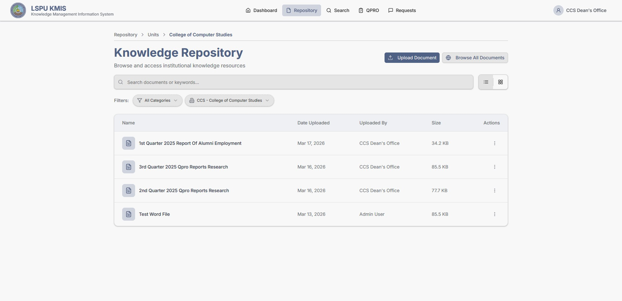
Figure 17. Screenshot of the system’s repository UI Figure 17 shows the visual implementation of
the KMIS document repository, directly addressing Research Objective 1 by providing a unified, secure platform for institutional documents. The UI demonstrates the successful integration of a database-backed structure where institutional assets such as accomplished PDO forms are stored with metadata and versioning. Also, the repository is supported with Role-Based Access Control (RBAC), which extends to unit-scoped permission assignment (READ/WRITE/ADMIN) and document-level permissions. The researchers confirm the system's commitment to displaying a unified file listing with standard metadata fields such as document type, unit of origin, and version number. This standardization, supported by database-backed versioning and traceability that ensures whether the user is viewing research outputs, course materials, or administrative policies, the information is uniformly structured and the UI incorporates clear upload workflows that mandate the inclusion of necessary metadata, which is essential for auditability and compliance.
Research Objective 2: To implement a semantic search functionality capable of processing natural language queries to optimize information discovery and improve search precision while streamlining data retrieval workflows.
The researchers implement a semantic search functionality capable of processing natural language queries, the researchers developed a robust Retrieval-Augmented Generation (RAG) pipeline optimized for institutional knowledge retrieval. This pipeline enables end-users to submit natural-language queries through a chat-style endpoint which uses LLM augmentation to convert retrieved materials into precise, human-friendly summaries. The system ensures high search precision by employing semantic processing: documents undergo chunking and are converted into vector embeddings. Furthermore, retrieval is optimized for speed using a managed vector index for efficient nearest-neighbor queries. This system supports streamlined workflows, including ad-hoc searching of attached files via a temporary session chat search path and continuous institutional

search using persistent document embeddings.

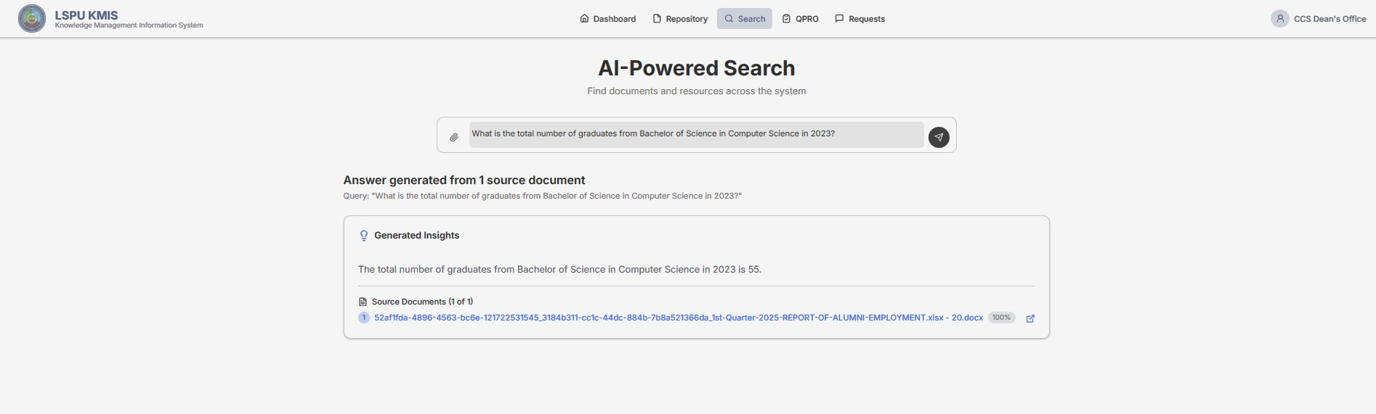
Figure 21. AI-Powered Search query output Figure 21 shows the system's successful
implementation of semantic search and the Retrieval-Augmented Generation (RAG) pipeline. The interface confirms the system's ability to streamline data retrieval workflows by presenting the source documents used to ground the answer, which significantly improves search precision, optimizes information discovery, and provides evidence-based responses to build user trust in the system's knowledge retrieval capabilities.
Research Objective 3: To develop an automated quarterly progress report on objectives analysis engine that intelligently evaluates strategic plan progress through AI-powered document analysis, providing real-time insights into key result areas and key performance indicator achievement across organizational units.
The researchers implemented an end-to-end QPRO analysis pipeline. This pipeline enables units to submit Quarterly Progress Report of Operation (QPRO) documents which immediately trigger a server-side Analysis Engine. The engine utilizes embeddings and vector search to semantically match extracted document evidence against the strategic plan. It then prompts an integrated Large Language Model (LLM) to synthesize structured analytic outputs, including alignment narratives, opportunities, gaps, recommendations, and a computed achievement score for AI-powered interpretation.
The LLM-generated outputs are validated and stored in the QPROAnalysis database model, linking them to the original document. Crucially, the system automatically extracts activities from the QPRO reports and maps them to Key Result Area / Key Performance Indicator identifiers. To provide real-time strategic insights, the system caches and processes analyses using background processing for timely performance and surfaces the final results through KPI/KRA dashboards and detail views, which render achievement percentages and status badges.

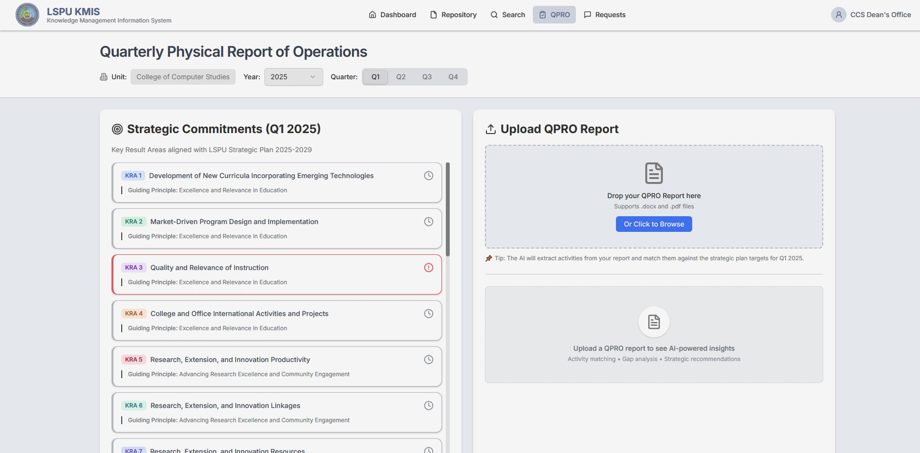
Figure 22. Submission Section of Reports Figure 22 shows the upload flow that allows
institutional units to submit their Quarterly Progress Report of Operation. The act of submission immediately triggers the server-side Analysis Engine, which begins the end-to-end process of ingesting the document, extracting and semantically analyzing its content using embeddings and Large Language Models, and mapping activities to Key Result Areas (KRAs) and Key Performance Indicators (KPIs).

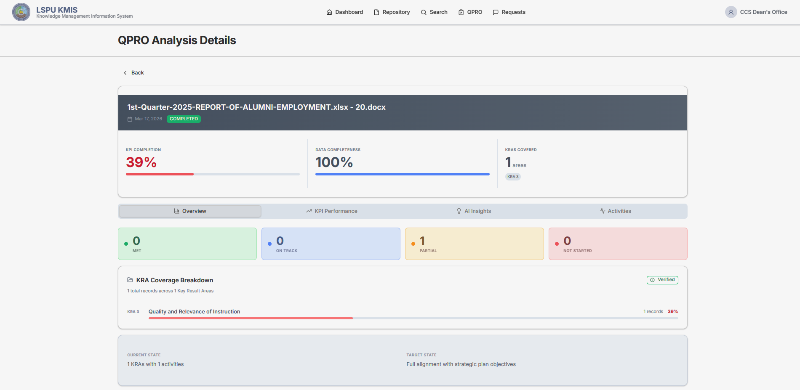
Figure 23. Overview of the Analyses
Figure 23 visualizes the overview section which shows the performance tracking dashboard that yields specific insights regarding the institution’s strategic alignment and operational performance.

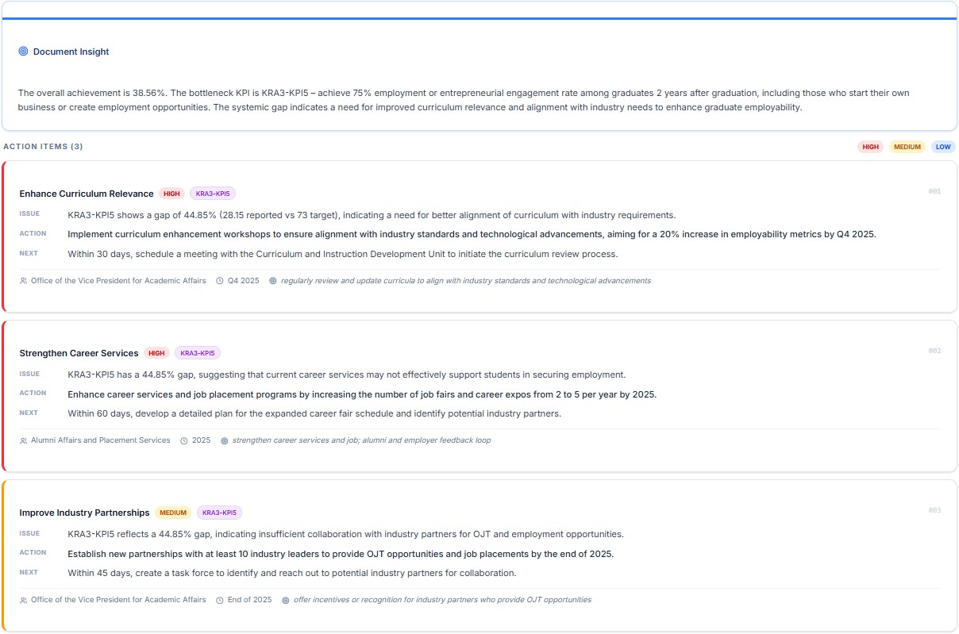
Figure 24. AI Generated Insights
Figure 24 illustrates the AI Insights module of the Knowledge Management Information System (KMIS), detailing the diagnostic assessment and recommended strategic interventions based on the evaluated institutional performance data. This automated output transforms raw quarterly reports into real-time, data-driven guidance, enabling administrators to swiftly monitor KRA achievement and make informed decisions on priority interventions or resource allocation.

Research Objective 4: To design and train a text classification model for the automated categorization of institutional accomplishments into specific key result areas (KRAs) and to evaluate the performance of the trained model using standard metrics such as accuracy, precision, recall, and F1-score.
To design and train a text classification model for the automated categorization of institutional accomplishments into specific Key Result Areas (KRAs) and to evaluate the performance of the trained model using standard metrics such as accuracy, precision, recall, and F1-score (Research Objective 4), the researchers systematically developed a transformer-based classifier. This involved extensive data preprocessing, including text extraction, cleaning, and oversampling the LSPU Strategic Plan 2025–2029 to create a balanced dataset of 22 distinct KRA classes. The researchers selected the DistilBERT model due to its optimal balance of speed and high-fidelity language understanding, fine-tuning it to learn mappings from QPRO text segments to the correct strategic objectives. The evaluation phase included rigorous testing using accuracy, precision, recall, and F1-score, along with a confusion matrix analysis, to confirm the model’s reliability in automatically segmenting and classifying operational data, thus establishing a foundational component for the system’s prescriptive analytics engine.

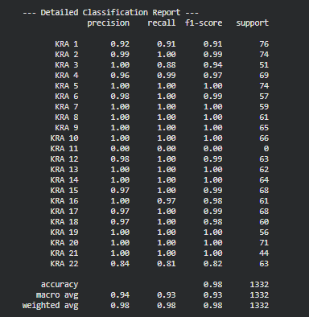
Figure 28. Model’s Performance Metrics
Figure 28 shows the performance metrics such as precision, recall, and f1-score which confirm the model’s reliability in automatically segmenting and recognizing institutional reports into the 22 Key Result Areas (KRAs).
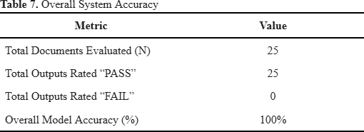
Table 7 presents the result of the Ground Truth Verification phase that summarizes the overall accuracy of the model’s generated insights. All 25 institutional documents were evaluated and achieved a “PASS” rating, resulting in no failures and a perfect overall model accuracy of 100%.

V. SUMMARY, CONCLUSIONS, AND RECOMMENDATIONS
This study titled “KNOWLEDGE MANAGEMENT (KM) INFORMATION SYSTEM
FOR LAGUNA STATE POLYTECHNIC UNIVERSITY - SANTA CRUZ CAMPUS” which
intends to develop a web-based Knowledge Management Information System (KMIS) for Laguna State Polytechnic University – Sta. Cruz Main Campus that unites institutional documents into a single, secure, and searchable platform, utilizing role-based access to documents, intelligent or semantic search to improve retrieval of documents, efficient research, and administration. The researchers implemented a secure repository with role-based access control features for core institutional documents and applied semantic search functionality using natural language queries to optimize discovery. The researchers also developed an automated quarterly progress report of operation (QPRO) analysis engine to evaluate strategic plan progress against key result areas (KRA) and key performance indicators (KPI). Lastly, the researchers design and train a KRA classification model to automatically categorize accomplishments into 22 specific KRAs and evaluate its performance using standard metrics.

Conclusion
Based on the findings, objectives and confirmed results from system development and evaluation from the study, the following conclusions are established:
- The study successfully developed a unified institutional document repository that utilizes Microsoft Azure’s blob storage. This centralized platform is secured because of the implemented RBAC (role-based access control) and a mechanism to request permission for cross-unit access.
- The developed system has produced a highly precise semantic search capability that was achieved through the implementation of Retrieval-Augmented Generation (RAG) pipeline. It allows users to submit natural language queries and uses an integrated Large Language Model (LLM) to convert retrieved document segments into accurate, human-friendly summaries grounded in institutional documents that are uploaded in the repository.
- The system did a good job at giving prescriptive analysis through the reports that are submitted by every unit. It is with the help of the automated QPRO analysis engine that was developed. Upon document submission, this engine uses vector search to semantically match extracted operational evidence against the strategic plan. The outputs include performance gaps and actionable recommendations that are displayed in dashboards fulfilling the objective to provide intelligent, real-time insights into strategic plan progress.
- The study designed a KRA text classification model to automatically recognize the

institutional accomplishments into the 22 specific Key Result Area (KRA) of the 2025-2029 LSPU Strategic Plan. The model is rigorously evaluated using standard metrics such as precision, recall and f1-score to confirm the model’s reliability.

Recommendations
Based on the conclusions drawn from the findings of the study, the following recommendations are offered to improve and address the identified challenges.
- Utilize an Optical Character Recognition (OCR) that is effective for extracting tables from PDF files as the current system only supports DOCX files.
- The future researchers can integrate a conversational AI assistant or chatbot. This improvement noted as a future upgrade in the scope and limitations will allow users to query the knowledge base using natural language that provides a more intuitive and context-aware experience than the current chat-style search.

LITERATURE CITED
AN APPROACH TO SEMANTIC EDUCATIONAL CONTENT MINING
USING NLP. (2022, July 19). Proceedings of the 16th International Conference on E-Learning (EL 2022). 16th International Conference on e-Learning. https://doi.org/10.33965/EL2022_202203L0 05
Anshari, M., Syafrudin, M., Tan, A., Fitriyani, N. L., & Alas, Y. (2023). Optimisation of Knowledge Management (KM) with Machine Learning (ML) Enabled. Information, 14(1), 35.
https://doi.org/10.3390/info14010035 Antonio de Carvalho Junior, M., &
Bandiera-Paiva, P. (2021). Implications of loosened Role-based Access Control session control implementation for the enforcement of Dynamic Mutually Exclusive Roles properties on Health Information Systems. Informatics in Medicine Unlocked, 27, 100780.
https://doi.org/10.1016/j.imu.2021.100780 Che, T.-Y., Mao, X.-L., Lan, T., & Huang, H.
(2024). A Hierarchical Context Augmentation Method to Improve Retrieval-Augmented LLMs on Scientific Papers. Proceedings of the 30th ACM SIGKDD Conference on Knowledge Discovery and Data Mining, 243–254. https://doi.org/10.1145/3637528.3671847
Dube, T. V. (2025). Research data management in academic libraries: Institutional repositories as a reservoir for research data. Library Management, 46(5), 319–331. https://doi.org/10.1108/LM-06-2024-0070
Eguchi, M., & Kyle, K. (2024). Building custom NLP tools to annotate discourse-functional features for second language writing research: A tutorial. Research Methods in Applied Linguistics, 3(3), 100153. https://doi.org/10.1016/j.rmal.2024.100153
Faruqui, S. H. A., Tasnim, N., Basith, I. I., Obeidat, S., & Yildiz, F. (2024). Integrating
A.I. in Higher Education: Protocol for a Pilot Study with “SAMCares: An Adaptive Learning Hub” (No. arXiv:2405.00330). arXiv. https://doi.org/10.48550/arXiv.2405.00330
Fitriasari, N. S., & Sensuse, D. I. (2025). Enhancing open innovation in university: Collaborative frameworks and knowledge management systems 4.0. Business Information Review, 42(3), 165–178. https://doi.org/10.1177/02663821251364066
Full article: Open repository development framework for knowledge sharing: Best practices in the architecture, engineering, and construction industry. (n.d.). Retrieved January 3, 2026, from https://www.tandfonline.com/doi/full/10.108 0/15623599.2025.2505687#abstract
Galgotia, D., & Lakshmi, N. (2022). Implementation of Knowledge Management in Higher Education: A Comparative Study of Private and Government Universities in India and Abroad. Frontiers in Psychology, 13, 944153.
https://doi.org/10.3389/fpsyg.2022.944153 Hafeez, S., Shahzad, K., Helo, P., & Mubarak, M.
F. (2025a). Knowledge management and SMEs’ digital transformation: A systematic literature review and future research agenda. Journal of Innovation & Knowledge, 10(3), 100728.
https://doi.org/10.1016/j.jik.2025.100728 Hafeez, S., Shahzad, K., Helo, P., & Mubarak, M.
F. (2025b). Knowledge management and SMEs’ digital transformation: A systematic literature review and future research agenda. Journal of Innovation & Knowledge, 10(3), 100728.
https://doi.org/10.1016/j.jik.2025.100728 Hou, Y., Jochim, C., Gleize, M., Bonin, F., &
Ganguly, D. (2021). TDMSci: A Specialized Corpus for Scientific Literature Entity Tagging of Tasks Datasets and Metrics. In P. Merlo, J. Tiedemann, & R. Tsarfaty (Eds.), Proceedings of the 16th Conference of the European Chapter of the Association for Computational Linguistics: Main Volume (pp. 707–714). Association for Computational Linguistics. https://doi.org/10.18653/v1/2021.eacl-main.

