Impact of Increased Rapid Response Team (RRT) Activations on Reduction in Code Blue Events: A Retrospective Comparative Quality Improvement Study (2024–2025)

Introduction
In-hospital cardiac arrest continues to remain a major concern in healthcare settings and is associated with high morbidity and mortality (1). In many cases, patients show early signs of deterioration several hours before the cardiac arrest actually occurs (2). Timely recognition of these warning signs and prompt intervention can improve patient outcomes and reduce preventable adverse events.
Rapid Response Teams (RRTs) were introduced in hospitals to provide immediate assessment and management of patients showing signs of clinical deterioration outside critical care areas (3). Studies have shown that effective use of RRT systems can reduce cardiac arrest rates, unplanned ICU admissions, and hospital mortality.
Despite these benefits, underutilization of RRT systems is still commonly seen in many institutions. Delayed activation may occur because of lack of awareness regarding activation criteria, hesitation among staff, fear of criticism, or inconsistent patient monitoring practices.
During review of hospital data in 2024, it was observed that RRT activations were relatively low while Code Blue events continued to occur in different clinical areas, particularly in wards, dialysis units, and outpatient departments. In response to these findings, a quality improvement initiative was started in 2025 to improve awareness regarding RRT activation and strengthen early escalation of care.

Objectives

Primary Objective
To determine whether increased RRT activations are associated with reduction in Code Blue events.

Secondary Objectives
- To evaluate trends in hospital mortality
- To assess changes in average length of stay
- To improve early recognition of patient deterioration
- To strengthen escalation practices among healthcare staff

Methods
A retrospective comparative quality improvement study was conducted in a tertiary care hospital. Data from January 2024 to December 2024 were compared with data from January 2025 to September 2025. Multiple interventions were introduced during the study period, including staff education sessions, reinforcement of RRT activation criteria, mock drills, strengthening of Modified Early Warning Signs (MEWS), and improved monitoring practices. Data related to RRT activations, Code Blue events, mortality trends, and average length of stay (ALOS) were collected from hospital records and analyzed.
Statistical Analysis: Data were analyzed using descriptive statistics and expressed as frequencies, percentages, and mean values. Percentage change was used to compare pre- and post-intervention outcomes.
Ethics Statement: Institutional Ethics Committee approval was obtained prior to data collection.

Study Design
This study was conducted as a retrospective comparative quality improvement study in a tertiary care hospital.
Two study periods were compared:
- January 2024 to December 2024 (pre-intervention phase)
- January 2025 to September 2025 (post-intervention phase)

Study Population

Inclusion Criteria
- All admitted hospitalized patients
- Documented RRT activations
- Recorded Code Blue events
- In-hospital mortality records

Exclusion Criteria
- Out-of-hospital cardiac arrests
- Dead on arrival cases
- Incomplete records

Root Cause Analysis
A detailed review was carried out to identify factors contributing to low RRT utilization and delayed escalation of care.
The major issues identified were:
- Limited awareness regarding RRT activation criteria
- Hesitation among staff members to escalate patients early
- Fear of criticism from senior clinicians
- Inconsistent adherence to monitoring protocols
- Lack of regular reinforcement of escalation policies
No major equipment-related issues were identified during the analysis.

RRT Activation Criteria
RRT activation was initiated for patients with any of the following conditions:
- Oxygen saturation below 90% despite oxygen support
- Heart rate below 40 bpm or above 130 bpm
- Systolic blood pressure below 90 mmHg
- Respiratory rate below 10 or above 30 breaths per minute
- Sudden neurological deterioration
- Altered mental status
- Seizure activity
- Stroke symptoms
- Major bleeding
- Sudden dislodgement of chest or tracheostomy tubes
- Concern raised by staff or patient attendants regarding clinical condition

Interventions
Multiple interventions were implemented from January 2025 onwards as part of the quality improvement initiative.
- Staff Awareness and Education: Educational posters, daily briefings, and awareness sessions were conducted to improve understanding regarding early recognition of patient deterioration and timely RRT activation.
- Practical Training and Mock Drills: Hands-on training sessions and simulation-based mock drills were organized for nursing staff and doctors working in wards, dialysis areas, and outpatient departments.
- Encouraging Early Escalation: Senior clinicians and department heads encouraged a supportive and non-punitive environment to reduce hesitation among healthcare staff regarding RRT activation.
- Reinforcement of Monitoring Practices: Compliance with 4-hourly vital signs monitoring was reinforced. Nursing supervisors regularly reviewed documentation practices and provided feedback to staff.
- Strengthening of MEWS: Modified Early Warning Signs (MEWS) were reinforced to support early identification of clinically deteriorating patients.
- Patient and Family Awareness: Patients and attendants were educated regarding warning signs and encouraged to report any sudden clinical changes immediately.

Figure 1. Baseline distribution of RRT activations and Code Blue events (2024).
Total Number of RRT from Jan 2024-Dec 2024: 35
Total Number of Code Blue event Jan 2024-Dec 2024: 14

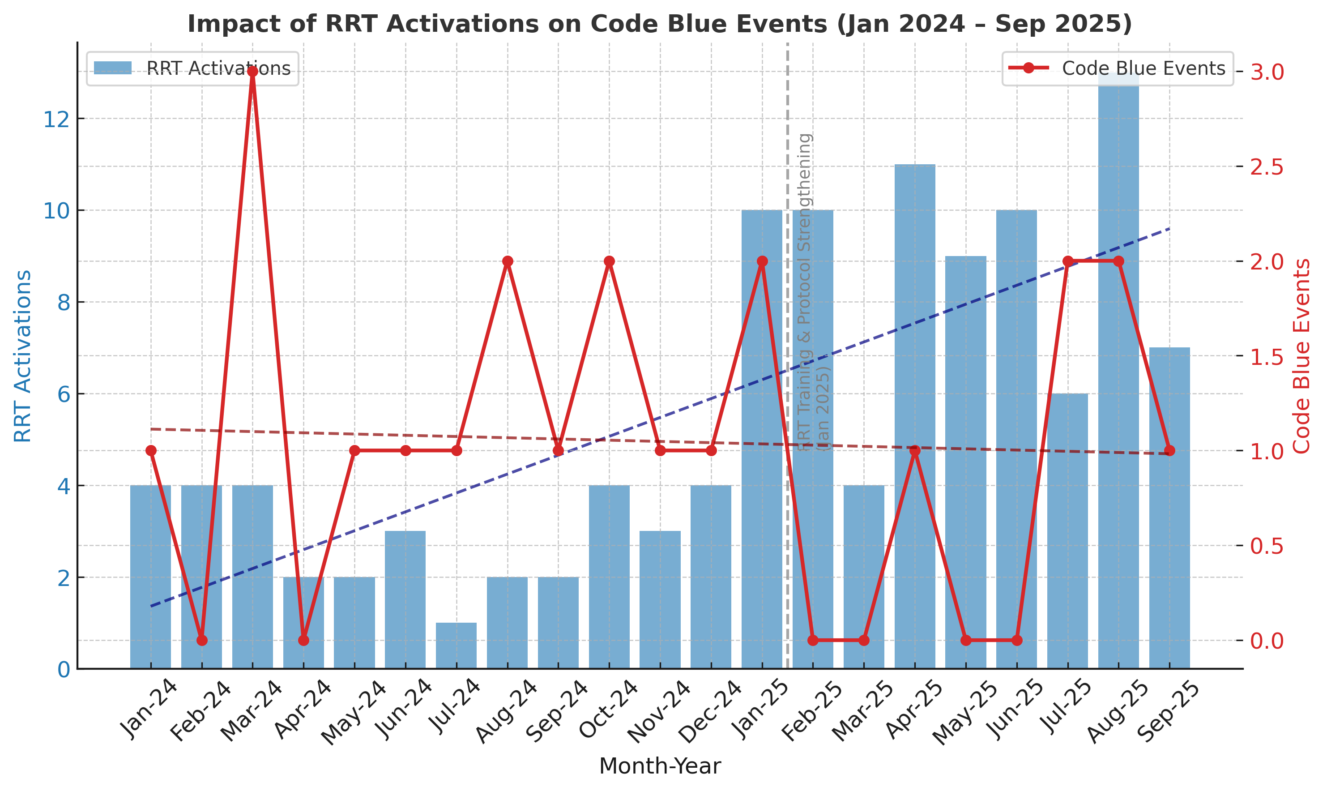
Figure 2. Post-intervention trend of RRT activations and Code Blue events (2025).
Total Number of RRT from Jan 2025-Sep 2025: 80
Total Number of Code event Jan 2025-Sep 2025: 08

Results
Following implementation of the interventions, a significant increase in RRT utilization was observed. During 2024, a total of 35 RRT activations were recorded. Between January and September 2025, the number increased to 80 activations. At the same time, Code Blue events demonstrated a declining trend in most months during the post-intervention period. The reduction was more noticeable in wards and dialysis units where focused training sessions had been conducted.
Mortality trends showed gradual stabilization during the intervention period. Months with fewer Code Blue events were generally associated with lower mortality trends, Mortality trends showed stabilization during the intervention period. of early recognition and timely intervention. Overall, increased utilization of the RRT system was associated with improvement in patient safety indicators and reduction in critical deterioration events.

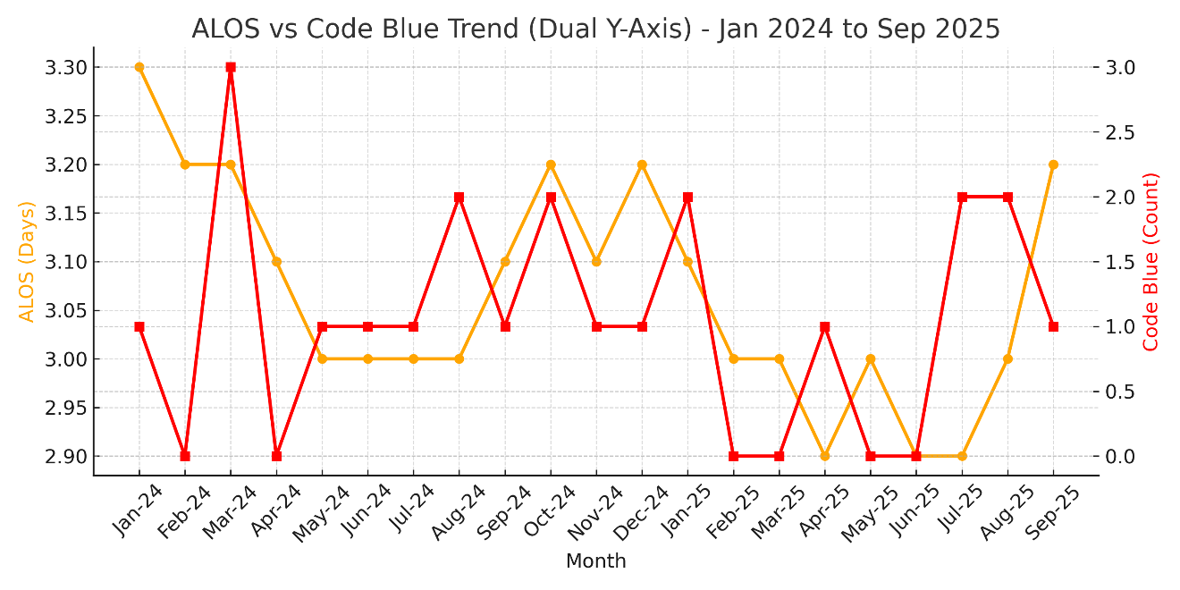
Year | RRT | Code Blue | ALOS
2024 | 35 | 14 | 3.28
2025 (Jan-Sep) | 80 | 8 | 3.03
Summary:
- Average ALOS (2024): 3.28 days
- Average ALOS (2025 till Sep): 3.03 days
- % Reduction: ~7.6% decrease in ALOS from 2024 to 2025

Discussion
The findings of this study suggest that improving awareness and utilization of Rapid Response Team services can positively influence patient safety outcomes. Many hospitalized patients show signs of deterioration before cardiac arrest occurs. Early identification and timely escalation provide an opportunity to intervene before the patient progresses to a critical stage. Similar findings have been reported in previous studies evaluating the effectiveness of Rapid Response Teams (5). One of the important observations during this project was the role of staff confidence and workplace culture in timely escalation. Initially, many staff members hesitated to activate RRT services because of fear of criticism or uncertainty regarding activation criteria. Continuous education, mock drills, and support from senior clinicians helped reduce this hesitation over time. Focused interventions in high-risk areas such as wards and dialysis units also contributed to better recognition of deteriorating patients. Reinforcement of regular vital signs monitoring and Modified Early Warning Signs supported earlier clinical intervention. The reduction in average length of stay and stabilization of mortality trends further indicate improvement in overall quality of patient care.

Analysis: Code Blue vs Mortality (Apr 2024 – Sep 2025)
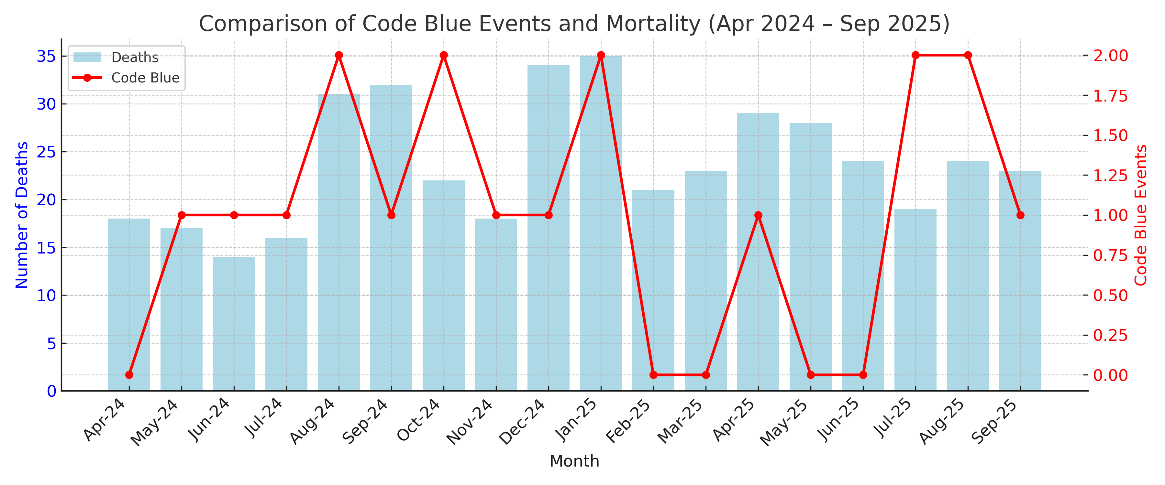
The comparative trend between Code Blue events and in-hospital deaths demonstrates a broad parallel pattern — months with higher Code Blue activation generally coincide with increased mortality rates.
In 2024, an upward trend in both Code Blue activations and deaths was seen between August and December 2024, indicating a possible period of higher patient acuity or delayed recognition of deterioration. Following the implementation of improvement measures (staff awareness, RRT training, and timely escalation protocols), a relative decline in Code Blue activations was observed during 2025, accompanied by stabilization or reduction in monthly deaths.
Clinically, this implies that the increase in Rapid Response Team (RRT) utilization and timely escalation may have contributed to fewer Code Blue events and a gradual reduction in hospital mortality. It highlights the importance of proactive monitoring and early intervention in preventing cardiac arrests and improving patient outcomes.

Limitations
This study was conducted in a single center and involved retrospective analysis of institutional data. Detailed patient-level analysis and advanced statistical testing were limited. Other hospital-related factors may also have influenced patient outcomes during the study period. No patient-level risk adjustment was performed.
Sustenance Plan
To maintain long-term improvement, the following measures will continue:
- Monthly review of RRT and Code Blue data
- Regular feedback sessions with clinical units
- Inclusion of RRT protocols in staff induction programs
- Quarterly mock drills and reinforcement training
- Ongoing involvement of senior clinicians in promoting early escalation practices

Conclusion
This quality improvement project demonstrated that increasing Rapid Response Team activations through staff education, awareness programs, and improved monitoring practices was associated with reduction in Code Blue events and improvement in patient safety outcomes. Early recognition of clinical deterioration and timely escalation remain important components of quality healthcare delivery. Sustained reinforcement of RRT systems may help reduce avoidable in-hospital cardiac arrests and improve overall patient care.

References
- Jones D, DeVita MA, Bellomo R. Rapid-response teams. N Engl J Med. 2011; 365:139–146. doi:10.1056/NEJMra0910926
- DeVita MA, Hillman K, Bellomo R. Medical emergency teams: developments and directions. Crit Care Med. 2006;34(9):2463–2478. doi: 10.1097/01.CCM.0000235743.84396.54
- Maharaj R, Raffaele I, Wendon J. Rapid response systems: a systematic review and meta-analysis. Crit Care. 2015; 19:254. doi:10.1186/s13054-015-0973-y
- Winters BD, Weaver SJ, Pfoh ER, Yang T, Pham JC, Dy SM. Rapid-response systems as a patient safety strategy: a systematic review. Ann Intern Med. 2013;158(5 Pt 2):417–425. doi:10.7326/0003-4819-158-5-201303051-00009
- Smith GB, Prytherch DR, Meredith P, Schmidt PE, Featherstone PI. The ability of the National Early Warning Score (NEWS) to discriminate patients at risk of early cardiac arrest. Resuscitation. 2013;84(4):465–470. doi: 10.1016/j.resuscitation.2012.12.016

