Steganography Information Sharing via Sound & Image for Secure Data Transmission

- Introduction
In the current era of digital communication, the secure transmission of sensitive information has become an impor-tant challenge. Data transmitted through public networks can be intercepted, modified, or accessed by unauthorized users. Modern communication systems therefore require techniques that can protect confidential information during transmission. Traditionally, cryptography has been used to secure digital communication by converting readable data into an encrypted form. Although cryptography protects the content of informa-tion, the presence of encrypted communication can still be easily identified on a network.
Steganography provides an alternative approach to secure communication by hiding the existence of the secret message itself. Instead of encrypting the data, steganography embeds secret information inside ordinary digital media such as im-ages, audio files, or videos [1]. The goal of a steganographic system is to hide the message in such a way that the modified media, known as the stego object, appears visually or audibly identical to the original cover media [2].
This research proposes a dual-media steganographic system that supports both image and audio data hiding. The system uses the Least Significant Bit (LSB) technique to embed secret messages into digital images and audio samples. LSB embedding is widely used in steganography because it allows data to be hidden with minimal impact on the visual or auditory quality of the media [3].
In addition to the steganographic process, the proposed sys-tem introduces a hardware-based access control mechanism. An ESP32 microcontroller is used as a hardware authentication token. The steganography application verifies the presence of the ESP32 device on the local network before allowing encoding or decoding operations. This hardware verification mechanism helps prevent unauthorized use of the steganogra-phy software.
The system is implemented using the Python programming language and the Flask web framework. The web interface allows users to upload images or audio files, enter secret mes-sages, and perform encoding or decoding operations through a simple interface.
The main objectives of this research are as follows:
- To design and implement a steganographic system ca-pable of hiding secret information in digital images and audio files using the Least Significant Bit (LSB) technique.
- To develop a web-based interface using Python Flask that allows users to easily encode and decode hidden

messages.
- To integrate an ESP32 microcontroller as a hardware authentication token that controls access to the steganog-raphy system.
- To evaluate the functionality of the system using differ-ent image and audio files with varying payload sizes.
- To demonstrate a practical implementation of steganog-raphy combined with hardware authentication for secure information sharing.
- Literature Review and Background
Research in the field of information hiding has evolved significantly over the past two decades. Various techniques have been developed to conceal secret information within digital media such as images, audio files, and video streams. Among these techniques, spatial domain methods have re-ceived considerable attention due to their simplicity and high embedding capacity. One of the most widely used spatial do-main approaches is the Least Significant Bit (LSB) substitution technique [2].
- Evolution of Image Steganography
Image steganography is one of the earliest and most widely studied forms of digital steganography. In standard digital images, each pixel is represented using intensity values that define the color components of the image. In grayscale images each pixel contains 8 bits, while in RGB images each pixel contains three color channels consisting of 8 bits each.
The LSB technique hides secret information by replacing the least significant bits of pixel values with bits of the secret message. Because these bits contribute very little to the overall pixel intensity, modifying them produces minimal visual distortion. Due to its simplicity and low computational complexity, LSB embedding has been widely used in many steganographic systems [1].
However, early LSB-based algorithms were often vulner-able to statistical steganalysis attacks. Techniques such as histogram analysis and Chi-square tests can sometimes re-veal the presence of hidden data if embedding patterns are predictable [3]. Researchers have therefore proposed various improvements and modifications to increase the robustness and security of LSB-based steganography.
- Challenges in Audio Steganography
Audio steganography involves embedding secret informa-tion inside digital sound signals. Compared to image steganog-raphy, audio steganography is more challenging because the Human Auditory System is highly sensitive to changes in sound signals. Even small distortions in audio samples may be detectable to listeners.
There are various methods that have been proposed for the purpose of audio steganography. Phase Coding, Spread Spectrum, and Echo Hiding are some of the prominent ones. Even though these methods offer greater robustness against compression and processing operations, they do not offer a greater embedding capacity. However, the LSB modification
of the audio samples offers a greater embedding capacity. This is the reason LSB is considered to be an appropriate method for the implementation of the steganographic system [4].
In the case of the practical implementation of the stegano-graphic system, the least significant bits of the audio samples are generally modified to accommodate the message. The least significant bits of the sound signal contribute very little to the overall amplitude of the sound signal. Therefore, the distortion is usually not noticeable.
- Hardware-Assisted Security Approaches
Recent advancements in the development of secure com-munication systems have also focused on the integration of hardware-based authentication mechanisms [4]. Such hard-ware tokens or microcontroller-based verification mechanisms are usually incorporated in access control-based applications to ensure that the software systems are not utilized by unau-thorized users.
Microcontrollers like ESP32 can be utilized for the imple-mentation of authentication mechanisms in software systems. This is because the presence of a particular hardware device can be verified on the local network before the execution of operations is allowed. This way, the unauthorized use of the software system can be restricted.
The proposed research will incorporate the integration of hardware-based authentication mechanisms with the data hiding mechanism based on steganography. The hardware-based authentication mechanism will be implemented using an ESP32 microcontroller.
- Theoretical Foundation and Methodology
In order to understand the working of the proposed system, it is important to explain the basic principles on which the steganographic techniques used in this research are based. The proposed system is focused on hiding the information inside the digital media such as images and audio files using simple bit-level operations. The proposed system is mainly based on the Least Significant Bit (LSB) technique to embed the secret information without any visible or audible distortions [1], [2]. Unlike complex transform-domain steganography tech-niques, the proposed system uses a spatial and time-domain approach where secret bits are directly embedded into the least significant bits of the media data. Because the least significant bits contribute very little to the overall value of the pixel or audio sample, modifying them usually does not
cause noticeable changes in the media file.
- Image Steganography Logic (Spatial Domain LSB)
Digital images are composed of a grid of pixels. In a typical RGB image, each pixel contains three color components: Red, Green, and Blue. Each component is represented using 8 bits, giving values ranging from 0 to 255.
In the proposed system, the Least Significant Bit of the red channel is modified to store the secret message bits. The embedding process works as follows:

  - The system reads the image and converts it into an array of RGB pixel values.
  - The secret message is converted into a stream of binary bits.
  - The algorithm selects pixels sequentially from the im-age.
  - The least significant bit of the red component of each pixel is replaced with one bit of the secret message.
For example, if the original red channel value of a pixel is:

10110110

and the message bit to embed is 1, the last bit is modified as:

10110111

Because the change only affects the least significant bit, the color intensity changes by only one level. Such a small change is generally imperceptible to the human eye. Similar LSB substitution techniques have been widely used in image steganography systems due to their simplicity and high em-bedding capacity [1].
After embedding the message bits, the modified pixel matrix is reconstructed to generate the final stego image. The stego image can then be saved and transmitted without revealing the presence of hidden data.

- Audio Steganography Logic (Time Domain LSB)
Audio steganography hides information inside digital sound signals. A digital audio file represents sound as a sequence of samples recorded at a fixed sampling rate.
In this research, WAV audio files are used because they are uncompressed and allow direct access to audio samples. The embedding process modifies the least significant bits of the audio samples to store message bits.
The process is performed as follows:
  - The input audio file is read and converted into a se-quence of audio samples.
  - The secret message is converted into binary format.
  - The algorithm iterates through the audio samples se-quentially.
  - The least significant bit of each sample is replaced with one bit of the secret message.
Because the modification occurs only in the least significant bit, the change in amplitude of the audio signal is extremely small. Such minor variations are typically not detectable by human hearing. LSB-based techniques are commonly used in audio steganography because they provide high embedding capacity while maintaining acceptable audio quality [4], [5].
After embedding the message bits, the modified samples are reconstructed to create the final stego audio file.
- System Architecture and Hardware Integration
The proposed system uses software-based steganography along with hardware-based authentication. The proposed ar-chitecture ensures the execution of the encoding and de-coding processes only when the authorized hardware device is connected to the network. Similar steganography-based communication systems have been proposed in the past under the scope of secure data transmission using hidden information techniques. [2], [7].
Flask Web GUI (User Interface)
Python Backend (Processing Engine)
Network Request
Verification
ESP32 Hardware Token (Authentication)
Image LSB Module
Audio LSB Module
Fig. 1. System architecture showing interaction between the web inter-face, Python processing engine, ESP32 hardware authentication device, and steganography modules.
The web interface is implemented using the Flask frame-work and allows users to upload media files and enter secret messages. The interface communicates with the Python back-end, which performs the steganography operations.
Before performing any encoding or decoding operation, the Python backend verifies the presence of the ESP32 hardware device on the local network. The ESP32 acts as a hardware authentication token and responds to verification requests sent by the application.
If the ESP32 device is detected and verified, the backend proceeds with the requested operation. Depending on the type of media selected by the user, the system activates either the image steganography module or the audio steganography module.
The image module embeds secret data into the least sig-nificant bits of image pixels, while the audio module embeds data into the least significant bits of audio samples. Similar LSB-based embedding techniques have been widely used in previous steganography research due to their simplicity and efficiency [1], [4]. This architecture therefore combines prac-tical steganographic data hiding with hardware-based access control.
- Algorithmic Workflow
The system performs steganographic encoding and decoding through a sequence of clearly defined steps. The workflow be-gins with hardware authentication, followed by media process-ing and data embedding. The algorithms below describe the procedures used for hardware validation, image steganography, audio steganography, and data extraction.

- Hardware Verification Algorithm
Before performing any encoding or decoding operation, the system verifies the presence of the ESP32 hardware device on the local network.

Algorithm 1 Hardware Verification Procedure
Require: Hardware IP Address IP

Algorithm 3 Audio LSB Data Embedding
Require: Cover Audio A, Secret Message M
Ensure: Stego Audio W
1: Convert M into binary bit stream B
2: Load audio samples from A
3: BitIndex ← 0
4: for each audio sample do

hw
Ensure: Authorization Status
1: Auth ← HTTPGET(IP_{hw} + ”/verify”)
2: if Auth response received then
3: return Authorized
4: else
5: return Access Denied
6: end if

- Image Steganography Algorithm
After successful hardware verification, the system embeds secret data inside the image using the Least Significant Bit (LSB) technique.

Algorithm 2 Image LSB Data Embedding
Require: Cover Image I, Secret Message M
Ensure: Stego Image S
1: Convert M into binary bit stream B
2: Load image I as RGB pixel array
3: BitIndex ← 0
4: for each pixel in image do
5: if BitIndex ≥ Length(B) then
6: break
7: end if
8: Replace LSB of pixel value with B[BitIndex]
9: BitIndex ← BitIndex + 1
10: end for
11: Save modified pixels as stego image S
12: return S

- Audio Steganography Algorithm
For audio files, the secret message is embedded into the least significant bits of audio samples.

- Data Extraction Algorithm
During decoding, the system extracts hidden bits from the least significant bits of the stego media.

- System Implementation and Interfaces

To demonstrate the practical feasibility of the proposed system, a complete working prototype was developed by integrating the ESP32 hardware device with the Python-based software application.
5: if BitIndex ≥ Length(B) then
6: break
7: end if
8: Replace LSB of sample with B[BitIndex]
9: BitIndex ← BitIndex + 1
10: end for
11: Reconstruct audio file W
12: return W

Algorithm 4 LSB Data Extraction Require: Stego Media S
Ensure: Extracted Message M
1: Initialize empty bit stream B
2: for each pixel or audio sample in S do
3: Extract LSB and append to B
4: end for
5: Convert binary stream B to text message M
6: return M

- The Web Application Interface
The software front-end is built using HTML dynamically served by the Python Flask framework. By hiding the internal processing steps and hardware network verification in the background, the system provides a highly accessible user experience.
The routing logic ensures that uploaded files are temporarily stored during processing and removed immediately after the operation is completed. This approach helps reduce the risk of data leakage and prevents sensitive information from being permanently stored on the server.
If the ESP32 hardware device is not detected on the
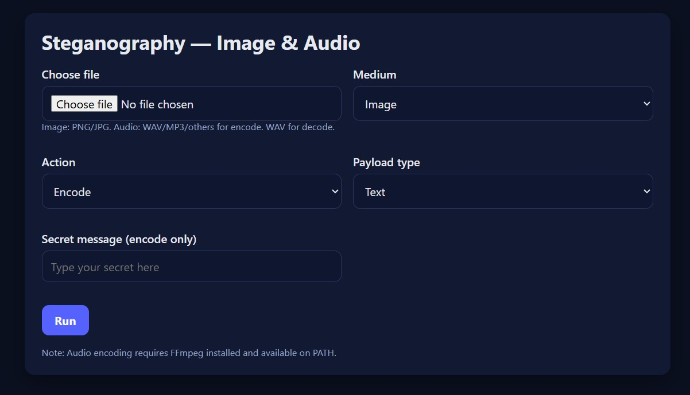

Fig. 2. Web Interface for Image and Audio Steganography Encoding and Decoding

local network, the system immediately blocks the requested operation and displays a warning message to the user. This prevents unauthorized access to the encoding and decoding functionalities.

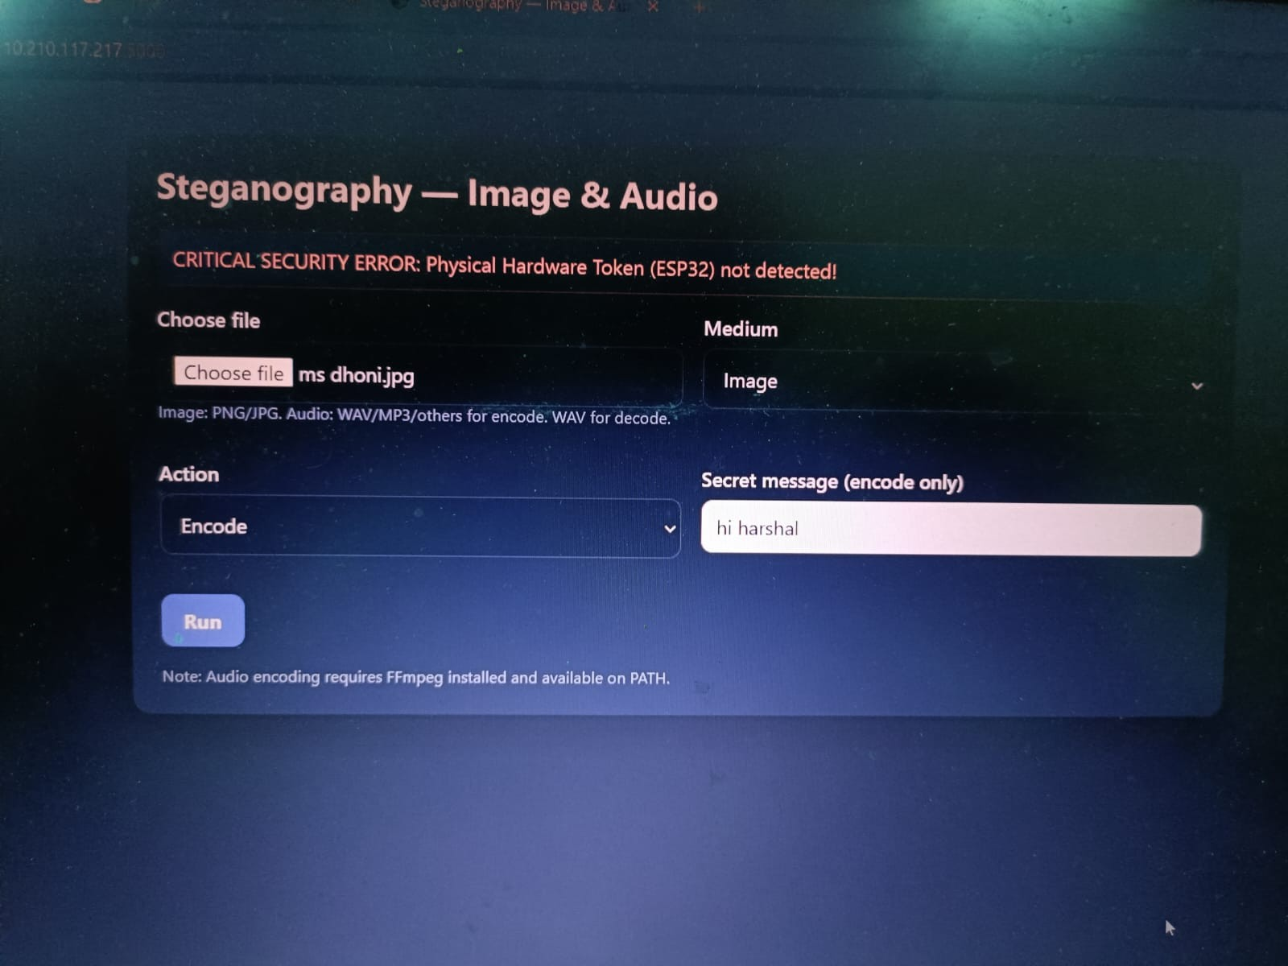
Fig. 3. Security warning displayed by the application when the ESP32 hardware token is not detected on the network.

- The Hardware Setup Configuration
The physical hardware authentication component of the system uses the ESP32-WROOM-32 (30-pin version) micro-controller. The microcontroller was programmed using the Arduino IDE in C++ to function as a lightweight HTTP server. When powered using a standard 5V USB connection, the ESP32 automatically connects to the local Wi-Fi router. The device continuously listens for verification requests sent by the
Python server.
When the Flask application sends a request to the predefined endpoint (for example, /verify), the ESP32 responds to confirm its presence on the network. If a valid response is received, the system allows the steganographic encoding or decoding process to proceed.
- Experimental Results and Evaluation
The effectiveness of a steganographic system is evaluated based on its ability to hide secret data while maintaining the original perceptual quality of the media file. In this work, experiments were conducted using different image and audio files with varying payload sizes. The goal of the evaluation was to verify that the hidden data could be embedded and successfully extracted without noticeable distortion in the media.
- Image Steganography Evaluation
For image steganography experiments, different image reso-lutions were used as cover media. Secret messages of varying sizes were embedded using the Least Significant Bit (LSB) technique. The evaluation focused on the relationship between the cover image size, payload size, and resulting stego image size.

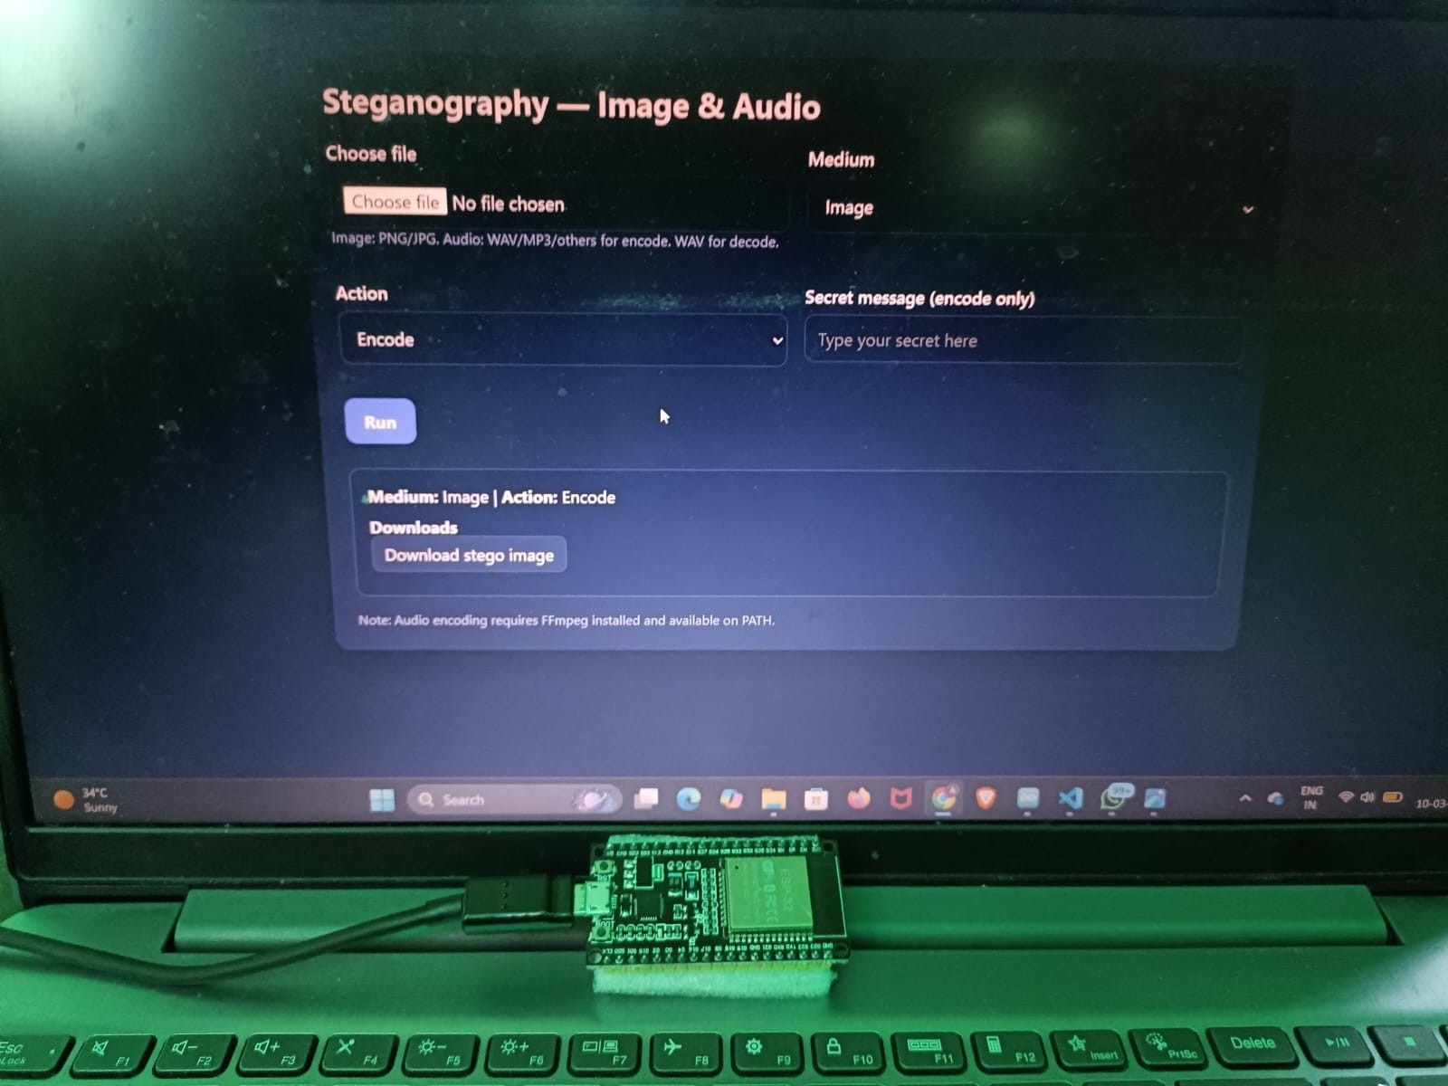
Fig. 4. Experimental hardware setup showing the ESP32-WROOM-32 microcontroller used as the hardware authentication token.

Table I summarizes the results obtained during the image steganography experiments.

TABLE I
Image Steganography Embedding Results

Image Resolution | Cover Size | Payload Size | Stego Size
512 × 512 | 22 KB | 3 KB | 27 KB
512 × 512 | 37 KB | 15 KB | 76 KB
800 × 600 | 120 KB | 25 KB | 156 KB
1024 × 1024 | 178 KB | 18 KB | 233 KB
1024 × 1024 | 438 KB | 37 KB | 728 KB
1920 × 1080 | 1.45 MB | 250 KB | 1.67 MB
1920 × 1080 | 1.68 MB | 500 KB | 2.29 MB

The results indicate that embedding secret data using the LSB technique introduces only a very small change in the overall file size of the image. Visual inspection of the stego images confirmed that there were no noticeable artifacts or distortions compared to the original cover images.
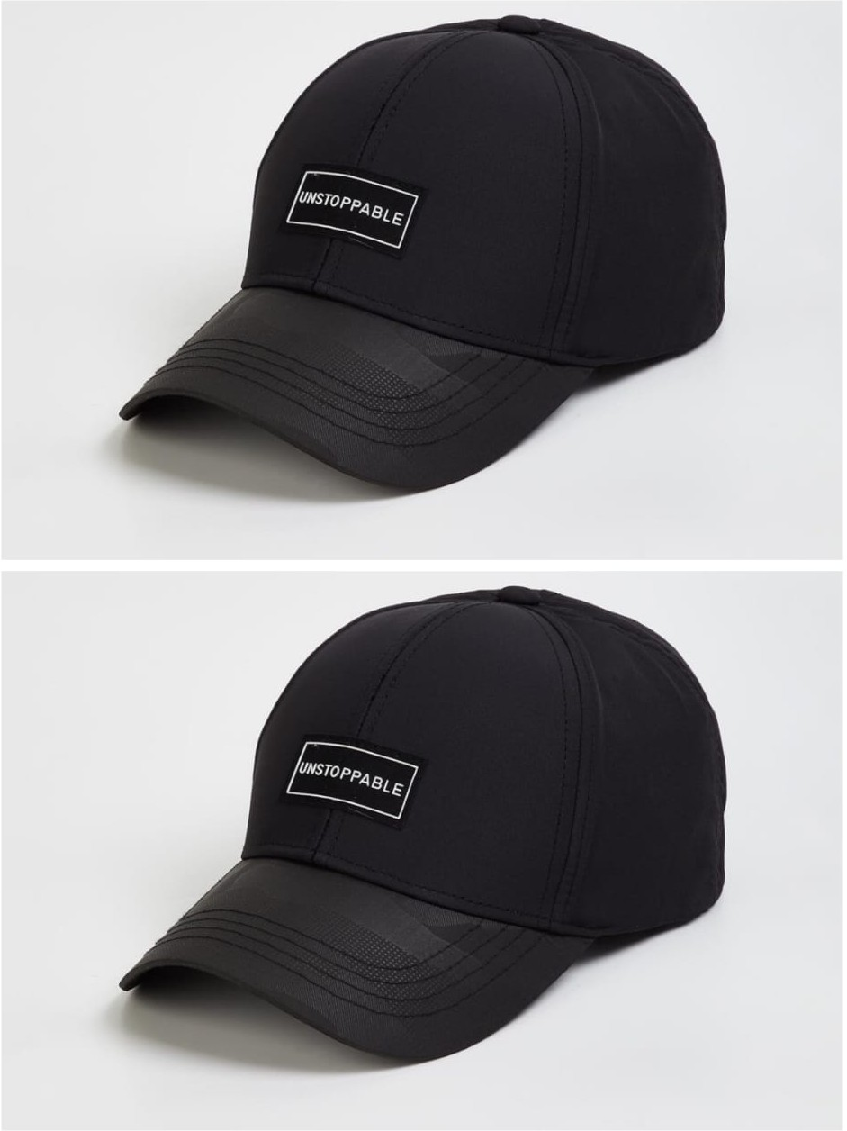
Fig. 5. Comparison between the original cover image and the generated stego image after embedding the secret message.

- Audio Steganography Evaluation
For audio steganography experiments, WAV audio files with different durations were used as cover media. Secret messages were embedded into the least significant bits of audio samples. Table II presents the results obtained for audio data embed-
ding.

TABLE II
Audio Steganography Embedding Results

Audio Length | Cover Size | Payload Size | Stego Size
10 Seconds | 860 KB | 5 KB | 962 KB
30 Seconds | 2.7 MB | 25 KB | 3.23 MB
60 Seconds | 4.3 MB | 100 KB | 4.8 MB
90 Seconds | 7.7 MB | 150 KB | 8.61 MB
120 Seconds | 12 MB | 200 KB | 13.15 MB
180 Seconds | 15.3 MB | 500 KB | 16.38 MB

The experimental results show that the proposed LSB-based audio steganography approach can successfully embed secret messages without producing noticeable changes in the audible quality of the audio signal.During testing, the encoded audio files were played using standard audio players and compared with the original audio files to observe any perceptible differ-ences.
- Role of Hardware-Based Authentication
An additional layer of security is provided through the use of the ESP32 hardware authentication mechanism. Since encoding and decoding operations require verification of the ESP32 device on the local network, unauthorized users cannot easily access the steganography functionality of the system.
This hardware-based verification mechanism enhances the overall security of the system by restricting access to autho-rized users.
- Real-World Applications
The integration of steganography with hardware-based au-thentication enables the proposed system to be applied in sev-eral practical security-sensitive environments. Some potential real-world applications are described below.
- Military and Defense: Sensitive operational information such as tactical coordinates or mission data can be hidden within standard satellite images or communication media. Hardware verification using the ESP32 device adds an additional layer of access control before the hidden information can be retrieved.
- Healthcare Data Privacy: Medical records or diagnostic reports can be embedded within medical images such as X-rays or MRI scans. This approach can help protect patient data during transmission across hospital networks while ensuring that only authorized systems can perform the decoding process.
- Corporate Data Protection: Organizations can use the proposed system to securely transfer confidential documents or intellectual property between departments or branch offices. By embedding sensitive information
within multimedia files and requiring hardware authen-tication, the risk of unauthorized data access can be reduced.
- Future Scope and Advancements
  - Hardware-Level Steganography Processing: The fu-ture versions of the proposed system can have the steganography processing done on the ESP32 or other embedded devices. This can enhance the security of the proposed system because the steganography can be done on the hardware itself.
  - Video Steganography Integration: The proposed sys-tem supports image and audio media. The steganography approach can be extended to video media files such as MP4 and MKV formats. This can provide a higher capacity to hide the data by using the spatial and
  - Adaptive or Intelligent Embedding Methods: Ad-vanced embedding techniques using machine learning or image analysis could be explored to identify suitable re-gions of media files where hidden data is less detectable. Such adaptive methods could improve resistance to steganalysis while maintaining high media quality.
- Conclusion
This study introduces a way to secretly share information using images and audio, along with a special hardware check. The system combines a technique called Least Significant Bit steganography with a small computer chip, the ESP32 microcontroller, which acts like a security guard that checks everything before the information is hidden or revealed.
A WebPage made with Python’s Flask framework lets users easily hide and find secret messages in pictures and music. Tests showed that the system can successfully hide secret information in images and audio files without changing how they look or sound. Adding a hardware check gives an extra layer of security, stopping people from using the secret message feature without permission. This means only authorized users can access the hidden messages.
The suggested method shows that using steganography along with simple hardware authentication can make data hiding systems more secure and easier to use. This system offers a practical way to securely send messages in situations where you need to both hide and control access to the data. By combining these two techniques, it’s possible to create a more reliable and efficient way to protect sensitive information. This approach can be really useful in environments where security and privacy are top priorities.
References
- N. F. Johnson and S. Jajodia, ”Exploring Steganography: Seeing the Unseen,” IEEE Computer, vol. 32, no. 2, pp. 26–34, 1998.
- F. A. P. Petitcolas, R. J. Anderson, and M. G. Kuhn, ”Information Hiding
— A Survey,” Proceedings of the IEEE, vol. 87, no. 7, pp. 1062–1078, July 1999.
- N. F. Johnson and S. Jajodia, ”Steganalysis of Images Created Using Current Steganography Software,” in Information Hiding, LNCS 1525, Springer, pp. 273–289, 1998.
- R. Patil and D. Pawar, ”Secure Audio Steganography by LSB for Hiding Information,” IJIERT, vol. 8, no. 3, pp. 45–50, 2021.

- R. Shanthakumari, E. M. R. Devi, R. Rajadevi, and B. Bharaneeshwar, ”Information Hiding in Audio Steganography using LSB Matching Revisited,” Journal of Physics: Conference Series, vol. 1911, no. 1, 2021.
- A. Mstafa and K. Elleithy, ”A Robust and Secure Video Steganography Method in DWT-DCT Domains Based on Multiple Object Tracking and ECC,” IEEE Access, vol. 5, pp. 5354–5365, 2017.
- T. Chen, L. Shangguan, Z. Li, and K. Jamieson, ”The Design and Implementation of a Steganographic Communication System over In-Band Acoustical Channels,” ACM Transactions on Sensor Networks, 2023.
- T. Morkel, J. H. P. Eloff, and M. S. Olivier, ”An Overview of Image Steganography,” in Proceedings of the Fifth Annual Information Security South Africa Conference (ISSA), South Africa, 2005.
- A. A. Alarood, A. M. Alghamdi, A. O. Alzahrani, A. Alzahrani, and
- Alsolami, ”Audio Steganography Method Using Least Significant Bit (LSB) Encoding Technique,” IJCSNS International Journal of Computer Science and Network Security, vol. 22, no. 7, pp. 427–435, 2022.
:contentReference[oaicite:0]index=0
- S. Gangurde and K. Tiwari, ”LSB Steganography Using Pixel Locator Sequence with AES,” arXiv preprint arXiv:2012.02494, 2020. :con-tentReference[oaicite:1]index=1
- A. Chadha and N. Satam, ”An Efficient Method for Image and Audio Steganography using Least Significant Bit (LSB) Substitution,” Interna-tional Journal of Computer Applications, vol. 68, no. 15, pp. 1–4, 2013.
:contentReference[oaicite:2]index=2
- S. Chakraborty, A. S. Jalal, and C. Bhatnagar, ”LSB Based Non Blind Predictive Edge Adaptive Image Steganography,” arXiv preprint arXiv:2201.01277, 2022. :contentReference[oaicite:3]index=3
- Y. Nour-El Aine and C. Leghris, ”Stego-CIMA: A Lightweight Steganography-Based Framework for Secure IoT Communication,” In-ternational Journal of Intelligent Engineering and Systems, vol. 18, no. 7, pp. 892–905, 2025. :contentReference[oaicite:4]index=4
- M. Yamni et al., ”Efficient Color Image Steganography Based on New Chaotic Map and Discrete Moment Transforms,” Mathematics and Computers in Simulation, vol. 225, pp. 52–71, 2024. :contentRefer-ence[oaicite:5]index=5
- B. K. Sahoo, P. Machado, I. K. Ihianle, A. Oikonomou, and S. Boppu, ”SteganoSNN: SNN-Based Audio-in-Image Steganography with Encryption,” arXiv preprint arXiv:2511.06573, 2025. :contentRefer-ence[oaicite:6]index=6

