EXTRACTION OF BACTERIOCINS FROM LACTOBACILLUS AND ITS EFFECT AGAINST CANDIDA ALBICANS, ASPERGILLUS, MALASSEZIA, FUSARIUM AND PENICILLIUM SP CAUSING SKIN INFECTIONS

AparnaRavi*¹,Dr. M. Thankavel ^{*2}

¹ Department of Microbiology, Nehru Arts And Science College, Coimbatore, aparnaravimicropg20@gmail.com, 9496556577.
² Deen School of Life Sciences, Nehru Atrs And Science college, Coimbatore. 9489591066.

ABSTRACT
This paper aims to examine the isolation of Lactobacillus from dairy products (milk, curd, and yogurt), extraction of its Bacteriocin as well as to determine their inhibitory effect against few skin pathogens such as: Candida albicans, Aspergillus sp, Malassezia sp, Fusarium sp, and Penicillium sp. The antagonistic activity of Lactobacillus sp. Bacteria is mainly due to the bacteriocin present in it, so in this study, directly the bacteriocin is extracted and checked against the indicated microorganisms. Kirby Bauer Disc Diffussion method is used and zone of clearance is observed around the pathogenic species indicating that they shows some kind of Antagostic activities which are further measured and noted, which gives a clear picture about the degree of resistance of bacteriocin against the organisms.
(Key words: Bacteriocin, Inhibitory effect, Antagonistic activity, Skin pathogens, Kirby Bauer disc diffusion).

- INTRODUCTION
Balanced skin is crucial for maintaining healthy skin functioning; but changes in the skin microbes are associated with skin diseases such as which caused by: Candida albicans, Aspergillus, Malassezia furfur, Fusarium, and Penicillium. Lactobacilli are probiotic belonging to the group of lactic acid bacteria, they are gram positive, non- sporulating, anaerobic or facultative anaerobic rods. They are commonly present in dairy products, soil, lakes, and intestinal tract of human and animals. Lactobacillus possess antagonistic activity against various pathogenic microorganisms. (Mohammad Khalilil, Aziz Homayouni Rd, Ahmad Tari Khosroushahi, Hadi Khosravi and Somayeh jafarzadeh).In the present study, the Lactobacillus sp from dairy products like milk, curd, and yogurt are isolated; then Bacteriocin is extracted from it and checked their efficacy against fungal pathogens using the technique of Kirby Bauer disc diffusion method. (Berliner and Munchener, Tierarztliche Wochenschrift 114 (11-12), 410-419, 2001), Bacteriocins are low molecular weight peptides secreted by the bacterial cells to kill sensitive cells present in the same ecosystem competing for food and other nutrients. Bacteriocins along with their native antibacterial property also exhibit additional antiviral, and antifungal property. Now a days, (Veeresh juturu, Jin chuan Wu). The dairy samples (milk, curd and yogurt) were collected in sterile containers from different places of Vandithavalam, Palakkad, kerala. (Sahar karami, Mohammod Roayeri, Mohammoud Rafieian – Kopoei). The samples were analysed microbiologically, identified and confirmed by biochemical tests. The bacteriocin action of Lactobacillus was studied against Candida albicans, Aspergillus, Malassezia furfur, Fusarium, Penicillium. (Jin chuan Wu).

- MATERIALS AND METHODS

  - Collection of milk samples
Raw milk samples of cow and goat were collected in a sterile container in the month of February 2022 at various places of Vandithavalam, Palakkad, Kerala for the isolation of Lactobacillus species and transported to the lab for examination under aseptic conditions.

  - Collection of curd samples
Homemade curd samples and commercially available curd samples of two different brands were collected for the isolation of Lactobacillus sp.
  - Collection of Yogurt samples
Yogurt samples of two different commercially brands were collected for the isolation of Lactobacillus sp.
  - Isolation of Candida albicans
Swabs were taken from patients with toe nail and skin infections characterized by fluid discharge, Colourchanges of the nail, Pain in the nail and toe. (Boni E. Elewski).
  - Isolation of Malassezia
Malassezia samples were collected by taking the Scrappings from various patients of head and neck dermatitis characterized by white patchy scales present in the affected areas with itching and dryness. (Diatte M. L. Saute. George Gaitanis, and Roderick James Hay).
  - Isolation of Aspergillus
Swabs were collected from patients with skin injury and burns. (Jo – Anne H. Burik, Roy Colven, and David H. Spach).

  - Isolation of Fusarium
Swabs were collected from skin lesions through aseptiv techniques. (Marcio Nucci, Elias Annaissie).
  - Isolation of Penicillium
Swabs were taken from patients of skin lesions with swelling and redness in the skin with discolouration. (Devanshi Mehta, Samuel A Hofacker, (…), and Sarah P Hammond).

- METHODS
Isolation and characterization of Lactobacillus from dairy samples
- The milk, curd and yogurt samples were serially diluted in various test tubes.
- MRS (de Man, Rogosa, and Sharpe agar- selective media for LB) agar plates were prepared.
- Swabs from various dilutions from each of the samples of milk, curd and yogurt were swabbed onto MRS agar plates using sterile techniques and control plates were maintained.
- All the inoculated plates of three different samples of different dilutions were incubated at 37 degree Celsius for exactly 24 hours and then plates were observed for growth. (Babak Haghshenas, Yousef Nami and Ahmad Yari Khosroushahi).
- Colonies formed in the plates were subjected for Staining and biochemical tests for the confirmation of the species of microorganisms present.

  - GRAMS’ STAINING
A clean grease free glass slide was taken, washed thoroughly, surface sterilised using ethanol and smear of single colony has been made on the slides and was allowed to dry, the smear is heat fixed by passing the slide above flame of Bunsen burner for 2-3 times. The smear was cooled and flooded with the primary stain -crystal violet, then wait for 1 minute was wash it under running tap water. Then added the Mordant- Gram’s iodine, waited for one minute and decolorized it with 95% ethyl alcohol, washed under running tap water. Finally added few drops of the counter stain -Safranin, waited for 1 minute and washed under running tap water, air dried and observed under oil immersion of 100X.

  - CATALASE TEST
A clean glass slide was taken, washed and added a drop of hydrogen peroxide to the center of the slide, then fresh culture of test organism is mixed properly to it using a tooth pick or inoculaion loop and observed for the presence of bubble formation.
  - OXIDASE TEST
Oxidase disc was taken, placed in a moisture free area and a small portion of test culture is Spreaded on to it using a toothpick or inoculation loop and observed for the presence of colour change.
  - INDOLE TEST
Tryptophan broth was prepared and poured into test tubes, kept for sterilization. Broth was cooled and inoculated with the test organisms and kept for incubation at 37 degree Celsius for 24 hours in an incubator. After 24 hours of incubation few drops of Kovac’s reagent as an indicator was added to the test tubes and observed the colour change.
  - METHYL RED TEST
MR-VP broth was prepared and poured in to sterile test tubes and kept for sterilization. Broth was inoculated with the test organisms and kept for incubation at 37 degree Celsius for 24 hours in an incubator. After incubation Methyl red reagent as an indicator was added and observed the colour change.
  - VOGES-PROSKAUER TEST
MR-VP broth was prepared and poured in to sterile test tubes and kept for sterilization. Broth was inoculated with the test organism and incubated at 37 degree Celsius for 24 hours in an incubator. After incubation add few drops of Barrit’s reagent A and Barrit’s reagent B, Shaked and observed the colour change.
  - CITRATE UTILIZATION TEST
Simmon citrate agar medium was prepared and sterilised, poured into test tubes and slants were prepared by keeping the test tubes by sliding above the glass rod. Now streaked with the test organism and kept for incubation at 37 degree Celsius for 24 hours.

  - CARBOHYDRATE FERMENTATION TEST
Glucose, Fructose, Sucrose, Xylose and Lactose fermentations are checked in this test. The test was performed by using 1% sugar in MRS broth. Media was poured into test tubes and Durham’s tube was inserted invertably into it. Test Culture is inoculated and the tubes were incubated at 37 degree Celsius for 24 hours. Phenol red was used as an indicator. Observed the colour changes and formation of gas bubbles after the reaction with phenol red.

3.9 Extraction of Bacteriocins
Extraction of bacteriocins from Lactobacillus was done using chloroform extraction method. (Ruixiang Zhao, Gaili, Duan, Tianyou Yang, Shengyang Niu, Ying Wang).

2.4.1 Isolation of Candida albicans species
Sabouraud Dextrose Agar media was prepared. Samples collected from patients were swabbed on to SDA plates at 37 degree Celsius 2-5 days and growth were observed. (Petros A. Maragkoudakis, Georgia Zoumpopoulou Christos Miaris, George Kalantzopoulos, Bruno pot, Effie, Tsakalidou).
(Shar Karami, Mohammad Roayaei, and Mahmoud Rafieian Kopaei).
2.5.1 Isolation of Malassezia species
Malassezia scrapings from patients were introduced to Dixon agar and SDA agar plates and incubated at 37 degree Celsius for 3-5 days and observed growth. (Abdourahim Abdillah, Saber Khelaifia, Didier Raoult, Fafi Bittae, Stephane Rengue).
    - Isolation of Aspergillus, Penicillium and Fusarium species
Swabs taken from patients were introduced into SDA plates and incubated at 25 degree Celsius for 2-5 days. (Sani U. Diso, Jaafar S. AdM, Lurwan Muazu, Muhammad S. Abdullah, Muhammad Ali).
- Checking the Antagonistic activity
Antimicrobial activity was tested by disc diffusion method. (James J. Biemer, M.D).
Candida albicans, Aspergillus, Malassezia, Fusarium and Penicillum samples were swabbed onto separate Muller Hinton Agar plates and sterile discs coated with Bacteriocins of Lactobacillus were placed on its surface at equal distance. Then the plates were incubated and
Observed the zone of inhibition around the discs. The diameter was measured and tabulated. (Beena Shino, Faizal C. Peedikayil, Syamala R. Jaiprakash, Gufran Ahmad Bilapur, Soni Kottayi, and Deepak Jose).
RESULTS AND DISCUSSIONS
In the MRS agar plates, small to medium white colonies were observed. Gram staining showed purple rods indicating gram positive rod shaped bacteria. Biochemical showing oxidase positive, catalase positive, indole positive, MR positive, Citrate positive, lactose fermentation positive indicated the lactic acid bacteria-Lactobacillus. Bacteriocin was extracted from it. Candida albicans, Aspergillus, Malassezia, Fusarium and Penicillum swabbed plates were inoculated with the bacteriocin coated discs and zone of clearance was observed around the discs. The diameter of zone was measured and tabulated.
Table -1 MORPHOLOGICAL CHARACTERISTICS
Sl.no | Characteristics | LB -1 observations | LB -2 Observations
1 | Colony morphology on Nutrient agar | Creamy pale white colonies were seen | Small white raised colonies were seen
2 | Colony morphology on MRS agar | Pale white coloured colonies were seen | Pale white coloured round colonies were seen
3 | Gram staining | Purple coloured rods in chains were observed | Purple coloured rods in chains were observed

Table -2 BIOCHEMICAL CHARACTERISTICS
Name of tests | Results (LB-1) | Results (LB-2)
Indole | Positive | Positive
Methyl red | Positive | Positive
Voges proskauer | negative | negative
Citrate utilization | Positive | Positive
Triple sugar iron agar | Negative | Negative
Oxidase | Negative | Negative
Catalase | Positive | Positive
Urease | Negative | Negative
Triple sugar iron agar tests | Negative | Negative
Carbohydrate utilisation | Glucose positive  Lactose positive  Sucrose positive | Glucose positive  Lactose positive  Sucrose positive
Capsule | Negative | Negative
Motility | Non motile | Non motile

Table-3 PHYSIOLOGICAL PROPERTIES
Sl.no | Physiological conditions | Isolate 1 | Isolate 2
1 | Growth at temperature | 15◦c negative  37◦c positive  45◦c positive | 15◦c negative  37◦c positive  45◦c positive
2 | Growth at pH | 3 positive  5 positive  7 positive  9 negative | 3 positive  5 positive  7 positive  9 negative
3 | Growth at NaCl (6.5%) | negative | positive

Table-4 MEASUREMENT OF ZONE OF INHIBITION AGAINST BACTERIOCIN OF LACTOBACILLUS
Organisms | Diameter of zone (mm)
Candica albicans | 14mm
Aspergillus sp | 15mm
Malassezia furfur | 14.5mm
Fusarium sp | 13mm
Penicillium | 12mm

LIST OF FIGURES
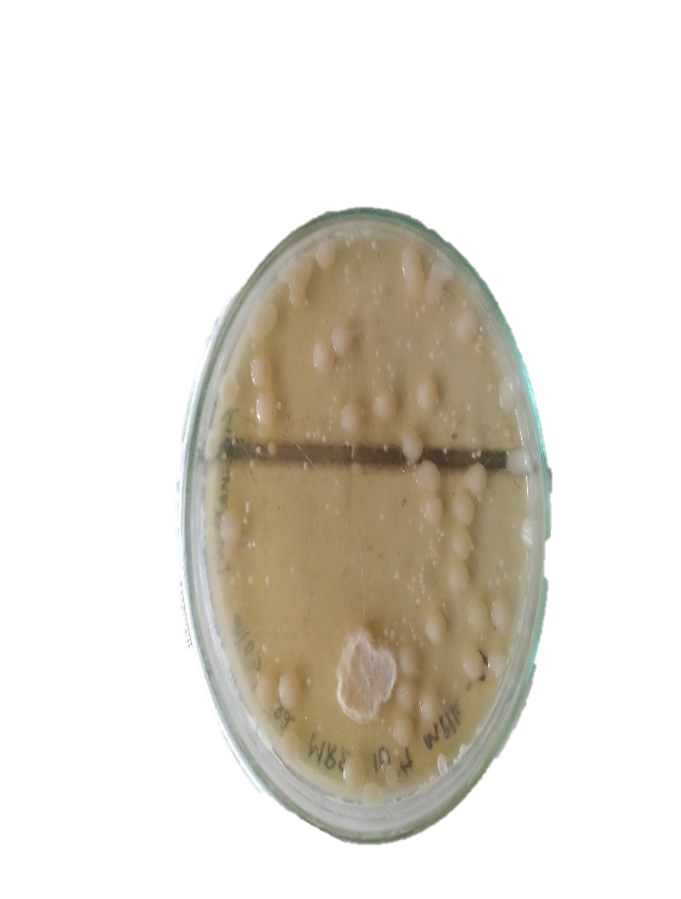
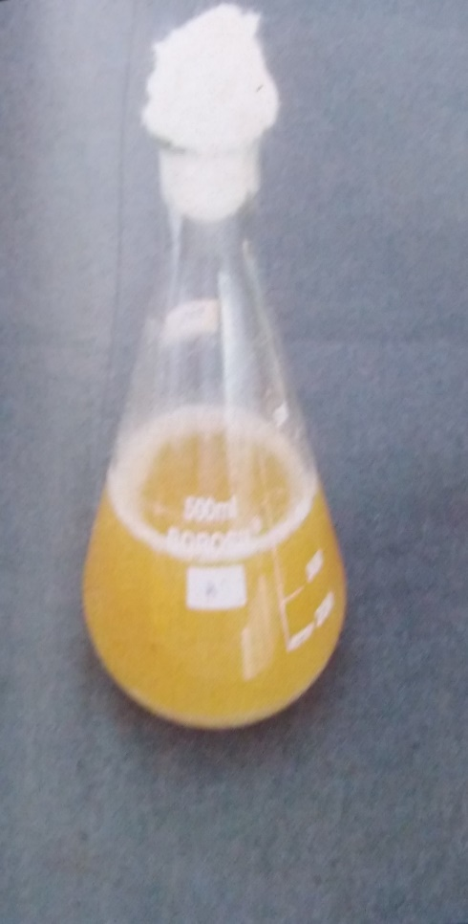
Fig-1 MRS agar
(Selective Media for Lactobacillus)
Fig -2- colonies on MRS Agar

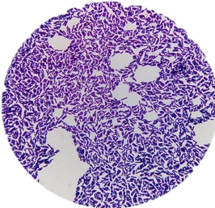
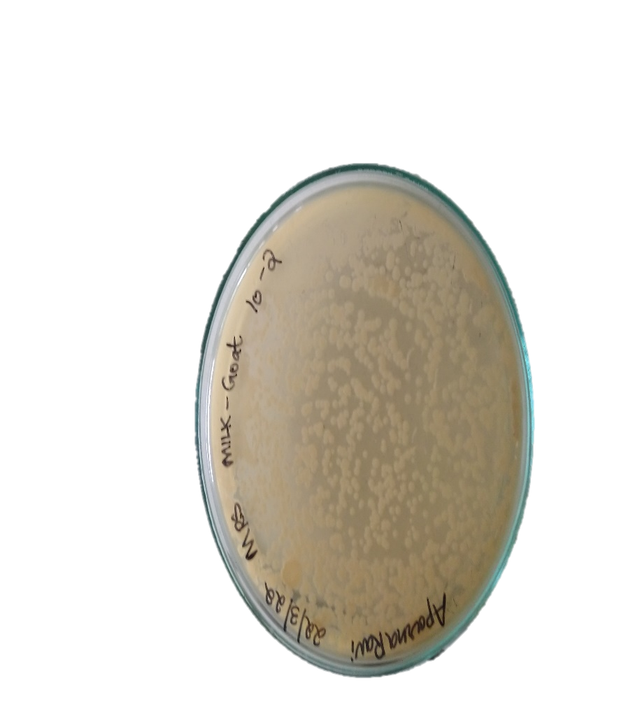
Fig - 4- microscopic observation of LB –
Fig -3- colonies on MRS agar medium
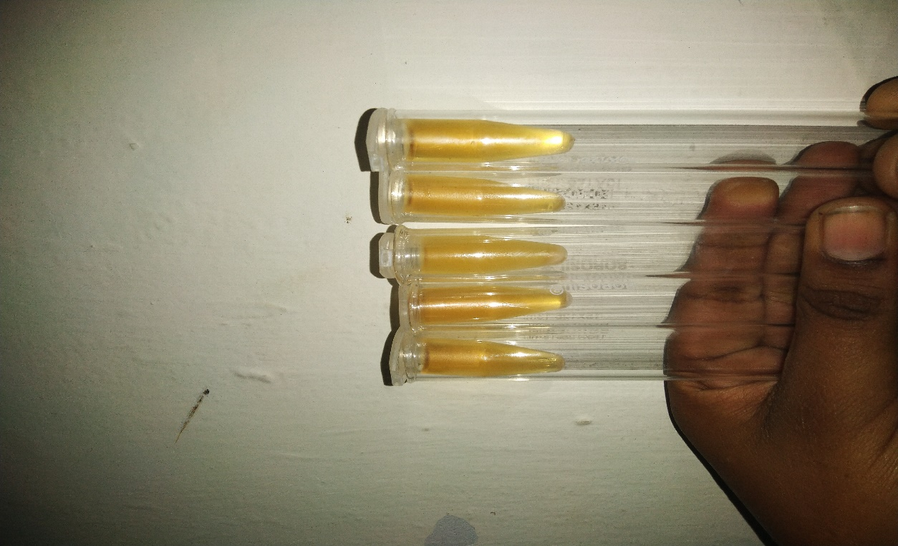
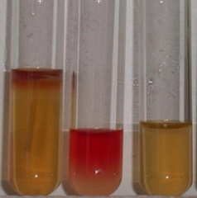
Gram positive rods
fig - 5- indole positive, MR positive,
VP negative
Fig- 6- Bacteriocinn extracted from
Lactobacillus

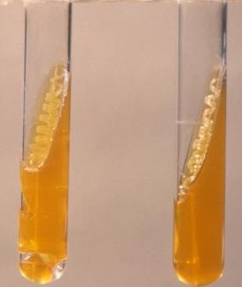
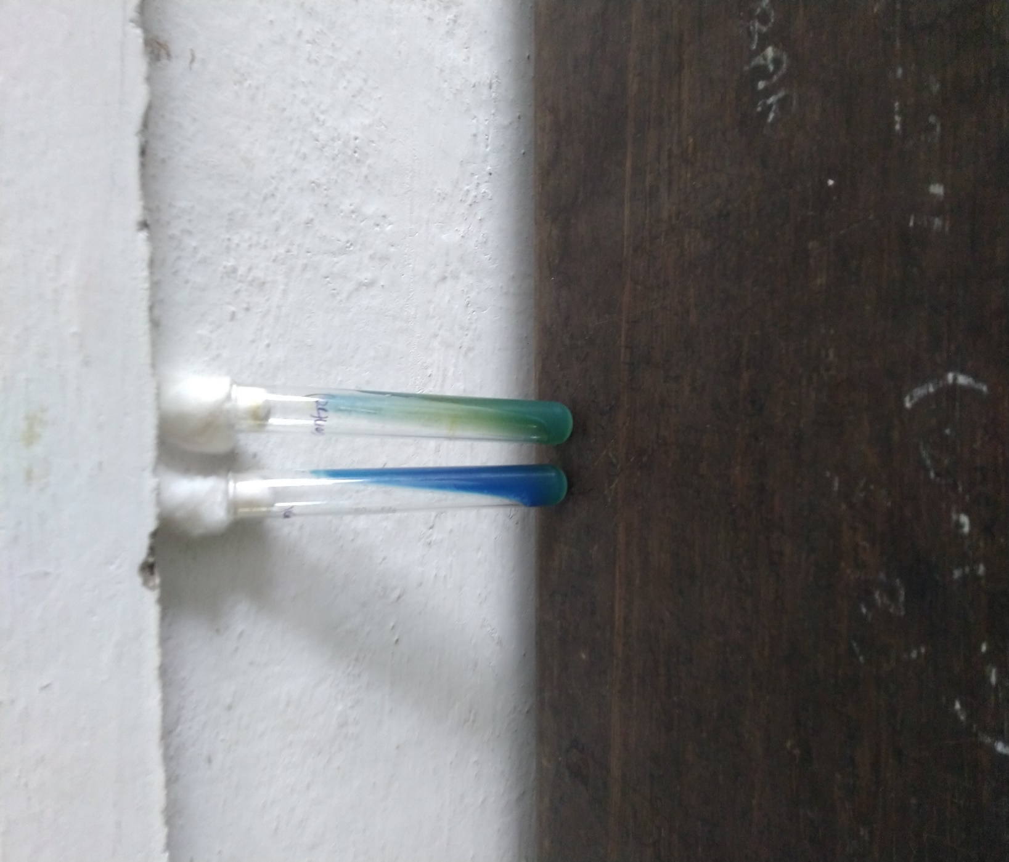
Fig 8- TSI negative
fig-7- citrate positive
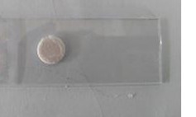
Fig -9- oxidase negative
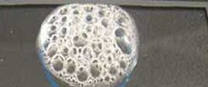
Fig - 10- catalase positive
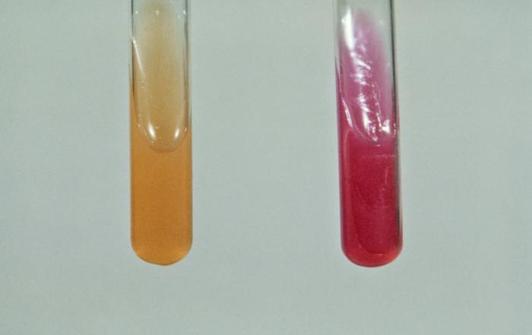
Fig -11- urease negative
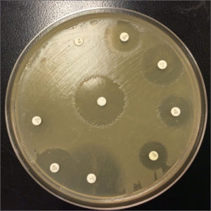
Fig -12-zone of inhibition of candida sp
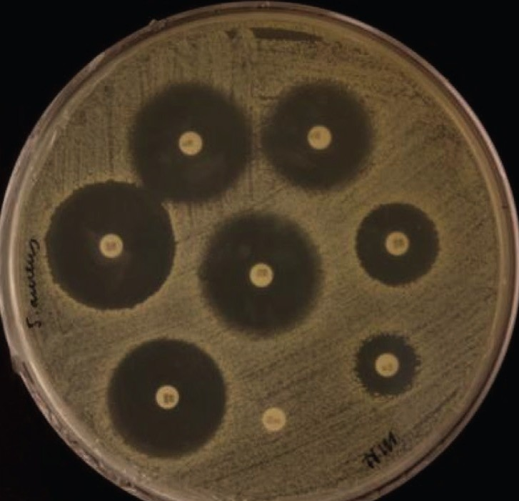
Fig – 13- zone of inhibition of fusarium sp
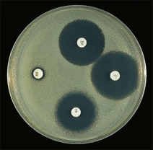
Fig -14- zone of inhibition of aspergillus sp
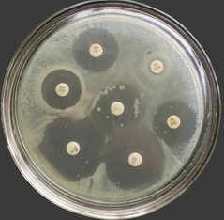
Fig – 15 – zone of inhibition of malassezia sp
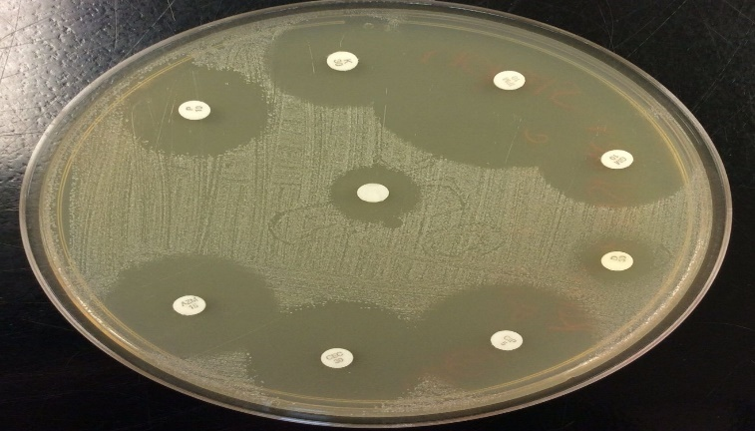
Fig -16- zone of inhibition of penicillium sp

CONCLUSION
A total of 2 raw milk samples from cow and 2 from goat, 2 curd samples (homemade and commercially available), and 2 yogurt samples were collected. Morphological, physiological, microscopic observation and biochemical characterisations were made and confirmed as Lactobacillus species. (gram staining, catalase tests, oxidase tests, methyl red, VP tests, Indole tests, citrate utilization tests, carbohydrate fermentation – Lactose fermentation tests , were done) The Bacteriocin extracted from Lactobacillus using chloroform method and their antagonistic activity is checked. They are found to be sensitive against human pathogen Candida albicans, Aspergillus, Malassezia, Fusarium, Penicillium, causing various skin infections in human beings. (Confirmed by the presence of clear zone around the colonies candida sp ) Studies have been made to understand the efficacy of bacteriocin from Lactobacillus and the diameter of sensitivity zone is measured and tabulated.

REFERENCES
- Abdourahim Abdillah, Saber Khelaifia, Didier Raoult, Fadi Bittar, Stephane Ranque.
Journal of fungi 6 (4), 350, 2020.
- Arthi Lakshmi, C.Vishnurekha, and Parisa Norouzi Baghkomeh.
Dental Research Journal, Wolters Kluwer- Medknow Publications
- Beena Shino, Faisal C. Peedikayil, Shyamala R. Jaiprakash, Gufran Ahmed Bijapur, Soni Kottayi, and Deepak Jose.
- Boni E. Elewski
- Devanshi Mehta, Samuel A Hofacker, (…), and Sarah P Hammond.
- Ditte M. L. Saunte, George Gaitanis and Roderick James Hay.
- Gupta, Adithya K. Baran, Robert, Summervell, Richard C.
- G. Lyratzopoulos, M.Ellis, R. Nerringer, D. W.Denning. James J. Biemer, M.D Journel of Infection, volume 45, issue 2, October 2002, pages 184-195
- Hawaz E.Isolation and identification of probiotic lactic acid bacteria from curd and in vivo evaluation of its growth inhibition activities against pathogenic bacteria.Afr J Microbiol Res.2014; 8: 1919-4251
- James J. Biemer, M.D
- Jo- Anne H. van Burik, Roy Colven, and David H. Spach.
Journal of clinical microbiology
- Kremery V, Barnes AJ (2002) Non –albicans Candida spp.Causing fungaemia: pathogenicity and antifungal resistance. J Hosp Infect 50; 243-260.doi: 10.1053/jhin.2001.1151.
- Lidia Lipinska, Robert Klewicki, Elzbieta Klewicka, Krzysztof Kotodziejczyk, Michal Sojka, and Adriana Nowak.
Bio med Research International, volume 2016, Article ID 5897486.
- Marcio Nucci, Elias Anaissie.
Clinical infectious diseses, volume 35, issue 8.15 october 2002, pages 909-920
- M.K.Schinabeck and M.A. Ghannoum
Journal of chemotherapy, volume 15, 2003- issue sup 2: Reference guide for Difficult- to-treat Fungal Infections
- Nimra Azeem, Muhammad Nawaz, (…), and Muhammad Rizwan Yousuf.
- Oyetyo VO. Phenotypic characterization and assessment of the inhibitory potential of Lactobacillus isolates from different sources.Afr J B IOTECHNOL.2004; 3: 335-7.
- Ruixiang Zhao, Gaili DuAN, Tianyou Yang, Shengyang Niu, Ying Wang.
Tropical journal of Pharmaceutical Research 14 (6), 989-995, 2015.
- Sabina Fijan, Anita Frauwallner, (…) and Irena Rogelj.
- Sofia Cosentino, Silvia Viale, Maura Deplano,Maria Elisabetta Fadda , and Maria Barbara Pisano.
- Sahar Karami, Mohammad Roayaei, (…), and Mahmoud Rafieian – Kopaei. Sani U Diso, JS Adam, Lurwan Mu’azu, Muhammad S Abdullah, Muhammad Ali.
ARC Jornal of Dermatoligy 5 (1), 12-16, 2020.
- Sani U Diso, JS Adam, Lurwan Mu’azu, Muhammad S Abdullah, Muhammad Ali.
ARC Jornal of Dermatoligy 5 (1), 12-16, 2020.
- Sawsan A. A, Maymouna M.O, Isolation and Identification of Lactic Acid Bacteria from Raw Cow Milk, White cheese and Rob in Sudan Pakistan Journal of Nutrition 2010: 9 (12): 1203- 1206.
- Shokryazdan P, Sieo CC, Kalavathy R, Liang JB,Alitheen NB, Faseleh Jahromi M et al. Probiotic potentialof Lactobacillus strains with antimicrobial activity against some human pathogenic strains. Biomed Res Int.2014; 2014: 927268
- V.K.Lal, R, Grover, S. Studies of environmental and nutritional factors on production of antifungal substance by Lactobacillus acidophilus. R. Food Microbial. 1990; 7: 199-206.

