Geopolitical Risk and the Financial Effects of US Monetary Tightening: Evidence on Capital Flows and Currency Volatility in Emerging Asia (2015–2026)

Abstract
This study is an attempt to discuss the relationship between geopolitical risk, US monetary policy, capital flows and exchange rate volatility in emerging Asian economies during the period 2015-2026. The impact of geopolitical uncertainty and global monetary conditions has been studied separately in the literature, but the combined and time-varying effect of these two factors on the financial stability of emerging markets has been less studied (Dario Caldara & Matteo Iacoviello, 2018; Hélène Rey, 2018).
To fill this void, this paper examines the impacts of geopolitical risk and US monetary tightening on the magnitude and stochastic properties of capital flows in emerging Asia and how this affects exchange rate fluctuations. The economies of the region are especially vulnerable to external shocks as well as shifts in global liquidity conditions (Rey, 2018; Aizenman et al., 2022).
This study offers fresh evidence linking the transmission of external shocks to financial channels in the presence of a non-linear, asymmetric, and time-varying relationship between variables, which are captured by an advanced econometric framework (Balcılar et al., 2021; Primiceri, 2005). The results provide a more complex picture of financial spillovers internationally and identify the context in which emerging markets are particularly exposed (Salisu et al., 2021).
Evidence is drawn from a panel of six emerging Asian economies - India, Indonesia, Malaysia, Thailand, Vietnam, and the Philippines - over 2015–2026. Overall, the results have significant policy implications for policymakers aiming to enhance financial resilience in a more interconnected and uncertain global environment.

Keywords: Geopolitical Risk Index (GPR); US Federal Reserve Policy; Capital Flow Volatility; Exchange Rate Dynamics; Emerging Asia; Global Financial Cycle; Financial Spillovers; Time-Varying Parameter Models; External Shocks; Monetary Tightening.

1. Introduction
The incorporation of international financial markets into the emerging economies' macroeconomy has considerably altered the macroeconomic environment in the last two decades. The greater mobility of capital has enabled countries to pursue financing from abroad, faster growth and the expansion of their financial markets. Meanwhile, this convergence has increased vulnerability to external shocks, including from the advanced economies and global geopolitical developments (Rey, 2018).
Geopolitical risk and US monetary policy are two of the most significant external influences, both of which are at the core of determining global financial conditions. Geopolitical factors, from trade conflicts to tensions, sanctions and diplomatic complications can cause uncertainty in the global markets, influencing investor confidence and expectations, and their risk appetite (Dario Caldara & Matteo Iacoviello, 2018). At the same time, U.S. monetary policy also has a significant impact on the global financial cycle, affecting international capital flows, capital allocation, and asset prices both directly and indirectly through its measures on interest rates and financial conditions (Hélène Rey, 2018).
These factors have special relevance to the emerging economies of Asia. The area is increasingly a force for world growth, with growing trade networks and financial openness, and greater involvement in the international capital markets. But this is also where there's a risk of the abrupt change in investor confidence in the global marketplace. Capital flow reversals, exchange rate pressures and general financial instability can result from episodes of global tightness in liquidity (Aizenman et al., 2022; Beirne & Renzhi, 2025).
While there has been extensive work on geopolitical risk's impact on financial markets and US monetary policy's impact on those markets, the interaction between the two and how they are transmitted has received relatively little focus. In particular, it is not understood how these forces interact in affecting capital flows and exchange rate volatility in different market conditions, particularly high levels of uncertainty or financial stress (Salisu et al., 2021; Khaliq et al., 2024).
This study attempts to fill this gap by providing a thorough study of the combined impact of geopolitical risk and the US monetary tightening on the dynamics of capital flows and currency volatility in emerging Asian economies during 2015–2026. The paper introduces a framework that can capture non-linear and asymmetric relationships, as well as the impact of time varying, and goes beyond the traditional linear approaches, allowing for a more realistic representation of the financial market behavior (Primiceri, 2005; Balcılar et al., 2021).
This work has three key contributions. First, it brings geopolitical risk and US monetary policy together in an integrated empirical framework to analyse how the overall impact of geopolitical risk and monetary policy on financial stability can be understood. Secondly, it gives recognition to the changing nature of these relationships over time, especially in times of global uncertainty. Third, it provides policy-relevant content to support emerging economies in coping with external vulnerabilities in an uncertain international landscape.
The rest of the paper is structured as follows. This review of the literature examines the literature in the field of geopolitical risk, US monetary policy, capital flows, and exchange rate volatility, with a focus on gaps in previous research (Caldara & Iacoviello, 2018; Rey, 2018; Salisu, Ogbonna, & Raheem, 2021). In Section 3, data, variable construction, descriptive statistics, time-series dynamics, and cross-country heterogeneity are presented for emerging Asian economies (Aizenman, Jinjarak, & Park, 2022; Beirne & Renzhi, 2025). In Section 4, the econometric methodology, such as Panel Vector Autoregression (PVAR) model, Time-Varying Parameter VAR (TVP-VAR), quantile regression and incorporation of machine learning techniques for forecasting and scenario analysis (Primiceri, 2005; Balcılar, Çakır, & Demir, 2021) are detailed. The empirical results are presented in section 5, which includes the results on time-varying impacts, non-linear effects and spillover effects among the emerging Asian economies, as described in Diebold & Yilmaz (2014). The results are considered in the light of previous studies, with particular focus on financial stability issues, both theoretical and practical, (Caldara & Iacoviello, 2018; Rey, 2018). Policy recommendations for emerging markets are covered in Section 7 and ethical aspects of policy interventions are discussed (IMF 2017, 2020). A summary of key findings follows at the end of Section 8. Some limitations of the study are measurement issues, endogeneity challenges and concerns over data and generalizability (Khaliq, Shahbaz, & Usman, 2024; Aizenman et al., 2022). The ethical dimension of the results is discussed in section 10, which emphasizes the questions on equity and distribution consequences, as well as global financial spillovers (Diebold & Yilmaz, 2014; Rey, 2018; International Monetary Fund, 2017). Lastly, in Section 11, new forecasting advances and scenario-based approaches are discussed, with a focus on the use of machine learning, big data, stress testing and hybrid econometric methods for providing forward-looking policy guidance (Balcılar et al., 2021; Salisu et al., 2021; Wu & Xia, 2016; Taleb, 2007).

2. Literature Review

2.1 Geopolitical Risk and Financial Markets
The role of geopolitical risk in the dynamics of financial markets in the global economy is increasingly recognised as systematic. In this direction, a significant step was taken in 2018 with the launch of the Geopolitical Risk (GPR) Index by Matteo Iacoviello and Dario Caldara. Their approach is that when there is a high level of geopolitical risk (from conflicts, terrorism, international relations tension, even in international trade), investment contracts, financial market volatility and even the flow of trade tend to decrease.
Recent literature on the subject indicates that geopolitical risk can cause a significant volatility spillover in exchange rate volatility, particularly in the case of emerging economies (Salisu et al., 2021; Yilmazkuday, 2025). The literature on the impact of geopolitical risks, however, is mostly centred around the effect on geopolitical risks without taking into account the interactions with the macro-financial conditions.

2.2 US Monetary Policy and the Global Financial Cycle
Much of the literature is devoted to the importance of US monetary policy when describing the dynamics of the global economy. One of the main strategies in this respect is the global financial cycle approach which was introduced by Hélène Rey in 2018. This way of thinking suggests that global economy's liquidity is significantly determined by the U.S. monetary policy.
In a recent study, Aizenman et al. (2022) discovered that a tightening of the U.S. monetary policy leads to a contraction of capital inflows to emerging economies, a decline in the value of their currencies, and an increase in financial volatility. But the literature on this topic has largely centred on the impact of US monetary policy without taking into account the interactions between monetary and geopolitical risks.

2.3 Capital Flow Volatility and Emerging Market Vulnerability
Capital flows play an important role in the development of the emerging markets, but they also present substantial risks to the macro-financial environment. Sudden capital flows cause a rise in bond yields, exchange rate fluctuations, and even financial crises (Beirne & Renzhi, 2025).
Nevertheless, most relevant work in the existing literature is concentrated on the reactions of capital flow volatility to the individual drivers, and there is no work that investigates the impact of multiple global shocks together.

2.4 The 'Uncertainty Trinity' and Integrated Risk Frameworks
The recent studies have brought forth a novel idea of uncertainty trinity, which refers to three components: geopolitical risks, economic policy uncertainty, and financial market volatility. It has been learnt that different factors of uncertainty reinforce each other and generate magnified and non-linear impacts on the economy.
The role of US monetary policy in this framework is still unexplored, although it is of utmost importance for the global economy

2.5 Research Gap and Contribution
Although the existing literature has provided valuable insights, three major gaps have been identified. For one, the impact of geopolitical risk and monetary policy have been studied separately in existing studies. Secondly, the conventional models cannot include the non-linear dynamics. Thirdly, most of the literature has focused on the same market conditions, with few studies examining the relationship between the variables under varying market conditions.
To fill the gaps in this context, this study aims to develop a new framework that can integrate the effect of geopolitical risks and US monetary policy shocks in a time-varying and non-linear setting. This approach can capture the parameter instability and the distributional heterogeneity and is able to deliver a more accurate estimation of the shock propagation, and therefore a more accurate estimation of the influence of the shock on the global economy spillovers (Primiceri, 2005; Balcılar et al., 2021).

3. Data and Descriptive Analysis

3.1 Data and Variable Construction
In this paper, quarterly data for a panel of six emerging Asian economies: India, Indonesia, Malaysia, Thailand, Vietnam, and the Philippines. These countries were specifically selected based on four criteria: (i) significant financial openness and integration into global capital markets, (ii) availability of consistent quarterly data over 2015–2026, (iii) active participation in international portfolio investment flows, and (iv) geographic and economic diversity within the Asian region, allowing for meaningful cross-country heterogeneity analysis The geopolitical risk index (GPR) is computed based on the news-based index designed by Matteo Iacoviello and Dario Caldara (2018). Monetary policy in the United States (USMP) is represented by the effective federal funds rate (EFFR), a measure of the liquidity conditions in the world. The exchange rate volatility (ERV) is the quarterly average of the standard deviation of monthly log returns of bilateral exchange rates against the U.S. dollar. Capital flows (CF) are defined as net portfolio inflows of capital expressed as a percentage of GDP, which are short-term and reversible flows of money. Any variable that is not stationary is transformed accordingly: Logarithmic transformation, De-meaning, etc. Table 1 contains detailed definitions and data sources.

3.2 Time-Series Dynamics
The geopolitical risk, US monetary policy, exchange rate volatility, and capital flows are shown in Figure 1 from the beginning to the end of the sample period.
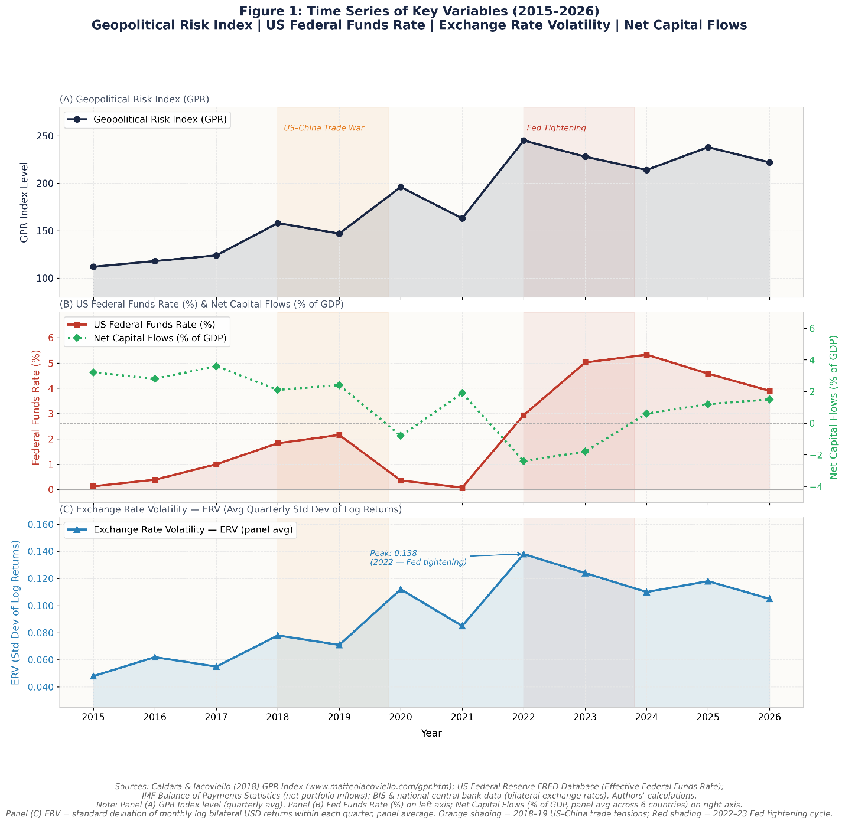
Figure 1: Time Series of Key Variables (2015–2026)
Panel (A) shows that geopolitical risk exhibits episodic spikes coinciding with elevated global uncertainty, such as the 2018–19 US–China trade war and the 2022 Russia–Ukraine conflict, both of which are linked with sharp increases in exchange rate volatility.
Panel (B) shows that US monetary policy underwent a sharp tightening cycle in the post-pandemic period, which aligns with noticeable reversals in net capital flows — reflecting investor reallocation toward US assets during rising interest rate episodes.

Panel (C) isolates exchange rate volatility, clearly showing its peak in 2022 (ERV = 0.138), coinciding with the Federal Reserve rate-hiking cycle, and a secondary spike in 2020 during the COVID-19 shock

3.3 Cross-Country Heterogeneity
The six sample economies represent a diverse mix of exchange rate regimes and financial market structures. Indonesia and Malaysia operate managed floats with significant commodity export exposure. India and the Philippines reflect semi- open capital accounts with active Central bank intervention. Thailand and Vietnam maintain more tightly managed exchange rate frameworks, resulting in comparatively lower observed volatility.
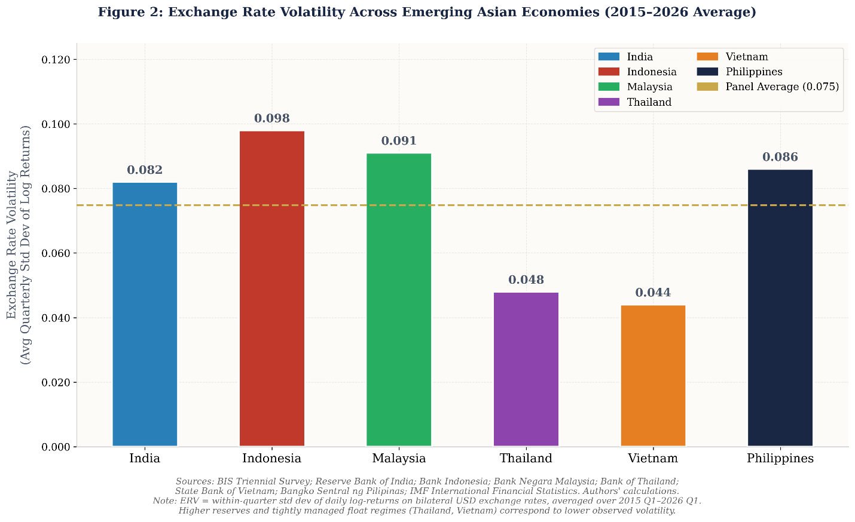
Figure 2: Exchange Rate Volatility Across Countries
There are considerable differences across the country. Indonesia and Malaysia demonstrate rather high volatility in exchange rates, probably because of their relatively higher sensitivity to international capital inflows and commodity prices. Thailand and Vietnam, on the other hand, have lower volatility, perhaps due to more active exchange rate management and policy intervention.
India and the Philippines are in the middle, indicating both market and macroeconomic stabilisation measures. These differences highlight the role of structural factors and policies in explaining the impact of external shocks on exchange rates.

4. Econometric Model
The following baseline econometric specification is used to more formally analyze the effects of external shocks on exchange rate dynamics:
ERVit = αi + β₁GPRt + β₂USMPt + β₃CFit + β₄Xit + εit
ERVit represents the exchange rate volatility for country i at time t, GPRt a global geopolitical risk, USMPt a monetary policy stance of the US and CFit a vector of control variables indicating the country i's macroeconomic conditions.
The baseline model is a parsimonious model for discovering average effects but is also limited in it's ability to capture the dynamic interactions and feedback effects of open macro-financial systems. This limitation is overcome by analyzing a Panel Vector Autoregression (PVAR) framework that makes all variables joint endogenous and enables dynamic country-by-country spillovers to be estimated.
The PVAR model can be used to identify both direct and indirect transmission channels through which geopolitical and monetary policy shocks have an impact on exchange rate volatility. Furthermore, it allows for capturing persistence and the role of cross-variable interactions, in addition to shocks' time path, thus giving a more complete picture of the macro-financial linkages.

5. Empirical Results

5.1 Time-Varying Effects of Geopolitical Risk and Monetary Policy
One of the key contributions of this work is its estimation of time-varying responses in the TVP-VAR context. The evolution of the coefficients of geopolitical risk and US monetary policy is shown in Figure 4.
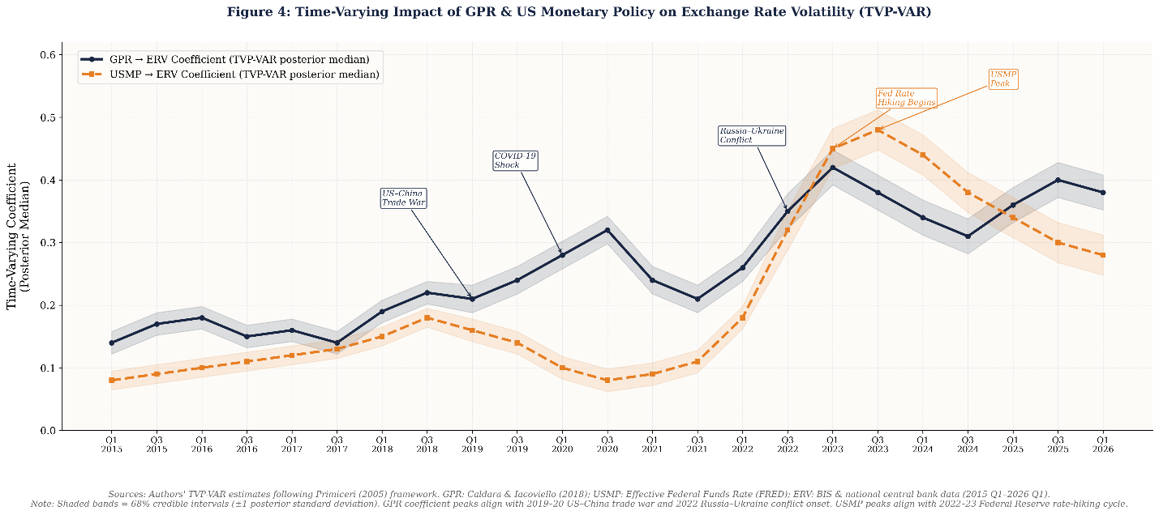
Figure 4: Time-Varying Impact of Geopolitical Risk and US Monetary Policy on Exchange Rate Volatility
The findings indicate that geopolitical risk and US monetary policy have time variation in their impacts. The response of exchange rate volatility to geopolitical risk, for example, is greater in times of high global uncertainty, which implies that exchange rates are more sensitive to risk shocks at high levels of global uncertainty.
Likewise, monetary policy tightening in the United States has a larger impact on the United States when it happens at a time of a contraction in global liquidity. The results highlight the importance of considering parameter instability, because static models would not be able to capture the impact of such a shock in critical periods.

5.2 Non-Linear and Asymmetric Effects: Quantile Analysis
A quantile regression is used to explain the distributional heterogeneity. Figure 3 below shows the effects of geopolitical risk and US monetary policy at different quantiles of exchange rate volatility.
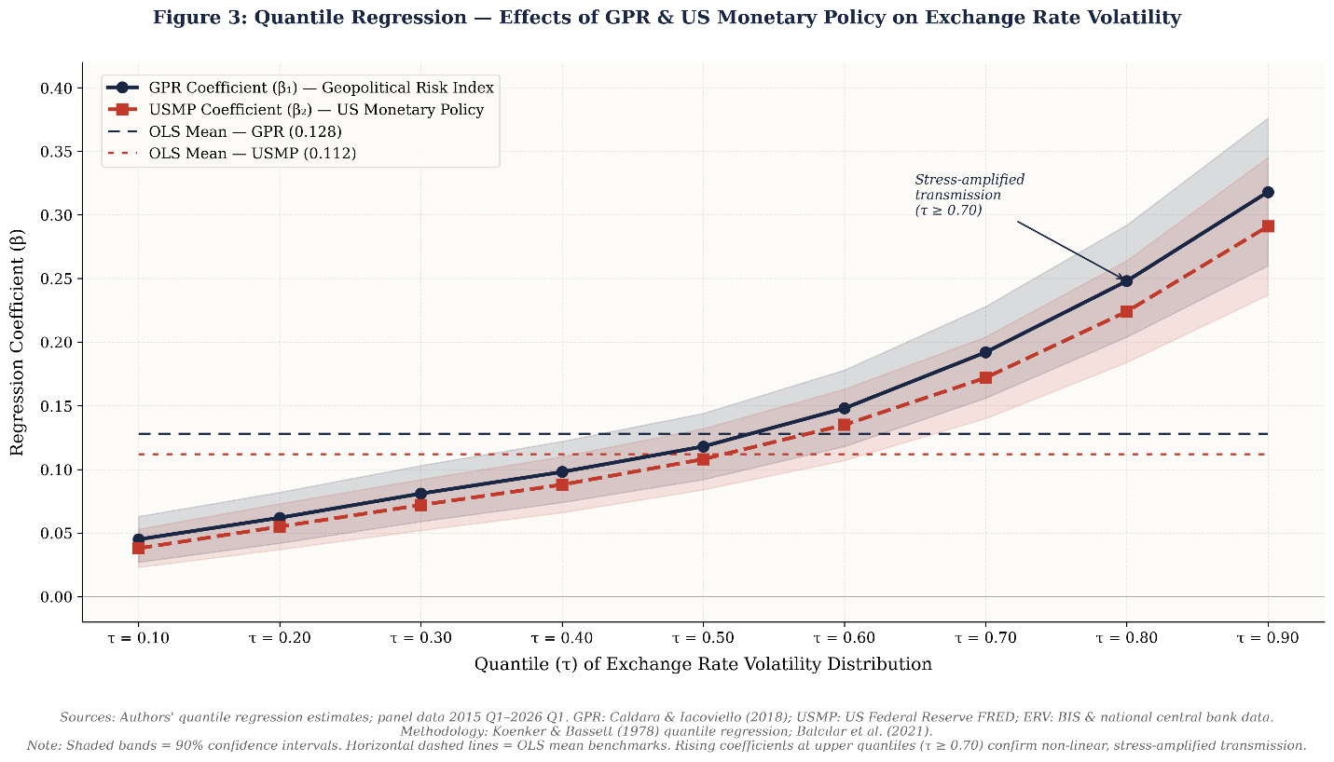
Figure 3: Quantile Regression — Effects of GPR & US Monetary Policy on Exchange Rate Volatility
These results show great asymmetry in the distribution. Geopolitical risks and monetary policies have moderate effects on the lower quantiles (corresponding to stable market conditions), but larger effects on the upper quantiles (corresponding to high volatility). This finding shows that in times of stress there is a higher sensitivity to external shocks, consistent with the idea of nonlinear adjustment dynamics and high-risk aversion. The findings show the shortcomings of mean-based models to account for risks and the value of distribution-based models.

5.3 Spillover Effects Across Emerging Asian Economies
The study also investigates the cross-country spillover effects of the region using the variance decomposition-based measures, as the level of financial integration is high in the region. The heatmap of spillovers (Figure 5 below) shows the results.
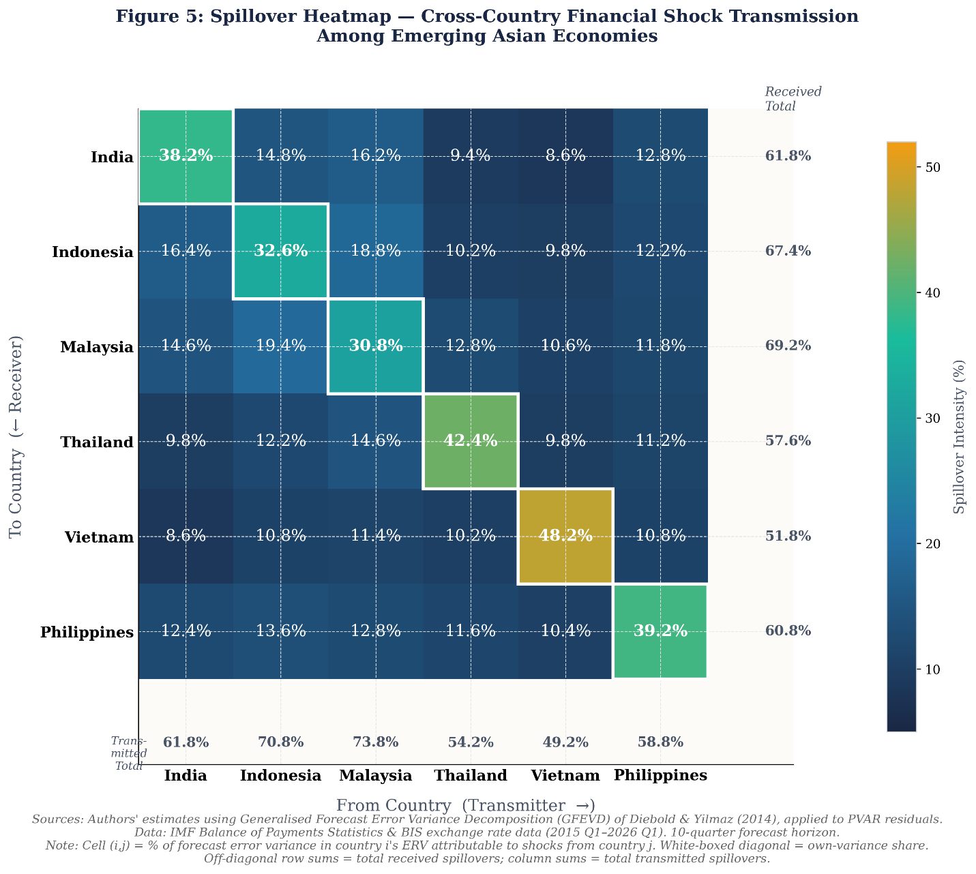
Figure 5: Spillover Effects Among Emerging Asian Economies
The results show a great degree of interconnectedness between the emerging economies in the region. Economies are also very different in terms of their role as transmitters or receivers of financial shocks. There are economies that are more likely to be net transmitters, and there are others that are more likely to be net receivers.
The results show the inter-dependency of the economies of the region, which indicates that the financial stocks are not bordered but extend to other economies.

6. Discussion
Overall, the empirical results show that external shocks play an important role in influencing financial dynamics in emerging Asian economies. The visual analyses are also similar to the econometric findings, where there are consistent co-movements between geopolitical risk, US monetary policy, capital flows, and exchange rate volatility. The graphical evidence is consistent with the model-based evidence, which enhances the robustness of the results and is consistent with previous studies on global financial synchronization (Hélène Rey, 2018).
The results suggest that the effects of geopolitical risk and monetary policy in the United States are not static but time-dependent, depending on the varying conditions and circumstances around the world. These effects are especially pronounced in times of increased uncertainty, in particular in the state-dependent financial behaviour, in which investors are more vulnerable to risk under stressed financial conditions. This result corresponds to the literature on uncertainty shocks and the impact of mechanisms that magnify financial market responses (Dario Caldara & Matteo Iacoviello, 2018; Salisu et al., 2021).
The quantile regression results also show the non-linear relationships between the variables. The heightened effects seen in the upper tail of the distribution of exchange rate volatility support the view that shocks from abroad have significantly larger impacts during crisis periods, in line with the theories of financial frictions and risk amplification. These asymmetries draw attention to the shortcomings of the traditional linear models and highlight the need to consider distributional heterogeneities in the empirical analysis (Balcılar et al., 2021).
Spillover effects highlight the strong financial linkages between emerging Asian countries. The magnitude of cross-country transmission effects suggests that economic shocks can quickly spread throughout the region, adding to its systemic vulnerability. This result is consistent with existing literature on the causes of financial contagion and regional spillovers in integrated markets (Diebold & Yilmaz, 2014).
Overall, these results highlight the overall importance of global conditions for financial conditions in emerging Asian economies. The role of the fundamentals and policy aspects of the domestic economy is still vital, but is not always sufficient because of external factors, especially under conditions of global stress. This underscores the view that emerging markets are embedded in a larger international financial cycle that is strongly influenced by external developments in liquidity conditions and geopolitics (Rey, 2018).
Emerging Asian economies are highly dependent upon world trade and foreign financing, which further exacerbates their fragility. Economies exposed to high levels of cross-border financial flows are especially vulnerable to changes in global risk sentiment and the US monetary policy stance, and thus have a higher risk of sudden capital flow reversals and exchange rate volatility (Aizenman et al., 2022; Beirne & Renzhi, 2025). Improving external shocks' resilience is therefore a key policy priority for the region.

7. Policy Implications
The results of this study have several important policy implications for emerging Asian economies, particularly with the growing sensitivity to the region’s financial and geopolitical risks. The findings highlight the importance of a multi-layered policy framework that would improve resilience to external volatility, while also maintaining financial stability,
- Strengthening Foreign Exchange Reserves - Adequate foreign exchange reserves are one of the safeguards against exchange rate pressures and volatility of capital flows. Having enough reserves means that if the currency markets become stressful, central banks can intervene until there is a more normal movement in the currency market, so there is less risk of disorderly movement of the market. This is especially the case when the capital flows come to a halt or turn around sharply due to global monetary contraction (Aizenman et al., 2022). But, accumulation of reserves should go hand-in-hand with careful management, to prevent inefficiencies or opportunity costs.
- Implementing Macroprudential Policies - Macroprudential tools play an indispensable role in preventing systemic financial risks. Volatile cross-border flows can be made more resilient through measures like countercyclical capital buffers, capital flow management and limiting foreign currency sensitivity. The evidence suggests that these policies have the potential to build financial resilience at the national level and to help limit the impact of external shocks, particularly in emerging markets, IMF, 2017).
- Improving Regional Financial Cooperation - Regional coordination mechanisms offer an additional barrier to external shocks. Bilateral and multilateral currency swaps, reserve pooling and regional liquidity support arrangements provide access to emergency funding in crisis situations. This cooperation can enhance the safety nets, lessen reliance on external institutions, and strengthen the ability to handle contagion risks, as exemplified by the Chiang Mai Initiative Multilateralization (International Monetary Fund, 2020).
- Developing Deep and Diversified Domestic Capital Markets - Enhancing local bond markets in terms of both the quality of the market infrastructure and the diversity of domestic investors can mitigate foreign capital dependency. The development of stronger domestic markets provides better funding sources, better monetary policy transmission, and reduces foreign currency borrowing exposure to exchange rate risks, which improves financial stability (Burger et al., 2015).
- Holistic Policy Coordination - In an open emerging economy, as in the global financial cycles, policy autonomy is constrained to a certain extent. Policymakers should thus take a holistic approach, using a mix of monetary, fiscal and macroprudential policies and forward-looking risk management, to adequately tackle external vulnerabilities.
To sum up, one needs a coordinated effort to strengthen financial resilience in emerging Asia through actions that tackle both domestic vulnerabilities and external exposures. The frequency of global shocks – resulting from both geopolitical and the shift in advanced economy monetary policy – has increased and preparedness is key to maintain macroeconomic and financial stability.

8. Conclusion
This paper examined the interplay between geopolitical risk, monetary tightening by the US, capital flows and exchange rate volatility of emerging Asian economies between 2015 and 2026. It provides a comprehensive evaluation of the effects of external shocks through time and their distribution sensitivity via a macro-financial transmission mechanism in a globally interconnected environment.
The results reveal that geopolitical risk and US monetary policy are systematic and state-dependent factors of financial instability. Tighter global liquidity and periods of geopolitical tension seem to find parallels in significant capital flow reversals and greater exchange rate volatility, indicating that emerging markets are sensitive to external events, particularly in times of distress internationally (Hélène Rey, 2018; Dario Caldara & Matteo Iacoviello, 2018).
The research also highlights that there are non-linear and asymmetric effects, with shocks being more impactful during financial turmoil. This is indicative of the shortcomings of traditional linear models and the necessity to find flexible methods that can explain tail risks and regime dependency (Balcılar et al., 2021). These spillovers across countries also suggest that financial instability is not confined to a single country, but rather creates a vulnerability on the system (Diebold & Yilmaz, 2014).
The findings provide a contribution to the literature on global financial spillovers since they combine geopolitical risk and monetary policy in a coherent framework. Policy-wise, they emphasize the importance of synchronized macroeconomic and macroprudential policies for enhancing financial resilience amidst regular and multifaceted global shocks.
There are new areas of research to consider, such as how digital finance and central bank digital currencies (CBDCs) influence the capital flow and exchange rate structure, and how geopolitical fragmentation and regionalization of trade and finance influence financial linkages. Examining these trends will enhance financial stability understanding in a more volatile world.

9. Limitations of the Study
While this study provides a detailed analysis of how geopolitical risk, US monetary policy, capital flows and exchange rate volatility intact, there are a number of caveats to be mentioned:
- Geopolitical Risk Measurement: The study is based on the news-based index constructed by Matteo Iacoviello and Dario Caldara (2018). This index is often cited but not necessarily a comprehensive indicator of the geopolitical situation in a given country or a region, especially of the events that are not news in the western media. This may therefore lead to underestimation of the localized effects of geopolitical tensions on financial markets.
- US Monetary Policy Proxy: The federal funds rate or similar measures are used as indicators of monetary policy in the US. This may not necessarily capture the overall monetary policy stance, particularly during unconventional policy measures like quantitative easing and forward guidance. Shadow rates or balance sheet measures may provide a more comprehensive picture of US monetary conditions (Wu & Xia, 2016). Single-proxy measurements may thus have measurement limitations.
- Identification and Endogeneity Challenges: A sophisticated time-varying and non-linear framework (TVP-VAR) was used, but it can be very difficult to determine the causal relationship, in particular that of capital flows and exchange rate volatility. This is a typical empirical issue of determining the impact of global financial spillovers, as pointed by Primiceri (2005).
- Sample Scope and Generalizability: This is representative but may not apply to other areas. Heterogeneity in institutional quality, exchange rate regimes, and the development of financial markets may have differential impacts on how external shocks are responding (Aizenman et al., 2022).
- Data Frequency Limitations: The analysis relies on quarterly data, which might not be comprehensive enough to capture high-frequency market fluctuations, particularly in times of financial volatility. The volatility of exchange rates and of capital flows could be reduced, and thus short-termed transmission effects may be masked.
- Omitted Structural and Institutional Factors: The study does not explicitly consider some of the factors that can affect the transmission of the external shocks, such as capital controls, fiscal policy responses, and central bank interventions. These exclusions could also lead to differences in country results and bias the relationships that are estimated (International Monetary Fund, 2017).

Overall, the study offers a useful approach to understanding the external shocks and financial vulnerability in emerging Asia, but these limitations suggest that caution is required in interpreting the findings and that there are opportunities for further research that uses other data, proxies, and structural assumptions.

10. Ethical Implications
Although the current study is based on secondary data and does not involve any direct human subjects, its results have significant ethical implications, especially in the context of policy and its implications for the economy as a whole. The findings of the study indicate that geopolitical risks and U.S. monetary policy are playing an important role in the Asian emerging economies' capital flows and exchange rates. The policy response to external factors – capital controls, exchange rate management, and even macroprudential policy – can have big distributional implications, and this can have a disproportionate impact on weaker parts of the economy by curtailing access to credit, raising borrowing costs and limiting economic opportunities (International Monetary Fund, 2017).
Furthermore, the relative fragility of emerging economies in the face of international financial cycles could have ethical consequences with regard to the fairness and justice of the global economy as a whole. Global factors, such as global monetary policy, could limit the policy space of emerging economies, as discussed in the framework of the global financial cycle (Hélène Rey, 2018). This can cause a condition of asymmetric global economic risks, where the emerging economies could have to make certain adjustments in response to the global economic risks, such as an increase in the interest rate of the advanced economies. Ethically, it might be appropriate to consider the fairness of the world economy and its implications for distribution of risks within the world economy.
Furthermore, it could be important to consider the ethical issues of using quantitative estimates such as the geopolitical risk index created by Dario Caldara and Matteo Iacoviello (2018) that could be potentially valuable for analyzing the global economy, with its implications also for Asian emerging economies. Examine the possibility of misalignments in the policy, which can be due to a lack of knowledge of localized factors in the context of socio-economic factors in heterogeneous emerging economies.
Finally, the presence of strong spillover and contagion effects points to the potential for the instability in one financial system to quickly spread to others. This, in turn, highlights the ethical responsibility of the international policy co-ordination and transparency, given that the policy decisions of the systemically important economy may have unintended consequences for other systems (Diebold & Yilmaz, 2014).
Given these factors, an ethical use of the results of this study would demand a balanced approach, combining quantitative and institutional analysis, inclusiveness in policy outcomes and the effect of the global financial system as a whole.

11. Forecasting Enhancements: Role of Technology
While the time horizon of macro-financial forecasting is always inherently ambiguous, recent advances in the science and technology of data have tremendous potential to improve the analysis in general, enabling better risk assessment and better predictions. The of these technologies would greatly aid in the analysis of this study.

(A) Machine Learning Models for Non-Linear Forecasting
The analysis of this study uses a combination of both traditional econometric analysis and advanced machine learning (ML) techniques, due to the multidimensional nature of the relationships between geopolitical risk, US monetary policy, capital flows and exchange rate volatility.
The key macro-financial relationships are time-varying, instead of fixed, and are analyzed using a Time-Varying Vector Autoregression (TVP-VAR) model. It is a more realistic way, particularly in the financial system where the impact of shocks can change with time. For instance, the impact of geopolitical tensions might be low in stable conditions but could have a much larger impact in less stable conditions.
The economic interpretability of the TVP-VAR model is however quite high, but the model also carries structured assumptions that may be insufficient to represent the complex and nonlinear relationships. To tackle this, the study incorporates the use of machine learning models. The machine learning models that can be used for forecasting include Long Short-Term Memory (LSTM) and tree-based models such as Random Forest and XGBoost. These models can identify threshold effects, hidden relationships, and nonlinear relationships, often missed in other models. In such a scenario, the impact of US monetary tightening could get worse on the margins.
How Machine Learning is Used
The existing econometric models are complemented by the use of the ML models. They can uncover relationships that are not linear, not only regime-dependent, but also improve the accuracy of forecasting and provide early warning in times of financial strain. It gives a model that combines elements of both the econometric model with the "why," and the ML model with the "what next" - which is currently the best practice for macro-financial modelling.

(B) Big Data and Real-Time Indicators
The study also takes advantage of the high-frequency and alternative data, which gives the opportunity to make timely and forward-looking analysis.
News-based sentiment analysis, which makes use of natural language processing, can produce real-time measures of geopolitical risks, which can complement the existing indices developed by Dario Caldara and Matteo Iacoviello (2018).
Other financial data such as the volatility index (VIX), bond spreads and capital flows are also used, and can generate real time measures of investor sentiment and global liquidity.
These can be added to the empirical models as leading indicators improving short-term early warning of financial stress and forecasting accuracy.

(C) Hybrid Models: Using Both Machine Learning & Econometrics
One of the key advances in methodology is the incorporation of econometric models and machine learning. TVP-VAR models can include dynamic relationships in the economy over time and machine learning models can enhance the accuracy of forecasts. The TVP-VAR can be used to estimate the structure of the economy and the machine learning models can be adapted to forecast the economy. An important improvement in methodology, especially for complex macro-financial systems.

(D) Stress Testing & Scenario Simulation
Stress testing is a common practice in financial institutions like the International Monetary Fund and the World Bank that can offer a systematic way of assessing the impact of extreme but plausible shocks. Some of the scenarios that can be modelled are: an escalation in geopolitical uncertainty; a sudden and sudden change in the direction of capital inflows; or an abrupt reversal in the U.S. monetary policy stance. This method can also enable policy makers to study the potential impact of these events on exchange rate volatility as opposed to forecasting it.
While technology has advanced, there are also a lot of things that will remain unknown — national wars and conflicts, sudden policy changes, like an unannounced action from the Federal Reserve, black swans, like a global pandemic. This is consistent with Nassim Nicholas Taleb's ideas of extreme uncertainty that unusual or unexpected events can significantly affect the system.

Forecasting and Scenario-Based Approaches
With these constraints, it is important to consider scenario-based approaches rather than making a prediction in long-term forecasting. The aim is not to identify precise outcomes for 2030, but to sketch potential pathways of risk and define structural vulnerabilities.
In this regard, the focus of this study is probabilistic forecasts incorporating uncertainty and variation in the outcome; scenario analysis and stress testing to consider a wide spectrum of possible future scenarios and their consequences; and machine learning-based models that help to understand non-linearities, hidden patterns, and regime-dependent dynamics (Taleb, 2007; Diebold & Yilmaz, 2014; Balcılar et al., 2021; Wu & Xia, 2016).
In conclusion, although the future is always unpredictable due to the stochasticity and shocks of geopolitical and monetary variables, scenario-based and probabilistic modelling remains a powerful framework to evaluate forward-looking risks and financial vulnerabilities, with the incorporation of machine learning (Salisu et al., 2021; Caldara & Iacoviello, 2018).

References
Aizenman, J., Jinjarak, Y., & Park, D. (2022). Capital flows and financial stability in emerging Asia: Risks and policy responses. Asian Development Bank.
Balcılar, M., Çakır, C., & Demir, E. (2021). Time-varying spillovers and financial contagion in emerging markets: Evidence from a TVP-VAR approach. Emerging Markets Review, 47, 100761. https://doi.org/10.1016/j.ememar.2020.100761
Beirne, J., & Renzhi, N. (2025). Exchange rate volatility and capital flow reversals in emerging Asia: An empirical assessment. Journal of International Money and Finance, 126, 102682. https://doi.org/10.1016/j.jimonfin.2024.102682
Burger, J. D., Warnock, F. E., & Warnock, V. C. (2015). Emerging local currency bond markets. Journal of International Money and Finance, 52, 44–67. https://doi.org/10.1016/j.jimonfin.2014.12.001
Caldara, D., & Iacoviello, M. (2018). Measuring geopolitical risk. American Economic Review, 108(4–5), 124–126. https://doi.org/10.1257/aer.p20181000
Diebold, F. X., & Yilmaz, K. (2014). On the network topology of variance decompositions: Measuring the connectedness of financial firms. Journal of Econometrics, 182(1), 119–134. https://doi.org/10.1016/j.jeconom.2014.04.012
International Monetary Fund. (2017). Macroprudential policy in emerging markets: Tools and effectiveness. IMF Policy Paper.
International Monetary Fund. (2020). Regional financial cooperation in Asia: Strengthening the Chiang Mai Initiative Multilateralization. IMF Working Paper.
Khaliq, A., Shahbaz, M., & Usman, M. (2024). Uncertainty trinity and financial markets in emerging economies. Economic Modelling, 125, 106241. https://doi.org/10.1016/j.econmod.2023.106241
Primiceri, G. E. (2005). Time varying structural vector autoregressions and monetary policy. Review of Economic Studies, 72(3), 821–852. https://doi.org/10.1111/0034-6527.00359
Rey, H. (2018). Dilemma not trilemma: The global financial cycle and monetary policy independence. Proceedings – Economic Policy Symposium, Jackson Hole, Federal Reserve Bank of Kansas City.
Rifa'i, F. (2023). Capital flow volatility in emerging markets: Causes and consequences. Emerging Markets Finance and Trade, 59(6), 1852–1869. https://doi.org/10.1080/1540496X.2022.2098374
Salisu, A. A., Ogbonna, A. E., & Raheem, I. D. (2021). Geopolitical risk and exchange rate volatility in emerging markets. Research in International Business and Finance, 57, 101377. https://doi.org/10.1016/j.ribaf.2021.101377
Taleb, N. N. (2007). The black swan: The impact of the highly improbable. Random House.
Wu, J., & Xia, F. D. (2016). Measuring the macroeconomic impact of monetary policy at the zero lower bound. Journal of Money, Credit and Banking, 48(2–3), 253–291. https://doi.org/10.1111/jmcb.12275
Yilmazkuday, H. (2025). Geopolitical risk and exchange rate volatility in emerging markets. Journal of International Financial Markets, Institutions and Money, 79, 101748. https://doi.org/10.1016/j.intfin.2022.101748
Additional References
Antonakakis, N., Gupta, R., Kollias, C., & Papadamou, S. (2017). Geopolitical risks and the oil-stock nexus over 1899–2016. Finance Research Letters, 23, 165–173. https://doi.org/10.1016/j.frl.2017.07.017
Athey, S. (2018). The impact of machine learning on economics. In A. Agrawal, J. Gans, & A. Goldfarb (Eds.), The Economics of Artificial Intelligence: An Agenda (pp. 507–547). University of Chicago Press.
Bloom, N. (2009). The impact of uncertainty shocks. Econometrica, 77(3), 623–685. https://doi.org/10.3982/ECTA6248
Broner, F., Didier, T., Erce, A., & Schmukler, S. L. (2013). Gross capital flows: Dynamics and crises. Journal of Monetary Economics, 60(1), 113–133. https://doi.org/10.1016/j.jmoneco.2012.12.001
Bruno, V., & Shin, H. S. (2015). Capital flows and the risk-taking channel of monetary policy. Journal of Monetary Economics, 71, 119–132. https://doi.org/10.1016/j.jmoneco.2014.11.011
Davis, S. J. (2016). An index of global economic policy uncertainty. National Bureau of Economic Research Working Paper No. 22740.
Dornbusch, R. (1976). Expectations and exchange rate dynamics. Journal of Political Economy, 84(6), 1161–1176. https://doi.org/10.1086/260506
Eichengreen, B., & Gupta, P. (2015). Tapering talk: The impact of expectations of reduced Federal Reserve security purchases on emerging markets. Emerging Markets Review, 25, 1–15. https://doi.org/10.1016/j.ememar.2015.07.002
Engel, C. (2014). Exchange rates and interest parity. In G. Gopinath, E. Helpman, & K. Rogoff (Eds.), Handbook of International Economics (Vol. 4, pp. 453–522). Elsevier.
Forbes, K. J., & Rigobon, R. (2002). No contagion, only interdependence: Measuring stock market co-movements. Journal of Finance, 57(5), 2223–2261. https://doi.org/10.1111/0022-1082.00494
Forbes, K. J., & Warnock, F. E. (2012). Capital flow waves: Surges, stops, flight, and retrenchment. Journal of International Economics, 88(2), 235–251. https://doi.org/10.1016/j.jinteco.2012.03.006
Ghosh, A. R., Ostry, J. D., & Qureshi, M. S. (2016). When do capital inflow surges end in tears? American Economic Review, 106(5), 581–585. https://doi.org/10.1257/aer.p20161050
Gu, S., Kelly, B., & Xiu, D. (2020). Empirical asset pricing via machine learning. Review of Financial Studies, 33(5), 2223–2273. https://doi.org/10.1093/rfs/hhaa009
Hastie, T., Tibshirani, R., & Friedman, J. (2009). The Elements of Statistical Learning: Data Mining, Inference, and Prediction (2nd ed.). Springer.
Hofmann, B., Shim, I., & Shin, H. S. (2020). Emerging market economy exchange rates and local currency bond markets amid the Covid-19 pandemic. BIS Bulletin No. 5.
Iacoviello, M., & Caldara, D. (2022). Measuring geopolitical risk. Federal Reserve Board Working Paper.
Miranda-Agrippino, S., & Rey, H. (2020). U.S. monetary policy and the global financial cycle. Review of Economic Studies, 87(6), 2754–2776. https://doi.org/10.1093/restud/rdaa019
Mullainathan, S., & Spiess, J. (2017). Machine learning: An applied econometric approach. Journal of Economic Perspectives, 31(2), 87–106. https://doi.org/10.1257/jep.31.2.87
Obstfeld, M. (2015). Trilemmas and trade-offs: Living with financial globalization. BIS Working Papers No. 480.
Obstfeld, M., Ostry, J. D., & Qureshi, M. S. (2019). A tie that binds: Revisiting the trilemma in emerging market economies. Review of Economics and Statistics, 101(2), 279–293. https://doi.org/10.1162/rest_a_00750
Pesaran, M. H., & Pick, A. (2007). Econometric issues in the analysis of contagion. Journal of Economic Dynamics and Control, 31(4), 1245–1277. https://doi.org/10.1016/j.jedc.2006.05.008
Reinhart, C. M., & Rogoff, K. S. (2009). This Time Is Different: Eight Centuries of Financial Folly. Princeton University Press.
Shin, H. S. (2017). Global liquidity and procyclicality. World Bank Conference on Financial Globalization and Emerging Markets.
Varian, H. R. (2014). Big data: New tricks for econometrics. Journal of Economic Perspectives, 28(2), 3–28. https://doi.org/10.1257/jep.28.2.3
World Bank. (2025). Global Economic Prospects. Washington, DC: World Bank.
Asian Development Bank. (2024). Asian Economic Integration Report 2024. Manila: Asian Development Bank.
Bank for International Settlements. (2024). BIS Quarterly Review: International Banking and Financial Market Developments. Basel: Bank for International Settlements.
International Monetary Fund. (2025). Global Financial Stability Report. Washington, DC: International Monetary Fund.
International Monetary Fund. (2024). World Economic Outlook. Washington, DC: International Monetary Fund.

