Influence of habitat type and anthropogenic impact on saurian diversity in fort ecosystems of Sindhudurg District, Maharashtra-India
ABSTRACT:
Saurian are the important predators in Indian ecosystem, which help to control insect and pest population indoor as well as in outdoor. They also help to reduce the use of chemical pesticides by serving as a voracious insectivorous as they feed on garden pests, insects and rodents. Group Sauria is also an important bioindicator of environmental health. As compared to regular habitats, forts offer more unique microhabitat structure like stone structures, crevices, vegetation, sunny spots as well as shaded areas which are beneficial for the survival of various saurian species. Many a times, forts are isolated from the human settlements. That protects the biodiversity from urbanization, pollution and agricultural expansion. The study presented here was aimed to evaluate the diversity, relative abundance, distribution of saurian and their relationship with their habitat in the selected coastal and inland fort ecosystems of Sindhudurg district (Maharashtra) in relation to varying levels of anthropogenic activities and their impact. The study was conducted from December 2024 to December 2025 at selected forts in Sindhudurg named as Yashwantgad Fort (Redi), Ramgad Fort and Sarjekot Fort using visual encounter method suggested by Doan (2003) and time constrained search method across three major seasons to assess the species composition and the role of microhabitat structures in relation to saurian diversity and abundance. This study showed considerable variation in the diversity on three selected forts. The Shannon diversity index was 0.943 for Yashwantgad Fort (Redi), 1.731 for Ramgad Fort and 1.63 for Sarjekot Fort. This showed that anthropogenic activities and habitat type influences total diversity of the fort area. It also highlighted the importance of responsible tourism and habitat-friendly management practices in Sindhudurg district.
KEYWORDS:
Fort ecosystem, Saurian diversity, Shannon diversity index, Sindhudurg
- INTRODUCTION:
Every animal group existing in the world continuously interacts with its environment for the survival. Among those, group Sauria plays a vital role in terrestrial ecosystem interactions. They play an important role to maintain the ecological balance through their involvement in prey-predator relationship. They better regulate the insect pest populations as well as they themselves are the food sources for higher trophic level organisms. They are poikilothermic and are highly sensitive to the environmental changes; specifically, temperature related changes. Obviously, they represent habitat specificity. Because of this, they are widely recognized as important bio-indicators of the health of a given ecosystem. Heterogeneity in the habitat provides shelter, basking and foraging opportunities. It supports higher saurian diversity in such type of habitats. Besides, species abundance and community composition is significantly affected by vegetation structure, moisture conditions and substrate composition.
Historical forts serve as unique and semi-natural ecosystems that support diverse flora and fauna. They also provide a variety of microhabitats that support a significant saurian diversity. Stone walls, rock crevices, abandoned buildings, mixed vegetation patches and basking sites and various hiding spots are available in the forts. In addition to that, historical forts also represent a better example of habitat fragmentation. It means the habitat specifications which are available inside the fort wall boundaries are different than those available on the outer side of those walls as well as on the slopes of the fort. Especially, the animals which are slow moving or less moving and non-migratory are differently distributed inside and outside of the fort. It is also seen in case of plants like grasses and shrubs etc.
There are several coastal and inland historical forts in the Sindhudurg district, which were belonging to the rule of Chhatrapati Raja Shivaji. In last few years, tourism activities have been increased in and around these historical forts in the Sindhudurg district. Due to that, these ecosystems have been subjected to varying degrees of anthropogenic threats and consequent disturbances. Intense tourist activities, exposure to saline waters and altered microclimates are often experienced by coastal forts. Inland forts are majorly influenced by extreme seasonal climatic fluctuations, agricultural practices, tourism and expansion of human settlements. In some forts, permanent human settlements are seen for several decades or even centuries. Due to such differences in environmental situations and disturbances due to human activities have been found to influence saurian species composition, abundance and the characteristic usage of available habitat. But till date, there is no even preliminary study made on co-relation of these factors and their impact on life of different animal groups in case of Sindhudurg district forts. This study is the first time and first-hand study; made as a case study for a specific animal group i.e. Sauria.
Total 5,796 species of lizards belonging to 38 families have been described all over the world (Mattison Chris, 2014). There are total 8 families represented by 50 genera and 165 species and subspecies within the limits of India (Tikader B. K., 1992). The Western Ghats along with Konkan region is recognized globally as biodiversity hotspot with major endemic species. Sindhudurg district is located in Northern Western Ghats. Habitat variations of Sindhudurg district includes coastal region, lateritic plateaus, forest areas along with human modified landscapes. Available literature covers only herpeto-faunal studies of protected areas, which had left several historical habitats unexplored. Several studies have documented reptile diversity in tropical ecosystems; however, limited research has been conducted on fort ecosystems of the Konkan region.
Several studies have documented reptilian diversity in forest ecosystems of Maharashtra, limited information is available regarding fort ecosystems and their saurian diversity, highlighting a significant gap in ecological knowledge. For biodiversity conservation and habitat management, understanding of species habitat relationships in fort ecosystem is essential. Therefore, the present study was undertaken to investigate the influence of habitat type and anthropogenic disturbances on saurian diversity in fort ecosystem of Sindhudurg district, Maharashtra. The study aimed to document the saurian diversity, compare their distribution and abundance across selected forts.
MATERIALS AND METHODS
  - Study Area
The present study was carried out in three selected forts of Sindhudurg district [16.1144° N, 73.6961° E], Maharashtra-India (Fig. 1). For the purpose, Yashwantgad Fort (Redi), Ramgad Fort and Sarjekot Fort were selected. Selection was based on their peculiar habitat characteristics, coastline proximity, and varying levels of anthropogenic activities. Sindhudurg district has tropical monsoon climate, with three distinct seasons i.e., summer, monsoon and winter.
Yashwantgad Fort (Redi) [15.7536° N, 73.6647° E] is a coastal fort which is located in Vengurla Tehsil of Sindhudurg district. Open lateritic plateaus, rocky crevices, stone walls and sparse vegetation are main characteristic features of this fort. Due to tourist spot, it experiences considerable anthropogenic activity throughout the year. It also experiences continuous exposure of saline winds. Various tourist activities influence the microhabitat in this fort.
Ramgad Fort [16.2363° N, 73.6094° E] is an inland fort which is located in Kankavli Tehsil of Sindhudurg district. Village settlements and agricultural landscapes surrounds this fort. It has minimum tourist pressure and low anthropogenic disturbance. Due to which it has stable habitat, crevices in curtain walls and stable vegetative patches which supports diverse reptilian fauna.
Sarjekot Fort [16.0853° N, 73.4623° E] is located near the estuarine region of Malvan Tehsil of Sindhudurg district. It experiences moderate tourism particularly during winter season. The walls of the fort are majorly abandoned, with large cracks and crevices. Due to coastal influence as well as human activity, it offers mixed natural and human influenced habitat.
  - Study Period and Survey Frequency
Field surveys were conducted from December 2024 to December 2025. All three major seasons i.e., Summer (March to May), Monsoon (June to September) and Winter (October to February) were covered in the study. Each study site was surveyed once in every 15 days during each month to ensure comprehensive documentation of saurian diversity.
  - Sampling Methods
Surveys were carried out using Visual Encounter Method (Crump & Scott, 1994; Doan, 2003). This method is widely accepted and employed for the diversity assessments of Reptiles. Within each fort surveys were conducted along predetermined paths. Major microhabitats such as cracks and crevices within curtain walls, other abandoned structures, vegetation patches and open areas which serves as basking sites for reptiles were surveyed.
Another method which was employed is Time-constrained searches (Crump & Scott, 1994). This method involves active searching of saurian species for fixed duration. To capture diurnal variations in activity of group Sauria, surveys were conducted during different times of day as well as night hours.
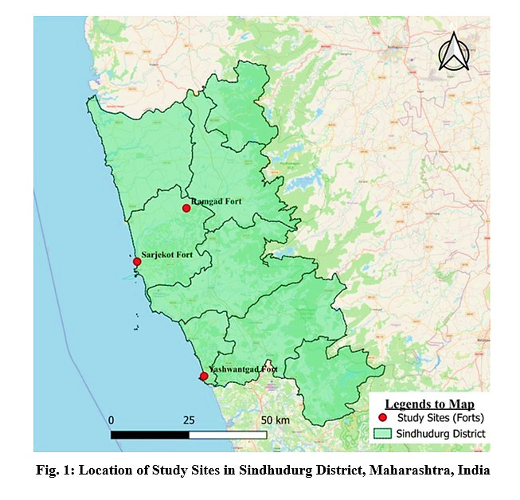
  - Data Collection
During each survey, observed species were identified using identification keys available in hand. Saurian species were identified based on external morphological characters including body coloration, size, scalation patterns and overall body morphology using standard taxonomic keys and published field guides. Environmental parameters like temperature, relative humidity, habitat type, vegetation cover, substrate characteristics and degree of anthropogenic disturbance were recorded. Data regarding species identity, number of individuals were recorded for each individual. Microhabitat type in which it is observed like walls, crevices, ground or vegetation type were also recorded. Activities like basking, foraging, resting etc. were recorded. Geographic location of each visit was noted using GPS Camera app in mobile. To maintain methodological consistency, surveys were conducted following similar observation duration, search intensity and transect length across all study sites.
  - Data Analysis
For each fort, species richness was calculated to evaluate total number of species recorded on each fort and to compare it with other forts. Shannon-Wiener diversity index and Simpson’s diversity index were calculated to understand the diversity pattern. To understand the distribution of individuals among the species, species evenness was calculated. Proportion of individuals of each species was taken into consideration to determine the relative abundance. All results were compared across three forts to evaluate the influence of habitat type and anthropogenic activities on diversity and distribution of saurian species.
The Shannon–Wiener diversity index (H′) was used to quantify species diversity and was calculated using the formula:
- $H^{'}= -∑(p_{i}\ln{p_{i}})$
where pᵢ represents the proportion of individuals of the iᵗʰ species (pᵢ = nᵢ / N), nᵢ is the number of individuals of species i, and N is the total number of individuals of all species recorded at a site.
Species dominance was assessed using Simpson’s dominance index (D):
- $D= ∑(p_{i}^{2})$
Simpson’s diversity was expressed as Simpson’s diversity index (1 − D):
- $1-D=1- ∑(p_{i}^{2})$
Species evenness was calculated using Pielou’s evenness index (J′) to evaluate the distribution of individuals among species:
- $J^{'}= \frac{H'}{\ln{S}}$
where S represents species richness. Diversity indices were calculated separately for each fort to allow comparison of saurian diversity, dominance and evenness across sites with varying habitat characteristics and levels of anthropogenic disturbance. Differences in saurian abundance among the selected fort ecosystems were analyzed using the Chi-square goodness-of-fit test. Statistical significance was determined at p < 0.05. Species diversity indices and comparative analyses were calculated using Microsoft Excel.
- RESULT AND DISCUSSION
  - Species Composition:
A total of 10 saurian species belonging to 5 genera and 5 families were recorded from the three selected forts i.e., Ramgad Fort, Sarjekot Fort and Yashwantgad Fort (Redi) during the study period covering all three seasons (Table 1). Family wise data analysis revealed that Gekkonidae was the most dominant family among all species from three forts in terms of species richness, followed by Scincidae and Agamidae. The family Varanidae was represented by only one species. The overall species composition varied among the forts, reflecting differences in habitat composition and environmental conditions.
Table 1. Checklist of saurian species recorded from selected forts of Sindhudurg District
Sr. No. | Species Name | Genus | Family | Common Name
1 | Calotes versicolor | Calotes | Agamidae | Oriental garden lizard
2 | Eutropis carinata | Eutropis | Scincidae | Keeled grass skink
3 | Eutropis macularia | Eutropis | Scincidae | Bronze grass skink
4 | Hemidactylus brookii | Hemidactylus | Gekkonidae | Brook’s house gecko
5 | Hemidactylus flaviviridis | Hemidactylus | Gekkonidae | Yellow-bellied house gecko
6 | Hemidactylus frenatus | Hemidactylus | Gekkonidae | Common house gecko
7 | Hemidactylus prashadii | Hemidactylus | Gekkonidae | Prashad’s gecko
8 | Monilesaurus elloti | Monilesaurus | Agamidae | Elliot’s forest lizard
9 | Monilesaurus rouxii | Monilesaurus | Agamidae | Roux’s forest lizard
10 | Varanus bengalensis | Varanus | Varanidae | Bengal monitor
  - Fort-wise Diversity:
Species richness varied among the three study sites (Table 2). Yashwantgad Fort (Redi) noted highest number of species, followed by Ramgad Fort, while Sarjekot Fort showed comparatively lower species richness. Variation in habitat complexity, vegetation cover and levels of anthropogenic disturbance are the factors that were associated with differences in the diversity.
Table 2. Fort-wise species richness and diversity indices
Fort | Species richness (S) | Shannon–Wiener index (H′) | Simpson’s diversity index (1–D) | Evenness (J′)
Yashwantgad Fort (Redi) | 9 | 0.943 | 0.386 | 0.429
Ramgad Fort | 8 | 1.731 | 0.789 | 0.832
Sarjekot Fort | 7 | 1.63 | 0.766 | 0.838
Certain species were consistently recorded across all three forts, indicating their broad habitat tolerance. In contrast, some species were restricted to specific forts, suggesting habitat specificity or sensitivity to environmental conditions.
  - Seasonal Variation:
During one year study period, it was observed that species richness and abundance were higher during post monsoon season (Fig. 2), while reduced activity and lower abundance were observed during late summer season. Seasonal differences were more noticeable in coastal forts, due to climatic factors and tourist activity.
Some species showed seasonal fluctuations in abundance, whereas others were recorded consistently throughout the year, indicating variation in activity patterns and habitat use among species.
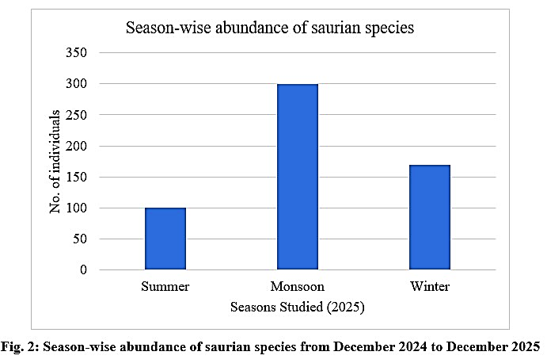
  - Abundance:
The relative abundance of saurian species varied significantly among the selected study sites. A Chi-square goodness-of-fit test was performed to examine variation in saurian abundance among the three fort ecosystems. The analysis revealed a significant difference in abundance distribution among the studied forts (χ² = 177.19, df = 2, p < 0.05), indicating that saurian abundance varied significantly across the selected habitats. Fort wise assessment revealed higher overall abundance at Yashwantgad Fort (Redi), followed by Ramgad Fort, and Sarjekot Fort (Fig. 3).
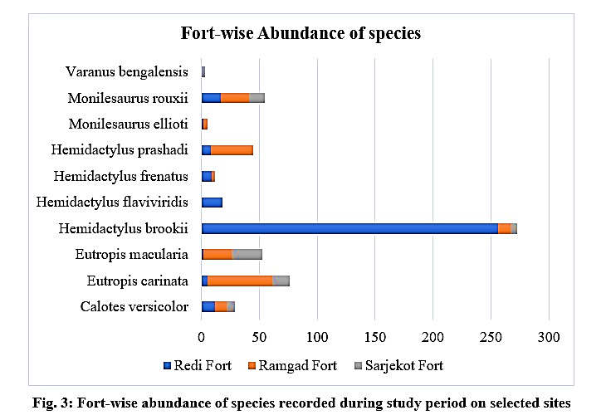
Availability of basking sites, microhabitat features and human interferences at study sites are the factors due to which these indices were influenced showing much variation. Species richness (S) was highest at Yashwantgad Fort (Redi) (9 species), followed by Ramgad Fort (8) and Sarjekot Fort (7). Shannon diversity (H′) was highest at Ramgad Fort, indicating greater species diversity and more balanced abundance distribution. Simpson’s index (1–D) also showed higher diversity at Ramgad Fort and Sarjekot Fort compared to Yashwantgad Fort (Redi). Evenness (J′) was lowest at Yashwantgad Fort (Redi), reflecting dominance by Hemidactylus brookii, whereas Ramgad Fort and Sarjekot Fort showed more even species distribution.
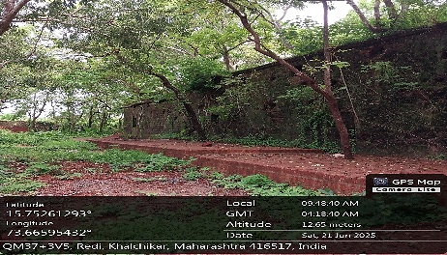 | 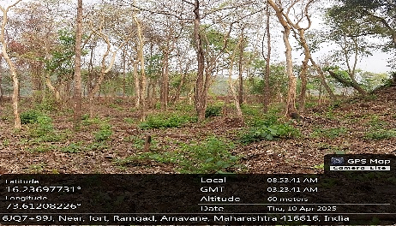 |  | 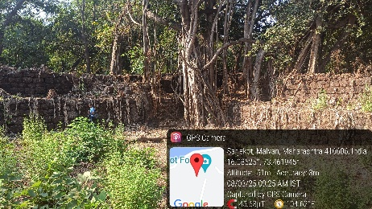
(a) | (b) |  | (c)
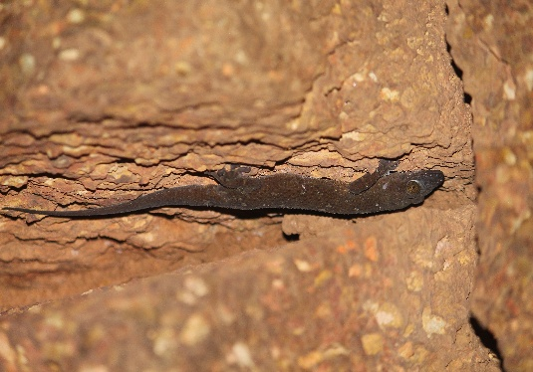 | 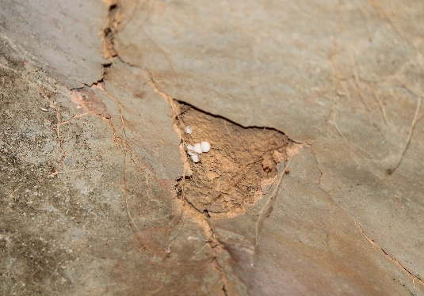 |  | 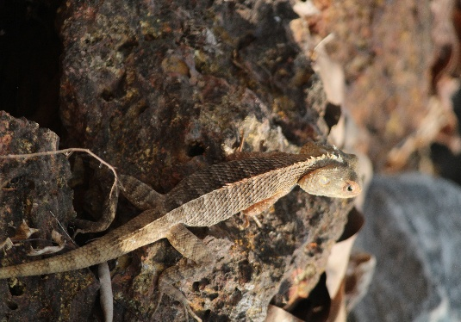
(d) | (e) |  | (f)
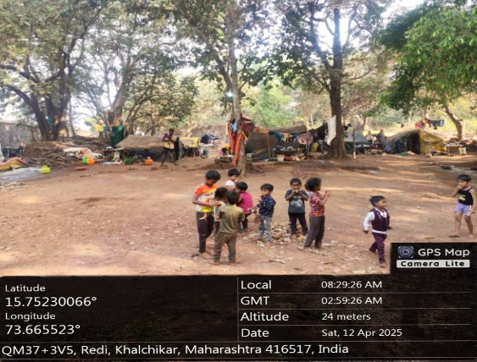 |  | 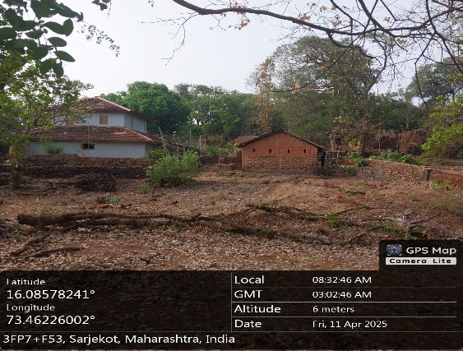
(g) |  | (h)
Fig. 4: Study sites showing habitat complexity (a) Yashwantgad Fort (Redi) (b) Ramgad Fort (c) Sarjekot Fort; (d) (e) Cracks and crevices in stone walls (f) Basking site within forts; (g) (h) Human disturbance and Settlements within forts
DISCUSSION
So far till date, no studies have been made specifically in relation to saurian diversity of Indian forts. Equally, researchers from other countries have also not mainly focused on the saurian diversity from the forts and allied areas in their respective geographical regions. So, obviously, the work presented in this paper is unique if the national as well as international scenario is concerned. Even in Sindhudurg district, this is the first attempt to evaluate the said diversity in the selected forts. Similarly, this work can be compared to some extent with the work done by other workers in the area of terrestrial diversity of saurian in different parts of India as well as the other countries. But still, this comparison may not be appropriate because the fort ecosystems and their habitat structure in and out of the actual fort constructions is quite different than the plateaus and other terrestrial habitats. In fact, parts of a fort represent habitat fragmentation and consequent distribution of the species itself. Besides, fort walls themselves serve as a separate unique habitat for harboring different species of reptiles over there. Besides, the availability of food also differs accordingly.
Saurian diversity was observed to vary with habitat type. Similar patterns have been reported in the Sinhagad Forest Region, where reptiles were most abundant in tropical dry deciduous forests compared to agricultural fields and hilltop plateaus. Total 3 species belonging to family Agamidae, 4 species belonging to family Gekkonidae, 3 species belonging to family Lygosomidae, 1 species belonging to family Mabuyidae, and 1 species belonging to family Varanidae were observed during the study (Pardeshi et al., 2021). 3 Skink species, 5 species of geckos and 3 species of lizards were observed around Panje-Dongri Wet Land, Uran, Navi Mumbai (Thakkar, A. N. et al., 2023).
The present study revealed clear variation in saurian diversity and abundance among Yashwantgad Fort (Redi), Ramgad Fort, and Sarjekot Fort. Well balanced species assemblage was exhibited by Ramgad fort with highest diversity and evenness values. Whereas Yashwantgad Fort (Redi) showed higher species richness but lower diversity due to dominance of few species, particularly Hemidactylus brookii. Intermediate diversity patterns were showed by Sarjekot Fort. Variations in habitat structures and disturbance levels attributed to these differences. Higher diversity in Ramgad fort is mainly due to relatively undisturbed surroundings and rich microhabitats. Yashwantgad Fort (Redi), despite supporting more species, was influenced greatly by anthropogenic activities.
Anthropogenic pressure, particularly tourism, played significant role in saurian diversity. Highest tourist activities were experienced by Yashwantgad Fort (Redi), showed reduced evenness. In contrast, Ramgad fort with minimum human activities support higher diversity and evenness in species distribution. Sarjekot Fort experiences moderate disturbance and hence intermediated diversity values. This indicated that anthropogenic activities negatively affect the overall diversity patterns. Environmental factors combined with anthropogenic activities strongly affects the species composition.
Within human-modified landscapes, historical forts act as an important habitat for reptilian fauna. Habitat disturbance and microhabitat loss are two major threats to the saurian diversity which were caused by unregulated tourism and human activities. For sustaining biodiversity in fort ecosystem, it is necessary to implement habitat friendly management practices and regulate tourist activity at certain forts.
- CONCLUSION
The study shows significant variation in saurian diversity across studied forts of Sindhudurg district. This variation was influenced by anthropogenic conditions, habitat structures and environmental conditions. Yashwantgad Fort (Redi) showed species dominance under higher anthropogenic pressure while Ramgad fort which was less disturbed supported higher diversity and showed evenness across species. The study highlights that fort ecosystems of Sindhudurg district support considerable saurian diversity. Habitat structure and anthropogenic disturbance significantly influence species distribution. Conservation measures such as habitat protection and controlled tourism are necessary to preserve reptilian diversity in these historically important landscapes. As forts provide ecologically important habitats, their inclusion in biodiversity conservation plans is necessary for reptile conservation.
Acknowledgements
The author acknowledges Miss Bhagyashri Parab and Dr. Bapu Bhogate (Asst. Professor, Chhatrapati Shivaji Krushi Mahavidyalaya, Kirlos, Sindhudurg) for valuable guidance during conduct of this study.
Conflict of Interest
The authors declare that they have no known competing financial or personal relationships that could have influenced the work reported in this paper.
Declaration of Generative AI and AI-assisted technologies in the writing process
The authors declare that no artificial intelligence tools were used to write this manuscript.
REFERENCES
- Aengals, R., Sathish Kumar, V.M., Palot, M.J. & Ganesh, S.R. (2018). A Checklist of Reptiles of India. 35 pp. Version 3.0.
- Boulenger, G. A. (1887). Catalogue of the lizards in the British Museum (2nd ed., Vol. 3). London, England: British Museum (Natural History).
- Chaitanya, R., Agarwal, I., Lajmi, A., & Khandekar, A. (2019). A novel member of the Hemidactylus brookii complex (Squamata: Gekkonidae) from the Western Ghats of Maharashtra, India. Zootaxa, 4646(2), 236–250. https://doi.org/10.11646/zootaxa.4646.2.2
- Chaitanya, R., Dhibar, A., Khandekar, A., Murthy, C., Meiri, S., & Karanth, P. (2025). Speciation in the Peninsular Indian Flying Lizard (Draco dussumieri) follows climatic transition and not physical barriers. Molecular Ecology, 34(12), e17800. https://doi.org/10.1111/mec.17800
- Das, I. (2010). A field guide to the reptiles of South-East Asia. London, England: New Holland Publishers. ISBN 978-1-4729-2057-7.
- Doan, T. M. (2003). Which methods are most effective for surveying rain forest herpetofauna? Journal of Herpetology, 37(1), 72–81. https://doi.org/10.1670/0022-1511(2003)037[0072:WMAMEF]2.0.CO;2
- Firoz, A. M., Das, A., & Dutta, S. K. (2009). Amphibians and reptiles of Northeast India: A photographic guide. Guwahati, India: Aaranyak.
- Gosavi, N., Lad, H., Jithin, V., & Naniwadekar, R. (2025). Effects of tree plantations on population and roosting ecology of an endemic agamid lizard in the Western Ghats Biodiversity Hotspot. Journal of Zoology, 328(1)
- Giri, V. B., & Bauer, A. M. (2008). A new ground-dwelling Hemidactylus (Squamata: Gekkonidae) from Maharashtra, with a key to the Hemidactylus of India. Zootaxa, 1700(1), 43–60. https://doi.org/10.11646/zootaxa.1700.1.3
- Hussain, A., & Tantarpale, V. T. (2017). Anthropogenic effect and seasonal diversity of lizards in Amravati urban area, Maharashtra, India. International Journal of Science and Research (IJSR), 6(9), 472–474.
- Khandekar A, Thackeray T, Mariappan R, Gangalmale S, Waghe V, Pawar S, Agarwal I (2023) A remarkable new species of gecko (Squamata: Gekkonidae: Hemidactylus) from scrublands at the southern tip of India. Vertebrate Zoology 73 433–450. https://doi.org/10.3897/vz.73.e101871
- Mattison Chris (2014). Nature Guide Snakes and other Reptiles and Amphibians. ISBN 978-1-4654-2103-6.
- Murthy, T. S. N. (1990). The lizards of India: An overview. British Herpetological Society Bulletin, 31, 7–13.
- Pal, A., Dey, S., & Roy, U. S. (2012). Seasonal diversity and abundance of herpetofauna in and around an industrial city of West Bengal, India. Journal of Applied Sciences in Environmental Sanitation, 7(4), 281–286.
- Pardeshi, A., Joglekar, R. V., & Shukla, C. S. (2021). Herpetofauna of Sinhagad Forest Region, northern Western Ghats, India. Reptiles & Amphibians, 28(1), 112–117. https://doi.org/10.17161/randa.v28i1.15365
- Sarang, S. S., & Jamble, M. N. (2025). Studies on diversity of saurian fauna in Kudal and Sawantwadi Tehsils (Sindhudurg – Maharashtra). Journal of Emerging Technologies and Innovative Research (JETIR), 12(4), 137-142. ISSN 2349-5162.
- Sharma, R. C. (2005). The fauna of India and the adjacent countries: Reptilia (Sauria) (Vol. 2, pp. 1–430). Kolkata, India: Zoological Survey of India. ISBN 81-8171-096-7.
- Smith, M. A. (1935). The fauna of British India, including Ceylon and Burma: Reptilia and Amphibia (Vol. 2: Sauria). London, England: Taylor & Francis.
- Srinivasulu, C., Srinivasulu, B., & Molur, S. (2014). The status and distribution of reptiles in the Western Ghats, India: Conservation assessment and management plan (CAMP). Coimbatore, India: Wildlife Information Liaison Development Society. ISBN 978-81-88722-40-2.
- Srivastava, D.P., A.S. Chauhan & R. Ahlawat (2018). Indian Spiny-tailed Lizard: First record of Saara Hardwickii (Gray, 1827) in south-western Hisar District of Haryana, India. Reptile Rap #187. In: Zoo’s Print 33(10): 09-14
- Sunagar, K.; Abraham, S.V. The Curious Case of the “Neurotoxic Skink”: Scientific Literature Points to the Absence of Venom in Scincidae. Toxins 2021, 13, 114. https://doi.org/10.3390/toxins13020114
- Thakkar, A. N., Bhoye, P. T., & Thakur, N. R. (2023). Diversity of snakes around Panje-Dongri wetland, Uran, Navi Mumbai west coast of India. International Journal of Advanced Research in Science, Communication and Technology, 3(3), 99–108.
- Tikader, B. K., & Sharma, R. C. (1992). Handbook of Indian lizards. Calcutta, India: Zoological Survey of India.
- Venugopal, P. D. (2010). An updated and annotated list of Indian lizards (Reptilia: Sauria) based on a review of distribution records and checklists of Indian reptiles. Journal of Threatened Taxa, 2(3), 725–738.
- Whitaker, R. H. (2006). Common Indian snakes: A field guide (pp. 1–138). New Delhi, India: Macmillan India Ltd.
- Yadav, O. V., Yankanchi, S. R., & Patil, A. M. (2014). Diversity, threats and conservation of herpetofauna in Shivaji University Campus, Kolhapur, Maharashtra, India. International Journal of Current Microbiology and Applied Sciences, 3(6), 395–406. ISSN 2319-770.

